

EC Upgrade BKK Use Case

Project Name
BKK Project Energy Components

Use-Case Name
EC_12_2_BKK_UC05_Well Chronology
Origination Date
14-Oct-2017

Revision History

Revision | Date | Description | Prepared  by | Checked  by | Approved by
1.0 | 14-Oct-2017 | Draft of Use Case “Well Chronology” | Wirasak C.
1.1 | 11-Nov-2017 | Review and feedback | Jennifer Lopez
1.2 | 26-Nov-2017 | Revised this Use Case from ITC comments | Wirasak C.
1.3 | 27-Mar-2018 | Updated as per EC 11,2 | Tieto
2 | 2-July-2020 | Thailand ECasaS | Wirasak C.
2 | 20-June-2021 | Updated as per EC12.2 | Tieto

Table of Contents

1. Use Case Information 3
2. Primary Flow: Well Chronology 3
3. Alternatives 5
3.1 Alternate Condition A1: Deleting Well Chronology 5
4. Exceptions 7
4.1 List of Common Issues/Errors 7
5. Additional Clarifying Information 7
5.1 Additional Variations 7
5.2 Business Rules: 7
5.3 Data Impacts 7

Use Case Information

Use Case Number and Name | EC_12_2_BKK_UC05_Well Chronology
Brief Description | This BF describes the entry of a well chronology captured by field personnel.
Related Use Cases | - N/A
EC Business Functions | - PRODUCTION TEST RESULT (PT.0010)
EC Roles  (list of EC Roles that should be able to execute this Use Case) | - Roles can be able to execute this use case are as follows:  - Erawan Administrator, Erawan Prod.Operator
Prerequisites | - N/A
Approver

Note: the toolbar on EC11.2 has changed. Refer to the image below for different buttons

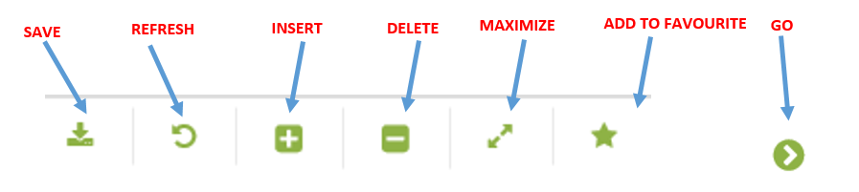

Primary Flow: Well Chronology
Trigger: User enter a Well Chronology
Step | Actor Action | System Response | Notes
 | Opens up the Well Chronology screen.  EC Production à Well Data à Well Chronology | - Blank navigational fields  - Yesterday’s date is default populated as the From Date  - Yesterday’s date is default populated as the To Date | The hierarchy will automatically populate upon area if defined by role.
 | Change the Date in the Navigator Pane to the range to be displayed. | Date range is changed
 | In the Navigator, navigate to the well using the drop down menus and clicks Go…  Operation Hierarchy  - Production Unit  - Production Sub Unit  - Area  - Sub Area  - Facility Class 2  - Facility Class 1  - Well | Well Chronology appears in the Data Window.  The Well Chronology window may be blank if there were no status changes on the Dates chosen in the navigator.
 | Mouse hover to Insert icon in the Tool Bar and click on Well Chronology | A new data entry form is created in the Well Chronology section of the screen.  The Day/Time are pre-populated with the well selected in the hierarchy and 00:00
 | Change Day/Time 00:00:00 for the time on all status changes. (The Date was selected in the navigator.) | Edit Date / Time to correct effective daytime date.
 | Click the Codedropdown and select the category | Well code options are displayed in a drop-down box  General  Downhole Completion  Equipment Failure | Code options include:  General Well Comment  Gas Lift Comment  - ESP Comment
 | Click the Well Bore Name dropdown and select the Well Bore for the selected Code | Well Bore options are selected.
 | Select the Activity and Activity 2(Optional) drop-down menu and time date is mandatory field. | Blank Text field is displayed | This field is a long comment description field
 | Click the Save icon in the Tool Bar | Data entry line with new status is added in the Data Window.
 | END OF USE CASE
 | END OF USE CASE

Alternatives

Alternate Condition A1: Deleting Well Chronology
Details: The steps below are followed to delete a Well Chronology.
Step | Actor Action | System Response | Notes
 | User opens up the Well Chronology screen  EC Production à Well Data à Well Chronology | The following fields are automatically populated:  - Yesterday’s date is default populated as the From Date  - Yesterday’s date is default populated as the To Date
 | Change the From Date and To Date in the Navigator Pane to include the dates of the well data being entered | Date is populated.
 | User :  Navigate to the Well that you need to enter data on using the drop down menus and click Go…  - Production Unit  - Production Sub Unit  - Area  - Sub Area  - Facility Class 2  - Facility Class 1  - Well | All previous data entries between the From date and To date are displayed in the Data Window.  The Data Window may be blank if there were no records between the From Date and To date.
 | Click anywhere on the Well Chronology record that needs to be deleted to insure focus on the right record | Record will be highlighted
 | Insure that the Status Area is shown at the bottom of the screen. If not, click on the Hide/Show Status Area button at the top of the page, then click on any editable data field in the Well Chronology area. | The Revision Text field in the Status Area will become editable.
 | Click into the Revision Text field and type the reason the test is being deleted, then click the Save button. | The Revision Text is saved when the EC Status shows Ready.
 | Insure that focus is still on the record to be deleted in the Well Chronology area and Mouse hover to delete button at the top of the screen to mark the record for deletion and click on Well Chronology | Hash-marks will obscure the record being deleted.
 | Click the Save icon in the Tool Bar | Data is saved.  Rows are sorted in chronological order
 | END OF USE CASE

Exceptions

List of Common Issues/Errors

 | Error | Error Message
 | User does not enter an EC required field | Error: “Please enter” + required field not entered.
 | User attempts to enter a start date greater than the current calendar date | Error:  “Daytime is greater than today’s Production Day.”

Additional Clarifying Information

Additional Variations

Business Rules:
Business Rule | Data Elements | Description
BR.1 | NA | User should only be able to see Hierarchy information for his/her own area.
BR.2 | Daytime | The start date cannot be greater than the current calendar date.  Date format is yyyy-mm-dd hh:mm

Data Impacts

Business Entry Screen | Description | Valid Values
Production Well Status - History
Daytime | Mandatory | yyyy-mm-dd hh:mm
Code | Mandatory | Drop-down

