**Problem Statement:**

Write a hive UDAF to find the largest integer in a column. Use your own dataset for the above problem statement and attach the steps performed, codes used with the result.

**Solution**:

UDAF Class:

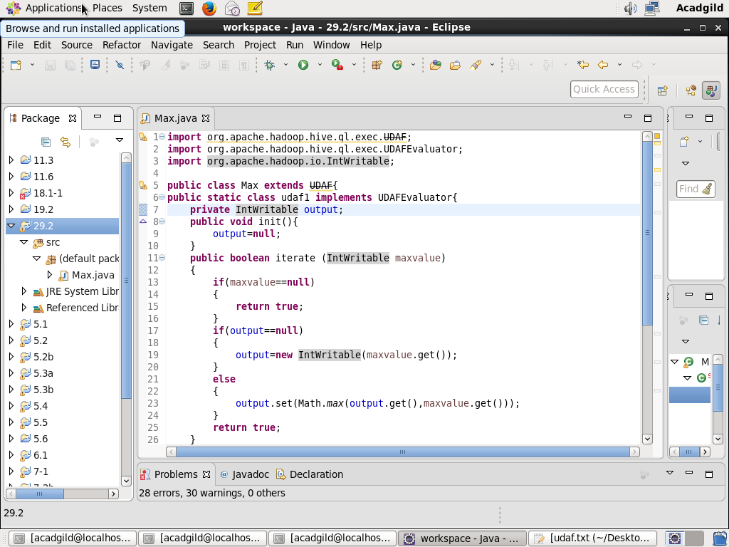

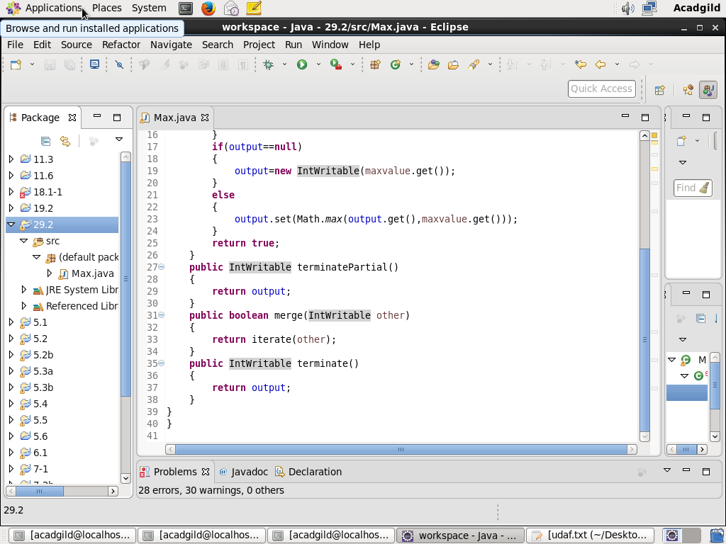

Creating the table, loading the data into the table and displaying the data:

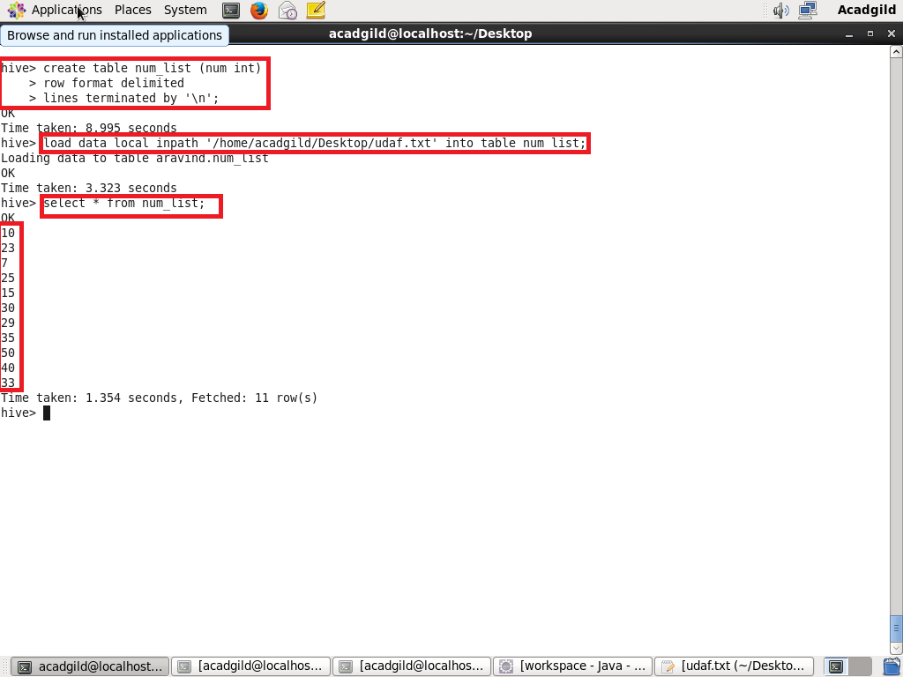

Adding jar, creating temporary function and using the temporary function:

