Question-1:
What is the optimal value of alpha for ridge and lasso regression? What will be the changes in the model if you choose to double the value of alpha for both ridge and lasso? What will be the most important predictor variables after the change is implemented?

Answer:

The optimal values of alpha for Ridge & Lasso Model are as follows:

Regularized Model | Alpha Value
Ridge | 2
Lasso | 0.001

On doubling the alpha values for both the models, there was a slight change discovered with Lasso regularized model but did not find any change in Ridge regularized column.

Regularized Model | Alpha Value | Important Predictor | Beta Co-efficient
Ridge | 2 | Building Type - Townhouse | -0.3655
Lasso | 0.001 | Building Type - Townhouse | -0.3499

Regularized Model | Alpha Value | Important Predictor | Beta Co-efficient
Ridge | 4 | Building Type - Townhouse | -0.3372
Lasso | 0.002 | Ground Living Area | 0.3297

On applying Ridge Regularization process, it was seen that important predictor did not changed i.e., Building Type – Townhouse variable remains to be the dominant one when it comes to predicting output (using Ridge) on doubling alpha values.

On the contrary, while applying Lasso Regularization process, it was seen that important predictor did changed from Building Type – Townhouse to Ground Living Area variable when it comes to predicting output (using Lasso) on doubling alpha values.

Question-2:
You have determined the optimal value of lambda for ridge and lasso regression during the assignment. Now, which one will you choose to apply and why?

Answer:

For Ridge Model, various range of alpha’s were taken to identify the mean train and test score in identifying hyperparameter. Following is the plot of alpha for different range.

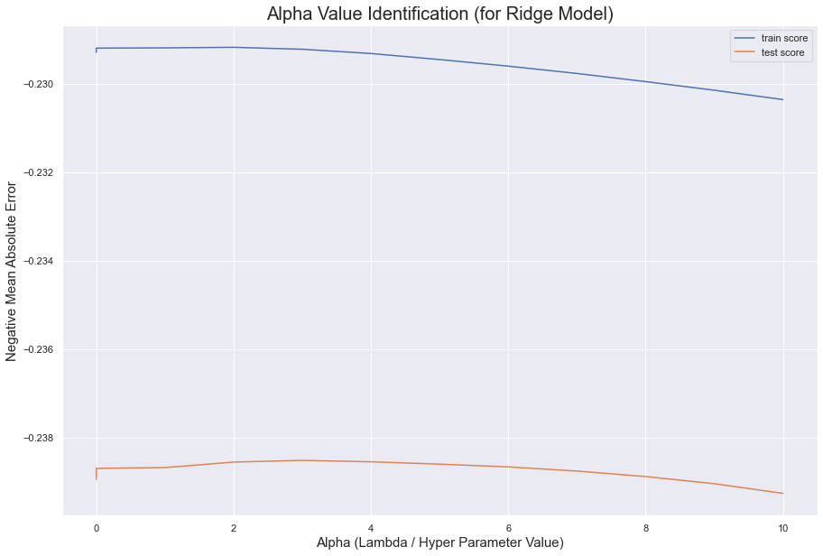

From the above graph, it is more of an evident that an alpha value of 2 will provide minimum mean train and test score. For this reason, alpha value of 2 was conclusively selected as to regularize the unregularized model.

For Lasso Model however, we see that at alpha value of 0.001 we get minimal Negative Mean Abosulte Error. If this Alpha value is lowered down further, we might not see any significant change in our model behaviour.

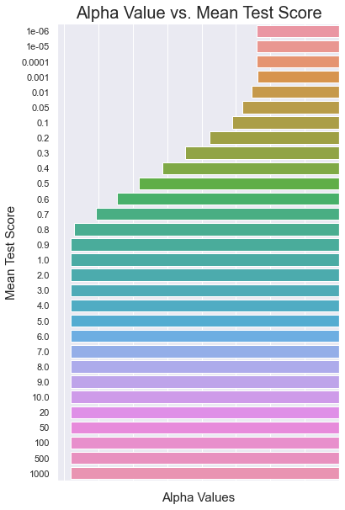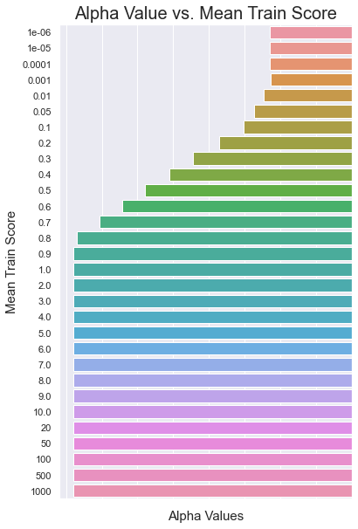
Question-3:
After building the model, you realised that the five most important predictor variables in the lasso model are not available in the incoming data. You will now have to create another model excluding the five most important predictor variables. Which are the five most important predictor variables now?

Answer:

For Lasso Model, following are the top 5 most important predictor variables.
Feature | Beta Co-efficient Value
BldgType_Twnhs | -0.349922104
GrLivArea | 0.333805625
Neighborhood_NridgHt | 0.30486133
Neighborhood_Somerst | 0.281891617
SaleCondition_Abnorml | -0.261963946

Assuming that, if those parameters are not available, we end up getting following variables as the 5 topmost predictor variables along with their respective beta co-efficient values.

Feature | Beta Co-efficient Value
OverallQual | 0.297939698
Neighborhood_Edwards | -0.254919603
MSZoning_RL | 0.244093013
LotConfig_CulDSac | 0.207522297
Foundation_BrkTil | -0.195212523

Question-4:
How can you make sure that a model is robust and generalisable? What are the implications of the same for the accuracy of the model and why?

Answer:

