SMARTRECO HACKATHON · PRODUCT & ARCHITECTURE DOCUMENTATION
Growise
Behavioural AI recommendations for an online learning marketplace
A product walkthrough, implementation architecture, and reviewer guide
EXPERIENCE  Learner journeys | RECOMMENDATIONS  Grounded, personal | OPERATIONS  Auditable admin console

Prepared from the live local application experience and the current source implementation.

01 · INTRODUCTION

What Growise is
Growise is a course marketplace that replaces generic “related courses” with a behavioural AI recommendation loop. It observes the meaningful choices a learner makes—searches, course views, card clicks, qualified dwell time and enrollment intent—and converts those signals into a concise, catalog-grounded next-step recommendation.
The product is designed as two complementary experiences. Learners receive a focused route through a large course catalog, while administrators can manage catalog quality and inspect the evidence, agent steps, model usage and outcomes behind every recommendation.

The problem
Traditional course discovery expects learners to articulate their goal, filter a large catalog and repeatedly evaluate alternatives. That creates three recurring problems: choice overload, recommendations that are not connected to current intent, and opaque systems that give operators no credible way to explain why a course was selected.

What we are solving
Growise turns passive browsing into a lightweight learning signal. It makes a recommendation only when evidence exists, retrieves candidate courses from the real catalog, applies relevance and diversity checks, generates a tailored explanation through Mesh, and stores the result with an inspectable trace. The result is a more useful learner experience without treating every click as a reason to call an LLM.
Design goal | How Growise addresses it
Personal relevance | Weighted interest signals, recency and exclusions shape a learner profile before retrieval.
Catalog grounding | Chroma retrieves real course candidates; generated product IDs are validated against the candidate set.
Cost discipline | A trigger gate serves the cached recommendation until there is enough new meaningful activity and the cooldown is complete.
Operational trust | The admin console exposes events, recommendation traces, Mesh calls and vector-sync health.

02 · ARCHITECTURE

Complete architecture
The frontend and backend are intentionally separated. Next.js provides server-rendered pages and interactive client components. FastAPI owns authentication, catalog mutations, behavioural event intake, recommendation delivery, operations data and the agent workflow. JWT bearer tokens keep cross-origin development simple; FastAPI enforces user and administrator boundaries on protected endpoints.
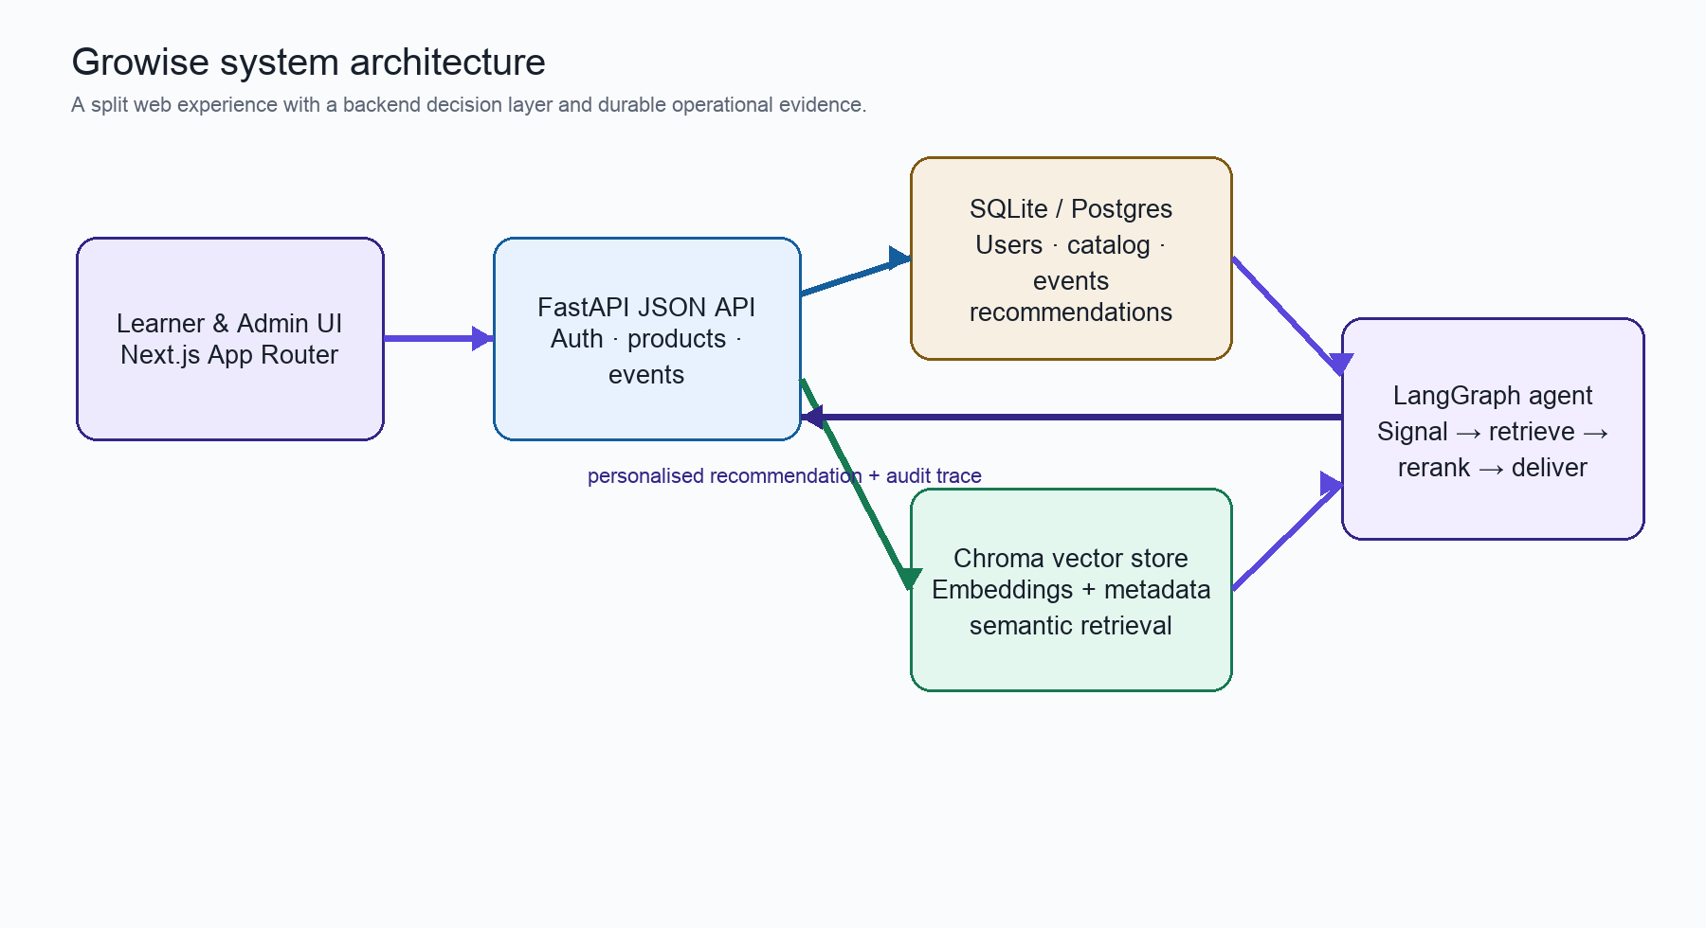
Figure 1. End-to-end Growise architecture. Reviewer action: Read left to right: the web UI records and requests; FastAPI coordinates durable data and the agent; the vector store supplies grounded candidates.

Component responsibilities
Layer | Responsibility | Key implementation choices
Next.js 16 frontend | Learner and admin journeys, course discovery, auth UI and event capture. | App Router, Tailwind UI, non-blocking tracker, API client.
FastAPI backend | JSON API, JWT validation, administrative guards and orchestration. | Routers for auth, products, events, enrollments, recommendations and agent ops.
SQL store | System of record for users, courses, events, enrollments, recommendations and run telemetry. | SQLAlchemy entities and durable recommendation history.
Chroma | Semantic catalog retrieval. | Course metadata + local all-MiniLM-L6-v2 embeddings; explicit sync status.
LangGraph + Mesh | Structured recommendation reasoning and persuasive narrative generation. | Bounded workflow, relevance checks, candidate validation and measured usage.

Behavioural intelligence and agent workflow
The tracker queues events in memory and flushes them every five seconds or at twenty events. It uses keepalive on page hide/unload so a final batch can complete without blocking navigation. Short visits remain available to operations, but only dwell at or above the qualifying threshold affects recommendation reasoning.
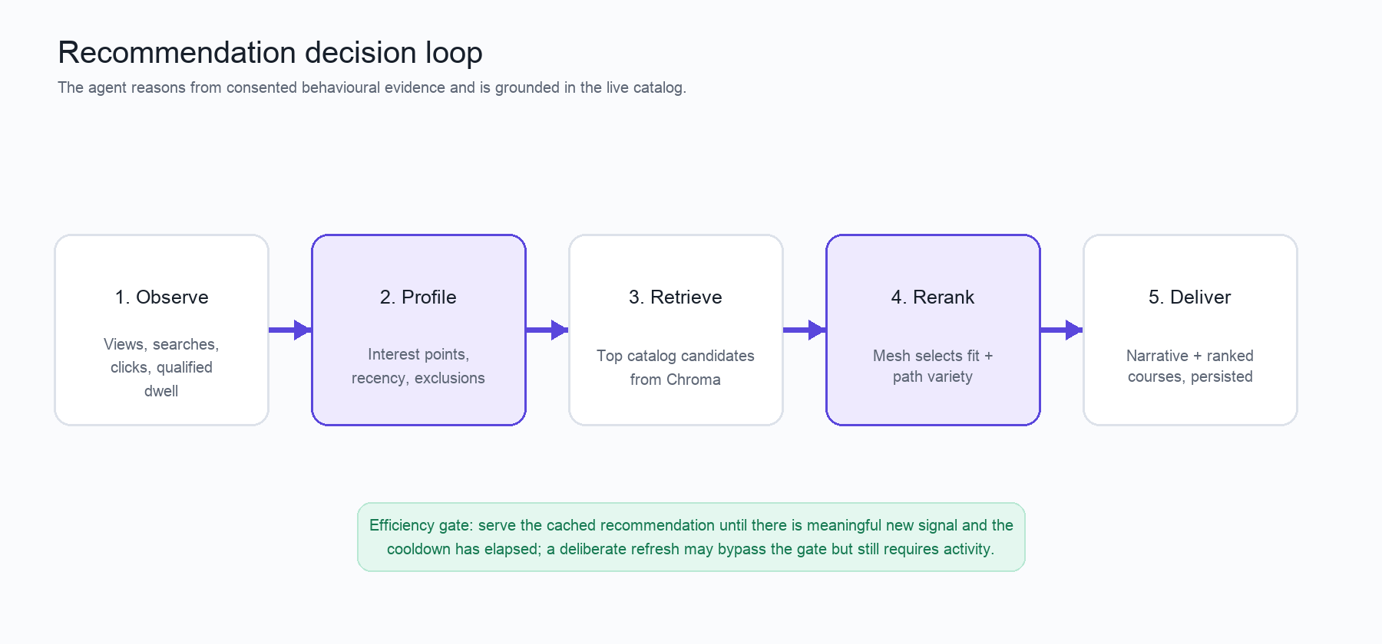
Figure 2. Behavioural signal to delivered recommendation. Reviewer action: Use this flow to verify the important boundary: an LLM never invents from an unconstrained catalog; it ranks and explains retrieved candidates.
In the profile stage, adjacent card-click and product-view events are collapsed into a single course-opening session. Interest is weighted by event type, dwell, enrollment intent and recency. Enrolled courses and recently dismissed recommendations become exclusions. Retrieval obtains a small candidate set from Chroma, relevance can be checked and refined once, and Mesh then reranks for fit and learning-path variety before the final narrative and ranked items are persisted.

Catalog integrity and persistence
Course administration uses a deliberate dual-write pattern. A product is committed to the primary database before Chroma is updated. If semantic upsert fails, the course remains visible with vector_synced=false and the failure is retained for the catalog-health view. This avoids losing a valid catalog edit while making retrieval readiness explicit and safely retryable.
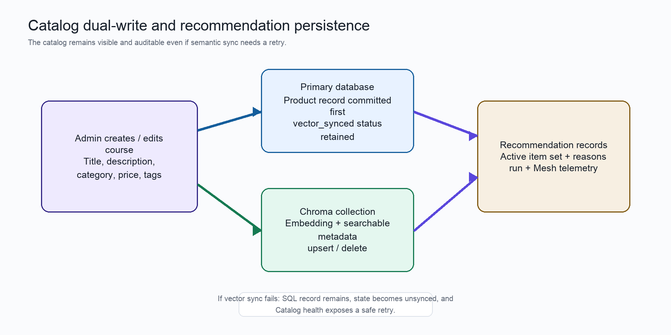
Figure 3. Dual-write catalog flow and recommendation evidence. Reviewer action: Verify that the primary record is committed first, then inspect Catalog health to see whether the semantic copy is ready or needs a retry.
03 · DATA, SECURITY AND EFFICIENCY

Data model and lifecycle
Record | Purpose | Lifecycle / guardrail
users | Email/password credential, role and tracking preference. | Password hash; JWT bearer token; user or admin role.
products | Course catalogue and vector-sync state. | Written first to SQL; semantic copy upserted; failed sync is recoverable.
events | Meaningful learner actions and metadata. | Batched async intake; short dwell retained but not always agent-eligible.
recommendations + items | Narrative and ranked, real-course selections. | New result becomes active; previous result is retained as history.
agent_runs + steps + Mesh logs | Traceable decision and model-use evidence. | Admin-only review surface; measured latency and token metadata.

Privacy and production guardrails
Tracking consent is explicit at sign-up. A learner may opt out, which stops client-side event queuing and prevents recommendation triggering without preventing ordinary use of the marketplace. The collector avoids raw scroll and mousemove streams; it records meaningful actions and one computed time-on-page event instead. Admin views are role-gated, and learner emails shown in operations are confined to that admin-only interface.

LLM-call efficiency
The recommendation endpoint first asks whether regeneration is warranted. No signal means no agent run. If an active recommendation exists, the backend requires enough new meaningful events since that recommendation and an elapsed cooldown; otherwise it returns the cached result. The explicit Refresh action is a deliberate user request, but it still requires at least some activity. This keeps the system responsive, reduces duplicate calls and preserves a stable recommendation until the learner’s behaviour materially changes.

04 · LEARNER EXPERIENCE

Learner journey and annotated screenshots
The learner experience is a continuous discovery loop: understand the value, create an account with consent, explore the catalog, inspect a course and return to a tailored next step. Each capture below includes a concrete reviewer action.

Figure 4. Learner landing page. Reviewer action: Select “Explore courses” to enter discovery, or use “See how it works” to connect the three-step story with the product behaviour.

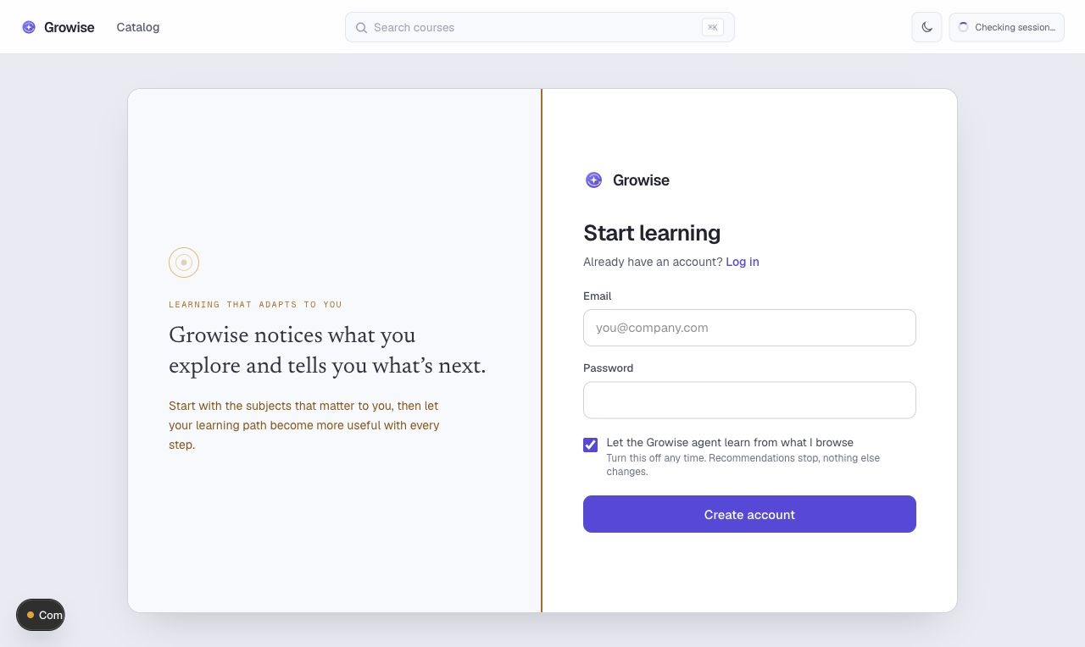
Figure 5. Sign-up page with tracking consent. Reviewer action: Create an account with the consent switch enabled to allow the recommendation agent to learn from meaningful browsing; switch it off to use Growise without recommendations.

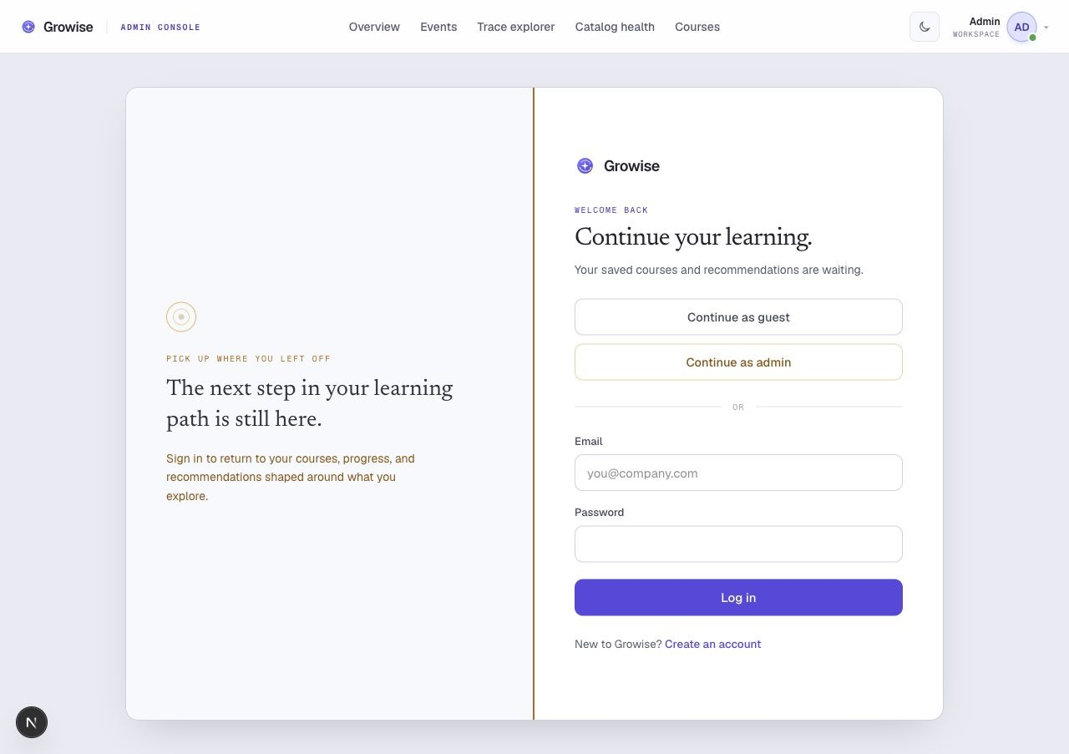
Figure 6. Learner login. Reviewer action: Use “Continue as guest” for the seeded learner walkthrough, or sign in with an existing email and password to restore courses and recommendations.


Figure 7. Filtered course catalogue. Reviewer action: Choose a category, level or price filter and open a course card; the resulting views and clicks become lightweight recommendation evidence after sign-in.

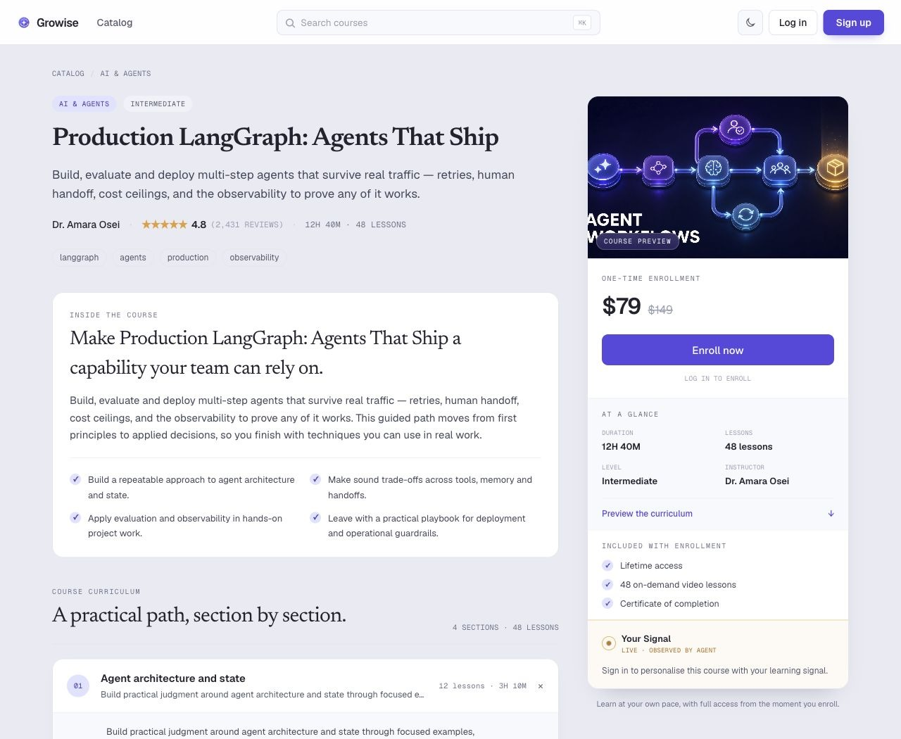
Figure 8. Course detail page. Reviewer action: Review the outcomes and expandable curriculum, then use “Enroll now” when ready; this is also the place where a signed-in learner sees the current learning signal.

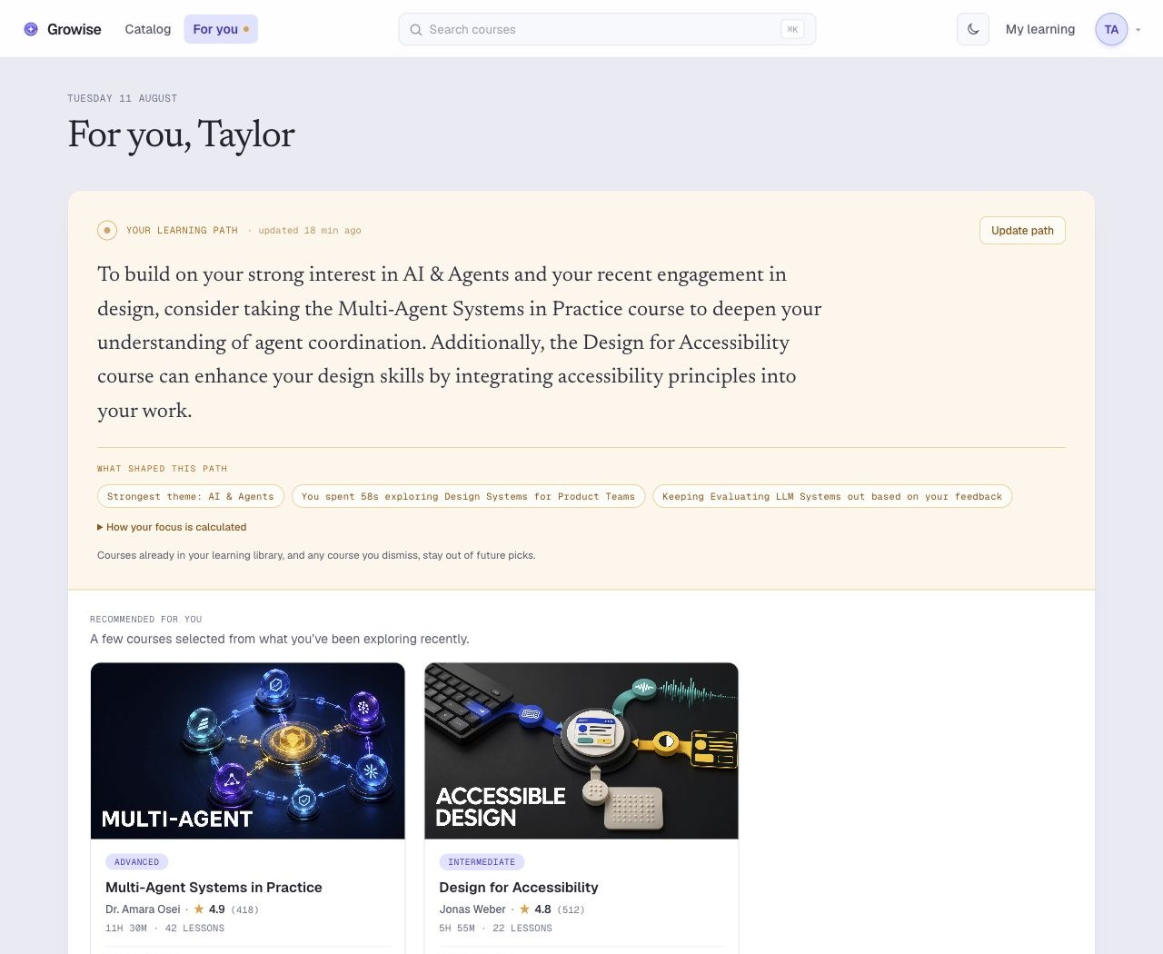
Figure 9. Personalised “For you” page. Reviewer action: Review the narrative and “Why this fits” explanations, then choose a recommended course or use “Not for me” to exclude a poor fit from future recommendations.


Figure 10. My learning library. Reviewer action: Open an enrolled course to continue learning; courses already owned are excluded from future recommendation candidates.

05 · ADMINISTRATOR EXPERIENCE

Admin journey and annotated screenshots
The admin console makes the recommendation system inspectable rather than magical. It is where a reviewer can confirm the operating health of the catalog, inspect consented signals and audit the exact decision path behind a learner-facing recommendation.
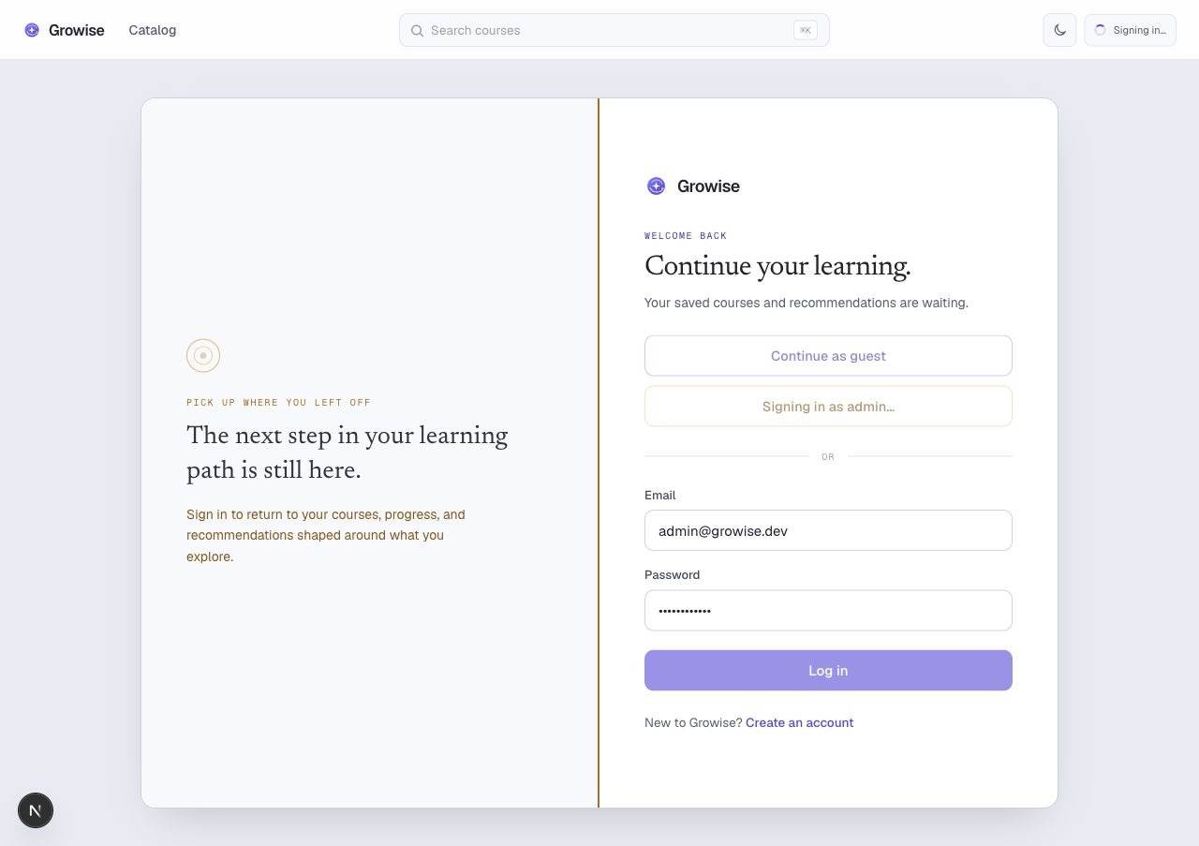
Figure 11. Administrator login path. Reviewer action: Choose “Continue as admin” on the sign-in screen to enter the seeded operational workspace and land on the recommendation dashboard.

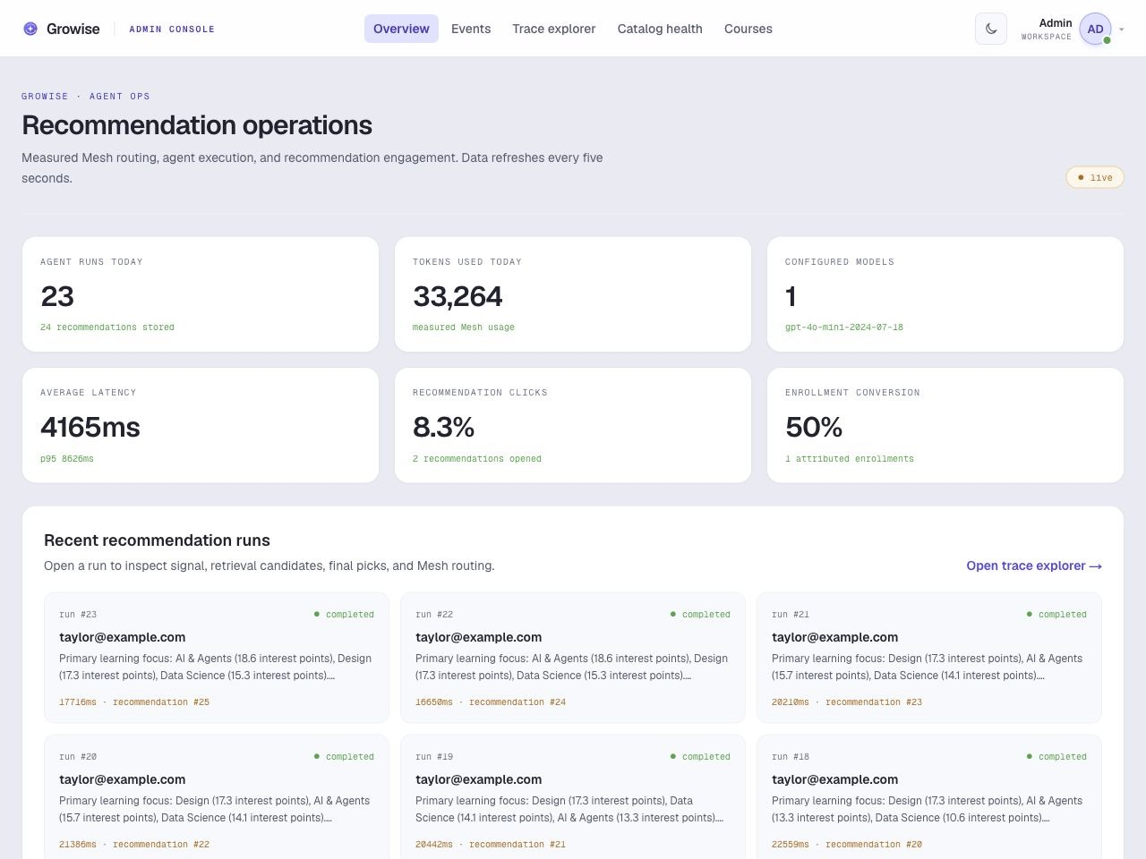
Figure 12. Recommendation operations dashboard. Reviewer action: Start here to review daily run volume, Mesh tokens, latency and recommendation engagement; open a recent run for its underlying trace.

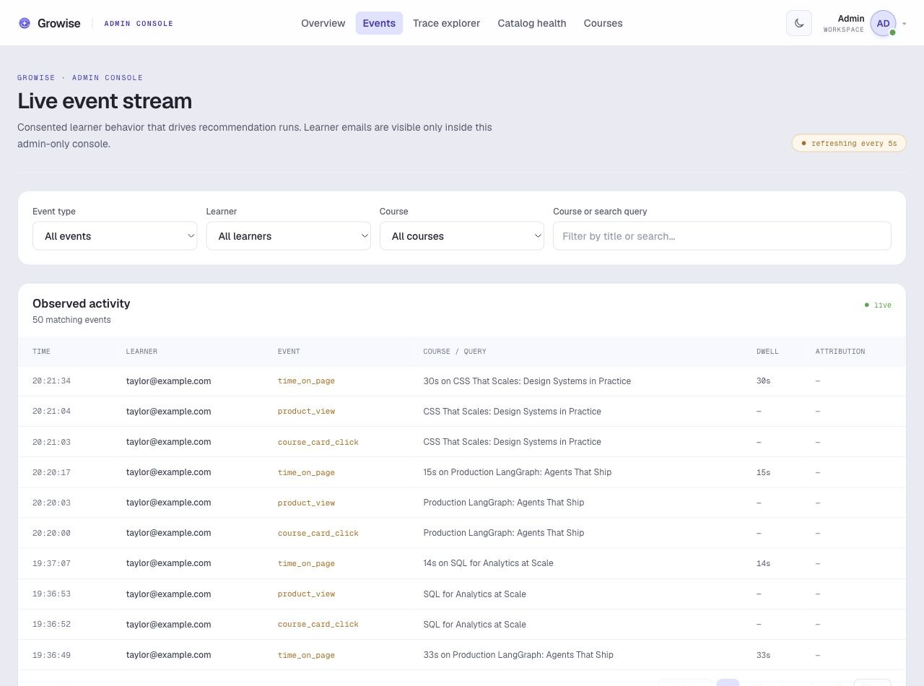
Figure 13. Live consented event stream. Reviewer action: Filter by event type, learner, course or search query to check the behavioural evidence available to the system.

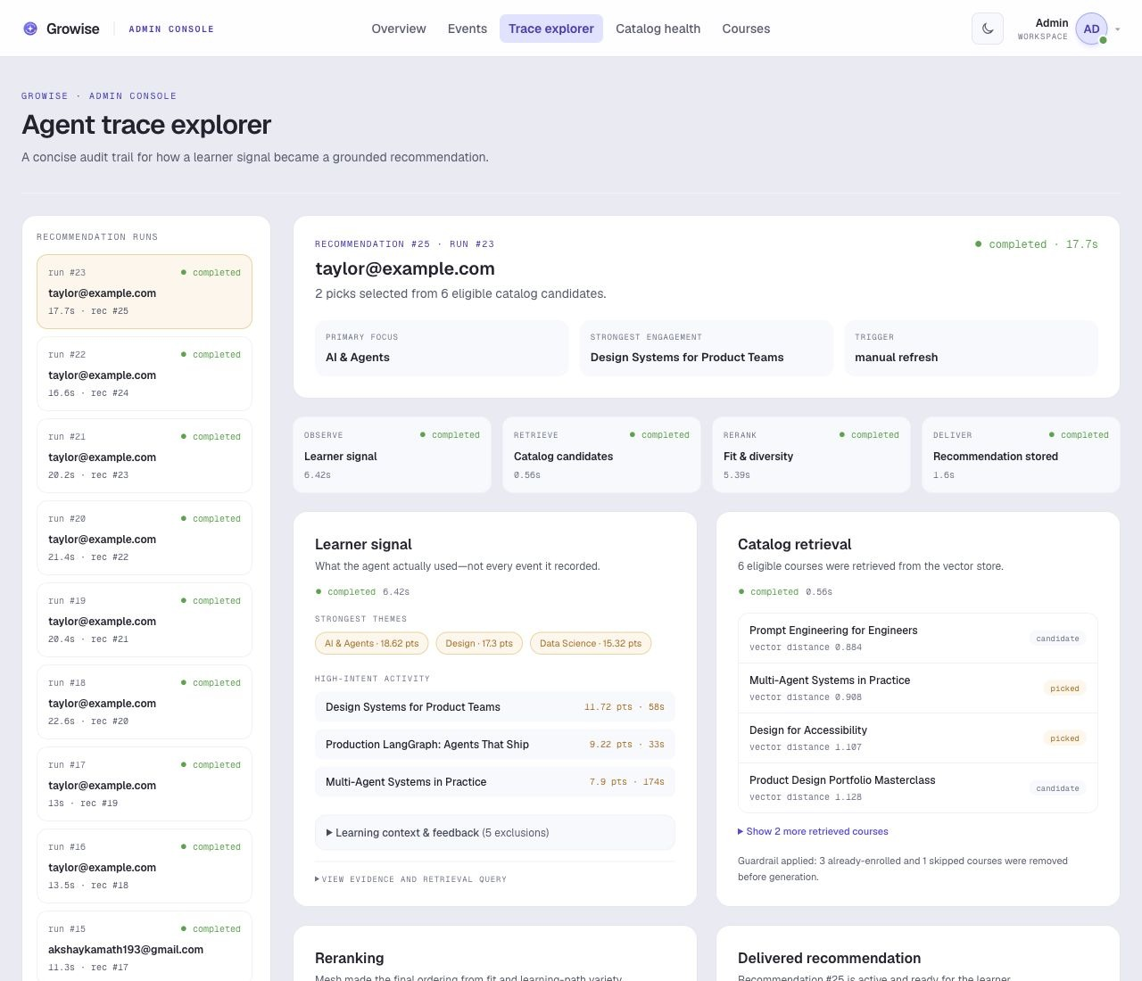
Figure 14. Agent trace explorer. Reviewer action: Select a recommendation run to verify the learner signal, retrieved candidates, exclusions, reranking, delivered courses and measured Mesh calls.

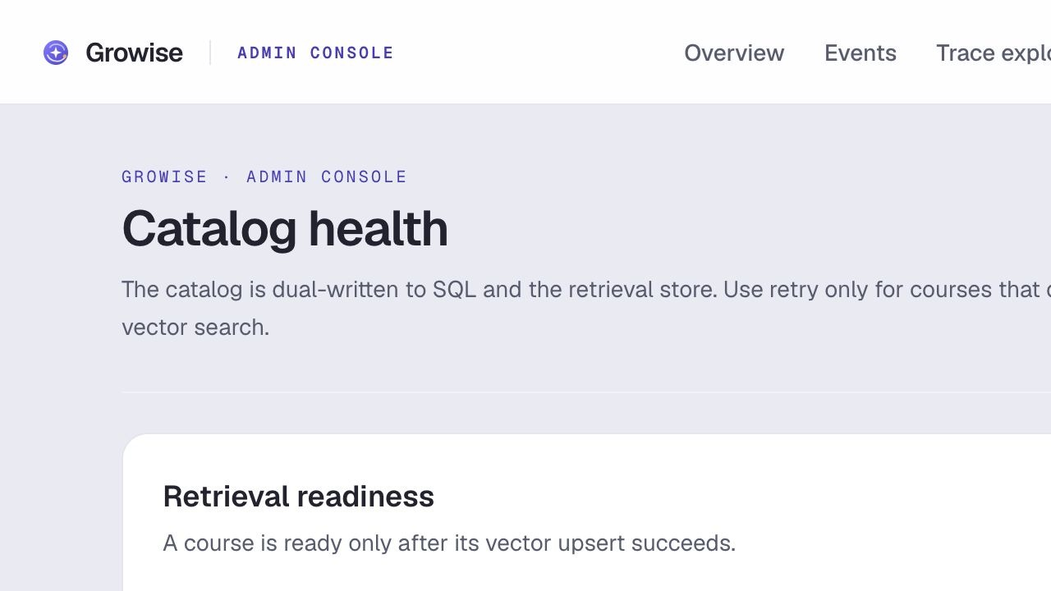
Figure 15. Catalog health. Reviewer action: Confirm retrieval coverage is 100%; if a course is unsynced, use “Retry unsynced courses” to repair only the affected vector records.

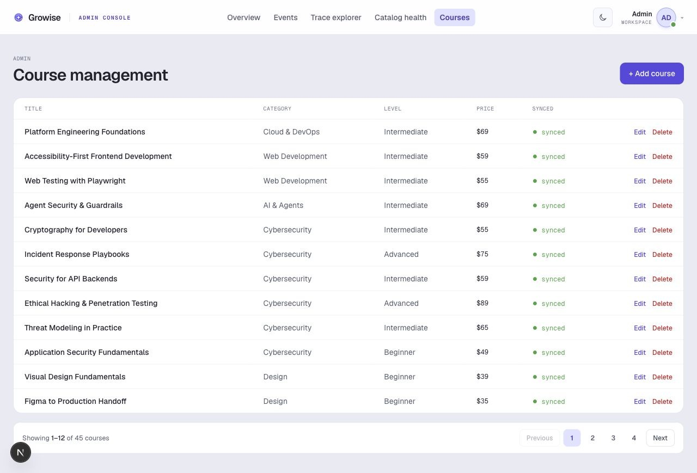
Figure 16. Course management. Reviewer action: Use “Add course” or “Edit” to maintain the catalog; check the Synced column after each change to confirm semantic retrieval readiness.

06 · REVIEWER QUICK PATH

Suggested end-to-end review
A concise demo sequence proves both the learner value and the operational controls. First, use the landing page to explain the promise. Next, sign in as the seeded learner, browse courses in one theme, open a few details and view the “For you” page. Finally, sign in as the administrator and use Agent Ops, Events, Trace Explorer and Catalog health to show that the recommendation is grounded, observable and operationally safe.
Step | Reviewer action | Expected evidence
1 | Open the landing page and catalogue. | Clear value proposition, filters and real catalog.
2 | Sign in as guest and explore several courses. | Consented views, clicks and dwell data appear in the live event stream.
3 | Open “For you” or choose Update path. | A short personalised narrative and real course recommendations.
4 | Sign in as admin and open the latest trace. | Signal, retrieval candidates, exclusions, ranking, recommendation and Mesh metrics.
5 | Open Catalog health and Course management. | Dual-write health, safe retry control and course-level sync status.

What makes this submission complete
Growise delivers the SmartReco brief as a working platform rather than a static recommendation widget: authentication and role separation, course CRUD with durable vector sync state, efficient behavioural tracking, a structured LangGraph workflow through Mesh, catalog-grounded personalised copy, stored recommendation history and a full administrator audit surface. The screenshots in this document are captured from the live local application and map directly to reviewer actions.

