**Code coverage for python using coverage.py**

$ python --version

3.10v

$ pip –version

22.1.1v

$ pip install pytest

$ pip install coverage

$ python –m coverage –version

$ python –m coverage report

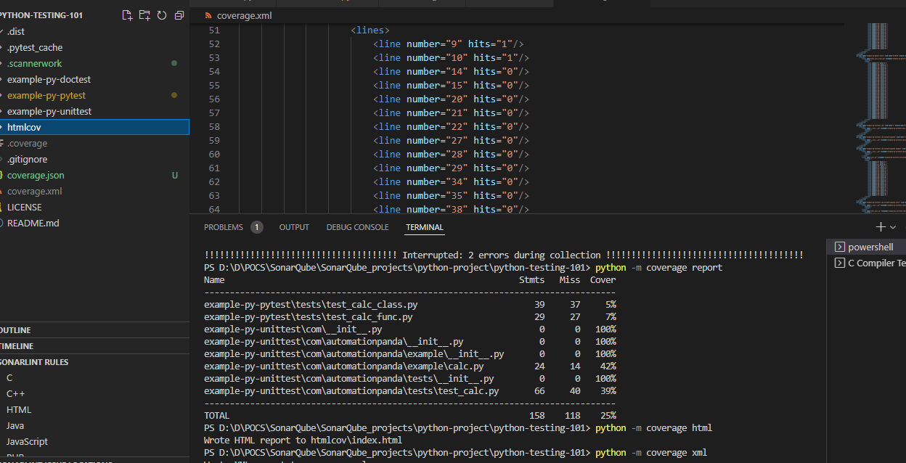

$ python –m coverage xml

$ python –m coverage html

$ python –m coverage json

$ python –m pytest –version

7.1.2v

Coverage.py Quick start

<https://coverage.readthedocs.io/en/6.4.1/install.html#install>

git clone <https://github.com/akshaykamthe651/Python_CodeCoverage_Coverge.py.git>

run following commands to generate reports in html , json & xml format

**Pytest :**

* Pytest is a testing framework it is a matured full-featured Python testing tool.
* Distributed under the terms of the [MIT](https://github.com/pytest-dev/pytest/blob/master/LICENSE) license, pytest is free and open source software.
* Also available commercially as [“pytest for enterprises”](https://docs.pytest.org/en/stable/tidelift.html)
* To exlplore more about pytest …
  + Official Website

[https://docs.pytest.org/en/stable/contents.html#](https://docs.pytest.org/en/stable/contents.html)

* + Documentation Pdf

<https://buildmedia.readthedocs.org/media/pdf/pytest/latest/pytest.pdf>

**Coverage.py :**

Coverage.py is a tool for measuring code coverage of Python programs. It monitors your program, noting which parts of the code have been executed, then analyzes the source to identify code that could have been executed but was not.Coverage measurement is typically used to gauge the effectiveness of tests. It can show which parts of your code are being exercised by tests, and which are not.overage.py is a tool for measuring code coverage of Python programs.

**Perform SCA :**

**sonar-project.properties file :**

sonar.host.url = http://sonar.cybage.com

sonar.projectKey = Mangesh_Python_Code_Coverage

sonar.projectName = Mangesh_Python_Code_Coverage_PoC

sonar.projectVersion = 1.0

sonar.login = SonarQube token

sonar.sources = /path/to/sources

Sonar.tests = /path/to/tests

sonar.python.coverage.reportPaths = ./coverage.xml

1. In order to display the code coverage in SonarQube server dashboard we have to specify path of coverage report (coverage.xml) generated by Coverage.py

sonar.python.coverage.reportPaths = ./coverage.xml