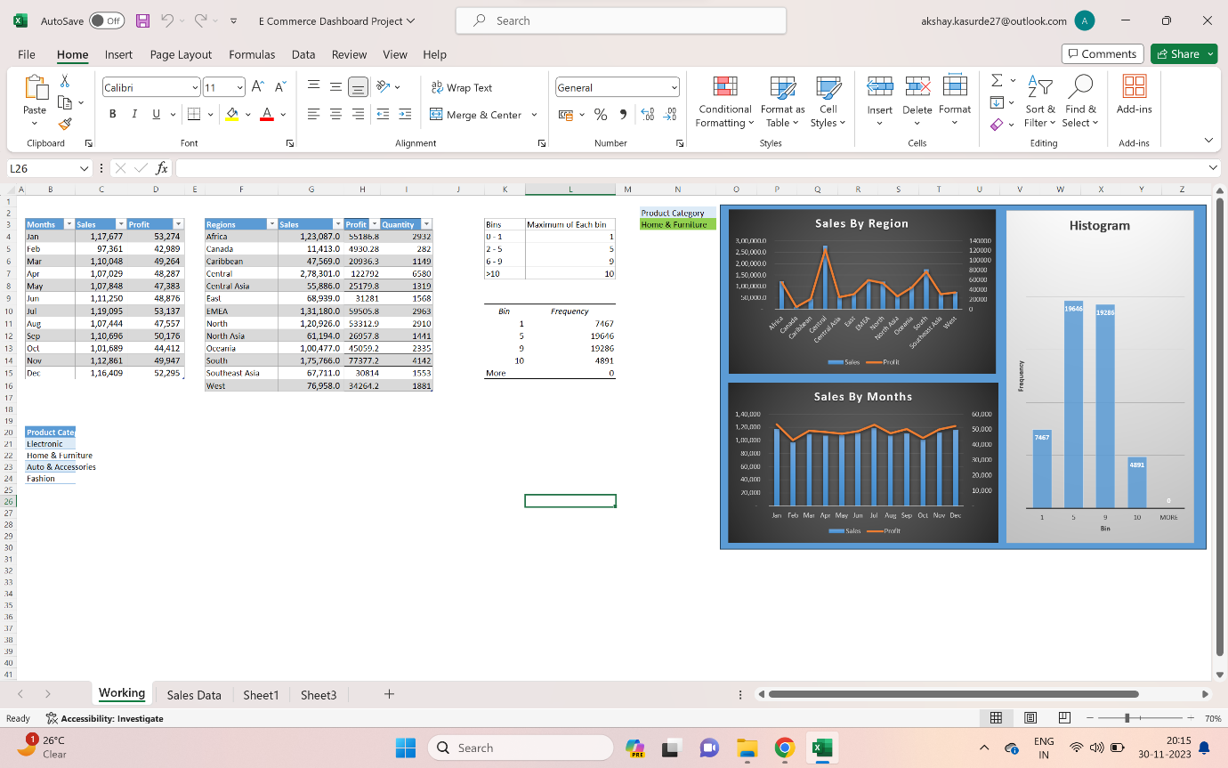

**Designing a Sales dashboard in Excel**

1. Created a table of Sales and Profit month-wise in a working sheet.
2. Created the sales table region-wise in the working sheet.
3. Created a User Control Combo box for Product Category
4. Created a Column Chart of the month-wise table and region-wise table
5. Created a Histogram.
6. Linked the table with a combo box.
7. Created a dashboard

This Sales Dashboard is prepared by using Microsoft Excel & Data Analysis Add-in Tool Histrogram.

By using this sales dashboard the company can analyze the sales data based on sales by region in a column chart and sales by months in column chart according to the various product category. They can also see the trend month-wise & product-wise accordingly and determine which region is giving the maximum profit with less quantity & vice versa.