**Index :**

1. Overview

2. Prerequisite

3. Business Model

4. Future Plan

5. Flow Chart

6. ERD

7. Use Case

8. Sequence Diagram

9. Implementation & User Interface

10. References / Bibliography

**OVERVIEW**

There are some emergency cases when we need to call some Electrician, Carpenter, Plumber, etc. to fix the problem, but we are not having time to go and look for them, or we have no idea whom to contact. Through this website, we provide a platform that will help an individual to find different vendors whenever and wherever required.

Vendor Finder provides a platform for an individual to search for the vendors according to their requirement. It enlist the various vendors who provides that service near by an individual. It gives us the functionality to filter out the vendors for a particular service as well as can filter by the required sub-services. Vendors will enlist as per their ratings which help the customers to get the best services.

**PRE-REQUISITES**

* Django 2.2.x
* Python 3.6
* PostgreSQL
* Jinja Templating
* Follow PEP style for writing codes

**BUSINESS MODEL**

* We are only responsible for providing platform only, not services.
* Vendor will provide door to door service to each customer.
* No two vendors know each other (i.e. vendor have to do the task given to him/her by himself/herself)
* Request for any extra required tool or equipment will be mutually agreed between customer and vendor.
* Customer has to pay a Base price to use our services.

# **FUTURE PLANS**

* If customer cancels his/her request for service, after vendor reaches his/her location, customer has to pay the cancellation charges.
* We will use ReST API to reduce requests made to the server.
* Request for services will be delivered to vendors on the basis of their Ratings.
* We will follow B2B model first, later may move to B2C
* There may be Hindi version of website available for vendors which have no knowledge of English language.
* Customers can be avoided by using our services, if they are not taking our services seriously ( customers will be blocked by admin, on the request of vendor)
* OTP will be made active for 180 second only.
* We will show the list of vendors to customers, filtered according to shortest distance

**FLOW CHART**

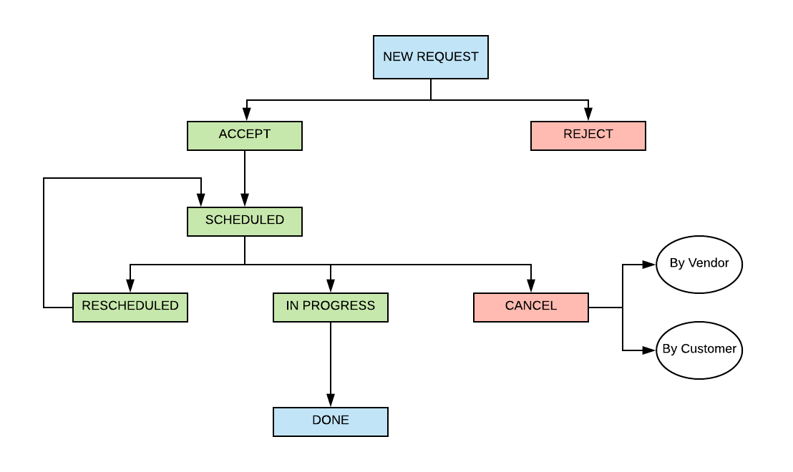

**ERD** 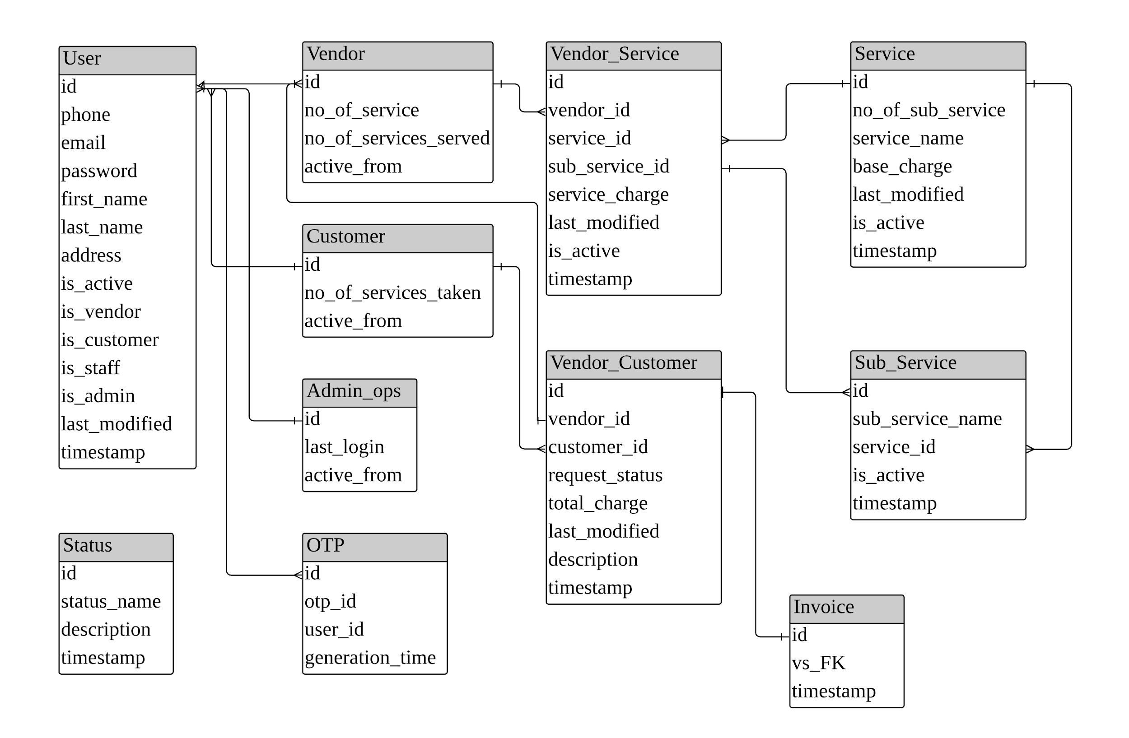

**Use Case**

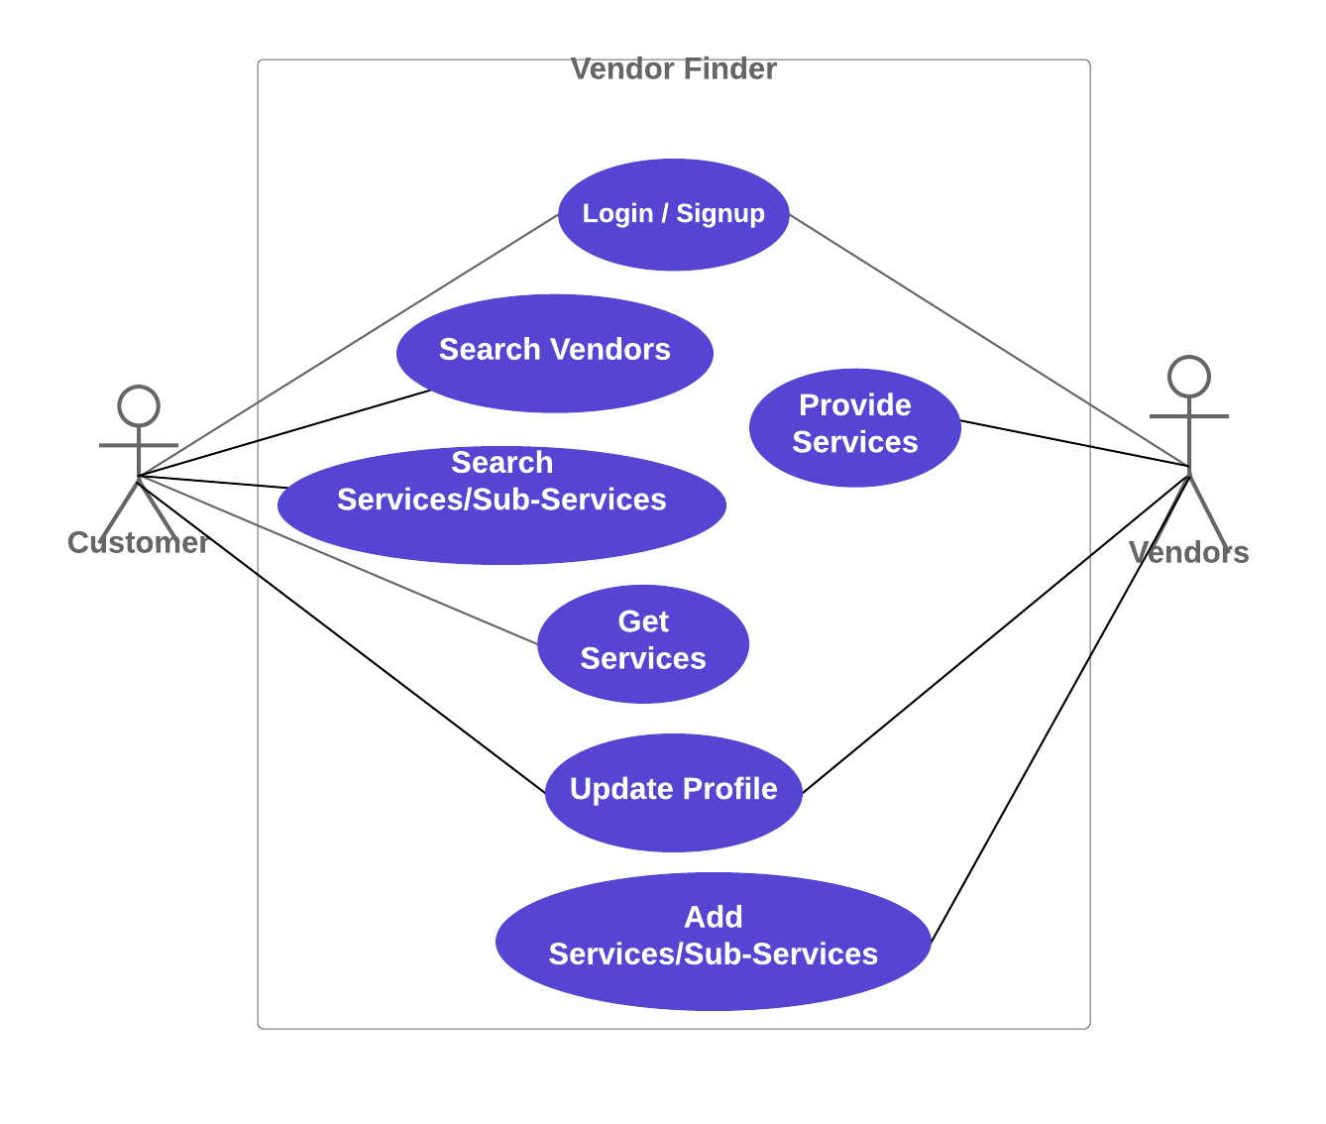

**Sequence Diagram**

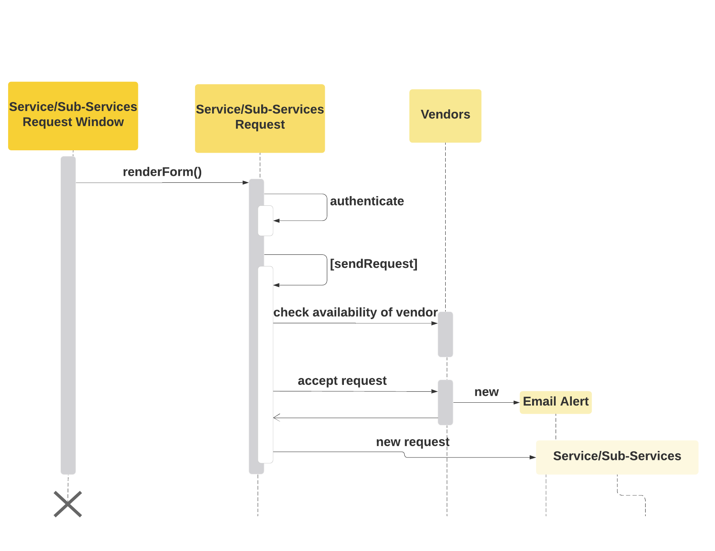

**Implementation & User Interface**

* Signup Page

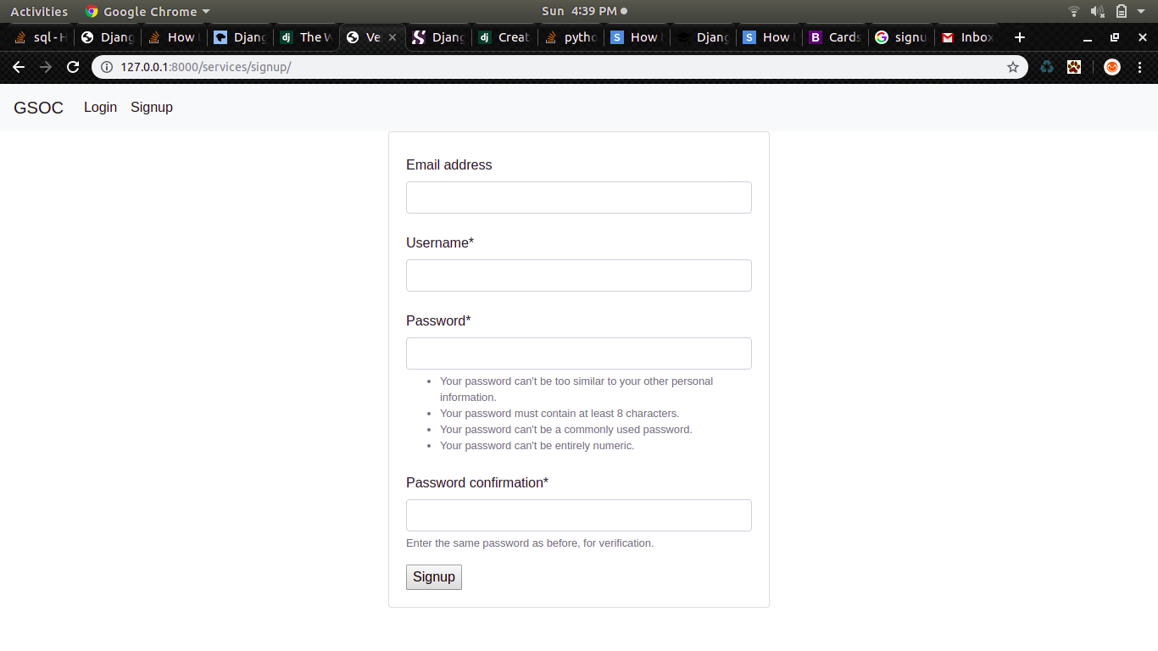

* Login Page

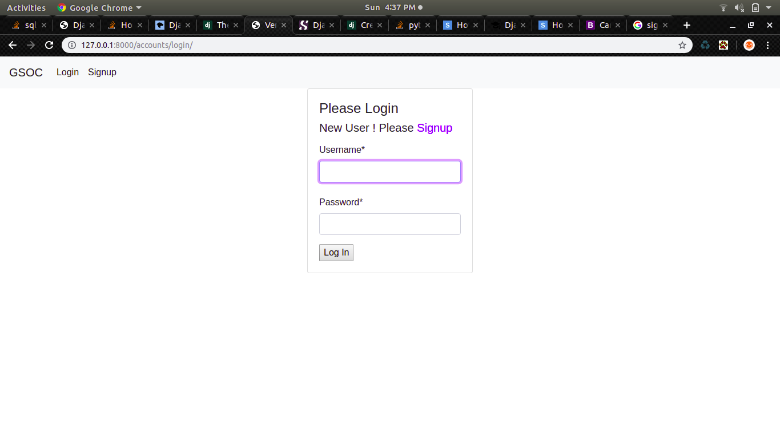

* Services Page

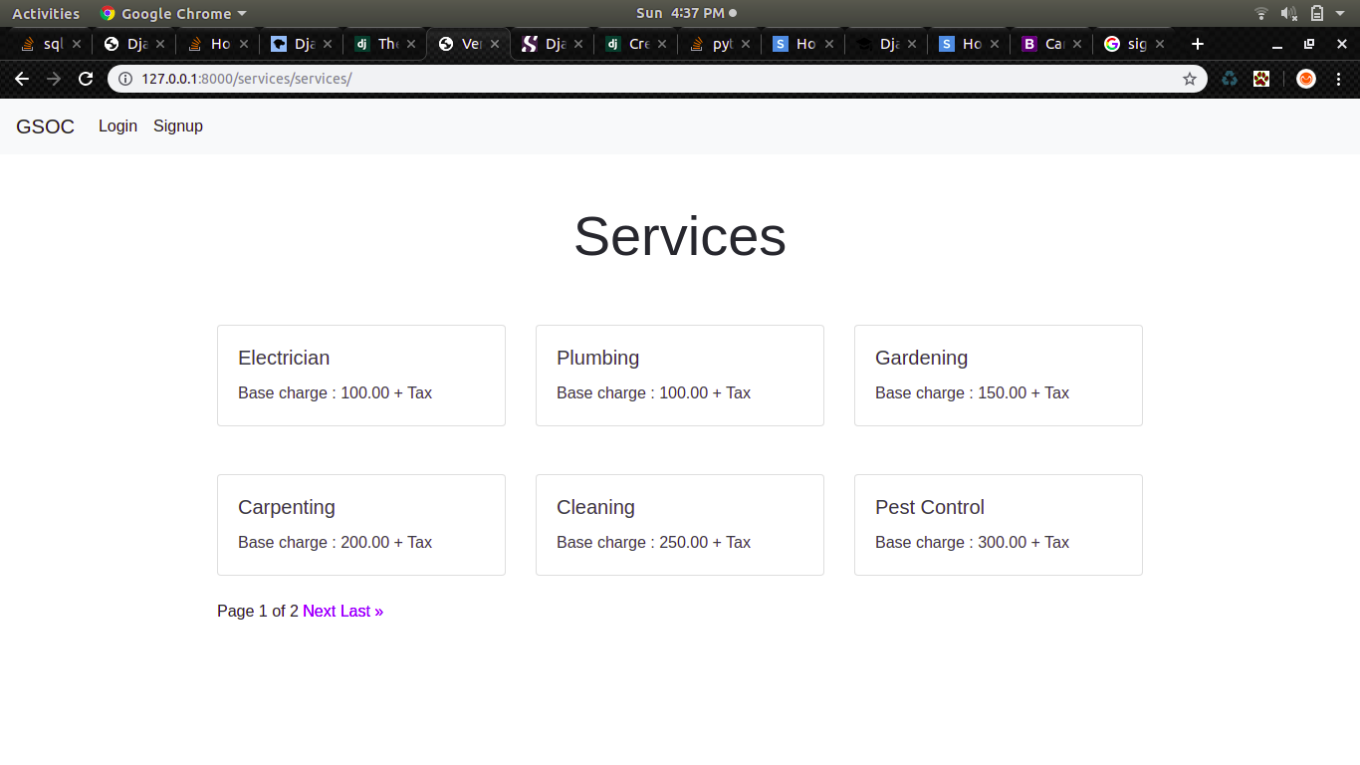

**References/Bibliography**

* Django Documentation
* StackOverFlow
* Lucidchart.com
* Justdial.com