IAM role
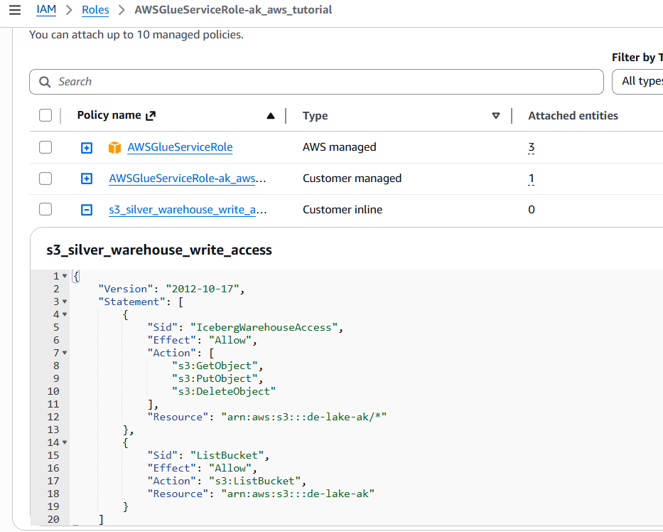
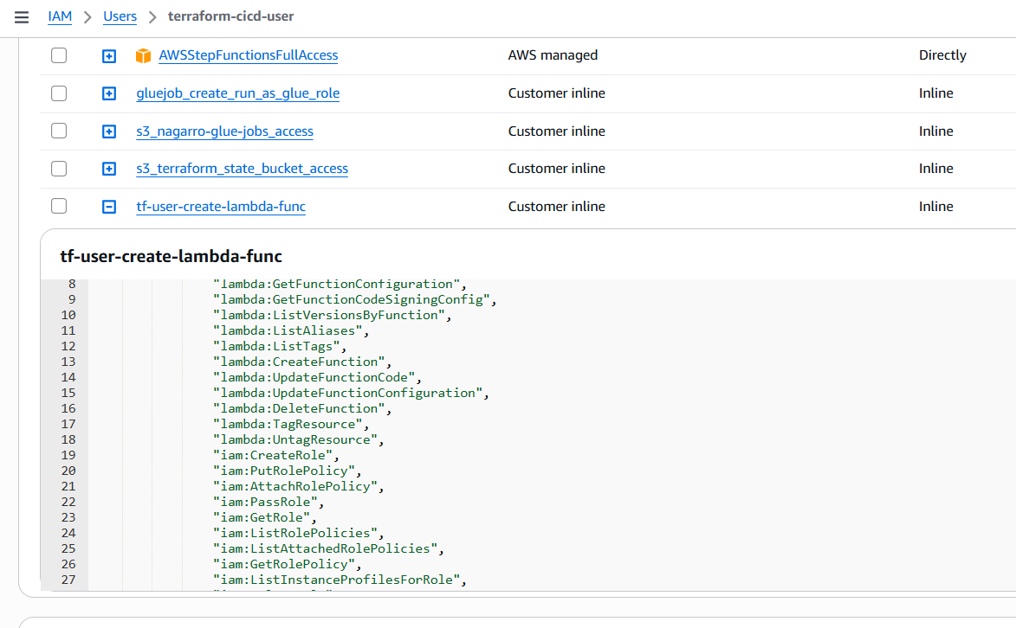
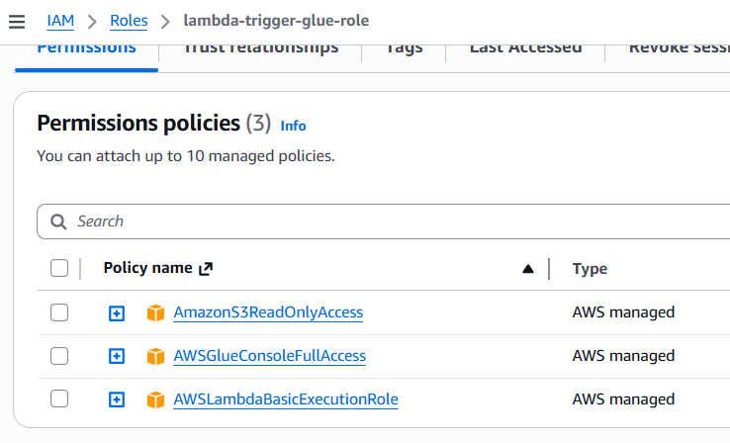
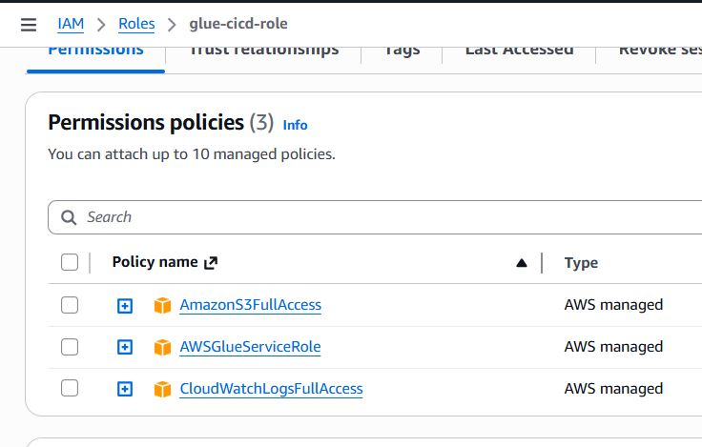
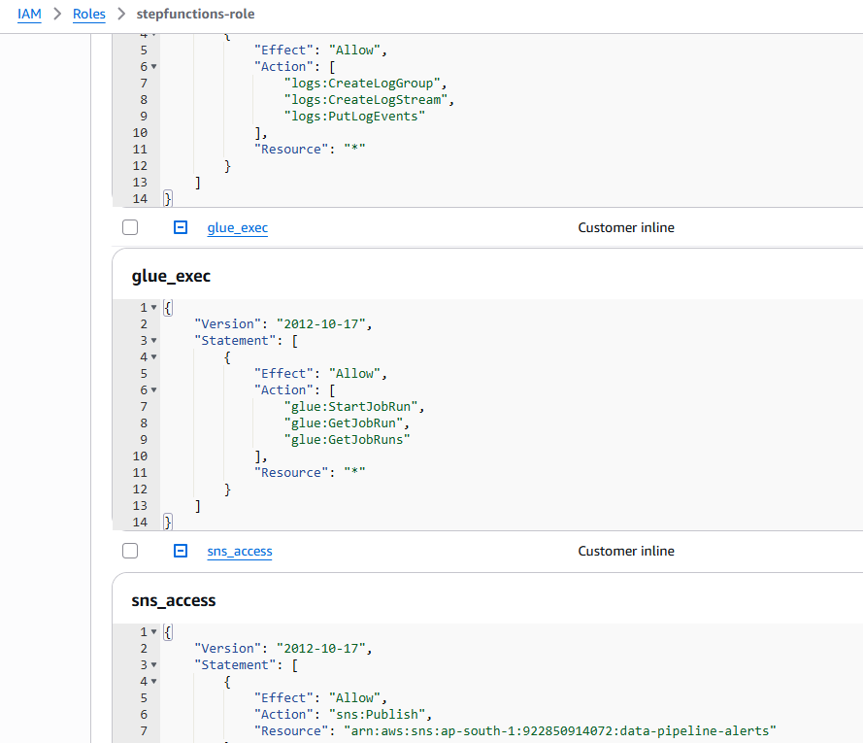

Crawlers
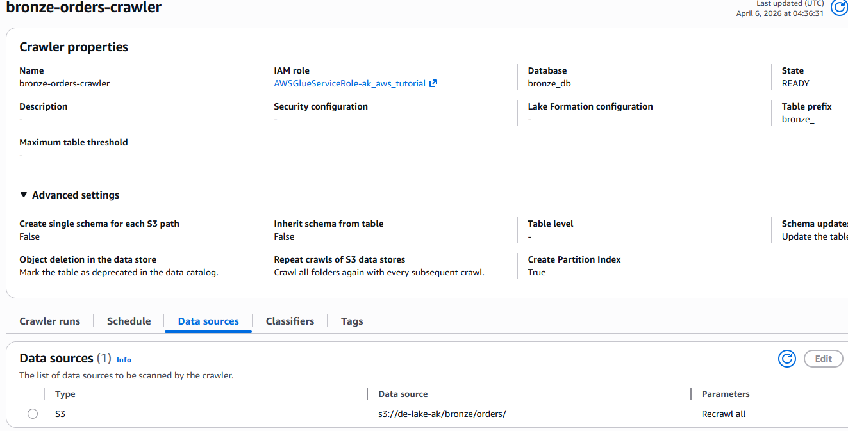
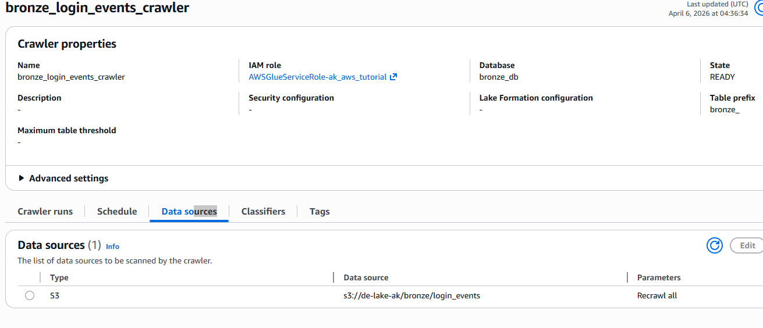

Athena Queries
select * from bronze_db.bronze_login_events;
DESCRIBE FORMATTED bronze_db.bronze_orders;
DELETE FROM silver_db.orders WHERE order_id IS NULL;
SELECT * FROM "silver_db"."orders$partitions";
SELECT * FROM "silver_db"."orders$history";

S3 Bucket event notification settings for running lambda
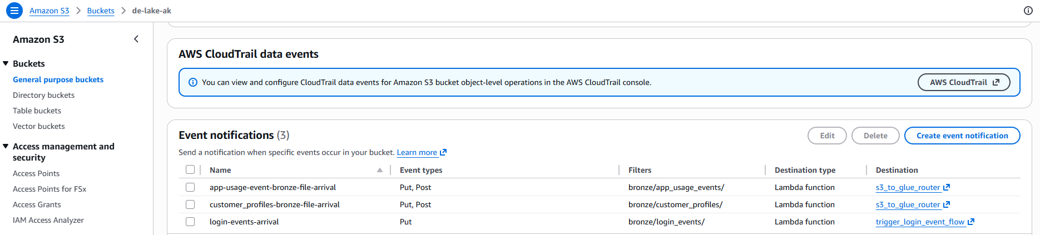

Lambda functions
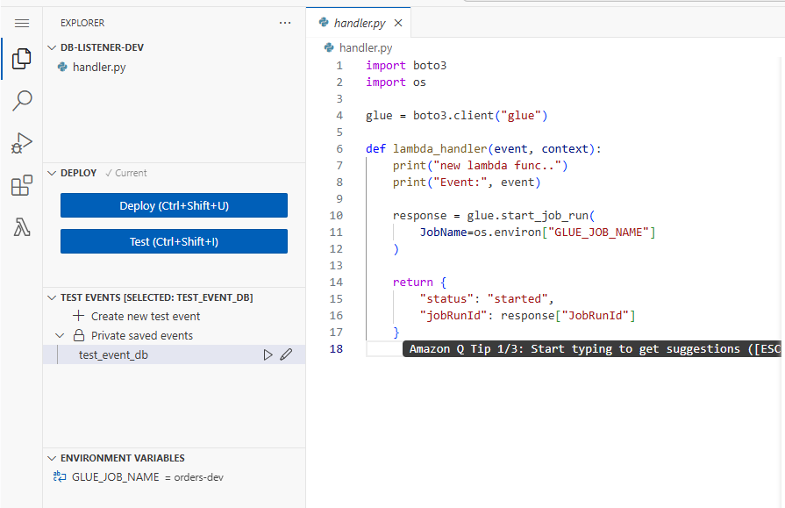
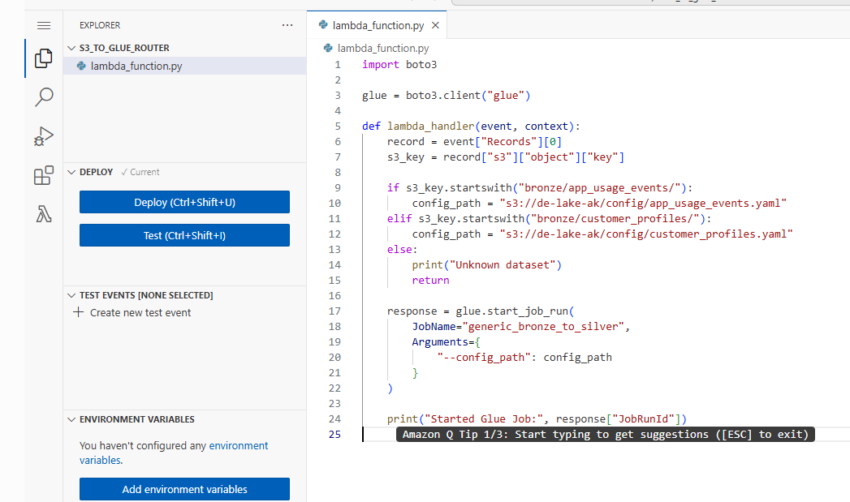
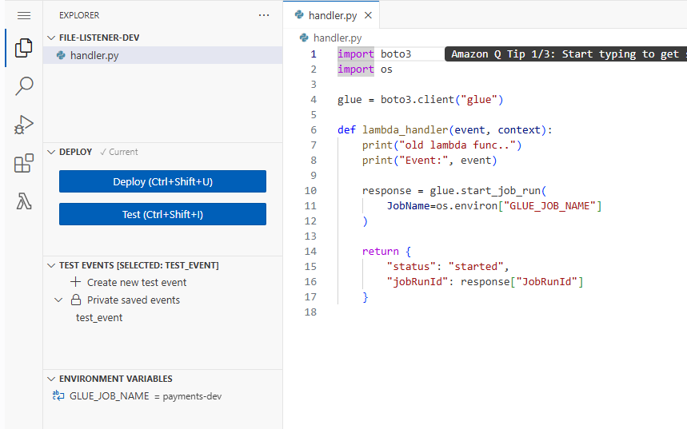

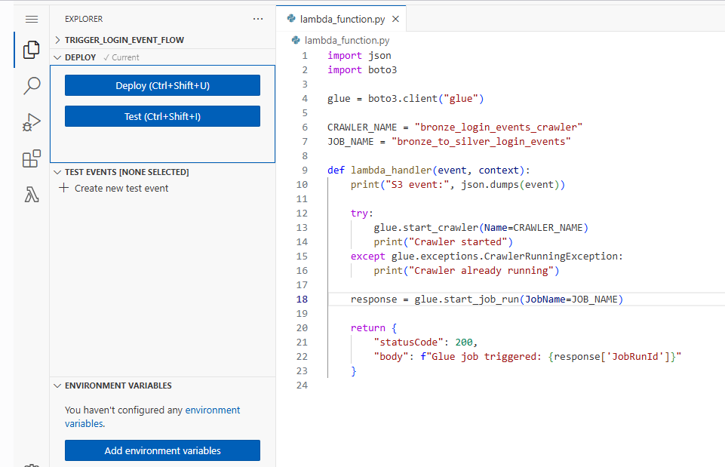

AWS Secret managers
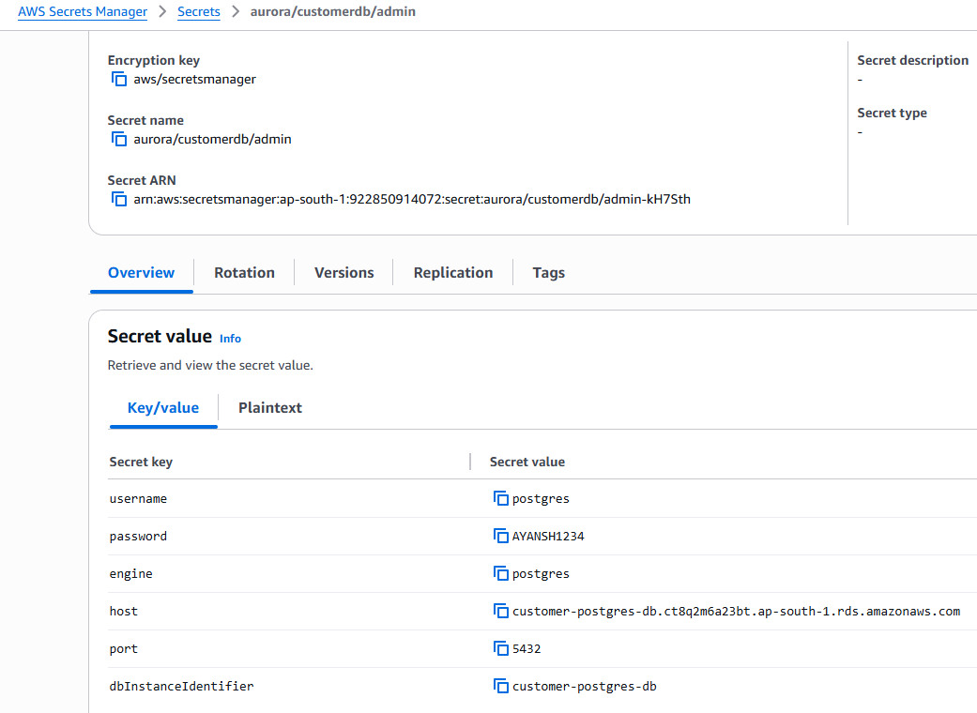
Code
# Use this code snippet in your app.
# If you need more information about configurations
# or implementing the sample code, visit the AWS docs:
# https://aws.amazon.com/developer/language/python/

import boto3
from botocore.exceptions import ClientError

def get_secret():

secret_name = "aurora/customerdb/admin"
region_name = "ap-south-1"

# Create a Secrets Manager client
session = boto3.session.Session()
client = session.client(
service_name='secretsmanager',
region_name=region_name
)

try:
get_secret_value_response = client.get_secret_value(
SecretId=secret_name
)
except ClientError as e:
# For a list of exceptions thrown, see
#https://docs.aws.amazon.com/secretsmanager/latest/apireference/API_GetSecretValue.html
raise e

secret = get_secret_value_response['SecretString']

# Your code goes here.

Glue jobs, params, run details

bronze_to_silver_order
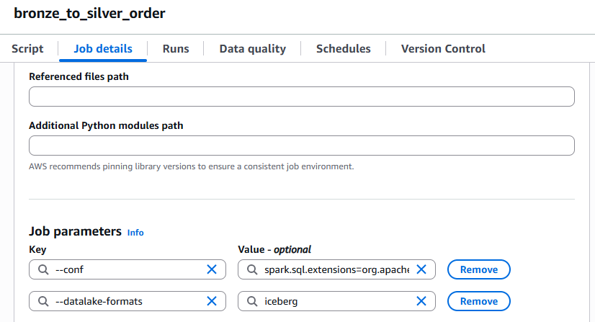
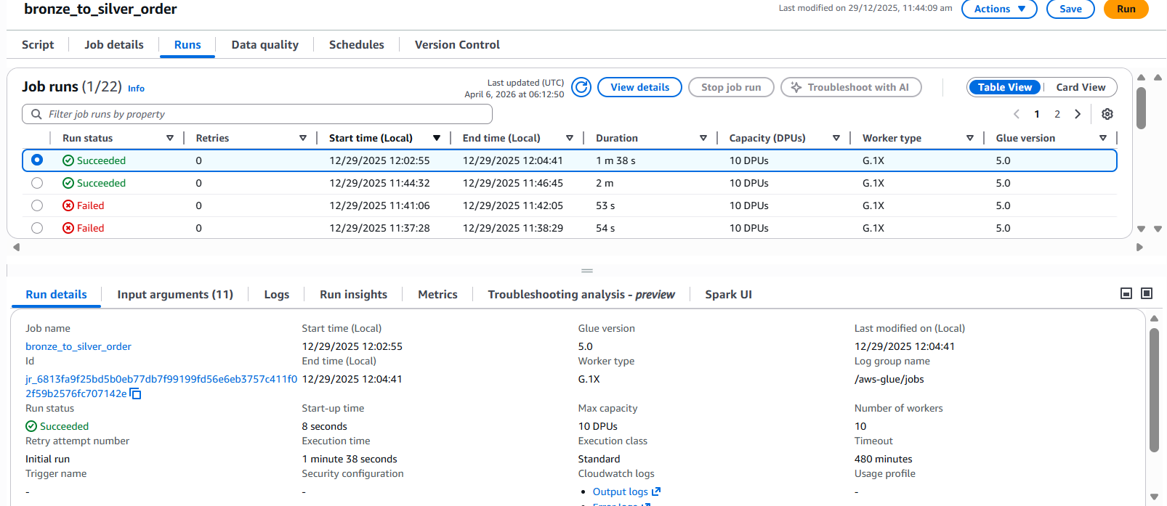
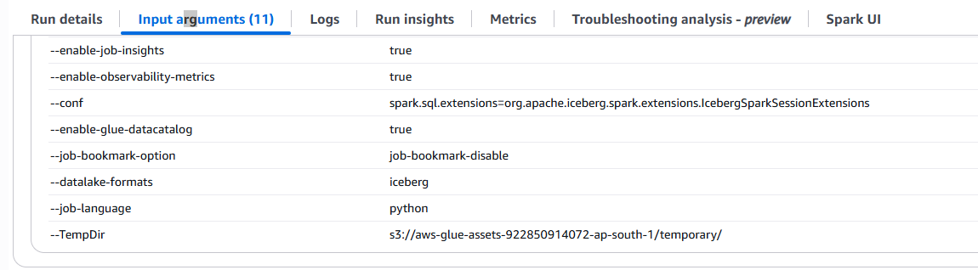
Code :-
import sys
from awsglue.transforms import *
from awsglue.utils import getResolvedOptions
from pyspark.context import SparkContext
from awsglue.context import GlueContext
from awsglue.job import Job
from pyspark.sql.window import Window
from pyspark.sql.functions import row_number, col, to_date, to_timestamp

## @params: [JOB_NAME]
args = getResolvedOptions(sys.argv, ['JOB_NAME'])

sc = SparkContext()
glueContext = GlueContext(sc)
spark = glueContext.spark_session

spark.conf.set("spark.sql.catalog.glue_catalog","org.apache.iceberg.spark.SparkCatalog")
spark.conf.set("spark.sql.catalog.glue_catalog.catalog-impl","org.apache.iceberg.aws.glue.GlueCatalog")
spark.conf.set("spark.sql.catalog.glue_catalog.io-impl","org.apache.iceberg.aws.s3.S3FileIO")
spark.conf.set("spark.sql.catalog.glue_catalog.warehouse","s3://de-lake-ak/warehouse/")

bronze_df = spark.read.table("bronze_db.bronze_orders")
#bronze_df = bronze_df.filter("order_date = current_date()")
print("read bronze")
print("original schema : ")
bronze_df.printSchema()

#dedup logic
# window_spec = Window.partitionBy("order_id").orderBy(col("updated_at").desc())
# dedup_df = (
# bronze_df
# .withColumn("rn", row_number().over(window_spec))
# .filter("rn = 1")
# .drop("rn")
# )

bronze_df = (
bronze_df
.withColumn("order_date", to_date(col("order_date"), "yyyy-MM-dd"))
.withColumn("updated_at", to_timestamp(col("updated_at"), "yyyy-MM-dd HH:mm:ss"))
)

print("updated schema : ")
bronze_df.printSchema()

bronze_df.createOrReplaceTempView("dedup_orders")
bronze_df.show()
print("dedup done")

# #create silver table first -- one time
# spark.sql("""
# CREATE TABLE IF NOT EXISTS glue_catalog.silver_db.orders (
# order_id INT,
# customer_id INT,
# order_amount DOUBLE,
# order_date DATE,
# order_status STRING,
# updated_at TIMESTAMP
# )
# USING iceberg
# PARTITIONED BY (order_date)
# TBLPROPERTIES (
# 'format-version'='2'
# )
# """)
# print("ddl create executed for silver")

spark.sql("""
MERGE INTO glue_catalog.silver_db.orders t
USING dedup_orders s
ON t.order_id = s.order_id

WHEN MATCHED THEN
UPDATE SET
t.customer_id = s.customer_id,
t.order_amount = s.order_amount,
t.order_date = s.order_date,
t.order_status = s.order_status,
t.updated_at = s.updated_at
-- discount_amount untouched

WHEN NOT MATCHED THEN
INSERT (
order_id,
customer_id,
order_amount,
order_date,
order_status,
updated_at,
discount_amount
)
VALUES (
s.order_id,
s.customer_id,
s.order_amount,
s.order_date,
s.order_status,
s.updated_at,
NULL
)

""")
print("merge done")

#schema evolution
#one time execution
# spark.sql("""ALTER TABLE glue_catalog.silver_db.orders
# ADD COLUMN discount_amount double;
# """)
# print("schema evolution done")

job = Job(glueContext)
job.init(args['JOB_NAME'], args)
job.commit()

silver_to_gold_order
import sys
from awsglue.transforms import *
from awsglue.utils import getResolvedOptions
from pyspark.context import SparkContext
from awsglue.context import GlueContext
from awsglue.job import Job
from pyspark.sql.window import Window
from pyspark.sql.functions import row_number, col, to_date, to_timestamp

## @params: [JOB_NAME]
args = getResolvedOptions(sys.argv, ['JOB_NAME'])

sc = SparkContext()
glueContext = GlueContext(sc)
spark = glueContext.spark_session

spark.conf.set("spark.sql.catalog.glue_catalog","org.apache.iceberg.spark.SparkCatalog")
spark.conf.set("spark.sql.catalog.glue_catalog.catalog-impl","org.apache.iceberg.aws.glue.GlueCatalog")
spark.conf.set("spark.sql.catalog.glue_catalog.io-impl","org.apache.iceberg.aws.s3.S3FileIO")
spark.conf.set("spark.sql.catalog.glue_catalog.warehouse","s3://de-lake-ak/warehouse/")

silver_df = spark.read.table("glue_catalog.silver_db.orders")
silver_df_clean = silver_df.filter(col("order_id").isNotNull())

print(spark.conf.get("spark.sql.extensions"))
print(spark.conf.get("spark.sql.catalog.glue_catalog"))
print(spark.conf.get("spark.sql.catalog.glue_catalog.catalog-impl"))
spark.sql("SELECT * FROM glue_catalog.silver_db.orders").show(1)

# spark.sql("""
# SELECT committed_at
# FROM glue_catalog.silver_db.orders$snapshots
# ORDER BY committed_at DESC
# LIMIT 1
# """).show()

##
# Get latest snapshot timestamp
# latest_snapshot_ts = spark.sql("""
# SELECT committed_at
# FROM silver_db.orders$snapshots
# ORDER BY committed_at DESC
# LIMIT 1
# """).collect()[0][0]

# latest_snapshot_ts = str(latest_snapshot_ts).replace(" UTC", "")
# print("Expiring snapshots older than:", latest_snapshot_ts)

# # Expire snapshots
# spark.sql(f"""
# CALL glue_catalog.system.expire_snapshots(
# 'silver_db.orders',
# '{latest_snapshot_ts}'
# )
# """)

# # Remove orphan files
# spark.sql("""
# CALL glue_catalog.system.remove_orphan_files('silver_db.orders')
# """)

# ##
# gold_df = (
# silver_df_clean
# .groupBy("order_date")
# .sum("order_amount")
# .withColumnRenamed("sum(order_amount)", "daily_revenue")
# .select("order_date", "daily_revenue")
# )

# gold_df.show()

# # #create gold table first -- one time
# spark.sql("""
# CREATE TABLE IF NOT EXISTS glue_catalog.gold_db.orders_aggregrated (
# order_date DATE,
# daily_revenue double
# )
# USING iceberg
# PARTITIONED BY (order_date)
# TBLPROPERTIES (
# 'format-version'='2'
# )
# """)

# gold_df.writeTo("glue_catalog.gold_db.orders_aggregrated").overwritePartitions()
# #updated data

job = Job(glueContext)
job.init(args['JOB_NAME'], args)
job.commit()

bronze_to_silver_login_events
import sys
from awsglue.transforms import *
from awsglue.utils import getResolvedOptions
from pyspark.context import SparkContext
from awsglue.context import GlueContext
from awsglue.job import Job
from pyspark.sql.functions import to_timestamp, col, current_timestamp, to_date

## @params: [JOB_NAME]
args = getResolvedOptions(sys.argv, ['JOB_NAME'])

sc = SparkContext()
glueContext = GlueContext(sc)
spark = glueContext.spark_session

job = Job(glueContext)
job.init(args['JOB_NAME'], args)

# Read bronze login events (bookmark enabled)
bronze_dyf = glueContext.create_dynamic_frame.from_options(
connection_type="s3",
connection_options={
"paths": ["s3://de-lake-ak/bronze/login_events/"]
},
format="json",
transformation_ctx="bronze_login_events"
)

df = bronze_dyf.toDF()

# Basic cleansing & enrichment
silver_df = (
df
.withColumn("login_time", to_timestamp("login_time"))
.withColumn("login_date", to_date("login_time"))
.withColumn("device", col("device"))
.withColumn("ingestion_ts", current_timestamp())
)

# Write to Silver
(
silver_df
.write
.mode("append")
.partitionBy("login_date")
.parquet("s3://de-lake-ak/silver/login_events/")
)

job.commit()

generic_bronze_to_silver
import sys
import boto3
import yaml
import json
import psycopg2
from awsglue.utils import getResolvedOptions
from pyspark.context import SparkContext
from awsglue.context import GlueContext
from awsglue.job import Job
from pyspark.sql.functions import col, to_date, to_timestamp

# -----------------------
# Read arguments
# -----------------------
args = getResolvedOptions(sys.argv, ['JOB_NAME', 'config_path'])

sc = SparkContext()
glueContext = GlueContext(sc)
spark = glueContext.spark_session

job = Job(glueContext)
job.init(args['JOB_NAME'], args) # MUST be before reads

# -----------------------
# Load YAML config from S3
# -----------------------
s3 = boto3.client("s3")

config_path = args["config_path"]
bucket = config_path.split("/")[2]
key = "/".join(config_path.split("/")[3:])

print(f"Config path received : {config_path}")
print(f"bucket : {bucket}")
print(f" key : {key}")
config_obj = s3.get_object(Bucket=bucket, Key=key)
config = yaml.safe_load(config_obj["Body"].read())

# -----------------------
# Read source data
# -----------------------
dataset = config["dataset"]
source_path = config["source"]["path"]
source_format = config["source"]["format"]
print(f"dataset : {dataset}")
print(f"source_path : {source_path}")
print(f"source_format : {source_format}")

transformation_ctx_val = "bronze_read_"+dataset
print(f"transformation_ctx_val : {transformation_ctx_val}")

format_options = {}

if source_format == "csv":
format_options = {
"withHeader": True,
"separator": ","
}

dyf = glueContext.create_dynamic_frame.from_options(
connection_type="s3",
connection_options={"paths": [source_path]},
format=source_format,
format_options=format_options,
transformation_ctx=transformation_ctx_val
)

df = dyf.toDF()

# -----------------------
# Transformations (generic)
# -----------------------
if "event_time" in df.columns:
df = df.withColumn(
"event_date",
to_date(to_timestamp(col("event_time")))
)

partition_col = config["silver"]["partition_by"]

if partition_col in df.columns:
df = df.withColumn(partition_col, to_date(partition_col))

df.show()

# -----------------------
# Write to Silver
# -----------------------
silver_path = config["silver"]["path"]
partition_col = config["silver"]["partition_by"]

print(f"silver_path : {silver_path}")
print(f"partition_col : {partition_col}")

(
df.write
.mode("append")
.partitionBy(partition_col)
.parquet(silver_path)
)

#write to database

if config.get("target", {}).get("type") == "rds_postgres":

secrets = boto3.client("secretsmanager")
secret_name = config["target"]["secret_name"]

secret_value = secrets.get_secret_value(SecretId=secret_name)
secret = json.loads(secret_value["SecretString"])

jdbc_url = (
f"jdbc:postgresql://{secret['host']}:"
f"{secret['port']}/{config['target']['database']}"
)
print(f"jdbc url - {jdbc_url}")

conn = psycopg2.connect(
host=secret["host"],
port=secret["port"],
dbname=config["target"]["database"],
user=secret["username"],
password=secret["password"]
)

create_table_sql = """
CREATE TABLE IF NOT EXISTS customer_profiles (
customer_id VARCHAR(50),
name VARCHAR(100),
email VARCHAR(150),
signup_date DATE
);
"""
cur = conn.cursor()
cur.execute(create_table_sql)
conn.commit()
cur.close()
conn.close()

print("table created..")

(
df.write
.format("jdbc")
.option("url", jdbc_url)
.option("dbtable", config["target"]["table"])
.option("user", secret["username"])
.option("password", secret["password"])
.mode("append")
.save()
)

print("table data created/appended..")

job.commit()

orders-dev
coming from terraform –
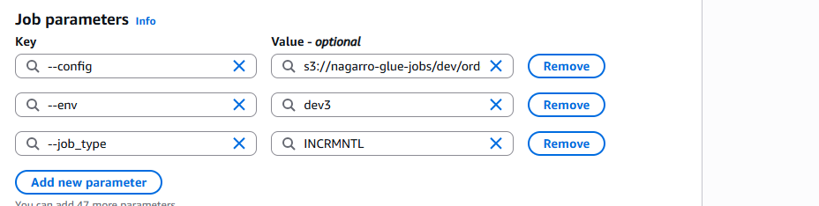
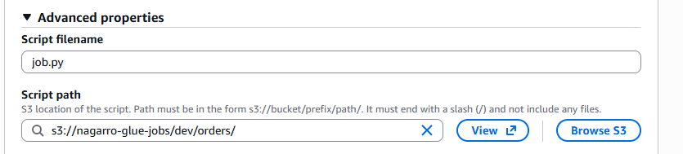
import sys
from awsglue.utils import getResolvedOptions
import json
import boto3

args = getResolvedOptions(
sys.argv,
['env', 'job_type', 'config']
)

print("===== ORDERS JOB =====")
print("ENV:", args['env'])
print("TYPE:", args['job_type'])
print("CONFIG:", args['config'])

print("Processing only NEW / UPDATED orders...")

config_path = args['config']

# Parse S3 path
# s3://bucket/key
bucket = config_path.replace("s3://", "").split("/")[0]
key = "/".join(config_path.replace("s3://", "").split("/")[1:])

# Read JSON from S3
s3 = boto3.client("s3")
response = s3.get_object(Bucket=bucket, Key=key)
config = json.loads(response["Body"].read().decode("utf-8"))

primary_key = config["primary_key"]
watermark_column = config["watermark_column"]
target_table = config["target_table"]

print("Primary Key ----- ", primary_key)
print("Watermark Column --- ", watermark_column)
print("Target Table ------ ", target_table)

Simple notifications service (SNS)
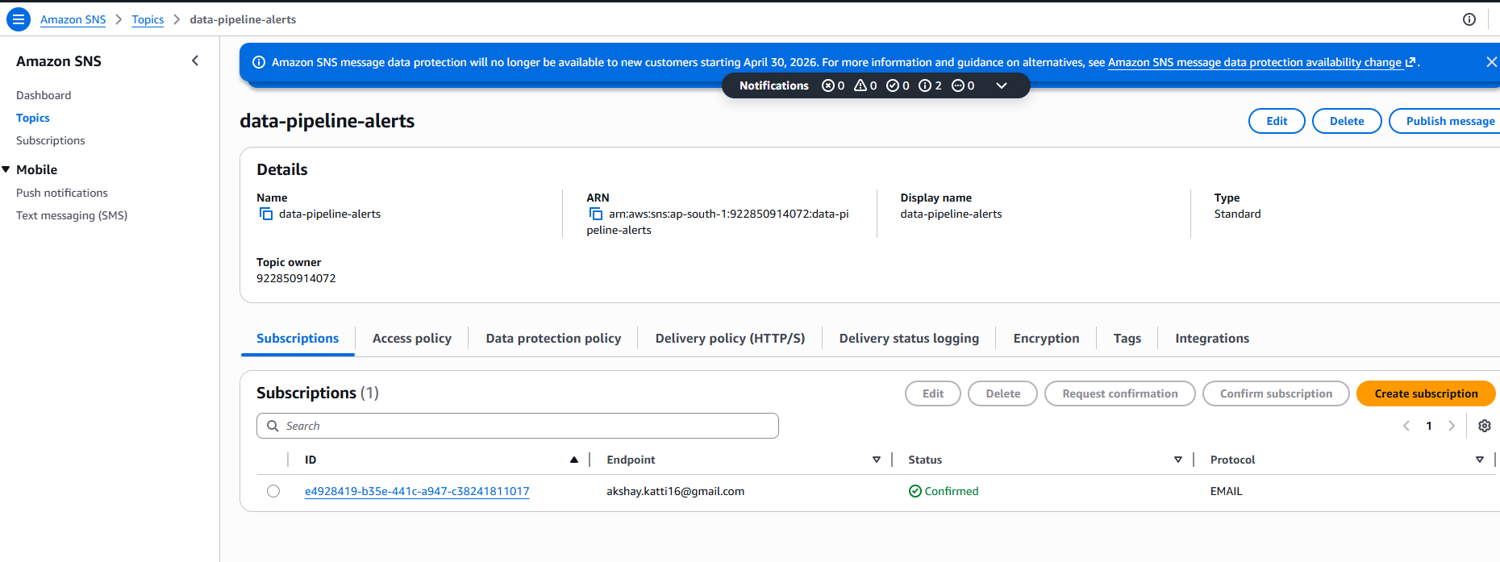

Step functions - state machines
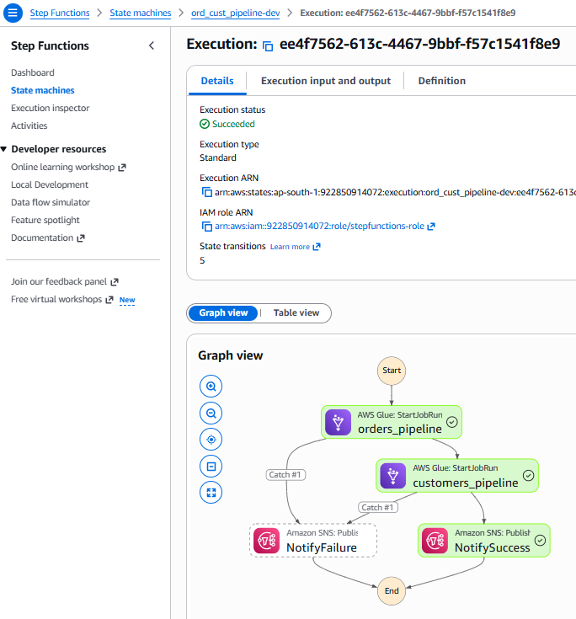

Cloudwatch
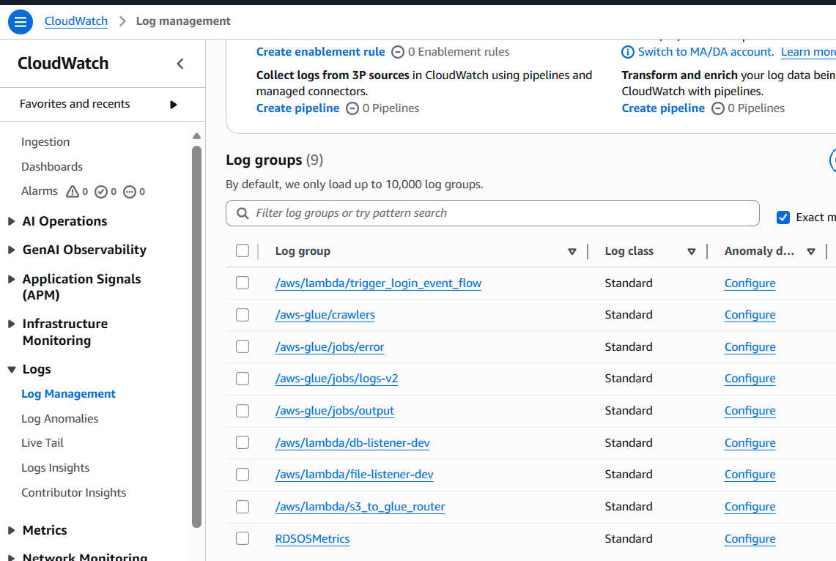
Cicd github repo (terraform, github actions, glue, lambda, step functions deployment) –
akshaykatti16/aws_de_cicd_demo

