Node-JS

- Node.js is a JavaScript runtime built on Chrome's V8 JavaScript engine.
- Node.js is a JavaScript running on the server.

- Initially js was frontend only to enhance UI only, and interaction on website. --> which is known for high performance and efficient execution of code.
- Crome v-8 Engine – known for high performance and efficient execution of code.
- In simple v8 engine converts js code to machine redable format.

History of Node-js :
- In 2009 an idea came in the mind of Ryan Dahl (Google Engineer) that why
not run JavaScript outside browser, so he took V8 engine and embedded in
a C++ program and called it Node.exe later on became Nodejs.

Prerequistics :
- Basic javascript.( advanced js will bonus)
- The REPL feature of Node is very useful in experimenting with Node.js codes and to
debug JavaScript codes.

REPL:
The REPL feature of Node is very useful in experimenting with Node.js codes and to
debug JavaScript codes.
Read — Reads user's input, parses the input into JavaScript data-structure,
and stores in memory.
Eval — Takes and evaluates the data structure.
Print — Prints the result.
Loop — Loops the above command until
NOTE – just type node in a terminal to use node environment.

Node.js Core Module
- Consider modules to be the same as JavaScript libraries. A set of
- functions you want to include in your application.
- Node.js has a set of built-in modules which you can use without any further
Installation.
JS fundamentals—
Eg.1 —
file1.js
const app = require('./file');

console.log(app);

file.js
module.exports= {
x:10,
y:20
}

Eg.2—
file1.js
const app = require('./file');

console.log(app);
console.log(app.z())

file.js
module.exports= {
x:10,
y:20,
z:function()
{
return 10;
}
}

Filter function—
let a = [1,2,3,4,6,5,8]

let result =a.filter((i)=>{
return i>3;
})

console.log(result)

Core Modules in Node-js –
Its nothing but inbuilt modules-
Globle module—Those modules which is inbuilt available and not need to import are the globle module.
- __dirname- It Is used to print the directory name.
- __filename
Non-globle module—Those modules which are need to import are the non-globle modules.
[ available in docs of node ].
Eg. 1.const fs= require(‘fs’)

Node-js Server :
http module-- It handles request and response of server in nodeJs. –I
eg-
const http = require('http');

http.createServer((req, resp) => {
resp.write("Hello..!");
resp.end();
}).listen(4500)
//use separate function instead for better understanding.
Eg-
Que—
- What if we deleted node modules..?
- Just use Npm install command
- Correct way to push data on git..?
- We shouldn’t push node modules on git because size is so large. In gb’s
- So to exclude that create a file like .gitignore and add name like /node_modules in that.

- Nodemon— auto run project

- For that install
npm i nodemon -g.
- if error then open windows powershell as run as administrator and type command
Set-ExecutionPolicy RemoteSigned -Scope CurrentUser.
- After this u can run your project as nodemon .\index.js

- Why node-js is async language..?
Node.js is asynchronous. This means that it can handle multiple requests at the same time without waiting for one to finish before starting another.

Make Simple API –
Eg.1. API with static data- (test this API with Postman)
const http = require('http');
http.createServer((req, resp) => {
resp.writeHead(200, { 'Content-Type': 'application/json' });
resp.write(JSON.stringify({ name: 'Rushi', email: 'rushi8@gmail.com' }));
resp.end();

}).listen(5000)

Eg.2. API with static data with different files.
data.js
const data = [{ name: 'Rushi', email: 'rushi8@gmail.com' },
{ name: 'Akash', email: 'akash@gmail.com' },
{ name: 'Prathamesh', email: 'pratu@gmail.com' }]
module.exports = data;

index.js
const http = require('http');
const data = require('./data');
console.log(data)

http.createServer((req, resp) => {
resp.writeHead(200, { 'Content-Type': 'application/json' });
resp.write(JSON.stringify(data));
resp.end();

}).listen(5000)

Take Input from command line—
- node index.js hello welcome [where ‘hello’ and ‘welcome’ both are inputs]
- and t
Make First html web-page—
let http = require('http');
http.createServer(function(req,res){
res.write("<h1>Hello Node</h1>");
res.end();
}).listen(4000)

Note-- Node can bydefault convert some tags into html but it failed for some tags so for that we need to follow below steps:
let http = require('http');
let page= `
<input type='text'/>
<input type='text'/>
<input type='text'/>`

http.createServer(function(req,res){
res.writeHead(200,{'Content-Type':"text/html"})
res.write(page);
res.end();
}).listen(4000)

How to Create File using Node:
const fs = require('fs');
fs.writeFileSync('apple.txt',"this is apple file");

To Create Multiple files in other direactory—
const fs = require('fs');
const path = require('path');
const dirPath = path.join(__dirname,'files')
//console.warn(dirPath)

for(i=0;i<5;i++)
{
fs.writeFileSync(dirPath+"/hello"+i+".txt","a simple tet file");
}

To read file names from any directory—
fs.readdir(dirPath,(err,files)=>{
// console.log(files)
files.forEach((item)=>{
console.log(item);
})
})

Note
- It is not possible to read data outside your node folder because the folder is a server. If it is possible then people create a website and read data from your computer’s D-drive, E-Drive .
- But there are some module some techniques with the help of which we can read data with users permission.
- It ask in the interview.

#Perform Crud operations on file--
To Write data in file from any directory—
const fs= require('fs');
const path =require('path')
const dirPath= path.join(__dirname,'crud');

const filePath = `${dirPath}/apple.txt`;

fs.writeFileSync(`${dirPath}/apple.txt`,"This is Text file")

To Read data from file—
const fs= require('fs');
const path =require('path')
const dirPath= path.join(__dirname,'crud');

const filePath = `${dirPath}/apple.txt`;

fs.readFile(filePath,'utf-8',(err,item)=>{
console.log(item)
})

To update file—
const fs= require('fs');
const path =require('path')
const dirPath= path.join(__dirname,'crud');

const filePath = `${dirPath}/apple.txt`;

fs.appendFile(filePath,' and file name is apple.txt',(err)=>{
if(!err)
{
console.log("file is updated..!")
}
})

To rename file—
const fs= require('fs');
const path =require('path')
const dirPath= path.join(__dirname,'crud');

const filePath = `${dirPath}/apple.txt`;

fs.rename(filePath,`${dirPath}/fruit.txt`,(err)=>{
if(!err)console.log("file name is updated..!")
})

To delete File—
const fs= require('fs');
const path =require('path')
const dirPath= path.join(__dirname,'crud');

const filePath = `${dirPath}/fruit.txt`;

fs.unlinkSync(filePath)

What is Buffer—
When we created a file then node js need some temporary memory to do the operations like as a ram, that is called buffer

Interview Questions
What is Buffer—
When we created a file then node js need some temporary memory to do the operations like as a ram, that is called buffer

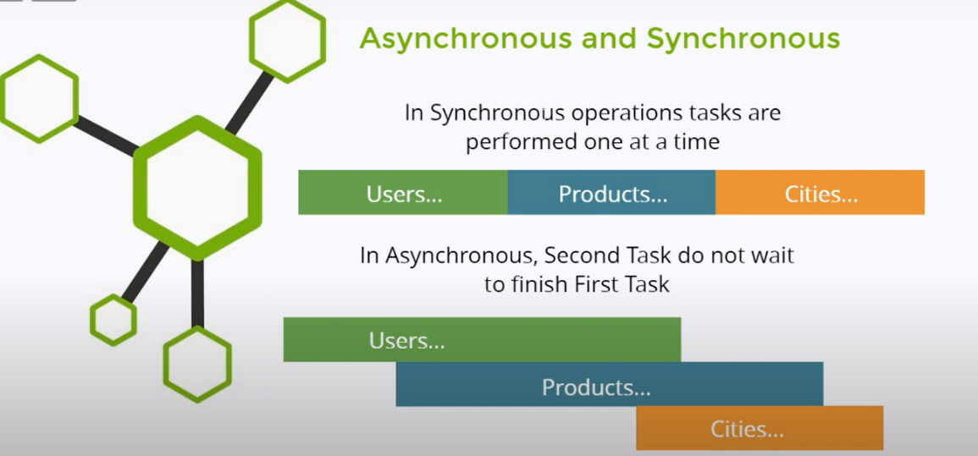
Asynchronous and SynchronousProgramming –
console.log("Start Execution")

setTimeout(()=>{
console.log("Logic Executes")
},2000)

console.log("Task Completes")

eg.
let a=10;
let b=0;

setTimeout(() => {
b=20;
}, 2000);

console.log(a+b)

Promises in js-
- In JavaScript, a promise is an object representing the eventual completion or failure of an asynchronous operation. Promises are a way to handle asynchronous operations in a cleaner and more readable way than callbacks.
Eg.
let a=10;
let b=0;

let waitingData= new Promise((resolve,reject)=>{
setTimeout(() => {
resolve(20);
}, 2000);
})

waitingData.then((data)=>{
b=data;
console.log(a+b)
})

#How Node-JS Works—
Let me give one example--
const x=1;

const y=x+2;

console.log(`Sum is: `+y);

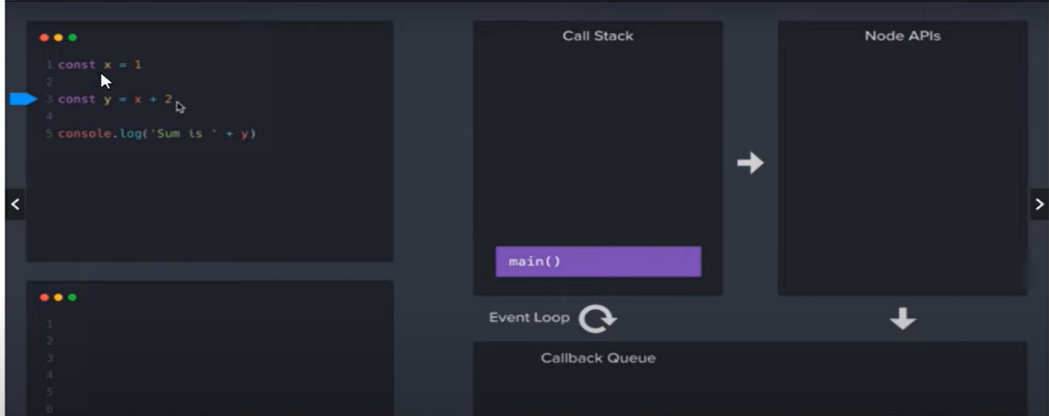
Steps- When u execute this code, each function is starting registered with Call Stack.

When u execute this code, your each function is starting registered with Call Stack.
- Call Stack creates a registry of each your code. Before executes like which function executes first and which function executes after that.
- We have many functions so how node js knows that which function should call first.
- First the main() function calls first as shown in diagram. Main() function is bydefault function available in nodeJS.
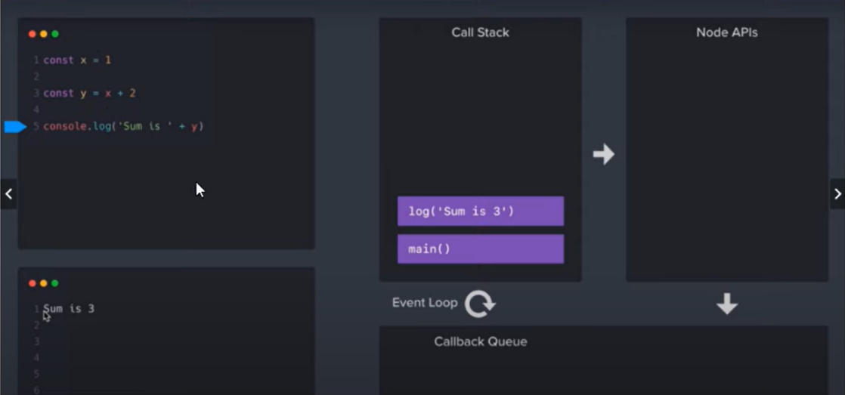

- After that log() function will call. After execution first console.log function removes and after that main removes.
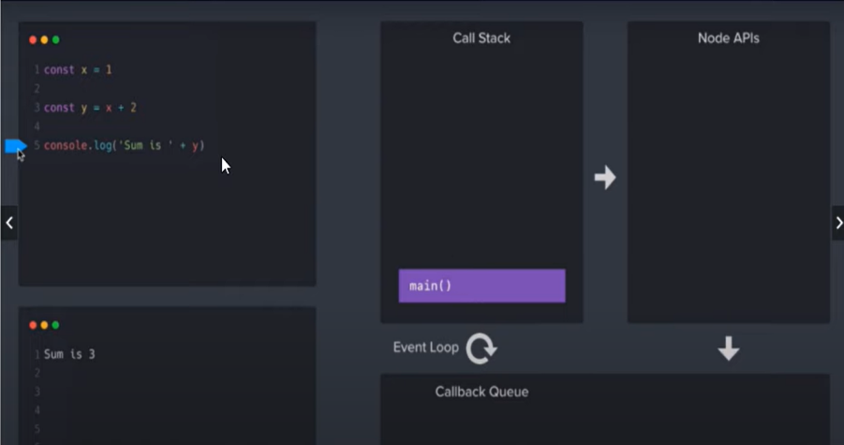

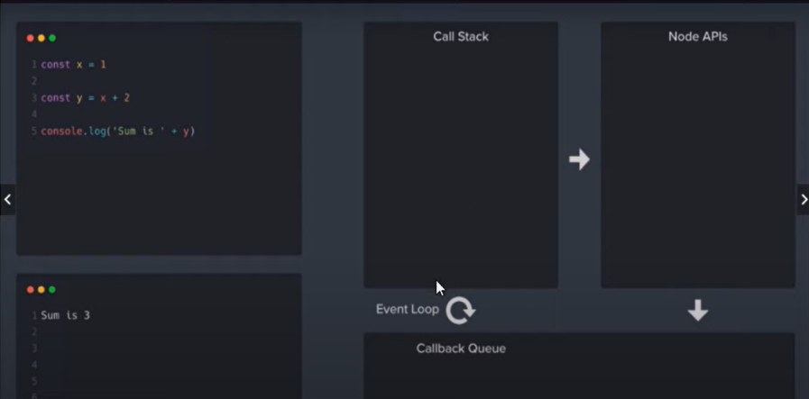

- Then What about Node API’s and Event Loop—For that refer below example-
console.log("Starting Up..!")

setTimeout(()=>{
console.log("2 Second log..!")
},2000)

setTimeout(()=>{
console.log("0 Second log..!")
},0)

console.log("Finishing Up..!")

Execution flow will like this Starting Up..! Finishing Up.. 0 Second log..! After Two seconds 2 Second log..!
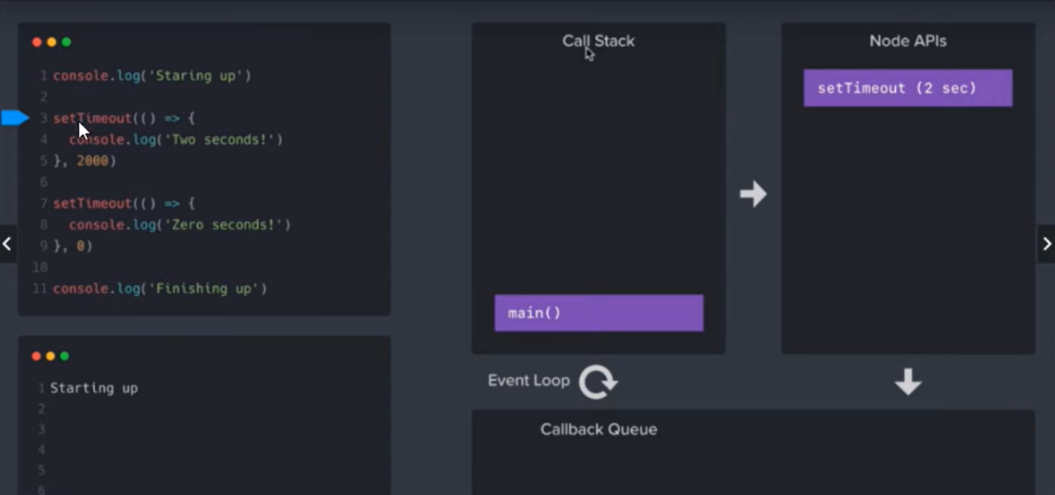
- First main() function executes then program comes in setTimeout, but why in node API because this is inherited from C++ ( because nodeJS is written in c,cpp and js). So Api means what, Interface between two programs/language.
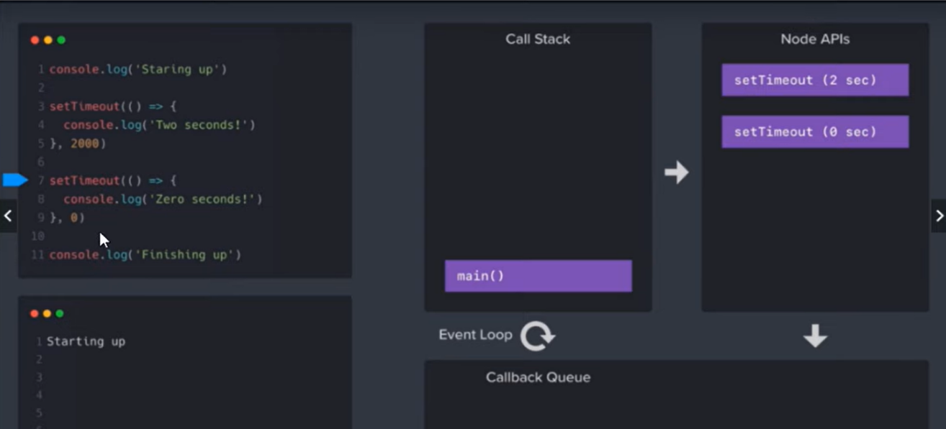

- When program comes at finishing up then NodeAPI sends 0 seconds to Callback queue.
- But why in callback que why not in CallStack because NodeAPI want the CallStack empty.

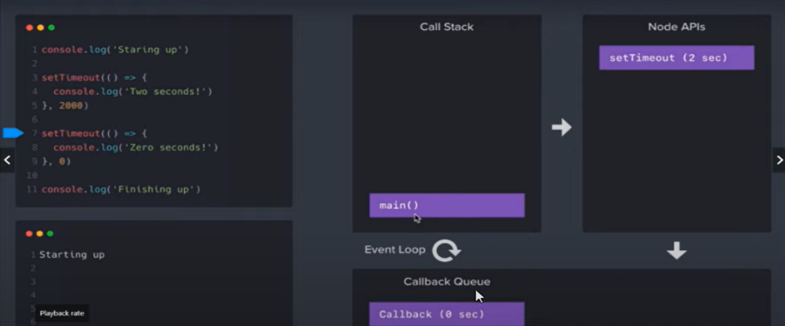
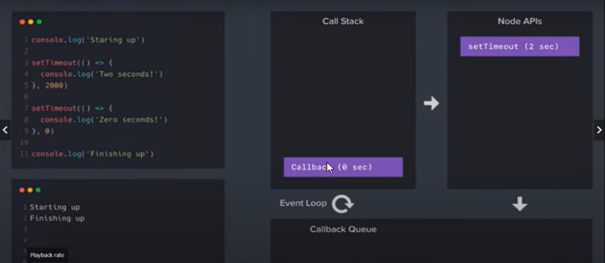

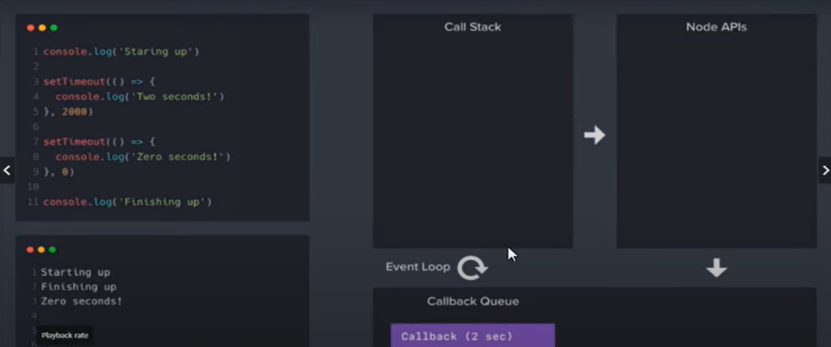

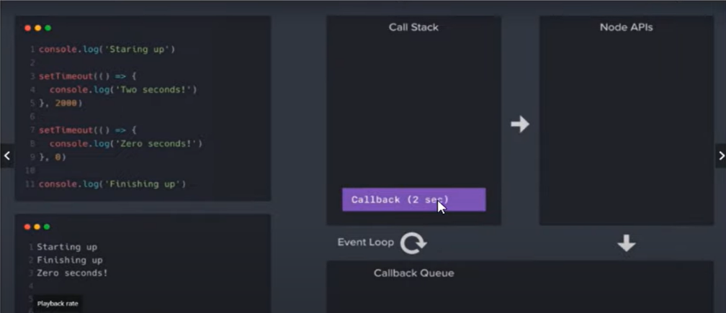

Express-JS Introduction—
- Express.js is a back-end web application framework for Node.js. It is designed to make it easy to create single-page, multi-page, and hybrid web applications.
Note-
- It’s very Easy framework as compared to other like angular, Spring boot.
- Express Js is used 99% node js applications
Advantages-
- You can write API’s in fewer lines.
- We can use Routes, middleware, get, post, html pages in less code.
Installation:
- npm i express/ npm install express.

Eg.
Note—use nodemon here
const express = require('express');

const app = express();

app.get('',(req,resp)=>{
resp.send("Hello... This is Home Page")
})

app.get('/about',(req,resp)=>{
resp.send("Hello,, This is About Page");
})

app.get('/help',(req,resp)=>{
resp.send("Hello,, This is Help Page");
})

app.listen(4500);

Routing Params - Request and Response :
For this u need to send request like this http://localhost:4500/?name=Rushi
const express = require('express')
const app = express();

app.get("",(req,resp)=>{
//console.log("Data send by Browser..!",req.query);
console.log("Data send by Browser..!",req.query.name);
resp.send("Welcome, This is a Home Page..!");
})

app.listen(4500);

Render HTML and JSON :
- Render html tags.
- Show JSON data.
- Link Pages.
Eg.
const express = require('express')
const app = express();

app.get("",(req,resp)=>{
//console.log("Data send by Browser..!",req.query);
console.log("Data send by Browser..!",req.query.name);
resp.send(`Welcome, This is a Home Page..!<br><br>
<a href='/about'>Go to About Page</a>
`);

})

app.get("/about",(req,resp)=>{
resp.send(`
<input type='text'>
<button>Click me</button><br><br>
<a href='/'>Go to About Page</a>
`)
})

app.get("/help",(req,resp)=>{
resp.send(
[
{
name:'Rushi',
email:'rushi@gmail.com'
},
{
name:'akash',
email:'akash@gmail.com'
}
]
)
})

app.listen(4500);

i-
How to get value from Parameter..?
const express = require('express')
const app = express();

app.get("/about",(req,resp)=>{
resp.send(`
<input type='text' value=${req.query.name}>
<button>Click me</button><br><br>
<a href='/'>Go to About Page</a>
`)
})

Make HTML Pages :
- Make folder for html files and access it.
- Make html files.
- Load html files
Steps-
- First Create a folder ‘public’ in your project
- Create 2-3 html pages in that like help.html, about.html, help.html,etc
- And refer the below js code.
Note- If you create index.html file it will become the root file for your project and you can run this by using link—
http://localhost:4500/ index.html
http://localhost:4500/about.html about.html.
etc.
const express = require('express')
const app = express();
const path = require('path');

const publicPath = path.join(__dirname,'public');
//console.log(publicPath) //to check the path is correct or not

app.use(express.static(publicPath))
//use is function of express
//static is function of express used to add static pages

app.listen(4500);

i-
- What is use of ‘path’ module..?
- It help to access folders of your project.

- Use of static method..?
- It Load the static pages.

Remove Extensions From URL :
Eg. Extensions are removed completely..
const express = require('express')
const app = express();
const path = require('path');

const publicPath = path.join(__dirname,'public');

app.get('', (_,resp)=>{
resp.sendFile(`${publicPath}/index.html`);
})
//we used _ instead of req because there is no use of req

app.get('/about',(_,resp)=>{
resp.sendFile(`${publicPath}/about.html`);
})

app.get('/help',(_,resp)=>{
resp.sendFile(`${publicPath}/help.html`);
})

app.get('/home',(_,resp)=>{
resp.sendFile(`${publicPath}/home.html`);
})
app.listen(4500);

4O4 Page/ Page Not Found :
- For that you need to create a new page in ‘public’ folder like Error.html and write some code in that like ‘Something Wents Wrong…!’.
- And refer below js code.
- Add below code in previous code.
app.get('*',(_req,resp)=>{
resp.sendFile(`${publicPath}/Error.html`);
})

- How to remove extensions from URL ?
- What is 4O4 page/ how to create..?
- How to load any file in the get method?

EJS Template Engine—
Installation npm i ejs
- Create a folder views and add create a file profile.ejs
Eg.1
Profile.ejs
<!DOCTYPE html>
<html lang="en">
<head>
<title>Document</title>
</head>
<body>
<h1>Hello <%=user.name %></h1>
<h1>Email: <%=user.email %></h1>
<h1>City: <%=user.city %></h1>
</body>
</html>

index.js
const { name } = require('ejs');
const express = require('express')
const path = require('path');

const app = express();
const publicPath = path.join(__dirname, 'public');

app.set('view engine','ejs');

app.get('/', (__, resp) => {
resp.sendFile(`${publicPath}/index.html`)
});

app.get('/profile', (__, resp) => {
resp.render('profile')
const user= {
name:"rushi",
email:"rushi@gmail.com",
city:"Pune"
}
resp.render('profile',{user})
});

app.listen(4500);

eg.2
profile.ejs
<!DOCTYPE html>
<html lang="en">
<head>
<title>Document</title>
</head>
<body>
<h1>Hello <%=user.name %>
</h1>
<h1>Email: <%=user.email %>
</h1>
<h1>City: <%=user.city %>
</h1>
<ul>
<% user.skills.forEach((item)=>{ %>

<li>
<%=item %>
</li>
<%}) %>
</ul>
</body>
</html>

Index.js
const { name } = require('ejs');
const express = require('express')
const path = require('path');

const app = express();
const publicPath = path.join(__dirname, 'public');

app.set('view engine','ejs');

app.get('/', (__, resp) => {
resp.sendFile(`${publicPath}/index.html`)
});

app.get('/profile', (__, resp) => {
resp.render('profile')
const user= {
name:"rushi",
email:"rushi@gmail.com",
city:"Pune",
skills:['java','python','CPP','JS']
}
resp.render('profile',{user})
});

app.listen(4500);

Dynamic Page with ejs—
Index.js
const { name } = require('ejs');
const express = require('express')
const path = require('path');

const app = express();
const publicPath = path.join(__dirname, 'public');

app.set('view engine','ejs');

app.get('/', (__, resp) => {
resp.sendFile(`${publicPath}/index.html`)
});

app.get('/profile', (__, resp) => {
resp.render('profile')
const user= {
name:"rushi",
email:"rushi@gmail.com",
city:"Pune",
skills:['java','python','CPP','JS']
}
resp.render('profile',{user})
});

app.get('/login',(__,resp)=>{
resp.render('login')
})

app.listen(4500);

login.ejs
<!DOCTYPE html>
<html lang="en">
<head>
<meta charset="UTF-8">
<meta name="viewport" content="width=device-width, initial-scale=1.0">
<title>Document</title>
</head>
<body>
<%- include('common/header'); %>
<h1>This is Login Page..!</h1>
</body>
</html>

Profile.ejs
This is same as previous example.
header.ejs [which is under views/common]
<nav>
<h3>Header File</h3>
</nav>

Middleware—
Ex.1
Index.js
const express = require('express')
const app = express();

//It will proceed further
const reqFilter = (req, resp, next) => {
//console.log('reqFilter');
if (!req.query.age) {
resp.send("Please Provide Age..!");
}
else if (req.query.age < 18) {
resp.send("You Cannot Access this Page..!");
}
else {
next();
}

}

app.use(reqFilter);

app.get('/', (req, resp) => {
resp.send('welcome to Home Page')
})

app.get('/user', (req, resp) => {
resp.send('Welcome to User Page')
})

app.listen(5000)

Ex.2
const express = require('express')
const app = express();

//It Filters request first then proceed further
const reqFilter = (req, resp, next) => {

if (req.query.username == 'admin' && req.query.password == 'admin123') {
next();
}
else if (req.query.username != 'admin' || req.query.password != 'admin123') {
resp.send("Please Enter Valid USername Or Password..!")
}
else {
resp.send("Please Enter Username and Password..!")
}
}

app.use(reqFilter);

app.get('/', (req, resp) => {
resp.send('Welcome to Home Page');
})

app.get('/user', (req, resp) => {
resp.send('Welcome to User Page')
})

app.get('/admin', (req, resp) => {
resp.send('Welcome to Admin Page..!')
})

app.listen(4500)

- What are the Types of Middleware..?
Types of MiddleWare—
- Application Level Middleware
- RouteLevel Middle Ware
- Error-Handling Middleware
- Built in middleware
- ThirdParty Middleware

Route Level Middleware
- Apply Middleware on single route
- Make middleware in different file
- Apple middleware in group of route.

Apply middle ware on single route
const express = require('express')
const app = express();

//It will proceed further
const reqFilter = (req, resp, next) => {
//console.log('reqFilter');
if (!req.query.age) {
resp.send("Please Provide Age..!");
}
else if (req.query.age < 18) {
resp.send("You Cannot Access this Page..!");
}
else {
next();
}

}

//app.use(reqFilter);

app.get('/', (req, resp) => {
resp.send('welcome to Home Page')
})

app.get('/user', reqFilter, (req, resp) => {
resp.send('Welcome to User Page')
})

app.listen(4500)

Make middleware in different file-
Index.js
const express = require('express')
const reqFilter= require('./middleware')
const app = express();

app.get('/', (req, resp) => {
resp.send('welcome to Home Page')
})

app.get('/user', reqFilter, (req, resp) => {
resp.send('Welcome to User Page')
})

app.listen(4500)

middleware.js

module.exports = reqFilter = (req, resp, next) => {

if (!req.query.age) {
resp.send("Please Provide Age..!");
}
else if (req.query.age < 18) {
resp.send("You Cannot Access this Page..!");
}
else {
next();
}

}

Apple middleware in group of route.
-middleware.js

module.exports = reqFilter = (req, resp, next) => {

if (!req.query.age) {
resp.send("Please Provide Age..!");
}
else if (req.query.age < 18) {
resp.send("You Cannot Access this Page..!");
}
else {
next();
}

}

Index.js
const express = require('express')
const reqFilter= require('./middleware')
const app = express();
const route = express.Router();

route.use(reqFilter);
app.get('/', (req, resp) => {
resp.send('welcome to Home Page')
})

app.get('/user', (req, resp) => {
resp.send('Welcome to User Page')
})

route.get('/about', (req, resp) => {
resp.send('Welcome to About Page')
})

route.get('/contact', (req, resp) => {
resp.send('Welcome to Contact Page')
});

app.use('/',route);

app.listen(4500)

How to Connect MongoDB to NodeJS
Install npm i mongodb
Refer this official Documentation
https://www.npmjs.com/package/mongodb

const {MongoClient} = require('mongodb');
const url = 'mongodb://localhost:27017';
let database ='ecom'; //ecom is database name created in mongodb

const client = new MongoClient(url);

async function getData()
{
let result = await client.connect();
let db= result.db(database);
let collection = db.collection('products'); //product is collection name

let response = await collection.find({}).toArray()
console.log(response);
}

getData();
//before run please ensure that there is data available in the ecom.products

Put Connectivity code in another file—
mongodb.js
const {MongoClient} = require('mongodb')
const url = 'mongodb://localhost:27017';
let database = 'ecom';
const client = new MongoClient(url);

async function dbConnect()
{
let result = await client.connect();
let db = result.db(database);
return db.collection('products'); //products is collection name
}

module.exports= dbConnect;

index.js
const dbConnect = require('./mongodb');

const main = async ()=>
{
let data = await dbConnect();
data=await data.find().toArray();
console.warn(data);

}
main();

to search according to name change only in index.js
index.js
const dbConnect = require('./mongodb');

const main = async ()=>
{
let data = await dbConnect();
data=await data.find({name:'rushi'}).toArray();
console.warn(data);

}

main();

Insert Data-
Insert.js
const dbConnect = require('./mongodb');

const insert = async () => {
console.log("insert function");
const collection = await dbConnect();
const result = await collection.insertOne(
{
name: 'Iphone', brand: 'apple', price: 400
}
);
console.log("Document inserted with _id: ", result.insertedId);
}

insert();

Update Data-
Ex:1
update.js
const dbConnect = require('./mongodb')

const updateData= async ()=>{
let data =await dbConnect();

let result =await data.updateOne(
{name:'rushi'},{
$set :{name:'rushi divase'}
});
console.warn(result);
}

updateData();

Ex:2: update multiple records
const dbConnect = require('./mongodb')

const updateData= async ()=>{
let data =await dbConnect();

let result =await data.update(
{name:'rushi'},{
$set :{name:'rushi divase'}
});
console.warn(result);
}

updateData();

Delete Data--
Delete Single Record
const dbConnect = require('./mongodb')

const deleteData= async ()=>{

let data =await dbConnect();
let result = await data.deleteOne({name:"Sakshi"})
console.warn(result.acknowledged)
{
console.log("Record Deleted..!")
}
}

deleteData();

Delete Multiple Records—
const dbConnect = require('./mongodb')

const deleteData= async ()=>{

let data =await dbConnect();
let result = await data.deleteMany({name:"Iphone"})
console.warn(result.acknowledged)
{
console.log("Record Deleted..!")
}
}

deleteData();

Api with MongoDB – (Dynamic):
- Get DataAPI
const express = require('express');
const dbConnect = require('./mongodb');

const app = express();

app.get('/', async (req, resp) => {
let data = await dbConnect();
data = await data.find({}).toArray();
//console.log(data) //first ensure that data in printing on console or not.
resp.send(data)
});

app.listen(5000)

Note- After Creating Test API with Postman or any API testing tool
- Can we pass body inside get method..?
Ans- NO

- Post DataAPI
const express = require('express');
const dbConnect = require('./mongodb');

const app = express();

app.use(express.json());

app.get('/', async (req, resp) => {
let data = await dbConnect();
data = await data.find({}).toArray();
//console.log(data) //first ensure that data in printing on console or not.
resp.send(data)
});

app.post('/', async (req,resp)=>{

let data = await dbConnect();
let result= await data.insertOne(req.body);
resp.send(result);

});

app.listen(5000)

- Put Data-
const express = require('express');
const dbConnect = require('./mongodb');

const app = express();

app.use(express.json());

app.get('/', async (req, resp) => {
let data = await dbConnect();
data = await data.find({}).toArray();
//console.log(data) //first ensure that data in printing on console or not.
resp.send(data)
});

app.post('/', async (req,resp)=>{

let data = await dbConnect();
let result= await data.insertOne(req.body);
resp.send(result);

});

app.put('/:name', async (req,resp)=>{
let data = await dbConnect();
let result = data.updateOne({
name:req.params.name},
{$set:req.body}
)

resp.send({result:"updated"})
})

app.listen(5000)

- Delete Data
const express = require('express');
const dbConnect = require('./mongodb');
const mongodb = require('mongodb')

const app = express();

app.use(express.json());
app.delete('/:id', async(req,resp)=>{
console.log(req.params.id)

const data = await dbConnect();
const result = await data.deleteOne({_id:new mongodb.ObjectId(req.params.id)})
resp.send(result)
})

app.listen(5000)

Mongoose-
What is mongoose-
- It is a npm package to mongo db with nodejs.
Difference between monodb driver and mongoose-
- Monogob is official mongodb Driver
- But there are some limitations in mongoDb which are fulfilled by mongoose
- We can make scemas inside mongoose and we can define datatype also and can apply validations also.
- Install npm i mongoose.

Eg. 1
const mongoose = require('mongoose')

const main = async () => {
await mongoose.connect("mongodb://localhost:27017/e-com");
const ProductSchema = new mongoose.Schema({
name: String,
price: Number
});
const ProductModel = mongoose.model('products', ProductSchema);
let data = new ProductModel({ name: "m8", price: 1000 });
let result = await data.save();
console.log(result);
}

main();

CRUD with Mongoose
Create—
const mongoose = require('mongoose')

const main = async () => {
await mongoose.connect("mongodb://localhost:27017/e-com");
const ProductSchema = new mongoose.Schema({
name: String,
price: Number,
brand: String,
category: String
});
const ProductModel = mongoose.model('products', ProductSchema);
let data = new ProductModel({
name: "m8",
price: 1000,
brand: "max",
category: "Mobile"
});
let result = await data.save();
console.log(result);
}

main();

Update-
const mongoose = require('mongoose')
mongoose.connect("mongodb://localhost:27017/e-com");
const ProductSchema = new mongoose.Schema({
name: String,
price: Number,
brand: String,
category: String
});
const updateInDB = async () => {
const Product = mongoose.model('products', ProductSchema);
let data = await Product.updateOne(
{ name: "m8" },
{
$set: { price: 750, name:"max111" }
}
)
console.log(data);
}

updateInDB();

Delete-
const mongoose = require('mongoose')
mongoose.connect("mongodb://localhost:27017/e-com");
const ProductSchema = new mongoose.Schema({
name: String,
price: Number,
brand: String,
category: String
});

const deleteInDB = async () => {
const Product = mongoose.model('products', ProductSchema);
let data = await Product.deleteOne({ name: 'm8' });
console.log(data);
}

deleteInDB();

find-
eg.1
const mongoose = require('mongoose')
mongoose.connect("mongodb://localhost:27017/e-com");
const ProductSchema = new mongoose.Schema({
name: String,
price: Number,
brand: String,
category: String
});

const findInDB = async () => {
const Product = mongoose.model('products', ProductSchema);
let data = await Product.find();
console.log(data);
}

findInDB();

eg.2
find by Name:
const findInDB = async () => {
const Product = mongoose.model('products', ProductSchema);
let data = await Product.find({name: "m8"});
console.log(data);
}

API with Mongoose [Project Level Api]:
1.Post—
config.js
const mongoose = require('mongoose');
mongoose.connect("mongodb://localhost:27017/ecom");

product.js
const mongoose = require('mongoose');

const productSchema = new mongoose.Schema({
name:String,
price:Number,
brand:String,
category: String
});

module.exports = mongoose.model('products', productSchema);

index.js
const express = require('express');
require('./config');
const Product = require('./product');

const app = express();
app.use(express.json());

app.post("/create", async (req,resp)=>{
let data = new Product(req.body);
let result = await data.save();
console.log(result)
resp.send("Done");
});

app.listen(5000);

get data—[write this code in index.js]
app.get("/list",async (req,resp)=>{
let data = await Product.find();
resp.send(data);
})

Delete data-
app.delete("/delete/:_id", async(req,resp)=>{
console.log(req.params)
let data = await Product.deleteOne(req.params);

Note- Test with the help of postman-
http://localhost:5000/delete/665edcfb1d28bba4c90c2475
update data—
app.put("/update/:_id", async(req,resp)=>{
console.log(req.params)
let data = await Product.updateOne(
req.params,
{
$set: req.body
}
);
resp.send(data);
})

Note- http://localhost:5000/update/665ed58e8fc9845b762617e7
Test the API using this..also pass body inside.

Project—
Steps—
- Setup backend first—
- Download nodejs
- Manage package.json
- Install, express, MongoDB packages and nodemon
- Make index.js and run it.
- Use npm init first
- Make a index.js and run it
Eg.
const express = require('express');
const app = express();

app.get("/",(rq,resp)=>{
resp.send("app is working..!")
});

app.listen(5000);

- Setup FrondEnd—
- Install ReactJs
- Run app
- Make a small change
- Remove the code from App.js and write a heading tag with ‘e-Dashboard’.
Eg.
import './App.css';

function App() {
return (
<div className="App">
<h1>E-DashBaord</h1>
</div>
);
}
export default App;

- Install Route - npm i react-router-dom
Eg.
App.js
import { BrowserRouter, Route, Routes } from 'react-router-dom';
import './App.css';
import Nav from './Nav';

function App() {
return (
<BrowserRouter>
<div className="App">
<Nav />
<Routes>
<Route path="/" element={<h1>Product Listing Component</h1>}></Route>
<Route path="/add" element={<h1>Add Product Component</h1>}></Route>
<Route path="/update" element={<h1>Update Product Component</h1>}></Route>
<Route path="/logout" element={<h1>Logout Product Component</h1>}></Route>
<Route path="/profile" element={<h1>Profile Component</h1>}></Route>

</Routes>
</div>
</BrowserRouter>
);
}

export default App;

Nav.js
import React from 'react'
import { Link } from 'react-router-dom';

function Nav() {
return (
<div>
<ul className='nav-ul'>
<li><Link to="/">Products</Link></li>
<li><Link to="/add">Add Product</Link></li>
<li><Link to="/update">Update Product</Link></li>
<li><Link to="/logout">Logout</Link></li>
<li><Link to="/profile">Profile</Link></li>
</ul>
</div>
)
}

export default Nav;

App.css
.nav-ul li {
display: inline-block;
padding: 10px;

}

- Step: add style to nav and add footer.js and change folder structure, create components folder and move all components in that excluding App.js

Footer.js
import React from 'react'

const Footer = () => {
return (
<div className="footer">
<h3>E-com Dashboard</h3>
</div>
)
}

export default Footer

App.css
.footer
{
position:absolute;
bottom: 0;
text-align: center;
width: 100%;
background-color:black;
color: white;
}

.nav-ul {
list-style-type: none; /* Removes the default bullet points from the list */
padding: 0; /* Removes the default padding */
margin: 0; /* Removes the default margin */
display: flex; /* Aligns the list items horizontally */
background-color: #333; /* Sets the background color of the navigation bar */
}

.nav-ul li {
padding: 14px 20px; /* Adds padding around each list item */
}

.nav-ul li a {
color: white; /* Sets the text color of the links to white */
text-decoration: none; /* Removes the underline from the links */
display: block; /* Makes the links take up the full height of the list item */
}

.nav-ul li a:hover {
background-color: #111; /* Changes the background color on hover */
}

- SignUp Page-
import React, { useState } from 'react'

function SignUp1() {

const [name, setName] = useState("");
const [password, setPassword] = useState("");
const [email, setEmail] = useState("");

const collectData=()=>{
console.warn(name,email,password);
}

return (
<div className='border shadow mt-4 col-4 offset-4 text-center p-3'>
<h1>Register</h1>
<input className='inputBox' type='text' placeholder='Enter Name' value={name}
onChange={(e) => setName(e.target.value)} />

<input className='inputBox' type='text' placeholder='Enter Email' value={email}
onChange={(e) => setEmail(e.target.value)} />

<input className='inputBox' type='password' placeholder='Enter Password' value={password}
onChange={(e) => setPassword(e.target.value)} />
<button className='btn btn-info' onClick={collectData}>Sign Up</button>
</div>
)
}

export default SignUp1

- SignUp API—
- Create database e-commerce and Schema users inside the MongoDB with the fields name,email and password.
- Create folder db inside backend and add config.js and User.js inside that and follow the below code.
config.js
const mongoose = require('mongoose');
mongoose.connect("mongodb://localhost:27017/e-commerce")

User.js
const mongoose = require('mongoose')

const userSchema = new mongoose.Schema({
name: String,
email: String,
password: String
});

module.exports = mongoose.model("users", userSchema);

index.js
const express = require('express');
require('./db/config')
const User = require("./db/User");
const app = express();
app.use(express.json());

app.post("/register", async(req,resp)=>{
let user = new User(req.body)
let result =await user.save();
resp.send(result);
})

app.listen(5000);

Imp-Note: - FrontEnd and Backend projects are running on two different ports so there will be a issue like ‘Blocked By CORS Policy’.
- So this will be resolved by backend only.
- So, to resolve this first install a package- npm i cors
- And change the following code in index.js
index.js
const express = require('express');
const cors = require("cors");

require('./db/config')
const User = require("./db/User");
const app = express();

app.use(express.json());
app.use(cors());

app.post("/register", async(req,resp)=>{
let user = new User(req.body)
let result =await user.save();
resp.send(result);
})

app.listen(5000);

- Step-6: Integrate API with ReactJS
- Just change in SignUp1.js ReactJs Project
SignUp1.js
import React, { useState } from 'react'
import { useNavigate } from 'react-router-dom';

function SignUp1() {

const [name, setName] = useState("");
const [password, setPassword] = useState("");
const [email, setEmail] = useState("");

const navigator = useNavigate();

const collectData = async () => {
console.warn(name, email, password);
let result = await fetch('http://localhost:5000/register', {
method: 'post',
body: JSON.stringify({ name, email, password }),
headers: {
'Content-Type': 'application/json'
},

});
result = await result.json();
console.warn(result);
if (result) {
navigator("/");
}
}

return (
<div className='border shadow mt-4 col-4 offset-4 text-center p-3'>
<h1>Register</h1>
<input className='inputBox' type='text' placeholder='Enter Name' value={name} onChange={(e) => setName(e.target.value)} />
<input className='inputBox' type='text' placeholder='Enter Email' value={email} onChange={(e) => setEmail(e.target.value)} />
<input className='inputBox' type='password' placeholder='Enter Password' value={password} onChange={(e) => setPassword(e.target.value)} />
<button className='btn btn-info' onClick={collectData}>Sign Up</button>
</div>
)
}

export default SignUp1

- Step7: Manage Signup flow—
- when the user will there then should not show the signup option and user is not there then should not show other option, so for that change the code like below:
- First create a js file like PrivateComponent.js in components folder.
PrivateComponent.js
import React from 'react'
import { Navigate, Outlet } from 'react-router-dom'

function PrivateComponent() {

const auth = localStorage.getItem('user');
return auth?<Outlet />:<Navigate to="/signup" />

}

export default PrivateComponent

App.js
import { BrowserRouter, Route, Routes } from 'react-router-dom';
import './App.css';
import Nav from './components/Nav';
import Footer from './components/Footer';
import SignUp1 from './components/SignUp1';
import PrivateComponent from './components/PrivateComponent';

function App() {
return (
<div className="App">
<BrowserRouter>

<Nav />
<Routes>
<Route element={<PrivateComponent />}>
<Route path="/" element={<h1>Product Listing Component</h1>}></Route>
<Route path="/add" element={<h1>Add Product Component</h1>}></Route>
<Route path="/update" element={<h1>Update Product Component</h1>}></Route>
<Route path="/logout" element={<h1>Logout Product Component</h1>}></Route>
<Route path="/profile" element={<h1>Profile Component</h1>}></Route>
</Route>
<Route path="/signup" element={<SignUp1 />}></Route>
</Routes>

</BrowserRouter>
<Footer />
</div>
);
}

export default App;

SignUp.js
import React, { useEffect, useState } from 'react'
import { useNavigate } from 'react-router-dom';

function SignUp1() {

const [name, setName] = useState("");
const [password, setPassword] = useState("");
const [email, setEmail] = useState("");
const navigator = useNavigate();

useEffect(() => {
const auth = localStorage.getItem('user');
if (auth)
{
navigator("/");
}
})

const collectData = async () => {
console.warn(name, email, password);
let result = await fetch('http://localhost:5000/register', {
method: 'post',
body: JSON.stringify({ name, email, password }),
headers: {
'Content-Type': 'application/json'
},

});
result = await result.json();
console.warn(result);
localStorage.setItem("user",JSON.stringify(result));
if (result) {
navigator("/");
}
}

return (
<div className='border shadow mt-4 col-4 offset-4 text-center p-3'>
<h1>Register</h1>
<input className='inputBox' type='text' placeholder='Enter Name' value={name} onChange={(e) => setName(e.target.value)} />
<input className='inputBox' type='text' placeholder='Enter Email' value={email} onChange={(e) => setEmail(e.target.value)} />
<input className='inputBox' type='password' placeholder='Enter Password' value={password} onChange={(e) => setPassword(e.target.value)} />
<button className='btn btn-info' onClick={collectData}>Sign Up</button>
</div>
)
}

export default SignUp1

Nav.js
import React, { useEffect } from 'react'
import { Link, useNavigate } from 'react-router-dom';

function Nav() {
const auth = localStorage.getItem('user');
const navigate = useNavigate();
const logout = () => {
localStorage.clear();
navigate("/signup");
}

return (
<div>
<ul className='nav-ul'>
<li><Link to="/">Products</Link></li>
<li><Link to="/add">Add Product</Link></li>
<li><Link to="/update">Update Product</Link></li>
<li><Link to="/profile">Profile</Link></li>
<li>
{auth ? <Link onClick={logout} to="/signup">Logout</Link> :
<Link to="/signup">Sign Up</Link>} </li>
</ul>
</div>
)
}

export default Nav;

- Login API in NodeJS—
- We have removed password from register API and make login API.
index.js
const express = require('express');
const cors = require("cors");

require('./db/config')
const User = require("./db/User");
const app = express();
app.use(express.json());
app.use(cors());

app.post("/register", async (req, resp) => {
let user = new User(req.body)
let result = await user.save();
resp.send(result);
})

app.post("/login", async (req, resp) => {

if (req.body.password && req.body.email) {
let user = await User.findOne(req.body).select("-password");
if (user) {
resp.send(user);
}
else {
resp.send({ result: "Not Found" })
}
}
else {
resp.send({ result1: "Not Found" })
}

})
app.listen(5000);

- Login API Component-
- Create Login.js in component and add below link to Nav.js
<li><Link to="/login">Login</Link></li>
- Add below line to App.js
<Route path='/login' element={<Login />}></Route>

Login.js
import React, { useState } from 'react'

function Login() {

const [email, setEmail] = useState('');
const [password, setPassword] = useState('');

const handleLogin=()=>{
console.warn(email,password)
}

return (
<div className='container'>
<div className='row'>
<div className='col-3 border offset-4 p-3 shadow text-center mt-4'>
<h1 className='display-6 mb-4'>Login Page</h1>
<input type='text' placeholder='Enter Name'
className='form-control mt-2' onChange={(e) => setEmail(e.target.value)}
value={email} />
<input type='password' placeholder='Enter Password'
className='form-control mt-2'
onChange={(e) => setPassword(e.target.value)}
value={password}
/>
<button className='btn btn-info mt-2' onClick={handleLogin}>Login</button>
</div>
</div>

</div>
)
}

export default Login

- Login API integration—
Login.js
import React, { useEffect, useState } from 'react'
import { useNavigate } from 'react-router-dom';

function Login() {

const [email, setEmail] = useState('');
const [password, setPassword] = useState('');
const navigate = useNavigate();

useEffect(() => { //this code is because of there was a problem like when we type end point of login manually then it was redirected on login after login so we add this code
let auth = localStorage.getItem('user');
if (auth) {
navigate("/");
}
})

const handleLogin = async () => {
console.warn(email, password)

let result = await fetch('http://localhost:5000/login', {
method: 'post',
body: JSON.stringify({ email, password }),
headers: {
'Content-Type': 'application/json'
},
});
result = await result.json();
console.warn(result);
if (result.name) {
localStorage.setItem('user', JSON.stringify(result));
navigate("/");
}
else {
alert("Please Enter Correct Details...!")
}

}

return (
<div className='container'>
<div className='row'>
<div className='col-3 border offset-4 p-3 shadow text-center mt-4'>
<h1 className='display-6 mb-4'>Login Page</h1>
<input type='text' placeholder='Enter Name'
className='form-control mt-2' onChange={(e) => setEmail(e.target.value)}
value={email} />
<input type='password' placeholder='Enter Password'
className='form-control mt-2'
onChange={(e) => setPassword(e.target.value)}
value={password}
/>
<button className='btn btn-info mt-2' onClick={handleLogin}>Login</button>
</div>
</div>

</div>
)
}

export default Login

- Update NavBar—
- We hide products before login and signup
- Show Logged-in user name
- Add logo and Style
- Test complete Flow.
Nav.js
import React, { useEffect } from 'react'
import { Link, useNavigate } from 'react-router-dom';

function Nav() {
const auth = localStorage.getItem('user');
const navigate = useNavigate();
const logout = () => {
localStorage.clear();
navigate("/signup");
}

return (
<div>
{auth ? <ul className='nav-ul'>
<li><Link to="/">Products</Link></li>
<li><Link to="/add">Add Product</Link></li>
<li><Link to="/update">Update Product</Link></li>
<li><Link to="/profile">Profile</Link></li>
<li><Link onClick={logout} to="/signup">Logout ({JSON.parse(auth).name}) </Link></li>

</ul>
:
<ul className='nav-ul nav-right'>
<li> <Link to="/signup">Sign Up</Link> </li>
<li> <Link to="/login">Login</Link> </li>

</ul>
}
</div>
)
}

export default Nav;

- Add Product API—
- First Create a Collection products in MongoDB.
- Create a Schema of Product.
- And create a post API.
Product.js
const mongoose = require('mongoose')

const productSchema = new mongoose.Schema({
name: String,
price: String,
category:String,
userId: String,
company:String
});

module.exports = mongoose.model("products", productSchema);

index.js (updated)
const express = require('express');
const cors = require("cors");

require('./db/config')
const User = require("./db/User");
const Product = require('./db/Product');
const app = express();

app.use(express.json());
app.use(cors());

app.post("/register", async (req, resp) => {
let user = new User(req.body)
let result = await user.save();
resp.send(result);
})

app.post("/login", async (req, resp) => {

if (req.body.password && req.body.email) {
let user = await User.findOne(req.body).select("-password");
if (user) {
resp.send(user);
}
else {
resp.send({ result: "Not Found" })
}
}
else {
resp.send({ result1: "Not Found" })
}

})

app.post("/add-product", async (req, resp) => {
let product = new Product(req.body);
let result = await product.save();
resp.send(result);
});

app.listen(5000);

- Add Product Component—
- Create AddProduct.js in components folder and import that in App.js.

AddProduct.js
import React, { useState } from 'react'

function AddProduct() {

const [name, setName] = useState('');
const [price, setPrice] = useState('');
const [category, setCategory] = useState('');
const [company, setCompany] = useState('');

const addProduct = () => {
console.warn(name, price, category, company)
}

return (
<div className='container mt-4'>
<div className='row'>
<div className='col-6 offset-3 border shadow p-4 text-center'>
<h1 className='display-6 mb-3'>Add Product</h1>
<input type='text' placeholder='Enter Product Name' className='form-control mb-2'
onChange={(e) => setName(e.target.value)} value={name} />

<input type='text' placeholder='Enter Product Price' className='form-control mb-2'
onChange={(e) => setPrice(e.target.value)} value={price} />

<input type='text' placeholder='Enter Product Category' className='form-control mb-2'
onChange={(e) => setCategory(e.target.value)} value={category} />

<input type='text' placeholder='Enter Product Compnay' className='form-control mb-2'
onChange={(e) => setCompany(e.target.value)} value={company} />
<button className='btn btn-info' onClick={addProduct}>Add Product</button>
</div>
</div>
</div>
)
}

export default AddProduct

- Integrate AddProduct API—
- Get userId from localStorage.( to know which user add that product)
- Add Integrate component with API.
AppProduct.js
import React, { useState } from 'react'

function AddProduct() {

const [name, setName] = useState('');
const [price, setPrice] = useState('');
const [category, setCategory] = useState('');
const [company, setCompany] = useState('');

const addProduct = async () => {
console.warn(name, price, category, company);
const userId = JSON.parse(localStorage.getItem('user'))._id;
// console.warn(userId);
let result = await fetch('http://localhost:5000/add-product', {
method: 'post',
body: JSON.stringify({ name, price, category, company, userId }),
headers: {
'Content-Type': 'application/json'
}
});
console.warn(result);
result = await result.json(); //to convert JSON.
if(result)
{

}
}

return (
<div className='container mt-4'>
<div className='row'>
<div className='col-6 offset-3 border shadow p-4 text-center'>
<h1 className='display-6 mb-3'>Add Product</h1>
<input type='text' placeholder='Enter Product Name' className='form-control mb-2'
onChange={(e) => setName(e.target.value)} value={name} />

<input type='text' placeholder='Enter Product Price' className='form-control mb-2'
onChange={(e) => setPrice(e.target.value)} value={price} />

<input type='text' placeholder='Enter Product Category' className='form-control mb-2'
onChange={(e) => setCategory(e.target.value)} value={category} />

<input type='text' placeholder='Enter Product Compnay' className='form-control mb-2'
onChange={(e) => setCompany(e.target.value)} value={company} />
<button className='btn btn-info' onClick={addProduct}>Add Product</button>
</div>
</div>
</div>
)
}

export default AddProduct

- Add Validation on AddProduct.js
import React, { useState } from 'react'

function AddProduct() {

const [name, setName] = useState('');
const [price, setPrice] = useState('');
const [category, setCategory] = useState('');
const [company, setCompany] = useState('');
const [error,setError] = useState(false);

const addProduct = async () => {
console.warn(name, price, category, company);

if(!name || !price || !category || !company)
{
setError(true);
return false; //It stops
}

const userId = JSON.parse(localStorage.getItem('user'))._id;
// console.warn(userId);
let result = await fetch('http://localhost:5000/add-product', {
method: 'post',
body: JSON.stringify({ name, price, category, company, userId }),
headers: {
'Content-Type': 'application/json'
}
});
console.warn(result);
result = await result.json(); //to convert JSON.
if(result)
{

}
}

return (
<div className='container mt-4'>
<div className='row'>
<div className='col-6 offset-3 border shadow p-4 text-center'>
<h1 className='display-6 mb-3'>Add Product</h1>
<input type='text' placeholder='Enter Product Name' className='form-control mb-2'
onChange={(e) => setName(e.target.value)} value={name} />
{error && !name &&<span className='invalid-input mb-2'>Enter Valid Name </span>}

<input type='text' placeholder='Enter Product Price' className='form-control mb-2'
onChange={(e) => setPrice(e.target.value)} value={price} />
{error && !price &&<span className='invalid-input mb-2'>Enter Valid Price</span>}

<input type='text' placeholder='Enter Product Category' className='form-control mb-2'
onChange={(e) => setCategory(e.target.value)} value={category} />
{error && !category &&<span className='invalid-input mb-2'>Enter Valid Category</span>}

<input type='text' placeholder='Enter Product Company' className='form-control mb-2'
onChange={(e) => setCompany(e.target.value)} value={company} />
{error && !company &&<span className='invalid-input mb-2'>Enter Valid Company </span>}

<button className='btn btn-info' onClick={addProduct}>Add Product</button>
</div>
</div>
</div>
)
}

export default AddProduct

- Create and integrate ProductList Api
index.js [add this code]
app.get('/products', async (req, resp) => {
let products = await Product.find();
if (products.length > 0) {
resp.send(products);
}
else {
resp.send({ result: "No Products Found.." })
}
})

ProductList.js
import React, { useEffect, useState } from 'react';

function ProductList() {
const [products, setProducts] = useState([]);

useEffect(() => {
getProducts();
}, []);

const getProducts = async () => {
let result = await fetch('http://localhost:5000/products');
result = await result.json();
setProducts(result);
};

console.warn("products", products);

return (
<div className='container mt-3'>
<div className='row'>
<div className='col-5 border offset-4 p-4 shadow-lg'>
<h3>Product List</h3>
<table className='table table-bordered'>
<thead>
<tr>
<th>S.No</th>
<th>Name</th>
<th>Price</th>
<th>Category</th>
</tr>
</thead>
<tbody>
{
products.map((item, index) =>
<tr key={index}>
<td>{index + 1}</td>
<td>{item.name}</td>
<td>{item.price}</td>
<td>{item.category}</td>
</tr>
)
}
</tbody>
</table>
</div>
</div>
</div>
);
}

export default ProductList;

- Create and integrate ‘delete’ API
index.js [add this code]
app.delete("/products/:id", async (req, resp) => {
const result = await Product.deleteOne({ _id: req.params.id });
resp.send(result);
})

ProductList.js [modify this]
import React, { useEffect, useState } from 'react';

function ProductList() {
const [products, setProducts] = useState([]);

useEffect(() => {
getProducts();
}, []);

const getProducts = async () => {
let result = await fetch('http://localhost:5000/products');
result = await result.json();
setProducts(result);
};

const deleteProduct =async (id)=>{
// console.warn(id)
let result =await fetch(`http://localhost:5000/products/${id}`,{
method:"Delete"
});
result = await result.json();
if(result)
{
getProducts();
}
}

console.warn("products", products);

return (
<div className='container mt-3'>
<div className='row'>
<div className='col-5 border offset-4 p-4 shadow-lg'>
<h3>Product List</h3>
<table className='table table-bordered'>
<thead>
<tr>
<th>S.No</th>
<th>Name</th>
<th>Price</th>
<th>Category</th>
<th>Operation</th>
</tr>
</thead>
<tbody>
{
products.map((item, index) =>
<tr key={item._id}>
<td>{index + 1}</td>
<td>{item.name}</td>
<td>{item.price}</td>
<td>{item.category}</td>
<td>
<button className='btn btn-danger' onClick={()=>deleteProduct(item._id)}>Delete</button>
</td>
</tr>
)
}
</tbody>
</table>
</div>
</div>
</div>
);
}

export default ProductList;

- Update—
- In this First add a link inside ProductList.js
<Link className='btn btn-info' to={"/update/"+item._id}>Update</Link>

- Modify in App.js also
<Route path="/update/:id" element={<UpdateProduct />}></Route>

- Create UpdateProduct.js and modify it.
import React, { useState } from 'react'
import { useNavigate } from 'react-router-dom';

function UpdateProduct() {

const [name, setName] = useState('');
const [price, setPrice] = useState('');
const [category, setCategory] = useState('');
const [company, setCompany] = useState('');

const navigator = useNavigate();

const updateProduct = () => {
console.warn(name,price,category,company)
}

return (
<div className='container mt-4'>
<div className='row'>
<div className='col-6 offset-3 border shadow p-4 text-center'>
<h1 className='display-6 mb-3'>Update Product</h1>
<input type='text' placeholder='Enter Product Name' className='form-control mb-2'
onChange={(e) => setName(e.target.value)} value={name} />

<input type='text' placeholder='Enter Product Price' className='form-control mb-2'
onChange={(e) => setPrice(e.target.value)} value={price} />

<input type='text' placeholder='Enter Product Category' className='form-control mb-2'
onChange={(e) => setCategory(e.target.value)} value={category} />

<input type='text' placeholder='Enter Product Company' className='form-control mb-2'
onChange={(e) => setCompany(e.target.value)} value={company} />

<button className='btn btn-info' onClick={updateProduct}>Update Product</button>
</div>
</div>
</div>
)
}

export default UpdateProduct

- Update api for get single data—
index.js
app.get("/product/:id", async (req, resp) => {
let result = await Product.findOne({ _id: req.params.id });
if (result) {
resp.send(result);
}
else {
resp.send({ result: "No Record Found..!" });
}
})

- Prefill Update Data
UpdateProduct.js
import React, { useEffect, useState } from 'react'
import { useNavigate, useParams } from 'react-router-dom';

function UpdateProduct() {

const [name, setName] = useState('');
const [price, setPrice] = useState('');
const [category, setCategory] = useState('');
const [company, setCompany] = useState('');

const params = useParams();

useEffect(() => {
getProductDetails();

}, [])

const getProductDetails = async () => {
console.warn(params);
let result = await fetch(`http://localhost:5000/product/${params.id}`);
result = await result.json();
// console.warn(result);
setName(result.name);
setPrice(result.price);
setCategory(result.category);
setCompany(result.company);
}

const navigator = useNavigate();

const updateProduct = () => {
console.warn(name, price, category, company)
}

return (
<div className='container mt-4'>
<div className='row'>
<div className='col-6 offset-3 border shadow p-4 text-center'>
<h1 className='display-6 mb-3'>Update Product</h1>
<input type='text' placeholder='Enter Product Name' className='form-control mb-2'
onChange={(e) => setName(e.target.value)} value={name} />

<input type='text' placeholder='Enter Product Price' className='form-control mb-2'
onChange={(e) => setPrice(e.target.value)} value={price} />

<input type='text' placeholder='Enter Product Category' className='form-control mb-2'
onChange={(e) => setCategory(e.target.value)} value={category} />

<input type='text' placeholder='Enter Product Company' className='form-control mb-2'
onChange={(e) => setCompany(e.target.value)} value={company} />

<button className='btn btn-info' onClick={updateProduct}>Update Product</button>
</div>
</div>
</div>
)
}

export default UpdateProduct

- Create update API-
index.js
app.put("/product/:id", async (req, resp) => {
let result = await Product.updateOne(
{ _id: req.params.id },
{ $set: req.body }
)
resp.send(result);
});

- Integrate API with reactjs
import React, { useEffect, useState } from 'react'
import { useNavigate, useParams } from 'react-router-dom';

function UpdateProduct() {

const [name, setName] = useState('');
const [price, setPrice] = useState('');
const [category, setCategory] = useState('');
const [company, setCompany] = useState('');

const params = useParams();

useEffect(() => {
getProductDetails();

}, [])

const getProductDetails = async () => {
console.warn(params);
let result = await fetch(`http://localhost:5000/product/${params.id}`);
result = await result.json();
// console.warn(result);
setName(result.name);
setPrice(result.price);
setCategory(result.category);
setCompany(result.company);
}

const navigator = useNavigate();

const updateProduct = async () => {
console.warn(name, price, category, company);
let result = await fetch(`http://localhost:5000/product/${params.id}`, {
method: 'put',
body: JSON.stringify({ name, price, category, company }),
headers: {
'Content-Type': 'application/json'
}
});
console.warn(result);
result = await result.json(); //to convert JSON.
if (result) {
navigator('/');
}
}

return (
<div className='container mt-4'>
<div className='row'>
<div className='col-6 offset-3 border shadow p-4 text-center'>
<h1 className='display-6 mb-3'>Update Product</h1>
<input type='text' placeholder='Enter Product Name' className='form-control mb-2'
onChange={(e) => setName(e.target.value)} value={name} />

<input type='text' placeholder='Enter Product Price' className='form-control mb-2'
onChange={(e) => setPrice(e.target.value)} value={price} />

<input type='text' placeholder='Enter Product Category' className='form-control mb-2'
onChange={(e) => setCategory(e.target.value)} value={category} />

<input type='text' placeholder='Enter Product Company' className='form-control mb-2'
onChange={(e) => setCompany(e.target.value)} value={company} />

<button className='btn btn-info' onClick={updateProduct}>Update Product</button>
</div>
</div>
</div>
)
}

export default UpdateProduct

- Make this change in App.js
<Route path="/update/:id" element={<UpdateProduct />}></Route>

- Make this change in ProductList.js and below the delete button
<Link className='btn btn-info' to={"/update/"+item._id}>Update</Link>

Search API—
- Create this API for search data In index.js.
app.get("/search/:key", async (req, resp) => {
let result = await Product.find({
"$or": [
{ name: { $regex: req.params.key } },
{ company: { $regex: req.params.key } },
{ category: { $regex: req.params.key } }

]
});
resp.send(result);
});

Integrate Search API—
ProductList.js
import React, { useEffect, useState } from 'react';
import { Link } from 'react-router-dom';

function ProductList() {
const [products, setProducts] = useState([]);

useEffect(() => {
getProducts();
}, []);

const getProducts = async () => {
let result = await fetch('http://localhost:5000/products');
result = await result.json();
setProducts(result);
};

const deleteProduct = async (id) => {
// console.warn(id)
let result = await fetch(`http://localhost:5000/products/${id}`, {
method: "Delete"
});
result = await result.json();
if (result) {
getProducts();
}
}

const searchHandle = async (e) => {
let key = e.target.value;
if (key) {
let result = await fetch(`http://localhost:5000/search/${key}`);
result = await result.json();
if (result) {
setProducts(result)
}
}
else {
getProducts();
}

}

console.warn("products", products);

return (
<div className='container mt-3'>
<div className='row'>
<div className='col-6 border offset-3 p-4 shadow-lg'>
<h3>Product List</h3>
<input type='text' className='form -control' onChange={searchHandle} />
<table className='table table-bordered'>
<thead>
<tr>
<th>S.No</th>
<th>Name</th>
<th>Price</th>
<th>Category</th>
<th>Operation</th>
</tr>
</thead>
<tbody>
{
products.length > 0 ? products.map((item, index) =>
<tr key={item._id}>
<td>{index + 1}</td>
<td>{item.name}</td>
<td>{item.price}</td>
<td>{item.category}</td>
<td>
<button className='btn btn-danger' onClick={() => deleteProduct(item._id)}>Delete</button>
<Link className='btn btn-info' to={"/update/" + item._id}>Update</Link>
</td>
</tr>
)
: <h1>No Result Found..!</h1>
}
</tbody>
</table>
</div>
</div>
</div>
);
}

export default ProductList;

JWT Token
npm i jsonwebtoken
- Install this package
- Create token in index.js
index.js
const express = require('express');
const cors = require("cors");

require('./db/config')
const User = require("./db/User");
const Product = require('./db/Product');

const Jwt = require('jsonwebtoken');//jwt
const jwtKey = 'e-com'; //jwt

const app = express();

app.use(express.json());
app.use(cors());

app.post("/register", async (req, resp) => {
let user = new User(req.body)
let result = await user.save();
resp.send(result);
})

app.post("/login", async (req, resp) => {

if (req.body.password && req.body.email) {
let user = await User.findOne(req.body).select("-password");
if (user) {
Jwt.sign({ user }, jwtKey, { expiresIn: "2h" }, (err, token) => {
if (err) {
resp.send({ result: "Something Went wrong, Please try after some time..!" })
}
resp.send({ user, auth: token })
})
}
else {
resp.send({ result: "Not Found" })
}
}
else {
resp.send({ result1: "Not Found" })
}

});

app.post("/add-product", async (req, resp) => {
let product = new Product(req.body);
let result = await product.save();
resp.send(result);
});

app.get('/products', async (req, resp) => {
let products = await Product.find();
if (products.length > 0) {
resp.send(products);
}
else {
resp.send({ result: "No Products Found.." })
}
});

app.delete("/products/:id", async (req, resp) => {
const result = await Product.deleteOne({ _id: req.params.id });
resp.send(result);
})

app.get("/product/:id", async (req, resp) => {
let result = await Product.findOne({ _id: req.params.id });
if (result) {
resp.send(result);
}
else {
resp.send({ result: "No Record Found..!" });
}
});

app.put("/product/:id", async (req, resp) => {
let result = await Product.updateOne(
{ _id: req.params.id },
{ $set: req.body }
)
resp.send(result);
});

app.get("/search/:key", async (req, resp) => {
let result = await Product.find({
"$or": [
{ name: { $regex: req.params.key } },
{ company: { $regex: req.params.key } },
{ category: { $regex: req.params.key } }

]
});
resp.send(result);
});
app.listen(5000);

- Handle Auth Token in ReactJS—
ProductList.js
import React, { useEffect, useState } from 'react';
import { Link } from 'react-router-dom';

function ProductList() {
const [products, setProducts] = useState([]);

useEffect(() => {
getProducts();
}, []);

const getProducts = async () => {
let result = await fetch('http://localhost:5000/products', {
headers: {
authorization: JSON.parse(localStorage.getItem('token'))
}
});
result = await result.json();
setProducts(result);
};

const deleteProduct = async (id) => {
// console.warn(id)
let result = await fetch(`http://localhost:5000/products/${id}`, {
method: "Delete"
});
result = await result.json();
if (result) {
getProducts();
}
}

const searchHandle = async (e) => {
let key = e.target.value;
if (key) {
let result = await fetch(`http://localhost:5000/search/${key}`);
result = await result.json();
if (result) {
setProducts(result)
}
}
else {
getProducts();
}

}

console.warn("products", products);

return (
<div className='container mt-3'>
<div className='row'>
<div className='col-6 border offset-3 p-4 shadow-lg'>
<h3>Product List</h3>
<input type='text' className='form -control' onChange={searchHandle} />
<table className='table table-bordered'>
<thead>
<tr>
<th>S.No</th>
<th>Name</th>
<th>Price</th>
<th>Category</th>
<th>Operation</th>
</tr>
</thead>
<tbody>
{
products.length > 0 ? products.map((item, index) =>
<tr key={item._id}>
<td>{index + 1}</td>
<td>{item.name}</td>
<td>{item.price}</td>
<td>{item.category}</td>
<td>
<button className='btn btn-danger' onClick={() => deleteProduct(item._id)}>Delete</button>
<Link className='btn btn-info' to={"/update/" + item._id}>Update</Link>
</td>
</tr>
)
: <h1>No Result Found..!</h1>
}
</tbody>
</table>
</div>
</div>
</div>
);
}

export default ProductList;

Login.js
import React, { useEffect, useState } from 'react'
import { useNavigate } from 'react-router-dom';

function Login() {

const [email, setEmail] = useState('');
const [password, setPassword] = useState('');
const navigate = useNavigate();

useEffect(() => { //this code is because of there was a problem like when we type end point of login manually then it was redirected on login after login so we add this code
let auth = localStorage.getItem('user');
if (auth) {
navigate("/");
}
})

const handleLogin = async () => {
console.warn(email, password)

let result = await fetch('http://localhost:5000/login', {
method: 'post',
body: JSON.stringify({ email, password }),
headers: {
'Content-Type': 'application/json'
},
});
result = await result.json();
console.warn(result);
if (result.auth) {
localStorage.setItem('user', JSON.stringify(result.user));
localStorage.setItem('token', JSON.stringify(result.auth));
navigate("/");
}
else {
alert("Please Enter Correct Details...!")
}

}

return (
<div className='container'>
<div className='row'>
<div className='col-3 border offset-4 p-3 shadow text-center mt-4'>
<h1 className='display-6 mb-4'>Login Page</h1>
<input type='text' placeholder='Enter Name'
className='form-control mt-2' onChange={(e) => setEmail(e.target.value)}
value={email} />
<input type='password' placeholder='Enter Password'
className='form-control mt-2'
onChange={(e) => setPassword(e.target.value)}
value={password}
/>
<button className='btn btn-info mt-2' onClick={handleLogin}>Login</button>
</div>
</div>

</div>
)
}

export default Login

SignUp1.js
import React, { useEffect, useState } from 'react'
import { useNavigate } from 'react-router-dom';

function SignUp1() {

const [name, setName] = useState("");
const [password, setPassword] = useState("");
const [email, setEmail] = useState("");
const navigator = useNavigate();

useEffect(() => {
const auth = localStorage.getItem('user');
if (auth)
{
navigator("/");
}
})

const collectData = async () => {
console.warn(name, email, password);
let result = await fetch('http://localhost:5000/register', {
method: 'post',
body: JSON.stringify({ name, email, password }),
headers: {
'Content-Type': 'application/json'
},

});
result = await result.json();
console.warn(result);
localStorage.setItem('user', JSON.stringify(result.result));
localStorage.setItem('token', JSON.stringify(result.auth));

if (result) {
navigator("/");
}
}

return (
<div className='border shadow mt-4 col-4 offset-4 text-center p-3'>
<h1>Register</h1>
<input className='inputBox' type='text' placeholder='Enter Name' value={name} onChange={(e) => setName(e.target.value)} />
<input className='inputBox' type='text' placeholder='Enter Email' value={email} onChange={(e) => setEmail(e.target.value)} />
<input className='inputBox' type='password' placeholder='Enter Password' value={password} onChange={(e) => setPassword(e.target.value)} />
<button className='btn btn-info' onClick={collectData}>Sign Up</button>
</div>
)
}

export default SignUp1

- Verify Jwt Auth Token in Node js
index.js
const express = require('express');
const cors = require("cors");

require('./db/config')
const User = require("./db/User");
const Product = require('./db/Product');

const Jwt = require('jsonwebtoken');//jwt
const jwtKey = 'e-com'; //jwt

const app = express();

app.use(express.json());
app.use(cors());

app.post("/register", async (req, resp) => {
let user = new User(req.body)
let result = await user.save();
resp.send(result);
})

app.post("/login", async (req, resp) => {

if (req.body.password && req.body.email) {
let user = await User.findOne(req.body).select("-password");
if (user) {
Jwt.sign({ user }, jwtKey, { expiresIn: "2h" }, (err, token) => {
if (err) {
resp.send({ result: "Something Went wrong, Please try after some time..!" })
}
resp.send({ user, auth: token })
})
}
else {
resp.send({ result: "Not Found" })
}
}
else {
resp.send({ result1: "Not Found" })
}

});

app.post("/add-product", verifyToken, async (req, resp) => {
let product = new Product(req.body);
let result = await product.save();
resp.send(result);
});

app.get('/products', verifyToken, async (req, resp) => {
let products = await Product.find();
if (products.length > 0) {
resp.send(products);
}
else {
resp.send({ result: "No Products Found.." })
}
});

app.delete("/products/:id", verifyToken, async (req, resp) => {
const result = await Product.deleteOne({ _id: req.params.id });
resp.send(result);
})

app.get("/product/:id", verifyToken, async (req, resp) => {
let result = await Product.findOne({ _id: req.params.id });
if (result) {
resp.send(result);
}
else {
resp.send({ result: "No Record Found..!" });
}
});

app.put("/product/:id", verifyToken, async (req, resp) => {
let result = await Product.updateOne(
{ _id: req.params.id },
{ $set: req.body }
)
resp.send(result);
});

app.get("/search/:key", verifyToken, async (req, resp) => {
let result = await Product.find({
"$or": [
{ name: { $regex: req.params.key } },
{ company: { $regex: req.params.key } },
{ category: { $regex: req.params.key } }

]
});
resp.send(result);
});

function verifyToken(req, resp, next) {
let token = req.headers['authorization'];
// console.warn("Middleware Called..!", token);
if (token) {
token = token.split(' ')[1];
// console.warn("middleware called if", token);
Jwt.verify(token, jwtKey, (err, valid) => {
if (err) {
resp.status(401).send({ result: "Please Provide Valid Token...!" })
}
else {
next();
}
})
}
else {
resp.status(403).send({ result: "Please Add token with header...!" })
}

}
app.listen(5000);

- Send Auth Token from ReactJS-
ProductList.js

import React, { useEffect, useState } from 'react';
import { Link } from 'react-router-dom';

function ProductList() {
const [products, setProducts] = useState([]);

useEffect(() => {
getProducts();
}, []);

const getProducts = async () => {
let result = await fetch('http://localhost:5000/products', {
headers: {
authorization: `bearer ${JSON.parse(localStorage.getItem('token'))}`
}
});
result = await result.json();
setProducts(result);
};

const deleteProduct = async (id) => {
// console.warn(id)
let result = await fetch(`http://localhost:5000/products/${id}`, {
method: "Delete",
headers: {
authorization: `bearer ${JSON.parse(localStorage.getItem('token'))}`
}

});
result = await result.json();
if (result) {
getProducts();
}
}

const searchHandle = async (e) => {
let key = e.target.value;
if (key) {
let result = await fetch(`http://localhost:5000/search/${key}`,{
headers: {
authorization: `bearer ${JSON.parse(localStorage.getItem('token'))}`
}
});
result = await result.json();
if (result) {
setProducts(result)
}
}
else {
getProducts();
}

}

console.warn("products", products);

return (
<div className='container mt-3'>
<div className='row'>
<div className='col-6 border offset-3 p-4 shadow-lg'>
<h3>Product List</h3>
<input type='text' className='form -control' onChange={searchHandle} />
<table className='table table-bordered'>
<thead>
<tr>
<th>S.No</th>
<th>Name</th>
<th>Price</th>
<th>Category</th>
<th>Operation</th>
</tr>
</thead>
<tbody>
{
products.length > 0 ? products.map((item, index) =>
<tr key={item._id}>
<td>{index + 1}</td>
<td>{item.name}</td>
<td>{item.price}</td>
<td>{item.category}</td>
<td>
<button className='btn btn-danger' onClick={() => deleteProduct(item._id)}>Delete</button>
<Link className='btn btn-info' to={"/update/" + item._id}>Update</Link>
</td>
</tr>
)
: <h1>No Result Found..!</h1>
}
</tbody>
</table>
</div>
</div>
</div>
);
}

export default ProductList;

UpdateProduct.js
import React, { useEffect, useState } from 'react'
import { useNavigate, useParams } from 'react-router-dom';

function UpdateProduct() {

const [name, setName] = useState('');
const [price, setPrice] = useState('');
const [category, setCategory] = useState('');
const [company, setCompany] = useState('');

const params = useParams();

useEffect(() => {
getProductDetails();

}, [])

const getProductDetails = async () => {
console.warn(params);
let result = await fetch(`http://localhost:5000/product/${params.id}`, {
headers: {
authorization: `bearer ${JSON.parse(localStorage.getItem('token'))}`
}
});
result = await result.json();
// console.warn(result);
setName(result.name);
setPrice(result.price);
setCategory(result.category);
setCompany(result.company);
}

const navigator = useNavigate();

const updateProduct = async () => {
console.warn(name, price, category, company);
let result = await fetch(`http://localhost:5000/product/${params.id}`, {
method: 'put',
body: JSON.stringify({ name, price, category, company }),
headers: {
'Content-Type': 'application/json',
authorization: `bearer ${JSON.parse(localStorage.getItem('token'))}`

}
});
console.warn(result);
result = await result.json(); //to convert JSON.
if (result) {
navigator('/');
}
}

return (
<div className='container mt-4'>
<div className='row'>
<div className='col-6 offset-3 border shadow p-4 text-center'>
<h1 className='display-6 mb-3'>Update Product</h1>
<input type='text' placeholder='Enter Product Name' className='form-control mb-2'
onChange={(e) => setName(e.target.value)} value={name} />

<input type='text' placeholder='Enter Product Price' className='form-control mb-2'
onChange={(e) => setPrice(e.target.value)} value={price} />

<input type='text' placeholder='Enter Product Category' className='form-control mb-2'
onChange={(e) => setCategory(e.target.value)} value={category} />

<input type='text' placeholder='Enter Product Company' className='form-control mb-2'
onChange={(e) => setCompany(e.target.value)} value={company} />

<button className='btn btn-info' onClick={updateProduct}>Update Product</button>
</div>
</div>
</div>
)
}

export default UpdateProduct

AddProduct.js
import React, { useState } from 'react'
import { useNavigate } from 'react-router-dom';

function AddProduct() {

const [name, setName] = useState('');
const [price, setPrice] = useState('');
const [category, setCategory] = useState('');
const [company, setCompany] = useState('');
const [error, setError] = useState(false);

const navigator = useNavigate();

const addProduct = async () => {
console.warn(name, price, category, company);

if (!name || !price || !category || !company) {
setError(true);
return false;
}

const userId = JSON.parse(localStorage.getItem('user'))._id;
// console.warn(userId);
let result = await fetch('http://localhost:5000/add-product', {
method: 'post',
body: JSON.stringify({ name, price, category, company, userId }),
headers: {
'Content-Type': 'application/json',
authorization: `bearer ${JSON.parse(localStorage.getItem('token'))}`

}
});
console.warn(result);
result = await result.json(); //to convert JSON.
if (result) {
navigator('/');
}
}

return (
<div className='container mt-4'>
<div className='row'>
<div className='col-6 offset-3 border shadow p-4 text-center'>
<h1 className='display-6 mb-3'>Add Product</h1>
<input type='text' placeholder='Enter Product Name' className='form-control mb-2'
onChange={(e) => setName(e.target.value)} value={name} />
{error && !name && <span className='invalid-input mb-2'>Enter Valid Name</span>}

<input type='text' placeholder='Enter Product Price' className='form-control mb-2'
onChange={(e) => setPrice(e.target.value)} value={price} />
{error && !price && <span className='invalid-input mb-2'>Enter Valid Price</span>}

<input type='text' placeholder='Enter Product Category' className='form-control mb-2'
onChange={(e) => setCategory(e.target.value)} value={category} />
{error && !category && <span className='invalid-input mb-2'>Enter Valid Category</span>}

<input type='text' placeholder='Enter Product Company' className='form-control mb-2'
onChange={(e) => setCompany(e.target.value)} value={company} />
{error && !company && <span className='invalid-input mb-2'>Enter Valid Company </span>}

<button className='btn btn-info' onClick={addProduct}>Add Product</button>
</div>
</div>
</div>
)
}

export default AddProduct

What is Node Js—
- Node is not a language
- This is server environment
- Node js can connect with database.
- Code and syntax is very similar to js.
- But not exactly same
- Node Js is free, open-source
- Node js use Chrome’s V8 engine to execute code.
Why do we use Node—
- Node is mostly used for API
- So we can connect the same database with web app, Mobile App.
- Node use js to we need not to use other language.
- Node is Super fast for API’s.
- With node and js u can be full stack developer.

