ADCDD

Distance and Direction Calculating System

Shivam Kumar Deepanshu Chaunhan Deepak Verma

AIT (CSE) AIT(CSE) AIT(CSE)

Chandigarh University Chandigarh University Chandigarh University

Mohali, Punjab, India Mohali, Punjab, India Mohali, Punjab, India

[17bcs4168@cuchd.in](mailto:17bcs4168@cuchd.in) [17bcs4145@cuchd.in](mailto:17bcs4145@cuchd.in) [17bcs4157@cuchd.in](mailto:17bcs4157@cuchd.in)

Deepak Chirag

AIT (CSE) AIT(CSE)

Chandigarh University Chandigarh University

Mohali, Punjab, India Mohali, Punjab, India

[17bcs4172@cuchd.in](mailto:17bcs4172@cuchd.in) [17bcs4174@cuchd.in](mailto:17bcs4174@cuchd.in)

# Introduction

**RADIO FREQUENCY** is the common method used for communicating in the modern world. Almost all the digital devices uses RF signals to receive and transmit data. Cell phone signal, Wi-Fi signals and Walkie Talkie etc. uses different frequencies to share information. There is a lot of advantage of RF signal for the growth of the society as well as some disadvantages on the hand of criminals and terrorists. Criminals uses RF technology to communicate with their crime partner while conducting any inauspicious activity. We developed a technique to find distance and direction of these RF signals which will help in finding the exact location of signal source. Cost of the tools and implementation is very less. For the implementation of system we use SDR device, android device, and a Wi-Fi router as a hardware and android studio to develop android app to detect distance and direction of the routers radio frequency signal.

Units we used for the calculation is db(decibel) for Radio Signal Strength Indicator (rssi), meter for distance, dbm(decibel milliwatt) for the power of signal by transmitter. dBm or dBmW (decibel-milliwatts) is a unit of level used to indicate that a power level is expressed in decibels (dB) with reference to one milliwatt (mW). It is used in radio, microwave and fiber-optical communication networks as a convenient measure of absolute power because of its capability to express both very large and very small values in a short form compared to dBW, which is referenced to one watt (1000 mW).

Radio signal detection can be useful for defence sector, augmented reality based games, smart vehicles like electric bike rental system to find the distance and directions of signal transmitter in that particular area.

# Calculation of Received Signal Strength Indicator (rsSi)

RSSI stands for Received Signal Strength Indicator. It is the strength of the transmitter’s signal as seen on the receiving device, e.g. a smartphone. The signal strength depends on distance and Broadcasting Power value. At maximum Broadcasting Power (+4 dBm) the RSSI ranges from -26 (a few inches) to -100 (40-50 m distance).

Due to external factors influencing radio waves—such as absorption, interference, or diffraction—RSSI tends to fluctuate. The further away the device is from the transmitter, the more unstable the RSSI becomes.

Rssi calculation formula

rssi = txPower + pathloss + rxGain + SystemGain

where txPower is the transmission power, pathloss is the amount of power lost in the environment due to movement of signals, rxGain is the gain power added by receiver.

RxGain can be simulated by antenna structure. The relationship between the transmit power and the received power of the wireless signal can be expressed by equation (1), PR is the received power of the wireless signal, PT is the transmit power of the wireless signal, r is the distance between the transceiver units, n propagation factor, value The size depends on the environment in which the wireless signal propagates.

PR=PT/(r^n) 　　（1）

Take the logarithm on both sides of formula (1) to obtain formula (2),

10・nlgr=10lgPT/PR（2）

Or

10 (n(log(r))) = 10log(PT/PR) (2)

The transmitting power of the node is known. Substituting the transmitting power into the equation (2) can get the equation (3),

10lgPR=A-10・nlgr （3）

Or

10(log(PR))=A-10・n(log(r)) （3）

The left half of equation (3), 10lgPR, is an expression that converts the received signal power to dBm, which can be directly written as equation (4). In equation (4), A can be regarded as the received signal power when the signal is transmitted 1m away.

PR（dBm）=A-10・nlgr （4）

Or

PR（dBm）=A-10・nlog(r) （4）

From the formula (4), it can be obtained that the values ​​of the constants A and n determine the relationship between the received signal strength and the signal transmission distance, and the influence of these two constants on the signal transmission distance is analyzed. Assuming that n does not change and A changes, the relationship curve shown in Figure 1 is shown. As shown in Figure 1, the signal propagation factor n is a fixed value, and the relationship between RSSI and propagation distance under different initial transmit signal powers. It can be seen that the short-distance signal attenuation of the wireless signal in the propagation process is quite severe, and the signal at a long distance shows a slow linear attenuation. When the transmission signal power increases, the increased propagation distance is approximately the ratio of the increase in the transmission signal power to the slope of the curve in the gentle phase

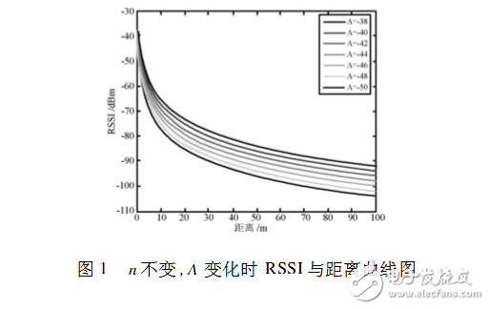

http://www.elecfans.com/uploads/allimg/171120/2755783-1G12011353O93.png

# Direction of radio signal

## Direction Finding

By using SDR, we find a strength(dBm) of a signal. Strength of a signal is in dBm (decibel millliwatts) is a unit of level used to indicate that a power level is expressed in decibels(dB) with reference to mill watt (mW). Every time when we move towards the direction of signal transmitter it gives us a high value in dBm and vice versa in other directions. Signal transmitter works like a burning candle which glows in all direction equally, signal transmitter transmits signal in all directions unless it is not a unidirectional antenna. It works as shown in figure below.

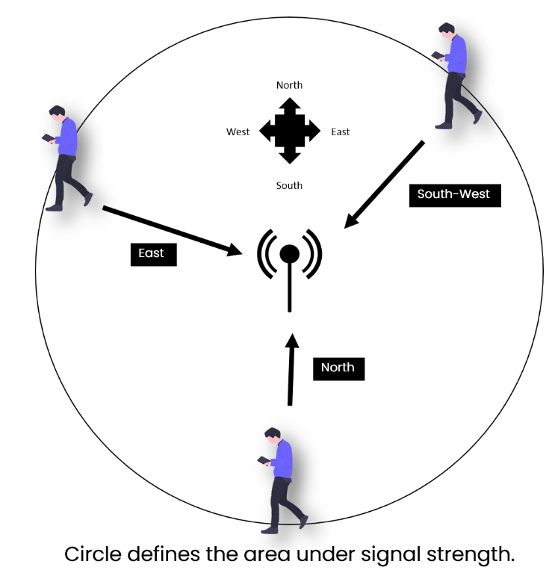

We use a simple and common mobile approach to find direction from distance position.

At different locations signal strength is different, we have to move to the direction of increasing signal strength. We also developed an android app for that which will indicate you the correct direction of transmitter.

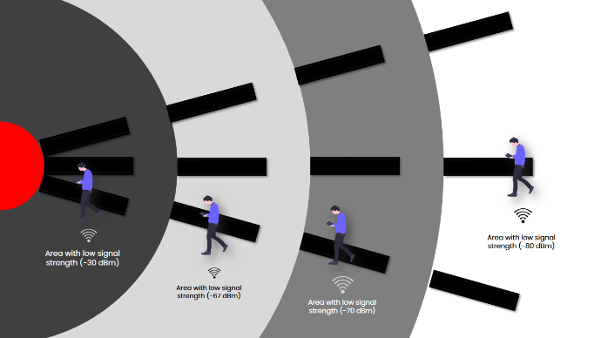

Range of weak signal to the best signal lies in the given order.

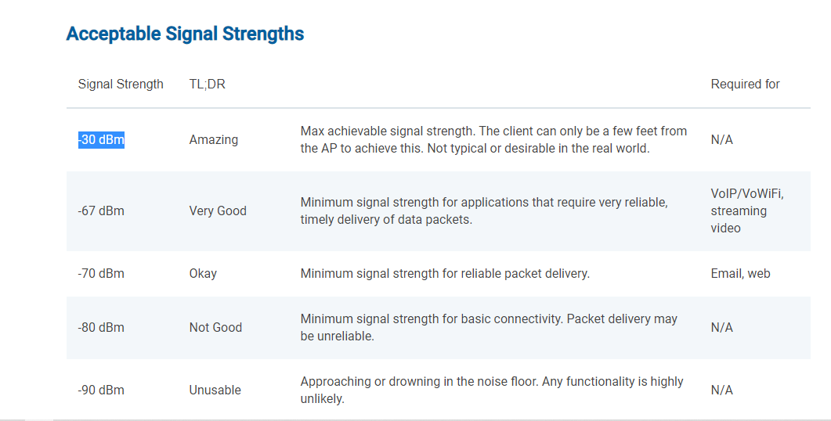

## Intersacting signal range area

As we imagine a signal strength circle, In case a user intersect the circle instead of reaching to the transmitter, we will get notification on our android app. It is done by revalidating signal strength and comparing its value with previous values,

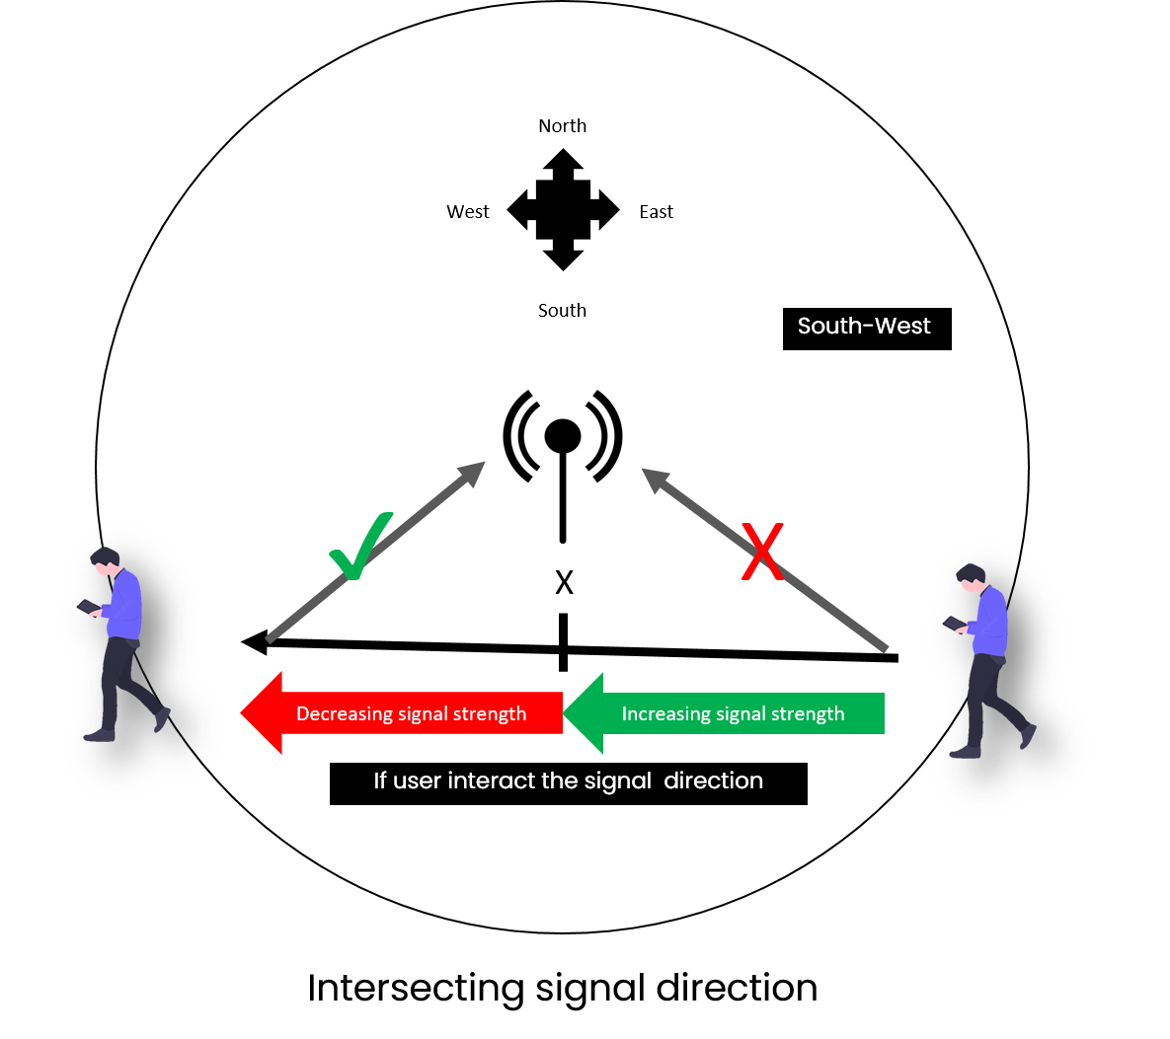

According to figure, left side of X or red arrow shows the decrease in the strength of signal and right side of the X or green arrow shows the increasing strength of a signal. X is a point from where mobile device have to move to different directions.

## Algorithmic and calculation in signal direction detection

Let’s take S1 as signal strength and S2 as last signal strength. We will use the following function to make the changes in directions.

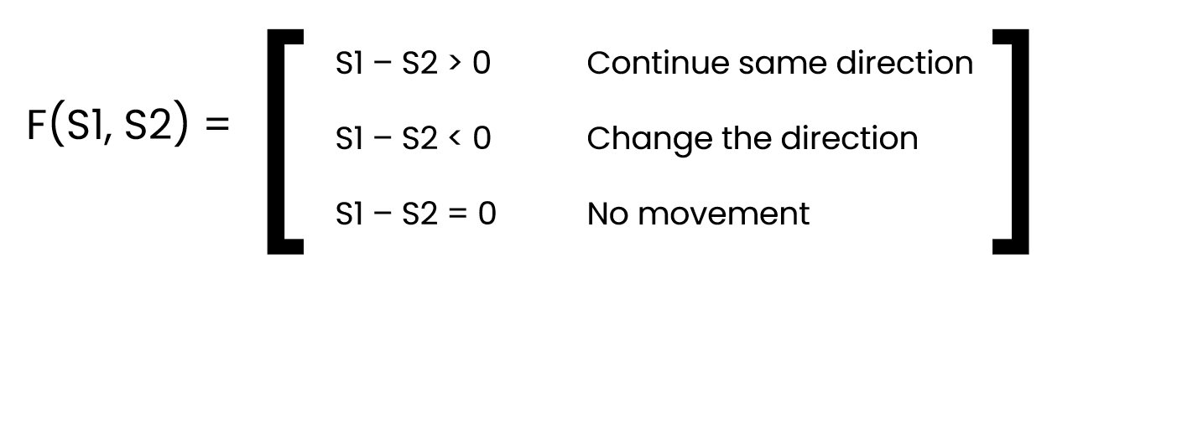

In the above figure, F(S1, S2) is a function which takes two integers as a current strength and previous strength. If (S1-S2) is greater than 0 it means increase in signal strength and user is going in correction direction but if (S1-S2) is less than 0 or negative, it means user is moving in wrong direction they need to change their direction to be on correct path. When mobile device moves from low signal to high signal, app will acknowledge with positive feedback and high to low signal, app will acknowledge with negative signal. If user follow increasing signal continuously, area for higher signal strength is small. Following the same user will reach near the signal transmitter.

# distance of radio signal

**Configuration of Transmitter & Receiver**

Radio signal distance is the distance between transmitter and receiver, it is can be determined by analysing radio frequency, wavelength and power of antenna.

Let’s consider a frequency F and speed of light C and find the wavelength from the following formula

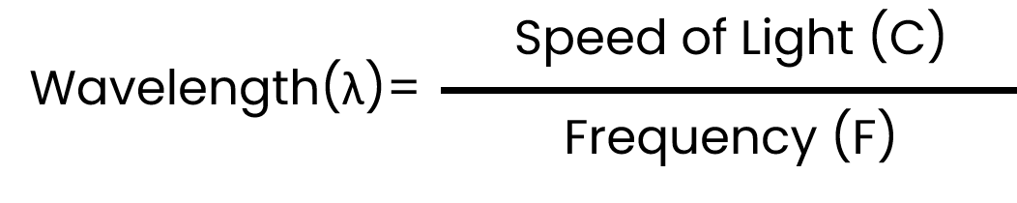

Now, from the wavelength, we find the height of the antenna from the following formula.

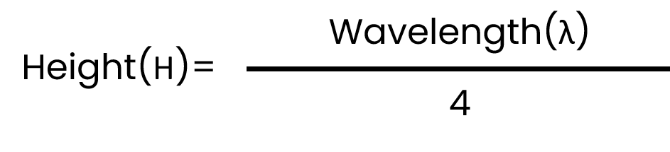

Now for a perfect sphere without any mountains, the distance *d*₁ from a transmitting antenna to the horizon or the line of sight, or radio horizon, can be calculated from the Pythagorean theorem

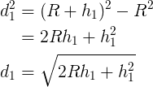

Where, *h*₁ is the transmitting antenna height (H) above the ground.

*R* = 6371 km is the mean Earth radius.

Note that the dimensions of *h*, *R* and *d* must be in the same units (e.g. meters or feet).

The equations above do not take into account the effect of the atmosphere on the propagation of VHF and UHF signals. Because of the refractive effects of atmospheric layers with different temperatures under normal conditions, RF signals propagate not in straight lines; they bend towards the Earth surface and can propagate over the horizon. If we consider the effect of the atmosphere on the propagation of RF signals, the Earth’s radius and hence the radio horizon can be increased by the factor of 4/3 or about 33%. Therefore, we can rewrite the formula above as

Formula

The distance *d*₂ from a receiving antenna to the horizon can be calculated using the same formulas.

## Formula

## These formulas do not take into account other factors influencing the RF signals propagation, for example, absorption, polarization, scattering, reflection, and diffraction

Hence d2 is the maximum distance (KM) from the transmitter to the receiver. As we move near to the transmitter, the android app we introduced will calculate the distance we travelled by using GPS. So, that it can give approximate value from anywhere in the radius of available signal strength of radio transmitter.

**Configuration and Calculation of Application**

**The effective antenna aperture/area** is a theoritical value which is a measure of how effective an antenna is at receiving power. The effective aperture/area can be calculated by knowing the gain of the receiving antenna.

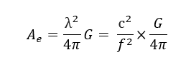

Where, Ae = Effective Antenna Aperture λ = Wavelength = c/f (where f = frequency, C = speed of light) G= Antenna gain (Linear Value) In the above formula, the Gain is assumed to be a linear value. However if Gain is in dB, then we could need to convert it from dB to a linear value to use in this formula. Alternatively, we could use the formula below. This assumes gain is in dB.

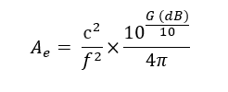

**The Friis transmission formula** is used in telecommunications engineering, equating the power at the terminals of a receive antenna as the product of power density of the incident wave and the effective aperture of the receiving antenna under idealized conditions given another antenna some distance away transmitting a known amount of power

Friis’ equation is

PR/PT = (AR*AT/ ((D^2)*(λ^2)))

Where

* PT is the power fed into the transmitting antenna input terminals.
* PR is the power available at receiving antenna output terminals.
* AR is the effective aperture area of the receiving antenna. (**The effective antenna aperture/area**)
* AT is the effective aperture area of the transmitting antenna. (**The effective antenna aperture/area**)
* D is the distance between antennas.
* λ is the wavelength of the radio frequency.
* PT and PR are in the same units.
* AR, AT, D and λ are in the same units.
* Distance d large enough to ensure a plane wave front at the receive antenna sufficiently approximated by d>=2a^2/ λ where a is the largest linear dimension of either of the antennas.

Replacing the effective antenna areas with their directivity (directivity is a parameter of an antenna or optical system which measures the degree to which the radiation emitted is concentrated in a single direction.) counterparts yields, as suggested by Friis' on using antenna effective area to characterize antenna performance over the contemporary use of directivity and gain metrics.

PR/PT = (DT*DR/ (λ/ (4πD)))

Where

* PT is the power fed into the transmitting antenna input terminals.
* PR is the power available at receiving antenna output terminals.
* DT is the isotropic directivity of the transmitting antenna in the direction of the receiving antenna. (https://en.wikipedia.org/wiki/Directivity)
* DR is the isotropic directivity of the receiving antenna in the direction of the transmitting antenna. https://en.wikipedia.org/wiki/Directivity
* D is the distance between antennas.
* λ is the wavelength of the radio frequency.
* PT and PR are in the same units.
* AR, AT, D and λ are in the same units.
* Distance d large enough to ensure a plane wave front at the receive antenna sufficiently approximated by d>=2a^2/ λ where a is the largest linear dimension of either of the antennas.
* The antennas are correctly aligned and have the same polarization.
* The antennas are in unobstructed free space, with no multipath.
* The bandwidth is narrow enough that a single value for the wavelength can be assumed.

In telecommunication, **the free-space path loss (FSPL)** is the attenuation of radio energy between the feed points of two antennas that results from the combination of the receiving antenna's capture area plus the obstacle-free, line-of-sight path through free space (usually air).

The free-space path loss (FSPL) formula derives from the Friis transmission formula (**The Friis transmission formula**). This states that in a radio system consisting of a transmitting antenna transmitting radio waves to a receiving antenna, the ratio of radio wave power received PR to the power transmitted PT is:

PR/PT = DT * DR * ((λ/4πD) ^ 2)

(As discussed in **The Friis transmission formula** section of this article.)

DT is the directivity of the transmitting antenna.

DR is the directivity of the receiving antenna.

λ is the signal wavelength.

D is the distance between the antennas

Distance between antennas D, must be large enough that the antennas are in the far field of each other (i.e. in range with each other) D >> λ.

**The free-space path loss** is the loss factor in this equation that is due to distance and wavelength, or in other words, the ratio of power transmitted to power received assuming the antennas are isotropic and have no directivity DT = DR = 1.

Signal will travel same in all the direction.

DT = 1

DR = 1

And PT/PR = FSPL (Free Space Signal Loss) or Power of signal transmit / Power of signal received.

1/FSPL = 1 * 1 * ((λ/4πD) ^ 2)

Or

FSPL = (4πD/ λ) ^ 2

Since the frequency of a radio wave F is equal to the speed of light C divided by the wavelength, the path loss can also be written in terms of frequency:

FSPL = (4πDF/ C) ^ 2

Where,

F = Frequency

C = Speed of Light

Unit of FSPL is db (decibel).

Now, we find the relation between FSPL and RSSI (discussed above), we get

FSPL as

PT/PR = (4πDF/ C) ^ 2 ------- (1)

Eq(1) can also be written as

FSPL(dB) = 10log10((4πDF/ C) ^ 2)

FSPL(dB) = 20log10((4πDF/ C))

FSPL(dB) = 20log10(D) + 20log10(F) – 147.55

FSPL = 20log10(D) + 20log10(F) – 147.55

PT/PR = 20log10 (D) + 20log10 (F) + K ----(2)

Where K = constant and value of K is

K = 92.45, D = KM and F = GHZ

K = -87.55, D = M and F = KHZ

K = -27.55, D = M and F = MHZ

K = 32.44, D = KM and F = MHZ

From above we get,

**D = 10 ^ (K – (20 * log10(F)) + (RSSI))/20)**

Where D is the distance between receiver and transmitter.

We are considering FSPL (PT/PR) = RSSI because

RSSI = Transmitter Power + FSPL + Receiver Gain + System Gain where we consider only Transmitter Power = 0, Receiver Gain = 0 and System Gain = 0. We get RSSI = FSPL.

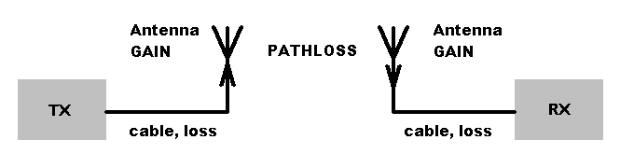

# Example

We also develop a prototype app to perform the same, we used Wifi router/Hotspot as a transmitter and mobile wifi as a receiver. It works on 2.4Ghz i.e. 2400Mhz. Output of the program is as follow.

We use

K = -27.55 (Constant for Mhz and meter)

F = 2400 Mhz

We get distance = 2.22 meter when RSSI is -47db.

Link for app to download :-

<https://drive.google.com/file/d/1r5wHPXUoSG54zy9b7Huyn6t6zdeNxG1i/view?usp=sharing>

Here is the some screenshots of app.

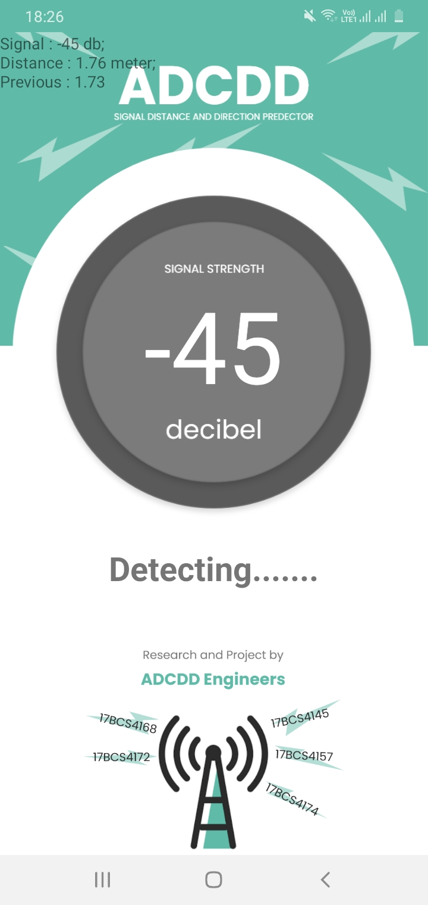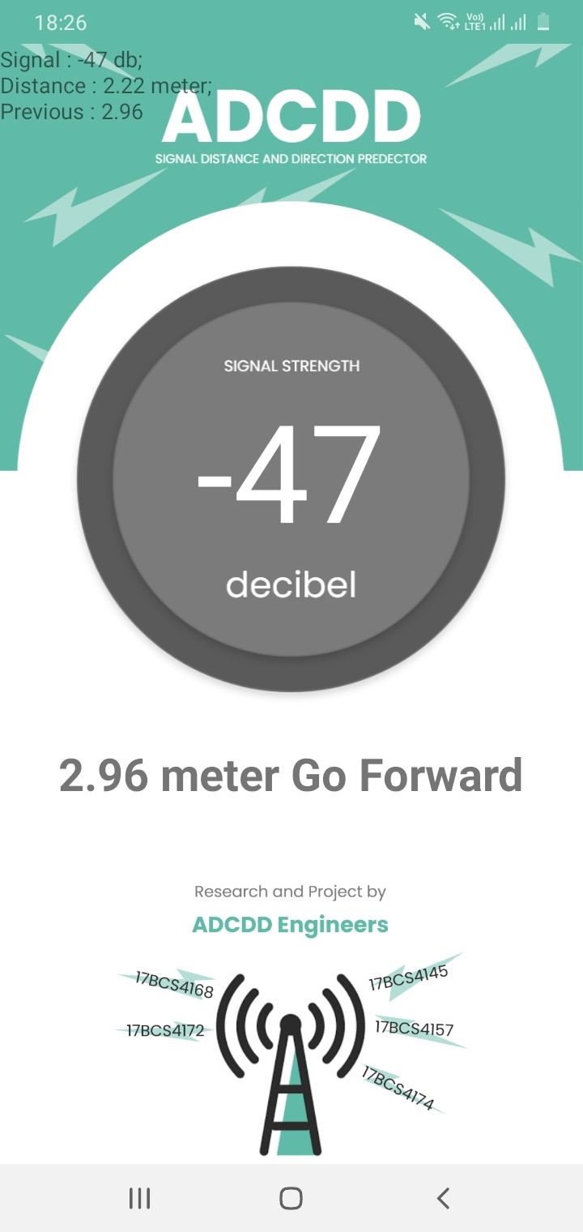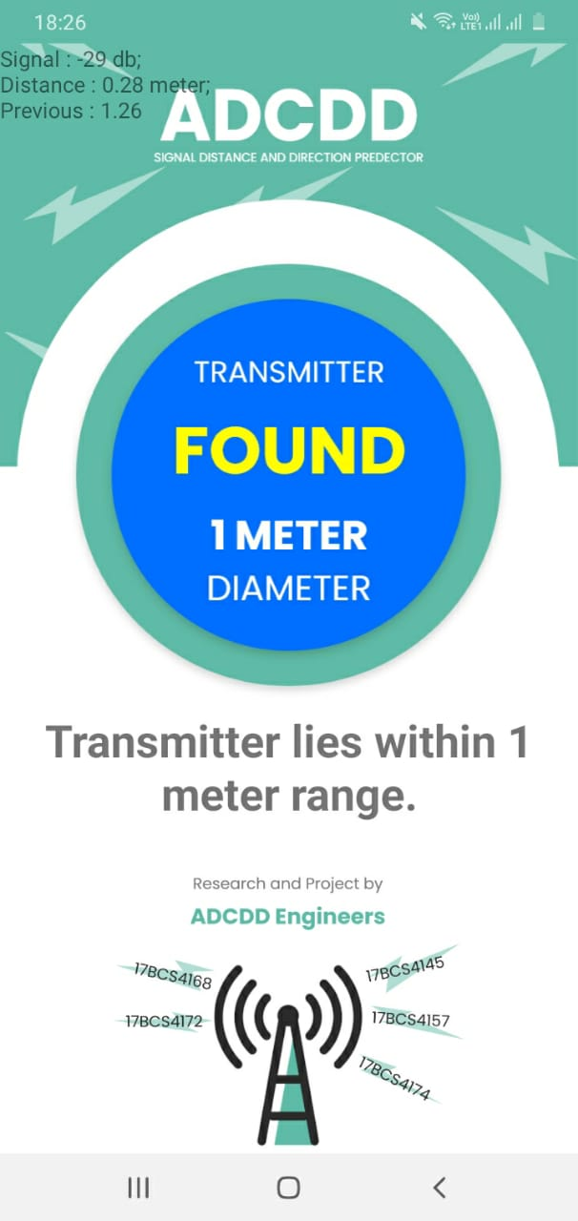

# Reference

1. <https://www.translatorscafe.com/unit-converter/en-US/calculator/radio-line-of-sight/>
2. <https://en.wikipedia.org/wiki/Signal_strength_in_telecommunications#:~:text=In%20telecommunications%2C%20particularly%20in%20radio,distance%20from%20the%20transmitting%20antenna>.
3. <http://www.elecfans.com/baike/wuxian/20171120582385.html>
4. <https://www.programmersought.com/article/55045845786/>
5. <https://cloud.tencent.com/developer/ask/123184>
6. <https://byjus.com/physics/propagation-constant/>
7. <https://en.wikipedia.org/wiki/DBm>
8. <https://en.wikipedia.org/wiki/Decibel>
9. <https://www.geeksforgeeks.org/running-user-interface-thread-in-android-using-kotlin/>
10. <https://developer.android.com/guide/background/threading>
11. <https://en.wikipedia.org/wiki/Free-space_path_loss#:~:text=In%20telecommunication%2C%20the%20free%2Dspace,free%20space%20(usually%20air)>.
12. <https://en.wikipedia.org/wiki/Friis_transmission_equation>
13. <https://www.everythingrf.com/rf-calculators/effective-antenna-aperture-calculator#:~:text=The%20effective%20antenna%20aperture%2Farea,gain%20of%20the%20receiving%20antenna>.
14. <https://www.sciencedirect.com/topics/engineering/isotropic-antenna#:~:text=The%20directivity%20of%20an%20antenna,is%201.64%20or%202.15%20dB>.
15. <https://en.wikipedia.org/wiki/Directivity>