#Example 1, code by Akshay Kripalani

x = c(1,2,3,4,5,5:10,5,6,7,8,9,10)

mean(x)

mfv(x)

median(x)

range=max(x)-min(x)

print(range)

var(x)

rawmoms = c(all.moments(x,order.max=4))

centralrawmoms=raw2central(rawmoms)

central2raw(centralrawmoms,eta=mean(x))

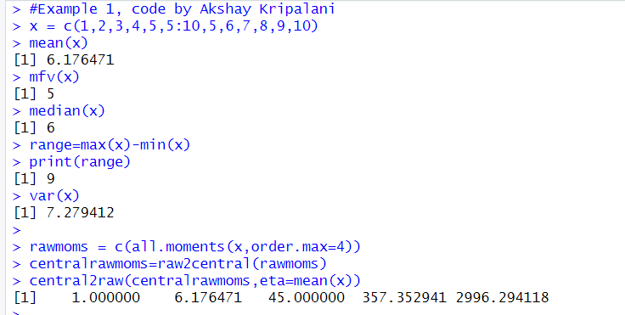

#Example 2, code by Akshay Kripalani

y = c(0,1,2,3)

p = c(0.1,0.2,0.3,0.4)

m0=1

m1=sum(y\*p)

m2=sum(y\*y\*p)

m3=sum(y\*\*3 \*p)

m4=sum(y\*\*4 \*p)

m = c(m0,m1,m2,m3,m4)

m

centralm = raw2central(m)

centralm

duration = faithful$eruptions

moment(duration,order=3,central=TRUE)

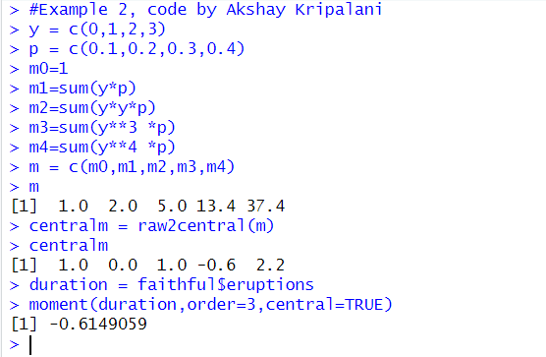

#Q1, code by Akshay Kripalani

x=c(0,1,2)

p=c(1/3,1/3,1/3)

r0=1

r1=sum(x\*p)

r1

r2=sum(x^2\*p)

r2

r3=sum(x^3\*p)

r3

r4=sum(x^4\*p)

r4

m=c(r0,r1,r2,r3,r4)

c=raw2central(m)

central2raw(c,eta=r1)

m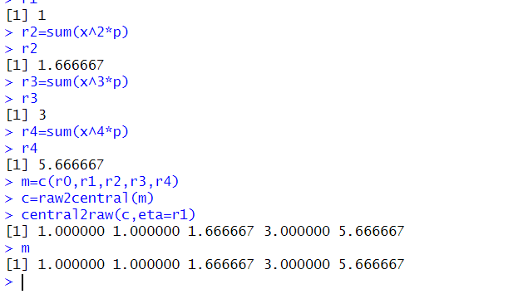

#Q2, code by Akshay Kripalani

a=3

m31=2

m32=10

m33=-30

rw1=a+m31

rw1

rw2=(2\*a\*rw1) - (a^2) + 10

rw2

rw3= (3\*a\*rw2) - (3\*a^2\*rw1) + (m33) + (a^3)

rw3

m=c(0,rw1,rw2,rw3)

mean= rw1 #mean= first r moment

centm=raw2central(m)

centm

variance=centm[2] # var is 2 central moment

variance

skewness=centm[3]/centm[2]^(3/2)

skewness

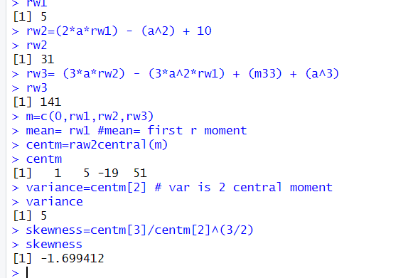

#Q3, code by Akshay Kripalani

x = c(0, 1, 2, 3)

p = c(1/4, 1/4, 1/4, 1/4)

m=mean(x)

m

e2=sum(x^2 \* p)

e2

variance= e2-mean^2

variance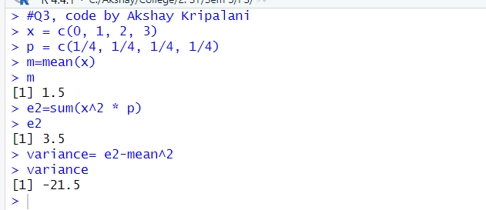

#Q4, code by Akshay Kripalani

x = c(-2, 3, 1)

p = c(1/3, 1/2, 1/6)

rw0= 1

rw1=sum(x\*p)

rw1

rw2=sum(x^2 \* p)

rw2

rw3=sum(x^3 \* p)

rw3

rw4=sum(x^4 \* p)

rw4

m=c(rw0,rw1,rw2,rw3,rw4)

c=raw2central(m)

central2raw(c,eta=rw1)

m