VISVESVARAYA TECHNOLOGICAL UNIVERSITY
“JnanaSangama”, Belgaum -590014, Karnataka.


LAB REPORT
on

OPERATING SYSTEMS

Submitted by

Akshay K S(1BM24CS029)

in partial fulfillment for the award of the degree of
BACHELOR OF ENGINEERING
in

COMPUTER SCIENCE AND ENGINEERING


B.M.S. COLLEGE OF ENGINEERING
(Autonomous Institution under VTU)

BENGALURU-560019
Feb-2026 to June-2026

B. M. S. College of Engineering,
Bull Temple Road, Bangalore 560019
(Affiliated To Visvesvaraya Technological University, Belgaum)
Department of Computer Science and Engineering


CERTIFICATE

This is to certify that the Lab work entitled “OPERATING SYSTEMS – 23CS4PCOPS” carried out by Akshay K S (1BM24CS029), who is Bonafide student of B. M. S. College of Engineering. It is in partial fulfilment for the award of Bachelor of Engineering in Computer Science and Engineering of the Visvesvaraya Technological University, Belgaum during the year Feb-2026 to June-2026.The Lab report has been approved as it satisfies the academic requirements in respect of a OPERATING SYSTEMS - (23CS4PCOPS) work prescribed for the said degree.

Seema Patil Dr. Kavitha Sooda
Assistant Professor Professor and Head
Department of CSE Department of CSE
BMSCE, Bengaluru BMSCE, Bengaluru

Index Sheet
Sl.  No. | Experiment Title | Page No.
1. | Write a C program to simulate the following CPU scheduling algorithm to  find turnaround time and waiting time.  a) FCFS  b) SJF  c) Priority  d) Round Robin | 1-3  4-9  10-15  16-19
2. | Write a C program to simulate multi-level queue scheduling algorithm considering the following scenario. All the processes in the system are divided into two categories – system processes and user processes. System processes are to be given higher priority than user processes. Use FCFS scheduling for the processes in each queue. | 20-23
3. | Write a C program to simulate Real-Time CPU Scheduling algorithms:  a) Rate- Monotonic  b) Earliest-deadline First  c) Proportional scheduling | 24-27  28-31  32-33
4. | Write a C program to simulate:  a) Producer-Consumer problem using semaphores.  b) Dining-Philosopher’s problem | 34-35  36-38
5. | Write a C program to simulate:  a) Bankers’ algorithm for the purpose of deadlock avoidance.  b) Deadlock Detection | 39-42  43-46
6. | Write a C program to simulate the following contiguous memory allocation techniques.  a) Worst-fit  b) Best-fit  c) First-fit | 47-50
7. | Write a C program to simulate page replacement algorithms.  a) FIFO  b) LRU  c) Optimal | 51-56

Course Outcomes
C01 | Apply the different concepts and functionalities of Operating System
C02 | Analyse various Operating system strategies and techniques
C03 | Demonstrate the different functionalities of Operating System.
C04 | Conduct practical experiments to implement the functionalities of Operating system.

Program-1
Question:
Write a C program to simulate the following CPU scheduling algorithm to find turnaround time and waiting time.
a) FCFS
b) SJF
c) Priority
d) Round Robin (Experiment with different quantum sizes for RR algorithm)

Code:
=>FCFS:
#include<stdio.h>

struct Process{
char name[10];
int AT,BT,CT,TAT,WT,RT;
}p[10];

int CPUTime=0;

void Input(int n){
for(int i=0;i<n;i++){
printf("Enter Process name , Arriving Time , Burst Time : ");
scanf("%s %d %d",&p[i].name,&p[i].AT,&p[i].BT);
}
}

void ReadyQueue(int size){
struct Process temp;
for(int i=0;i<size;i++){
for(int j=0;j<size-i-1;j++)
if(p[j].AT>p[j+1].AT){
temp=p[j];
p[j]=p[j+1];
p[j+1]=temp;
}
}
}

void Compute(int n){
for(int i=0;i<n;i++){
int startTime=CPUTime;
CPUTime=CPUTime+p[i].BT;
p[i].CT=CPUTime;
p[i].TAT=p[i].CT-p[i].AT;
p[i].WT=p[i].TAT-p[i].BT;
p[i].RT=startTime-p[i].AT;
}
}

void Output(int n){
float avgWT=0,avgTAT=0,avgRT=0;
printf("\nPID \t AT \t BT \t CT \t TAT \t WT \t RT");
for(int i=0;i<n;i++){
printf("\n%s \t %d \t %d \t %d \t %d \t %d \t %d",p[i].name,p[i].AT,p[i].BT,p[i].CT,p[i].TAT,p[i].WT,p[i].RT);
avgWT+=p[i].WT;
avgTAT+=p[i].TAT;
avgRT+=p[i].RT;
}
avgWT/=n;
avgTAT/=n;
avgRT/=n;
printf("\nAverage WT : %.3f",avgWT);
printf("\nAverage TAT : %.3f",avgTAT);
printf("\nAverage RT : %.3f",avgRT);
}

int main(){
int n;
printf("Akshay KS\n1BM24CS029\n");
printf("Enter number of Processes : ");
scanf("%d",&n);

Input(n);
ReadyQueue(n);
Compute(n);
Output(n);
}

Output :
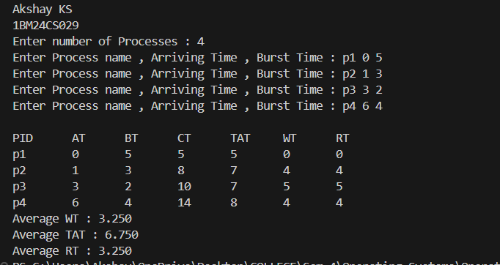

=>SJF:
#include<stdio.h>

struct Process{
char name[10];
int AT,BT,CT,TAT,WT,RT;
}p[10];

void Input(int n){
for(int i=0;i<n;i++){
printf("Enter Process name , Arriving Time , Burst Time : ");
scanf("%s %d %d",&p[i].name,&p[i].AT,&p[i].BT);
}
}

void sort(int n){
struct Process temp;
for(int i=0;i<n;i++){
for(int j=0;j<n-i-1;j++)
if(p[j].AT>p[j+1].AT){
temp=p[j];
p[j]=p[j+1];
p[j+1]=temp;
}
}
}

void Output(int n){
float avgWT=0,avgTAT=0,avgRT=0;
printf("\nPID \t AT \t BT \t CT \t TAT \t WT \t RT");
for(int i=0;i<n;i++){
printf("\n%s \t %d \t %d \t %d \t %d \t %d \t %d",p[i].name,p[i].AT,p[i].BT,p[i].CT,p[i].TAT,p[i].WT,p[i].RT);
avgWT+=p[i].WT;
avgTAT+=p[i].TAT;
avgRT+=p[i].RT;
}
avgWT/=n;
avgTAT/=n;
avgRT/=n;
printf("\nAverage WT : %.3f",avgWT);
printf("\nAverage TAT : %.3f",avgTAT);
printf("\nAverage RT : %.3f",avgRT);
}

void SJF(int n){
Input(n);
sort(n);
int CPUTime=0;
int completed[10]={0};
int done=0;
while(done!=n){
int idx=-1,minBT=99999;
for(int i=0;i<n;i++){
if(!completed[i] && p[i].AT <= CPUTime){
if(p[i].BT < minBT){
minBT = p[i].BT;
idx = i;
}
}
}
if(idx == -1){
CPUTime++;
continue;
}
int startTime=CPUTime;
CPUTime=CPUTime+p[idx].BT;
p[idx].CT=CPUTime;
p[idx].TAT=p[idx].CT-p[idx].AT;
p[idx].WT=p[idx].TAT-p[idx].BT;
p[idx].RT=startTime-p[idx].AT;
completed[idx]=1;
done++;
}

Output(n);

}

int main(){
int n;
printf("Akshay KS\n1BM24CS029\n");
printf("Enter number of Processes : ");
scanf("%d",&n);
SJF(n);
}

Output :

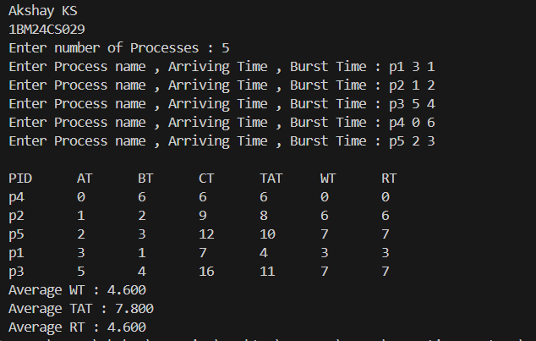

=>SRTF:
#include<stdio.h>

struct Process{
char name[10];
int AT,BT,CT,TAT,WT,RT,remaining,start;
}p[10];

void Input(int n){
for(int i=0;i<n;i++){
printf("Enter Process name , Arriving Time , Burst Time : ");
scanf("%s %d %d",&p[i].name,&p[i].AT,&p[i].BT);
p[i].remaining=p[i].BT;
}
}

void sort(int n){
struct Process temp;
for(int i=0;i<n;i++){
for(int j=0;j<n-i-1;j++)
if(p[j].AT>p[j+1].AT){
temp=p[j];
p[j]=p[j+1];
p[j+1]=temp;
}
}
}

void Output(int n){
float avgWT=0,avgTAT=0,avgRT=0;
printf("\nPID \t AT \t BT \t CT \t TAT \t WT \t RT");
for(int i=0;i<n;i++){
printf("\n%s \t %d \t %d \t %d \t %d \t %d \t %d",p[i].name,p[i].AT,p[i].BT,p[i].CT,p[i].TAT,p[i].WT,p[i].RT);
avgWT+=p[i].WT;
avgTAT+=p[i].TAT;
avgRT+=p[i].RT;
}
avgWT/=n;
avgTAT/=n;
avgRT/=n;
printf("\nAverage WT : %.3f",avgWT);
printf("\nAverage TAT : %.3f",avgTAT);
printf("\nAverage RT : %.3f",avgRT);
}

void SRTF(int n){
Input(n);
sort(n);
int CPUTime=0;
int completed[10]={0};
int done=0;

while(done!=n){
int idx=-1,min=9999;
for(int i=0;i<n;i++){
if(!completed[i] && p[i].AT<=CPUTime){
if(p[i].remaining < min){
min=p[i].remaining;
idx=i;
}
}
}

if(idx==-1){
CPUTime++;
continue;
}

if(p[idx].remaining == p[idx].BT){
p[idx].start = CPUTime;
}

p[idx].remaining--;
CPUTime++;
if(p[idx].remaining == 0){
p[idx].CT= CPUTime;
p[idx].TAT = p[idx].CT - p[idx].AT;
p[idx].WT = p[idx].TAT - p[idx].BT;
p[idx].RT = p[idx].start - p[idx].AT ;
done++;
completed[idx]=1;
}

}

Output(n);
}

int main(){
int n;
printf("Akshay KS\n1BM24CS029\n");
printf("Enter number of Processes : ");
scanf("%d",&n);
SRTF(n);
}

Output :

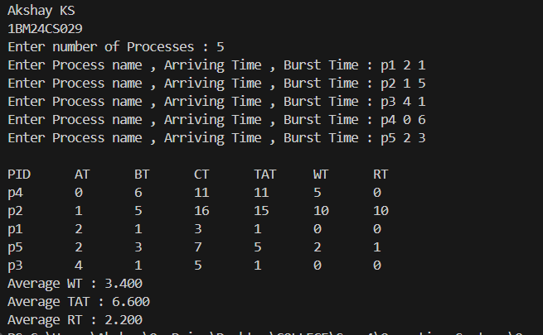

=>Priority Scheduling – Non Preemptive:
#include<stdio.h>

struct Process{
char name[10];
int AT,BT,CT,TAT,WT,RT;
int priority;
}p[10];

void Input(int n){
for(int i=0;i<n;i++){
printf("Enter Process name , Arriving Time , Burst Time , Priority : ");
scanf("%s %d %d %d",&p[i].name,&p[i].AT,&p[i].BT,&p[i].priority);
}
}

void sort(int n){
struct Process temp;
for(int i=0;i<n;i++){
for(int j=0;j<n-i-1;j++)
if(p[j].AT>p[j+1].AT){
temp=p[j];
p[j]=p[j+1];
p[j+1]=temp;
}
}
}

void Output(int n){
float avgWT=0,avgTAT=0,avgRT=0;
printf("\nPID \t AT \t BT \t P \t CT \t TAT \t WT \t RT");
for(int i=0;i<n;i++){
printf("\n%s \t %d \t %d \t %d \t %d \t %d \t %d \t %d",p[i].name,p[i].AT,p[i].BT,p[i].priority,p[i].CT,p[i].TAT,p[i].WT,p[i].RT);
avgWT+=p[i].WT;
avgTAT+=p[i].TAT;
avgRT+=p[i].RT;
}
avgWT/=n;
avgTAT/=n;
avgRT/=n;
printf("\nAverage WT : %.3f",avgWT);
printf("\nAverage TAT : %.3f",avgTAT);
printf("\nAverage RT : %.3f",avgRT);
}

void PriorityNP(int n){
Input(n);
sort(n);
int done=0,CPUTime=0,completed[10]={0};
while(done!=n){
int idx=-1,minP=999;
for(int i=0;i<n;i++){
if(!completed[i] && p[i].AT <= CPUTime){
if(p[i].priority < minP){
minP = p[i].priority;
idx = i;
}
}
}

if(idx == -1){
CPUTime++;
continue;
}

int startTime=CPUTime;
CPUTime=CPUTime+p[idx].BT;
p[idx].CT=CPUTime;
p[idx].TAT=p[idx].CT-p[idx].AT;
p[idx].WT=p[idx].TAT-p[idx].BT;
p[idx].RT=startTime-p[idx].AT;
completed[idx]=1;
done++;

}

Output(n);

}

int main(){
int n;
printf("Akshay KS\n1BM24CS029\n");
printf("Enter number of Processes : ");
scanf("%d",&n);
PriorityNP(n);
}

Output :

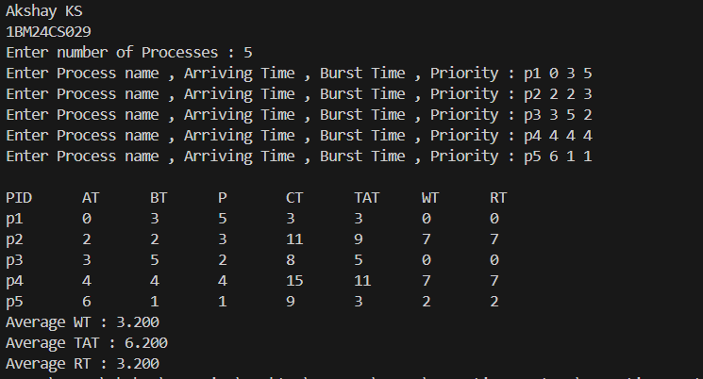

=>Priority Scheduling – Preemptive:
#include<stdio.h>

struct Process{
char name[10];
int AT,BT,CT,TAT,WT,RT,start,remaining;
int priority;
}p[10];

void Input(int n){
for(int i=0;i<n;i++){
printf("Enter Process name , Arriving Time , Burst Time , Priority : ");
scanf("%s %d %d %d",&p[i].name,&p[i].AT,&p[i].BT,&p[i].priority);
p[i].remaining=p[i].BT;
}
}

void sort(int n){
struct Process temp;
for(int i=0;i<n;i++){
for(int j=0;j<n-i-1;j++)
if(p[j].AT>p[j+1].AT){
temp=p[j];
p[j]=p[j+1];
p[j+1]=temp;
}
}
}

void Output(int n){
float avgWT=0,avgTAT=0,avgRT=0;
printf("\nPID \t AT \t BT \t P \t CT \t TAT \t WT \t RT");
for(int i=0;i<n;i++){
printf("\n%s \t %d \t %d \t %d \t %d \t %d \t %d \t %d",p[i].name,p[i].AT,p[i].BT,p[i].priority,p[i].CT,p[i].TAT,p[i].WT,p[i].RT);
avgWT+=p[i].WT;
avgTAT+=p[i].TAT;
avgRT+=p[i].RT;
}
avgWT/=n;
avgTAT/=n;
avgRT/=n;
printf("\nAverage WT : %.3f",avgWT);
printf("\nAverage TAT : %.3f",avgTAT);
printf("\nAverage RT : %.3f",avgRT);
}

void PriorityP(int n){
Input(n);
sort(n);
int done=0,CPUTime=0,completed[10]={0};
while(done!=n){
int idx=-1,minP=999;
for(int i=0;i<n;i++){
if(!completed[i] && p[i].AT <= CPUTime){
if(p[i].priority < minP){
minP = p[i].priority;
idx = i;
}
}
}

if(idx == -1){
CPUTime++;
continue;
}

if(p[idx].remaining == p[idx].BT){
p[idx].start = CPUTime;
}

p[idx].remaining--;
CPUTime++;
if(p[idx].remaining == 0){
p[idx].CT= CPUTime;
p[idx].TAT = p[idx].CT - p[idx].AT;
p[idx].WT = p[idx].TAT - p[idx].BT;
p[idx].RT = p[idx].start - p[idx].AT ;
done++;
completed[idx]=1;
}

}

Output(n);

}

int main(){
int n;
printf("Akshay KS\n1BM24CS029\n");
printf("Enter number of Processes : ");
scanf("%d",&n);
PriorityP(n);
}

Output :

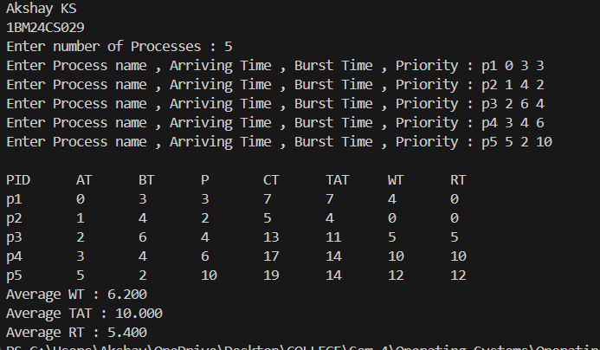

=>Round Robin :
#include<stdio.h>

struct Process{
char name[10];
int AT,BT,CT,TAT,WT,RT;
int start,remaining;
}p[10];

int queue[20];
int front=0,rear=-1;

void enqueue(int i){
rear++;
queue[rear]=i;
}

int dequeue(){
if(front>rear)
return -1;

int i=queue[front];
front++;
return i;
}

void Input(int n){
for(int i=0;i<n;i++){
printf("Enter Process name, Arrival Time, Burst Time: ");
scanf("%s %d %d",p[i].name,&p[i].AT,&p[i].BT);

p[i].remaining=p[i].BT;
}
}

void sort(int n){
struct Process temp;

for(int i=0;i<n;i++){
for(int j=0;j<n-i-1;j++){
if(p[j].AT > p[j+1].AT){
temp=p[j];
p[j]=p[j+1];
p[j+1]=temp;
}
}
}
}

void Output(int n){
float avgWT=0,avgTAT=0,avgRT=0;

printf("\nPID\tAT\tBT\tCT\tTAT\tWT\tRT");

for(int i=0;i<n;i++){
printf("\n%s\t%d\t%d\t%d\t%d\t%d\t%d",
p[i].name,p[i].AT,p[i].BT,p[i].CT,p[i].TAT,p[i].WT,p[i].RT);

avgWT+=p[i].WT;
avgTAT+=p[i].TAT;
avgRT+=p[i].RT;
}

printf("\nAverage WT : %.3f",avgWT/n);
printf("\nAverage TAT : %.3f",avgTAT/n);
printf("\nAverage RT : %.3f",avgRT/n);
}

void RoundRobin(int n,int timeQuant){

int CPUTime=0,completed=0;
int visited[10]={0};

Input(n);
sort(n);

while(completed < n){

for(int i=0;i<n;i++){
if(p[i].AT <= CPUTime && visited[i]==0){
enqueue(i);
visited[i]=1;
}
}

int idx = dequeue();

if(idx == -1){
CPUTime++;
continue;
}

if(p[idx].remaining == p[idx].BT)
p[idx].start = CPUTime;

int execTime = timeQuant;

if(p[idx].remaining < execTime)
execTime = p[idx].remaining;

CPUTime += execTime;
p[idx].remaining -= execTime;

for(int i=0;i<n;i++){
if(p[i].AT <= CPUTime && visited[i]==0){
enqueue(i);
visited[i]=1;
}
}

if(p[idx].remaining > 0){
enqueue(idx);
}
else{
p[idx].CT = CPUTime;
p[idx].TAT = p[idx].CT - p[idx].AT;
p[idx].WT = p[idx].TAT - p[idx].BT;
p[idx].RT = p[idx].start - p[idx].AT;

completed++;
}
}

Output(n);
}

int main(){
int n,timeQuant;
printf("Akshay KS\n1BM24CS029\n");
printf("Enter number of processes: ");
scanf("%d",&n);
printf("Enter Time Quantum: ");
scanf("%d",&timeQuant);

RoundRobin(n,timeQuant);

return 0;
}
Output :
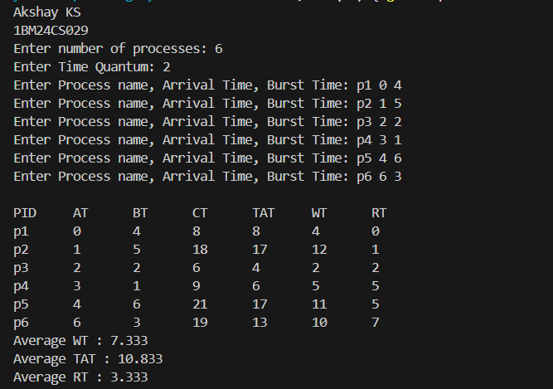

Program-2
Question:
Write a C program to simulate multi-level queue scheduling algorithm considering the following scenario. All the processes in the system are divided into two categories – system processes and user processes. System processes are to be given higher priority than user processes. Use FCFS scheduling for the processes in each queue.

Code:
#include <stdio.h>
#define MAX 10

typedef struct
{
int pid, at, bt, rt, ct, tat, wt, queue;
} Process;

int main()
{
Process p[MAX];
int n, i, time = 0, completed = 0;
int tq = 2;

printf("Enter number of processes: ");
scanf("%d", &n);

for (i = 0; i < n; i++)
{
printf("\nP%d\n", i + 1);
p[i].pid = i + 1;

printf("Arrival Time: ");
scanf("%d", &p[i].at);

printf("Burst Time: ");
scanf("%d", &p[i].bt);

printf("Queue (1-System, 2-User): ");
scanf("%d", &p[i].queue);

p[i].rt = p[i].bt;
}

printf("\nGantt Chart:\n");

while (completed < n)
{

int executed = 0;

for (i = 0; i < n; i++)
{
if (p[i].queue == 1 && p[i].rt > 0 && p[i].at <= time)
{

executed = 1;

if (p[i].rt > tq)
{
printf("P%d ", p[i].pid);
time += tq;
p[i].rt -= tq;
}
else
{
printf("P%d ", p[i].pid);
time += p[i].rt;
p[i].rt = 0;
p[i].ct = time;
completed++;
}
}
}

if (!executed)
{
for (i = 0; i < n; i++)
{
if (p[i].queue == 2 && p[i].rt > 0 && p[i].at <= time)
{

executed = 1;

printf("P%d ", p[i].pid);
p[i].rt--;
time++;

if (p[i].rt == 0)
{
p[i].ct = time;
completed++;
}

break;
}
}
}

if (!executed)
{
time++;
}
}

float total_tat = 0, total_wt = 0;

printf("\n\nPID\tAT\tBT\tCT\tTAT\tWT\n");

for (i = 0; i < n; i++)
{
p[i].tat = p[i].ct - p[i].at;
p[i].wt = p[i].tat - p[i].bt;

total_tat += p[i].tat;
total_wt += p[i].wt;

printf("P%d\t%d\t%d\t%d\t%d\t%d\n",
p[i].pid, p[i].at, p[i].bt,
p[i].ct, p[i].tat, p[i].wt);
}

printf("\nAverage TAT = %.2f", total_tat / n);
printf("\nAverage WT = %.2f\n", total_wt / n);

return 0;
}

Output :
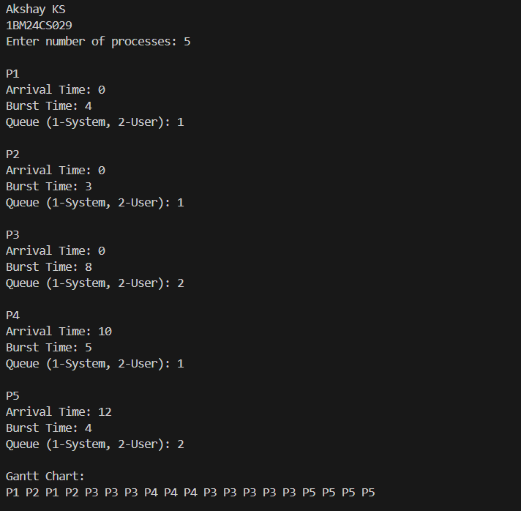

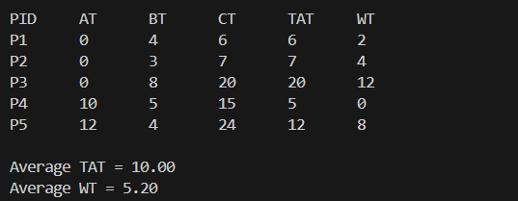

Program-3

Question:
Write a C program to simulate Real-Time CPU Scheduling algorithms:
a) Rate- Monotonic
b) Earliest-deadline First
c) Proportional scheduling

Code:
=> Rate- Monotonic:
#include<stdio.h>
#include<math.h>

struct Task{
char name[10];
int capacity,time;
int remaining,nextArrival;
}t[10];

int gcd(int a,int b){
while(b!=0){
int temp=b;
b=a%b;
a=temp;
}
return a;
}

int lcm(int a,int b){
int result=(a*b)/gcd(a,b);
return result;
}

void sort(int n){
struct Task temp;
for(int i=0;i<n;i++){
for(int j=0;j<n-i-1;j++){
if(t[j].time>t[j+1].time){
temp=t[j];
t[j]=t[j+1];
t[j+1]=temp;
}
}
}
}

void check(int n,float util,int hyperperiod){
float bound=n*(pow(2,(float)1/n)-1);
if( util<= bound){
printf("\n%.4f <= %.4f => true",util,bound);
printf("\nScheduling will occur for %dms",hyperperiod);
}else if(util <= 1){
printf("\nScheduling will occur as util obeys %.4f <= 1 => true and will occur for %dms",util,hyperperiod);
}else{
printf("\nNot schedulable");
}
}

int main(){
int n,completed=0,time=0,hyperperiod=1;
float util=0;
printf("Enter number of processes : ");
scanf("%d",&n);

for(int i=0;i<n;i++){
printf("Enter task name, capacity,time period : ");
scanf("%s %d %d",&t[i].name,&t[i].capacity,&t[i].time);

hyperperiod=lcm(hyperperiod,t[i].time);
util+= (float)t[i].capacity/t[i].time;
t[i].remaining=0;
t[i].nextArrival=0;
}

sort(n);
printf("\nLCM : %d",hyperperiod);
printf("\nRate Monotonic Scheduling:");
printf("\nPID \t Capacity \t Time Period");
for(int i=0;i<n;i++){
printf("\n%s \t %d \t %d",t[i].name,t[i].capacity,t[i].time);
}

check(n,util,hyperperiod);

while(time<hyperperiod){
int idx=-1;
for(int i=0;i<n;i++){
if(time==t[i].nextArrival){
t[i].remaining=t[i].capacity;
t[i].nextArrival+=t[i].time;
}
}

for(int i=0;i<n;i++){
if(t[i].remaining >0){
idx=i;
break;
}
}

if(idx!=-1){
printf("\n%dms onwards : Process %s running ",time,t[idx].name);
time++;
t[idx].remaining--;
}else{
printf("\n%dms onwards : CPU IdleTime ",time);
time++;
}
}

return 0;
}

Output :
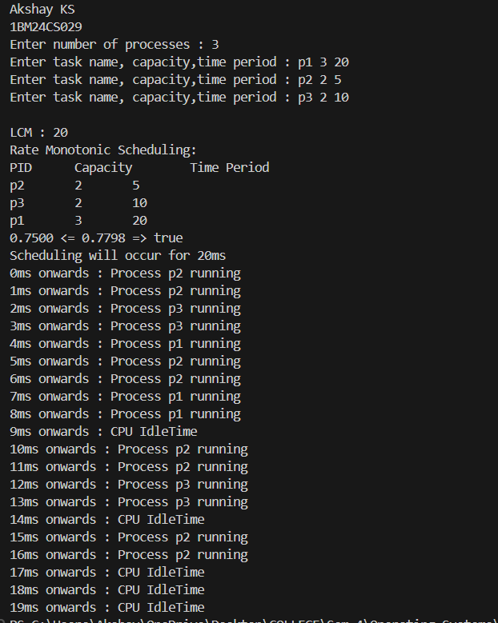

=> Earliest-deadline First:
#include<stdio.h>
#include<math.h>

struct Task{
char name[10];
int capacity,time,deadline;
int remaining,nextArrival;
}t[10];

int gcd(int a,int b){
while(b!=0){
int temp=b;
b=a%b;
a=temp;
}
return a;
}

int lcm(int a,int b){
int result=(a*b)/gcd(a,b);
return result;
}

void sort(int n){
struct Task temp;
for(int i=0;i<n;i++){
for(int j=0;j<n-i-1;j++){
if(t[j].time>t[j+1].time){
temp=t[j];
t[j]=t[j+1];
t[j+1]=temp;
}
}
}
}

void check(int n,float util,int hyperperiod){
float bound=n*(pow(2,(float)1/n)-1);
if( util<= bound){
printf("\n%.4f <= %.4f => true",util,bound);
printf("\nScheduling will occur for %dms",hyperperiod);
}else if(util <= 1){
printf("\nScheduling will occur as util obeys %.4f <= 1 => true and will occur for %dms",util,hyperperiod);
}else{
printf("\nNot schedulable");
}
}

int main(){
int n,completed=0,time=0,hyperperiod=1;
float util=0;
printf("Akshay KS\n1BM24CS029\n");
printf("Enter number of processes : ");
scanf("%d",&n);

for(int i=0;i<n;i++){
printf("Enter task name, capacity,time period,deadline: ");
scanf("%s %d %d %d",&t[i].name,&t[i].capacity,&t[i].time,&t[i].deadline);

hyperperiod=lcm(hyperperiod,t[i].time);
util+= (float)t[i].capacity/t[i].time;
t[i].remaining=0;
t[i].nextArrival=0;
}

sort(n);
printf("\nLCM : %d",hyperperiod);
printf("\nEarliest Deadline First Scheduling:");
printf("\nPID\tCapacity\tTime\tDeadline");
for(int i=0;i<n;i++){
printf("\n%s \t %d \t %d \t %d",t[i].name,t[i].capacity,t[i].time,t[i].deadline);
}

check(n,util,hyperperiod);

while(time<hyperperiod){
int idx=-1,min_dead=9999;
for(int i=0;i<n;i++){
if(time==t[i].nextArrival){
t[i].remaining=t[i].capacity;
t[i].nextArrival+=t[i].time;
}
}

for(int i=0;i<n;i++){
if(t[i].remaining > 0){
int abs_deadline = t[i].nextArrival - t[i].time + t[i].deadline;
if(abs_deadline < min_dead){
min_dead = abs_deadline;
idx = i;
}
}
}

if(idx!=-1){
printf("\n%dms onwards : Process %s running ",time,t[idx].name);
time++;
t[idx].remaining--;
if(t[idx].remaining==0) completed++;
}else{
printf("\n%dms onwards : CPU IdleTime ",time);
time++;
}
}

return 0;
}

Output :

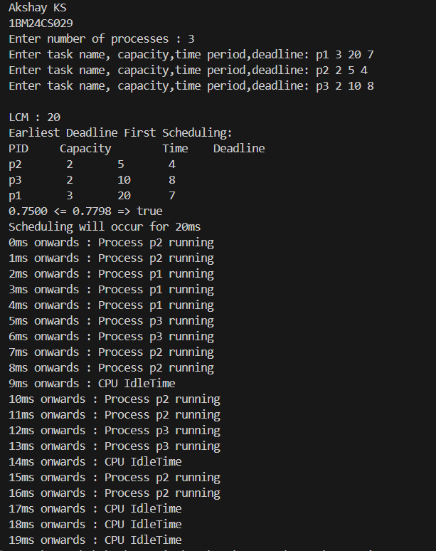

=> Proportional scheduling:
#include <stdio.h>
#include <stdlib.h>
#include <time.h>
typedef struct
{
char name[5];
int tickets;
} Process;

int main()
{
int n, total_tickets = 0;
float total_T = 0.0;
printf("Enter the number of Processes: ");
scanf("%d", &n);
Process p[n];
srand(time(NULL));
for (int i = 0; i < n; i++)
{
printf("\nProcess %d:\n", i + 1);
sprintf(p[i].name, "P%d", i + 1);
printf("Tickets: ");
scanf("%d", &p[i].tickets);
total_tickets += p[i].tickets;
total_T += p[i].tickets;
}
printf("\n--- Proportional Share Scheduling ---\n");
printf("Enter the Time Period for scheduling: ");
int m;

scanf("%d", &m);
for (int i = 0; i < m; i++)
{
int winning_ticket = rand() % total_tickets + 1;
int accumulated_tickets = 0;
int winner_index;
for (int j = 0; j < n; j++)
{
accumulated_tickets += p[j].tickets;
if (winning_ticket <= accumulated_tickets)
{
winner_index = j;
break;
}
}
printf("Tickets picked: %d, Winner: %s\n", winning_ticket,
p[winner_index].name);
}
for (int i = 0; i < n; i++)
{
printf("\nThe Process: %s gets %0.2f%% of Processor Time.\n", p[i].name,
((p[i].tickets / total_T) * 100));
}
return 0;
}
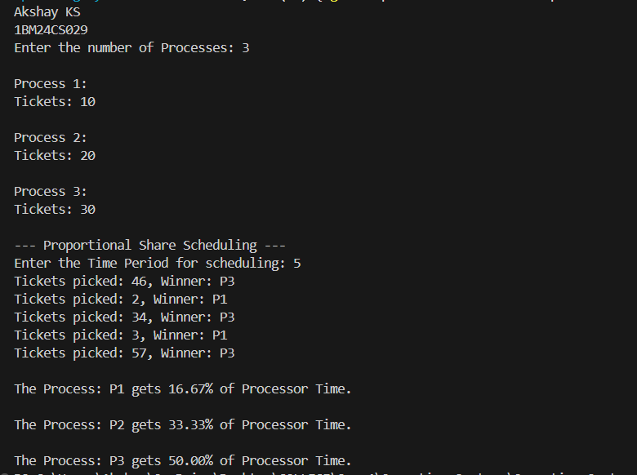
Output :

Program-4
Question:
Write a C program to simulate:
a) Producer-Consumer problem using semaphores.
b) Dining-Philosopher’s problem
Code:
=> Producer-Consumer problem :
#include <stdio.h>
#include <pthread.h>
#include <unistd.h>
#include <semaphore.h>
#define BUFFER_SIZE 5
int buffer[BUFFER_SIZE];
int in = 0, out = 0;
sem_t empty; // counts empty slots
sem_t full; // counts filled slots
pthread_mutex_t mutex; // for mutual exclusion

void *producer(void *arg)
{
int item, i = 0;
while (1)
{
item = i++; // produce an item (here just incrementing number)
sem_wait(&empty); // wait for empty slot
pthread_mutex_lock(&mutex); // enter critical section
buffer[in] = item;
printf("Produced: %d at buffer[%d]\n", item, in);
in = (in + 1) % BUFFER_SIZE;
pthread_mutex_unlock(&mutex); // leave critical section
sem_post(&full); // signal that new item is available
sleep(1); // simulate time to produce
}
}

void *consumer(void *arg)
{
int item;
while (1)
{
sem_wait(&full); // wait for filled slot
pthread_mutex_lock(&mutex); // enter critical section
item = buffer[out];
printf("Consumed: %d from buffer[%d]\n", item, out);
out = (out + 1) % BUFFER_SIZE;
pthread_mutex_unlock(&mutex); // leave critical section
sem_post(&empty); // signal that a slot is free
sleep(2); // simulate time to consume
}
}
int main()
{
pthread_t prod, cons;
printf("Akshay KS\n1BM24CS029\n");
sem_init(&empty, 0, BUFFER_SIZE);
sem_init(&full, 0, 0);
pthread_mutex_init(&mutex, NULL);
pthread_create(&prod, NULL, producer, NULL);
pthread_create(&cons, NULL, consumer, NULL);
pthread_join(prod, NULL);
pthread_join(cons, NULL);
sem_destroy(&empty);
sem_destroy(&full);
pthread_mutex_destroy(&mutex);
return 0;
}
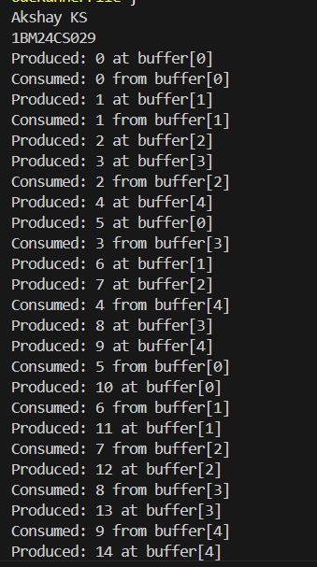
Output :
=> Dining-Philosopher’s problem :

#include <stdio.h>
#include <pthread.h>
#include <unistd.h>
#define N 5 // Number of philosophers
pthread_mutex_t forks[N]; // One mutex per fork
pthread_t philosophers[N];

void *philosopher(void *num)
{
int id = *(int *)num;
int left = id; // left fork index
int right = (id + 1) % N; // right fork index
while (1)
{
printf("Philosopher %d is thinking.\n", id);
sleep(1); // Thinking
// To avoid deadlock, philosophers with even id pick left then right,
// odd id pick right then left.
if (id % 2 == 0)
{
// Pick up left fork
pthread_mutex_lock(&forks[left]);
printf("Philosopher %d picked up left fork %d.\n", id, left);
// Pick up right fork

pthread_mutex_lock(&forks[right]);
printf("Philosopher %d picked up right fork %d.\n", id, right);
}
else
{ // Pick up right fork
pthread_mutex_lock(&forks[right]);
printf("Philosopher %d picked up right fork %d.\n", id, right); // Pick up left
pthread_mutex_lock(&forks[left]);
printf("Philosopher %d picked up left fork %d.\n", id, left);
}
// Eating
printf("Philosopher %d is eating.\n", id);
sleep(2); // Put down forks
pthread_mutex_unlock(&forks[left]);
pthread_mutex_unlock(&forks[right]);
printf("Philosopher %d put down forks %d and %d.\n", id, left, right);
}
return NULL;
}

int main()
{
int i;
int ids[N]; // Initialize forks (mutexes)
printf("Akshay KS\n1BM24CS029\n");
for (i = 0; i < N; i++)
{
pthread_mutex_init(&forks[i], NULL);
ids[i] = i;
}
// Create philosopher threads
for (i = 0; i < N; i++)

{
pthread_create(&philosophers[i], NULL, philosopher, &ids[i]);
} // Join threads (will never happen here, but good practice)
for (i = 0; i < N; i++)
{
pthread_join(philosophers[i], NULL);
}
// Destroy mutexes (unreachable here)
for (i = 0; i < N; i++)
{
pthread_mutex_destroy(&forks[i]);
}
return 0;
}

Output :

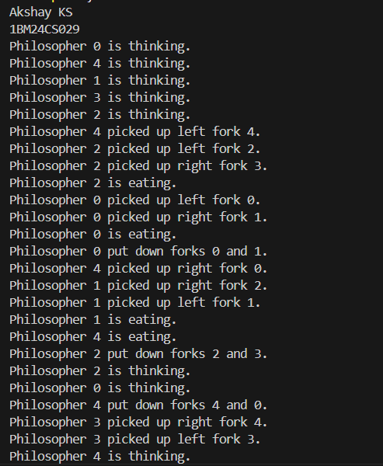

Program-5
Question:
Write a C program to simulate:
a) Bankers’ algorithm for the purpose of deadlock avoidance.
b) Deadlock Detection

Code:
=> Bankers’ algorithm:
#include<stdio.h>
#include <stdbool.h>

#define MAX_PROCESSES 10
#define MAX_RESOURCES 10

int main() {
int n, m;
printf("Akshay KS\n1BM24CS029\n");
printf("Enter number of processes: ");
scanf("%d", &n);

printf("Enter number of resource types: ");
scanf("%d", &m);

int allocation[MAX_PROCESSES][MAX_RESOURCES];
int max[MAX_PROCESSES][MAX_RESOURCES];
int need[MAX_PROCESSES][MAX_RESOURCES];
int available[MAX_RESOURCES];

// Input Allocation matrix
printf("\nEnter Allocation Matrix:\n");
for (int i = 0; i < n; i++) {
for (int j = 0; j < m; j++) {
scanf("%d", &allocation[i][j]);
}
}

// Input Max matrix
printf("\nEnter Max Matrix:\n");
for (int i = 0; i < n; i++) {
for (int j = 0; j < m; j++) {
scanf("%d", &max[i][j]);
}
}

// Input Available array
printf("\nEnter Available Resources:\n");
for (int j = 0; j < m; j++) {
scanf("%d", &available[j]);
}

// Calculate Need matrix
for (int i = 0; i < n; i++) {
for (int j = 0; j < m; j++) {
need[i][j] = max[i][j] - allocation[i][j];
}
}

bool finish[MAX_PROCESSES] = {false};
int safeSequence[MAX_PROCESSES];

int work[MAX_RESOURCES];

// Work = Available
for (int j = 0; j < m; j++) {
work[j] = available[j];
}

int count = 0;

while (count < n) {
bool found = false;
for (int i = 0; i < n; i++) {
if (finish[i] == false) {
bool canExecute = true;

// Check if Need <= Work
for (int j = 0; j < m; j++) {
if (need[i][j] > work[j]) {
canExecute = false;
break;
}
}

// If process can execute
if (canExecute) {

// Release allocated resources
for (int j = 0; j < m; j++) {
work[j] += allocation[i][j];
}

safeSequence[count] = i;
count++;

finish[i] = true;
found = true;
}
}
}

if (!found) {
break;
}
}

// Check if system is safe
if (count == n) {
printf("\nSystem is in SAFE state.\n");
printf("Safe Sequence: ");

for (int i = 0; i < n; i++) {
printf("P%d", safeSequence[i]);

if (i != n - 1) {
printf(" -> ");
}
}

printf("\n");
}
else {
printf("\nSystem is NOT in safe state.\n");
}

return 0;
}

Output :

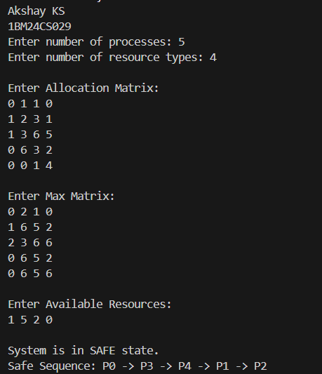

=> Deadlock Detection:
#include <stdio.h>
#include <stdbool.h>

#define MAX_PROCESSES 10
#define MAX_RESOURCES 10

int main() {
int n, m;

// n = number of processes
// m = number of resource types
printf("Akshay KS\n1BM24CS029\n");
printf("Enter number of processes: ");
scanf("%d", &n);

printf("Enter number of resource types: ");
scanf("%d", &m);

int allocation[MAX_PROCESSES][MAX_RESOURCES];
int request[MAX_PROCESSES][MAX_RESOURCES];
int available[MAX_RESOURCES];

// Input Allocation matrix
printf("\nEnter Allocation Matrix:\n");
for (int i = 0; i < n; i++) {
for (int j = 0; j < m; j++) {
scanf("%d", &allocation[i][j]);
}
}

// Input Request matrix
printf("\nEnter Request Matrix:\n");
for (int i = 0; i < n; i++) {
for (int j = 0; j < m; j++) {
scanf("%d", &request[i][j]);
}
}

// Input Available array
printf("\nEnter Available Resources:\n");
for (int j = 0; j < m; j++) {
scanf("%d", &available[j]);
}

bool finish[MAX_PROCESSES];
int work[MAX_RESOURCES];
int safeSequence[MAX_PROCESSES];

// Initialize work = available
for (int j = 0; j < m; j++) {
work[j] = available[j];
}

// Initialize finish[]
// If allocation is zero, process already finished
for (int i = 0; i < n; i++) {
bool zeroAllocation = true;

for (int j = 0; j < m; j++) {
if (allocation[i][j] != 0) {
zeroAllocation = false;
break;
}
}

finish[i] = zeroAllocation;
}

int count = 0;

while (1) {
bool found = false;

for (int i = 0; i < n; i++) {

if (finish[i] == false) {

bool canExecute = true;

// Check if Request <= Work
for (int j = 0; j < m; j++) {
if (request[i][j] > work[j]) {
canExecute = false;
break;
}
}

if (canExecute) {

// Process finishes and releases resources
for (int j = 0; j < m; j++) {
work[j] += allocation[i][j];
}

finish[i] = true;
safeSequence[count] = i;
count++;

found = true;
}
}
}

// No more processes can proceed
if (!found) {
break;
}
}

// Check deadlock
bool deadlock = false;

for (int i = 0; i < n; i++) {
if (finish[i] == false) {
deadlock = true;
break;
}
}

if (!deadlock) {
printf("\nNo Deadlock detected.\n");

printf("Safe Sequence: ");
for (int i = 0; i < count; i++) {
printf("P%d", safeSequence[i]);

if (i != count - 1) {
printf(" -> ");
}
}

printf("\n");
}
else {
printf("\nDeadlock detected.\n");

printf("Processes involved in deadlock: ");

for (int i = 0; i < n; i++) {
if (finish[i] == false) {
printf("P%d ", i);
}
}

printf("\n");
}

return 0;
}

Output :

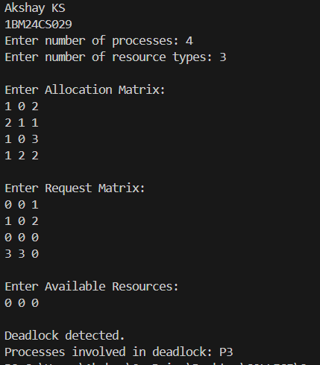

Program-6
Question:
Write a C program to simulate the following contiguous memory allocation techniques.
a) Worst-fit
b) Best-fit
c) First-fit

Code:
#include <stdio.h>

void firstFit(int blocks[], int m, int processes[], int n)
{
int allocated[10] = {0};

printf("\nFirst Fit:\n");
printf("Process No\tProcess Size\tBlock No\tBlock Size\n");

for(int i = 0; i < n; i++)
{
int flag = 0;

for(int j = 0; j < m; j++)
{
if(allocated[j] == 0 && blocks[j] >= processes[i])
{
printf("%d\t\t%d\t\t%d\t\t%d\n",
i + 1, processes[i], j + 1, blocks[j]);

allocated[j] = 1;
flag = 1;
break;
}
}

if(flag == 0)
{
printf("%d\t\t%d\t\tNot Allocated\n",
i + 1, processes[i]);
}
}
}

void bestFit(int blocks[], int m, int processes[], int n)
{
int allocated[10] = {0};

printf("\nBest Fit:\n");
printf("Process No\tProcess Size\tBlock No\tBlock Size\n");

for(int i = 0; i < n; i++)
{
int best = -1;

for(int j = 0; j < m; j++)
{
if(allocated[j] == 0 && blocks[j] >= processes[i])
{
if(best == -1 || blocks[j] < blocks[best])
{
best = j;
}
}
}

if(best != -1)
{
printf("%d\t\t%d\t\t%d\t\t%d\n",
i + 1, processes[i], best + 1, blocks[best]);

allocated[best] = 1;
}
else
{
printf("%d\t\t%d\t\tNot Allocated\n",
i + 1, processes[i]);
}
}
}

void worstFit(int blocks[], int m, int processes[], int n)
{
int allocated[10] = {0};

printf("\nWorst Fit:\n");
printf("Process No\tProcess Size\tBlock No\tBlock Size\n");

for(int i = 0; i < n; i++)
{
int worst = -1;

for(int j = 0; j < m; j++)
{
if(allocated[j] == 0 && blocks[j] >= processes[i])
{
if(worst == -1 || blocks[j] > blocks[worst])
{
worst = j;
}
}
}

if(worst != -1)
{
printf("%d\t\t%d\t\t%d\t\t%d\n",
i + 1, processes[i], worst + 1, blocks[worst]);

allocated[worst] = 1;
}
else
{
printf("%d\t\t%d\t\tNot Allocated\n",
i + 1, processes[i]);
}
}
}

int main()
{
int blocks[10], processes[10];
int m, n;
printf("Akshay KS\n1BM24CS029\n");

printf("Enter number of memory blocks: ");
scanf("%d", &m);

printf("Enter sizes of %d memory blocks:\n", m);
for(int i = 0; i < m; i++)
{
scanf("%d", &blocks[i]);
}

printf("Enter number of processes: ");
scanf("%d", &n);

printf("Enter sizes of %d processes:\n", n);
for(int i = 0; i < n; i++)
{
scanf("%d", &processes[i]);
}

firstFit(blocks, m, processes, n);
bestFit(blocks, m, processes, n);
worstFit(blocks, m, processes, n);

return 0;
}

Output :

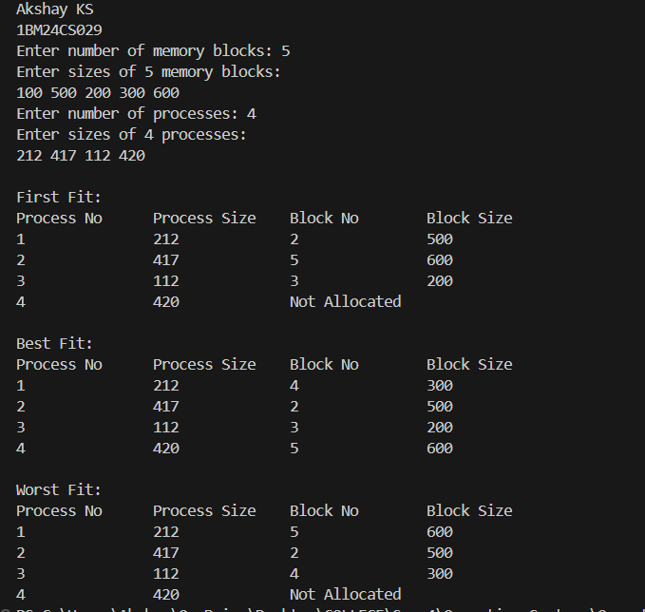

Program-7
Question:
Write a C program to simulate page replacement algorithms.
a) FIFO
b) LRU
c) Optimal

Code:
#include <stdio.h>

void printFrames(int frames[], int n,int page) {
printf("Page %d -> [",page);
for(int i = 0; i < n; i++) {
if(frames[i]== -1) continue;
printf("%d ", frames[i]);
}
printf("]\n");
}

void FIFO(int pages[], int n, int f) {
int frames[f], faults = 0, next = 0;

for(int i = 0; i < f; i++)
frames[i] = -1;

printf("\nFIFO:\n");

for(int i = 0; i < n; i++) {
int found = 0;

for(int j = 0; j < f; j++) {
if(frames[j] == pages[i]) {
found = 1;
break;
}
}

if(!found) {
frames[next] = pages[i];
next = (next + 1) % f;
faults++;
}

printFrames(frames, f,pages[i]);
}

printf("Page Faults = %d\n", faults);
}

void Optimal(int pages[], int n, int f) {
int frames[f], faults = 0;

for(int i = 0; i < f; i++)
frames[i] = -1;

printf("\nOptimal:\n");

for(int i = 0; i < n; i++) {
int found = 0;

for(int j = 0; j < f; j++) {
if(frames[j] == pages[i]) {
found = 1;
break;
}
}

if(!found) {
int pos = -1;

for(int j = 0; j < f; j++) {
if(frames[j] == -1) {
pos = j;
break;
}
}

if(pos == -1) {
int farthest = -1;

for(int j = 0; j < f; j++) {
int k;

for(k = i + 1; k < n; k++) {
if(frames[j] == pages[k]) {
if(k > farthest) {
farthest = k;
pos = j;
}
break;
}
}

if(k == n) {
pos = j;
break;
}
}
}

frames[pos] = pages[i];
faults++;
}

printFrames(frames, f,pages[i]);
}

printf("Page Faults = %d\n", faults);
}

void LRU(int pages[], int n, int f) {
int frames[f], time[f], faults = 0;

for(int i = 0; i < f; i++) {
frames[i] = -1;
time[i] = -1;
}

printf("\nLRU:\n");

for(int i = 0; i < n; i++) {
int found = 0;

for(int j = 0; j < f; j++) {
if(frames[j] == pages[i]) {
found = 1;
time[j] = i;
break;
}
}

if(!found) {
int pos = -1;

for(int j = 0; j < f; j++) {
if(frames[j] == -1) {
pos = j;
break;
}
}

if(pos == -1) {
pos = 0;

for(int j = 1; j < f; j++) {
if(time[j] < time[pos])
pos = j;
}
}

frames[pos] = pages[i];
time[pos] = i;
faults++;
}

printFrames(frames, f,pages[i]);
}

printf("Page Faults = %d\n", faults);
}

int main() {
int n, f;
printf("Akshay KS\n1BM24CS029\n");

printf("Enter number of pages: ");
scanf("%d", &n);

int pages[n];

printf("Enter reference string: ");
for(int i = 0; i < n; i++)
scanf("%d", &pages[i]);

printf("Enter number of frames: ");
scanf("%d", &f);

FIFO(pages, n, f);
Optimal(pages, n, f);
LRU(pages, n, f);

return 0;
}

Output :

