Transformer Architecture — Complete Step-by-Step Notes
From Tokens and Embeddings to Encoder, Decoder, Attention, and Final Output

1. What is a Transformer?
A Transformer is a deep-learning architecture mainly used for natural language processing tasks such as translation, text generation, summarization, question answering, and chatbots. Unlike RNNs and LSTMs, a Transformer does not process words one by one using recurrence. Instead, it uses attention to understand how words relate to each other.
The Transformer was introduced in the paper “Attention Is All You Need.” Its biggest idea is that each token can directly look at other tokens and learn relationships, even if they are far apart in the sentence.
2. Why Transformers were Needed
- RNNs process tokens sequentially, so training is slow.
- RNNs and even LSTMs can struggle with very long-distance relationships.
- Transformers handle long-range relationships more effectively using attention.
- Transformers allow much more parallel processing than recurrent models.
- This makes them very powerful for large datasets and large language models.
3. Big Picture of the Transformer Architecture
The original Transformer has two major parts:
- Encoder — reads and understands the input sequence.
- Decoder — uses that understanding and generates the output sequence.
Simple flow:
Input Sentence
↓
Tokenization
↓
Input Embedding + Positional Encoding
↓
N Encoder Layers
↓
Encoder Output
↓
Decoder receives shifted target sequence
↓
Output Embedding + Positional Encoding
↓
Masked Self-Attention
↓
Cross-Attention with Encoder Output
↓
Feed Forward
↓
Linear + Softmax
↓
Next Token / Output Probabilities
4. Step-by-Step Transformer Working Process
Step 1: Input Sequence (Tokens)
The process starts with a sentence or sequence of words. Example:
Input: "I love machine learning"
The sentence is first tokenized, which means it is broken into smaller units called tokens. Depending on the tokenizer, these tokens can be words, subwords, or smaller pieces.
Possible tokens: ["I", "love", "machine", "learning"]
These tokens are still text. Neural networks cannot directly work with text, so they must be converted into numerical form.
Step 2: Input Embedding
Each token is converted into a dense vector called an embedding. An embedding captures useful information about the token in numeric form.
I → [0.12, -0.40, 0.91, ...]
love → [0.05, 0.31, 0.22, ...]
machine → [0.66, -0.14, 0.57, ...]
learning → [0.24, 0.80, 0.10, ...]
Unlike one-hot encoding, embeddings are dense and can capture semantic similarity. For example, the embeddings of “cat” and “dog” may be closer than “cat” and “table.”
Step 3: Positional Encoding
Transformers process tokens largely in parallel, so they need extra information to know the order of the tokens. That information is added using positional encoding.
- Embedding tells what the token means.
- Positional encoding tells where the token appears in the sequence.
Concept:
Final Input Representation = Token Embedding + Positional Encoding
This is important because word order changes meaning. For example:
"Dog bites man" ≠ "Man bites dog"
Step 4: Input goes into the Encoder Stack
The original Transformer uses N encoder layers stacked one above another. Each encoder layer has two major sub-blocks:
- Multi-Head Self-Attention
- Feed Forward Neural Network
Each of these is wrapped with a residual connection and layer normalization.
5. Encoder Layer — Internal Working
Step 5A: Multi-Head Self-Attention in the Encoder
In self-attention, each token looks at other tokens in the same input sentence and learns which ones are important.
Example sentence:
"The cat drinks milk because it is thirsty."
When the model processes the token "it", it can attend strongly to "cat" because that word helps identify what "it" refers to.
Inside attention, each token is transformed into three vectors:
- Query (Q) — what this token is looking for
- Key (K) — what this token offers for matching
- Value (V) — the actual information carried by the token
Attention flow:
Query × Keyᵀ
↓
Similarity scores
↓
Scale by √d_k
↓
Softmax
↓
Attention weights
↓
Weighted sum of Values
↓
Context-aware output
This gives each token a new representation that includes information from other related tokens.
Step 5B: Why Multi-Head Attention?
Instead of using only one attention calculation, the Transformer uses multiple attention heads. Each head sees the same tokens but can learn different types of relationships.
- One head may learn subject-verb relationships.
- Another head may learn grammar-related relationships.
- Another head may learn long-distance context.
- Another head may focus on location or object relationships.
Important point:
Number of tokens ≠ Number of attention heads
For example, if a sentence has 20 tokens and the model has 8 heads, each of those 8 heads processes relationships among the same 20 tokens.
Step 5C: Add & Norm after Self-Attention
The output of multi-head attention is added back to the original input of that sub-layer. This is called a residual connection.
Output = Input + Attention_Output
Then layer normalization is applied. This helps training remain stable and allows deep networks to learn more effectively.
Step 5D: Feed Forward Network
After self-attention, each token representation is passed through a feed-forward neural network. This network is applied independently to each position.
The feed-forward network further transforms the token representation and helps the model learn richer patterns.
Step 5E: Add & Norm after Feed Forward
Again, the feed-forward output is added to the sub-layer input through a residual connection, and then normalized.
Output = Previous_Output + FeedForward_Output
Then apply LayerNorm
After one encoder layer is completed, its output goes to the next encoder layer. This continues for N encoder layers.
6. What comes out of the Encoder?
After passing through all encoder layers, we get the encoder output — a contextual representation of the full input sentence. This means each token now carries information about itself plus its relationship with the other tokens.
7. Decoder Side — Step-by-Step
Step 7A: Target Sequence (Shifted)
The decoder does not directly start with the final output. During training, it receives the target sequence shifted to the right.
Example:
Actual target sentence: "<start> I love NLP <end>"
Shifted decoder input: "<start> I love NLP"
Expected outputs: "I love NLP <end>"
This shifted input helps the decoder learn to predict the next token at every step.
Step 7B: Output Embedding
Just like on the encoder side, decoder input tokens are converted into embeddings.
Step 7C: Positional Encoding in Decoder
Positional encoding is also added on the decoder side so the model knows token order.
8. Decoder Layer — Internal Working
Step 8A: Masked Multi-Head Self-Attention
The first block in the decoder is masked self-attention. It is similar to self-attention, but with one crucial difference: the decoder must not look at future words.
Example target sequence:
"I love machine learning"
When predicting "machine", the decoder is allowed to look only at earlier tokens such as "I" and "love", and possibly the current position during training setup, but not at the future token "learning".
Why this mask is needed:
- Without masking, the model could cheat during training by seeing future words.
- Masking ensures true next-token prediction behavior.
Concept:
Position 1 can attend to: 1
Position 2 can attend to: 1,2
Position 3 can attend to: 1,2,3
Position 4 can attend to: 1,2,3,4
But never future positions.
Step 8B: Add & Norm
The output of masked self-attention is combined with its input through a residual connection and then normalized.
Step 8C: Multi-Head Cross-Attention
The second attention block in the decoder is cross-attention. Here the decoder looks at the encoder output.
Where do Q, K, and V come from?
- Query (Q) comes from the decoder.
- Key (K) comes from the encoder output.
- Value (V) comes from the encoder output.
This allows the decoder to ask: Which parts of the input sentence are most relevant for generating the next output word?
Example in translation:
Input: "I love Python"
Output: "J'aime Python"
When generating the word related to "love", the decoder can attend to the encoded representation of the input word "love".
Step 8D: Add & Norm
Again, residual connection and layer normalization are applied after cross-attention.
Step 8E: Feed Forward Network
After cross-attention, the decoder output passes through a feed-forward neural network, just like in the encoder.
Step 8F: Add & Norm
The feed-forward output is again combined with the previous value and normalized.
This completes one decoder layer. The output then passes to the next decoder layer, and this repeats for N decoder layers.
9. Final Output Stage
Step 9A: Linear Layer
After the final decoder layer, each token representation is passed through a linear layer. This layer maps the decoder output into a score for every possible word in the vocabulary.
Step 9B: Softmax
Softmax converts those scores into probabilities.
Raw scores → [2.1, 0.4, 5.8, 1.2, ...]
Softmax → [0.03, 0.01, 0.91, 0.05, ...]
The word with the highest probability is often chosen as the next token, depending on the decoding strategy.
Step 9C: Output Probabilities / Next Token Prediction
The model predicts the next token, appends it to the generated sequence, and repeats the decoder process until an end token is produced or the maximum length is reached.
10. Training Time vs Inference Time
Training time:
- The full target sequence is available.
- The decoder receives the shifted target sequence.
- Masking prevents the model from seeing future positions.
- The model learns to predict the next token at every position.
Inference time / generation time:
- The model starts with a start token or prompt.
- It predicts one token at a time.
- That new token is fed back as input for the next prediction.
- The process continues autoregressively.
11. Simple End-to-End Example
Suppose we want to translate:
English input: "I love AI"
Full flow:
- Tokenize the input sentence: "I", "love", "AI"
- Convert tokens into embeddings.
- Add positional encoding.
- Pass through encoder self-attention and feed-forward layers.
- Obtain encoder output.
- Give decoder the shifted target input, for example "<start> J'"
- Apply masked self-attention in decoder.
- Apply cross-attention with encoder output.
- Pass through decoder feed-forward network.
- Apply linear layer and softmax.
- Predict next token such as "aime".
- Feed it back into the decoder and continue until the sentence is complete.
12. Meaning of Important Terms in the Diagram
Term | Meaning
Input Sequence | Original sentence given to the encoder.
Input Embedding | Vector representation of each input token.
Positional Encoding | Position information added to embeddings.
Multi-Head Self-Attention | Each token attends to other tokens in the same sequence.
Masked Multi-Head Self-Attention | Decoder self-attention that blocks future tokens.
Cross-Attention | Decoder attends to encoder output.
Feed Forward | Dense neural network applied to each token position.
Add / Residual Connection | Adds previous input to current sub-layer output.
Norm | Layer normalization for stable training.
Linear | Projects decoder output to vocabulary-sized scores.
Softmax | Converts scores into output probabilities.
Mask | Prevents the decoder from seeing future tokens.
N× Encoder Layer | The encoder block is repeated N times.
N× Decoder Layer | The decoder block is repeated N times.
13. Encoder vs Decoder
Part | Main Job | Key Attention Type
Encoder | Understand the input sentence and create contextual representations. | Self-attention
Decoder | Generate the output sequence one token at a time. | Masked self-attention + cross-attention
14. Quick Revision Summary
- Tokens are the split pieces of the sentence.
- Embeddings convert tokens into dense numerical vectors.
- Positional encoding adds order information.
- Encoder uses multi-head self-attention and feed forward networks.
- Decoder uses masked self-attention, cross-attention, and feed forward networks.
- Q = what to search for, K = what can be matched, V = information to use.
- Masking prevents seeing future tokens in generation.
- Linear + Softmax produce output word probabilities.
- Multi-head attention means same tokens are studied through different learned perspectives.
- Residual connections and normalization make training stable.
15. Final One-Line Flow
Tokens → Embeddings → Positional Encoding → Encoder → Decoder → Linear → Softmax → Next Token
16. Transformer Architecture Diagram
The following image shows the full original Transformer encoder-decoder architecture. It is placed here after the explanation so you can connect each block in the diagram with the step-by-step notes above.
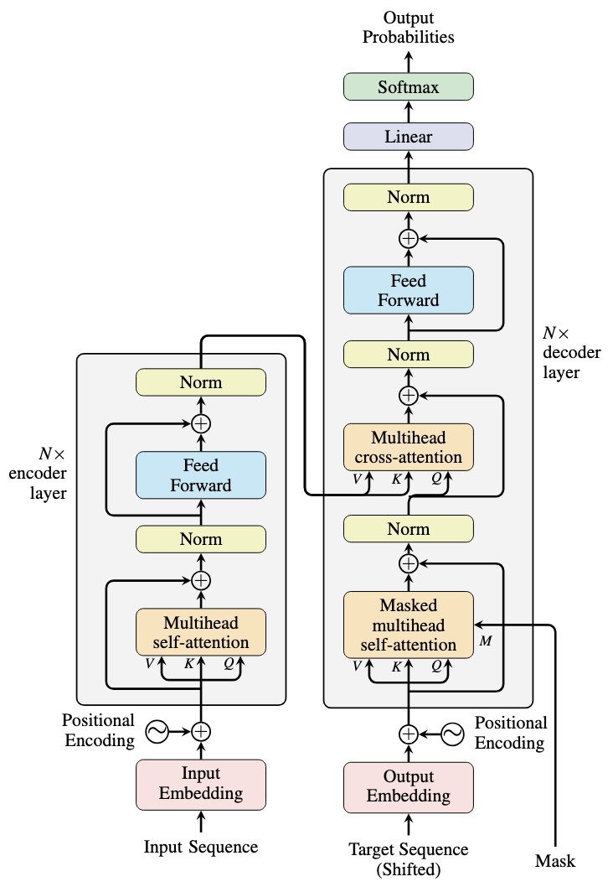
Figure: Transformer Architecture (Encoder–Decoder)

