TRANSFORMER ARCHITECTURE

1. Why Transformers Were Created: From RNNs to Attention
Before Transformers, sequence tasks such as language translation and text generation commonly used Recurrent Neural Networks (RNNs), followed by improved variants such as LSTMs and GRUs.

1.1 RNNs: What They Tried to Do
An RNN processes a sentence one token at a time and carries a hidden state forward. In theory, that hidden state can remember earlier information.
- Example: “The movie that I watched yesterday was amazing.” The model should remember “movie” when it reaches “was amazing.”
- RNN processing is sequential: word 1 → word 2 → word 3 → …

1.2 Why RNNs Were Not Enough
- Long-term dependency problem: information from far-away words can become difficult to preserve.
- Vanishing/exploding gradients can make learning long sequences difficult.
- Sequential processing is slow because later tokens depend on earlier computations, limiting parallel training.
- LSTMs/GRUs improved memory, but they still process sequences recurrently and can be expensive for very long contexts.
Important: RNNs did not completely “fail.” They worked well for many tasks, but their limitations motivated researchers to find better ways to model long-range relationships and train in parallel.

1.3 Attention Arrived
Attention allowed a model to directly focus on the most relevant parts of an input instead of compressing all information into one fixed-size state. This was especially useful in sequence-to-sequence translation systems.

1.4 2017: “Attention Is All You Need”
In 2017, researchers at Google introduced the Transformer architecture in the paper “Attention Is All You Need” by Vaswani et al. The major idea was to remove recurrence from the core architecture and rely primarily on attention mechanisms.
- Self-attention lets every token examine relationships with other tokens.
- Multi-head attention lets the model learn several kinds of relationships in parallel.
- Positional encoding supplies token-order information because there is no recurrence.
- Parallel processing makes training much more efficient than token-by-token recurrent computation.
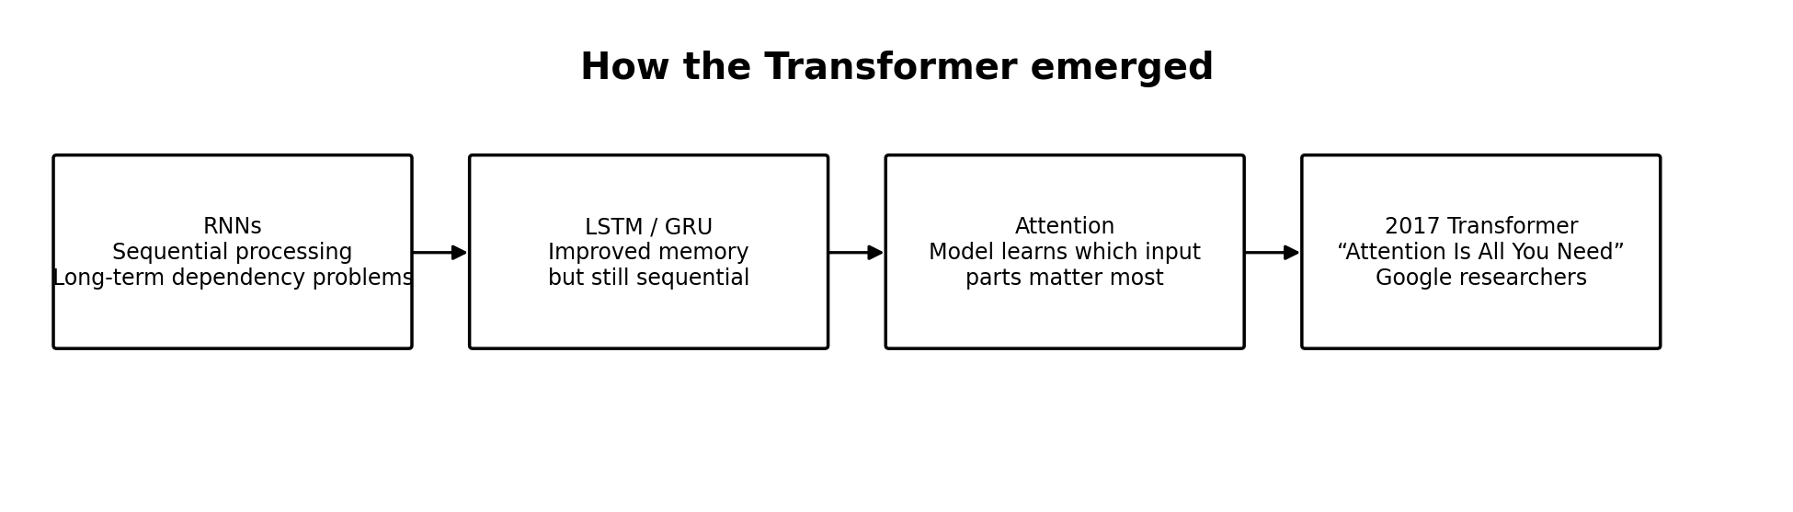

2. Big Picture: Original Transformer Architecture
The original Transformer was designed as an encoder-decoder model, especially for tasks such as machine translation.
Simple meaning: Encoder = understands/represents the input. Decoder = generates the output using what it has generated so far plus information from the encoder.

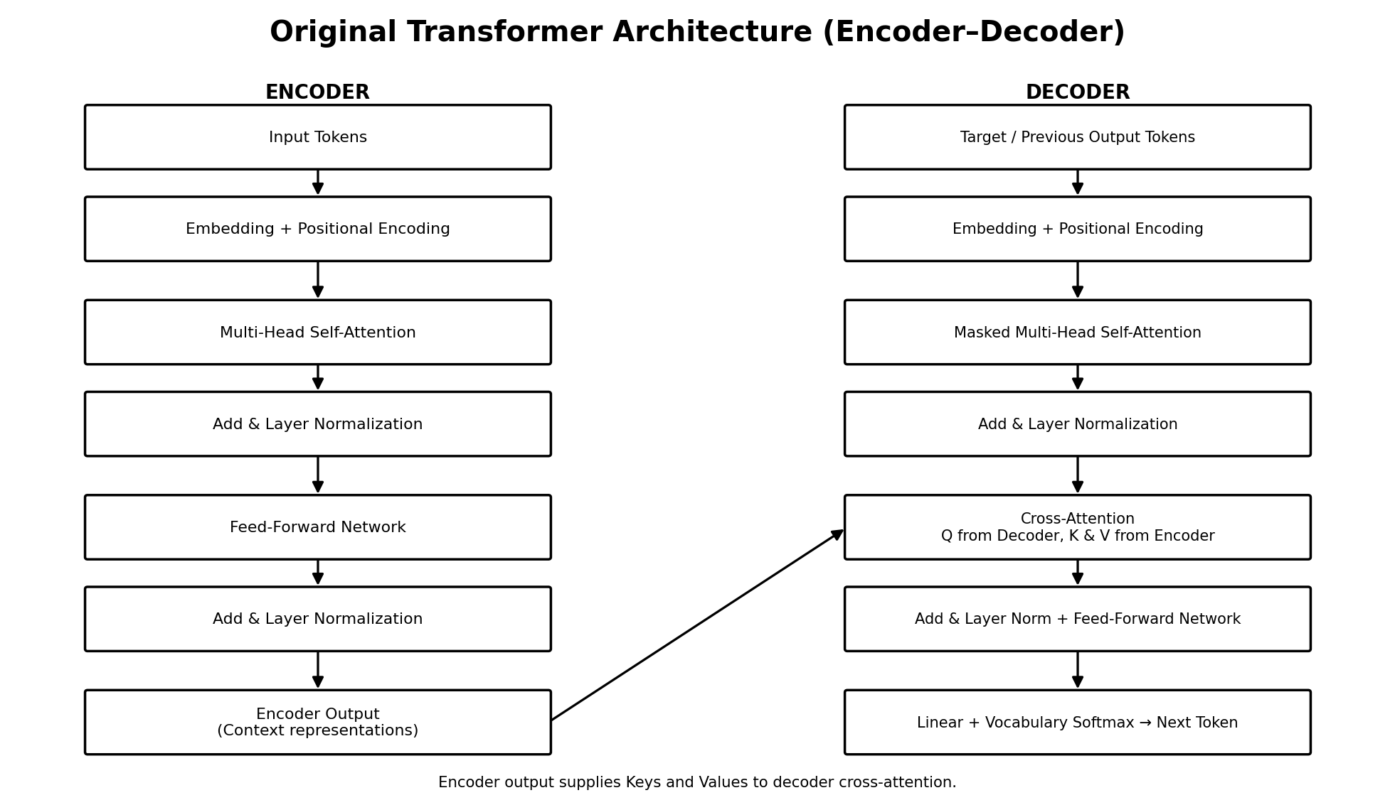

3. Step 1 — Tokenization, Embeddings, and Position

3.1 Tokenization
Text is split into tokens. A token can be a whole word, part of a word, punctuation, or another text unit depending on the tokenizer.
Example: “I love machine learning” → [I] [love] [machine] [learning]

3.2 Embeddings
Each token is converted into a numerical vector. The vector is a learned representation that lets the neural network perform mathematical operations on language.

3.3 Positional Encoding / Position Information
Self-attention does not automatically know whether a token came first, second, or tenth. Therefore, position information is added so the model can distinguish different token orders.
Example: “Dog bites man” and “Man bites dog” contain similar words, but their order changes the meaning. Position information helps the Transformer preserve that difference.

4. Step 2 — Self-Attention: Q, K, and V
Self-attention is the central mechanism of a Transformer. It allows a token to decide how much attention it should give to other tokens in the same sequence.

4.1 Query, Key, Value
Component | Easy Meaning | Purpose
Query (Q) | What am I looking for? | Comes from the current token representation.
Key (K) | What information do I contain? | Compared with a Query to calculate relevance.
Value (V) | What information should I contribute? | Weighted using attention scores and combined into the output.

4.2 Attention Calculation
The standard scaled dot-product attention formula is:
Attention(Q, K, V) = softmax(QKᵀ / √dₖ) V
1. Compare Query with Keys using a dot product to create similarity/relevance scores.
2. Scale the scores by √dₖ for numerical stability.
3. Apply Softmax to convert scores into normalized attention weights.
4. Use those weights to combine the Value vectors.
Critical distinction: The Softmax inside attention creates attention weights — it does NOT directly choose the final answer word. A separate final vocabulary Softmax is used later for next-token prediction.

4.3 Simple Word Example
Sentence: “Akshay went to the bank because he needed money.” When the representation for “bank” is formed, attention may assign higher weight to “money” than to unrelated tokens. That helps the model represent “bank” in a financial context rather than a river-bank context.

5. Step 3 — Multi-Head Attention
Instead of calculating attention only once, the Transformer performs attention through multiple heads. Each head has its own learned Q, K, and V projections and can learn a different relationship pattern.
- One head may focus on grammatical relationships.
- Another may focus on subject–verb relationships.
- Another may focus on long-range semantic relationships.
- The outputs of all heads are concatenated and projected into a combined representation.
Easy memory: Self-attention = one way of looking at relationships. Multi-head attention = several learned ways of looking at relationships at the same time.

6. Encoder: How the Input Is Understood
A typical encoder block contains multi-head self-attention followed by a feed-forward network. Residual connections and layer normalization are used around these sublayers.
1. Input tokens become embeddings + position information.
2. Multi-head self-attention lets each input token attend to all input tokens.
3. Add/Residual connection helps preserve the original signal and improves gradient flow.
4. Layer Normalization stabilizes the representation.
5. Feed-Forward Network transforms each token representation through learned nonlinear layers.
6. The encoder outputs contextual representations for the entire input sequence.
Encoder output: It is not a sentence answer. It is a set of context-rich numerical vectors representing the input.

7. Decoder: Masked Self-Attention
The decoder generates the output sequence. Its first attention sublayer is masked (causal) self-attention.

7.1 What Are “Future Words”?
During training, the complete correct target sentence is already stored in the training dataset. Therefore, without masking, a position could accidentally look at tokens that occur later in that target sentence. Those later tokens are called future tokens relative to the current position.
Example target: “I love machine learning.” When the model is learning the representation at “love,” it must not use “machine” or “learning” as information from the future.
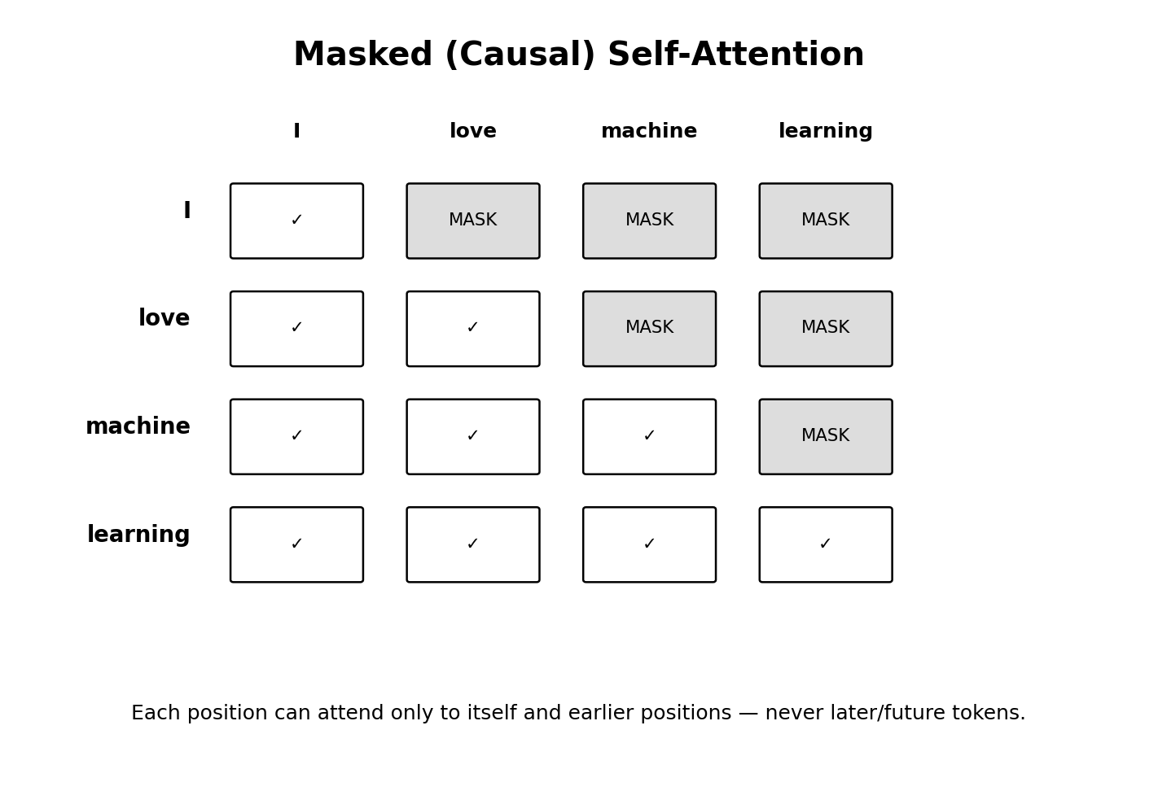

7.2 Why Masking Is Needed
- Prevents the decoder from cheating by using later target tokens during training.
- Matches real generation, where future output tokens do not exist yet.
- Makes next-token prediction autoregressive: each new token depends only on available context.
One sentence to remember: Masked attention means a token can attend to itself and earlier tokens, but not to tokens that come later.

8. Cross-Attention: Connecting Encoder and Decoder
After masked self-attention, the decoder uses cross-attention to retrieve useful information from the encoder output.
The direction matters: Query (Q) comes from the decoder. Key (K) and Value (V) come from the encoder output.

1. The decoder representation after masked self-attention becomes the Query.
2. The encoder representations provide Keys and Values.
3. Decoder Q is compared with encoder K values to obtain attention scores.
4. Softmax converts those scores into cross-attention weights.
5. The weights combine encoder V vectors, giving the decoder the input information most useful at that moment.
Example: Encoder input = “I love machine learning.” If the decoder is producing a translation and is currently deciding how to translate “machine,” its Query can attend strongly to the encoder representation associated with “machine.”
Correction to a common misunderstanding: Cross-attention does not directly compare “encoder weighted values” with “decoder weighted values.” It compares Decoder Query with Encoder Keys, then uses the resulting weights to combine Encoder Values.

9. Feed-Forward Network, Residual Connections, and Layer Normalization

9.1 Feed-Forward Network (FFN)
After attention, each token representation is passed through the same small neural network independently. This provides additional nonlinear transformation capacity.

9.2 Residual / Skip Connection
The input of a sublayer is added back to its output. This helps information and gradients flow through deep stacks of Transformer layers.

9.3 Layer Normalization
Layer normalization keeps activations well-scaled and helps training remain stable.

10. Final Output: Linear Layer + Vocabulary Softmax
After the decoder layers, the model must choose the next token. A linear projection converts the decoder representation into one score (logit) for every token in the vocabulary. A final Softmax converts those logits into probabilities.
Possible Next Token | Example Probability
network | 0.62
model | 0.17
system | 0.08
algorithm | 0.03
The system then chooses or samples a token according to its decoding strategy. The chosen token is appended to the sequence, and the generation process repeats.

11. Complete Worked Example — Original Encoder–Decoder Transformer
Task: Translate the input sentence “I love AI” into another language. The exact translation is not important here; the goal is to follow the architecture.
1. Encoder receives “I love AI,” tokenizes it, creates embeddings, and adds position information.
2. Encoder self-attention learns relationships among “I,” “love,” and “AI.” All input positions may attend to all other input positions.
3. Encoder produces context-rich vectors for the input.
4. During training, the decoder receives the target sequence shifted right. Masked self-attention prevents each target position from looking at later target tokens.
5. Cross-attention uses Decoder Q and Encoder K/V so the decoder can focus on relevant input information.
6. Decoder FFN and additional stacked layers refine the representation.
7. Linear + final vocabulary Softmax predicts the next target token.
8. The predicted token is appended, and the decoder repeats until an end token/stop condition is reached.

12. How This Relates to ChatGPT / GPT-Style Models
This is where it is important not to mix two architectures. The original Transformer in the 2017 paper is encoder–decoder. GPT-style language models are commonly described as decoder-only autoregressive Transformers using causal/masked self-attention.
Very important: Your human “query” or prompt is NOT the same as the mathematical attention Query (Q). The prompt is converted into tokens and hidden representations; Q, K, and V are learned projections created inside attention layers.

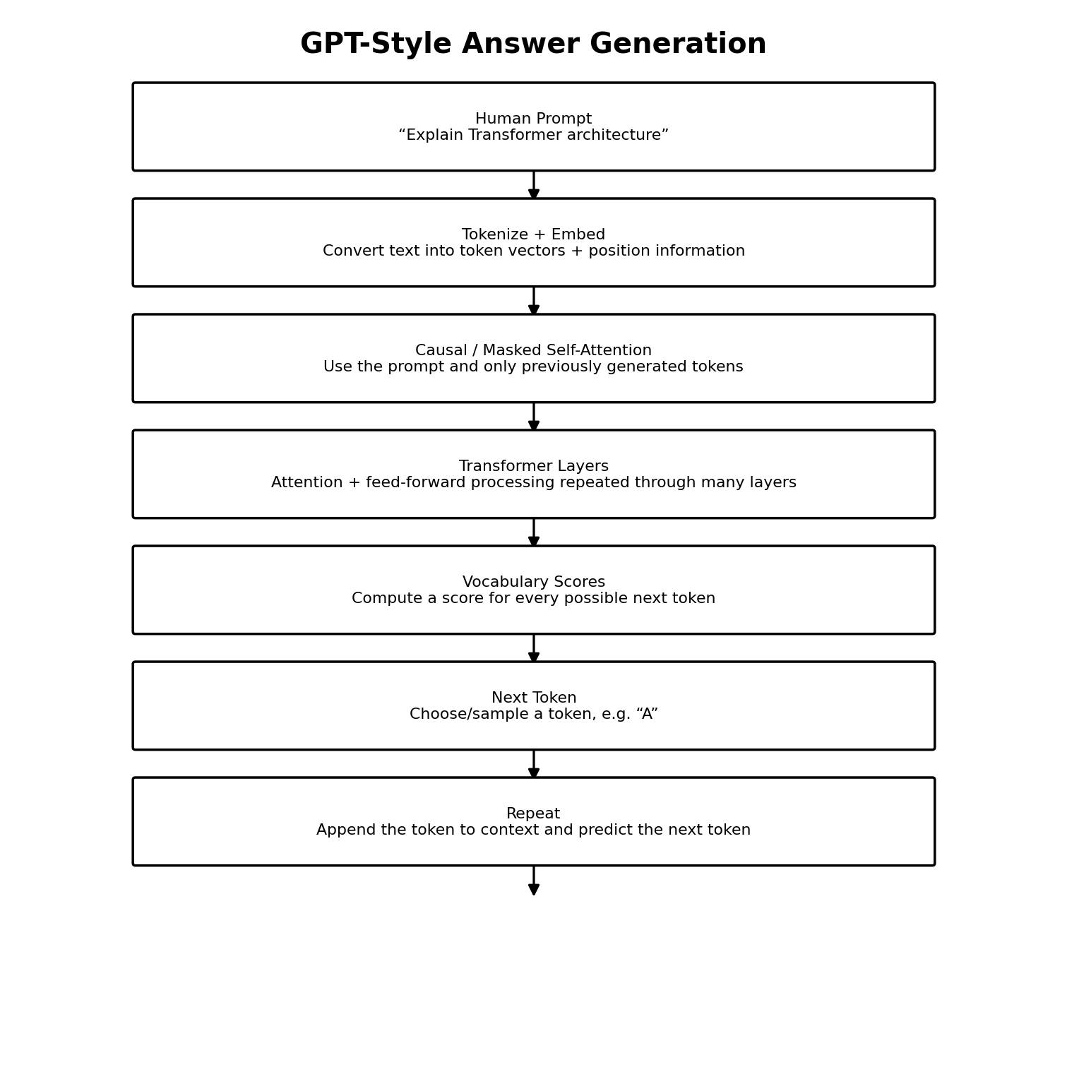

12.1 Human Question Example
Human asks: “Explain Transformer architecture.”
1. The prompt is tokenized and converted to vectors.
2. Causal/masked self-attention lets each position use the prompt and earlier tokens, not later future tokens.
3. After many Transformer layers, the model calculates vocabulary logits for the next token.
4. Suppose the next token is “A.” It is appended to the context.
5. Now the context becomes: “Explain Transformer architecture A”. The model predicts the next token, perhaps “Transformer.”
6. This repeats token by token until the answer is complete.
Simple GPT memory line: Prompt + previously generated tokens → causal attention → next-token probabilities → choose next token → append → repeat.

13. Do Not Confuse the Two Softmax Operations
Softmax | What It Converts | What It Produces
Attention Softmax | Q–K similarity scores | Attention weights showing how much one token should use other token Values.
Final Vocabulary Softmax | Vocabulary logits | Probabilities for possible next tokens.
Shortcut: Attention Softmax = “Where should I look?” Final Softmax = “Which token should I generate next?”

14. RNN vs Transformer — Quick Comparison
Feature | RNN / LSTM | Transformer
Processing | Primarily sequential | Highly parallel during training
Long-range relationships | Can be difficult over long sequences | Direct attention links between positions
Core memory mechanism | Hidden/recurrent state | Attention over token representations
Order information | Built into recurrence | Must be supplied through position information
Training scalability | Limited by sequential dependency | Generally scales better with parallel hardware

15. Quick Revision Notes
- RNNs process sequences recurrently; long dependencies and sequential computation motivated newer architectures.
- 2017 paper “Attention Is All You Need” introduced the Transformer.
- Original Transformer = Encoder + Decoder.
- Encoder self-attention: input tokens can attend to all input tokens.
- Decoder masked self-attention: target/generated positions cannot look at later tokens.
- Cross-attention: Decoder Q + Encoder K/V.
- Multi-head attention learns several relationship patterns in parallel.
- FFN adds nonlinear processing; residual connections and layer normalization help deep training.
- Attention Softmax creates attention weights; final vocabulary Softmax creates next-token probabilities.
- GPT-style generation: prompt + previous tokens → causal attention → predict next token → repeat.

16. 60-Second Explanation You Can Say
“Transformers were introduced to overcome important limitations of recurrent models such as slow sequential processing and difficulty capturing very long-range dependencies. In 2017, the paper “Attention Is All You Need” introduced an encoder-decoder architecture based mainly on self-attention. Tokens are converted into embeddings with position information, and self-attention uses Query, Key, and Value vectors to calculate which tokens are relevant to each other. Multi-head attention learns multiple relationship patterns. In the decoder, masked self-attention prevents the model from seeing future target tokens, and cross-attention lets the decoder retrieve relevant encoder information using decoder Queries and encoder Keys and Values. Finally, a linear layer and vocabulary Softmax predict the next token. GPT-style models use the same core Transformer idea but typically use decoder-only causal attention and generate answers one token at a time.””

17. References / Important Reading
- Vaswani, A. et al. (2017). “Attention Is All You Need.” Advances in Neural Information Processing Systems (NeurIPS/NIPS).
- DataCamp tutorial: “How Transformers Work.”
- For further study: self-attention, positional encoding, encoder-only models (BERT), decoder-only models (GPT), and encoder-decoder models (T5).

