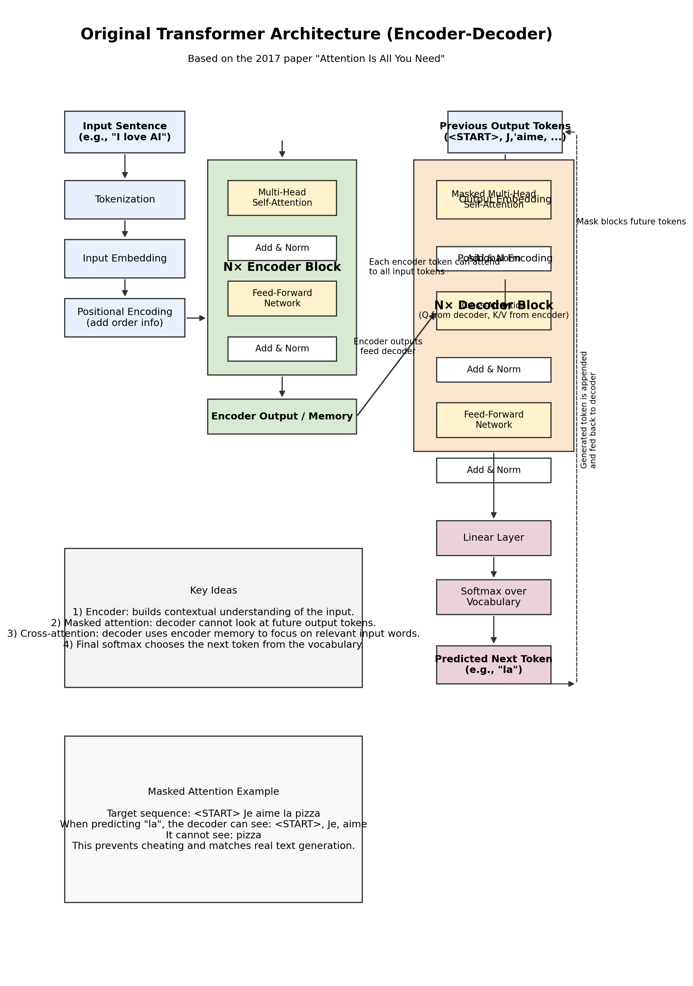
Figure 1. Full original Transformer architecture with encoder, decoder, masked attention, cross-attention, and final output generation.

1. High-level idea
- The encoder reads and understands the input sentence.
- The decoder generates the output sentence one token at a time.
- Masked attention stops the decoder from seeing future output words.
- Cross-attention helps the decoder look back at the encoder output to generate the correct next token.

2. Why Transformer was introduced
- Before Transformers, sequence models mainly used RNNs, LSTMs, and GRUs.
- These models processed tokens one by one, which made training slow and made long-range dependencies difficult to capture.
- Attention mechanisms improved this, and in 2017 Google researchers introduced the Transformer in the paper “Attention Is All You Need.”
- The big idea was: instead of recurrence, use attention as the main mechanism for learning relationships between words.

3. Step-by-step process of the architecture
Step 1: Input sentence: Example input: “I love AI”. The model first receives the input sentence.
Step 2: Tokenization: The sentence is split into tokens such as [I, love, AI].
Step 3: Embeddings: Each token is converted into a dense vector representation.
Step 4: Positional encoding: Because attention processes tokens in parallel, positional encoding tells the model the order of the words.
Step 5: Encoder self-attention: Inside the encoder, each token compares itself with all input tokens. This helps the model learn relationships like AI being related to love in the sentence context.
Step 6: Encoder feed-forward network: After attention, each position goes through a feed-forward network. Residual connections and layer normalization stabilize learning.
Step 7: Encoder output / memory: The encoder produces contextual representations of the whole input sentence. These are stored as memory for the decoder.
Step 8: Decoder input: The decoder begins with <START> and the previously generated output tokens.
Step 9: Masked self-attention in decoder: The decoder can look only at earlier output tokens. It cannot see future tokens. This ensures the model generates text step by step without cheating.
Step 10: Cross-attention: Now the decoder uses its current state as Query, and the encoder output as Keys and Values. This helps it decide which input words are most relevant for predicting the next output word.
Step 11: Decoder feed-forward network: The decoder further processes the attended information.
Step 12: Linear + Softmax: The decoder output is passed to a linear layer and then a softmax over the vocabulary. This gives probabilities for the next possible token.
Step 13: Output generation: The most likely token is selected, appended to the output, and fed back into the decoder. The loop continues until the full answer or sentence is generated.

4. Attention formula and what Q, K, V mean
- Attention is computed as:
Attention(Q, K, V) = softmax((QKᵀ) / √dₖ) V
- Q (Query): what the current token is looking for.
- K (Key): what each token offers for matching.
- V (Value): the actual information carried by each token.
- Softmax converts similarity scores into normalized attention weights.

5. What happens in masked attention?
Example target sentence: “Je aime la pizza”
When predicting “la”, the decoder can see only: <START>, Je, aime. It cannot see “pizza”.
- This mask blocks future positions in the output sequence.
- It prevents cheating during training.
- It also matches real inference, because future words do not exist yet when the model is generating text.

6. What happens in cross-attention?
In cross-attention:
- Query comes from the decoder output after masked self-attention.
- Key comes from the encoder output.
- Value also comes from the encoder output.
Meaning: the decoder asks, “Based on what I have generated so far, which parts of the input sentence should I focus on now?”

7. Worked example: English to French
- Input to encoder: “I love pizza”.
- Encoder understands the full input and creates contextual memory.
- Decoder starts with <START>.
- First predicted token may be “Je”.
- Next, decoder sees <START>, Je and predicts “aime”.
- Then decoder sees <START>, Je, aime and uses cross-attention to focus strongly on “pizza” in the encoder memory, and predicts “la” or directly “pizza” depending on the target sentence structure.
- This process repeats until the end token is produced.

8. Important note: Original Transformer vs GPT-style models
- The original Transformer has both an encoder and a decoder.
- BERT mainly uses the encoder side.
- GPT / ChatGPT style models mainly use decoder-only causal attention.
- So when people say “Transformer,” they may mean the original full architecture or one of its later variants.

9. Quick revision table
Component | Purpose
Embedding | Convert tokens into vectors
Positional Encoding | Add word-order information
Encoder Self-Attention | Understand relations among input tokens
Masked Decoder Self-Attention | Use only previous output tokens
Cross-Attention | Connect decoder with encoder information
Feed-Forward Network | Further process each position independently
Linear + Softmax | Choose the next token from the vocabulary

Sample answer: “The original Transformer architecture was introduced in the 2017 paper Attention Is All You Need. It has two main parts: an encoder and a decoder. The encoder reads the input and learns contextual relationships using self-attention. The decoder generates the output one token at a time using masked self-attention, so it cannot see future words. Then it uses cross-attention to focus on relevant encoder outputs. Finally, a linear layer and softmax predict the next token. This process repeats until the full output is generated.”

