
LearningLink Programming Standards

February 27th, 2012

Table of Contents

Introduction 1
1.0 Programming Standards 2
1.1.1 General 2
1.1.2 Scripting and Authoring Tools 2
1.2 SCORM 1.2 Standards 2
1.2.1 Manifest 3
1.2.2 SCORM 1.2 API Communication 3
1.3 508 Accessibility Standards and Best Practices 4
1.3.1 Standards 4
1.3.2 Best Practices for Accessibility 6
Appendix A: Glossary 8
Appendix B: Question Recommendations 9
Appendix C: Media Types 19
Appendix D: Recommended User Instructions 25
Appendix E: Recommended Body Text Standards 31
Appendix F: SCORM Data Model Calls Supported by Successfactors 44

Introduction
LearningLink is the Department of Labor's portal for the delivery of Web-based Training programs and the enterprise system of record for recording training completion. LearningLink supports business and management processes by providing agencies, staff, and customers with single-site access for the management, delivery, and development of learning and knowledge. This document provides programming standards that should be followed (e.g. conforming to Shared Content Object Reference Model (SCORM) version 1.2, meeting Section 508 accessibility standards, etc.) to ensure your web-based training course/program is compatible with LearningLink. In addition, the appendices provide supplemental information on question recommendations, media types, recommended user instructions, recommended body text standards and SCORM data model calls supported by Successfactors.

Programming Standards

General
The following standards should be used during programming:
- Write comments for the code when appropriate and possible
- Program courseware to conform to SCORM 1.2 standards whenever possible to facilitate reuse of course objects and interoperability within LearningLink. The use of SCORM 2004 should be coordinated with OWPI prior to course development.
- Program courseware to conform to Section 508 accessibility standards.
- Program course content to be self-contained. Course Sharable Content Objects (SCOs) may not rely on server-side scripting to function

Scripting and Authoring Tools
LearningLink WBT can be created using native Web scripting technologies. They include:
- HTML
- JavaScript
- XML
- DHTML
- CSS
In addition to native Web scripting technologies, authoring tools such as Adobe Flash may be used.
Use of native Web scripting tools, along with common proprietary tools, allows for maximum client usability as well as flexibility when editing and updating content.
In the course, the vendor must credit the office responsible for creating the course.

SCORM 1.2 Standards
LearningLink content is required to conform to the Shared Content Object Reference Model (SCORM) version 1.2. Courseware SCORM packages will be loaded into the learning management system (LearningLink), a branded implementation of Successfactors (v. 6.3.9). The vendor shall provide copies of the ADL SCORM Conformance Test Suite (v. 1.2.7) logs in PDF or HTML format at the time of delivery. The test suite can be downloaded free of charge from ADL’s website (http://www.adlnet.gov). SCORM packages to be loaded to the LearningLink environment shall be delivered to the LearningLink administration team in standard zipped (PIF) format. Vendors shall make these packages available on CD or via an FTP site owned by the vendor (preferred method).

Manifest
The course package must contain a properly formatted SCORM 1.2 manifest with the following elements:
- Identifier. An identifier that is unique to the manifest that associates a resource to an organizational item (for example, a lesson) defined earlier in the manifest.
- Type. The type of the resource. Currently, this specification defines only
the “Web content” type.
- SCORM Type. Specify either SCO or Asset.
- HREF. Specify a reference to the “entry point” of a resource. Fully
qualified external URLs are permitted.

SCORM 1.2 API Communication
To successfully pass the ADL SCORM Conformance Test Suite (V. 1.2.7) the course must contain an application programming interface (API) that can communicate with the LearningLink LMS. The following core API calls to the LMS must be included to enable proper tracking of the Learner’s session. A complete list of data elements within each API call are included in Appendix F: SCORM Data Model Calls Supported by Successfactors.
- LMSInitialize(). Called when the Learner loads the course from the LMS.
- LMSFinish(). Called when the Learner exits the course and returns to the LMS. Must account for both direct exiting (Learner presses a dedicated exit link or button) as well as indirect exiting (Learner closes course window).
- LMSGetValue(). Called when the course requests a stored value from the LMS, such as when retrieving the last page visited (bookmark).
- LMSSetValue(). Called when the course sends a value from the course to the LMS, such as the current page (bookmark).
- LMSCommit(). Called to commit sent data to the server. Depending on client and server bandwidth, LMSCommit() should be called after each LMSSetValue() for high-bandwidth connections. Otherwise, LMSCommit() should be called upon when the Learner exits the course, just before LMSFinish().
- LMSGetLastError() - This function provides content with a way of assessing whether or not any given API call was successful, and if it was not successful, what went wrong.
- LMSGetErrorString() - This function returns a textual description of the error represented by an error code number.
- LMSGetDiagnostic() – This function would return an LMS-specific error description based on an error code number.

508 Accessibility Standards and Best Practices
All Web-based Training deployed on Learning Link must be in compliance with Section 508 of the Rehabilitation Act of 1973, as amended. DOL Course Owners must require vendors to complete a VPAT (Voluntary Product Accessibility Template) http://www.itic.org/index.php?src=gendocs&ref=vpat
or GPAT (Government Product Accessibility Template) http://buyaccessible.net/blog/?p=110
to certify Section 508 compliance before DOL procures or accepts the product for use. Course Owners are responsible for Section 508 acceptance testing and evaluation against the vendor’s VPAT prior to acceptance. This includes evaluating the 508 compliance of Web-based Training courses provided from other Federal Agencies. Course Owners will be asked for their 508 testing and evaluation results to ensure 508 compliance prior to their course being deployed on LearningLink. Please contact the Department of Labor’s Section 508 Program Manager in OASAM/OCIO for additional guidance on Section 508 evaluation and acceptance testing Section508@dol.gov V 202-693-4441 TTY 202-693-8064

Standards
The current 508 Standards are found on the U.S. Access Board’s website http://www.access-board.gov/sec508/standards.htm
Department of Labor’s DLMS 9 Chapter 600 “ IT Accessibility Management” supports Section 508 compliance at DOL.
To comply with 508 Standards, the developer must test whether the content and functionality of a Web-based Training can be delivered to users with the following types of disabilities:
- Motor impaired. The user is unable to use the mouse and must navigate and interact with the course using only the keyboard.
- Vision impaired. The user is blind or has visual impairment or color blindness.
- Hearing impaired. The user is deaf or hard of hearing.
- Cognitive/learning disabilities.
To address each of these types of disabilities, the developer must include the following:
- Keyboard navigation must be supported. To enable access to users who employ alternate input devices, all course navigation controls must be functional using the keyboard alone.
- Text Alternatives must be provided for all visual elements and interaction. To enable visually impaired users to access course content, the course must include a text alternative for all relevant visual content including still pictures, animations, and interactions. This text alternative must be renderable by a screen reader such as JAWS, WindowEyes or NVDA
- Synchronized closed captioning for video must be provided. To enable hearing impaired users to access dialogue, narration, music, or other relevant audio content, the course must provide the user with a control option to display synchronized closed captioning text.
- Audio must not auto launch. Auto launch interferes with an assistive technology end user’s ability to navigate the course page, especially if they are new to the course and have yet to locate links and buttons to pause the audio or lower the volume. Audio description must also be considered to support some training courses, dependant on build.
- Many employees at DOL use 800x600 screen resolution settings to meet their accommodation needs. All courses must be usable when displayed in 800x 600. Buttons, controls and scroll bars must not be “lost” off the visible screen when 800x600 resolution is employed.
- All Flash products must be accessible. Please refer to the VHA’s free course on creating accessible Flash as a resource if your course is Flash-based. http://www.ehealth.va.gov/508/flash/index.asp
- If you are creating a new training module, please choose your authoring tool with 508 in mind. Many authoring tools do not automatically support accessible content creation. For guidance, please contact your DOL Section 508 Program Manager at Section508@dol.gov.

Best Practices for Accessibility
There are some best practices to incorporate either to be in compliance with Section 508 or to avoid unnecessary work by creating two versions of text content, one for the person without disabilities and one for the person with disabilities. Some examples follow.
Inclusive Language
Some users may not be able to click areas of the screen. Therefore, all-inclusive language should be used throughout the courseware.
- Use “select” rather than “click”.
Example: Select Next to continue.
Example: Select OK.
Some assistive technology does not work well with references to buttons and some other elements. Therefore, an alternative to these words should be used through the courseware.
- Use option rather than button or other elements.
Example: Select the Save option.
Example: From the File menu, select the Save option.
OR
Use the element name without mentioning what the element is.
Example: Select Save.
Example: From the File menu,
Tests, quizzes, and other types of interaction pose special challenges for users with disabilities. If an equivalent experience is not possible or would be inappropriate, a text alternative can be provided. For example, a drag-and-drop matching interaction could not be accessible to a blind person because it relies on the user’s ability to identify objects on screen and coordinate their movement towards a specific target on the screen with a mouse. An alternative for this type of interaction would be to describe the interaction in a way that would be understandable to a blind person without the drag-and-drop functionality but retaining the instructional content.
Text alternatives for matching, sorting, or sequencing interactions must be written to be understandable to visually impaired users that will be using a screen reader tool such as JAWS.
Example:
The following is a text alternative to the sorting exercise on this screen for visually impaired users.
Listen to the following phrases and decide whether they are or are not a Credit Processing Step.
First phrase. Reviewing a credit bureau report.
Is this phrase one of the steps in the Credit Process. Yes or no?
The correct answer is Yes. Reviewing a credit bureau report is part of gathering and verifying information.
Quiz question results prompts such as failure to select the correct question must allow the assistive technology user to interact with the prompt. For example, a dialogue box stating that the answer was incorrect verses text notifications in red at the top of a page with no change in focus.

Appendix A: Glossary
Term | Definition
Bookmark | The bookmark marks the last screen on which the student worked before exiting the system. Bookmark information is passed transparently from the courseware to a management system database for storage when a student exits the training before completing course. Student bookmark information is retrieved from the management server when a student re-enters the course. Procedures for integrating this feature with the LMS database are provided in the SOW Addendum.
Courseware | Courseware refers to the WBT and all supplemental materials. It includes the necessary auxiliary materials and any special applications, programs, or other software necessary to present instruction.
Government-Furnished Information (GFI) | Any information provided by the government to support WBT development. This information includes documents, specifically instructional materials in print or data format, supplied to the contractor/developer before and during the execution of the contract.
Interactivity | A process by which the computer presents instruction and responds individually to each student’s input.
Storyboard | A deliverable that visually describes media content placed in every screen in the course. Storyboards display the content and detail to the flow and interactivity of each screen. They describe in detail all images, animation, movie segments, sound, text, and navigational paths.
Web-based Training (WBT) | A group of predominantly interactive, training and training support products delivered over the Worldwide Web. WBT products include instructional software and software management tools used in support of instructional programs.

Appendix B: Question Recommendations
Question Type/Screen | Placement | Format/Rule |  |  |  |  |  | Examples
Multiple Choice/Completion
Screen Title | Top | SB: Arial, 10pt, Centered  Prg: Arial, 18pt, Bold, White, Centered |  |  |  |  |  | Practice  Knowledge Check – Question #1
User Instructions | Two lines below the screen title | SB: Arial, 10pt, Left Justified  Prg: Arial, 14pt, Bold, White, Left Justified  Use the term ‘Select’ versus ‘Choose,’ ‘Click,’ or ‘Pick.’ |  |  |  |  |  | Select the correct response.  Based on the image provided, select the reason(s) why the employer is in violation of excavation requirements in Subpart P.
Question | Two lines below the user instructions | SB: Arial, 10pt, Left Justified  Prg: Arial, 14pt, Bold, White, Left Justified  Use appropriate punctuation.
Responses | Two lines below the question | SB: Arial, 10pt, Left Justified  Prg: Arial, 14pt, Bold, White, Left Justified  Each response is preceded by a lowercase a, b, c, or d followed by a period then two blank spaces.  If the responses reflect a specific order, then they are preceded by a number and followed by a period and two blank spaces.  Do not capitalize the first letter of a response if it begins a question stem.  Capitalize the first letter of all other responses (e.g., when the stem is a question).  Only use periods after a response if it is a complete sentence or completes a sentence begun in the stem.
Submit Button | Two lines below the responses | Left Justified
User Prompt | Bottom | SB: Arial, 10pt, Centered  Prg: Arial, 14pt, Bold, Yellow, Centered |  |  |  |  |  | Click the SUBMIT button when finished.
Dropdown Lists
Screen Title | Top | SB: Arial, 10pt, Centered  Prg: Arial, 18pt, Bold, White, Centered |  |  |  |  | Practice  Knowledge Check – Question #1
User Instructions | Two lines below the screen title | SB: Arial, 10pt, Left Justified  Prg: Arial, 14pt, Bold, White, Left Justified |  |  |  |  | Using the dropdown lists provided, select the correct soil type for each example.  Using the dropdown lists provided, select the best label for each graphic.
Question/Scenario | Two lines below the user instructions | SB: Arial, 10pt, Left Justified  Prg: Arial, 14pt, Bold, White, Left Justified  Use appropriate punctuation.  Do not use dropdown lists as part of a statement/fill in the blank.
Submit Button | Below responses (2 blank lines separating the two). | Left Justified
User Prompt | Bottom | SB: Arial, 10pt, Centered  Prg: Arial, 14pt, Bold, Yellow, Centered |  |  |  |  | Click the SUBMIT button when finished.
Knowledge Check Introduction
Screen Title | Top | SB: Arial, 10pt, Centered  Prg: Arial, 18pt, Bold, White, Centered |  |  | Knowledge Check Introduction
User Instructions | N/A | N/A |  |  | N/A
Screen Text | Two lines below the user instructions | SB: Arial, 10pt, Left Justified  Prg: Arial, 14pt, Bold, White, Left Justified |  |  | When completing the Knowledge Check, keep the following in mind:  The questions are self-paced. You can take as much time as you need to complete each question.  There are <insert #> questions in this Knowledge Check. You must obtain 100% to successfully complete the Knowledge Check.  After completing all questions, you will receive a Knowledge Check Summary screen. This Screen will display the question with "correct " or "incorrect" beside each question.  For each incorrect question, you will first review the lesson screen(s) relevant to the question. Then, you will retake the question. You will continue this process - review material, retake the question - until you have successfully answered all questions.
Submit Button | Two lines below the responses | Left Justified
User Prompt | Bottom | SB: Arial, 10pt, Centered  Prg: Arial, 14pt, Bold, Yellow, Centered |  |  | Click the FORWARD button to continue.
Knowledge Check
Screen Title | Top | SB: Arial, 10pt, Centered  Prg: Arial, 18pt, Bold, White, Centered |  |  |  |  | Knowledge Check – Question # 1
User Instructions | Two lines below the screen title | Dependent upon type of question used. |  |  |  |  | Dependent upon type of question used.
Question/Scenario | Two lines below the user instructions | SB: Arial, 10pt, Left Justified  Prg: Arial, 14pt, Bold, White, Left Justified  Use appropriate punctuation.  Do not use dropdown lists as part of a statement/fill in the blank.
Submit Button | Two lines below the responses | Left Justified
User Prompt | Bottom | SB: Arial, 10pt, Centered  Prg: Arial, 14pt, Bold, Yellow, Centered |  |  |  |  | Click the SUBMIT button when finished.
Knowledge Check Summary
Screen Title | Top | SB: Arial, 10pt, Centered  Prg: Arial, 18pt, Bold, White, Centered |  |  |  |  | Knowledge Check – Summary
User Instructions | N/A | N/A |  |  |  |  | N/A
Screen Text | Two lines below the user instructions | SB: Arial, 10pt, Left Justified, Columns  Prg: Arial, 14pt, Bold, White, Left Justified, Columns  The question number and corresponding topic name are provided followed by the student grade on the line directly beneath it.  Questions answered correctly are highlighted in green.  Questions answered incorrectly are highlighted in red. |  |  |  |  | Question #1: Behaviors of a Problem Characterization  Your answer is Correct  Question #2: Components of Air  Your answer is Incorrect
Submit Button | Two lines below the responses | Left Justified
User Prompt | Bottom | SB: Arial, 10pt, Centered  Prg: Arial, 14pt, Bold, Yellow, Centered |  |  |  |  | Click the FORWARD button to review material for each incorrect question.
Comprehensive Knowledge Check Introduction
Screen Title | Top | SB: Arial, 10pt, Centered  Prg: Arial, 18pt, Bold, White, Centered |  | Knowledge Check Introduction
User Instructions | N/A | N/A |  | N/A
Screen Text | Two lines below the user instructions | SB: Arial, 10pt, Left Justified  Prg: Arial, 14pt, Bold, White, Left Justified |  | When completing the Comprehensive Knowledge Check, keep the following in mind:  The questions are self-paced. You can take as much time as you need to complete each question.  There are <insert #> questions in this Comprehensive Knowledge Check. You must obtain 100% to successfully complete the Knowledge Check.  After completing all questions, you will receive a Comprehensive Knowledge Check Summary screen. This Screen will display the question with "correct " or "incorrect" beside each question.  For each incorrect question, you will first review the lesson screen(s) relevant to the question. Then, you will retake the question. You will continue this process - review material, retake the question - until you have successfully answered all questions.
Submit Button | Two lines below the responses | Left Justified
User Prompt | Bottom | SB: Arial, 10pt, Bold, Yellow, Centered  Prg: Arial, 14pt, Bold, Yellow, Centered |  | Click the FORWARD button to continue.
Comprehensive Knowledge Check
Screen Title | Top | SB: Arial, 10pt, Centered  Prg: Arial, 18pt, Bold, White, Centered |  |  |  | Comprehensive Knowledge Check – Question # 1
User Instructions | Two lines below the screen title | Dependent upon type of question used. |  |  |  | Dependent upon type of question used.
Question/Scenario | Two lines below the user instructions | SB: Arial, 10pt, Left Justified  Prg: Arial, 14pt, Bold, White, Left Justified  Use appropriate punctuation.  Do not use dropdown lists as part of a statement/fill in the blank.
Submit Button | Two lines below the responses | Left Justified
User Prompt | Bottom | SB: Arial, 10pt, Centered  Prg: Arial, 14pt, Bold, Yellow, Centered |  |  |  | Click the SUBMIT button when finished.
Comprehensive Knowledge Check Summary
Screen Title | Top | SB: Arial, 10pt, Bold, White, Centered  Prg: Arial, 18pt, Bold, White, Centered |  |  |  | Comprehensive Knowledge Check – Summary
User Instructions | N/A | N/A |  |  |  | N/A
Screen Text | Two lines below the user instructions | SB: Arial, 10pt, Bold, White, Left Justified, Columns  Prg: Arial, 14pt, Bold, White, Left Justified, Columns  The question number and corresponding topic name are provided followed by the student grade on the line directly beneath it.  Questions answered correctly are highlighted in green.  Questions answered incorrectly are highlighted in red. |  |  |  | Question #1: Behaviors of a Problem Characterization  Your answer is Correct  Question #2: Components of Air  Your answer is Incorrect
Submit Button | Below responses (2 blank lines separating the two). | Left Justified
User Prompt | Bottom | SB: Arial, 10pt, Bold, Yellow, Centered  Prg: Arial, 14pt, Bold, Yellow, Centered |  |  |  | Click the FORWARD button to review material for each incorrect question.
Feedback for Practice Questions
Correct | To the right of the Submit button. | SB: Arial, 10pt  Prg: Arial, 14pt, Bold, yellow  Correct! <Restate question with the correct answer.>  Ex. Correct! The hood is the most important part of the ventilation system because it collects and contains the contaminant. | Correct! The hood is the most important part of the ventilation system because it collects and contains the contaminant.
Incorrect | To the right of the Submit button. | SB: Arial, 10pt  Prg: Arial, 14pt, Bold, yellow  Incorrect. <State the correct answer and restate the question with the correct answer.>  Ex. Incorrect. The correct answers are a, b, and d. Remember that a hood contains the emitted contaminant. | Incorrect. The correct answers are a, b, and d. Remember that a hood contains the emitted contaminant.

Appendix C: Media Types
Media
Type | File Format | Example | Description | Strategy | Level of Difficulty
Animated Introduction | .swf | 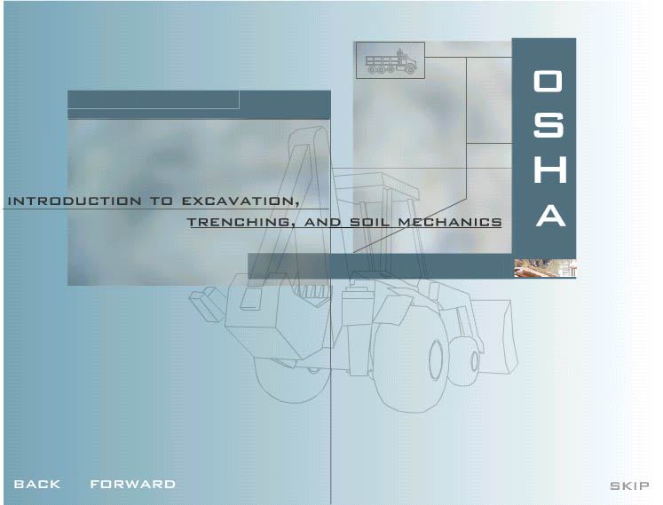 | This media component consists of a series of animated screens including text, photos, line art etc, which introduce the entire course.  The animated sequences can be programmed to run continuously until the main menu screen appears, or the sequences may contain embedded controls such as back, forward and skip buttons for user control. | This type of screen/media element provides an excellent method to engage/motivate students and to begin a course introduction. | 2-3
3-D Animation | .mov  .avi  .mpg | 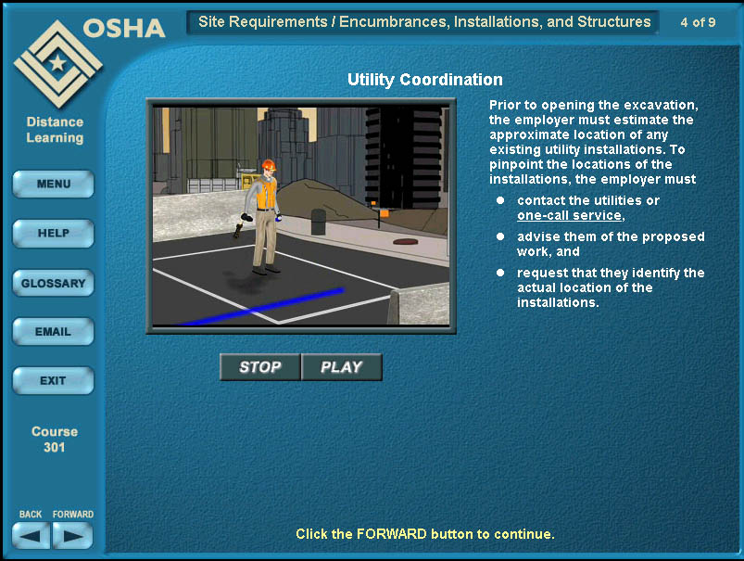 | A complex 3-D animation may include special effects, audio, animated characters, multiple layers, or detailed environments. Since they are not easily modified, complex 3-D animations are the most time-consuming media element to create and require detailed information from a SME. Reuse the animations or elements of complex 3-D animations when possible. | 3-D animations provide a great way to re-create a scenario or work environment. They are also good for illustrating:  - character animations  - 3-D particle systems such as  -explosions  -fire  -water effects  - smoke  - highly detailed and accurate models that need to be created from scratch, such as environments, machinery, or organic models | 4
2-D Animation | .swf | 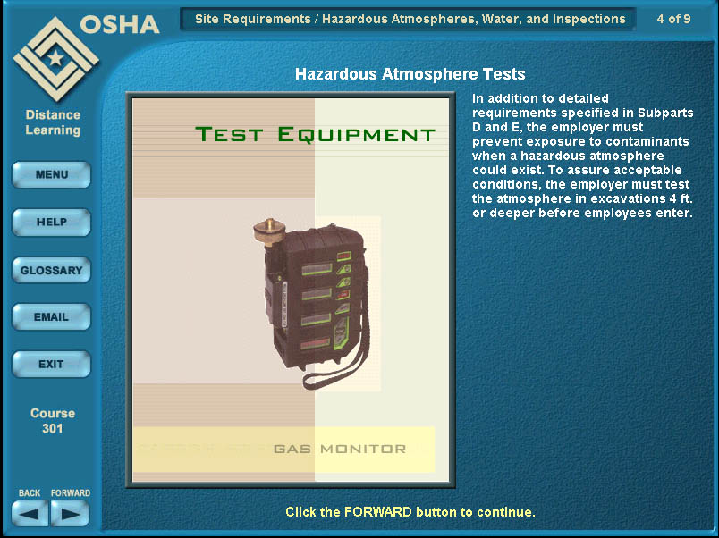 | A 2-D animation is an animated illustration created in a 2-D package (Flash) that has simple elements (e.g. shapes, text. photos) animated with simple movements and a limited number of layers. These types of graphics are less time-consuming and are often used when little to no reference items are available. | 2-D animations may be used in several different ways to:  - present different terms or several different photos of an object or environment similar to a slide show  - move text or simple shapes, for example showing chemical abbreviations or particles coming out of a vent  - animate arrows in flow or schematic diagrams to show a process. | 2
Animated Line art | .mov  .avi  .swf | 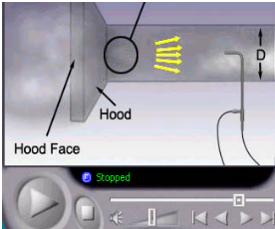 | This media type starts with a simple line drawing from a reference manual or slide. The source line art is scanned in or redrawn in a vector based graphics package and this artwork is then is brought into an animation package to add descriptive animated details such as moving arrows, pivoting ladders, etc. These work best with high quality source drawings for the artist to work with andthey do require detailed information and input from a SME. | Animated line art may be used in several different ways to:  - illustrate a simple example of how a piece of equipment functions  - illustrate air flow | 2
2/3-D Illustration | .jpg | 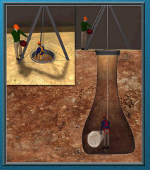  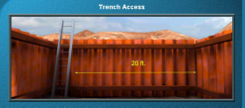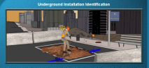 | Illustrations require a significant amount of time to create because often the illustration must be developed by the artist working from a line drawing or a photograph.  Illustrations are static but can include simple interactions such as hot spots with links to pop-up boxes of information.  A 3-D illustration is static and not animated. This type of illustration provides the detail and perspective that a flat (2-D) graphic does not provide and is required to adequately explain a concept. | Illustrations are very helpful for providing:  - a unique perspective on an environment or object  - detail unavailable in existing photos or graphics  - a recreation of a photo or illustration that is copyrighted  - modifications/edits to a detailed illustration  3-D illustrations are very helpful for providing:  an accurate example of an environment or object  -detail unavailable in existing photos or flat graphics, photo, or illustration. | 3-4
Static Graphic | .jpg  tiff | 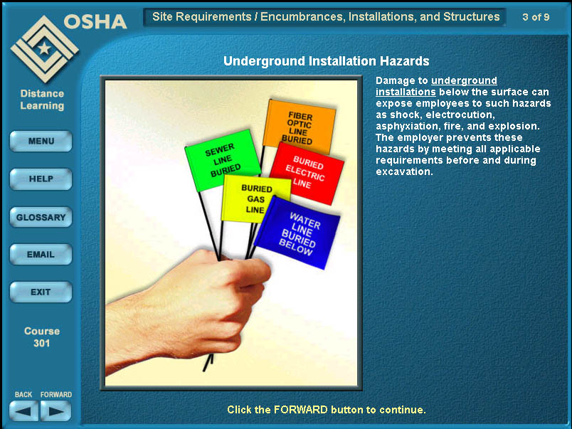 | A static graphic is not animated. This type of image is great for presenting process flows and static visuals.  Examples of static graphics include:  - diagrams  - illustrations  - photo illustration collage | Simple illustrations are used to:  - recreate complex diagrams  - design collages  - generate tables of information  - modify/edit/existing art work/photographs | 1-2
Photo | .jpg  tiff | 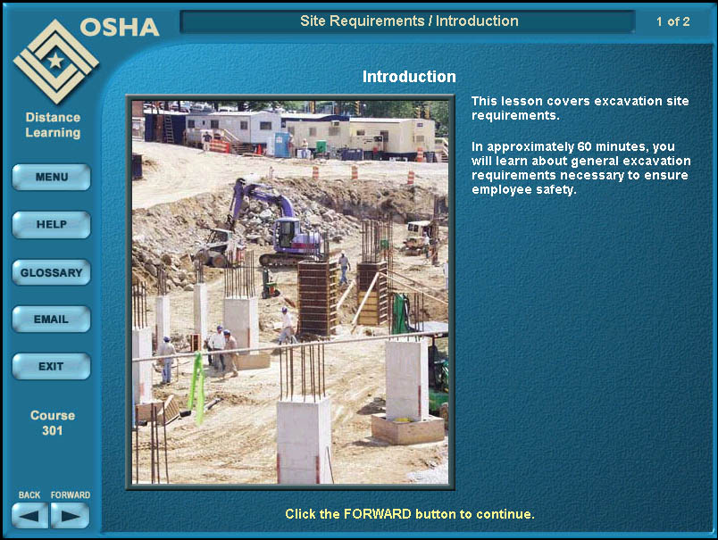 | Photography is an important component of visual instructional content. Photographs can be used “as is” with little editing or manipulated and edited for either static or animated visuals.  ---- must obtain written copyright permissions for all photos used unless they are obtained from one of the following sources  - royalty-free websites  - client owned material  - government-furnished material  - a photo or clip-art CD that has been purchased. | Photos can be:  - used to depict scenes in the field or office  - used to show actual details of machinery or instrumentation  - annotated to include instructional information to enhance the raw image  Photographs are very powerful when used to:  - provide a “true-to-life” example of a work environment  - show a piece of machinery | 1-2
Digital Video | .mov  .avi  .mpg | 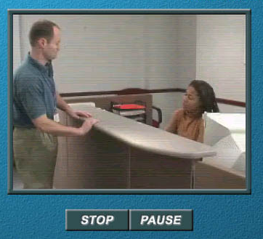 | Digital Video can be time-consuming and more costly to produce if there is not “near broadcast quality source material” that has been previously shot and that aligns exactly with the storyboard content.  When using existing video, obtain written copyright permission unless the video is obtained from one of the following sources:  - royalty-free websites  - client owned material  government-furnished  material | Digital Video is best used to:  - provide a “true-to-life” example of a work environment  - illustrate how to perform a task  - demonstrate how a piece of machinery works | 4

Appendix D: Recommended User Instructions
Screen | Prompt Text | Format | Layout/Position
Splash
Forward | Select FORWARD to learn how to use this training course. | SB: Arial, 10pt, button name in all caps  Prg: Arial, 14pt, bold white; button name in all caps | Rollover on text
Back | Select BACK to replay the opening animation. | SB: Arial, 10pt, button name in all caps  Prg: Arial, 14pt, bold white; button name in all caps | Rollover on text
Skip | Select SKIP to go immediately to the training course. | SB: Arial, 10pt,button name in all caps  Prg: Arial, 14pt, bold white; button name in all caps | Rollover on text
Lesson Menu | Select a lesson to continue. | SB: Arial, 10pt  Prg: Arial, 14pt, Bold, white | Centered beneath the logo at bottom of screen.
Topic Menu | Select a topic to continue. | SB: Arial, 10pt,  Prg: Arial, 14pt, Bold, yellow | Centered beneath topic buttons.
Lesson Introduction | Select FORWARD to continue. | SB: Arial, 10pt  Prg: Arial, 14pt, Bold, yellow | Centered at the bottom of the main content area.
Lesson Objectives
Menu | Select MENU to select a topic. | SB: Arial, 10pt  Prg: Arial, 14pt, Bold, yellow | Centered at the bottom of the main content area.
Print | Select PRINT to print the document(s). | SB: Arial, 10pt  Prg: Arial, 14pt, Bold, yellow | Centered at the bottom of the main content area.
Topic Introduction | Select FORWARD to continue. | SB: Arial, 10pt  Prg: Arial, 14pt, Bold, yellow | Centered at the bottom of the main content area.
Topic Content
Forward | Select FORWARD to continue. | SB: Arial, 10pt  Prg: Arial, 14pt, Bold, yellow | Centered at the bottom of the main content area.
Animation/Video | Select PLAY to view the animation. | SB: Arial, 10pt  Prg: Arial, 14pt, Bold, yellow | Centered at the bottom of the main content area.
Clickable Graphic | Select the image.  Select the fan. | SB: Arial, 10pt  Prg: Arial, 14pt, Bold, yellow | Centered at the bottom of the main content area.
Practice
Submit | Select SUBMIT when finished. | SB: Arial, 10pt  Prg: Arial, 14pt, Bold, yellow | Centered at the bottom of the main content area.
Practice
At the end of a topic | Select MENU to select a topic. | SB: Arial, 10pt  Prg: Arial, 14pt, Bold, yellow | Centered at the bottom of the main content area.
Lesson Summary
Menu | Select MENU to select a topic. | SB: Arial, 10pt  Prg: Arial, 14pt, Bold, yellow | Centered at the bottom of the main content area.
Resources | Select RESOURCES to access additional information about this lesson – FAQs, Links, and Forums. | SB: Arial, 10pt  Prg: Arial, 14pt, Bold, white | The last sentence (left justified) of the main content area.
Resources | Select a resource option to access additional information, or select MENU to select a topic. | SB: Arial, 10pt, Bold, yellow  Prg: Arial, 14pt, Bold, yellow | Centered at the bottom of the main content area.
FAQs | N/A

Screen | Prompt Text | Format | Layout/Position
Links | Select a link to access additional information, or select CLOSE WINDOW to close the window and return to the course. | SB: Arial, 10pt  Prg: Arial, 14pt, Bold, yellow | Centered at the bottom of the main content area.
Forums | N/A
Knowledge Check Intro | Select FORWARD to continue | SB: Arial, 10pt  Prg: Arial, 14pt | Centered at the bottom of the main content area.
Knowledge Check Question | Select SUBMIT when finished. | SB: Arial, 10pt  Prg: Arial, 14pt, Bold, yellow |  | Centered at the bottom of the main content area.
Knowledge Check Summary | Select FORWARD to review material for each incorrect question. | SB: Arial, 10pt  Prg: Arial, 14pt, Bold, yellow |  | Centered at the bottom of the main content area.

Screen | Prompt Text | Format | Layout/Position
Knowledge Check Review | Select FORWARD to continue. | SB: Arial, 10pt  Prg: Arial, 14pt, Bold, yellow | Centered at the bottom of the main content area.
Animation/Video | Select PLAY to view the animation. | SB: Arial, 10pt  Prg: Arial, 14pt, Bold, yellow | Centered at the bottom of the main content area.
Clickable Graphic | Select the image.  Select the fan. (for example) | SB: Arial, 10pt  Prg: Arial, 14pt, Bold, yellow | Centered at the bottom of the main content area.
Comprehensive Knowledge Check Intro | Select FORWARD to continue. | SB: Arial, 10pt, Bold, yellow  Prg: Arial, 14pt, Bold, yellow | Centered at the bottom of the main content area.
Comprehensive Knowledge Check Question | Select SUBMIT when finished. | SB: Arial, 10pt  Prg: Arial, 14pt, Bold, yellow | Centered at the bottom of the main content area.
Comprehensive Knowledge Check Summary | Select FORWARD to continue. | SB: Arial, 10pt  Prg: Arial, 14pt, Bold, yellow | Centered at the bottom of the main content area.

Screen | Prompt Text | Format | Layout/Position
Glossary | N/A
Help | N/A
Congratulations | Select MENU to continue. | SB: Arial, 10pt  Prg: Arial, 14pt, Bold, yellow | Centered at the bottom of the main content area.
Print Certificate | Select PRINT CERTIFICATE to print a certificate of completion. | SB: Arial, 10pt  Prg: Arial, 14pt, Bold, white | The last sentence (left justified) of the main content area.
Certificate | N/A

Appendix E: Recommended Body Text Standards
Topic | Standards | Example
Capitalization
a. General capitalization:
- the first word of a sentence
- the first word after a colon, if the colon introduces a complete statement
- titles of publications
- each word in a phrase that is then made into an acronym
- days, months
- holidays
- the pronoun “I,”
- proper names
The only exceptions to this standard would occur when it is necessary to meet client conventions.
 | b. Titles
 | 1. Topic
 | i. Capitalize the first letter of each word (with the exception of articles a, an, and the; the prepositions at, by, for, in, of, on, to, and up (unless they are the first or last word of the Title); and the conjunctions and, as, but, if, or, and nor.) | All Returns Are In  SB: Arial, 10pt  Prg: Arial, Bold, 16pt.
 | ii. Italicize all titles when referenced directly. | In the lesson, Principles of Industrial Ventilation, you learned….
Capitalization Continued | iii. Do not capitalize words that are parts of titles. | As discussed in Industrial Ventilation, industrial ventilation is a method of controlling…
 | iv. If titles are hyphenated capitalize both words. | Continuous Line-Type Detectors
 | 2. Screen
 | i. Capitalize the first letter of each word (with the exception of articles a, an, and the; the prepositions at, by, for, in, of, on, to, and up (unless they are the first or last word of the Title); and the conjunctions and, as, but, if, or, and nor.) | All Returns Are In  SB: Arial, 10pt  Prg: Arial, Bold, 18pt.
 | ii. Italicize any reference to the title of a lesson and/or topic.
 | iii. If titles’ are hyphenated, both words are capitalized.
 | 3. Graphic Titles
 | i. Capitalize the first letter of each word (with the exception of articles a, an, and the; the prepositions at, by, for, in, of, on, to, and up (unless they are the first or last word of the Title); and the conjunctions and, as, but, if, or, and nor.) | All Returns Are In  SB: Arial, 10pt  Prg: Arial, Bold, 14pt.
 | ii. If a title is hyphenated, both words before and after hyphen are capitalized. | Continuous Line-Type Detectors
 | 4. Labels
 | i. First letter of a label is upper case | Rotor blades
Capitalization Continued | c. Lesson/Topic/Title References
 | 1. Capitalize the first letter of a lesson/topic reference | Lesson 6: Local Exhaust Ventilation
 | 2. Capitalize the first letter of each word (with the exception of articles a, an, and the; the prepositions at, by, for, in, of, on, to, and up (unless they are the first or last word of the Title); and the conjunctions and, as, but, if, or, and nor.) | SB: Arial, 10pt  Prg: Arial, Bold, 14pt.
 | 3. If titles are hyphenated, both words before and after hyphen are capitalized. | Continuous Line-Type Detectors
 | d. Lists
 | 1. Columns
 | i. Capitalize the first letter of all important words in column titles, but capitalize only the first letter of the first word in column entries
 | 2. Bulleted
i. The first letter of the first word of each bulleted item is in lower case.
Note: Reference the bullet section for more details.
 | 3. Numbered
 | i. Capitalize the first letter of the first word of each item in the numbered list.
Capitalization Continued | e. Button names
 | 1. Use all caps | Click the FORWARD button to continue.
 | f. Pop-Up Text boxes
 | 1. First letter of each sentence is capitalized. | SB: Arial, 10pt  Prg: Arial, Bold, 14pt.
 | g. Screen Text
 | 1. First letter of each sentence is capitalized.
 | 2. If word is hyphenated, use lower case for each first letter.
 | h. Mathematical Equations
 | 1. User lower case letters for mathematical equations | a + b = c
Abbreviations
 | a. Time
 | 1. Use the lowercase abbreviations a.m. and p.m. with periods between the letters and a space between the time and the a.m./p.m. designation. | 8 a.m.
Acronyms
 | a. Write out (define) the entire acronym the first time it appears (in each lesson) followed by a blank space and the acronym in parenthesis. Thereafter, use the abbreviation. | Ex. Local Exhaust Ventilation (LEV)
 | b. The first letter of each word in the acronym is capitalized
 | c. Plural Acronyms – add a lowercase “s” to the end | LEVs
 | d. Possessive Acronyms – add an apostrophe and an “s” | LEV’s
 | e. Add acronym to glossary
Numbers
 | a. Write out numbers at the beginning of a sentence (unless referencing a standards document). Rephrase a sentence to avoid beginning with numbers. Use hyphens after written out numbers ending in ‘y’. | Thirty-one
 | b. Express all numbers numerically. | Lesson 2; 7 cans
 | c. Express all fractions numerically. | 3½ cans; ¾ in
 | d. Use numbers followed by the words million, billion, and higher amounts, unless exact amounts are required. | 5 million cans
 | e. Use decimals for amounts less than one percent and always precede the decimal point by a 0. | 0.07%
 | f. Use commas for large numbers. | 2,537,250,000
Symbols
 | a. Add one space before and after the “=” sign
 | b. Add one space before and after mathematical signs | , , ,        x, etc.
 | c. When x is used to indicate “crossed with” or magnification, it is separated from the accompanying words by a space.
 | d. Add one space before and after bracket sets. | {abcd}, [abcd], (abcd)
 | e. Use the degree symbol instead of the word degree following a figure denoting measurement. | 2°
 | f. Do not use the “&” instead of the word “and” unless it is part of a formal name/title.
 | g. Use the % symbol for all percentage references, with no space between the # and %. | 2% NOT 2 percent
Mathematical Equations
 | a. Use lower case letters for mathematical equations. | a + b = c
 | b. Exponents and subscripts are a smaller point size than the corresponding number/symbol.
Units of Measure
 | a. Express units of measure in their abbreviated forms. | Weight or Mass:  Pounds = lb  Ounce = oz.  Ton = tn.  Weight = wt.  Length:  Inches = in  Square Inch = sq. in  Feet/Foot = ft.  Square Foot = sq. ft.  Yard = yd.  Mile = mi. | Time:  Second = sec.  Minute = min.  Hour = hr.  Month = mo.
 | b. Include a space between the number and unit of measure. | 2 ft.
 | c. To express a relation between two or more similar measures, the units of measure are repeated. | 2 ft. x 6 ft. x 9 ft.
 | d. Do not use symbols to reference units of measure.  Exceptions: Percentages and Degrees | 2 in. NOT 2’’  2% NOT 2 percent  2° NOT 2 degrees
Punctuation Continued
 | a. Commas
 | 1. In a series of three or more items, follow the comma, comma, and convention. | Three agents used in extinguishing fires are water, carbon dioxide, and dry chemicals.
 | b. Quotation Marks
 | 1. Place commas and periods within quotation marks. | “I believe in the sun,” she said, “even when it isn’t shining.”
 | 2. Place a question mark inside quotation marks when it is part of the actual quote. | “To be, or not to be?”
 | c. Colon
 | 1. First letter after the colon is typically lower case. | There are two designs of dry chemical fire extinguishers: stored-pressure and cartridge-operated.
 | Exception: Capitalize the first word after a colon only if it introduces a complete statement. | The results are conclusive: Four out of five dentists …
 | d. Hyphens
 | 1. Use hyphens after written-out numbers ending in y (only when used at the beginning of a sentence). | Thirty-one
 | 2. Use hyphens to separate numbers that are not inclusive. | Social security and/or telephone numbers
 | 3. Use hyphens in compounds containing a participle when the compound precedes the noun it modifies. | Fire-extinguishing agents,  life-threatening pathogens
Punctuation Continued | 4. Use hyphens where it’s necessary to clarify the meaning of compound adjectives. | Fast-sailing ships (fast modifies sailing) vs. fast sailing ships (fast modifies ships)
 | 5. Do not use hyphens in compounds containing an adverb ending in ly when the compound precedes the noun it modifies. | Widely accepted solution
 | 6. Do not use hyphens to write words formed with prefixes (there may be some exceptions). | Antisocial, omnipresent
 | e. Em dash
 | 1. Use instead of commas or parentheses if the meaning that follows is essential to the sense of the structure. | He had spent several hours carefully explaining the operation – an operation that would put an end to the resistance.
 | 2. Use before a final clause summarizing a series of ideas.
 | f. sub and superscripts
 | 1. Use subscripts when appropriate such as when referring to elements or in mathematical equations. | Helium= H_{e} ; Static Pressure Loss= SP_{LOSS}
 | 2. Use superscripts when appropriate such as when referring to temperatures. | 25
Bulleted Lists
 | a. Spacing
 | 1. Insert two spaces after a bullet
 | 2. Insert two spaces between bullets (dependent upon screen real estate). | Follow formatting conventions on screen 1 of 5 in E&T/Protective Systems/General Requirements.
 | b. Left justify bullets
 | c. Punctuation – Objective Screens | Follow formatting conventions established in E&T.
 | 1. Place colon at the end of the stem (if the last word of the stem is a verb, do not use a colon).
 | 2. If different verbs are used in different bullets, place the verb in initial caps on a line above the bullet group for which the verb applies.
 | 3. The first letter of the first word of each bulleted item is lower case.
 | d. Punctuation – Content Screens
 | 1. Place colon at the end of the stem (if the last word of the stem is a verb, do not use a colon).
 | 2. Follow the comma, comma, and convention
 | 3. The last bullet in the list ends with a period/appropriate punctuation
Bulleted Lists Continued | e. Punctuation – Practice/Knowledge Check/Module Comprehensive Module Check/Course Knowledge Check Screens
 | 1. Place colon at the end of the stem (if the last word of the stem is a verb, do not use a colon).
 | 2. Use appropriate punctuation (period) at the end of each bullet.
 | 3. For ‘fill in the blanks’ format capitalize and punctuate bulleted items accordingly. Ex. If fill in the blank begins a sentence, first letter of each bullet is capitalized and sentence ends with appropriate punctuation.
 | h. Left Justify Bullets
General Lists
 | a. Vertically align dollar signs ($), decimals, commas, and mathematical symbols in columns of numbers.
 | b. Capitalize the first letter of all the important words in column titles, but capitalize only the first letter of the first word in column entries.
Numbered Lists
 | a. Used primarily for procedures and/or practice/knowledge check questions.
 | b. Begin list items with a number followed by a period with one space between the period and the list item. | 1. Industrial Ventilation
 | c. Use appropriate punctuation for complete sentences.
 | d. Do not insert a line space between items in a numbered list.
 | e. If included within content, indent the list 5 spaces.
 | f. If included with a question, left-justify the list.
Formatting
 | a. Font (type, size, and attributes)
 | 1. Screen text | SB: Arial, 10pt  Prg: Arial, Bold, 14pt.
 | 2. Graphic text | SB: Arial, 10pt  Prg: Arial Bold, 14pt.
 | 3. Title Bar | SB: Arial, 10pt  Prg: Arial Bold, 16pt.
 | 4. Screen Title | SB: Arial, 10pt  Prg: Arial Bold, 18pt.
 | 5. User Prompts | SB: Arial, 10pt  Prg: Arial Bold, 14pt.
 | b. Attributes
 | 1. Italicize Topic title references
 | 2. Graphic titles are bold
 | 3. Prompt text is bold
 | c. General Spacing
 | 1. One space after a period.
 | 2. One blank line between paragraphs
 | 3. Two spaces between a bullet and the list items that follow
 | 4. One blank space between bullets
 | 5. No space on either side of a forward slash. | Tapers/Contractions/Expansions are designed to move air
 | d. Alignment
 | 1. Paragraphs are left justified
 | 2. Bullets are left justified
 | e. Forward Slash
Pop-Ups/Rollovers
 | a. Underline only the words/phrases to be clicked. | excavation face  NOT excavation face.
 | b. Text box disappears when you roll off the item.
 | c. Capitalize the first letter of each sentence.
 | d. Sentences end with appropriate punctuation.
 | e. In the first sentence, include the name/phrase/topic that was clicked.
Text within Graphics
 | a. Titles
 | 1. Capitalize the first letter of each word (minus, for example, articles a, an, and the; the prepositions at, by, for, in, of, on, to, and up (unless they are the first or last word of the Title); and the conjunctions and, as, but, if, or, and nor.) | SB: Arial, 10pt.  Prg: Arial, Bold, 16pt.
 | 2. Center with graphic.
 | b. Regular graphic text
 | 1. Two points smaller than graphic title.
 | 2. Follows same standards for screen text.
 | 3. Labels | SB: Arial, 10pt.  Prg: Arial, Regular, 14pt.
 | 4. Text | SB: Arial, 10pt.  Prg: Arial, Bold, 14pt.
Titles
 | a. Lesson/Topic
 | 1. Capitalize the first letter of each word (minus, for example, articles a, an, and the; the prepositions at, by, for, in, of, on, to, and up (unless they are the first or last word of the Title); and the conjunctions and, as, but, if, or, and nor.) | SB: Arial, 10pt.  Prg: Arial, Bold, 16pt.
 | b. Graphic
 | 1. Capitalize the first letter of each word (minus, for example, articles a, an, and the; the prepositions at, by, for, in, of, on, to, and up (unless they are the first or last word of the Title); and the conjunctions and, as, but, if, or, and nor.) | SB: Arial, 10pt.  Prg: Arial, Bold, 16pt.
Prompt Text
 | a. Center at the bottom of the main content area. | SB: Arial, 10pt  Prg: Arial, Bold, 14pt

Appendix F: SCORM Data Model Calls Supported by Successfactors
SCORM DATA MODEL CALLS SUPPORTED BY Successfactors - Source, Successfactors Content Integration Guide
API | Data Model Element
LMSInitialize( ) | The content must call this function before calling any other API function. It indicates to the LMS system that the content is going to communicate. The LMS can take any initialization steps required in this function. For instance, this can contact the CMI via AICC messaging to pull down the cmi.core variables for quick access.
LMSGetValue( ) | This function is used to pass data from the CMI to the content. Only one value is returned for each call. The category and/or element is named in the parameter.
LMSGetValue( ) | The following LMSGetValue parameters are supported by Plateau:
LMSGetValue( ) | cmi.core._children - returns "student_id, student_name, lesson_location, credit, lesson_status, entry, score, total_time, exit, session_time"·
LMSGetValue( ) | cmi.core.student_id
LMSGetValue( ) | cmi.core.student_name
LMSGetValue( ) | cmi.core.lesson_location - 255 char string typically used for bookmarking
LMSGetValue( ) | cmi.core.credit - returns "no-credit" or "credit"
LMSGetValue( ) | cmi.core.lesson_status - indicates SCO completion - returns one of the following: "passed", "completed", "failed", "incomplete", "browsed", or "not attempted"
LMSGetValue( ) | cmi.core.entry - returns "ab-initio", "resume", or ""
LMSGetValue( ) | cmi.core.score._children - returns "raw, min, max"
LMSGetValue( ) | cmi.core.score.raw - the raw score value
LMSGetValue( ) | cmi.core.score.max - the maximum possible score - if not set, assumed 100
LMSGetValue( ) | cmi.core.score.min - the minimum possible score - if not set, assumed 0
LMSGetValue( ) | cmi.core.total_time - returns the sum of all a learner's session times
LMSGetValue( ) | cmi.core.lesson_mode - returns "browse", "normal", or "review"
LMSGetValue( ) | cmi.suspend_data - 4096 char string usually used for progress data
LMSGetValue( ) | cmi.launch_data - 4096 char string used to pass data to the SCO on launch from the LMS
LMSGetValue( ) | cmi.objectives._children - returns "id, score, status"
LMSGetValue( ) | cmi.objectives._count - returns the number of objectives currently stored for this SCO.
LMSGetValue( ) | cmi.objectives.n.id - returns the objective identifier where "n" is the objective number
LMSGetValue( ) | cmi.objectives.n.score._children - returns "raw, min, max "
LMSGetValue( ) | cmi.objectives.n.score.raw - the raw objective score value
LMSGetValue( ) | cmi.objectives.n.score.min - The minimum possible score - if not set, assumed 0
LMSGetValue( ) | cmi.objectives.n.score.max - the maximum possible objective score - if not set, assumed 100
LMSGetValue( ) | cmi.objectives.n.status - indicates if the learner has completed the objective - returns one of the following: "passed", "completed", "failed", "incomplete", "browsed", or "not attempted"
LMSGetValue( ) | The following are legitimate element names, but are write-only. These would therefore return "" and set an error: 404 - element is write-only.
LMSGetValue( ) | cmi.core.exit
LMSGetValue( ) | cmi.core.session_time
LMSSetValue( ) | This function is used to pass data from the content to the LMS. The parameter indicates which category or element is being set. Only one value may be set with a single function call.
LMSSetValue( ) | The following LMSSetValue parameters are supported by Plateau:
LMSSetValue( ) | cmi.core.lesson_location - 255 char string usually used for bookmarking
LMSSetValue( ) | cmi.core.lesson_status - indicates SCO completion - accepts "passed", "completed", "failed", "incomplete", "browsed", "not attempted"
LMSSetValue( ) | cmi.core.score.raw - the raw score value
LMSSetValue( ) | cmi.core.score.max - the maximum possible score - if not set, assumed 100
LMSSetValue( ) | cmi.core.score.min - the minimum possible score - if not set, assumed 0
LMSSetValue( ) | cmi.core.exit - indicates how the learner left the SCO - accepts "time-out", "suspend", or "logout"
LMSSetValue( ) | cmi.core_session_time - Time spent in the SCO - HHHH:MM:SS.SS
LMSSetValue( ) | cmi.suspend_data - 4096 char string usually used for progress data
LMSSetValue( ) | cmi.objectives.n.id - the objective identifier where "n" is the objective number
LMSSetValue( ) | cmi.objectives.n.score.raw - the raw objective score value
LMSSetValue( ) | cmi.objectives.n.score.min - The minimum possible score - if not set, assumed 0
LMSSetValue( ) | cmi.objectives.n.score.max - the maximum possible objective score - if not set, assumed 100
LMSSetValue( ) | cmi.objectives.n.status - indicates if the learner has completed the objective - accepts "passed", "completed", "failed", "incomplete", "browsed", or "not attempted"
LMSSetValue( ) | The following are legitimate element names, but are read-only. These would therefore return "false" and set an error: 403 - element is read-only:
LMSSetValue( ) | cmi.core.student_id
LMSSetValue( ) | cmi.core.student_name
LMSSetValue( ) | cmi.core.credit
LMSSetValue( ) | cmi.core.entry
LMSSetValue( ) | cmi.core.total_time
LMSSetValue( ) | cmi.core.lesson_mode
LMSSetValue( ) | cmi.launch_data
LMSSetValue( ) | The following elements are legitimate element names, but are keywords for multiple elements. These would therefore return "" and set the error code 402 - "Invalid set value, element is a keyword":
LMSSetValue( ) | cmi.core._children
LMSSetValue( ) | cmi.core.score._children
LMSSetValue( ) | cmi.objectives._children
LMSSetValue( ) | cmi.objectives._count
LMSSetValue( ) | cmi.objectives.n.score._children
LMSCommit( ) | Any values set using the LMSSetValue command are stored for delivery. This function submits any values not yet sent to the LMS.
LMSFinish( ) | The content must call this function before it terminates, if it successfully called LMSInitialize at any point. It signals to the LMS that the content has finished communicating. The content may not call any API function except LMSGetLastError after it calls LMSFinish
LMSGetLastError( ) | This function provides content with a way of assessing whether or not any given API call was successful, and if it was not successful, what went wrong. This routine returns an error code from the previous API call. Each time an API function is called (with the exception of this one), the error code is reset in the API. The content may call this any number of times to retrieve the error code, and the code will not change until the next API call.
LMSGetErrorString( ) | This function returns a textual description of the error represented by an error code number.
LMSGetDiagnostic( ) | This function would return an LMS-specific error description based on an error code number.

