Application Design Document
Draft

Transit Grant (TG)
RELEASE 1.0

Document No.: OLMS-TG-SDD.doc

Office of Labor-Management Standards
Office of the Assistant Secretary for Administration and Management
U.S. Department of Labor
200 Constitution Avenue, NW
Washington, DC 20210
01January 2018

Revision History
Document Version | Date | Change | Author
1 | 01/31/2018 | Initial draft | Bineeta Adityan

Table of Contents
1. Introduction 8
1.1. Transit Employee Protection 8
1.2. DOL’s Procedure for Certification of Protective Arrangement for Federal Transit Administration (FTA) grants 8
1.3. Purpose and Scope 9
1.3.1. Purpose 9
1.3.2. Scope 9
1.4. Organization of this Document 9
1.5. Points of Contact 9
1.6. Glossary 10
1.7. References 11
1.8. Constraints 11
2. Software Application Design Overview 12
2.1. Software Application Architecture Description 12
2.1.1. Technical Architecture 14
2.2. Design Rationale 15
2.3. Security 15
2.3.1. Firewalls 16
2.3.2. Passwords 16
2.3.3. Access Controls and Levels 16
2.3.4. Application Downtimes 16
2.3.5. Confidentiality 16
2.3.6. Integrity 16
2.3.7. Availability 16
2.4. Risk Management 17
2.5. Database Schema 17
3. Unit Design Organization 18
3.1. Login Screen 19
3.2. Tools 19
3.2.1. Users 19
3.2.2. State Assignments 20
3.2.3. Regions 20
3.2.4. Edit Transit Agencies and their Protections 22
3.3. Projects 36
3.3.1. Creating the Project record 36
3.3.2. Project Listing 37
3.4. Login/Logout 39
3.4.1. Login Page 39
3.4.2. Logout 39
4. File and Database Design 40
4.1. Database Mangement Application Files 40
4.1.1. Logical Database Design 40
4.1.2. Data Flow 41
4.1.3. Physical Database Design 43
4.1.4. Database Tables 44
4.1.5. DBMS File Size 52
4.1.6. Frequency of Database Update 52
5. Input/Output Design 53
5.1. Application Input Design 53
5.1.1. Landing Page 53
Appendix A Detailed Application Requirements Derived from Functional Requirements A-1
Appendix B Database Schema B-1
Appendix C Stored Procedures C-1

Table of Figures
Figure 1. Software Application Architecture High-Level Overview 12
Figure 2. Transit Grant Workflow 13
Figure 3. Application Topology 15
Figure 4. Component and Sub-Component Flow Chart 18
Figure 5: Login Page 19
Figure 6. Users Page 19
Figure 7 : State Assignments 20
Figure 8: Regions 21
Figure 9: Transit Agency Listing 22
Figure 10: Add New Agency 22
Figure 11. Filer Search Window 23
Figure 12: Notes 23
Figure 13: Unions 24
Figure 14: Service Area Providers 24
Figure 15: Special Terms 25
Figure 16: Add New Special Terms 25
Figure 17: Protections Editor 26
Figure 18: Contact 26
Figure 19: Attorneys 27
Figure 20: Projects 28
Figure 21: Edit Unions 28
Figure 22: Add New Union 28
Figure 23: Union Information 29
Figure 24: Contact 29
Figure 25: Union Attorneys 30
Figure 26: Edit Attorneys 31
Figure 27: Add New Attorney 31
Figure 28: Edit Title 33
Figure 29: Add New Title 33
Figure 30: Edit Statute 34
Figure 31: Add new Statute 34
Figure 32: Edit Terms 35
Figure 33: UPA NPA and National Model 35
Figure 34: Incoming Outgoing email 36
Figure 35: Project Listing 37
Figure 36. Transit Grant Login Page 39
Figure 37. Landing Page 39
Figure 38. Logical Data Model 40
Figure 39. High Level Data Flow Diagram 42
Figure 41. Physical Database 43
Figure 42. Landing Page 53
Figure 43. Transit Grant Database Schema B-1

Table of Tables
Table 1: Points of Contact 9
Table 2: Glossary 10
Table 3: User Page 19
Table 4: User Editor – Column Information 20
Table 5: State Assignment Editor 20
Table 6:Address Information Tab 21
Table 7:Edit States Tab 21
Table 8:Contacts Tab 21
Table 9:Transit Agency listing 22
Table 10:Add Provider 22
Table 11:Notes 23
Table 12:Unions 24
Table 13:Service Area Providers 24
Table 14:Special Terms 25
Table 15:Protections 26
Table 16:Contacts Tab 26
Table 17:Attorneys Tab 27
Table 18:Projects 28
Table 19:Add Union 28
Table 20:Contacts Tab 29
Table 21:Attorneys Tab 30
Table 22:Add new Attorney 31
Table 23:Title Maintenance 33
Table 24:Statute 34
Table 25:Terms 35
Table 26:UPA NPA and National Model 35
Table 27:Incoming/Outgoing Email 36
Table 28:XML data set 36
Table 29:Project List View 37
Table 30:DSP Project Definition section. 38
Table 31:Sub-Recipients 38
Table 32: Objects, Other correspondence, notes and attachments 38
Table 33:TG_ADDRESS 44
Table 34:TG_CATEGORY 44
Table 35:TG_CONTACT 44
Table 36:TG_CORRESPONDENCE_TYPE 45
Table 37:TG_KEYWORD 45
Table 38:TG_NOTE 45
Table 39:TG_CONTACT 45
Table 40:TG_PROJECT 46
Table 41:TG_PROJECT_CERTIFICATION 46
Table 42:TG_PROJECT_CERTIFICATION 46
Table 43:TG_CONTACT 47
Table 44:TG_PROJECT_CORRESPONDENCE 47
Table 45:TG_PROJECT_PROVIDER 47
Table 46:TG_PROJECT_REFERRAL 47
Table 47:TG_PROJECT_SNAP 47
Table 48:TG_PROJECT_STATUS 48
Table 49:TG_PROJECT_STATUTE 48
Table 50:TG_PROJECT_UNION 48
Table 51:TG_PROT-UNION 48
Table 52:TG_PROTECTION 48
Table 53:TG_PROTECTION_NUSAP 49
Table 54:TG_PROTECTION_OTHER 49
Table 55:TG_PROVIDER 49
Table 56:TG_PROVIDER_AREA_PROVIDER 49
Table 57:TG_PROVIDER_CONTACT 49
Table 58:TG_PROVIDER_NOTE 49
Table 59:TG_PROVIDER_TERM 50
Table 60:TG_PROVIDER_UNION 50
Table 61:TG_REGION 50
Table 62:TG_REGION_CONTACT 50
Table 63:TG_STANDARD_AGREEMENT 50
Table 64:TG_STATE 51
Table 65:TG_STATUS 51
Table 66:TG_STATUTE 51
Table 67:TG_TERM 51
Table 68:TG_TITLE 51
Table 69:TG_UNION 52
Table 70:TG_UNION_CONTACT 52
Table 71:TG_USER 52
Table 72:TG_USER_SIGNATURE 52

Introduction

Transit Employee Protection
Federal law, 49 U.S.C 5333(b) requires arrangements to protect the interests of mass transit employees when federal funds are used to acquire, improve, or operate a mass transit system (public transportation) . Section 5333(b) specifies that these protective arrangements must provide for the preservation of rights and benefits of employees under existing collective bargaining agreements, the continuation of collective bargaining rights, the protection of individual employees against a worsening of their positions in relation to their employment, assurances of employment to employees of acquired transit systems, priority of reemployment, and paid training or retraining programs. 49 U.S.C. § 5333(b)(2).
The Department of Labor (DOL) must certify that protective arrangements are in place and meet the above requirements for all grants of assistance under of the Federal Transit Law before the Department of Transportation’s Federal Transit Administration (FTA) can release funds.

DOL’s Procedure for Certification of Protective Arrangement for Federal Transit Administration (FTA) grants
The Federal Transit Administration (FTA) will submit completed grant applications for urban projects to the Department of Labor (DOL) with a request for DOL’s certification that the requirements of Section 5333(b) haven been satisfied for the grant. Upon receipt of copies of applications from the Department of Transportation, the Department of Labor will process those applications, which must be in final form. The Federal Transit Administration will provide the Department with the information necessary to enable the Department to certify the project
DOL reviews that the application is complete and include all the required information as described in section ‘Requirements for Certification’. These urban projects will be referred by DOL to interested labor organizations in the service area of a project for the unions prior to DOL certification.
Recipient and Sub recipient– A recipient is any entity receiving funding. A sub recipient is any entity identified in the grant application as receiving funds from a recipient.
Service Area - The service area includes the geographic area over which the project is operated, adjacent areas, and the area whose population is served by the transit project receiving federal financial assistance. For example, if a transit system connects or competes with a second transit system; employees of that second system are considered to be in the service area. If a transit system feeds into a facility that serves rail and bus, then the rail and bus employees may be entitled to protections as service area employees. This can result in a transit company or authority providing protective arrangements for employees other than its own, and negotiating such arrangements with union representatives even though the union may not bargain collectively with its own employees.

DOL may certify term and conditions without referral if the grant application falls under one of the following exceptions.
1) Neither the grant recipient’s employees, nor those of any other transit provider in the service area are represented by a union, (in which case the Act’s protections are contained in a "Nonunion Protective Arrangement" developed by DOL).
2) The grant specifies that is only for routine replacement items.
3) The grant amends a previous grant in a manner that is not material.
4) The grant specifies that it is only for a Job Access project serving populations less than 200,000
5) The grant capitalizes a State Infrastructure Bank account
6) The grant is for the Over-the-Road Bus or Other Than Urbanized program (in which case the Act’s protections are contained in the Special Warranty developed by DOL).
Once a grant application is referred, the parties have 15 days to inform DOL of any objection to the recommended terms. DOL reviews the objection to find that an objection is sufficient. (In order for an objection to be sufficient it must "raise" material issues that may require alternative employee protections," or "concern changes in legal or factual circumstances that may materially affect the rights or interests of employees." 29 C.F.R. § 215.3(d) (3).) If no objection is made or DOL does not find the objection sufficient, DOL certifies the proposed terms. DOL then provides FTA with the certified protective arrangements to be made applicable to the federal assistance.
If DOL determines that an objection is sufficient, it will direct the parties to negotiate on specific issues defined by DOL. If the parties reach agreement within 30 days, DOL reviews the agreement and issue the Certification. If the parties are unable to reach agreement within 30 days, DOL will review the final proposals and, if possible, issue an interim certification permitting FTA to release funds based on terms and conditions determined by DOL. Following the interim certification, the parties may continue negotiations. If they are unable to reach agreement, DOL will determine the terms for Final Certification within 60 days. DOL may request briefs on the issues in dispute before issuing the final certification. DOL reviews briefs and deliberates with SOL over Determination of Issues as necessary and drafts Certification language or Re issue Interim as Final Cert. (60 days from Interim).

Purpose and Scope

Purpose
This application design document presents a technical solution described in terms of detailed functional components as needed by the stakeholders and the target users.

Scope
This document is limited in scope to the following:
The application accommodates National Office users. The Websphere application consists of approximately 10 Java Server Pages. The database portion of the application consists of 54 tables specific to the Transit Grant system and ? stored procedures.

Organization of this Document
This document is organized to give the reader high-level information initially, and progressively more detailed information about the application’s design and structure in subsequent sections. This allows the reader to skip to the level of detail desired.

Points of Contact
Table 1 provides the role, name, and contact information for the project’s key internal stakeholders.
Table 1: Points of Contact
Name | Role | Phone/Email
 | Project Sponsor
Avieon Morgan | Federal Project Manager/COR | 202-693-0563  Morgan.Avieon@dol.gov
Karen Torre | Chief, Division of Statutory Programs | 202-693-1209  torre.karen@dol.gov
Denise Diminuco | Lead Program Specialist, Division of Statutory Programs | 202-693-0221  diminuco.denise@dol.gov
Christopher Wiederkehr | Contractor Project Manager | 202-693-1242
Bineeta Adityan | Requirements Analyst | 202-693-0712
Ran Li | Project Lead / Sr. Developer | 202-693-0422
Latha Adalam | Developer | 202-693-1191
Divya Prabhadevi | Developer | 202-693-1102
Rahul Gupta | QA Manager | 202-693-1183
Sravanthi Pichika | Tester | 202-693-1163

Glossary
Table 2 defines specialized terms, acronyms, and abbreviations used in this document.
Table 2: Glossary
Term | Definition
CHG | Change
COR | Contracting Officer’s Representative
DAO | Data Access Object
DD | District Office
DOL | Department of Labor
e.LORS (5.14) | Electronic Labor Organizations and Reports System
FRD | Functional Requirements Document
GSS | General Services Support
GUI | Graphical User Interface (a type of user interface that allows users to interact with electronic devices using images rather than text commands)
OASAM | Office of the Assistant Secretary for Administration and Management
OCIO DEN Subnet D | Organization charged with providing information technology General Services Support (GSS) shared by the Wage and Hour Division (WHD), the Office of Federal Contract Compliance Programs (OFCCP), the Office of Workers’ Compensation Programs (OWCP), and the Office of Labor Management Standards (OLMS). The organization formerly was known as the Division of Information Technology Management Services (DITMS)).
OLMS | Office of Labor Management and Standards
OMB | Office of Management and Budget
PO | Program Office
RD | Regional Director
RTM | Requirements Traceability Matrix
SDD | Specification Design Document
SDLC | Software Development Lifecycle
sFTP | Secure File Transfer Protocol
SME | Subject Matter Experts
SQL | Structured Query Language

References
This section provides a bibliography of key investment references and deliverables that have been produced to this point.
- OLMS Configuration Management Plan (document number: SID_OLMS_CMP_V2_1_20120608.doc)
- SP Functional Requirements
- ICT Concept of Operations – Compliance Assistance System (CAS)

Constraints
Technical constraints include the pre-defined platform specifications, as approved by OCIO. DB2 is the approved database platform, and IBM WebSphere RAD is the approved GUI application framework. IBM WebSphere is the approved application server. User validation and authentication methodology is constrained to a standardized process to be defined by OCIO.

Software Application Design Overview
This section briefly describes the application architectures and design specifications. The overview information in this section may partially repeat some of the content of the preliminary design document (such as, the application description and the flow diagrams).

Software Application Architecture Description
Figure 1 presents a high-level diagram of the Transit Grant architecture. Users interact with components in the Presentation Layer. Each layer interacts with the one below. The Data Layer components interact with the data sources. Areas of concern cross-cutting all layers interact with components in each layer as appropriate.
Figure 1. Software Application Architecture High-Level Overview

There are three architectural layers in the Transit Grant design:
- the presentation layer where input pages and confirmation/error messages display;
- the business layer where business critical processes are executed in an IT environment; and
- the data layer where the DB2 database is used, and stored procedures are executed.
Code related to security, operational management, and communication areas of concern crosscut the three layers.

Figure 2. Transit Grant Workflow
The business logic, workflow rules, and data access represented by this workflow are designed and developed in a component-based framework where openness, accessibility, and flexibility are key performance traits. The software application is scalable to handle additional users and transactions as necessitated by changes in technology, laws, or regulations.
JSP pages provide the means for data capture, views, and updates. Basic field-level validations are conducted to help ensure information quality before applying the business logic.
Discrete application functions are developed and deployed to the WebSphere Application Server (WAS) to support a use case or specific process within a use case.

Technical Architecture
The following criteria were used in the development of the architecture:
Users: Increased number of users without a response time increase.
Organizations: Ease of accommodating National Office users and technology changes.
Interfaces: Easy to adopt and increasingly secure applications interfaces.
N-tier technical architecture: For the authentication assurance Level 2, OMB guidelines are followed for which the Level 2 requires confidence that the asserted identity is accurate. Level 2 provides for single-factor remote network authentication, including identity-proofing requirements for presentation of identifying materials or information.
The web server tier provides the presentation of information to the end user and access to single sign-on. The Java Server Pages (JSP) are served from this tier after interacting with JavaBeans (JB) in the WAS.
The data tier depends on a specific transaction for a specific form or report.
The application tier, which is supported by WAS, provides the functionality of the transactions and data processing associated with business rules, centralized user management, and workflow management. WAS also provides the support for the RAD Integrated Development Environment (IDE) for the development effort.
A DB2 RDBMS (relational database management system) server supports the storage of the common data model, the database management components, and the physical storage required for Transit Grant.

Figure 3. Application Topology

Design Rationale
The design was selected based on the need to use approved tools as well as existing network and database infrastructure.

Security
This section includes security considerations for the application. It ensures the application is compliant with government standards. It states specific security considerations to be addressed by the application design.
The Transit Grant application is part of the OLMS umbrella of applications and complies with the security requirements specified in the OLMS System Security Plan.
The Transit Grant application captures the Personally Identifiable Information. The Transit Grant application uses appropriate Departmental security measures to provide for proper storage, access, and audit trails related to the data collected.
Code related to security, operational management, and communication areas of concern crosscut the three layers.
Transit Grant application can only be accessed within the DOL firewall either on a DOL desktop or through CITRIX.
Employing form-based security, the Websphere Application Server (WAS) manages the first two layers of access security:
Using Active Directory to “Authenticate” username/password pairs.
Authorizes authenticated users based on membership in LDAP group. This is not a granular control. Users are either allowed or denied access based on OLMS wide group.
Users in the LDAP group can access the applications. Once in the application, the application looks in the table TG_USER for the user’s record. From there, the TITLE_ID is pulled. The TITLE_ID determines the application security. The numbers stored in TITLE_ID provide the following security levels:
- Chief/Team Leader
- Program Specialist
For more details and specifications, please see the OLMS information security officer (ISO).

Firewalls
Firewalls are managed by the OCIO DEN Subnet D.

Passwords
Passwords must comply with the Department’s Computer Security Handbook (CSH).

Access Controls and Levels
Access Controls and Levels comply with the Department’s Computer Security Handbook (CSH), and are managed by the OCIO DEN Subnet D.

Application Downtimes
Application support is limited to the standard Monday – Friday support hours, 8:00 a.m. to 5:30 p.m. Eastern. In addition, the application may have down times to allow for backup, recovery, archival operations, and other maintenance and upgrade functions. TRANSIT GRANT should be recoverable per specifications in the Disaster Recovery Plan if listed as part of the agency’s disaster recovery plan.

Confidentiality
Transit Grant follows Departmental policies to ensure sensitive data is protected.

Integrity
In compliance with the Department’s CSH, System and Information Integrity Procedures, Vol. 17, Version 0.6, and NIST SP 800-53, Revision 3, Operational Control SI-10, the application shall meet the following requirements:
- To minimize instances of Cross Site Scripting and SQL injection attacks, the application shall implement adequate input validation.
- The application shall check for accuracy, completeness, validity and authenticity of data inputs.
- Rules for checking valid syntax (e.g., character set, length, numerical range, acceptable values) must be in place to verify that inputs match specified definitions for format and content. For instance, user inputs passed to interpreters must be prepared for special characters etc., to prevent the content from being unintentionally interpreted as commands. This is a High priority requirement.

Availability
The Transit Grant application is available 99.99% unless the application is off-line for maintenance. Typically, the IT team should schedule maintenance only during non-business hours or on weekends or holidays. The application must be available during the hours 8:00 am to 10:00 pm Eastern Time, to accommodate users in other regions of the country. If emergency maintenance is unavoidable, the IT team should give users advance notice to limit disruptions.
The Transit Grant application should support twelve (12) users at any given time. Peak usage periods might experience more concurrent usage; however, only about three users have access to the application.
The Websphere portion of the application will be run on a Websphere application server. Maintenance of the server is the responsibility of OCIO DEN Subnet D. Any disruptions to the normal operation of the server will require support from the relevant personnel within OCIO DEN Subnet D. The forms and Java code running on the Websphere server are the responsibility of the OLMS IT team and any defects will need to be corrected by the team. Additionally, future enhancements will also be the responsibility of the OLMS IT team.

Risk Management
Transit Grant is an operational application and identified risks are maintained in the OLMS Risk Management Plan and Risk Register. These documents are stored in the Project Web Access (PWA) repository.
The estimated risk and magnitude of harm resulting from the loss, misuse, or unauthorized access to or modification of information in the application is minimal.

Database Schema
See Appendix B.

Unit Design Organization
The application is segmented into the following design units: (Figure 4). The components of each design unit are the functional coherent parts of the application (i.e., user login, logging, etc.). Each component is described in terms of what is does as well as what it does not do, and how a component relates to and depends on other components. The objects perform discrete functions.

Figure 4. Component and Sub-Component Flow Chart

The object hierarchy and relationship between objects are described in Related Objects
Please note: only first level dependencies are shown in Table 67.
Table 67

Login Screen
The system shall provide a login window for all OLMS-DSP staff. The application uses the Windows’/Active Directory login username and password. In case the user has already logged into another application that uses the windows login credential, TG system will use the same active directory login and will proceed to the next step of authentication.
Upon successful validation of the login credential, the system will proceed to the database authentication step to check the permission level to use the system.
Failure to locate the user in the active directory group or in database with valid permission will result an error message and will prevent the user from proceeding further
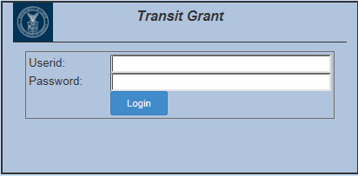
Figure 5: Login Page

Tools
The data listed in the Referral and Certification documents are managed and maintained using different editors. Each menu options listed under the Tool menu are detailed below:

Users

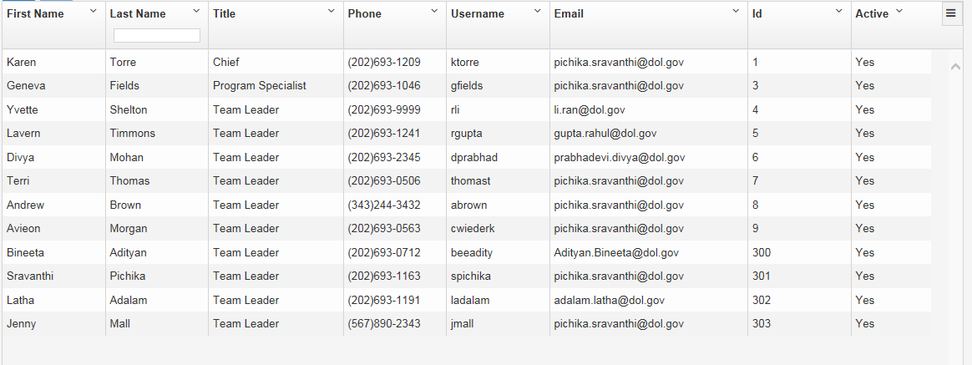
Figure 6. Users Page
Table 3: User Page
Element | Field Type | Comments
Show Active Employees Only: | Check Box | Filer option to hide the inactive users. The check box will be changed by default.
Add | Button | To add new users to the list.
Edit | Button | To update the information related to the existing users.

Table 4: User Editor – Column Information
Element Name | Data Type | Table Name | Column Name
First Name | Varchar | TG_USER | FIRSTNAME
Last Name | Varchar | TG_USER | LASTNAME
Title | Varchar | TG_TITLE | TITLE
Phone | Integer | TG_USER | PHONE
Email | Varchar | TG_USER | EMAIL
Id | Integer | TG_USER | USER_ID
Active | Varchar | TG_USER | ACTIVE
Refer functional permission document for the details of each roles and the corresponding permissions.

State Assignments
Once a grant is received from FTA, the TG user assigned to the location (State) specified in the grant application is responsible for processing the grant application and generate the referral document. The state assignment for each TG Users is maintained though the State Assignments Editor.

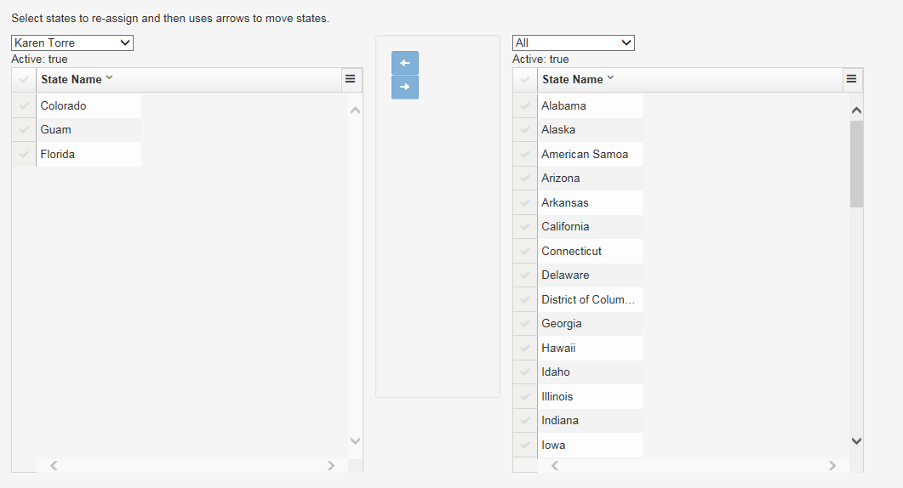
Figure 7 : State Assignments
Table 5: State Assignment Editor
Element Name | Data Type | Table Name | Column Name
State Name | Varchar | TG_STATE | STATE_NAME
<List of name> | Drop Down | TG_USER | FIRSTNAME LASTNAME

Regions
Grants are administered by different FTA regions. Users will not be able to create new regions in the application, however various functions such as; re-Assign states or managing contacts in a region will be allowed.

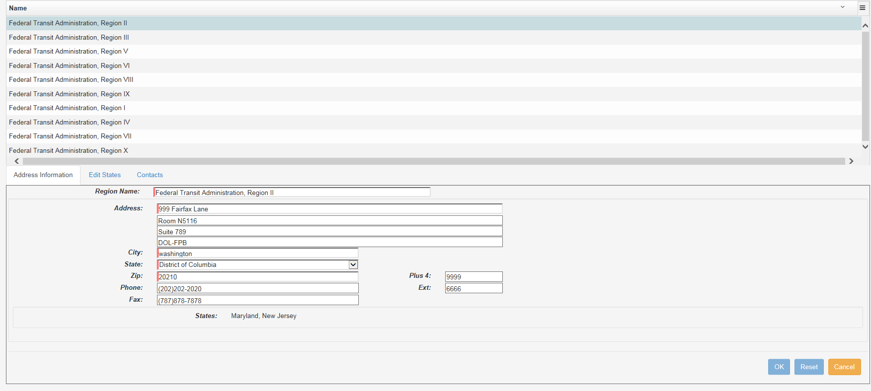
Figure 8: Regions
Table 6:Address Information Tab
Element Name | Data Type | Table Name | Column Name
Region Name | Varchar | TG_STATE | STATE_NAME
Address | Varchar | TG_ADDRESS | ADDRESS_LINE 1  ADDRESS_LINE 2  ADDRESS_LINE 3  ADDRESS_LINE 4
City | Varchar | TG_ADDRESS | CITY
State | Varchar | TG_STATE | STATE_NAME
Zip | Character | TG_ADDRESS | ZIP
Plus 4 | Character | TG_ADDRESS | ZIP_PLUS4
Phone | Character | TG_ADDRESS | PHONE
Ext | Varchar | TG_ADDRESS | EXT
Fax | Character | TG_ADDRESS | FAX

Table 7:Edit States Tab
Element Name | Data Type | Table Name | Column Name
<Region Name> | Drop Down | TG_REGION | REGION_NAME
Name | Varchar | TG_STATE | STATE_NAME

Table 8:Contacts Tab
Element Name | Data Type | Table Name | Column Name
Name | Drop Down | TG_REGION | REGION_NAME
Title | Varchar | TG_STATE | STATE_NAME
On Referral | Based on the field “Include Contact on Referral”
Email | Based on the field “Send Certification Conformation to this Contact”
In Care of | Varchar | TG_CONTACT | IN_CARE_OF_NAME
Send Certification Confirmation to this Contact | Check Box | TG_CONTACT | SEND-REFERRAL_TO_EMAIL
Include Contact on Referral | Check Box | TG_CONTACT | LIST_ON_REFERAL
Same As Region Address | Check Box | TG_CONTACT | SAME_AS_PARENT_ADDRESS

Edit Transit Agencies and their Protections
This page allows the users to create and maintain the profile of all Transit Agencies. The Transit Agency list will be organized by State in this page.
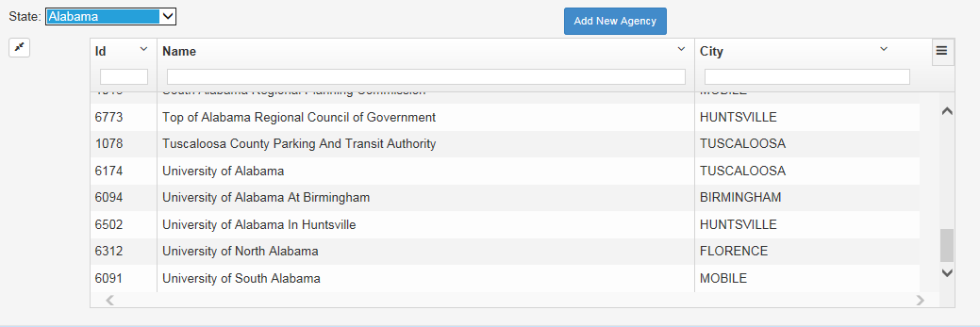
Figure 9: Transit Agency Listing
Table 9:Transit Agency listing
Element | Field Type | Table Name | Column Name
State | Drop Down | TG_STATE | STATE_NAME
Id | Integer | TG_PROVIDER | GRANTEE_ID
Name | Varchar | TG_PROVIDER | PROVIDER_NAME
City | Varchar | TG_ADDRESS | CITY

Add New Agency
The following window will open when clicking the button “Add New Agency” to create new Agency.
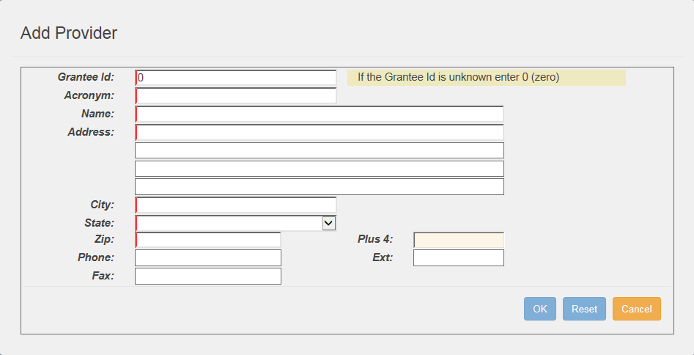
Figure 10: Add New Agency
Table 10:Add Provider
Element Name | Data Type | Table Name | Column Name
Grantee_id | Integer | TG_PROVIDER | GRANTEE_ID
Acronym | Varchar | TG_PROVIDER | PROVIDER_ACRONYM
Name | Varchar | TG_PROVIDER | PROVIDER_NAME
Address | Varchar | TG_ADDRESS | ADDRESS_LINE 1  ADDRESS_LINE 2  ADDRESS_LINE 3  ADDRESS_LINE 4
City | Varchar | TG_ADDRESS | CITY
State | Varchar | TG_STATE | STATE_NAME
Zip | Character | TG_ADDRESS | ZIP
Plus 4 | Character | TG_ADDRESS | ZIP_PLUS4
Phone | Character | TG_ADDRESS | PHONE
Ext | Varchar | TG_ADDRESS | EXT
Fax | Character | TG_ADDRESS | FAX

Edit Existing Agencies and their protections
The Transit Agency’s profile will be maintained in this page.

Agency Information
This tab list the same fields listed in the Add Provider page.
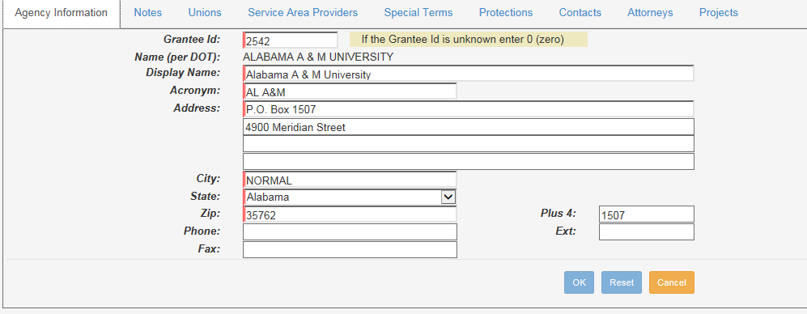
Figure 11. Filer Search Window

Notes
Any additional information about the selected Transit Agency will be added to this page.

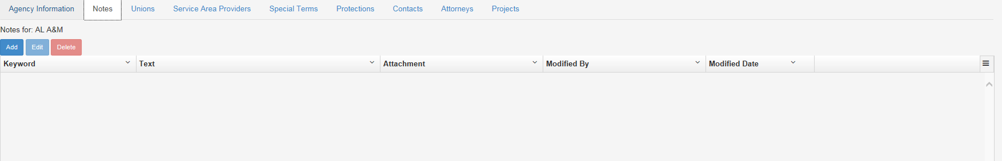
Figure 12: Notes
The following window will open when clicking the “Add” button.

Table 11:Notes
Element Name | Data Type | Table Name | Column Name
Keyword | Varchar | TG_NOTE | KEYWORDS
Text | Integer | TG_NOTE | NOTE_TEXT
Attachments | Varchar | TG_NOTE | NOTE_ATTACHMENT
Modified By | Varchar | TG_USER | FIRSTNAME LASTNAME
Modified Date | Date | TG_NOTE | MOD_DATE

Unions
Agency and the Unions association will be managed via the Unions tab. The tab also lists separate sections that list the unions corresponding to the Service Area Provider associated to the selected agency.

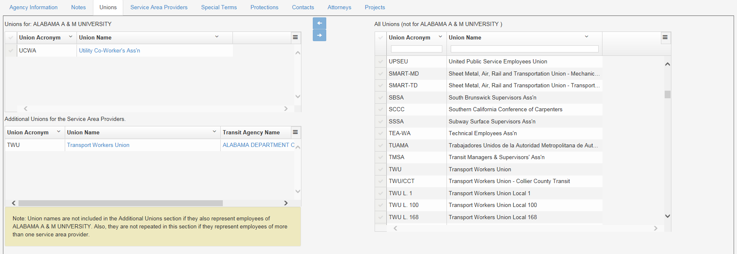
Figure 13: Unions
Table 12:Unions
Element Name | Data Type | Table Name | Column Name
Union Acronym | Varchar | TG_UNION | UNION_ACRONYM
Union Name | Varchar | TG_UNION | UNION_NAME
Transit Agency Name | Varchar | TG_PROVIDER | PROVIDER_NAME

Service Area Providers
The service area providers are the transit agencies serving in the geographic area over which the project is operated, adjacent areas, and the area whose population is served by the transit project.

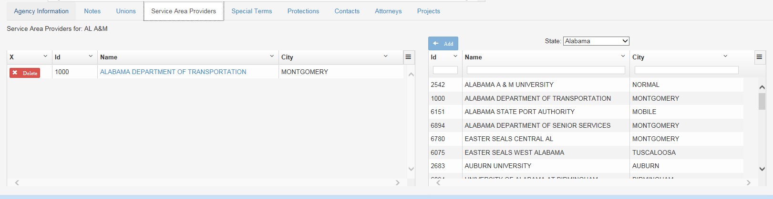
Figure 14: Service Area Providers
Table 13:Service Area Providers
Element Name | Data Type | Table Name | Column Name
ID | Integer | TG_PROVIDER | GRANTEE_ID
Name | Varchar | TG_PROVIDER | PROVIDER_NAME
City | Varchar | TG_ADDRESS | CITY
State | Varchar | TG_STATE | STATE_NAME

Special Terms
The system has a feature to save Special Terms and Conditions that need to appear in the referral document. All terms and conditions added to the selected agency will be listed in the referrals and certificates. Each item will be numbered in the same order as added.

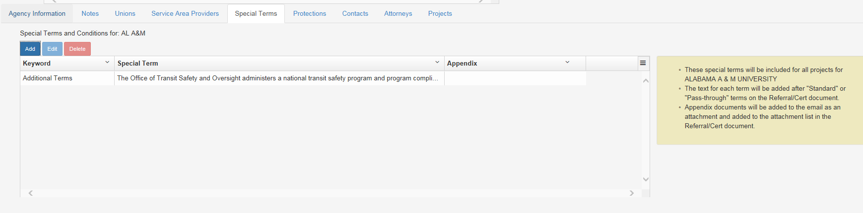
Figure 15: Special Terms

The following window will open when clicking the “Add” button.

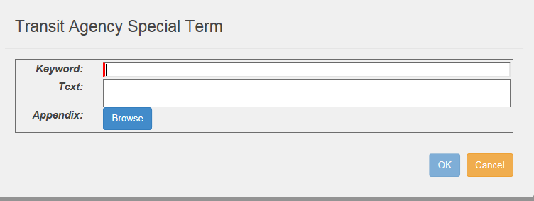
Figure 16: Add New Special Terms
An “Edit” and “Delete” buttons are also provided on this tab for managing the Special Terms added.

Table 14:Special Terms
Element Name | Data Type | Table Name | Column Name
Keywords | Varchar | TG_PROVIDER_TERM | TERM_ACRONYM
Special Terms / Text | Varchar | TG_PROVIDER_TERM | TERM_TEXT
Appendix | Blob | TG_PROVIDER_TERM | TERM_APPENDIX

Protections
The protections page provides a feature to create and manage the protections associated to the Transit Agencies.

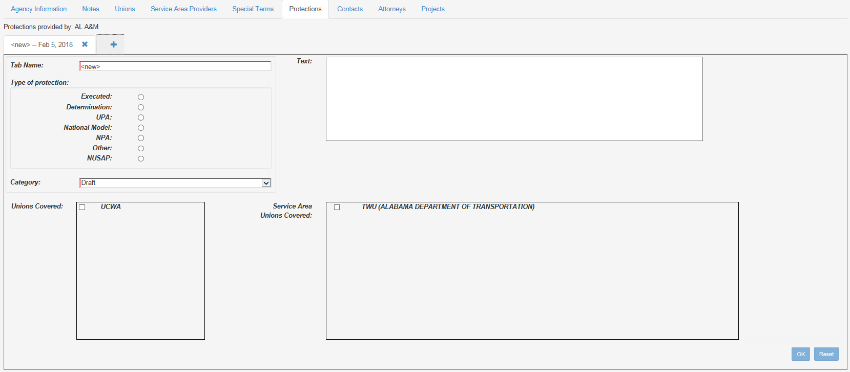
Figure 17: Protections Editor
.
Table 15:Protections
Element Name | Data Type | Table Name | Column Name
Tab Name | Varchar | TG_PROTECTION | PROTECTION_NAME
Type of Protection | Varchar | TG_PROTECTION | EXEC_DETERMINATION
Category | Varchar | TG_CATEGORY | CAT_NAME
Unions Covered | Varchar | TG_UNION | UNION_ACRONYM
Service Area Unions Covered | Varchar | TG_UNION (TG_PROVIDER) | UNION_ACRONYM (PROVIDER_NAME)
Text | Varchar | TG_PROTECTION | PROTECTION_TEXT

Contact
The Contact tab provides a feature to manage the contacts for any transit agency imported to the system.
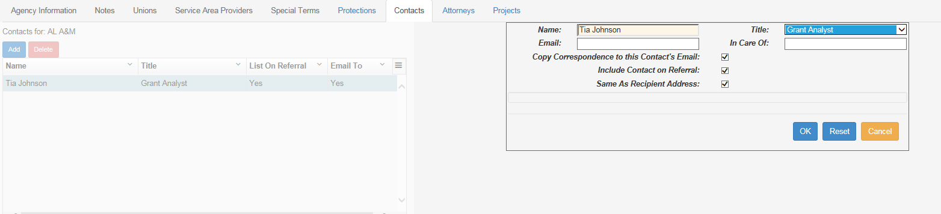
Figure 18: Contact
An “Add” and “Delete” buttons are also provided on this tab for managing the contacts.

Table 16:Contacts Tab
Element Name | Data Type | Table Name | Column Name
Name | Varchar | TG_CONTACT | CONTACT_NAME
Title (column title on the screen) | Varchar | TG_TITLE | TITLE
On Referral | Based on the field “Include Contact on Referral”
Email To | Based on the field “Copy Correspondence to this Contact’s Email”
In Care of | Varchar | TG_CONTACT | IN_CARE_OF_NAME
Email
Title (field listed in the editor) | Drop Down
Copy Correspondence to this Contact’s Email | Check Box | TG_CONTACT | SEND-REFERRAL_TO_EMAIL
Include Contact on Referral | Check Box | TG_CONTACT | LIST_ON_REFERAL
Same As Recipient Address | Check Box | TG_CONTACT | SAME_AS_PARENT_ADDRESS

Attorneys
The Attorneys tab provides a feature to manage the attorneys for any transit agency imported to the system.
Figure 19: Attorneys
An “Add” and “Delete” buttons are also provided on this tab for managing the contacts.
Table 17:Attorneys Tab
Element Name | Data Type | Table Name | Column Name
Name | Varchar | TG_CONTACT | CONTACT_NAME
Title (column title on the screen) | Varchar | TG_TITLE | TITLE
On Referral | Based on the field “Include Contact on Referral”
Email To | Based on the field “Copy Correspondence to this Contact’s Email”
In Care of | Varchar | TG_CONTACT | IN_CARE_OF_NAME
Email
Title (field listed in the editor) | Drop Down
Copy Correspondence to this Contact’s Email | Check Box | TG_CONTACT | SEND-REFERRAL_TO_EMAIL
Include Contact on Referral | Check Box | TG_CONTACT | LIST_ON_REFERAL
Same As Recipient Address | Check Box | TG_CONTACT | SAME_AS_PARENT_ADDRESS

Projects
The Projects tab lists all projects (Grant Applications) associated to the Transit Agency.
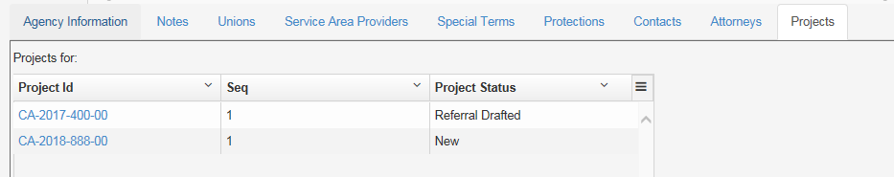
Figure 20: Projects
Table 18:Projects
Element Name | Data Type | Table Name | Column Name
Project Id | Character | TG_PROJECT | PROJECT_ID
Seq | Integer | TG_PROJECT | PROJECT_SEQ
Project Status | Varchar | TG_STATUS | STATUS_DESCRIPTION

Edit Unions
The transit grant system stores the information related to unions representing employees of the grantee, its contractors and/or other service area providers.

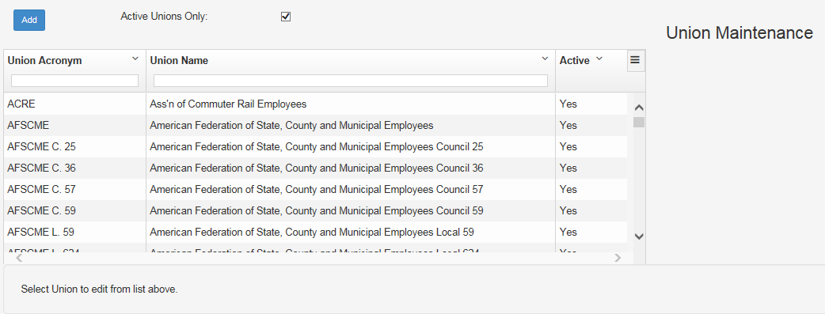
Figure 21: Edit Unions

Add New Union
The following window will open when clicking the button “Add” to create new Union.
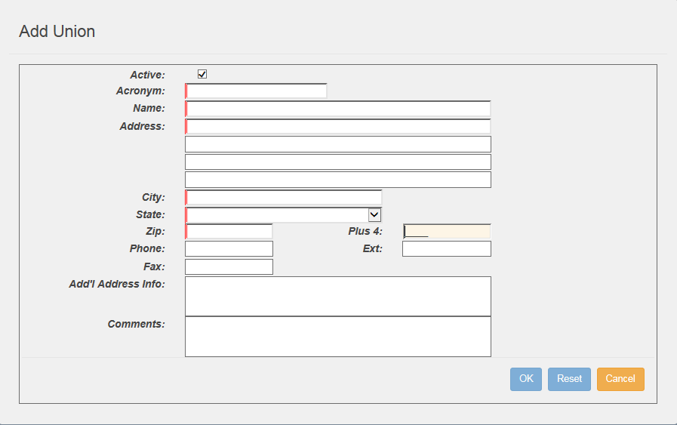
Figure 22: Add New Union
Table 19:Add Union
Element Name | Data Type | Table Name | Column Name
Active | Character | TG_UNION | IS_ACTIVE
Acronym | Varchar | TG_UNION | UNION_ACRONYM
Name | Varchar | TG_UNION | UNION_NAME
Address | Varchar | TG_ADDRESS | ADDRESS_LINE 1  ADDRESS_LINE 2  ADDRESS_LINE 3  ADDRESS_LINE 4
City | Varchar | TG_ADDRESS | CITY
State | Varchar | TG_STATE | STATE_NAME
Zip | Character | TG_ADDRESS | ZIP
Plus 4 | Character | TG_ADDRESS | ZIP_PLUS4
Phone | Character | TG_ADDRESS | PHONE
Ext | Varchar | TG_ADDRESS | EXT
Fax | Character | TG_ADDRESS | FAX
Add’l Address Info | Varchar | TG_ADDRESS | ADDITIONAL_ADDRESS_INFO
Comments | Varchar | TG_ADDRESS | UNION_COMMENTS

Union Information
The Union Information tab will open when selecting any union listed in the “Edit Unions” page.
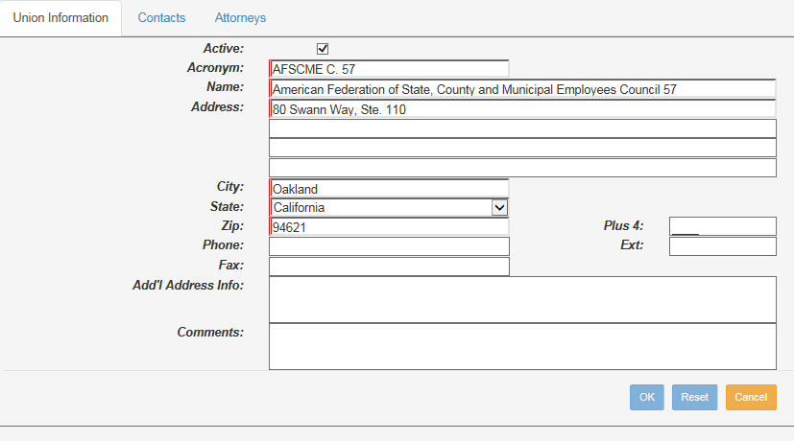
Figure 23: Union Information

Contacts
The Contact tab provides a feature to manage the contacts for the Union selected.
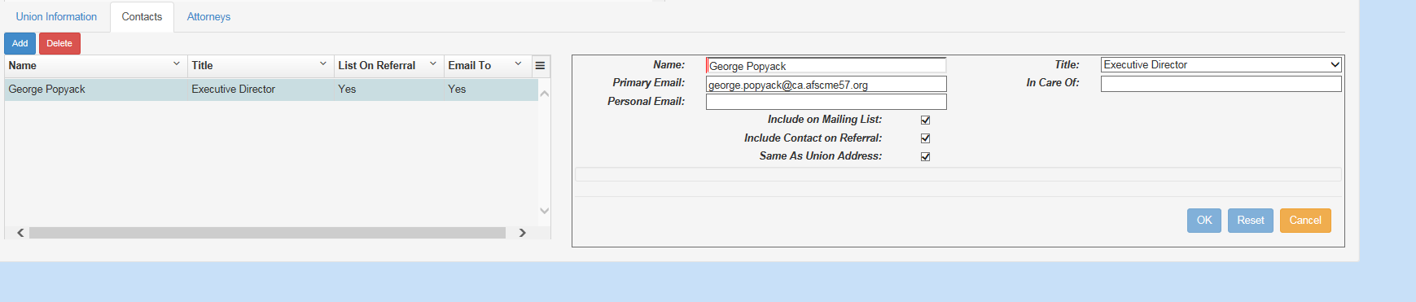
Figure 24: Contact
An “Add” and “Delete” buttons are also provided on this tab for managing the contacts.
Table 20:Contacts Tab
Element Name | Data Type | Table Name | Column Name
Name | Varchar | TG_CONTACT | CONTACT_NAME
Title (column title on the screen) | Varchar | TG_TITLE | TITLE
List On Referral | Based on the field “Include Contact on Referral”
Email To | Based on the field “Copy Correspondence to this Contact’s Email”
In Care of | Varchar | TG_CONTACT | IN_CARE_OF_NAME
Title (field listed in the editor) | Drop Down | TG_TITLE | TITLE
Primary Email | Varchar | TG_CONTACT | EMAIL
Personal Email | Varchar | TG_CONTACT | EMAIL_2
Include on Mailing List | Check Box | TG_CONTACT | SEND-REFERRAL_TO_EMAIL
Include Contact on Referral | Check Box | TG_CONTACT | LIST_ON_REFERAL
Same as Union Address | Check Box | TG_CONTACT | SAME_AS_PARENT_ADDRESS
Address | Varchar | TG_ADDRESS | ADDRESS_LINE 1  ADDRESS_LINE 2  ADDRESS_LINE 3  ADDRESS_LINE 4
City | Varchar | TG_ADDRESS | CITY
State | Varchar | TG_STATE | STATE_NAME
Zip | Character | TG_ADDRESS | ZIP
+4 | Character | TG_ADDRESS | ZIP_PLUS4
Phone | Character | TG_ADDRESS | PHONE
Ext | Varchar | TG_ADDRESS | EXT
Fax | Character | TG_ADDRESS | FAX

Attorneys
The Attorneys tab provides a feature to manage the attorneys for the Union.
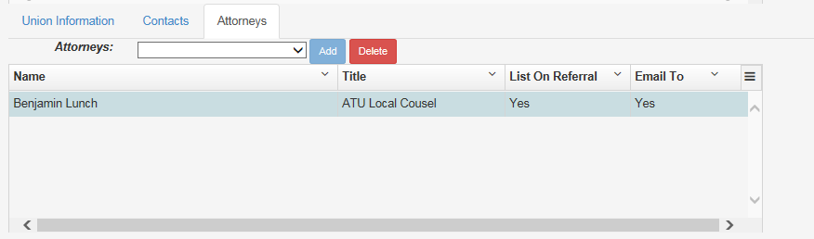
Figure 25: Union Attorneys
An “Add” and “Delete” buttons are also provided on this tab for managing the attorneys.
Table 21:Attorneys Tab
Element Name | Data Type | Table Name | Column Name
Name | Varchar | TG_CONTACT | CONTACT_NAME
Title (column title on the screen) | Varchar | TG_TITLE | TITLE
On Referral | Based on the field “Include Contact on Referral”
Email To | Based on the field “Copy Correspondence to this Contact’s Email”

Edit Attorneys
The Attorneys page provides a feature to manage all attorneys.
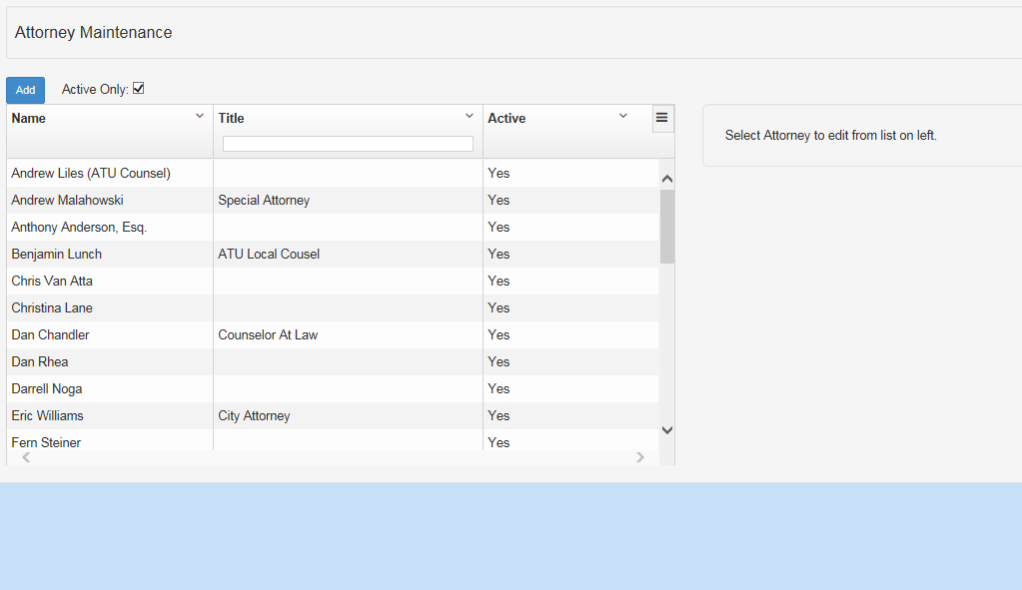
Figure 26: Edit Attorneys
The page has an “Add” button to create new Attorney record. An Active only filer is added to filter only active records to be listed in this page. Unchecking this check box will list the entire list of attorneys, including the inactive ones.

Clicking Add button will open the following page.
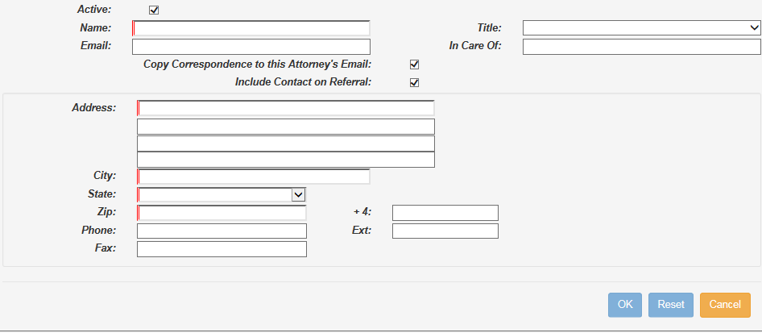
Figure 27: Add New Attorney
Table 22:Add new Attorney
Element Name | Data Type | Table Name | Column Name
Active
Name | Varchar | TG_CONTACT | CONTACT_NAME
Title | Varchar | TG_TITLE | TITLE
Email
In Care of | Varchar | TG_CONTACT | IN_CARE_OF_NAME
Copy Correspondence to this Attorney’s Email | Check Box | TG_CONTACT | SEND-REFERRAL_TO_EMAIL
Include Contact on Referral | Check Box | TG_CONTACT | LIST_ON_REFERAL
Address | Varchar | TG_ADDRESS | ADDRESS_LINE 1  ADDRESS_LINE 2  ADDRESS_LINE 3  ADDRESS_LINE 4
City | Varchar | TG_ADDRESS | CITY
State | Varchar | TG_STATE | STATE_NAME
Zip | Character | TG_ADDRESS | ZIP
+4 | Character | TG_ADDRESS | ZIP_PLUS4
Phone | Character | TG_ADDRESS | PHONE
Ext | Varchar | TG_ADDRESS | EXT
Fax | Character | TG_ADDRESS | FAX

Edit Title
The system will maintain a list of titles. Users will be able to add, edit and delete titles. The page has different tabs for each type of titles.
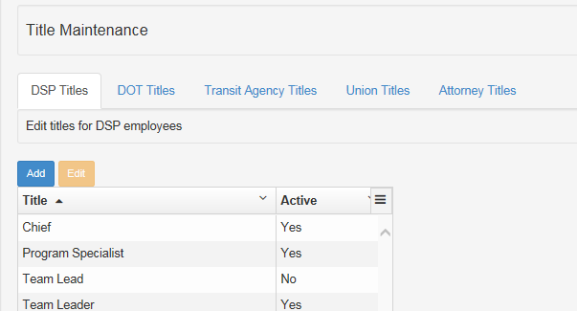
Figure 28: Edit Title
Each tab has an “Add” and “Edit” buttons to create new Title records and edit any existing records. Clicking “Add” button will open the following window.
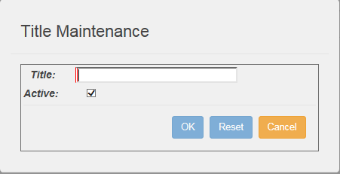
Figure 29: Add New Title

Table 23:Title Maintenance
Element Name | Data Type | Table Name | Column Name
Title | Varchar | TG_TITLE | TITLE
Active | Character | TG_TITLE | ALLOW_SELECTION

Edit Statute
The system will maintain a list of Statues. Users will be able to add new statues, also edit and inactivate existing Statutes.
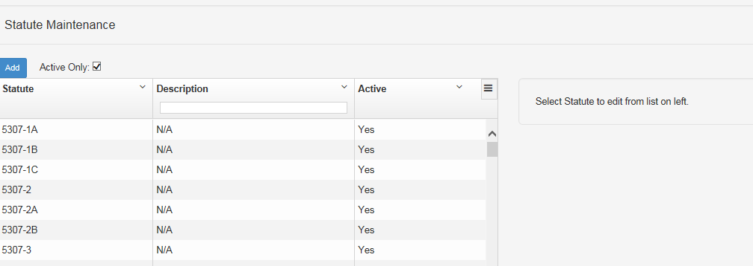
Figure 30: Edit Statute
An “Add” button is listed in this page to add new Statutes to the list. Clicking “Add” button will open the following window.
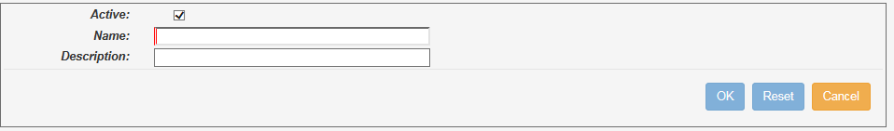
Figure 31: Add new Statute

Table 24:Statute
Element Name | Data Type | Table Name | Column Name
Active | Character | TG_STATUTE | ACTIVE
Name | Varchar | TG_STATUTE | STATUE
Description | Varchar | TG_STATUTE | STATUTE_DESCRIPTION

Edit Terms
The system will maintain a list of standard terms and conditions that needs to be listed in the Referral and Cert documents. The Users will be able to update the text through this page.
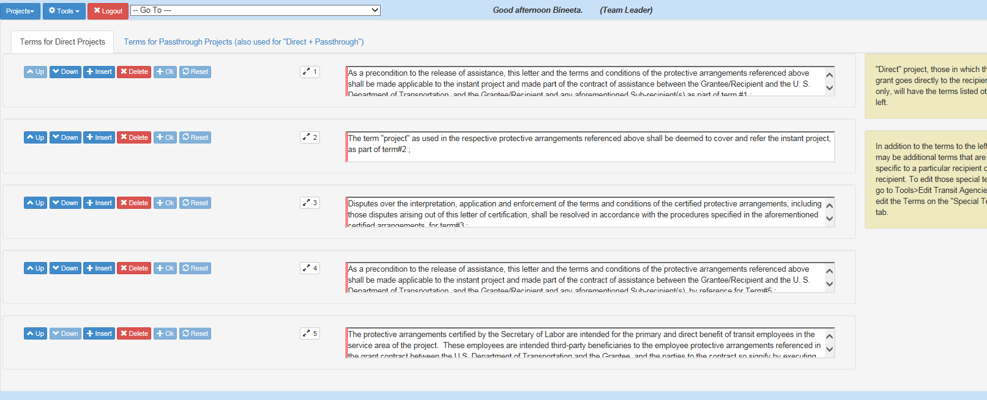
Figure 32: Edit Terms

Table 25:Terms
Element Name | Data Type | Table Name | Column Name
Text field | Varchar | TG_TERM | TEXT
Sequence Number listed | Integer | TG_TERM | Seq

Edit UPA, NPA and National Model
This page lists the UPA, NPA and National Model Protections. The user will use this editor to maintain the Text, Date and any attachments that are commonly used for these type of protections.
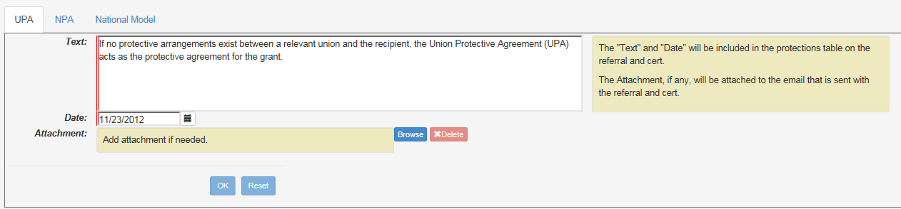
Figure 33: UPA NPA and National Model

Table 26:UPA NPA and National Model
Element Name | Data Type | Table Name | Column Name
Tab Name | Varchar | TG_STANDARD_AGREEMENT | AGREEMENT_NAME
Text | Varchar | TG_STANDARD_AGREEMENT | TEXT
Date | Date | TG_STANDARD_AGREEMENT | AGREEMENT_DATE
Attachment | Blob | TG_STANDARD_AGREEMENT | ATTACHMENT

Incoming/Ougoing Email Text
This page maintains the incoming and outgoing email text. The page let the user to update the outgoing email text.
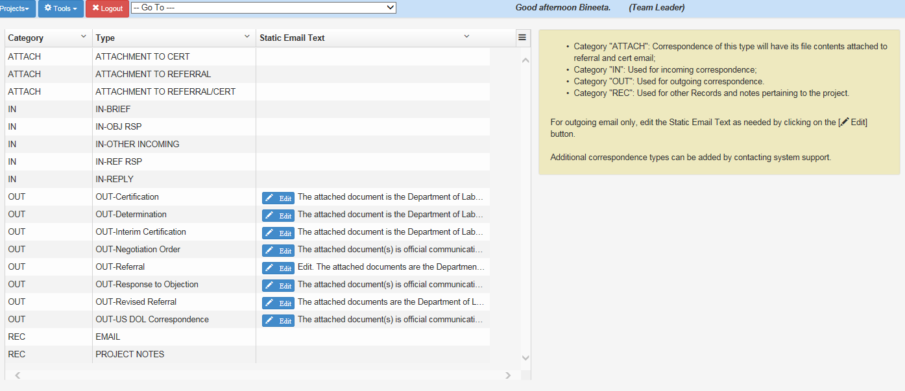
Figure 34: Incoming Outgoing email

Table 27:Incoming/Outgoing Email
Element Name | Data Type | Table Name | Column Name
Category | Varchar | TG_CORRESPONDENCE_TYPE | IN_OUT
Type | Varchar | TG_CORRESPONDENCE_TYPE | DESCRIPTION
Static Email Text | Clob | TG_CORRESPONDENCE_TYPE | EMAIL_TEXT

Projects
The grant application being tracked is known within the application as a project. FTA email the grant application to a secured email box. The Transit Grant application is connected to this email box and periodically checks for new emails. When found a new email, it validates the authenticity as well as the data condition. All successfully processed emails will be placed in the eLORS database.

Creating the Project record
The grant application file received from FTA shall be in a predetermined format (.xml) agreed upon by FTA and DSP. This application file will include the following data set.
Table 28:XML data set
Element Name | Description | Data Type
ProjectID | Federal Award Identification Number (FAIN) | String
applicationName | A short description of the project | String
Recipient
id | Recipient ID | String
name | Recipient’s Name | String
addressLine1 | Recipient’s address line 1 | String
addressLine2 | Recipient’s address line 2 | String
city | City from Recipient’s address | String
state | State from Recipient’s address | String
zip | Zip code Recipient’s address | String
Recipient’s Contact
name | Recipient’s Name | String
phone | Recipient’s Phone number | String
email | Recipient’s email address | String
FTA Contact
name | FTA Contact person’s Name | String
phone | FTA Contact person’s Phone number | String
email | FTA Contact person’s email address | String
Funding Source (may list more than 1 funding source)
statute | Funding source | String
amount | Amount listed | String
Recipient
id | Recipient ID | String
name | Recipient’s Name | String
addressLine1 | Recipient’s address line 1 | String
addressLine2 | Recipient’s address line 2 | String
city | City from Recipient’s address | String
state | State from Recipient’s address | String
Once the validation is completed the data will be imported to the eLORS database. A project record will be added to the project page. If the Transit Agency listed in the application file does not exist in the database, the system will create a new Transit Agency and the related data will be added to that agency.

Project Listing
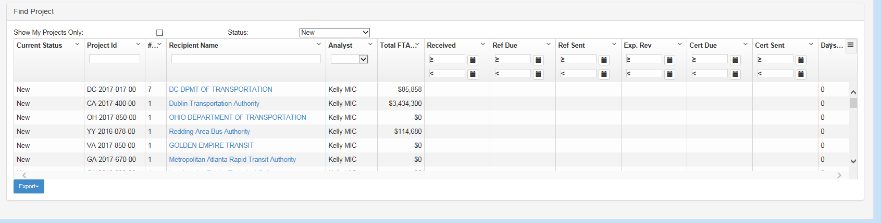
Figure 35: Project Listing
Table 29:Project List View
Element Name | Data Type | Table Name | Column Name
Current Status | Varchar | TG_STATUS | STATUS_DESCRIPTION
Project Id | Character | TG_PROJECT | PROJECT_ID
# | Integer | TG_PROJECT | PROJECT_SEQ
Recipient Name | Varchar | TG_PROVIDER | PROVIDER_NAME
Analyst | Varchar | TG_USER | FIRSTNAME LASTNAME
Total FTA | Integer | TG_PROJECT_STATUTE | AMOUNT
Received | Date | TG_PROJECT | RECEIVED DATE
Ref Due | Date | TG_PROJECT | REF_DUE_DATE
Ref Sent | Date | TG_PROJECT | REF_SENT_DATE
Exp. Rev | Date | TG_PROJECT | REF_EXPIRE
Cert Due | Date | TG_PROJECT | CERT_DUE_DATE
Cert Sent | Date | TG_PROJECT | CERT_SENT_DATE
Days | Number of days since the project is acknowledged

Table 30:DSP Project Definition section.
Element Name | Data Type | Table Name | Column Name
Project Id | Character | TG_PROJECT | PROJECT_ID
Recipient ID | Integer | TG_PROVIDER | GRANTEE_ID
Total FTA Amount | Sum of the mount corresponding to all active Statute codes listed in the XML file.
Project Manager | Varchar | TG_PROJECT | PROJECT MANAGER
Statutes Code | Varchar | TG_STATUTE | STATUTE
Amount | Varchar | TG_STATUTE | Amount
Status | Character | TG_STATUTE | ACTIVE
Project Description | Varchar | TG_PROJECT | PROJECT_INFO
Recipient Name | Varchar | TG_PROVIDER | PROVIDER_NAME
Point of Contact | Varchar | TG_USER | RECIP_POINT_OF_CONTACT
Analyst (Drop down list) | Varchar | TG_USER | FIRSTNAME LASTNAME
Category | Varchar | TG_CATEGORY | CAT_NAME
Referral Required | Varchar | TG_PROJECT | REFERRAL_NEEDED
Direct | Varchar | TG_PROJECT | PASS_THROUGH
Table 31:Sub-Recipients
Element Name | Data Type | Table Name | Column Name
Id | Integer | TG_PROVIDER | GRANTEE_ID
Name | Varchar | TG_PROVIDER | PROVODER_NAME
City | VARCHAR | TG_ADDRESS | CITY
Table 32: Objects, Other correspondence, notes and attachments
Element Name | Data Type | Table Name | Column Name
Type | Varchar | TG_CORRESPONDENCE_TYPE | DESCRIPTION
Date | Date | TG_PROJECT_CORRESPONDENCE | RECEIVED_DATE
Attachment | Varchar | TG_NOTE | FILE_NAME
Sufficient | Character | TG_PROJECT_CORRESPONDENCE | OBJECTION_SUFFICIENT
Timely | Character | TG_PROJECT_CORRESPONDENCE | OBJECTION_TIMELY
Response | Date | TG_POJECT_CORRESPONDENCE | RESPONSE_DATE
Keyword | Varchar | TG_NOTE | KEYWORDS
Comment | Varchar | TG_NOTE | NOTE_TEXT

Login/Logout
The application uses the Windows login username and password. An Active Directory group determines whether a user has access to the application. A validated user may access only those application components that the user has permission to use. The user may not access any other OLMS applications through Transit Grant.

Login Page
The Transit Grant login page (Figure 7) enables the user to login to the Transit Grant application.
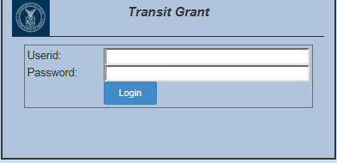
Figure 36. Transit Grant Login Page

Logout
The Landing page displays for users assigned the User role after the user’s login has been verified and authenticated.
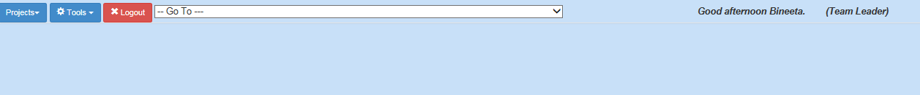
Figure 37. Landing Page

Logout – Logs out user, and displays Transit Grant Login page (Figure 7).
Logout ends the user’s session.

File and Database Design
The design is based on the need to maintain similarity with existing OLMS applications while improving overall application and database efficiency.

Database Management Application Files
This section shows the final design of the DBMS files.

Logical Database Design
The logical data model (Figure 9) organizes data in terms of entities and relationships without regard to the data management technology.
Figure 38. Logical Data Model

Data Flow
The Data Flow Diagram (Figure 10) illustrates high level processes and data flows through each process.
Figure 39. High Level Data Flow Diagram

Physical Database Design
The physical database design specifies the physical configuration of the database on the storage media. It also includes database artifacts required to create relationships between tables.
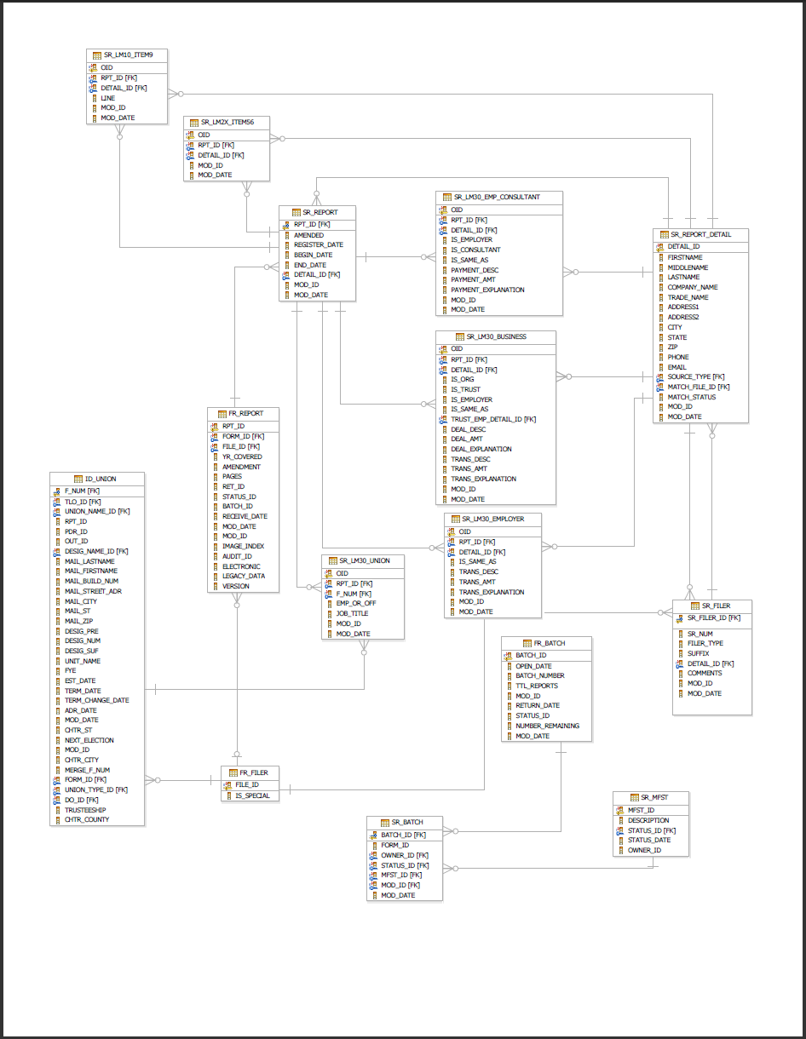
Figure 41. Physical Database

Database Tables
Table 32 through Table 70 list the tables accessed by Transit Grant.
Table 33:TG_ADDRESS
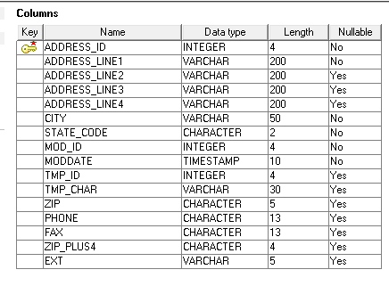
Table 34:TG_CATEGORY
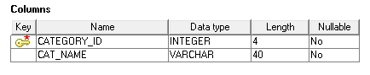
Table 35:TG_CONTACT
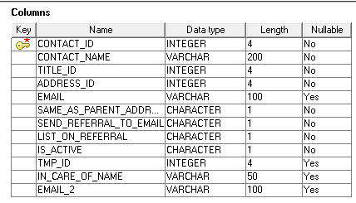
Table 36:TG_CORRESPONDENCE_TYPE
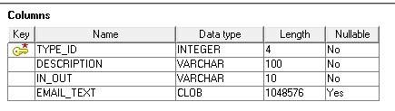
Table 37:TG_KEYWORD
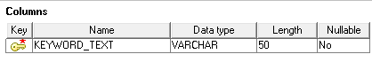
Table 38:TG_NOTE
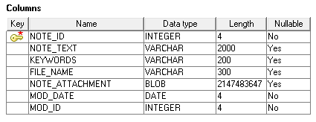
Table 39:TG_CONTACT
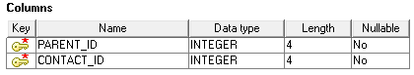
Table 40:TG_PROJECT
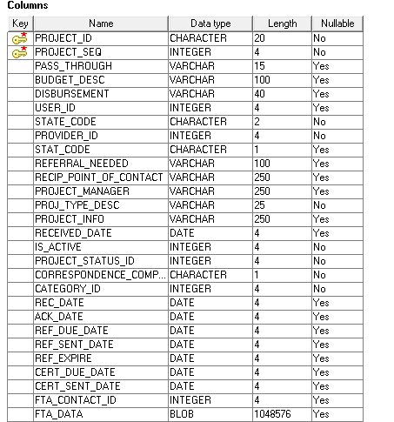
Table 41:TG_PROJECT_CERTIFICATION
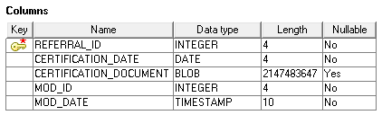
Table 42:TG_PROJECT_CERTIFICATION
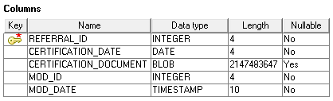
Table 43:TG_CONTACT
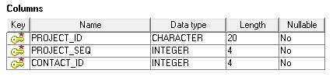
Table 44:TG_PROJECT_CORRESPONDENCE
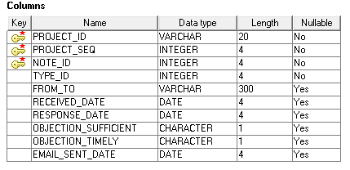
Table 45:TG_PROJECT_PROVIDER
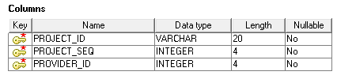
Table 46:TG_PROJECT_REFERRAL
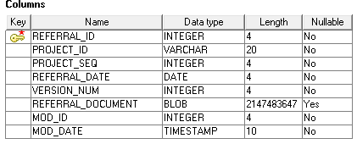
Table 47:TG_PROJECT_SNAP
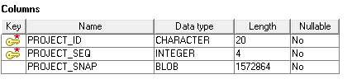
Table 48:TG_PROJECT_STATUS
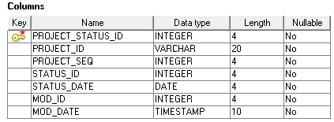
Table 49:TG_PROJECT_STATUTE
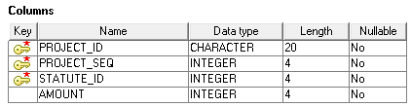
Table 50:TG_PROJECT_UNION
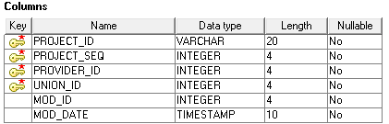
Table 51:TG_PROT-UNION
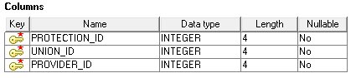
Table 52:TG_PROTECTION
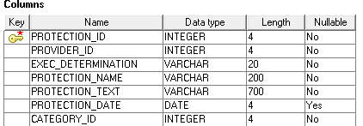
Table 53:TG_PROTECTION_NUSAP
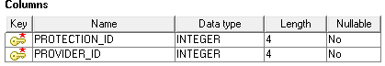
Table 54:TG_PROTECTION_OTHER
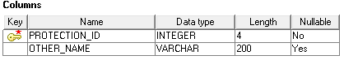
Table 55:TG_PROVIDER
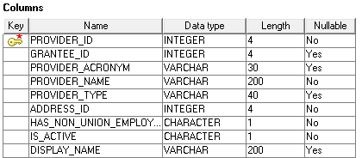
Table 56:TG_PROVIDER_AREA_PROVIDER
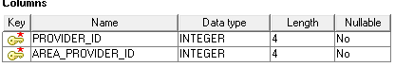
Table 57:TG_PROVIDER_CONTACT
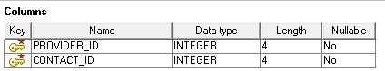
Table 58:TG_PROVIDER_NOTE
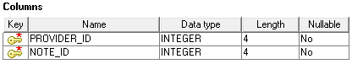
Table 59:TG_PROVIDER_TERM
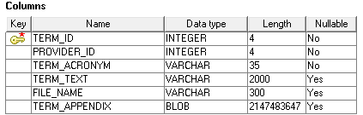
Table 60:TG_PROVIDER_UNION
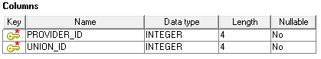
Table 61:TG_REGION
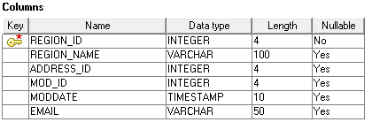
Table 62:TG_REGION_CONTACT
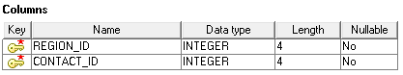
Table 63:TG_STANDARD_AGREEMENT
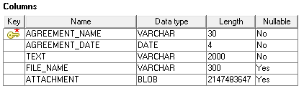
Table 64:TG_STATE
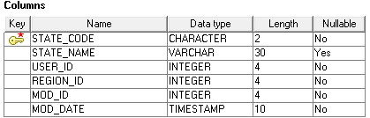
Table 65:TG_STATUS
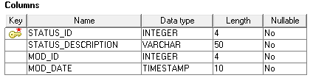
Table 66:TG_STATUTE
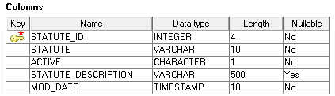
Table 67:TG_TERM
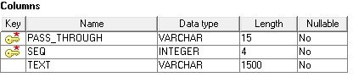
Table 68:TG_TITLE
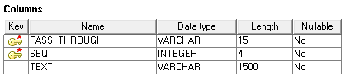
Table 69:TG_UNION
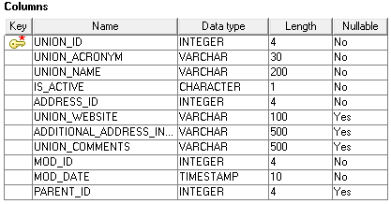
Table 70:TG_UNION_CONTACT
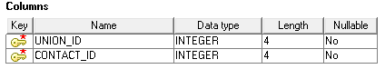
Table 71:TG_USER
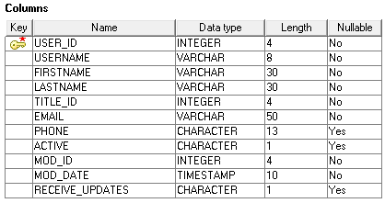
Table 72:TG_USER_SIGNATURE
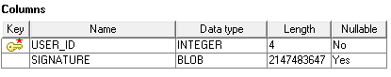

DBMS File Size
The database uses less than five (5) megbites for data storeage.

Frequency of Database Update
Typically, the database is updated three (3) to five (5) times per week.

Input/Output Design
This section provides the detailed design of the application’s inputs and outputs.

Application Input Design
This section provides data element definitions, the layout of all input data pages, and a graphic representation of each interface. Graphics are named. All data elements associated with each page are defined or referenced.

Landing Page
The Landing page (Figure 13) displays for users assigned the user’s role after the user’s login has been verified and authenticated.
Figure 42. Landing Page
The navigation links are as follows:
- Tools – Menu item to navigate to different tools.
- Project – Menu item to navigate to the Project and FTA email listing page.
- Logout – Logs out user, and displays Transit Grant Login page (Figure 7).

Detailed Application Requirements Derived from Functional Requirements

Please refer to the Software Requirements Specification for detailed application requirement derived from the functional requirements.

Database Schema

Figure 43. Transit Grant Database Schema

Stored Procedures

