E-COMMERCE DATA ANALYTICS
END-TO-END DATA ANALYTICS PROJECT REPORT
From Raw Transaction Data to Final Power BI Business Intelligence Report

Project Component | Source / Technology
Raw dataset | data.csv
Data preparation & exploratory analysis | Python / Pandas / NumPy / Matplotlib / Seaborn
Prepared analysis dataset | ecommerce_analysis_ready (2).xls.xlsx
SQL analysis | MySQL — sql ecomers analysis.sql
Final BI report | Microsoft Power BI — POWER BI LASTS.pbix

Dataset period analyzed: 01 December 2010 to 09 December 2011
Prepared as a comprehensive project / portfolio report

Table of Contents
- 1. Executive Summary
- 2. Business Problem and Objectives
- 3. Source Files and Project Architecture
- 4. Raw Dataset Profiling
- 5. Data Cleaning and Transformation in Python
- 6. Data Quality Findings
- 7. Prepared Analysis Dataset
- 8. Exploratory Data Analysis
- 9. MySQL Database and SQL Analysis
- 10. Excel Analysis and Validation
- 11. Power BI Data Model and Measures
- 12. Final Power BI Report
- 13. Detailed Dashboard Page Analysis
- 14. Data-Driven Business Findings
- 15. Business Recommendations
- 16. Limitations and Data-Quality Caveats
- 17. Final Validation and Deployment Checklist
- 18. Conclusion
- Appendix A — Key Metrics
- Appendix B — SQL Query Inventory
- Appendix C — Python Notebook Workflow

1. Executive Summary
This project is an end-to-end e-commerce analytics solution built from raw transactional data through Python preparation, SQL analysis, Excel validation, and an interactive Power BI report. The raw dataset contains 541,909 transaction rows and 8 original columns. The final prepared analysis table contains 536,482 rows and 20 columns, including transaction classification and derived calendar fields.
The final analysis identifies 25,900 distinct orders, 4,372 identified customers, 4,070 unique stock codes, and 38 countries. Sales quantity totals 5,437,786 units, while cancellation quantity is 274,732 units. There are 3,836 cancelled orders, corresponding to an order-level cancellation rate of 14.81% using the project's cancelled-order / total-order definition.
The Power BI report contains five pages: Executive Overview, Product Analysis, Customer Analysis, Country Analysis, and Cancellation Analysis. The report combines KPI cards, slicers, trend charts, ranking visuals, and detailed tables to support both management-level monitoring and detailed investigation.

Headline findings
- The United Kingdom dominates the dataset with 23,494 orders (90.71% of all orders) and 4,511,107 sales quantity (82.96% of sales quantity).
- November 2011 is the strongest month by sales quantity at 749,765 units and also has the highest order count at 3,462 orders.
- Cancellation activity peaks in October 2011 by cancelled orders in the prepared dataset, with 441 cancelled orders.
- The top 10 products contribute 8.58% of sales quantity, while the top 10 customers by quantity contribute 15.28%.
- The notebook calculates revenue measures during analysis: sales transaction value is £14,138,243.60, cancellation value is £714,303.20, producing an implied net value of £13,423,940.40. These revenue fields were not included in the final exported 20-column analysis table or the SQL table definition, so they should be treated as exploratory rather than final dashboard KPIs.

2. Business Problem and Objectives
The project addresses the need to convert a large transactional e-commerce dataset into an interactive analytical solution that can answer practical business questions about orders, products, customers, countries, sales quantity, and cancellations.

2.1 Business questions
- How large is the overall order, customer, product, and quantity activity?
- Which products generate the highest sales quantity?
- Which customers place the highest number of orders or purchase the highest quantity?
- Which countries contribute the most orders, customers, and quantity?
- How does sales quantity change month by month?
- Where and when are cancellations concentrated?
- Which products show unusually high cancellation quantity?
- How can the results be converted into operational recommendations?

2.2 Project objectives
- Profile and understand the raw data.
- Clean and transform the dataset in Python.
- Create reusable analytical fields such as transaction type and calendar attributes.
- Validate business measures through SQL and Excel.
- Build an interactive Power BI model and DAX measures.
- Develop a multi-page BI report for executive and detailed analysis.
- Produce evidence-based findings and recommendations.

3. Source Files and Project Architecture
Stage | File | Role
1. Raw data | data.csv | Original 541,909-row transaction dataset.
2. Python workflow | ecommerce_analysis_ready.csv(1).ipynb | Profiling, cleaning, feature engineering, EDA, and export.
3. Prepared Excel | ecommerce_analysis_ready (2).xls.xlsx | 20-column analysis dataset plus KPI and analytical worksheets.
4. SQL | sql ecomers analysis.sql | Database table definition and business-analysis queries.
5. Power BI | POWER BI LASTS.pbix | Final interactive dashboard and DAX-based analysis.

The intended architecture is: Raw Data → Python Cleaning/EDA → Prepared Dataset → MySQL/Excel Validation → Power BI Modeling and DAX → Interactive Dashboard → Business Insights.
This architecture is appropriate for a portfolio-level analytics project because it demonstrates the complete workflow rather than relying on a single visualization tool.

4. Raw Dataset Profiling
The raw CSV contains 541,909 rows and 8 columns.
Field | Type / Role | Raw finding
InvoiceNo | Transaction identifier | 25,900 distinct invoice numbers
StockCode | Product identifier | 4,070 distinct stock codes
Description | Product description | 1,454 missing values
Quantity | Transaction quantity | 10,624 negative values
InvoiceDate | Transaction timestamp | No parsing failures in notebook
UnitPrice | Unit price | 2,515 zero-price rows; 2 negative-price rows in raw data
CustomerID | Customer identifier | 135,080 missing values (24.93%)
Country | Geography | 38 countries

The raw dataset is transaction-level rather than already aggregated. This is important because a single invoice can contain multiple product rows, so order counts must generally use DISTINCTCOUNT/unique InvoiceNo rather than row counts.

4.1 Raw data quality
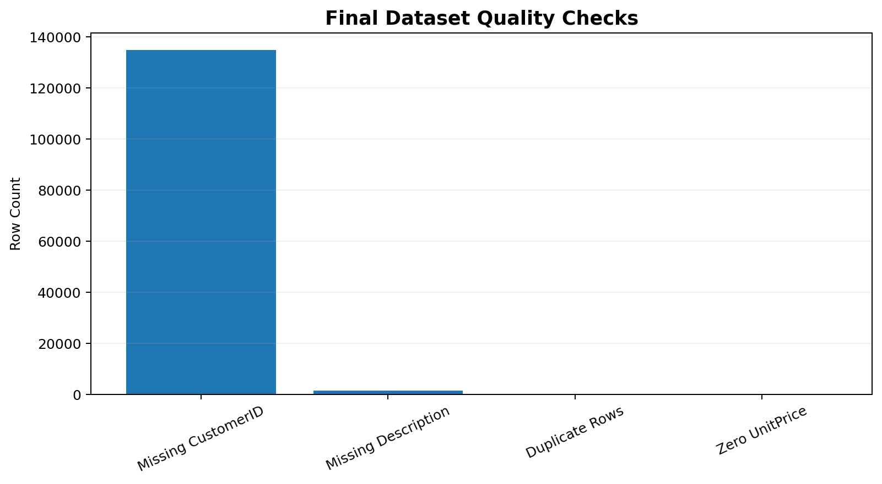
Figure 1. Final prepared-dataset quality checks; raw-data missingness was higher before preparation.
The largest raw-data quality issue is missing CustomerID information. Nearly one quarter of raw rows have no customer identifier. This does not necessarily mean the transactions should be deleted: the transactions remain useful for product, country, date, and quantity analysis. Instead, customer-level analysis should explicitly distinguish identified customers from unknown customers.

5. Data Cleaning and Transformation in Python
The notebook is structured as a practical exploratory and preparation workflow. It begins with environment/file checks, loads the raw CSV using Latin-1 encoding, profiles the dataset, examines missingness, converts the date field, removes duplicates, classifies transactions, creates analytical quantity fields, derives calendar attributes, performs exploratory analysis, and exports the final analysis table.

5.1 Loading and inspection
- The notebook checks the current working directory and available files.
- The CSV is loaded with encoding='latin1' and low_memory=False.
- head(), tail(), columns, dtypes, info(), and describe(include='all').T are used for initial inspection.
- A missing-value summary is created with both count and percentage.

5.2 Date transformation
InvoiceDate is converted with pandas to_datetime(..., format='mixed', errors='coerce'). The notebook then derives Date, Year, MonthNumber, MonthName, Quarter, Day, DayName, Hour, and MonthYear.
Derived field | Purpose
Date | Date-level filtering and time analysis
Year | Annual filtering/grouping
MonthNumber | Chronological month sorting
MonthName | Readable month labels
Quarter | Quarter-level analysis
Day | Day-of-month analysis
DayName | Day-of-week analysis
Hour | Intraday pattern analysis
MonthYear | Monthly trend grouping

5.3 Duplicate handling
The notebook explicitly calculates duplicates and then runs drop_duplicates(). The raw file contains 5,268 duplicate rows (0.97% of raw rows). The final prepared table contains no exact duplicate rows.

5.4 Transaction classification
The analysis uses transactionaltype with Sale and Cancellation categories. SalesQty is created so that sales rows carry their quantity and cancellation rows carry zero. CancellationQty is created so that cancellation rows use the absolute value of their negative quantity and sale rows carry zero.

5.5 Revenue exploration
The notebook also calculates Revenue, SalesRevenue, and CancellationValue. These are useful exploratory financial measures, but the final exported analysis_df intentionally contains 20 fields and excludes those three revenue fields. Therefore, this project should not describe the Power BI report as a revenue dashboard unless revenue is explicitly added later.

5.6 Customer handling
The notebook creates customer_df using CustomerID.notna() for customer-level analysis and creates a CustomerStatus field to distinguish Unknown Customer from Identified Customer. The exported 20-column table does not include CustomerStatus.

6. Exploratory Data Analysis
The notebook explores transaction type, country performance, product performance, customer activity, monthly trends, day-of-week behavior, hourly activity, correlations, and quantity outliers.

6.1 Overall transaction profile
Metric | Value
Final rows | 536,482
Distinct orders | 25,900
Identified customers | 4,372
Countries | 38
Products / stock codes | 4,070
Sales quantity | 5,437,786
Cancellation quantity | 274,732
Cancelled orders | 3,836
Sale orders | 22,064
Cancellation order rate | 14.81%

6.2 Monthly sales trend
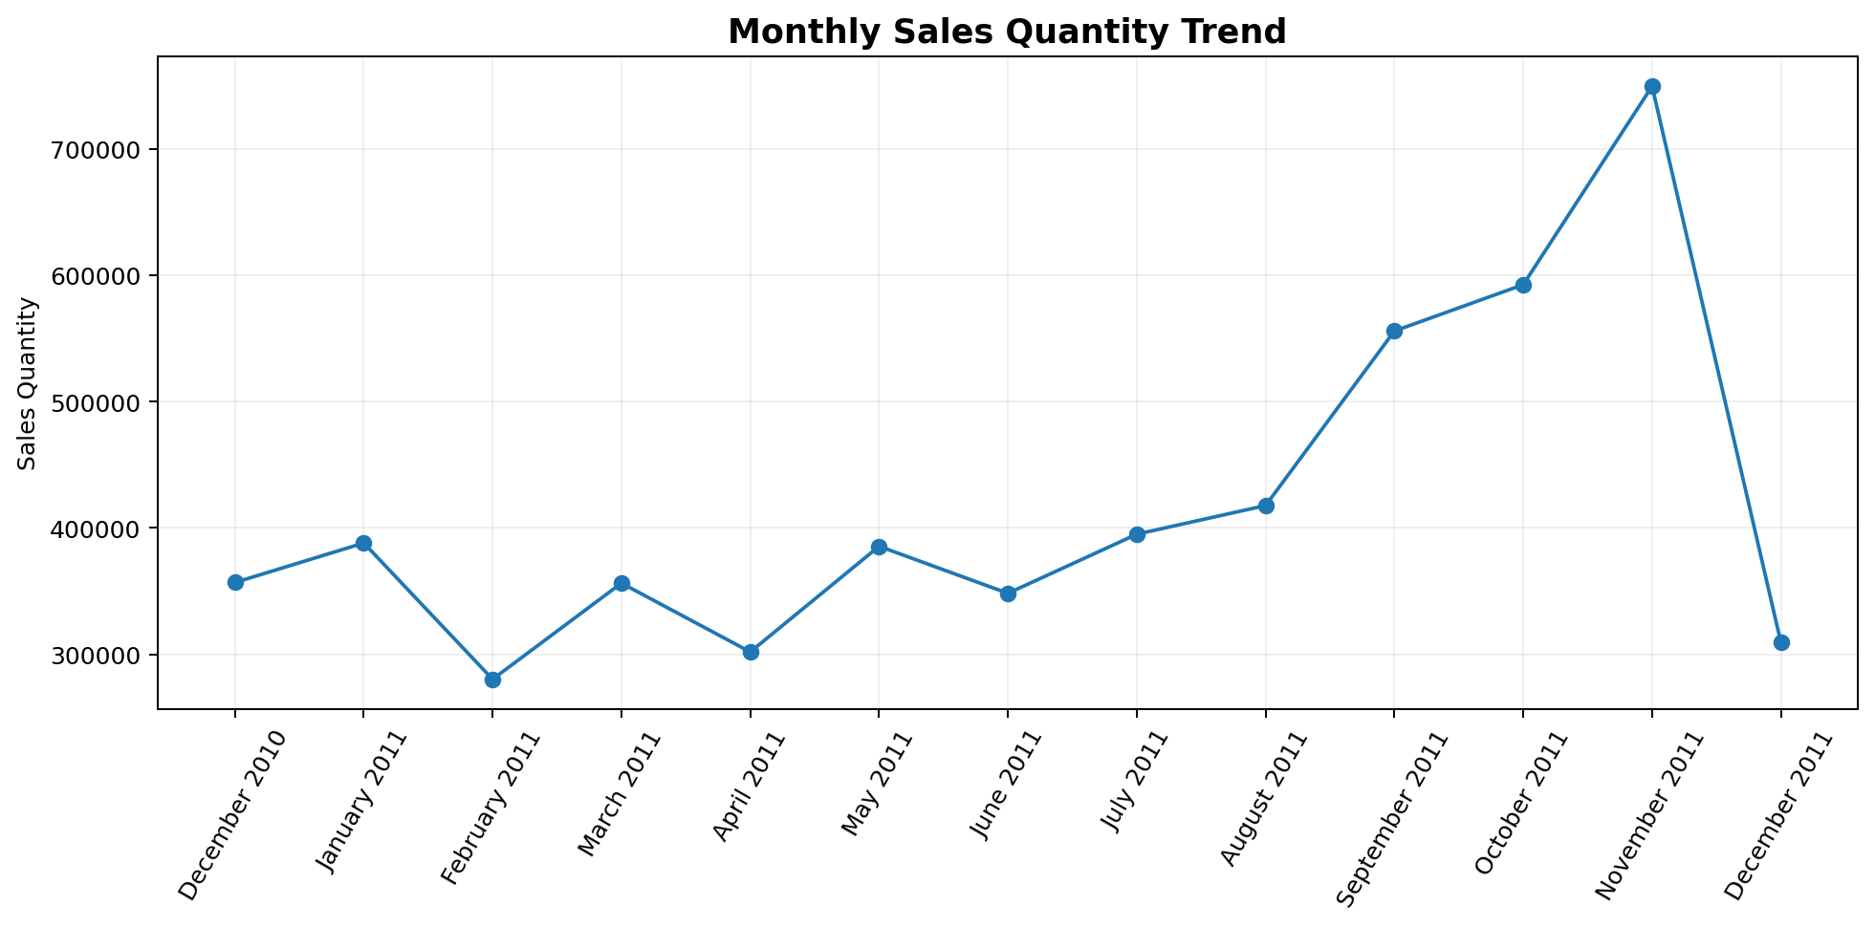
Figure 2. Monthly sales quantity trend from December 2010 through December 2011.
November 2011 is the peak month by sales quantity at 749,765 units. It also has the highest number of orders at 3,462. September and October also show strong activity, while February is materially lower than the surrounding months.

6.3 Geographic performance
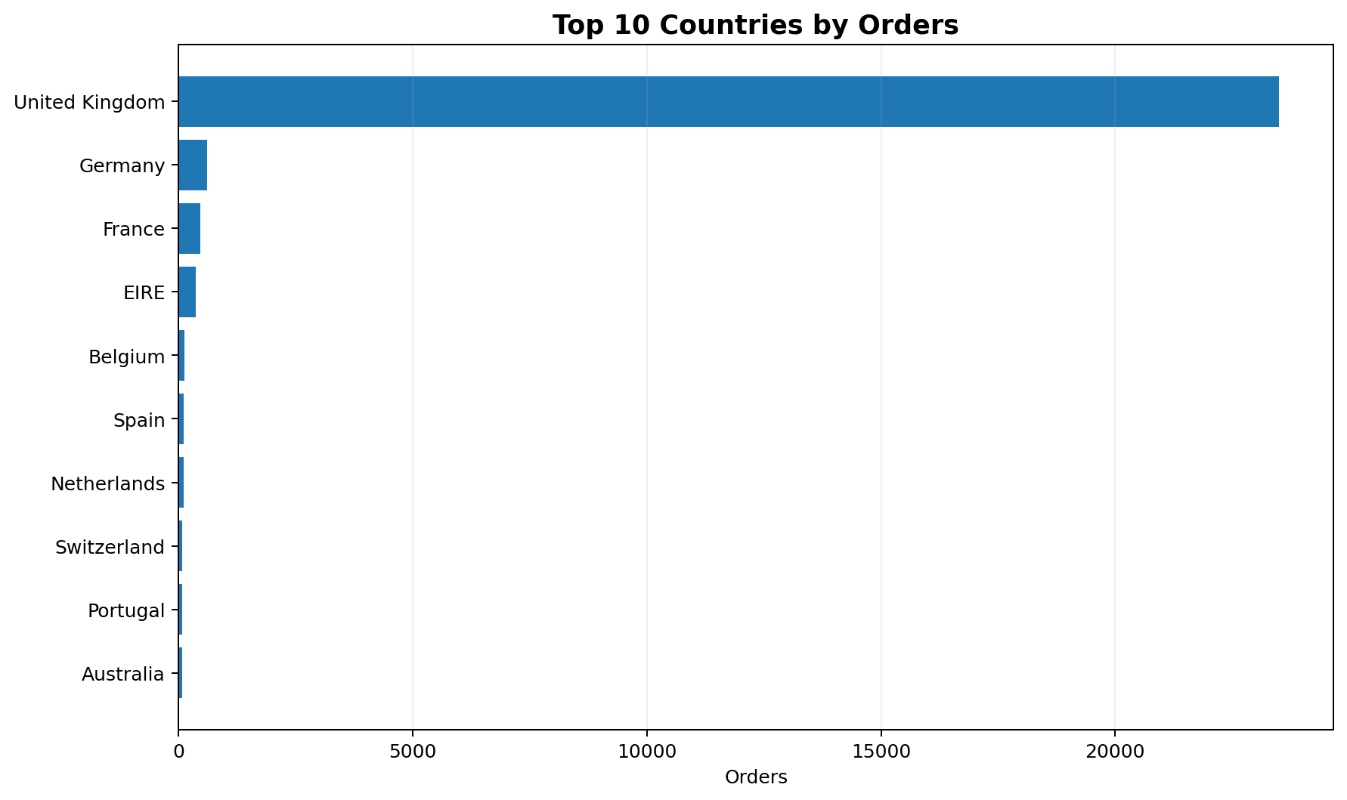
Figure 3. Top 10 countries by distinct order count.
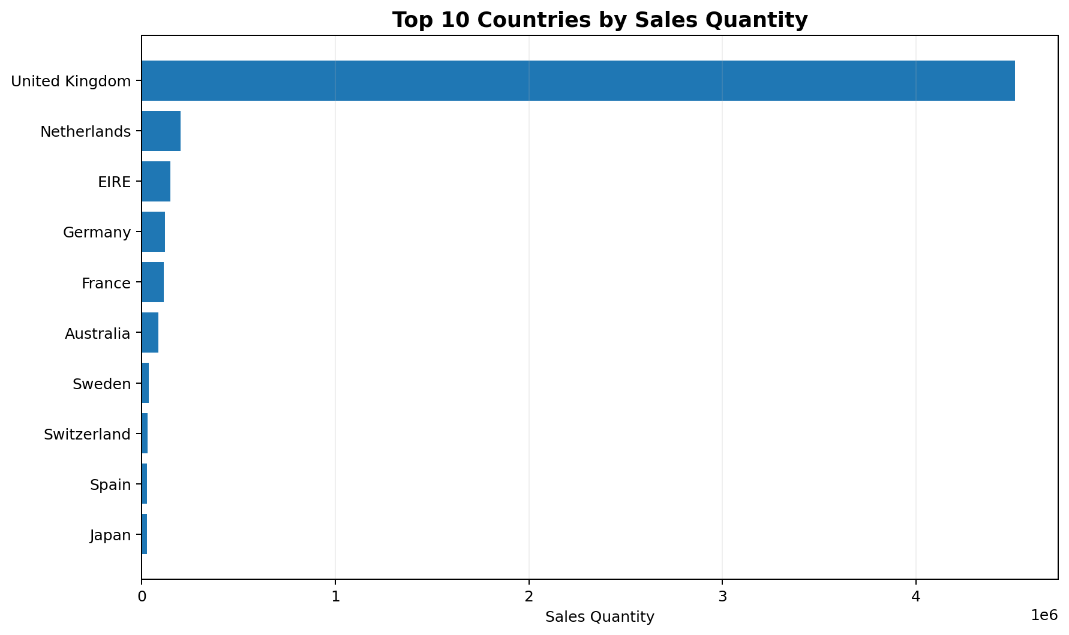
Figure 4. Top 10 countries by sales quantity.
The United Kingdom is the dominant market: 23,494 orders, 4,511,107 sales quantity, and 3,950 identified customers. It represents 90.71% of all orders and 82.96% of sales quantity. This concentration means that overall business trends are strongly influenced by UK activity.

6.4 Product performance
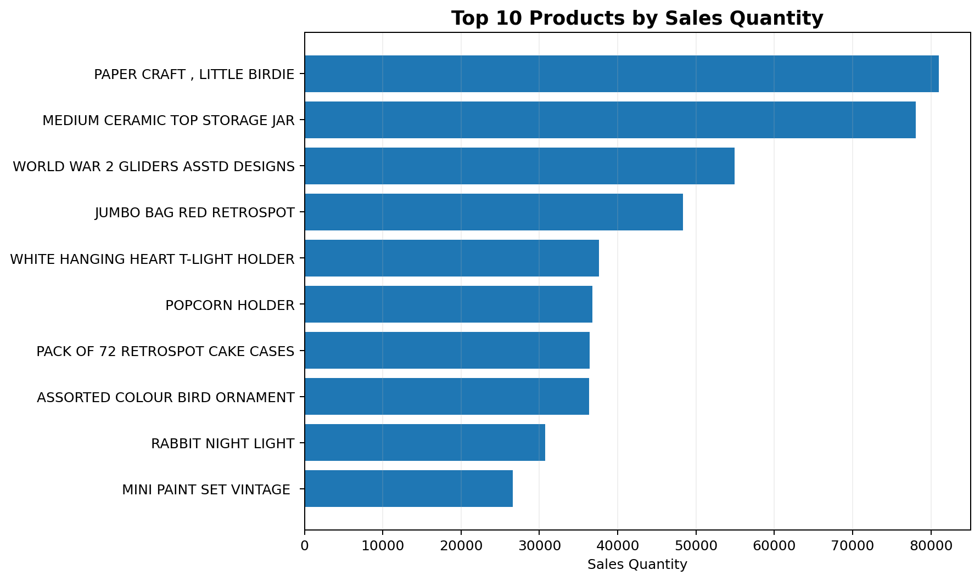
Figure 5. Top 10 products by sales quantity.
The top 10 products account for 8.58% of total sales quantity. The leading product in the prepared dataset is StockCode 23843, PAPER CRAFT , LITTLE BIRDIE, with 80,995 sales quantity. Some extremely large quantities are concentrated in products that also show unusually high cancellation quantities, so these products warrant validation before operational decisions are made.

6.5 Customer performance
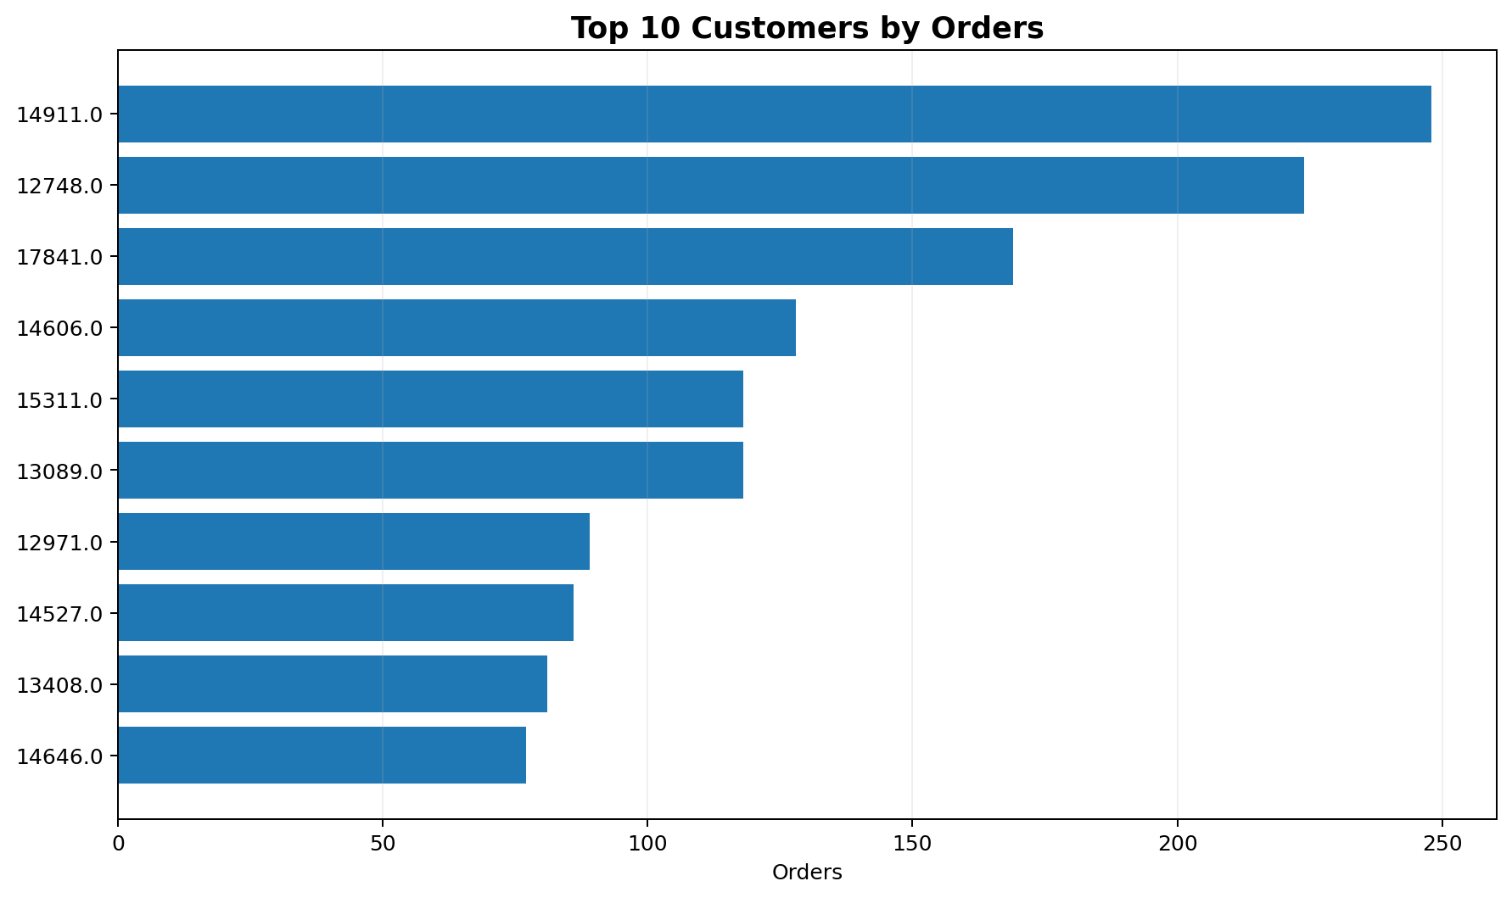
Figure 6. Top 10 customers by distinct order count.
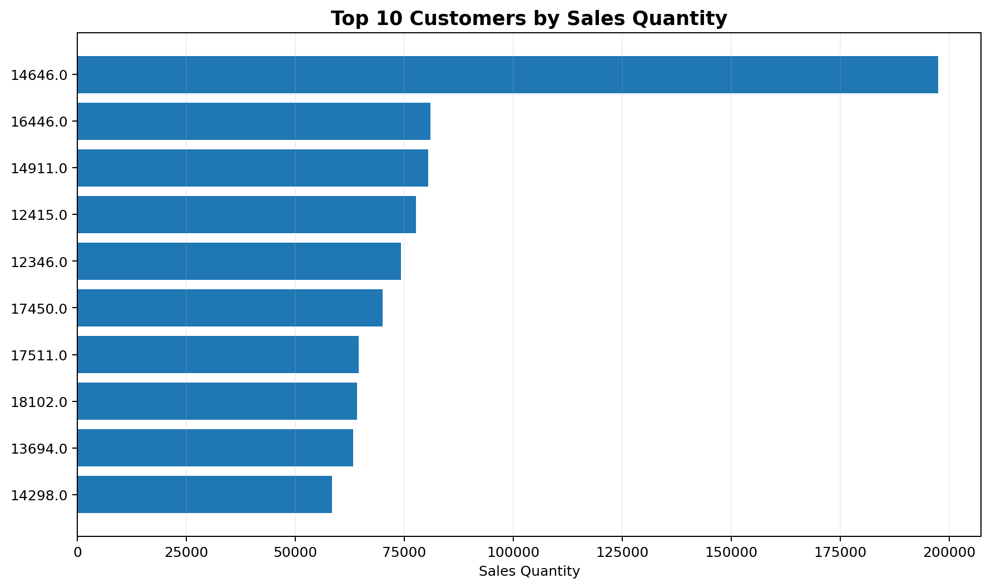
Figure 7. Top 10 customers by sales quantity.
The customer analysis identifies 4,372 customers with non-null CustomerID values. The top 10 customers by order count account for 5.17% of all orders, while the top 10 by quantity account for 15.28% of sales quantity. The difference between order concentration and quantity concentration suggests that frequency and volume are different dimensions of customer value.

6.6 Cancellation trend
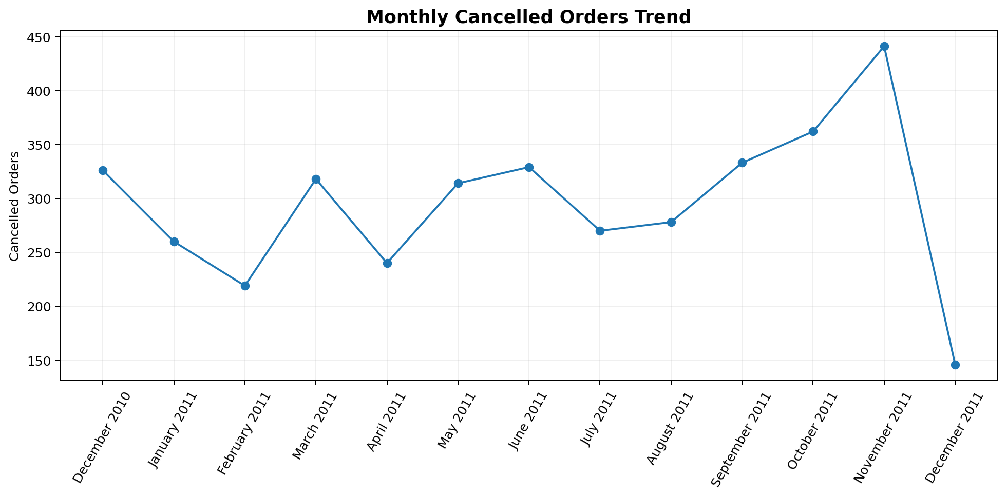
Figure 8. Monthly cancelled-order trend.
Cancellation activity reaches its highest cancelled-order count in November 2011, with 441 cancelled orders. The dedicated Power BI cancellation page is therefore appropriate because cancellation behavior varies materially over time.

6.7 Day and hour patterns
The notebook includes day-of-week and hourly analysis. Thursday has the highest distinct order count among named weekdays in the prepared data, while Saturday has no observed orders. The hour-level analysis is dominated by hour 0 in the stored timestamp data. This should be interpreted cautiously because the timestamp distribution may reflect how the source system records transaction times rather than customer shopping behavior.

9. MySQL Database and SQL Analysis
The SQL script creates an ecommerce_analysis database and an ecommerce table with the prepared 20-column structure. The schema contains transaction identifiers, product fields, quantity, date/time, customer and country fields, transaction classification, derived sales/cancellation quantities, and calendar attributes.

9.1 SQL schema
SQL field group | Fields
Transaction | InvoiceNo, InvoiceDate
Product | StockCode, Description, UnitPrice
Quantity | Quantity, SalesQty, CancellationQty
Customer / geography | CustomerID, Country
Transaction type | transactionaltype
Calendar | Date, Year, MonthNumber, MonthName, Quarter, Day, DayName, Hour, MonthYear

9.2 SQL queries implemented
- Distinct order count using COUNT(DISTINCT InvoiceNo).
- Total sales quantity using SUM(SalesQty).
- Transaction-type summary using GROUP BY transactionaltype.
- Top 10 countries by distinct orders and sales quantity.
- Top 10 products by sales quantity.
- Monthly quantity and distinct order analysis grouped by Year, MonthNumber, and MonthName.
- Top 10 customers by distinct orders and sales quantity, excluding null CustomerID.
The SQL layer provides an independent validation path for the Power BI model and demonstrates that the project is not dependent on Power BI alone.

10. Excel Analysis and Validation
The prepared Excel workbook contains the main 20-column analysis dataset plus dedicated analytical worksheets. The workbook includes KPI, Monthly_Analysis, Country_Analysis, Product_Analysis, Customer_Analysis, and Cancellation_Analysis sheets.
Worksheet | Observed purpose
ecommerce_analysis_ready (1) | Main 536,482-row prepared dataset with 20 columns.
KPI | Overall KPI summary: 25,900 orders, 4,373 customer count in the worksheet, and 5,437,786 sales quantity.
Monthly_Analysis | Monthly sales quantity and distinct invoice analysis.
Country_Analysis | Country-level orders, customers, and quantity.
Product_Analysis | Product-level sales quantity, cancellation quantity, and distinct invoices.
Customer_Analysis | Customer-level quantity, orders, and cancellation quantity.
Cancellation_Analysis | Sale/cancellation order and quantity summary plus detailed cancellation analysis.

The Excel KPI sheet reports 4,373 customers, whereas the prepared data's non-null CustomerID distinct count is 4,372. This one-unit difference is consistent with a blank/null customer category being represented in the pivot-style KPI output. For a formal customer KPI, the recommended definition is to state explicitly whether unknown/blank customer records are included.

11. Power BI Data Model and Measures
The final PBIX is configured as a 1920×1080, Fit-to-Page report and uses the Fluent2-CY26SU09 base theme. Enhanced tooltips and drill filtering are enabled in the report configuration. The model exposes an EcommerceData entity and a DateTable entity through the report visuals.

11.1 Core measures visible in the PBIX
- Total Orders
- Total Products
- Total Quantity
- Total Customers
- Total Countries
- Orders per Customer
- Cancellation Quantity
- Cancellation Rate
- Cancelled Orders
- Cancellation Order Rate
The report uses measures dynamically in card visuals, charts, and tables. This allows the same KPI to respond to the selected date, year, country, and transaction-type context.

11.2 Report interactions
- Date slicer
- Year slicer
- Transaction Type slicer
- Country slicer
- Page navigator
- Cross-filtering of visuals
- Enhanced tooltips
The report configuration explicitly enables drillFilterOtherVisuals and enhanced tooltips, supporting an interactive rather than static dashboard experience.

The PBIX contains five pages, each with a distinct analytical purpose.
Page | Role | Major elements verified from PBIX
Executive Overview | Management summary | KPI cards, monthly quantity, monthly cancellation, country quantity, slicers, page navigation
Product Analysis | Product performance | Product KPIs, cancellation quantity by product, product table, product quantity chart
Customer Analysis | Customer behavior | Customer/order/quantity cards, customer rankings, orders per customer
Country Analysis | Geographic performance | Country KPI cards, customer and quantity rankings, country-focused visuals
Cancellation Analysis | Cancellation monitoring | Cancellation KPIs, monthly cancelled orders, top cancelled products, country cancellation table

12.1 Executive Overview
The Executive Overview contains Total Orders, Total Products, Cancellation Rate, Total Customers, and Total Quantity cards. It also contains Month Year analysis for cancellation quantity, monthly SalesQty, country-level quantity, and four slicers for Date, Year, transactionaltype, and Country. This is appropriately positioned as the first page because it provides both high-level KPIs and filtering controls.

12.2 Product Analysis
The Product Analysis page contains product-level KPI cards, a cancellation quantity bar chart, a product detail table, and a quantity ranking chart. It supports questions about high-volume products and products associated with cancellation activity.

12.3 Customer Analysis
The Customer Analysis page contains multiple KPI cards and charts using StockCode/customer-related measures, including Total Quantity, customer counts, Total Orders, Total Customers, and Orders per Customer. The final interpretation should focus on customer frequency and quantity separately because the two dimensions identify different customer behaviors.

12.4 Country Analysis
The Country Analysis page contains Total Countries, Total Orders, Total Customers, Total Quantity, country-level customer and quantity visuals, and additional cards including Cancellation Quantity. This supports geographic prioritization and comparison of market size versus transaction activity.

12.5 Cancellation Analysis
The Cancellation Analysis page is the most operationally focused page. It contains Cancellation Quantity, Cancellation Rate, Cancelled Orders, and Cancellation Order Rate cards; a monthly cancelled-order line chart; a Top 10 Cancelled Products chart; and a country-level table containing cancelled orders, cancellation quantity, cancellation rate, and cancellation order rate.
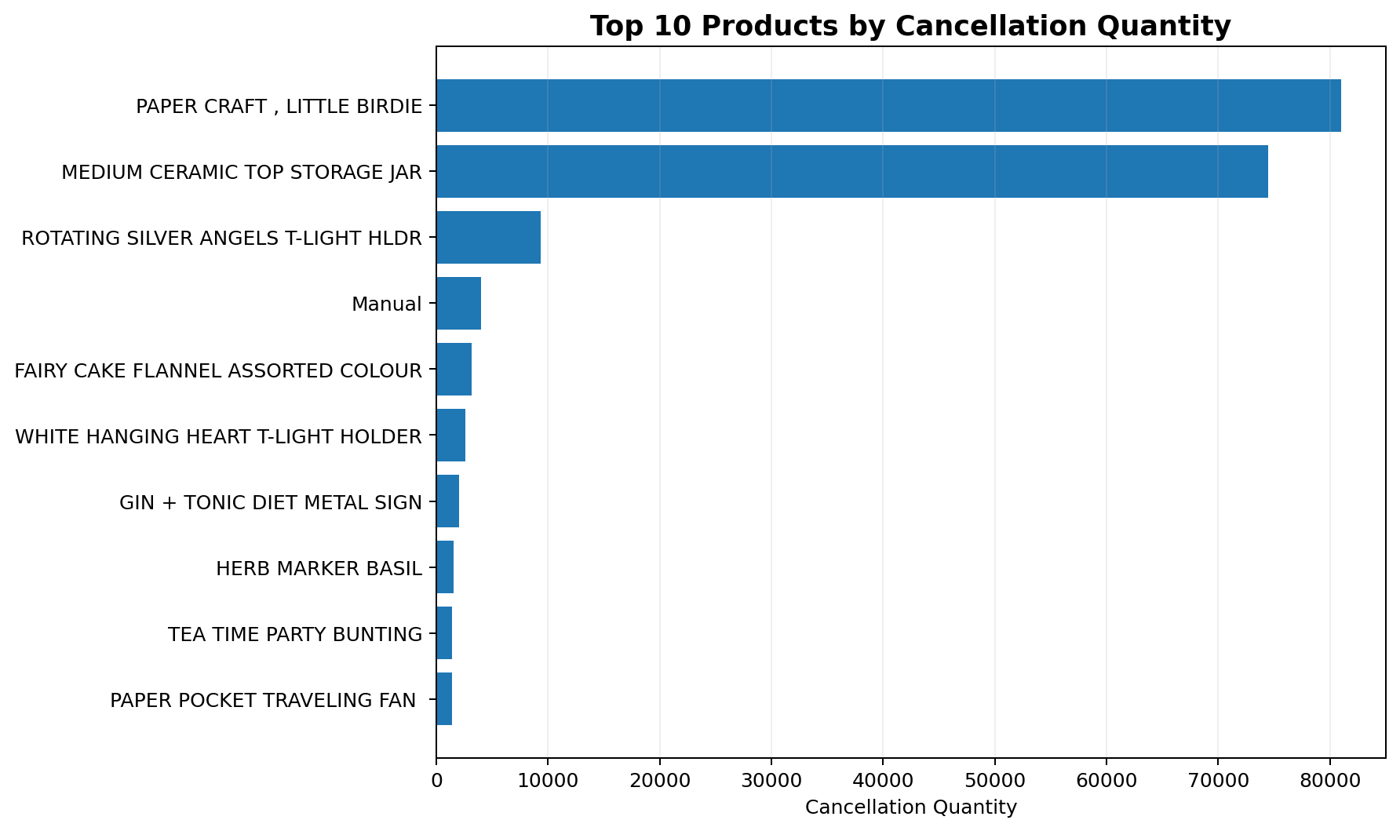
Figure 9. Top products by cancellation quantity from the prepared analysis data.

14. Data-Driven Business Findings

Finding 1 — Strong geographic concentration
The United Kingdom generates 23,494 of 25,900 distinct orders, or 90.71%, and 4,511,107 of 5,437,786 sales quantity, or 82.96%. The business is therefore highly concentrated in one market. Overall company-level trends should be interpreted with this concentration in mind.

Finding 2 — Late-2011 volume acceleration
Sales quantity rises strongly toward the end of 2011 and peaks in November at 749,765 units. November also records 3,462 orders, the highest monthly order count in the prepared dataset.

Finding 3 — Cancellation is material at order level
There are 3,836 cancelled orders out of 25,900, giving an order-level cancellation rate of 14.81%. This is high enough to justify a dedicated cancellation dashboard rather than treating cancellations as a small exception.

Finding 4 — Cancellation is concentrated in particular products
The leading cancellation-quantity product is PAPER CRAFT , LITTLE BIRDIE, with 80,995 cancellation quantity. The same product also appears among the highest-quantity products, indicating that volume and cancellation exposure can coexist.

Finding 5 — Customer frequency and volume are different
The top customer by order frequency has 248 distinct orders, while the top customer by quantity has 197,491 units. This demonstrates why a single 'best customer' metric can be misleading.

Finding 6 — Data quality must be considered in customer analysis
The prepared table still contains 134,931 rows without CustomerID (25.15%). Customer-level conclusions therefore apply to identified customers and should not be generalized to all transactions without qualification.

Finding 7 — Large quantity outliers require validation
The prepared data contains extreme quantities, including 80,995 units for a product and 74,215 units for another product. These may represent legitimate bulk transactions or data-entry/business-process anomalies. They materially influence quantity-based rankings and should be validated before using quantity alone for inventory or product decisions.

15. Business Recommendations
Recommendation | Action
1. Protect the core UK market | Because the UK contributes more than 90% of orders, operational reliability and customer retention in the UK should receive priority.
2. Investigate cancellation drivers | Review products and months with the highest cancellation quantities/orders. Examine inventory, fulfillment, pricing, product quality, and customer-service processes.
3. Separate customer frequency from customer value | Use both order frequency and quantity, and ideally revenue/margin once validated, to segment customers.
4. Review high-volume outliers | Validate extreme quantities before making inventory or demand forecasts. Bulk orders may be genuine but should not automatically be treated as normal demand.
5. Monitor late-year demand | November shows the strongest quantity and order activity. Inventory and fulfillment capacity should be evaluated ahead of high-volume periods.
6. Expand market-level analysis | Countries outside the UK should be compared using both absolute activity and normalized rates, because smaller markets can have high percentages from small denominators.
7. Formalize revenue analysis | If financial reporting is required, add validated SalesRevenue, CancellationValue, NetRevenue, and margin measures to the final model rather than relying on quantity alone.

16. Limitations and Data-Quality Caveats
A professional report should explicitly document what the current project can and cannot prove.
- The raw-to-final row reduction is 5,427 rows (1.00%). The notebook explicitly shows 5,268 exact duplicate rows and a drop_duplicates() step, which explains most but not all of the reduction. The remaining 159 rows are not explained by the visible notebook cells and should not be attributed to a specific cleaning rule without further verification.
- CustomerID is missing in 134,931 prepared rows. Customer analysis therefore covers identified customers only.
- SalesQty contains 1,336 negative values even though the notebook creates SalesQty based on transaction type. These records are classified as Sale in the prepared table and should be investigated before treating SalesQty as strictly non-negative sales volume.
- The notebook computes revenue fields, but the final 20-column export omits them. Revenue therefore should not be presented as a final Power BI KPI unless the model is extended.
- The Excel KPI worksheet shows 4,373 customers while the non-null distinct CustomerID count is 4,372; this is consistent with a blank customer category in pivot-style output and should be documented in KPI definitions.
- Cancellation Rate and Cancellation Order Rate depend on the project's measure definitions. The report should document the exact numerator and denominator for each before being used for management reporting.
- High-volume outliers can dominate quantity-based rankings. Product and customer decisions should therefore be supported by additional measures such as revenue, margin, order frequency, or validated business context.

17. Final Validation and Deployment Checklist
☐ Reconcile Power BI Total Orders with SQL COUNT(DISTINCT InvoiceNo).
☐ Reconcile Power BI Total Quantity with SUM(SalesQty).
☐ Confirm the customer KPI definition: identified customers only or blank/unknown included.
☐ Validate cancellation quantity and cancellation order rate against the prepared data.
☐ Check the DateTable relationship and month sorting.
☐ Test Date, Year, Country, and Transaction Type slicers.
☐ Test cross-filtering and page navigation.
☐ Review high-volume and high-cancellation products.
☐ Validate all extreme quantity records before operational use.
☐ Publish the final PBIX to Power BI Service if required.
☐ Export the final dashboard to PDF for submission/portfolio use.
☐ Store the raw data, notebook, cleaned dataset, SQL script, PBIX, and final report together with a README.

18. Conclusion
This project demonstrates a complete data analytics lifecycle using a real transaction-level e-commerce dataset. The work starts with 541,909 raw rows, moves through Python-based profiling and transformation, creates a 536,482-row prepared analysis table, validates core metrics with SQL and Excel, and culminates in a five-page interactive Power BI report.
The analysis shows a business dominated by the United Kingdom, with 90.71% of orders coming from that market. Demand is strongest in November 2011 at 749,765 units, while cancellations are substantial enough to require dedicated monitoring, with 3,836 cancelled orders and 14.81% cancellation at the order level.
The project is strongest when presented as an end-to-end analytics solution rather than only a Power BI dashboard. Its main areas for final hardening are KPI-definition consistency, investigation of extreme quantities and negative SalesQty records, explicit treatment of missing customers, and reconciliation of the 159-row difference between the visible notebook duplicate-removal result and the final prepared file.

Appendix A — Key Metrics
Metric | Final prepared data
Raw rows | 541,909
Prepared rows | 536,482
Rows removed | 5,427
Raw exact duplicate rows | 5,268
Prepared exact duplicate rows | 0
Distinct orders | 25,900
Identified customers | 4,372
Countries | 38
Unique stock codes | 4,070
Sales quantity | 5,437,786
Cancellation quantity | 274,732
Cancelled orders | 3,836
Sale orders | 22,064
Cancellation order rate | 14.81%
Sales transaction value (exploratory) | £14,138,243.60
Cancellation value (exploratory) | £714,303.20
Implied net transaction value (exploratory) | £13,423,940.40
Prepared date range | 01-Dec-2010 to 09-Dec-2011

Appendix A.1 Top countries
Country | Orders | Customers | Sales Quantity
United Kingdom | 23,494 | 3,950 | 4,511,107
Germany | 603 | 95 | 119,154
France | 461 | 87 | 112,061
EIRE | 360 | 3 | 147,280
Belgium | 119 | 25 | 23,237
Spain | 105 | 31 | 27,944
Netherlands | 101 | 9 | 200,937
Switzerland | 74 | 21 | 30,618
Portugal | 71 | 19 | 16,231
Australia | 69 | 9 | 84,199

Appendix A.2 Top products by quantity
StockCode | Description | Quantity | Cancel Qty | Orders
23843 | PAPER CRAFT , LITTLE BIRDIE | 80,995 | 80,995 | 2
23166 | MEDIUM CERAMIC TOP STORAGE JAR | 78,033 | 74,494 | 257
84077 | WORLD WAR 2 GLIDERS ASSTD DESIGNS | 54,951 | 1,200 | 540
85099B | JUMBO BAG RED RETROSPOT | 48,375 | 1,115 | 2,135
85123A | WHITE HANGING HEART T-LIGHT HOLDER | 37,579 | 2,578 | 2,235
22197 | POPCORN HOLDER | 36,749 | 427 | 839
21212 | PACK OF 72 RETROSPOT CAKE CASES | 36,396 | 380 | 1,334
84879 | ASSORTED COLOUR BIRD ORNAMENT | 36,354 | 80 | 1,467
23084 | RABBIT NIGHT LIGHT | 30,739 | 108 | 1,009
22492 | MINI PAINT SET VINTAGE | 26,633 | 196 | 390

Appendix A.3 Top customers by orders
CustomerID | Orders | Quantity | Cancellation Qty
14911 | 248 | 80,490 | 3,335
12748 | 224 | 25,275 | 1,538
17841 | 169 | 22,833 | 206
14606 | 128 | 6,187 | 246
15311 | 118 | 38,147 | 474
13089 | 118 | 31,025 | 283
12971 | 89 | 9,289 | 86
14527 | 86 | 2,088 | 33
13408 | 81 | 16,232 | 110
14646 | 77 | 197,491 | 772

Appendix B — SQL Query Inventory
The supplied SQL script contains the following logical analysis blocks:
- CREATE DATABASE ecommerce_analysis
- USE ecommerce_analysis
- CREATE TABLE ecommerce with the 20 prepared fields
- Total distinct orders
- Total sales quantity
- Transaction-type counts and quantities
- Top 10 countries by orders and quantity
- Top 10 products by quantity
- Monthly quantity and order trend
- Top 10 customers by orders and quantity
The supplied SQL schema includes InvoiceNo, StockCode, Description, Quantity, InvoiceDate, UnitPrice, CustomerID, Country, transactionaltype, SalesQty, CancellationQty, Date, Year, MonthNumber, MonthName, Quarter, Day, DayName, Hour, and MonthYear.

Appendix C — Python Notebook Workflow
Notebook stage | Implemented operation
Environment/file check | os.getcwd() and os.listdir()
Load | pd.read_csv(..., encoding='latin1', low_memory=False)
Inspection | head, tail, columns, dtypes, info, describe
Missing values | count and percentage summary plus plot
Date parsing | pd.to_datetime(..., format='mixed', errors='coerce')
Date features | Date, Year, MonthNumber, MonthName, Quarter, Day, DayName, Hour, MonthYear
Duplicate check | duplicated(), duplicate inspection, drop_duplicates()
Transaction analysis | transactionaltype value counts and percentages
Quantity logic | SalesQty and CancellationQty
Revenue exploration | Revenue, SalesRevenue, CancellationValue
Customer handling | customer_df and CustomerStatus
Business analysis | country, product, customer, monthly, day, and hour analysis
Statistical exploration | correlation matrix and quantity boxplot
Export | analysis_df.to_csv(..., encoding='utf-8-sig')

The notebook contains 60 non-empty code/markdown cells in the supplied file. The workflow is therefore substantial enough to document as an actual data-preparation and exploratory-analysis stage rather than a simple file conversion.

