🔷 Overview of Snowflake Architecture
Snowflake's architecture is composed of three main layers:
- Database Storage Layer
- Compute Layer (Virtual Warehouses)
- Cloud Services Layer
Each of these layers is decoupled, which provides flexibility and scalability. Let’s break each one down in detail.

1. 🗄️ Database Storage Layer
Purpose:
Responsible for persistently storing all data loaded into Snowflake.
Key Characteristics:
- Columnar storage: Data is stored in a compressed, optimized columnar format.
- Automatic optimization: Snowflake handles indexes, partitioning, and metadata optimization without user intervention.
- Immutable data: Data is stored as immutable files for consistency and reliability.
- Encryption: All data is encrypted using strong encryption methods, both at rest and in transit.
How it works:
- When you load data (e.g., from S3, Azure Blob, or GCS), Snowflake ingests and stores it in optimized internal structures.
- This storage layer is shared across all compute clusters, making it accessible to multiple users and workloads simultaneously.

2. ⚙️ Compute Layer (Virtual Warehouses)
Purpose:
Executes SQL queries and performs all data processing tasks.
Key Characteristics:
- Comprised of Virtual Warehouses (also called clusters).
- Independent compute clusters: Each virtual warehouse is an isolated MPP (Massively Parallel Processing) compute cluster.
- Scalable and elastic: Warehouses can be resized, paused, resumed, and auto-scaled based on workloads.
- Concurrency handling: Multiple warehouses can query the same data concurrently without performance bottlenecks.

How it works:
- Each virtual warehouse pulls data from the shared storage layer only when needed, processes it, and then returns results.
- You can spin up multiple warehouses for different teams or workloads (e.g., ETL, BI, data science) without interference.
Example:
- A large organization might use one warehouse for daily ETL jobs and another for analysts running dashboards—both operating simultaneously on the same data.

3. 🧠 Cloud Services Layer
Purpose:
Handles the coordination and metadata management.
Key Components:
- Authentication and security: Manages user access and single sign-on (SSO).
- Metadata management: Keeps track of schema, table definitions, query history, access privileges, etc.
- Query parsing and optimization: Compiles and optimizes SQL queries before execution.
- Infrastructure management: Automatically manages provisioning, performance tuning, and failures.
How it works:
This layer runs on a multi-tenant compute fabric provided by Snowflake and is not exposed to users directly. It ensures:
- Efficient query planning and optimization
- Seamless multi-user access
- Time travel and fail-safe features (enabled by metadata tracking)

🔄 Decoupled Architecture
One of Snowflake’s most revolutionary ideas is its multi-cluster, shared-data architecture, where:
- Storage is centralized
- Compute is independent
- Services are abstracted
This decoupling enables:
- Elastic scalability: Add or remove compute clusters on demand.
- Concurrency scaling: Avoid contention by using separate compute clusters.
- Pay-for-what-you-use: Since compute and storage are billed separately, you only pay for active usage.

Snowflake is also known for “Shared-Nothing” Architecture. This means every node has its own independent compute and storage and nothing gets shared among other nodes.

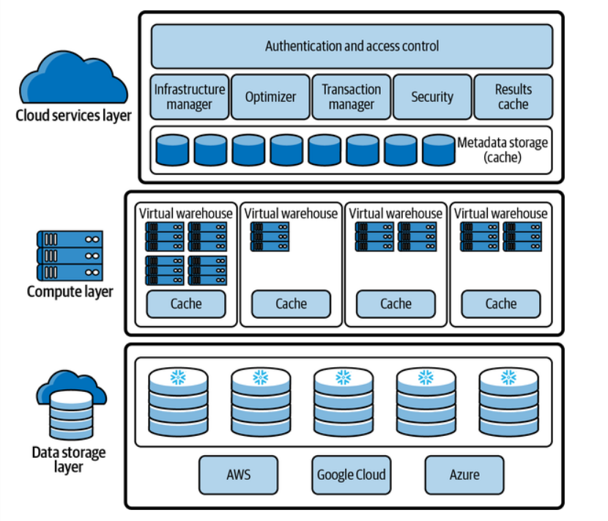

What Does "Immutable Data" Mean?
Immutable means unchangeable—once data is written to storage, it cannot be altered in place. Instead of modifying existing files, Snowflake:
- Creates new files for every data change (inserts, updates, deletes).
- Keeps metadata to track which versions are active.

✅ Why Snowflake Uses Immutable Storage
Here are the main reasons:

1. Consistency & Reliability
- Because data files are never overwritten, Snowflake avoids partial writes, corruption, or race conditions from multiple concurrent processes.
- This ensures ACID compliance: atomicity, consistency, isolation, durability.

2. Versioning for Time Travel & Fail-Safe
- When data is immutable, Snowflake can easily keep track of historical versions.
- This enables powerful features like:
  - Time Travel: Query or restore data as it existed hours or days ago.
  - Zero-Copy Cloning: Instant, cost-free clones of tables/databases, based on metadata pointers.
  - Fail-Safe: A 7-day recovery window for dropped or changed data.
These would be complex and inefficient if files were mutable and constantly changing.

3. Efficient Data Pruning and Caching
- Since files don’t change, Snowflake can efficiently cache and prune unneeded data during query execution.
- The optimizer knows exactly which files contain relevant data.
- This improves query performance and reduces I/O.

4. Simplifies Concurrency and Parallelism
- With immutable files, many virtual warehouses can read the same data simultaneously without coordination or locking.
- New changes don’t interfere with current queries; they just write new data.
This is crucial for scalability and performance in shared environments.

5. Support for Append-Only Storage
Cloud object storage (like S3, Azure Blob, GCS) is optimized for append-only or immutable data access patterns. Mutating files in place is:
- Expensive
- Error-prone
- Inefficient
Snowflake leverages cloud-native capabilities by writing data once and using metadata to manage logical changes.

🔁 How Are Updates and Deletes Handled?
When you run UPDATE or DELETE, Snowflake doesn’t modify files in-place. Instead:
- It marks old records as invalid using metadata.
- It writes new files with updated data.
- Queries automatically see the latest, correct version.
This is called copy-on-write and is common in modern data systems (like Apache Iceberg, Delta Lake, etc.).
Example: Employee Table Use Case
Let’s say you have a table:
CREATE TABLE employee (
emp_id INT,
name STRING,
salary NUMBER
);
Now you perform the following actions over time:

📥 Step 1: Insert Data
INSERT INTO employee VALUES (1, 'Alice', 80000), (2, 'Bob', 75000);
🔸 Snowflake writes this data into immutable storage files (e.g., a columnar file stored in S3). These files never change.
📦 Let's call this File A:
File A:
(1, 'Alice', 80000)
(2, 'Bob', 75000)

✏️ Step 2: Update Alice's Salary
UPDATE employee SET salary = 85000 WHERE emp_id = 1;
🔸 Snowflake does not update File A. Instead:
- It marks Alice’s old record as “invalid” via metadata.
- It creates File B with the new record:

File B:
(1, 'Alice', 85000) ← new record
Now, queries will see Alice’s updated salary by excluding old rows marked invalid (in File A) and including new ones (from File B).

🧱 How This Immutability Supports Snowflake's Features

✅ 1. ACID Compliance
Let’s break this down:
- Atomicity: The update either creates File B completely or not at all. No partial changes.
- Consistency: Snowflake’s metadata layer ensures all changes maintain schema and referential rules.
- Isolation: Concurrent users querying the employee table won’t see the update until it’s committed and metadata is switched.
- Durability: Once files are written and metadata updated, they are permanently stored and backed by cloud storage.
🔁 Because files are immutable, changes are safe, atomic, and easily rolled back if needed. No file corruption risk.

⏳ 2. Time Travel
You can now go back in time and query the previous state of the table:
SELECT * FROM employee AT (OFFSET => -1);
Snowflake knows:
- At T1 → File A was valid.
- At T2 → File A is partially invalid, and File B is valid for Alice.
Thanks to immutability and metadata versioning, Snowflake can reconstruct past states without rewrites or rollback logs.

🪞 3. Zero-Copy Cloning
You can clone the table instantly:
CREATE TABLE employee_clone CLONE employee;
What happens?
- Snowflake creates a new metadata pointer to the same data files (File A + B).
- No data is copied.
- You can now make changes to employee_clone, and Snowflake will create new files (immutable) as needed.
🔁 Original files are untouched. Changes in one table do not affect the other.

✂️ 4. Data Pruning
Suppose you run:
SELECT * FROM employee WHERE emp_id = 2;
- Snowflake’s optimizer knows from metadata that File B has only emp_id = 1.
- It skips reading File B entirely.
- It reads only the relevant row from File A.
This is data pruning — enabled by immutability and rich metadata.

⚡ 5. Caching
Because the files never change:
- Snowflake can safely cache data pages in memory or SSD.
- There’s no risk that a cached file becomes outdated or inconsistent due to writes.
- Read performance improves dramatically.

🔁 Summary Table
Feature | How Immutability Helps
ACID | Prevents in-place changes; changes are atomic, durable, and safe
Time Travel | Tracks changes via metadata; retrieves old file versions
Zero-Copy Cloning | Clones metadata, not files; changes create new files
Data Pruning | Metadata maps data segments to values; skips irrelevant files
Caching | Files never change → safe to cache and reuse across queries

Why No in-place updates in Snowflake or Hadoop?
- Immutable, Append-Only Storage (Cloud Object Storage)
- Snowflake uses S3, Azure Blob, or Google Cloud Storage, which are optimized for:
  - Large file reads/writes
  - Append-only access patterns
- These systems do not support fine-grained in-place file mutations.
- In-place changes in Systems like Snowflake would be:
  - Expensive (involves rewriting whole blocks)
  - Error-prone (partial updates, network failures) leading to inconsistent data
  - Incompatible with how object storage is designed

2. Columnar Format and Performance
- Snowflake and Hadoop store data in columnar formats (e.g., Parquet, ORC, internal Snowflake format).
- Columnar storage is great for analytics (OLAP) because it:
  - Compresses well
  - Prunes unneeded columns
- But it's inefficient for in-place updates, since columns are stored in separate files.

3.High Concurrency Without Locking
- Immutability enables concurrent reads and writes without locks.
- In-place updates in RDBMS require:
  - Row or page-level locks
  - Complex concurrency control (e.g., MVCC, 2PL)
  - Transaction logs (redo/undo)
- Snowflake avoids all this by versioning through metadata and maintaining immutable files.

Snowflake and Hadoop are built for OLAP (analytical queries) — complex, long-running reads over large datasets. These workloads don’t require frequent single-row updates, so immutability works just fine.
Imagine your data as a book:
In a traditional RDBMS, updating a row is like using white-out and writing over a sentence.In Snowflake, updating a row is like leaving the old page intact and inserting a new page with updated text. Readers will know which page to read based on the table of contents (metadata).

