Deploying Wordpress with Mysql using docker compose

Pre-requisites:

1. Ubuntu machine

2. Docker installed into it (sudo apt install docker.io)

Steps:

1. Create a folder and get into it

• mkdir <folder_name>

• cd <folder_name>

1. Create a yaml file

• sudo nano docker-compose.yml

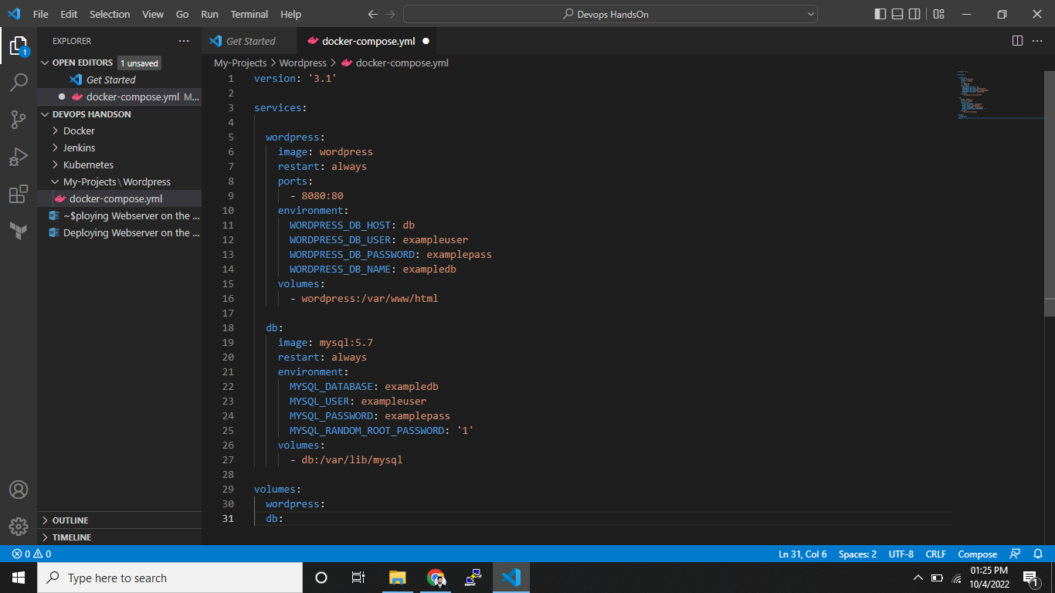

1. Build the docker compose file:

• sudo docker-compose up -d

1. Ensure the containers are running:

• sudo docker ps

1. Take the public Ip address and paste it in the browser with port as mentioned in script.

• <public_IP>:<port>

