**Terraform scripts to Provision AWS EKS**

Steps to be followed:

1. Create an IAM (Identity Access Management) user in AWS and add user to the user_group

* Sign in into AWS console with your crendentials
* IAM -> Add user -> name -> add to Group -> add tags -> ok and save.
* After adding user ,Download **new_user_credentials.csv** file .
* Go to the file location and copy the credentials
* Open the terminal

**$ cd Downloads/**

**$ aws configure --profile <profile name>**

**$ AWS Access Key ID : <paste from the csv file>**

**$ AWS Secret Access Key: <paste from the csv file>**

**$ Default region name: us-east-1**

**$ Default output format: json**

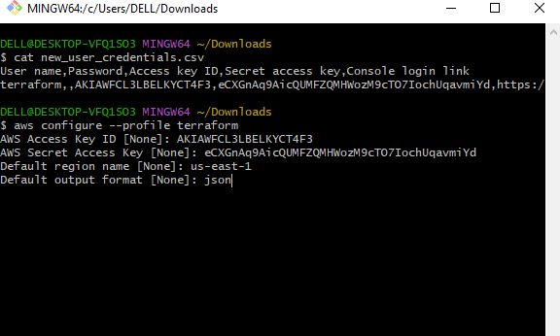

1. Create the following Terraform Scripts:

* provider.tf
* vpc.tf
* internet-gateway.tf
* subnets.tf
* eips.tf
* nat-gateways,tf
* route-tables.tf
* route-table-association.tf
* eks.tf
* eks-nodegroup.tf

1. Please find below url of my Github Repository for the Source code , where you can find all the Terraform Scripts as mentioned above.

<https://github.com/akshaykumart/terraform-EKS.git>

1. Go to the Terminal :

* **$ cd Terraform** //Location where your Terraform files are located in local
* **$ terraform version** //validate the terraform version
* **$ aws –version** // Validate the AWS version
* **$ terraform init**  // Initialize the terraform Environment

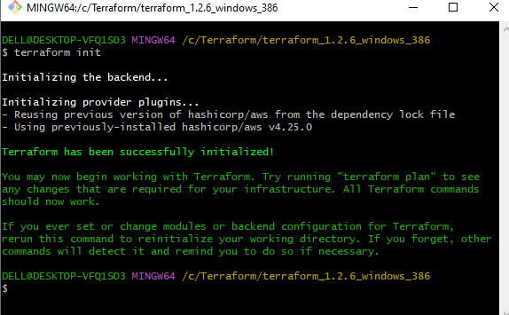

* **$ terraform plan**
* **$ terraform apply**

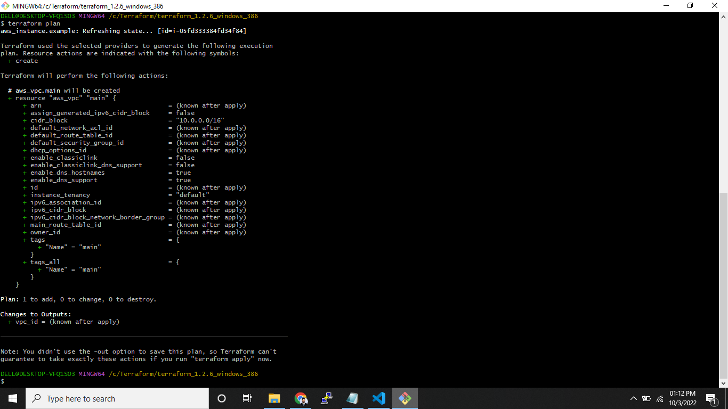

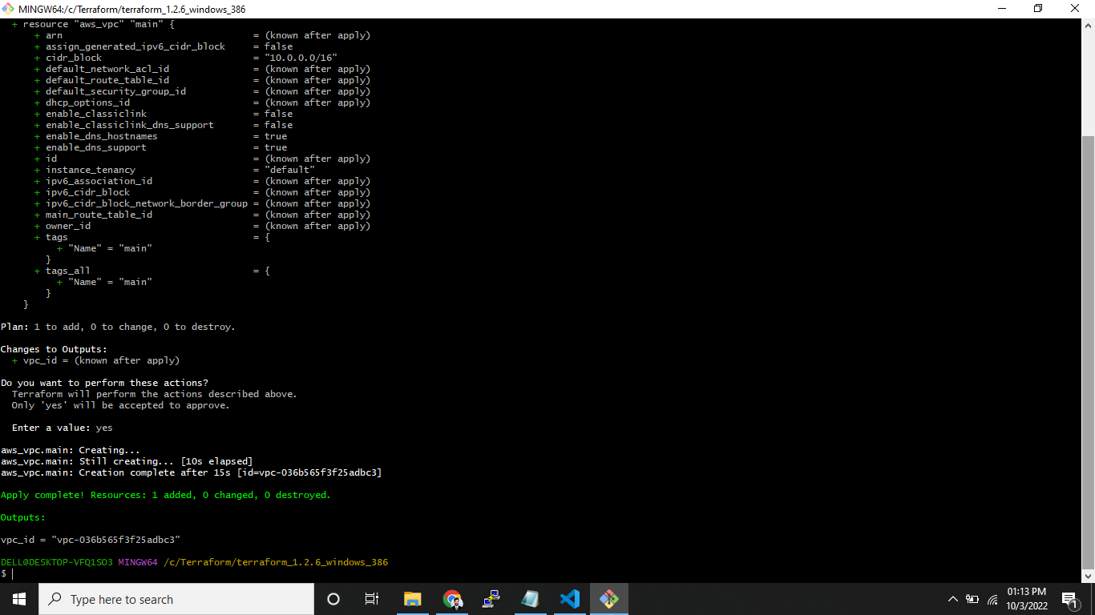

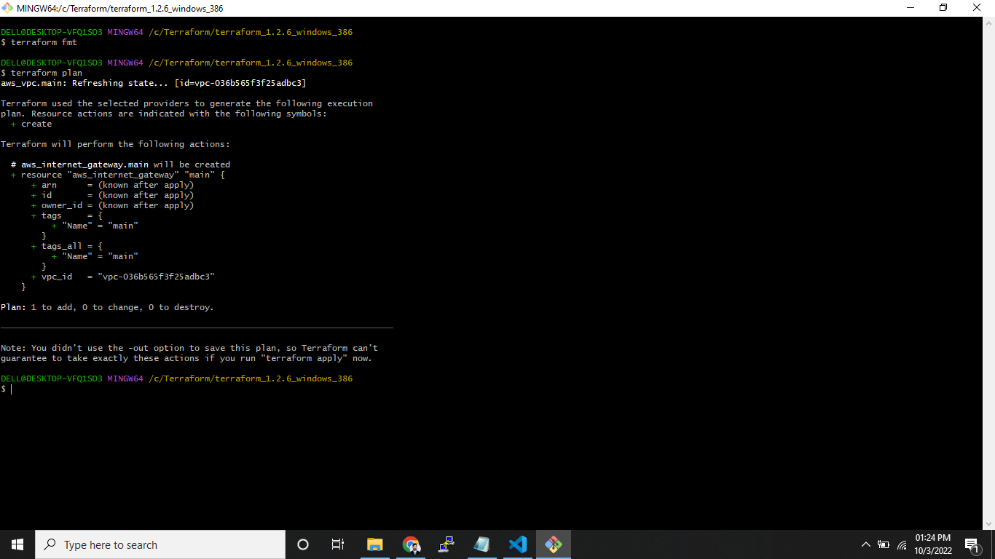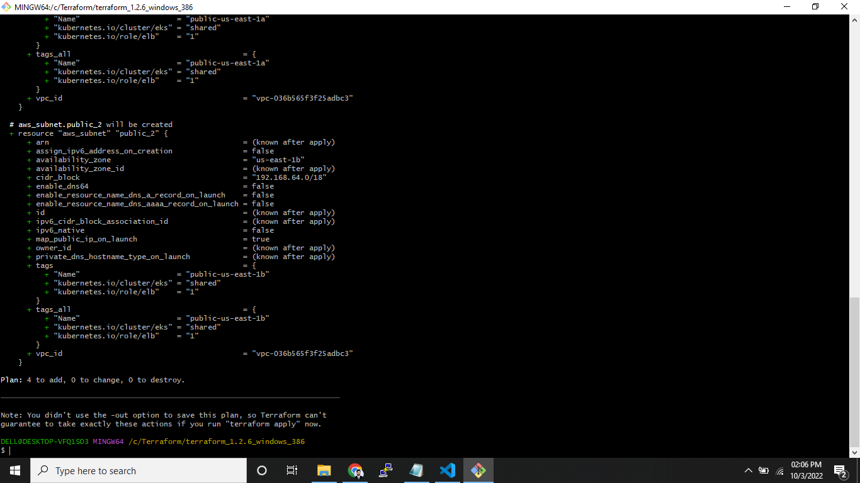

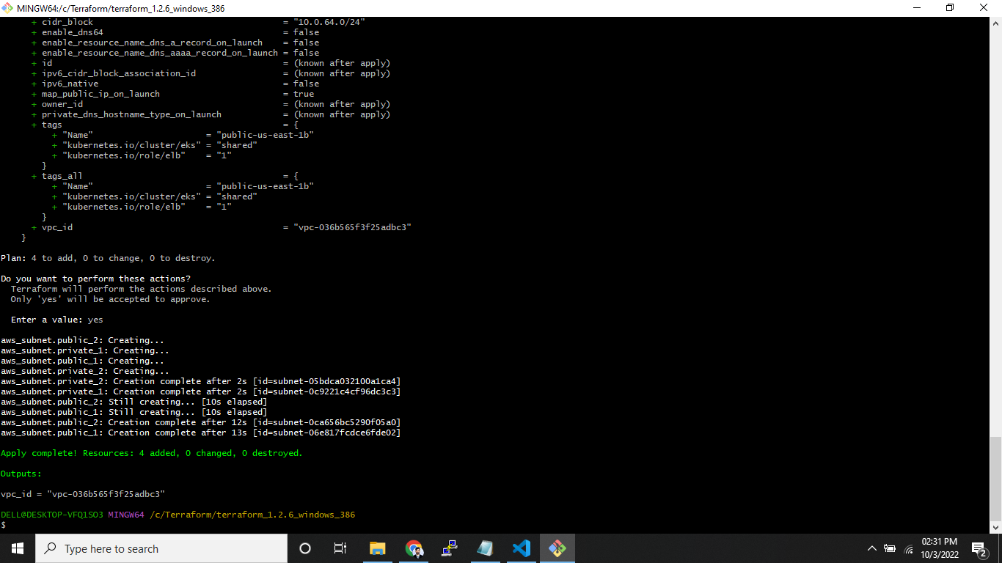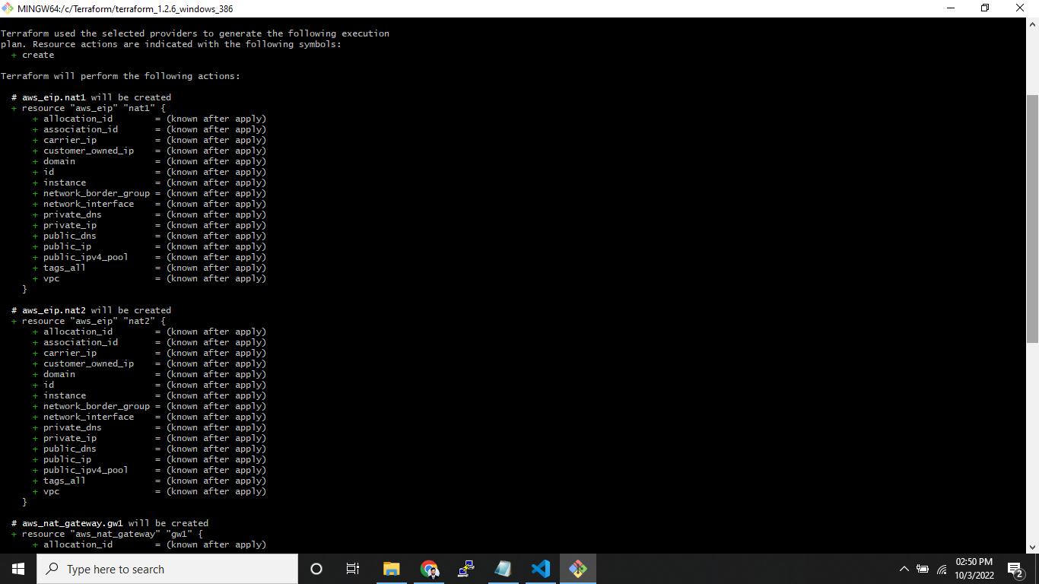

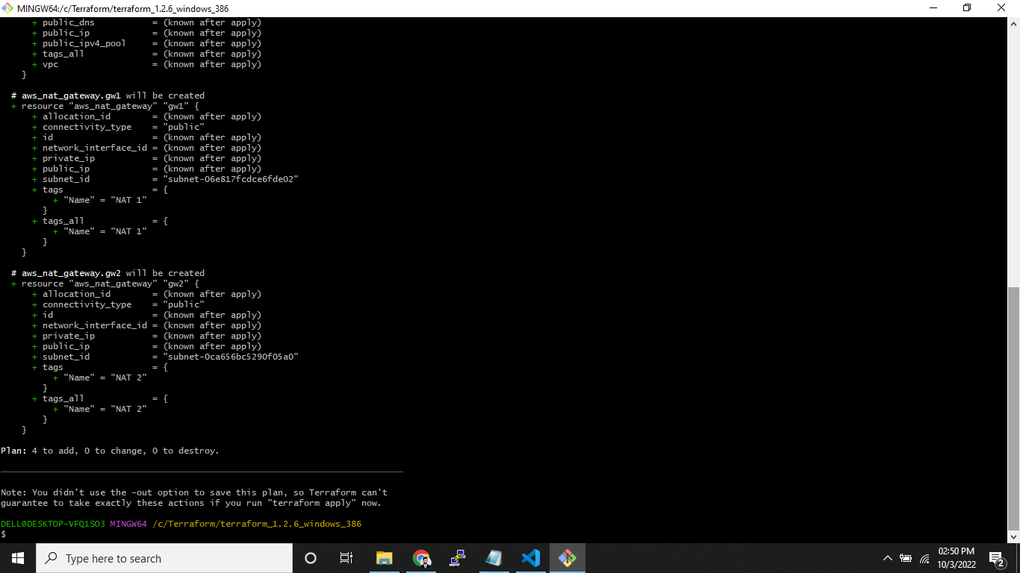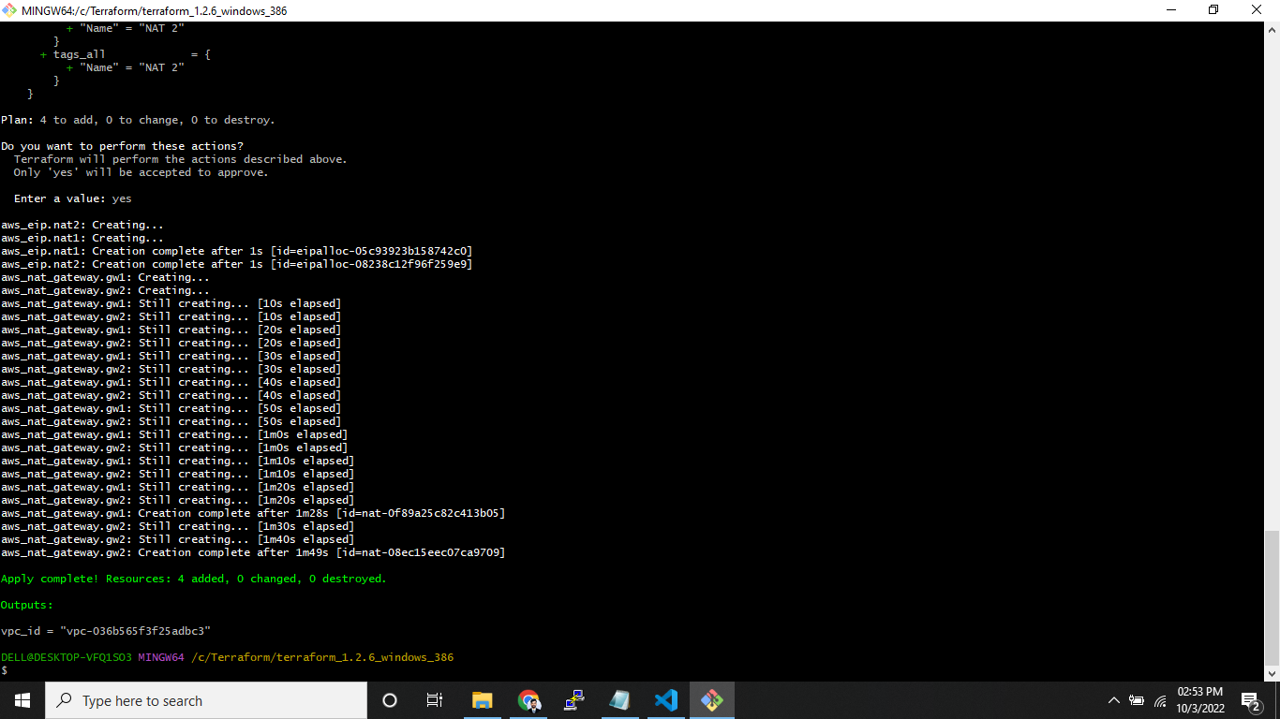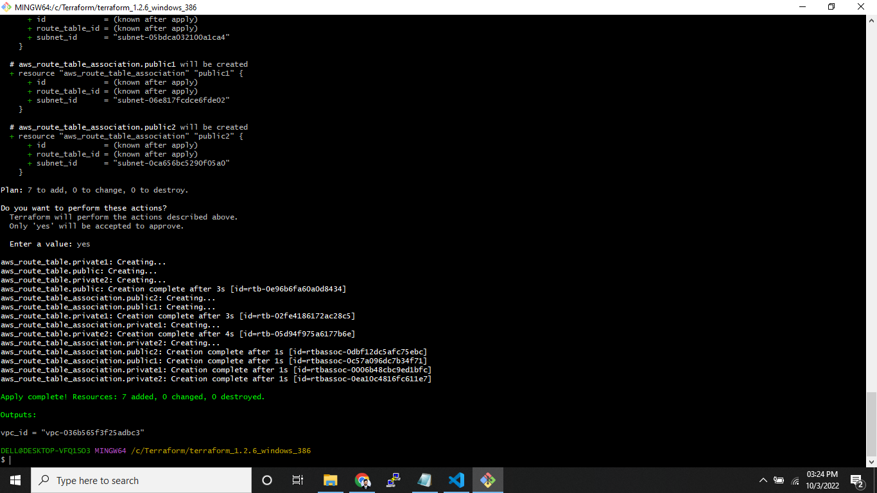

1. ***Validations:***

* Login to AWS console and check whether the following things are created or not.

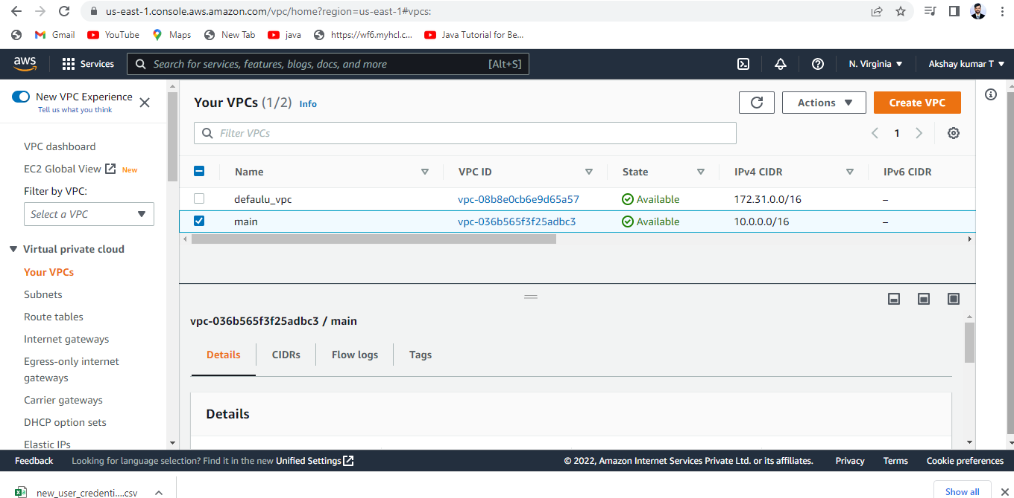

* Validate own VPC created as per the Terraform script as shown above

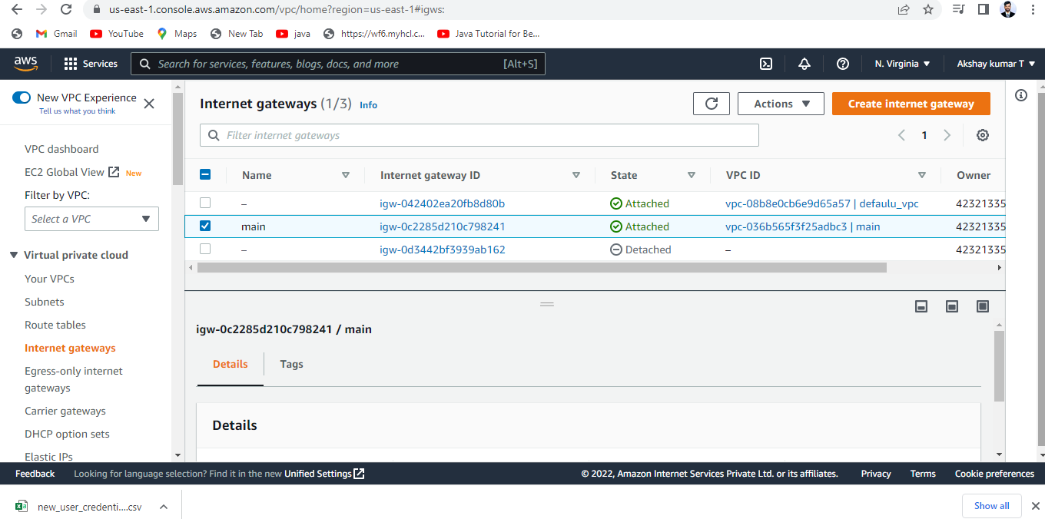

* Validate IGW (Internet Gate Way) created as per the Terraform script as shown above

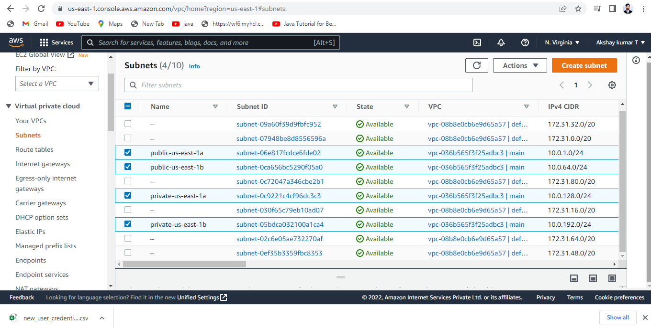

* Validate Subnets created as per the Terraform script as shown above.

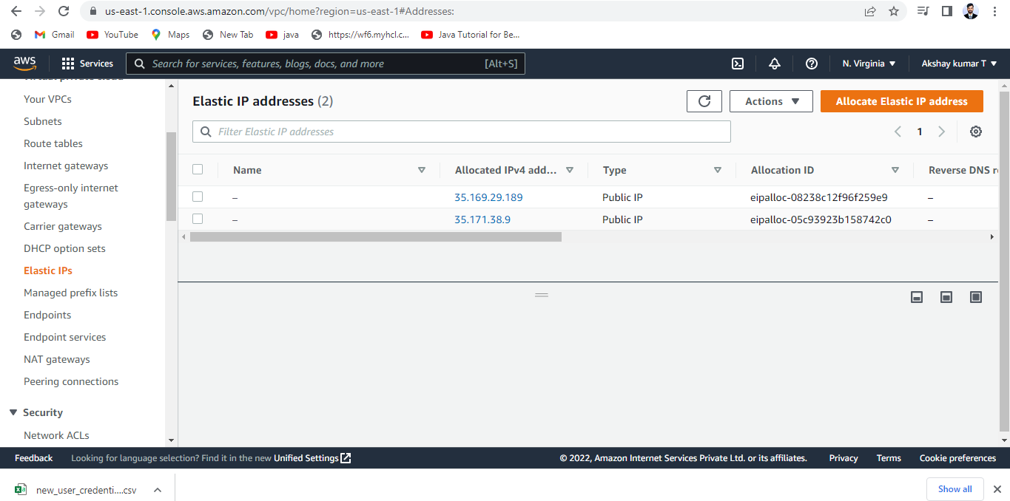

* Validate Elastic IP’s created as per the Terraform Script as shown above.

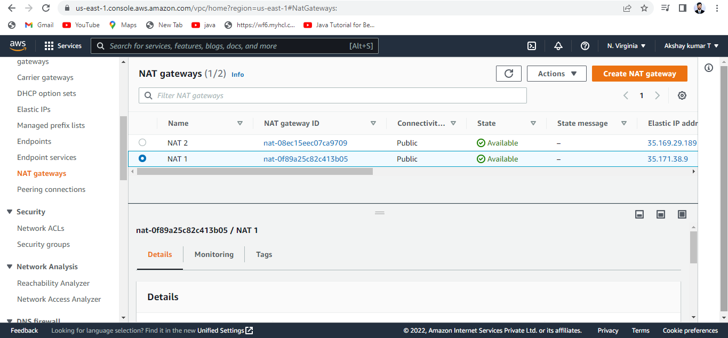

* Validate NAT Gateways created as per the Terraform Script as shown above.

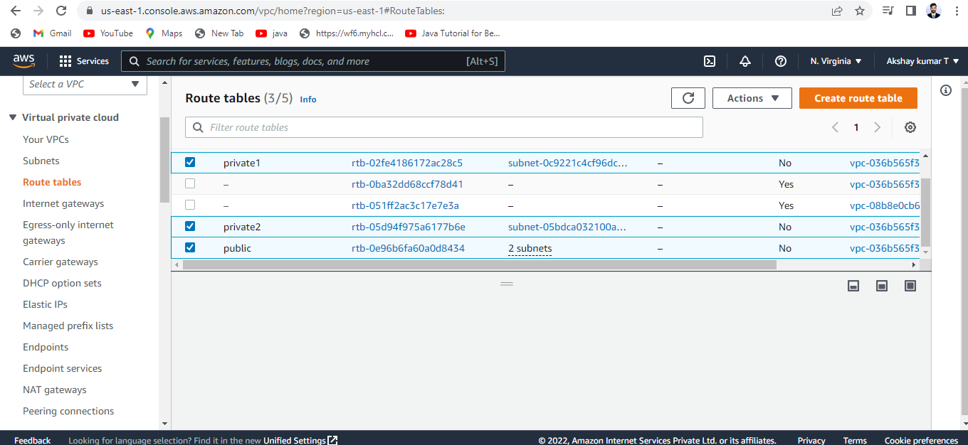

* Validate the Routing Tables as per the Terraform script as shown above.

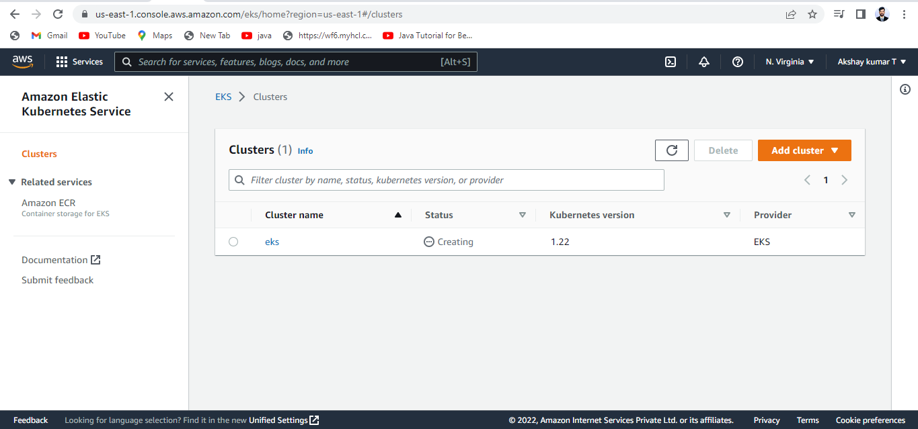

* Validate the EKS Cluster as per the Terraform Script as shown above.