- Introduction
1.1 Project Objective & Importance & Findings
Our project aims at analyzing how air quality (PM 2.5) can be affected by several weather factors, such as temperature, humanity, wind direction, etc in metropolitan area. The dataset used in our project is PM 2.5 data collected from Beijing, China in three-year period.
In recent years, air quality is the most severe pollution problem in China due to the rapid industrialization and increasing energy consumption. In Beijing, the PM 2.5 can be higher than 500 in winter, which means the air is toxic for human, especially for children with a relatively vulnerable immune system. Moreover, PM 2.5 is a cross-country problem. It is not limited by borders and is a global issue.
We found that PM 2.5 is usually higher in winter, but lower in summer. Moreover, we noticed the PM 2.5 varies in different period of one day. We hope we can find the underlying relationship among these weather factors and provide a direction for future study to effectively solve the high PM 2.5 issue for metropolitan area with similar population and energy consumption.
1.2 Background & Literature Review
PM 2.5 is a matrix to evaluate air quality. When PM 2.5 is higher than 100, it indicates a mild pollution; when the PM 2.5 is approaching 200, the pollution is moderate; when it overs 500, the air pollution is severe and can increase in the incidence of various respiratory diseases and resident mortality rates.
There are several researchers analyzed different factors that affect PM 2.5. Liang mentioned the PM 2.5 have a positive relationship with the energy consumption which related with the development speed of China's economic. That explained the fact that when the economic growth slowed down after 2014, air quality improved. (Liang, 2016) In another article, Yuan mentioned that PM 2.5 varies based on consumption of different type of fuel. Beijing's heating system contributes the largest influence on PM 2.5. Hence, Yuan suggested to make a reasonable plan on PM2.5 emission during heating period and using clean energy (Yuan,2015)
2. Computational Setup
2.1 Outline of the steps
The dataset was processed by removing the unavailable entries. Apart from meteorological factors, the repetitive pattern of PM2.5 level through time, both for hours in a day and for months in a year, was observed after elementary visualization of the dataset. It was thus worthwhile to conduct the discussion with respect to different seasons of the year and different time during the day through clustering. Multiple regression was performed to investigate causal relationships among variables. Issues of multicollinearity were taken into consideration. Validity of the models was evaluated by Adjusted R-squared and P-Value. The model was fine-tuned by residual analysis. The resulting best model was applied to another weather dataset to predict the PM2.5 level of other locations around the world.
2.2 Challenges and Solution
N.a values causing errors during code execution. Given the size of the dataset, the Missingno library was employed to check the quality of the data and to remove the observations with missing values.
There four totally four air quality monitors placed in the city to collect data. The reads were mostly different between different monitors; however, the meteorological data was shared. Therefore, PM2.5 level for the entire city were obtained by taking the average of the reads from four monitors.
Clustering went problematic at first when we tried to cluster all points in the dataset. Clusters resulted in rectangular shapes which failed to express the similarity among the data points. It was later realized that the clustering process involved PM2.5 level as the only dimension. Take clustering for PM2.5 level during different months of a year as an example. The 5-year dataset contained 5 entries for each month, which were averaged to represent the typical pollution level, generating only 12 data points to be clustered. Similar procedures were conducted to cluster PM2.5 levels during different hours of the day. Clustering directed the dummy variables in the multiple regression.
The original summary of Statsmodels regression output did not include VIF and residual analysis plot, which were necessary in examining multicollinearity and fine-tuning the model. VIF values were obtained using variance, inflation, factor function from Statesmodels. Residual plots were generated using matplotlib manually.
Model mining was a major challenge since many meteorological variables were interrelated. In the search for the best regression model, the full model with all variables was established as the basis and the significant independent variables whose P-value was below α=0.05 were removed from the model. VIF being over 5 indicated high multicollinearity among dew point, temperature, and humidity. Dew point was excluded from the model. Table 2.2 compared the VIF for the whole and reduced model.
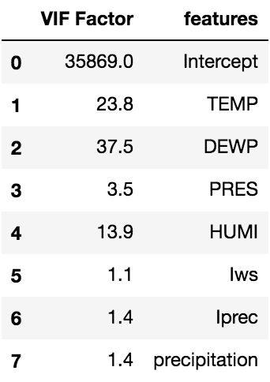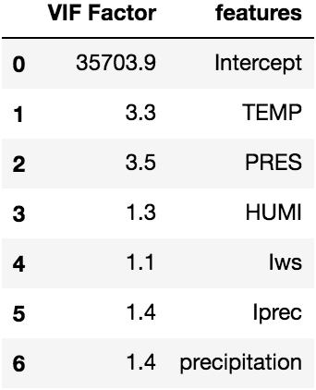
Table 2.2 VIF comparison with/without DEWP
Plus, the model needed to be fine-tuned due to heteroscedasticity founded by residual analysis (Figure 2.2-1). An increasing trend in residuals was present as the fitted value increased in the original model. Therefore, the dependent variable was transformed into its natural logarithm. The updated model was able to moderately alleviate the problem (Figure 3.2)
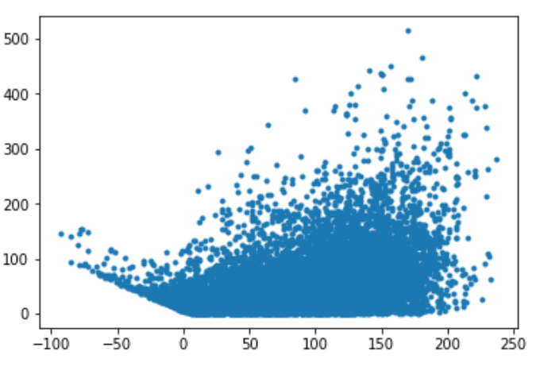
Figure 2.2 Residual Analysis of pre-transformation Model
2.3 Complexity Analysis
Our entire analysis is done using the in-built library functions. The python library functions are highly optimized codes and hence they do not take much time to run. The only part of the analysis which takes comparatively longer is the pairplot function of the seaborn library. This function is used for the exploratory data analysis and visualization part.
2.4 Complexity Analysis with the datasize
The dataset that we use is relatively small. We have about 50000 rows in our dataset of which about 60% has missing values and hence they are removed. So our working dataset has around 20000 rows.
We divide our dataset in different sizes from 0 to the maximum number of rows. We run our regression equation on that truncated dataset for 50 times and then take the mean of the time taken to run the code. We then plot the different times taken to run the code against the size of the dataset and we find that there is a gradual increase in the time with the size of the dataset. When we plot our graph against the different benchmarks we find it fitting around the logarithmic curve.
3. Results
3.1 Descriptive Statistics & Multiple Regression
The original dataset was collected by four PM2.5 detectors placed in the city. After data cleaning and descriptive statistics. Initial operations yielded 19k observations of 9 variables: PM2.5 level, time, month, humidity, temperature, dew point, pressure, precipitation, and wind speed. The descriptive statistics was displayed in Appendix I.
Data is clustered in terms of hours and months because PM2.5 levels were showing similar characteristics for certain times of the day and certain times of the year. The elbow method was used to determine the optimal centroid counts. Analysis yield that there should be 3 clusters for hours and 2 clusters for months, as shown by Figure 3.2. The KMeans clustering method generated the pairplots in Figure 3.2.2. Clusters are introduced to regression equations as dummy variables. Two hour-dummy variables and 1 month-dummy variables were added. Base case is accepted as the hours around midnight. This means that midnight hours are compared with other two hour groups of morning and noon. In terms of comparison among months, the base case is cold months and we aimed to find how warmer months differ from them.
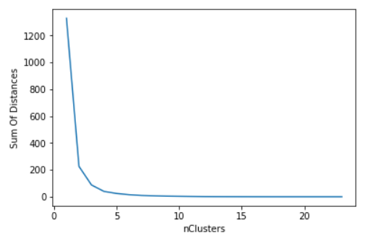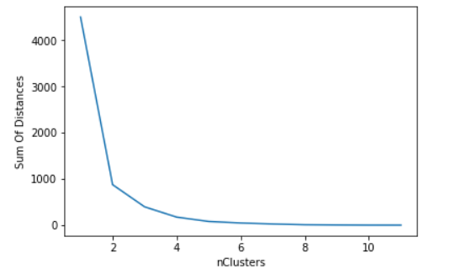
Figure 3.2.1 Elbow Method outputs of clustering by hours (left) and months (right)
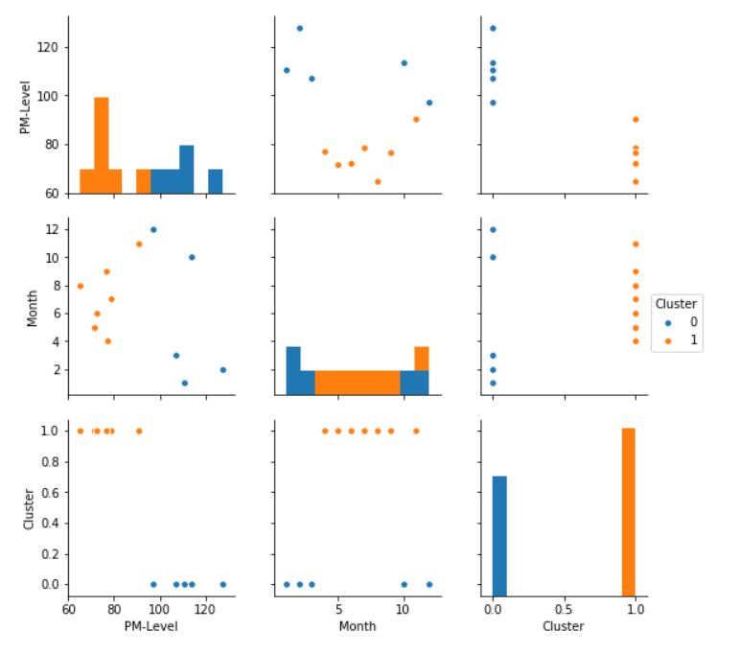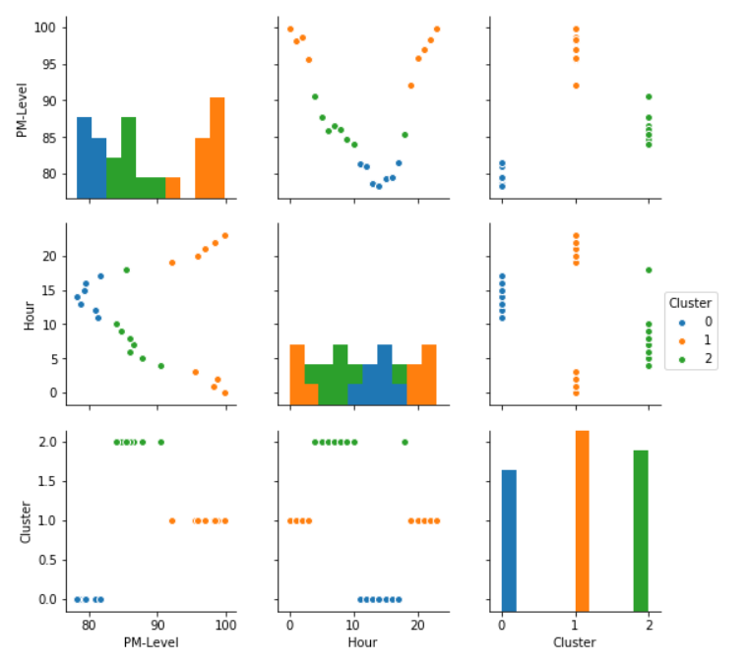
Figure 3.2.2 Parirplots after clustering by hours (left) and by months (right)
Multiple regression modeling after fine tuning generated the following regression equation:
ln(PM2.5 Level) =20.1777 - 0.0122TEMP - 0.0170PRES + 0.0200HUMI - 0.0051Iws
- 0.0487 Iprec + 0.3943HourDummy1 + 0.2019HourDummy2 +0.4462MonthDummy
The greatest R-squared value was achieved with these variables present. Regression results (Table 3.2-1) showed that every independent variable is significant in analyzing the PM2.5 levels because every p-value of every independent variable was close to zero. Temperature, pressure, wind speed and cumulative precipitation negatively impacts PM2.5 levels whereas humidity positively impacted PM2.5 levels. Dummy variables of hour and month introduced a positive offset to the regression equation.
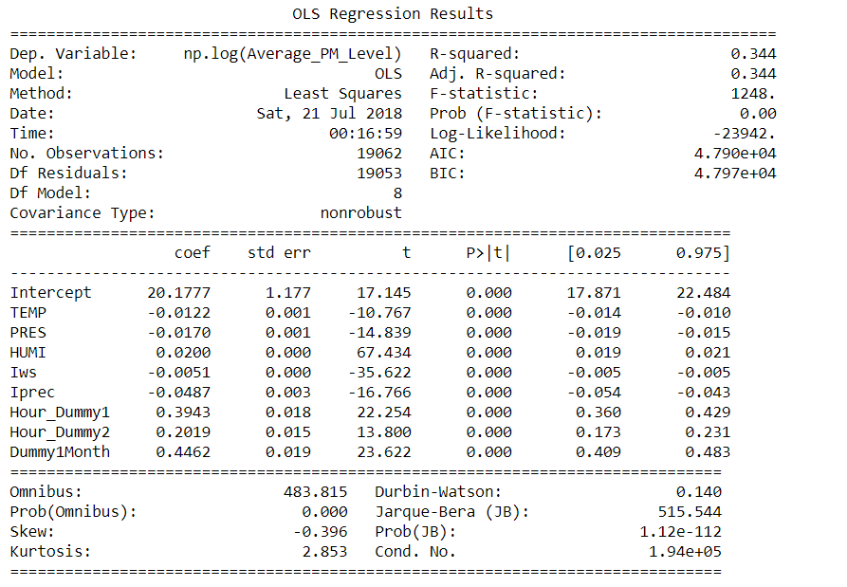
Table 3.2-1 Regression output of the final multiple regression model
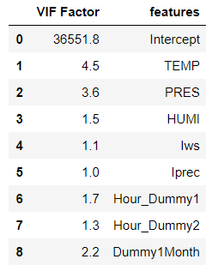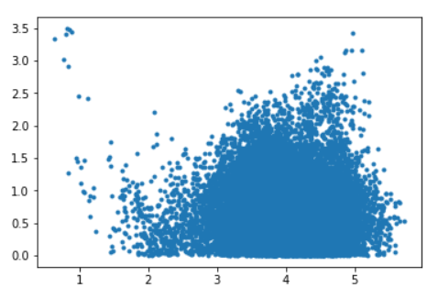
Tabel 3.2-2 VIF Values Figure 3.2 Residual Analysis of post-transformation Model
An examination of VIF values (Table 3.2-2) proved that there was no multicollinearity in the current model. Every independent variable bring new information to our linear regression model and they cannot be expressed by the combination of other independent variables.
Residual analysis shows that logarithm transformation of Average_PM_Level column has worked and residuals are more evenly distributed than previous results (Figure 2.2). However, the scatters in the plot was still not evenly distributed. Further solutions involves more advanced non-linear models, which was recommended for future research.
4. Conclusion and Recommendations
We found the regression model of PM 2.5 level and weather factors. Precipitation has the strongest negative influence on PM level, while humidity has the strongest positive influence. The current research cast light on categorization of PM2.5 levels. For different hours of the day, PM2.5 level reaches the bottom in the afternoon and the peak at midnight. In a year, PM2.5 is lower in summer and higher in winter. Based on the research results, the following recommendations were proposed.
First, related anti-PM2.5 plans and policies should differentiate depending on geographical location. Metropolitan area is prone to have higher PM 2.5 level than rural area. For different cities, we need to develop differentiated strategies that align with cities’ specific climate conditions.
Second, more systematic action plans should be specifically distinguished to the degree of different time zones in a day and different months in a year. Government shall issue stricter anti-pollution regulations in fall and winter, but can lenient to some extent in summer to find a balance between the need for economic development and the urge for improve air quality.
Third, local governments in southern Africa, western Asia, southern North America, and coastal areas of South America are recommended to put more emphasis on the threat from PM2.5. These locations are highly vulnerable to the problem because their climate conditions will elevate PM2.5 concentration if the pollutant was released into the air.
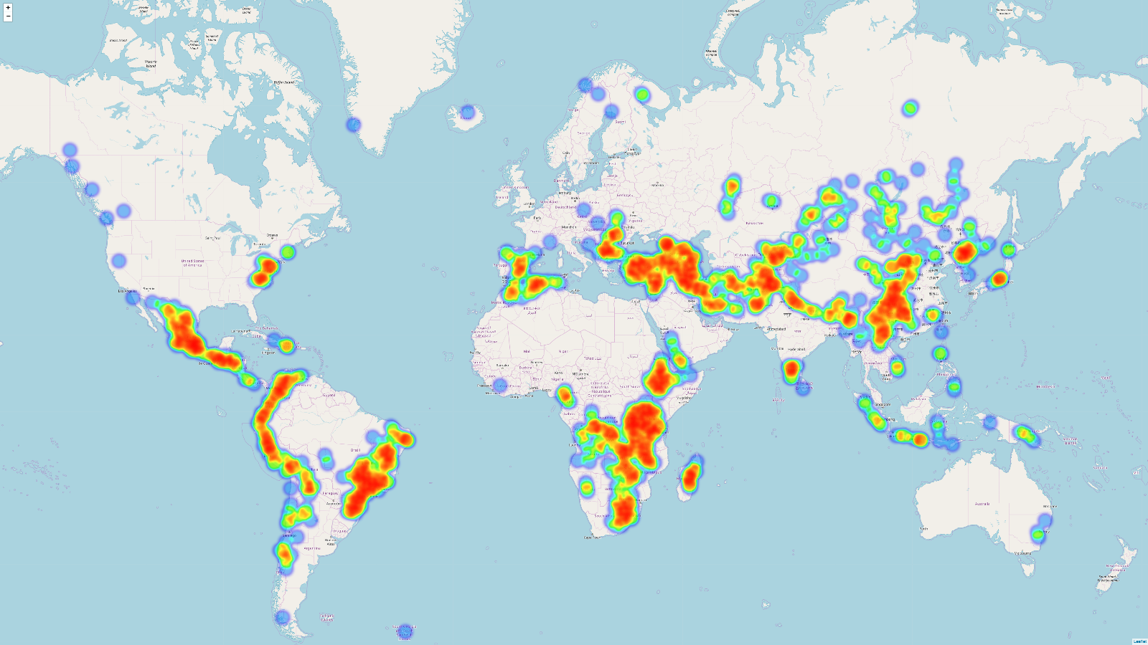
Figure 4.2-1
Last, future research was recommended to advance in modeling, given the low Adjusted R-squared of the current model. More options of non-linear regression should be tested to better capture the influence of climate conditions on PM2.5 concentration. Plus, the source of PM2.5 should be investigated to control the such pollution from its source. Also, diffusion of PM2.5 in the air requires further study. PM2.5 will probably cause bigger damage by diffusing to a place with immature responsive plans.

References
1. What is PM2.5 and Why You Should Care. (n.d.). Retrieved from https://blissair.com/what-is-pm-2-5.htm
2. Liang, X., S. Li, S. Zhang, H. Huang, and S. X. Chen (2016), PM2.5 Data Reliability, Consistency, and Air Quality Assessment in Five Chinese Cities, J. Geophys. Res. Atmos., 121, 10220â€“10236
3. Yuan, S., Xu, W., & Liu, Z. (2015). A Study on the Model for Heating Influence on PM2.5 Emission in Beijing China. Retrieved from https://www.sciencedirect.com/science/article/pii/S1877705815027769

Appendix:
descriptive:
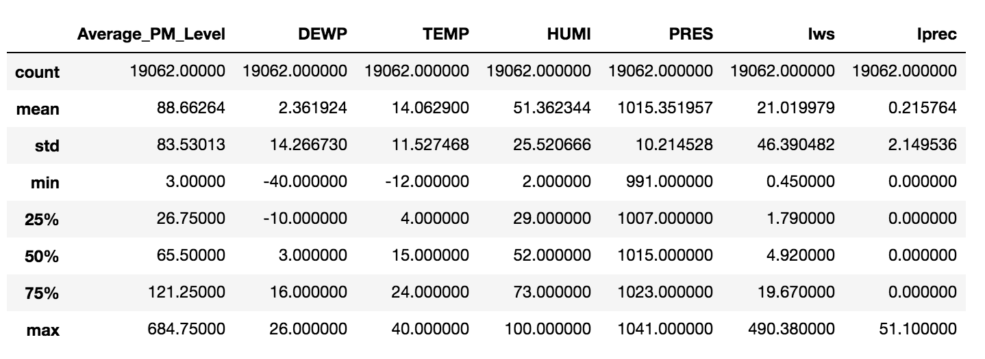
correlations:
