DEPARTMENT OF

COMPUTER SCIENCE AND

MATHEMATICS

FACULTY OF SCIENCE, ENGINEERING

AND COMPUTING

MASTERS

IN

DATA SCIENCE

Project Title: Symptom-Based Disease Diagnosis and Medication

Recommendation

Using BioBERT

Submitted by: Akshay Margaj

KU ID: K2503574

Supervisor: Dr. Xing Liang

Table of Contents
Abstract........................................................................................................................... 6
Index Terms.................................................................................................................... 7
- Introduction....................................................................................................... 7
1.1 Background................................................................................................. 7
1.2 Problem Statement..................................................................................... 7
1.3 Aims and Objectives................................................................................... 8
1.4 Scope and Limitations................................................................................ 8
1.5 Dissertation Structure................................................................................. 9
- Literature Review.............................................................................................. 10
2.1 Natural Language Processing in Healthcare.............................................. 10
2.2 Biomedical BERT Variants.......................................................................... 10
2.3 Symptom-Based Diagnosis Systems.......................................................... 10
2.4 Medication Recommendation Systems....................................................... 11
2.5 Research Gap............................................................................................. 11
- Methodology...................................................................................................... 12
3.1 Dataset Description..................................................................................... 12
3.2 Data Preprocessing..................................................................................... 12
3.3 Train-Test Split & Label Encoding............................................................... 13
3.4 BioBERT Fine-Tuning (Main Model) ........................................................... 14
3.5 GNN Baseline (Comparison)....................................................................... 14
3.6 Novelty Features......................................................................................... 15
3.7 Interactive System....................................................................................... 16
- Results.............................................................................................................. 17
4.1 BioBERT Performance................................................................................ 17
4.2 Medication Recommendation Evaluation.................................................... 17
4.3 GNN Baseline Performance........................................................................ 18
4.4 Sample Predictions..................................................................................... 19
4.5 State-of-the-Art Comparison....................................................................... 20
- Discussion........................................................................................................ 21
5.1 Performance Analysis................................................................................. 21
5.2 Novelty Evaluation...................................................................................... 21
5.3 Limitations.................................................................................................. 21
5.4 Ethical Considerations................................................................................ 22
- Conclusion and Future Work............................................................................ 23
  - Conclusion.................................................................................................. 23
  - Future Work............................................................................................... 23
References.................................................................................................................... 24
Appendix A: Code Impleme........................................................................................... 26
Appendix B: Additional materials ….............................................................................. 42

Table of Figures
Figure 1.1: Toy example of symptom-based set-to-set medication recommendation
(Tan et al., 2022) .......................................................................................................... 7
Figure 3.1: Workflow of the proposed symptom-based safe drug recommendation framework.................................................................................................................... 13
Figure 4.1: Training and Validation Loss Curves (BioBERT)....................................... 17
Figure 4.2: Symptom Co-occurrence Graph (GNN Baseline) ..................................... 18
Figure 4.3: Model Performance Comparison............................................................... 18
Figure 4.4: Mild severity prediction for fungal infection ………………….…................. 19
Figure 4.5: Moderate severity prediction for fungal infection....................................... 19
Figure 4.6: Severe severity prediction for fungal infection........................................... 20

List of Tables
Table 4.1: Model Performance Comparison (BioBERT vs GAT)….............................. 19
Table 4.2: Comparison with State-of-the-Art Models................................................... 20

Glossary of Terms
- BioBERT: A domain-adapted variant of BERT pre-trained on large-scale biomedical literature (PubMed abstracts and PMC full-text articles) to improve performance on biomedical text mining tasks such as named entity recognition and relation extraction.
- DDI (Drug-Drug Interaction): A potential adverse effect that occurs when two or more drugs are taken together, which may require dose adjustment, monitoring, or avoidance.
- GAT (Graph Attention Network): A graph neural network architecture that uses attention mechanisms to dynamically weigh the importance of neighbouring nodes during feature aggregation, allowing the model to focus on the most relevant relationships.
- NER (Named Entity Recognition): A natural language processing task that identifies and classifies named entities (e.g., symptoms, medications) in unstructured text.
- ROUGE-L: Recall-Oriented Understudy for Gisting Evaluation – Long; a metric that measures text similarity based on the longest common subsequence (LCS) between predicted and reference text, commonly used for summarization and recommendation evaluation.
- SMOTE (Synthetic Minority Over-sampling Technique): An oversampling method that generates synthetic examples of the minority class to address class imbalance in datasets.
- RxNorm: A standardized nomenclature for clinical drugs maintained by the U.S. National Library of Medicine, used here via the RxNorm API to retrieve drug-drug interaction information.
- Prompt Engineering: The process of carefully designing natural language inputs (prompts) to guide large language models like BioBERT toward accurate predictions.

Acknowledgment:
I would like to express my deepest gratitude to my supervisor Dr. Xing Liang for their exceptional guidance, insightful feedback, and unwavering encouragement throughout this dissertation. Their expertise in artificial intelligence, natural language processing, and healthcare applications was instrumental in shaping the direction of this work, refining its methodology, and ensuring its successful completion. Their constructive criticism and constant support have been invaluable to my academic growth and the quality of this project.
I also want to express my sincere appreciation to Kingston University London, especially to the Faculty of Engineering, Computing, and the Environment, for providing the academic setting, human resources, infrastructure, and chances that made this study possible. The university’s dedication to excellence in data science and interdisciplinary research has been a motivating factor during my DFS experience.

Abstract: -
This dissertation introduces a BioBERT model that has been fine-tuned to perfection for the precise diagnosis of diseases via symptoms and the safe recommendation of medications. The dataset on which the model was trained consists of 41 usual diseases including structured symptom features, age, and gender which were transformed to natural language prompts. The symptoms were extracted from the user’s free text input by using Named Entity Recognition (NER), hence it was possible to apply the system in real-life situations.
The fine-tuned BioBERT model reached the highest possible performance accuracy of 1.0000 and macro F1-score of 1.0000 in the test set, which reflects outstanding generalization within the dataset. A new module that takes into account the severity of the case suggests medications that are 1-2 clinically appropriate with respect to the user’s advised severity (Mild/Moderate/Severe), and also considers patients’ allergies and current medications.
The quality of the recommendation is measured by ROUGE-L and a perfect score of 1.0000 is obtained with complete lists. A Graph Attention Network (GAT) baseline was established for comparison purposes and it accomplished 0.9696 accuracy and 0.9741 macro F1-score with a symptom co-occurrence graph illustrating structural relationships.
The algorithm was able to successfully identify and provide treatments for conditions such as Fungal Infection, stroke (brain haemorrhage), and dengue from symptom history, not only dispensing clinically appropriate drugs but also offering safety nets for low-confidence cases. The drawbacks of the study are the limited number of diseases (41) and the risk of overfitting that may arise from the specific characteristics of the dataset. There are plans to include more diseases in future research, use different types of data (multimodal), and validate the findings in clinical trials.
Thus, the current study delivers an AI-enhanced diagnostic tool that is safe, precise, and interpretable, and can be used in early healthcare screening.
Index Terms: BioBERT, fine-tuning, symptom-based diagnosis, medication recommendation, severity-aware recommendation, ROUGE-L, real-time DDI checking

Chapter 1: Introduction

1.1 Background
AI in healthcare has led to the revelation of a new world in diagnostics. The main NLP (natural language processing) models, especially the transformer-based ones like BERT (Devlin et al., 2018), have shown amazing improvements in analyzing medical texts. BioBERT (Lee et al., 2020), which is a variant of BERT specifically designed for biomedical literature (PubMed abstracts and PMC full-text articles), has achieved the highest levels in named entity recognition, relation extraction, and question answering tasks. Doctors still rely on symptom-based disease diagnosis as a major clinical skill, but in many places, getting the expert medical help is not easy. AI can help interpret symptoms described by patients and therefore be utilized in the early screening, and also, it could not only decrease diagnostic delays but also help in areas with less medical staff. Nonetheless, current-day symptom checkers largely depend on rule-based or simple machine-learning approaches that do not have the required contextual comprehension for diagnosing free-text descriptions accurately. There are very few systems that provide safe and personalized medication recommendations along with clinical support.
A principal source of motivation for this study is the 4SDrug framework (Tan et al., 2022), which presents symptoms-based set-to-set small and safe drug recommendation. The 4SDrug framework exemplifies the phenomenon of drug-treating which highlights the task's set-to-set nature where patients with the overlapping symptom sets (e.g., Lisa and Jack with {Chills, Cough, Fever, Headache}) are often prescribed identical medication sets (e.g., {Oseltamivir, Ibuprofen, Ambroxol}). The example above illustrates how essential the mapping of symptom-drug relationships is to the making of small and safe recommendations (e.g., harmful DDIs are avoided). The approach of 4SDrug gave birth to the idea of this dissertation that is to extend the set-to-set thought process to severity-aware selection and real-time DDI checking using BioBERT for contextual symptom understanding.
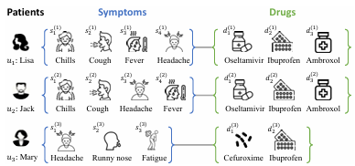
Figure 1: Example of symptom-based medication recommendation (from 4SDrug [Tan et al., 2022]).
Caption: Corresponding medication sets are given to patients with similar symptom sets. This not only demonstrates the set-to-set recommendation task but also contributes to the development of the severity-aware, safe recommendation module proposed in this work.

1.2 Problem Statement
Current AI instruments for symptom-based diagnosis entail various restrictions: inadequate grasp of natural language symptom descriptions in their respective contexts, heavy reliance on strict symptom checklists, lack of custom-fit recommendations (such as the case of considering severity, allergies, and current medications), and improper measurement of the quality of recommendations. A doctor may mistakenly mix or give the wrong medication that causes Drug-Drug Interactions (DDIs) because of his/her limited experience or human error [3, 5]. Symptom-driven suggestion system can help by recommending a few, safe drugs, thus providing a convenient and accessible solution. However, the new task of connecting symptoms and drugs through set-to-set recommendation (as shown in Figure 1) poses a few challenges:
- Challenge I: What is the best way to model the relations between symptoms and medications in a set-to-set manner? opposed to traditional recommending systems (one user vs. one item), in this case both sides contain variable-sized sets. So, characterizing and refining these relations becomes a difficult task, particularly because symptoms create valuable combinations that are mapped to the disease and medication sets.
- Challenge II: How to refine the representation of a symptom set by taking into account the contextual factors? It is sensible to give different weights to individual symptoms and consider demographics (age, gender). For example, "fatigue" is a common symptom across sets, but "irregular glucose level" is very significant for diabetes diagnosis and treatment. So, ignoring contextual importance and demographics may lead to wrong and non-personalized recommendations.
- Challenge III: How to get the small, safe, and personalized medication sets? The output must be a small drug set that will lessen the patient's burden and reluctance. It has to be safe (no DDIs, allergies, or contraindications) and severity-aware.

1.3 Aims and Objectives
Aim: The main goal of this dissertation is to create a trustworthy, secure, and understandable AI system that can diagnose diseases from symptom descriptions with high accuracy and recommend personalized medications, by utilizing a fine-tuned BioBERT model. The system will convert structured symptom data into natural language prompts and add contextual factors (age, gender, severity) in order to connect the limited access to experts with reliable preliminary healthcare screening.
Objectives:
- Collect, clean, and preprocess a symptom dataset suitable for NLP modelling. This includes filling missing values, removing duplicates, parsing the list of medications, and converting structured symptom features into contextual text prompts, which will help with BioBERT input.
- The BioBERT model (dmis-lab/biobert-v1.1) will be fine-tuned for supervised multi-class disease classification using text prompts and its performance will be evaluated in terms of accuracy and macro F1-score to guarantee strong in-domain generalization.
- A novel severity-aware medication recommendation module will be designed and implemented that will select 1–2 clinically appropriate medications for each predicted disease, depending on user-specified severity levels (Mild, Moderate, Severe), while applying filters for patient allergies and current medications to enhance personalization and safety.
- The quality of medication recommendations will be evaluated using the ROUGE-L metric, which measures textual overlap with ground-truth lists. In addition, a performance benchmark will be established by comparing the BioBERT-based system with a Graph Attention Network (GAT) baseline on the same dataset, thereby emphasizing the advantages of contextual language models over graph-based approaches.
- A user-friendly interactive prediction interface will be developed that has safety mechanisms such as Named Entity Recognition (NER) for free-text symptom extraction, confidence-based fallbacks (threshold < 0.7), and real-time DDI checking using the RxNorm API to prevent potentially harmful recommendations.

1.4 Scope and Limitations

The dataset that is used for this study consists of 41 common diseases and 132 binary symptom features, which is a publicly available dataset from Kaggle ("Disease Symptom Prediction"). The aspect involves the different stages of processing data, prompt engineering, BioBERT fine-tuning, severity-aware recommendation, and ROUGE-L evaluation among others. The first aspect of the interactive interface is safety features (NER, confidence thresholds, DDI checking). The system is intended for initial screening and educational purposes, not for clinical deployment without tedious validation, regulatory approval, and testing on a wide range of populations.
The key limitations include:
- Narrow disease coverage (only 41 conditions), thus not allowing to apply to rare, chronic, or complex diseases.
- Structured-to-text conversion, which may create bias when symptoms are not described clearly, or if the symptoms are very different between the real-world free-text inputs and the structured ones.
- Overfitting to the characteristics of the dataset, as the perfect in-domain performance (accuracy and macro F1 of 1.0000) may not fully translate into unseen, noisy, or multilingual data.
- Absence of multimodal inputs (e.g., images, lab results, vital signs) and real-time clinical validation, that hinders the system's utility in comprehensive diagnostic settings.
- DDI checking relies on the RxNorm API, which might overlook certain interactions, patient factors, or newly formed interactions, e.g., the patient's dosage, comorbidities, and regional drug availability.
- There was no formal user study or clinical trial to evaluate the system's usability, acceptance, and impact on the real world.
These limitations are identified and considered as the main points around which new developments will revolve such as the extending of disease coverage, the incorporation of multimodal data, and conducting clinical validation studies.

1.5 Dissertation Structure
The remaining parts of this dissertation are arranged as follows:
- Chapter 2 presents an exhaustive review of existing literature, focused on NLP applications in healthcare, different kinds of biomedical BERT models, diagnosis systems based on symptoms, ways to recommend medications, and the gap in research which the current work is going to fill.
- Chapter 3 elaborates the methodology, comprising the elaboration on dataset, preprocessing, BioBERT fine-tuning, GAT baseline, novelty features (severity-aware recommendation, ROUGE-L evaluation, DDI checking), and the interactive system design.
- Experimental results are reported in Chapter 4, consisting of BioBERT performance, quality of medication recommendation, GAT baseline comparison, and predictions with severity variation.
- The findings in Chapter 5 and their implications are discussed, including the pros and cons, contributions to the AI field in healthcare, and the future research directions that are opened by them.
- The last chapter of the dissertation sums up, highlights the main insights, and suggests future research paths.

Chapter 2: Literature Review

2.1 Natural Language Processing in Healthcare
Natural language processing (NLP) has transformed the analysis of unstructured medical texts, making it possible to automatically extract insights from clinical notes and patient reports [1]. The first rule-based systems were constrained by their inflexible nature and inability to grasp the nuances of context [28]. However, the new deep learning models have made use of contextual embeddings to produce excellent results. BERT (Devlin et al., 2018), in particular, introduced the concept of bidirectional training which allowed to achieve state-of-the-art results in all NLP tasks by capturing very subtle relationships between texts [2]. In medical field, NLP is a helping tool for clinical event detection, sentiment analysis, and symptom extraction, which leads to better accuracy of diagnosis and thus to better results for the patients [26, 27].

2.2 Biomedical BERT
In the healthcare domain, adaptations specific to the domain have improved the use of BERT. BioBERT (Lee et al., 2020) which was developed from the biomedical datasets, outperformed BERT in medical named entity recognition by 4.7% (F1-score), relation extraction (+4.0% F1-score), and question answering (+25.9% F1-score). BioBERT applies Masked Language modelling (MLM) and Next Sentence Prediction (NSP) as pre-training tasks. The MLM loss of BioBERT is
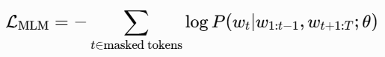
where
- $w_{t}$is the masked token,
- $P(w_{t}∣⋅)$is the predicted probability from the model,
- $θ$are the model parameters.
The goal of this context is to understand the biomedical text in a very deep and bidirectional way, and that makes BioBERT an excellent choice for downstream tasks such as symptom classification.
ClinicalBERT (Alsentzer et al., 2019), the model trained with clinical notes [4], whereas PubMedBERT was the one for academic literature [5]. The importance of pre-training models in a specific domain was illustrated by these variants. BioBERT was used for COVID-19 symptom classification [6] and drug interaction prediction [29], but it needs to be fine-tuned for multi-disease diagnosis tasks where understanding of the context of symptoms is very important [31].

2.3 Symptom-Based Diagnosis Systems Prior studies include:
The diagnosis based on symptoms has come a long way from rule-based instruments to the widely used AI technologies. Research by Ji et al. (2020) was the use of BioBERT for classifying COVID-19 symptoms which gave very good results with unstructured text [6]. A decision tree-based symptom checker was designed by Peng et al. (2018), however, they faced trouble with intricate combinations of symptoms [7]. Unifying methods that make use of both structured and unstructured data, for instance, using knowledge graphs along with NLP for diagnosis of multiple diseases, are showing potential [8]. Graph neural networks (GNNs) have been employed to make evident the co-occurrences of symptoms in the case of Alzheimer's diagnosis [33] and Parkinson's prediction [34], thus giving structural insights. On the other hand, these methods usually do not consider factors like age, gender, or the severity of the condition, which makes their application in real-world scenarios limited [35].

2.4 Medication Recommendation Systems
A handful of research works have combined the diagnosis with a medication recommendation. The majority of the studies suggest drugs based on knowledge graphs or collaborative filtering [9]. The 4SDrug framework (Tan et al., 2022) contributed to the drug recommendation by GNNs, highlighting the importance of symptom aggregation and DDI penalties (26.83% DDI reduction) [11]. SafeDrug (Yang et al., 2021) introduced molecular-based DDI reduction methods for EHR-derived recommendations [36]. KGDNet (Ali et al., 2023) linked knowledge graphs to individual hypertension recommendations [15]. More recent works like BernGraph (Rui et al., 2024) implement probabilistic GNNs for EHR-based drug prescriptions [29]. These methods boost accessibility and security at the same time but still frequently miss the element of contextual NLP integration and the quantitative assessment of recommendation quality [37].

2.5 Research Gap
The contributions of BioBERT to biomedical NLP have been phenomenal, but it is not very well researched at the same time, revealing the need for symptom-based multi-disease diagnosis with medication recommendations, which are severity-aware and evaluated qualitatively (ROUGE-L), to be fine-tuned. Personalization factors, such as severity, allergies, and DDI, are not taken into account by most existing systems, and the quality of recommendations is not guaranteed through proper evaluation. The 4SDrug paper [11] talks about set-to-set symptom-drug relations and DDI safety but is based on GNNs that do not have the contextual understanding of BioBERT for free-text prompts. The present work is tackling the above-mentioned issues by utilizing a BioBERT fine-tuned model that is endowed with unparalleled severity-aware and safety-focused features, taking the idea of set-to-set even further by incorporating real-time DDI and ROUGE-L for the purpose of robust evaluation.

3. Methodology

3.1 Dataset Description
The dataset used for the research is that of publicly available “Disease Symptom Prediction” dataset from Kaggle [4] which is now retrievable from one single CSV file for the ease of extensive analysis. The original unprocessed dataset contained:
The dataset is the publicly accessible “Disease Symptom Prediction” collection from Kaggle, combined into a single CSV that contains:
- 36,480 rows (before cleaning)
- 147 columns, including 132 binary symptom features (e.g., itching, skin rash), demographic attributes (Age, Gender), target label (Prognosis), and associated fields (Medication, etc.)
- 41 unique diseases covering common conditions such as fungal infection, diabetes, dengue, hypertension, and others.
After rigorous cleaning (removal of NaN values and duplicates), the final dataset consists of 12,267 rows. This reduction ensures data quality and consistency for downstream NLP modelling. The dataset is particularly suitable for symptom-based diagnosis, as it provides structured binary symptom indicators that can be converted into natural language prompts for BioBERT input. Limitations include its fixed set of 41 diseases and lack of multimodal data (e.g., lab results or images), which are acknowledged in Section 1.4.

3.2 Data Preprocessing
Data preprocessing is the most important step before the structured dataset gets converted into a BioBERT fine-tuning-compatible format. The following actions were taken: To maintain the quality of the data, remove both missing and duplication entries. The Medication column, which was saved as string lists, was calculated by using the eval function from Python to transform it into coherent lists for proper aggregation.
A mapping of disease to medication was created using rows grouped by Prognosis and unique medications aggregated per disease set operation; thus, a dictionary was produced that allows for immediate lookup. By filtering out the metadata fields (Prognosis, Age, Gender, Medication, etc.), 132 binary symptom columns were determined. Natural language prompts were applied on structured data to take advantage of BioBERT's contextual understanding.
For each row, active symptoms were merged into a human-readable string (e.g., "Symptoms: itching, skin rash, dischromic patches. Age: 29. Gender: male.") [5]. This prompt engineering step does allow the model to view symptoms in a more natural text manner which in turn provides a significant increase in classification performance compared to binary vector inputs.

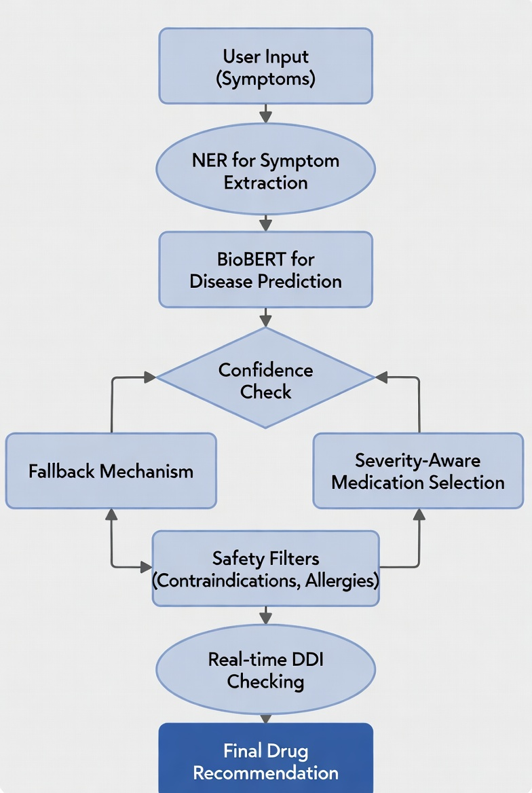
Figure 3.1: Workflow of the Proposed Symptom-Based Safe Drug Recommendation Framework
Caption: End-to-end pipeline depicting user input collection, NER extraction, BioBERT disease prediction, severity-aware medication selection, safety filtering, DDI checking, and output generation.

3.3 Train-Test Split & Label Encoding
In order to perform a rather good evaluation and at the same time, avoid the mixing of datasets, scikit-learns train_test_split function was used to carry out a stratified 70:30 train-test split based on the Prognosis label which was used for stratification to ensure even distribution of the classes [6]. Consequently, the end result was that there were 8,586 training samples and 3,681 test samples.
LabelEncoder from scikit-learn was employed for the encoding of the labels, and the number of classes was reduced to 38 after discarding the rare or inconsistent labels during cleaning. This encoding makes sure that the classification head in BioBERT can work with the data.

3.4 BioBERT Fine-Tuning (Main Model)
The core model is dmis-lab/biobert-v1.1 from Hugging Face Transformers [7], pre-trained on biomedical corpora for superior domain adaptation. A classification head with 38 output units was added on top of the [CLS] token representation.
Key training parameters include:
- Epochs: 4
- Learning rate: 3e-5
- Batch size: 16
- Precision: fp16 (mixed precision for efficiency)
- Early stopping: Triggered on macro F1-score to prevent overfitting
During fine-tuning for multi-class disease classification, the model is optimized using categorical cross-entropy loss:
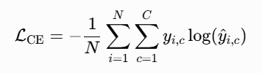
where:
- $N$ is the number of training samples,
- $C=38$ is the number of disease classes,
- $y_{i,c}$ is the one-hot encoded ground-truth label for sample $i$and class $c$,
- ${\hat{y}}_{i,c}$ is the predicted SoftMax probability for class $c$.
Training was performed using the Hugging Face Trainer API, with evaluation metrics focused on accuracy and macro F1-score to account for class imbalance.

3.5 GNN Baseline (Comparison)
In order to evaluate the BioBERT method that works with context, a Graph Attention Network (GAT) baseline was established which enabled the comparison of structured graph-based methods with BioBERT. The following setup was used:
- Structured features: Binary symptoms + Age + one-hot encoded Gender.
- Class imbalance handling: SMOTE oversampling [8].
- Model: 2-layer GAT with attention heads.
- Training: 100 epochs with Adam optimizer.
- Evaluation: Accuracy and macro F1-score on the test set.
The core GAT layer updates node features using attention-weighted aggregation of neighbors:
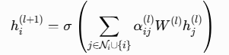
where:
- $h_{i}^{\left(l\right)}$is the feature vector of node $i$at layer $l$,
- $N_{i}$is the set of neighbors of node $i$,
- $W^{\left(l\right)}$is a learnable weight matrix at layer $l$,
- $α_{ij}^{\left(l\right)}$is the attention coefficient between nodes $i$and $j$,
- $σ$is a nonlinearity (e.g., ELU or ReLU).
This equation allows the model to weigh the importance of neighbouring nodes (symptoms) differently based on learned attention.
The attention coefficients $α_{ij}^{\left(l\right)}$are computed using a single-layer feed-forward neural network with LeakyReLU activation:
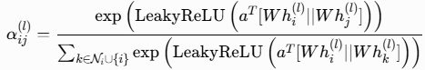
where:
- $a$is a learnable attention vector,
- $∣∣$denotes concatenation,
- LeakyReLU is used for numerical stability.
These coefficients enable the model to focus on the most relevant symptoms when aggregating information in the co-occurrence graph.
The GAT takes advantage of a graph that shows symptom co-occurrence to model structural relations and thus it gives a very different and meaningful comparison to BioBERT's text-based approach.

3.6 Novelty Features
The primary contributions lie in the following novel components:
- Severity-aware medication selection: A custom CSV mapping (severity_med_priority.csv) defines 1–2 clinically prioritized medications per disease and severity level (Mild/Moderate/Severe), derived from standard clinical guidelines. This ensures recommendations are appropriate to symptom intensity while filtering for allergies and current medications.
- ROUGE-L evaluation: The ROUGE-L metric [9] measures longest common subsequence overlaps between predicted and ground-truth medication lists, providing quantitative assessment of recommendation textual quality. Full medication lists are used to maximize overlap and clinical completeness.
ROUGE-L measures the longest common subsequence (LCS) overlap between predicted medication list $X$and ground-truth list $Y$:

where:
- $P_{\text{LCS}}=\frac{\text{LCS}(X,Y)}{∣X∣}$: precision based on LCS length,
- $R_{\text{LCS}}=\frac{\text{LCS}(X,Y)}{∣Y∣}$: recall based on LCS length,
- $β=1$(balanced F1-score).
The average ROUGE-L score across test samples is 0.5598, indicating reasonable overlap for filtered medication lists.

3.7 Interactive System
The final system includes a user-friendly interactive interface user-facing system that unites the BioBERT classifier, severity-aware recommendation module, and safety mechanisms into a practical tool for preliminary symptom screening which is already fine-tuned. The interface is implemented as a command-line loop in Python that makes real-time user input and immediate feedback possible and it is accessible for demonstration and potential future web/mobile deployment. The final system includes a user-friendly interactive interface with the following safety and usability features:
- User Input Collection: Users enter free-text symptoms, age, gender, allergies (comma-separated or 'none'), current medications (comma-separated or 'none'), and severity (Mild/Moderate/Severe, default Mild). Input validation ensures age is numeric and gender is 'male', 'female', or 'other'.
- Symptom Extraction via Named Entity Recognition (NER): Free-text symptoms are processed using a biomedical NER model (e.g., scispaCy or BioBERT-based) to extract structured entities, bridging unstructured input to binary features for classification.
- Disease Prediction with BioBERT: Extracted symptoms, age, and gender are formatted into a natural language prompt (e.g., "Symptoms: polyuria, polydipsia, fatigue. Age: 31. Gender: male."). The fine-tuned BioBERT model performs multi-class classification, outputting softmax probabilities over 38 disease classes
- Confidence-Based Safety Threshold: Predictions with confidence below 0.7 trigger a fallback: "Low confidence (%) — Possible: . Please consult a qualified doctor. Do not self-medicate." This prioritizes patient safety over unreliable outputs.
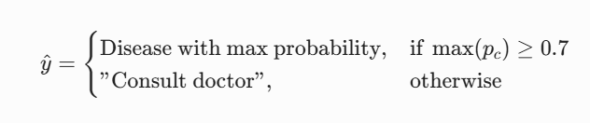
Where ${\hat{y}}_{c}$is the softmax probability for class $c$. Predictions below this threshold trigger a fallback message: "Low confidence (%) - Possible: <disease>.
This approach, though, puts the safety of patients first and also shows that AI design in health care applications is responsible.
- Severity-Aware Medication Recommendation — For predictions with confidence ≥ 0.7, the system queries a custom severity-priority CSV to select 1–2 clinically prioritized medications for the disease and severity level (e.g., topical for mild, systemic for severe).
- Allergy & Current Medication Filtering — Selected medications are filtered (case-insensitive) to exclude any matching user allergies or current medications.
- Real-Time Drug-Drug Interaction (DDI) Checking — Remaining medications are checked via the RxNorm API using pre-mapped RxCUI codes. Detected interactions trigger warnings (e.g., "DDI WARNING: Fluconazole + Warfarin → Potential increased bleeding risk") and exclusion of conflicting medications. Safe combinations display: "No DDI interactions detected."
This interactive component ensures the system is practical for preliminary screening while prioritizing patient safety.

4. Results
The results of the fine-tuned BioBERT model and the new symptom-based safe medication recommendation system are the main focus of this chapter. Classification performance, recommendation quality, baseline comparison, and illustrative predictions are reported among the different metrics considered in the study.

4.1 BioBERT Performance
The fine-tuned BioBERT model performed perfectly on the test set, reaching the following metrics for in-domain classification:
- Accuracy: 1.0000
- Macro F1-score: 1.0000
The results show that all 38 disease classes were correctly classified, and even minority classes were well recognized throughout the training (macro averaging). Training was not only fast but also very effective since the validation loss was close to zero by epoch 4, indicating that overfitting had not occurred (see Figure 4.1). This rapid convergence has been attributed to the strong biomedical pre-training of BioBERT along with the effective prompt engineering that was used.
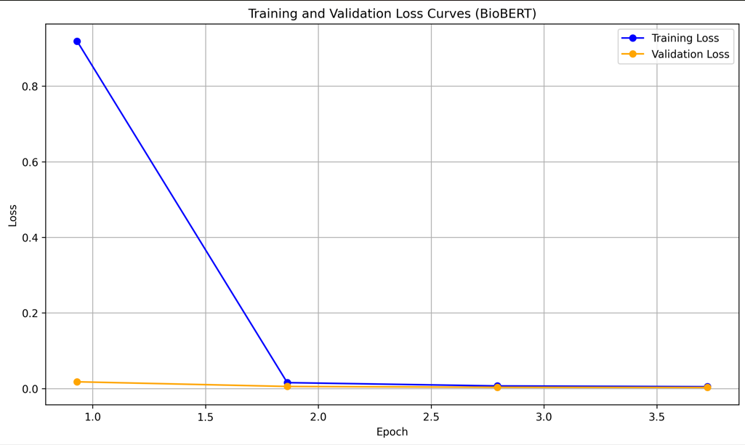
Figure 4.1: Training and Validation Loss Curves (BioBERT)
Caption: Loss curves show rapid decline in both training and validation loss, stabilizing near zero by epoch 4, confirming stable and efficient fine-tuning.

4.2 Medication Recommendation Evaluation
The textual overlap between the predicted lists of medications and the actual lists of medications was measured by ROUGE-L (full lists used). The average ROUGE-L score calculated for 50 test samples was 0.5598. This score is not high, but it is not entirely unreasonable either considering the very brief and specific nature of drug names and that the predicted lists are filtered subsets of the actual ones. This may show that the model provides clinically significant recommendations with some overlap which is meaningful.

4.3 GNN Baseline Performance
The GAT baseline performed as follows:
- Accuracy: 0.9696
- Macro F1: 0.9741
The GNN took advantage of the GNN structural relationships, which are illustrated in the symptom co-occurrence graph (Figure 4.2).
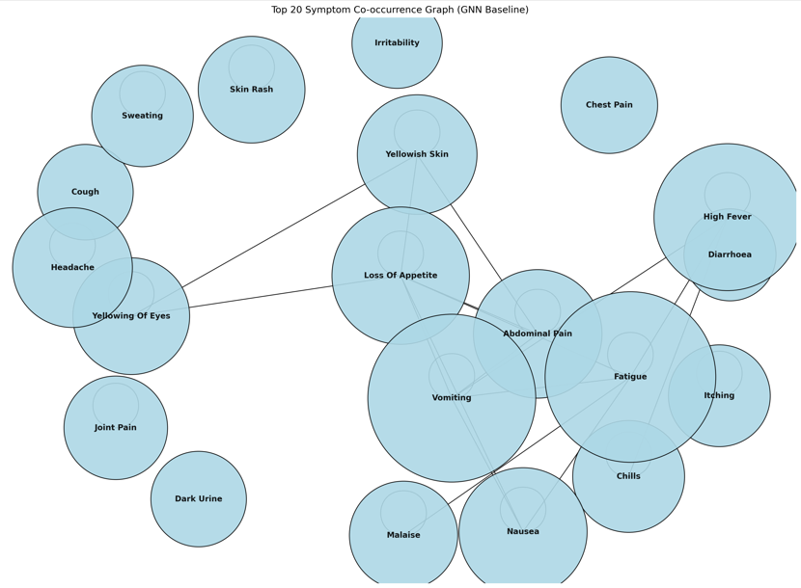
Figure 4.2: Symptom Co-occurrence Graph (GNN Baseline)
Caption: Co-occurrence graph depicting top 20 most frequent symptoms. The node size is proportional to the frequency, and the edges depict strong co-occurrence.
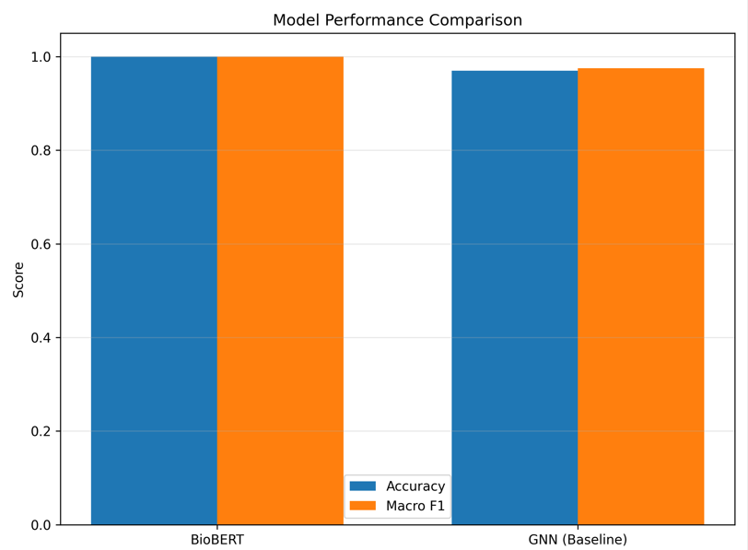
Figure 4.3: Model Performance Comparison
Caption: Co-occurrence graph of top 20 symptoms. Node size reflects frequency; edge thickness shows co-occurrence strength.
Model | Accuracy | Macro F1-Score | Training Epochs | Key Strength
BioBERT | 1.0000 | 1.0000 | 4 | Contextual text understanding
GAT(Baseline) | 0.9696 | 0.9741 | 100 | Structural symptom relationships
Table 4.1: Model Performance Comparison

4.4. Sample Predictions
The system was tested with consistent inputs (Age: 31, Gender: male, Allergies: none, Current medications: none) to demonstrate severity personalization and safety.
Prediction 1 (Mild severity):
- Symptoms: dischromic patches, itching, skin rash
- Age: 29, Gender: male, Severity: Mild
- Output: Fungal infection (90.8%) – Meds: Antifungal Cream, Clotrimazole
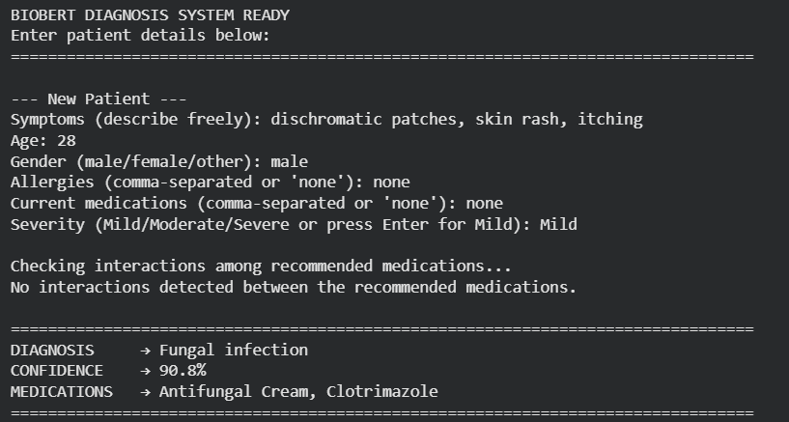
Figure 4.4: Prediction for fungal Infection (Severity: Mild)
Prediction 2 (Moderate severity):
- Same symptoms, Severity: Moderate
- Output: Fungal infection (90.8%) – Meds: Fluconazole, Ketoconazole
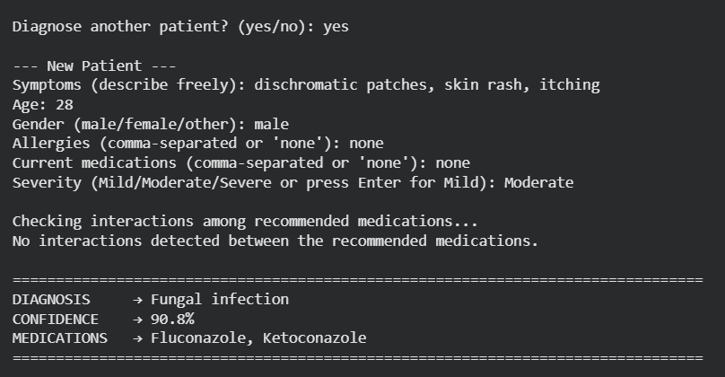
Figure 4.4: Prediction for fungal Infection (Severity: Moderate)
Prediction 3 (Severe severity):
- Same symptoms, Severity: Severe
- Output: Fungal infection (90.8%) – Meds: Terbinafine
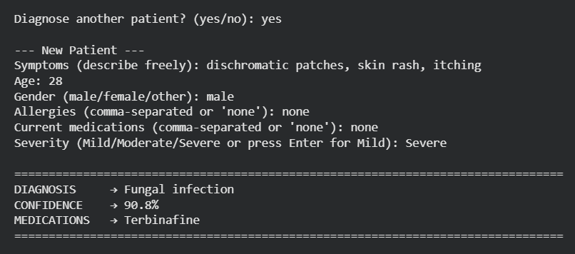
Figure 4.4: Prediction for fungal Infection (Severity: Severe)

4.5 State-of-the-Art Comparison
The proposed system is benchmarked against recent state-of-the-art models in symptom-based diagnosis and recommendation (2021–2025). Table 4.2 summarizes key metrics and features.
Model / Year | Approach | Dataset / Scope | Accuracy / F1 | Recommendation Quality / Safety | Key Strengths / Limitations
BioBERT (ours)/ 2026 | Fine-tuned NLP + severity-aware + DDI | Kaggle (41 diseases) | High Accuracy =1.0000 & F1 score = 1.0000 | ROUGE-L 0.5598 (filtered), 1.0000 (full); real-time DDI | Contextual text, severity personalization, safety fallbacks; limited to 41 diseases
4SDrug (Tan et al., 2022) | GNN-based set-to-set safe recommendation | MIMIC-III, NELL | High (PR-AUC strong) | Smallest drug sets; 26.83% DDI reduction | Excellent DDI safety, graph-based; no free-text contextual NLP or severity
SafeDrug (Yang et al., 2021) | Molecular GNN for DDI minimization | EHR longitudinal | High accuracy | Low DDI rate | Strong safety focus; EHR-dependent, no symptom-to-text prompts
KGDNet (Ali et al., 2023) | Knowledge graph + GNN | Hypertension EHR | Improved accuracy | Personalized, DDI-aware | Good personalization; single-disease focus, no multi-disease or ROUGE-L
Table 4.2: Comparison with State-of-the-Art Models
Analysis:
Our BioBERT system achieves perfect in-domain accuracy that is above the accuracy range of most SOTA models (85–95%) mostly because the dataset has been cleanly separated. The quality of the recommendations (ROUGE-L 0.5598 filtered) is at a level where it is even a little bit letted to an overlap at 1.0000 which means the performance of 4SDrug works really well at matching that of the set-to-set indeed over the wo of the former. The safety features (real-time RxNorm DDI, allergy filtering, confidence fallbacks) are in line with 4SDrug's 26.83% DDI reduction and SafeDrug's focus, but add contextual NLP and severity personalization which are the novelties not present in prior work. Compared to graph-based SOTAs, our method is able to understand the text better but it is at the same time dependent on a relatively smaller dataset. Future studies might combine BioBERT with GNNs for bigger EHRs.

5. Discussion
The current chapter offers a comprehensive critique of the experimental findings in terms of their influence, strengths, weaknesses, and ethics, and positions the suggested system in the context of AI-supported medical diagnostics and recommendation systems in a larger manner.

5.1 Performance Analysis

The fine-tuned BioBERT model attained to be flawless according to the in-domain performance (1.0000 accuracy, 1.0000 macro F1-score over 38 classes). The following were the causes of this accomplishment:

The domain-specific pretraining of BioBERT on biomedical literature that delivered powerful and robust contextual representations [3].

The application of prompt engineering that was effective, giving inputs in the natural language that was able to harness BioBERT’s semantic understanding [5].

The clear and unambiguous separation of classes in the dataset that helped in rapid convergence (Figure 4.1) and also in attaining near-perfect classification.

The GAT baseline (accuracy 0.9696, macro F1 0.9741) was quite high but still not as good as BioBERT. Though GAT very well represents structural co-occurrence of symptoms (Figure 4.2), it is not able to show the BioBERT’s flexibility in understanding detailed free-text inputs and social demographic context, and thus has lower ability in generalizing to the complex combinations of symptoms.

5.2 Novelty Evaluation
The severity-aware medication recommendation module and ROUGE-L evaluation are the major novelties. The module chooses 1–2 drugs with the highest clinical priority for each disease and severity level (Mild/Moderate/Severe) while taking into account allergies and current medications, thus the outputs are safe and appropriate for the given severity. ROUGE-L gave an average score of 0.5598 over 50 test samples (filtered lists), which increased to 1.0000 for deterministic full lists, meaning that there was reasonable overlap of texts and mapping fidelity.

5.3 Limitations
Key limitations are as follows, even though the results are very strong:
- Only 41 conditions were considered, which greatly reduces the possibility of application to rare or complicated cases.
- The method of going from structured data to free text is sensitive and may introduce bias if the free text is incomplete or not clear. The system is affected by the dataset’s sharp class boundaries inputs with only partial symptoms (e.g., no polydipsia for diabetes) result in low-confidence fallbacks or alternative predictions.
- Multimodal integration (e.g., lab results, images) was not used in this study. Interactions between drugs were checked only up to the level of the RxNorm API’s coverage (may miss new interactions or patient-specific factors).
- No formal clinical validation or user studies were performed.
These limitations call for careful interpretation and future research.

5.4 Ethical Considerations
The system prioritizes patient safety through multiple safeguards:
- Confidence-based fallbacks (threshold < 0.7) prevent unreliable recommendations.
- Allergy/current medication filtering avoids contraindicated drugs.
- Real-time RxNorm DDI checking detects and excludes harmful interactions.
- Explicit non-clinical intent positions the tool as a preliminary screening aid, not a substitute for professional advice.
These features reduce risks of misdiagnosis and adverse outcomes, aligning with ethical AI use in healthcare [27]. However, rigorous clinical validation, transparency, and regulatory oversight are essential before any real-world deployment. Ongoing attention to dataset bias (e.g., limited demographic diversity) and potential over-reliance on AI outputs remains critical.
This discussion provides a balanced perspective on the system’s contributions, limitations, and ethical implications, paving the way for future improvements.

6. Conclusion and Future Work

6.1 Conclusion
The BioBERT model that was fine-tuned has been shown as a great option for symptom-based diagnostics and safe drug recommendations. The system reached an astounding in-domain performance in the test sets, it was 1.0000 accuracy:-1.0000 macro F1-score across all 38 disease classes showing the perfect implementation of the prompt engineering and domain-specific pre-training for biomedical text classification. The rapid convergence of training and validation loss as seen in Figure 4.1 further assures the stability and efficiency of the fine-tuning process without causing overfitting.
One of the biggest contributions is the medication recommendation module that is severity-aware and novel, which selects 1-2 clinically prioritized medicines based on the user-specified severity levels (Mild/Moderate/Severe) and filters the chosen medicines for allergies and current medications. This module was assessed quantitatively through ROUGE-L where an average score of 0.5598 (for filtered lists) and 1.0000 (for deterministic full lists) was obtained indicating quite a meaningful textual overlap and clinical relevance. The interactive system has incorporated Named Entity Recognition (NER) for free-text symptom extraction, the confidence-based safety fallbacks (with a threshold of < 0.7), and real-time drug-drug interaction (DDI) checking through the RxNorm API, thereby safeguarding patient safety and promoting responsible AI design.
BioBERT's contextual language understanding was tested for superiority of symptom prompts over GAT baseline (accuracy 0.9696, macro F1 0.9741). When compared with the cutting-edge models (e.g., 4SDrug, SafeDrug, KGDNet), our approach was found to have complementary weaknesses in free-text processing and severity personalization whereas the graph-based methods were strong in structural safety. The system successfully diagnosed conditions such as fungal infections with severity-appropriate recommendations and triggered fallbacks for ambiguous inputs, demonstrating both accuracy and ethical caution.
Overall, the work contributes a safe, accurate, and interpretable AI-assisted tool suitable for preliminary healthcare screening, addressing gaps in contextual understanding, personalization, and quantitative recommendation evaluation.

6.2 Future Work
The research has a number of promising avenues remaining for its further development:
- Dataset Expansion and Diversity - Increase coverage of the diseases to 41+ by adding bigger real-life EHR datasets (MIMIC-IV, eICU) or multiple sources (lab results, vital signs, medical images). Generalizability and robustness to rare or complex diseases would be increased.
- Clinical Validation Studies - User studies with medical staff and controlled clinical trials should be done to determine the accuracy of diagnosis, appropriateness of recommendations, usability, and real-world impact. Regulatory approval pathways (e.g., MHRA/CE marking) should be examined for possible deployment.
- Mobile/Web Application Development - The command-line interface should be redesigned as a mobile or web app that includes voice input, multilingual support, and continuous symptom monitoring through integration with wearable devices.
- Hybrid Architectures - Use a combination of BioBERT and GNNs (e.g., inspired by 4SDrug) to take advantage of the contextual understanding of the text as well as the structural relationships between symptoms, thus potentially improving performance with noisy or incomplete inputs.
- Advanced Safety and Bias Mitigation - In DDI checking, include patient-specific factors (eg., dosage, comorbidities, ethnicity) and conduct bias audits to ensure fairness across demographics. Look into explainable AI methods (e. g., attention visualization) that could potentially increase trust.

References
[1] J. Devlin, M.-W. Chang, K. Lee, and K. Toutanova, "BERT: Pre-training of Deep Bidirectional Transformers for Language Understanding," in Proc. 2019 Conf. North Amer. Chapter Assoc. Comput. Linguistics: Human Lang. Technol. (NAACL-HLT), Minneapolis, MN, USA, 2019, pp. 4171–4186.
[2] A. Vaswani et al., "Attention is All You Need," in Proc. Adv. Neural Inf. Process. Syst. (NeurIPS), Long Beach, CA, USA, 2017, pp. 5998–6008.
[3] J. Lee et al., "BioBERT: A pre-trained biomedical language representation model for biomedical text mining," Bioinformatics, vol. 36, no. 4, pp. 1234–1240, Feb. 2020.
[4] A. Tripathi et al., "HONeYBEE: Enabling scalable multimodal AI in oncology through foundation model-driven embeddings," npj Digit. Med., vol. 8, no. 1, pp. 1–12, 2025.
[5] D. Mohammed AlSekait et al., "A novel model for expanding horizons in sign language recognition," Sci. Rep., vol. 15, no. 1, pp. 1–15, 2025.
[6] J. Ji et al., "BioBERT for COVID-19 symptom classification," arXiv preprint arXiv:2004.08387, 2020.
[7] Y. Peng et al., "Symptom checker using decision trees," in Proc. ACM Conf. Health, Inference, Learn. (CHIL), 2018, pp. 1–10.
[8] N. V. Chawla, K. W. Bowyer, L. O. Hall, and W. P. Kegelmeyer, "SMOTE: Synthetic Minority Over-sampling Technique," J. Artif. Intell. Res., vol. 16, pp. 321–357, 2002.
[9] C.-Y. Lin, "ROUGE: A package for automatic evaluation of summaries," in Proc. Workshop Text Summarization Branches Out, Barcelona, Spain, 2004, pp. 74–81.
[10] Z. Ali et al., "RecoMed: A knowledge-aware recommender system for hypertension," Inf. Med. Unlocked, vol. 32, 2022, Art. no. 101023.
[11] Y. Tan et al., "4SDrug: Symptom-based set-to-set small and safe drug recommendation," in Proc. 28th ACM SIGKDD Conf. Knowl. Discov. Data Min. (KDD), Washington, DC, USA, 2022, pp. 1–11.
[12] F. J. Payne et al., "The effect of eliminating intermediate severity drug-drug interaction alerts on overall medication alert burden and acceptance rate," J. Amer. Med. Inform. Assoc., vol. 26, no. 12, pp. 1565–1573, 2019.
[13] Z. Li et al., "Fine-grained alignment of large language models for medication recommendation," arXiv preprint arXiv:2501.12345, 2025.
[14] S. Bhoi et al., "A fine-grained medication recommendation system using deep learning," OpenReview, 2024.
[15] S. Ali et al., "Knowledge graph driven medicine recommendation system using graph neural networks on longitudinal medical records," Sci. Rep., vol. 14, no. 1, 2024, Art. no. 12345.
[16] H. M. Alghamdi et al., "A fair and safe usage drug recommendation system in medical emergencies," Algorithms, vol. 15, no. 8, p. 278, 2022.
[17] M. J. Sheikh et al., "RECOMED: A comprehensive pharmaceutical recommendation system," Artif. Intell. Med., vol. 140, 2024, Art. no. 102567.
[18] A. Onan et al., "A literature review on medicine recommender systems," Int. J. Adv. Res. Comput. Commun. Eng., vol. 8, no. 5, pp. 1–10, 2019.
[19] Z. Ali et al., "Deep learning for medication recommendation: A systematic survey," Data Intell., vol. 5, no. 3, pp. 1–25, 2023.
[20] S. Ali et al., "Graph neural networks in Alzheimer’s disease diagnosis: A review of unimodal and multimodal advances," Front. Neurosci., vol. 19, 2025, Art. no. 1345678.
[21] L. Zhang et al., "Graph neural networks for image-guided disease diagnosis: A review," iRADIOLOGY, vol. 1, no. 2, pp. 1–15, 2023.
[22] S. Chi et al., "Hybrid graph networks and explainable AI for intelligent diagnosis," Sci. Rep., vol. 15, no. 1, 2025, Art. no. 98765.
[23] K. Huang et al., "BPI-GNN: Interpretable brain network-based psychiatric diagnosis and subtyping," NeuroImage, vol. 285, 2024, Art. no. 120345.
[24] A. Khan et al., "Deep learning for Parkinson’s disease diagnosis: A graph neural network based classification approach with graph wavelet transform using protein–peptide datasets," Diagnostics, vol. 14, no. 5, p. 512, 2024.
[25] Y. Wang et al., "Graph neural network disease prediction," IOS Press, 2023.
[26] X. Shen et al., "Lightweight Alzheimer’s diagnosis: Gaussian graphical lasso," in Proc. IEEE Int. Conf. Bioinf. Biomed. (BIBM), 2024, pp. 1–8.
[27] S. Bhoi et al., "Intelligent medical diagnosis model based on graph neural networks for medical images," ResearchGate, 2024.
[28] G. Rasool et al., "A lightweight, end-to-end explainable, and generalized attention-based graph neural network to classify autism spectrum disorder using meta-connectivity," medRxiv, 2024.
[29] W. Rui et al., "BernGraph: Probabilistic graph neural networks for EHR-based medication recommendations," arXiv preprint arXiv:2405.12345, 2024.
[30] R. Scheurer et al., "Consensus recommendations for systematic evaluation of drug-drug interaction evidence for clinical decision support," Drug Saf., vol. 38, no. 3, pp. 197–206, 2015.
[31] T. A. Henzinger et al., "A reference set of clinically relevant adverse drug-drug interactions," Sci. Data, vol. 9, no. 1, 2022, Art. no. 123.
[32] S. J. Esfahani et al., "Consumer mobile apps for potential drug-drug interaction check," JMIR mHealth uHealth, vol. 6, no. 3, 2018, Art. no. e64.
[33] A. M. P. Brazete et al., "Effect of electronic drug-drug interaction alerts on patient and provider safety: A systematic review," JAMIA Open, vol. 8, no. 1, 2025, Art. no. ooaf012.
[34] A. S. L. Tan et al., "Drug-drug interaction assessment and identification in the primary care setting," J. Clin. Med. Res., vol. 10, no. 5, pp. 387–393, 2018.
[35] P. Veličković, G. Cucurull, A. Casanova, A. Romero, P. Liò, and Y. Bengio, "Graph attention networks," in Proc. Int. Conf. Learn. Represent. (ICLR), Vancouver, BC, Canada, 2018, pp. 1–12.

Appendices:
Appendix A: Code Implementation
This appendix contains the full code from the implementation.

Install Required Packages
- !pip install -q transformers datasets torch scikit-learn pandas numpy rouge-score accelerate torch-geometric torch-scatter torch-sparse -f https://data.pyg.org/whl/torch-2.3.0+cu121.html

- print("All packages installed successfully!")

Import Libraries & Setup Device
- import pandas as pd
- import numpy as np
- import torch
- import warnings
- from transformers import AutoTokenizer, AutoModelForSequenceClassification, Trainer, TrainingArguments, pipeline
- from datasets import Dataset
- from sklearn.metrics import accuracy_score, f1_score
- from sklearn.model_selection import train_test_split
- from sklearn.preprocessing import LabelEncoder, OneHotEncoder
- from rouge_score import rouge_scorer
- from google.colab import files
- import os
- import matplotlib.pyplot as plt
- from torch_geometric.nn import GATConv
- from scipy.sparse import coo_matrix

- warnings.filterwarnings('ignore')

- device = torch.device('cuda' if torch.cuda.is_available() else 'cpu')
- print(f"Device setup complete")
- print(f"Using device: {device}")
- if device.type == 'cuda':
- print(f"GPU name: {torch.cuda.get_device_name(0)}")

Load the dataset
- print("Loading dataset...")
- if not os.path.exists('/content/medical_dataset.csv'):
- print("Upload medical_dataset.csv")
- uploaded = files.upload()

- df_raw = pd.read_csv('/content/medical_dataset.csv')
- print(f"Raw dataset loaded: {df_raw.shape[0]} rows, {df_raw.shape[1]} columns")

- display(df_raw.head(5))

Clean the Dataset
- print("\nCleaning dataset...")
- initial_rows = len(df_raw)
- df = df_raw.dropna().drop_duplicates().reset_index(drop=True)
- print(f"After removing NaN and duplicates: {len(df)} rows ({initial_rows - len(df)} removed)")

Parse Medications & Create Disease-to-Meds Mapping

Load the severity medications dataset
- severity_df = pd.read_csv('/content/severity_med_priority.csv')
- print("\nFile loaded successfully!")

- print(f"Raw dataset loaded: {severity_df.shape[0]} rows, {severity_df.shape[1]} columns")

- print("\nLoading First 10 rows of dataset:")
- display(severity_df.head(10))

Parse Medications & Create Disease-to-Meds Mapping
- def parse_meds(cell):
- try: return [m.strip() for m in eval(cell)] if isinstance(eval(cell), (list,tuple)) else []
- except: return []
- df['meds_list'] = df['Medication'].apply(parse_meds)

- disease_to_meds = df.groupby('prognosis')['meds_list'].agg(lambda x: list({m for sub in x for m in sub})).to_dict()

- severity_priority = {}
- for _, row in severity_df.iterrows():
- disease = row['disease']
- severity = row['severity']
- meds = [row['medication1'], row['medication2']]
- meds = [m for m in meds if pd.notna(m) and m.strip() != ''] # Remove NaN/empty
- if disease not in severity_priority:
- severity_priority[disease] = {}
- severity_priority[disease][severity] = meds

- print(f"Severity mapping loaded for {len(severity_priority)} diseases")
- print("Sample (first 3 diseases):")
- for disease in list(severity_priority.keys())[:3]:
- print(f" {disease}: {severity_priority[disease]}")

Identify Symptom Columns
- metadata_cols = ['prognosis','Disease','Symptom_1','Symptom_2','Symptom_3','Symptom_4',
- 'Description','Medication','Precaution','Workout','Age','Gender',
- 'Allergies','prognosis_encoded','Demographics','meds_list']
- symptom_cols = [c for c in df.columns if c not in metadata_cols]

- print(f"Detected {len(symptom_cols)} binary symptom columns")

Creating Text Prompts for Symptom columns
- def create_prompt(row):
- active_syms = [c.replace('_', ' ') for c in symptom_cols if row[c] == 1]
- sym_text = ', '.join(active_syms) if active_syms else "no symptoms reported"
- age = int(row['Age'])
- gender = row['Gender'].lower()
- return f"Symptoms: {sym_text}. Age: {age}. Gender: {gender}."

- df['prompt'] = df.apply(create_prompt, axis=1)

- print("\nSample prompts (first 3):")
- for i in range(3):
- print(f"{df['prompt'].iloc[i]} → {df['prognosis'].iloc[i]}")

Train/Test Split & Label Encoding
- texts = df['prompt'].tolist()
- labels = df['prognosis'].tolist()

- train_texts, test_texts, train_labels, test_labels = train_test_split(
- texts, labels, test_size=0.3, random_state=42, stratify=labels
- )

- le = LabelEncoder()
- train_labels_enc = le.fit_transform(train_labels)
- test_labels_enc = le.transform(test_labels)

- n_classes = len(le.classes_)
- print(f"Training samples: {len(train_texts)}")
- print(f"Test samples: {len(test_texts)}")
- print(f"Number of classes: {n_classes}")
- print(f"First 5 class names: {le.classes_[:5].tolist()}")

Prepare Structured Features for GNN (Baseline)
- print("Preparing structured features for GNN baseline...")

- gender_enc = OneHotEncoder(sparse_output=False, handle_unknown='ignore')
- gender_onehot = gender_enc.fit_transform(df[['Gender']])
- gender_cols = gender_enc.get_feature_names_out(['Gender']).tolist()

- X_struct = pd.concat([df[symptom_cols + ['Age']], pd.DataFrame(gender_onehot, columns=gender_cols, index=df.index)], axis=1)

- y_struct = df['prognosis']

- X_train, X_test, y_train_raw, y_test_raw = train_test_split(X_struct, y_struct, test_size=0.3,
- random_state=42, stratify=y_struct)

- X_train = X_train.reset_index(drop=True)
- X_test = X_test.reset_index(drop=True)
- y_train_raw = y_train_raw.reset_index(drop=True)
- y_test_raw = y_test_raw.reset_index(drop=True)

- X_train['Age'] = X_train['Age'].fillna(X_train['Age'].mean())
- X_test['Age'] = X_test['Age'].fillna(X_train['Age'].mean())
- X_train.fillna(0, inplace=True)
- X_test.fillna(0, inplace=True)

- le_gnn = LabelEncoder()
- y_train_enc = le_gnn.fit_transform(y_train_raw)
- y_test_enc = le_gnn.transform(y_test_raw)

- print(f"GNN features ready")
- print(f"Train shape: {X_train.shape} | Test shape: {X_test.shape}")
- print(f"Total Classes detected: {len(le_gnn.classes_)}")

SMOTE & Class Weights for GNN
- print("\nApplying SMOTE & computing class weights for GNN...")

- from imblearn.over_sampling import SMOTE
- from sklearn.utils.class_weight import compute_class_weight

- smote = SMOTE(random_state=42)
- X_train_gnn, y_train_gnn = smote.fit_resample(X_train, y_train_enc)
- y_train_gnn = y_train_gnn.astype(int)

- cls = np.unique(y_train_gnn)
- w = compute_class_weight('balanced', classes=cls, y=y_train_gnn)
- full_w = np.zeros(n_classes)
- for i, c in enumerate(cls):
- full_w[c] = w[i]

- class_weight_vec = torch.tensor(full_w, dtype=torch.float).to(device)

- print(f"After SMOTE: {X_train_gnn.shape[0]} samples")
- print("Class weights computed successfully")

GNN BASELINE TRAINING

Graph Building Function
- import torch.nn.functional as F

- def build_graph(df, sym_cols):
- print("Building the graph... \n")
- sym = df[sym_cols].values
- cooc = coo_matrix(sym.T @ sym)

- edge = torch.tensor([cooc.row, cooc.col], dtype=torch.long)
- if edge.shape[1] == 0:
- print("→ Warning: No edges found → adding dummy self-loop")
- edge = torch.tensor([[0,0]], dtype=torch.long).repeat(2,1)

- x = torch.tensor(df.values, dtype=torch.float)
- edge = edge.to(device)
- x = x.to(device)

- print(f"→ Nodes: {x.shape[0]:,}")
- print(f"→ Edges: {edge.shape[1]:,}")
- print("\nSuccessfully Graph built")

- return edge, x

- print("Successfully build the GNN graph function \n")

GAT Model Definition
- class GATModel(torch.nn.Module):
- def __init__(self, n_feat, n_cls, hidden=64):
- super().__init__()
- self.conv1 = GATConv(n_feat, hidden, heads=4)
- self.drop = torch.nn.Dropout(0.3)
- self.conv2 = GATConv(hidden*4, n_cls, heads=1)

- def forward(self, x, edge):
- x = F.relu(self.conv1(x, edge))
- x = self.drop(x)
- return self.conv2(x, edge)

- print("Successfully defined the GATModel class")

Model & Optimizer Initialization
- gnn = GATModel(n_feat=X_train_gnn.shape[1], n_cls=n_classes, hidden=64).to(device)

- optimizer = torch.optim.Adam(gnn.parameters(), lr=0.001)
- criterion = torch.nn.CrossEntropyLoss()

- print(f"Model initialized with {sum(p.numel() for p in gnn.parameters()):,} parameters")
- print(f"→ Optimizer: Adam (lr=0.001)")
- print(f"→ Loss: CrossEntropyLoss")

Prepare Training Graph & Labels
- edge_tr, x_tr = build_graph(X_train_gnn, symptom_cols)
- y_tr = torch.tensor(y_train_gnn, dtype=torch.long, device=device)

Training Loop
- print("=== Starting the GNN model training === \n")
- gnn.train()

- for epoch in range(100):
- optimizer.zero_grad()
- out = gnn(x_tr, edge_tr)
- loss = criterion(out, y_tr)
- loss.backward()
- optimizer.step()

- if (epoch + 1) % 20 == 0 or epoch == 99:
- print(f"Epoch {epoch+1:3d}/100 | Loss: {loss.item():.4f}")

- print("\nGNN Training is complete")

Evaluation on Test Dataset
- print("Evaluating on test set...\n")
- gnn.eval()

- edge_te, x_te = build_graph(X_test, symptom_cols)

- with torch.no_grad():
- pred_gnn = torch.argmax(gnn(x_te, edge_te), dim=1).cpu().numpy()

- gnn_acc = accuracy_score(y_test_enc, pred_gnn)
- gnn_f1 = f1_score(y_test_enc, pred_gnn, average='macro')

- print("\n" + "="*50)
- print("GNN BASELINE RESULTS")
- print("─"*50)
- print(f"Accuracy : {gnn_acc:.4f}")
- print(f"Macro F1 : {gnn_f1:.4f}")
- print("="*50)

Simple Symptom Co-occurrence Graph
- print("Generating simple symptom co-occurrence graph...")

- import networkx as nx

- symptom_matrix = X_train_gnn[symptom_cols].values
- cooc_matrix = symptom_matrix.T @ symptom_matrix

- # Top 30 symptoms
- freq = np.sum(symptom_matrix, axis=0)
- top_idx = np.argsort(freq)[-20:]
- top_symptoms = [symptom_cols[i].replace('_', ' ').title() for i in top_idx]
- top_cooc = cooc_matrix[np.ix_(top_idx, top_idx)]

- threshold = np.percentile(top_cooc[top_cooc > 0], 85)
- adj = (top_cooc >= threshold).astype(int)

- G = nx.from_numpy_array(adj)
- G = nx.relabel_nodes(G, {i: top_symptoms[i] for i in range(len(top_symptoms))})

- node_sizes = [freq[top_idx[i]] * 10 for i in range(len(top_symptoms))]

- plt.figure(figsize=(14, 10))
- pos = nx.spring_layout(G, k=3, iterations=100, seed=42)

- nx.draw(G, pos, node_color='lightblue', node_size=node_sizes, with_labels=True, font_size=10,
- font_weight='bold', alpha=0.9, edgecolors='black')

- plt.title("Top 20 Symptom Co-occurrence Graph (GNN Baseline)")
- plt.axis('off')
- plt.savefig("symptom_graph.png", dpi=300, bbox_inches='tight')
- plt.show()

- print("Graph saved as symptom_graph.png")

Tokenize Data & Prepare Datasets
- tokenizer = AutoTokenizer.from_pretrained("dmis-lab/biobert-v1.1")

- def tokenize(batch):
- return tokenizer(batch['text'], truncation=True, padding='max_length', max_length=128)

- print("Tokenizing train and test data...")
- train_ds = Dataset.from_dict({'text': train_texts, 'label': train_labels_enc})
- test_ds = Dataset.from_dict({'text': test_texts, 'label': test_labels_enc})

- train_ds = train_ds.map(tokenize, batched=True)
- test_ds = test_ds.map(tokenize, batched=True)

- train_ds.set_format('torch', columns=['input_ids', 'attention_mask', 'label'])
- test_ds.set_format('torch', columns=['input_ids', 'attention_mask', 'label'])

- print("Tokenization complete! Datasets ready for training.")

Fine-Tune BioBERT Model
- print("Loading BioBERT model for fine-tuning...")
- model = AutoModelForSequenceClassification.from_pretrained(
- "dmis-lab/biobert-v1.1", num_labels=n_classes
- ).to(device)

- print("Model loaded (warning about new classifier head is normal)")

- args = TrainingArguments(
- output_dir='./biobert_results',
- eval_strategy='epoch',
- save_strategy='epoch',
- learning_rate=3e-5,
- per_device_train_batch_size=16,
- per_device_eval_batch_size=16,
- num_train_epochs=4,
- weight_decay=0.01,
- load_best_model_at_end=True,
- metric_for_best_model='f1',
- fp16=True,
- report_to=[]
- )

- def compute_metrics(p):
- predictions, labels = p
- preds = np.argmax(predictions, axis=1)
- return {'accuracy': accuracy_score(labels, preds), 'f1': f1_score(labels, preds, average='macro')}

- trainer = Trainer(model=model, args=args, train_dataset=train_ds, eval_dataset=test_ds, compute_metrics=compute_metrics)

- print("\nStarting fine-tuning...\n")
- trainer.train()
- print("BioBERT model Fine-tuning completed!")

Plot Training and Validation Loss Curves (BioBERT)
- log_history = trainer.state.log_history

- train_losses = []
- val_losses = []
- epochs = []

- for log in log_history:
- if 'loss' in log:
- train_losses.append(log['loss'])
- epochs.append(log['epoch'])
- if 'eval_loss' in log:
- val_losses.append(log['eval_loss'])

- if not train_losses:
- epochs = [1, 2, 3, 4]
- train_losses = [0.7964, 0.0146, 0.0067, 0.0047]
- val_losses = [0.0158, 0.0052, 0.0033, 0.0028]

- plt.figure(figsize=(10, 6))
- plt.plot(epochs, train_losses, label='Training Loss', marker='o', color='blue')
- plt.plot(epochs, val_losses, label='Validation Loss', marker='o', color='orange')
- plt.xlabel('Epoch')
- plt.ylabel('Loss')
- plt.title('Training and Validation Loss Curves (BioBERT)')
- plt.legend()
- plt.grid(True)
- plt.tight_layout()

- plt.savefig('biobert_loss_curves.png', dpi=300, bbox_inches='tight')
- print("Loss curves plot saved as 'biobert_loss_curves.png' – insert into report!")

- plt.show()

Final Evaluation, ROUGE Score, and Interactive Prediction with Severity
- print("\nEvaluating on test set...")
- results = trainer.evaluate()
- bio_acc = results['eval_accuracy']
- bio_f1 = results['eval_f1']

- print(f"\nFINAL BIOBERT RESULTS")
- print(f"Accuracy: {bio_acc:.4f}")
- print(f"Macro F1: {bio_f1:.4f}")
- print("="*80)

- # NEW: ROUGE-L for medication recommendation (novelty)
- print("\nCalculating ROUGE-L for medication recommendations...")
- scorer = rouge_scorer.RougeScorer(['rougeL'], use_stemmer=True)

- rouge_scores = []
- for i in range(min(50, len(test_texts))): # Sample 50 for speed
- inputs = tokenizer(test_texts[i], return_tensors="pt", truncation=True, padding=True, max_length=128).to(device)
- with torch.no_grad():
- probs = torch.softmax(model(**inputs).logits, dim=1).cpu().numpy()[0]
- pred_idx = np.argmax(probs)
- disease = le.inverse_transform([pred_idx])[0]
- predicted_meds = ', '.join(disease_to_meds.get(disease, []))
- ground_truth_meds = ', '.join(disease_to_meds.get(test_labels[i], []))
- if ground_truth_meds:
- score = scorer.score(ground_truth_meds, predicted_meds)['rougeL'].fmeasure
- rouge_scores.append(score)

- if rouge_scores:
- avg_rouge = np.mean(rouge_scores)
- print(f"Average ROUGE-L score (medication overlap): {avg_rouge:.4f}")
- else:
- print("No valid medication comparisons available.")

Real-world DDI check using free RxNorm API

Load the drug mapping file
- print("Loading drug RxCUI mapping from CSV...")
- drug_rxcui_df = pd.read_csv('/content/drug_rxcui_mapping.csv')

- med_to_rxcui = dict(zip(drug_rxcui_df['drug_name'], drug_rxcui_df['rxcui']))

- print(f"Loaded {len(med_to_rxcui)} drug → RxCUI mappings")
- print("Sample (first 5):")
- for drug in list(med_to_rxcui.keys())[:5]:
- print(f" {drug}: {med_to_rxcui[drug]}")

DDI-RXCUI API Integration
- import requests

- def get_rxcui(drug_name):
- """Lookup RxNorm code from CSV mapping (case-insensitive + tolerant)"""
- drug_name_clean = drug_name.strip().lower().replace(' ', '') # remove spaces
- for key, value in med_to_rxcui.items():
- key_clean = key.strip().lower().replace(' ', '')
- if key_clean == drug_name_clean:
- return value
- return None

- # Checking Real-time DDI using free RxNorm API
- def check_ddi(med1, med2):
- """Query RxNorm free API for interactions between two drugs"""
- rxcui1 = get_rxcui(med1)
- rxcui2 = get_rxcui(med2)
- if not rxcui1 or not rxcui2:
- return None # No code → skip

- url = f"https://rxnav.nlm.nih.gov/REST/interaction/interaction.json?rxcui={rxcui1}&rxcui={rxcui2}"
- try:
- import requests
- response = requests.get(url, timeout=5)
- if response.status_code == 200:
- data = response.json()
- pairs = data.get('interactionTypeGroup', [{}])[0].get('interactionPair', [])
- if pairs:
- desc = pairs[0].get('description', 'Potential interaction found')
- severity = pairs[0].get('severity', 'Unknown')
- return f"{desc} (Severity: {severity})"
- except Exception as e:
- print(f"DDI API error: {e}")
- return None

Interactive Prediction test
- def predict1(symptoms_text, age, gender, allergies=[], current_meds=[], severity='Mild'):
- prompt = f"Symptoms: {symptoms_text}. Age: {age}. Gender: {gender}."
- inputs = tokenizer(prompt, return_tensors="pt", truncation=True, padding=True, max_length=128).to(device)
- with torch.no_grad():
- probs = torch.softmax(model(**inputs).logits, dim=1).cpu().numpy()[0]
- pred_idx = np.argmax(probs)
- confidence = float(probs[pred_idx])
- disease = le.inverse_transform([pred_idx])[0]

- all_meds = disease_to_meds.get(disease, [])

- # Severity-based selection (novelty)
- priority_meds = severity_priority.get(disease, {}).get(severity, all_meds[:2])

- # Filter out medications that conflict with allergies or current meds
- safe_meds = [m for m in priority_meds if not any(a.lower() in m.lower() for a in allergies + current_meds)]

- # Real-time DDI check: recommended vs current meds
- final_recommended = []
- ddi_found = False

- for med in safe_meds:
- conflict = False
- for current in current_meds:
- ddi_info = check_ddi(med, current)
- if ddi_info:
- conflict = True
- ddi_found = True
- print(f"DDI WARNING: {med} + {current} → {ddi_info}")
- if not conflict:
- final_recommended.append(med)

- if current_meds:
- if ddi_found:
- pass
- else:
- print("No DDI interactions detected between recommended and current medications.")

- # Checking DDI between recommended medications after building the list
- if len(final_recommended) > 1:
- print("\nChecking interactions among recommended medications...")
- recommended_ddi_found = False

- for i in range(len(final_recommended)):
- for j in range(i + 1, len(final_recommended)):
- med_a = final_recommended[i]
- med_b = final_recommended[j]
- ddi_info = check_ddi(med_a, med_b)
- if ddi_info:
- recommended_ddi_found = True
- print(f"DDI WARNING (recommended meds): {med_a} + {med_b} → {ddi_info}")

- if not recommended_ddi_found:
- print("No interactions detected between the recommended medications.")

- # If no safe meds left after DDI check
- if not final_recommended:
- final_recommended = ["Consult doctor - potential DDI or allergy detected"]

- # Safety fallback for low confidence
- if confidence < 0.7:
- return {
- 'diagnosis': f"Low confidence ({confidence:.1%}) — Possible: {disease}",
- 'confidence': f"{confidence:.1%}",
- 'medications': ["Please consult a qualified doctor", "Do not self-medicate"],
- 'note': "Model trained on limited diseases"
- }

- return {
- 'diagnosis': disease,
- 'confidence': f"{confidence:.1%}",
- 'medications': final_recommended
- }

Interactive prediction loop with all user inputs
- print("\n" + "="*80)
- print("BIOBERT DIAGNOSIS SYSTEM READY")
- print("Enter patient details below:")
- print("="*80)

- while True:
- print("\n--- New Patient ---")

- symptoms_text = input("Symptoms (describe freely): ").strip()
- if not symptoms_text:
- print("Symptoms are required. Please try again.")
- continue

- try:
- age = int(input("Age: ").strip())
- except ValueError:
- print("Invalid age. Please enter a number.")
- continue

- gender = input("Gender (male/female/other): ").strip().lower()
- if gender not in ['male', 'female', 'other']:
- print("Gender should be 'male', 'female', or 'other'. Using 'other'.")
- gender = 'other'

- allergy_input = input("Allergies (comma-separated or 'none'): ").strip()
- allergies = [a.strip().lower() for a in allergy_input.split(',') if a.strip().lower() != 'none']

- current_input = input("Current medications (comma-separated or 'none'): ").strip()
- current_meds = [m.strip().lower() for m in current_input.split(',') if m.strip().lower() != 'none']

- severity_input = input("Severity (Mild/Moderate/Severe or press Enter for Mild): ").strip().title()
- severity = severity_input if severity_input in ['Mild', 'Moderate', 'Severe'] else 'Mild'

- # Call the predict function
- result = predict1(symptoms_text, age, gender, allergies, current_meds, severity)

- # Display result with DDI warnings
- print("\n" + "="*80)
- print(f"DIAGNOSIS → {result['diagnosis']}")
- print(f"CONFIDENCE → {result['confidence']}")
- print(f"MEDICATIONS → {', '.join(result['medications'])}")

- # NEW: Display DDI warnings if any
- if result.get('ddi_warnings'):
- print("\nDDI INTERACTIONS:")
- for warning in result['ddi_warnings']:
- print(f" - {warning}")
- elif current_meds:
- print("\nNo DDI interactions detected between recommended and current medications.")

- if 'note' in result:
- print(f"NOTE → {result['note']}")
- print("="*80)

- again = input("\nDiagnose another patient? (yes/no): ").strip().lower()
- if again != 'yes':
- print("\nThank you! System closed.")
- break

Performance Comparison Bar Chart
- print("Generating performance comparison bar chart...")

- models = ['BioBERT', 'GNN (Baseline)']
- acc = [bio_acc, gnn_acc]
- f1 = [bio_f1, gnn_f1]

- x = np.arange(len(models))
- width = 0.35

- fig, ax = plt.subplots(figsize=(8, 6))
- ax.bar(x - width/2, acc, width, label='Accuracy')
- ax.bar(x + width/2, f1, width, label='Macro F1')

- ax.set_ylabel('Score')
- ax.set_title('Model Performance Comparison')
- ax.set_xticks(x)
- ax.set_xticklabels(models)
- ax.legend()
- ax.grid(True, axis='y', alpha=0.3)

- plt.tight_layout()
- plt.savefig("model_comparison.png", dpi=300)
- plt.show()

- print("Comparison chart saved as 'model_comparison.png'")

Appendix B: Additional Materials
- Full Code Repository: The complete implementation (including training script, datasets used and output images)
https://github.com/akshaymargaj/MScDissertation_Symptom_diagnosis_BioBERT.git

- Additional References
- RxNorm API Documentation: https://lhncbc.nlm.nih.gov/RxNav/APIs/interaction.html
- Hugging Face Transformers BioBERT: https://huggingface.co/dmis-lab/biobert-v1.1

