**Course: SMAD**

**Name: Akshay Matre Roll No. 11**

**Div: TY-A Batch: B3**

**Assignment No. 8**

**Title:**  Cost Estimation Project

**Theory:**

In this experiment, we will learn how to estimate cost, effort and duration for a software project, and then select one solution approach which will be found suitable to fulfil the organizational goal. A software project is not just about writing a few hundred lines of source code to achieve a particular objective. COCOMO (Constructive Cost Model) was proposed by Boehm. According to him, there could be three categories of software projects: organic, semidetached, and embedded.

Basic COCOMO Model

The basic COCOMO model helps to obtain a rough estimate of the project parameters. It estimates effort and time required for development in the following way: Effort = a * (KDSI) b PMTdev = 2.5 * (Effort) c Months

| **Software project** | ***a*** | ***b*** | ***c*** |
| --- | --- | --- | --- |
| Organic | 2.4 | 1.05 | 0.38 |
| Semi-detached | 3.0 | 1.12 | 0.35 |
| Embedded | 3.6 | 1.20 | 0.32 |

**Simulation:**

1. Organic

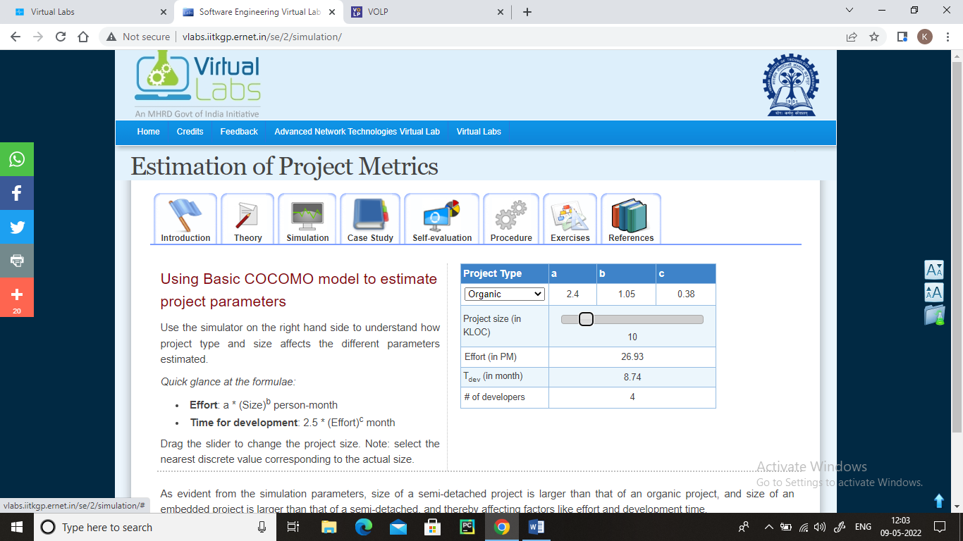

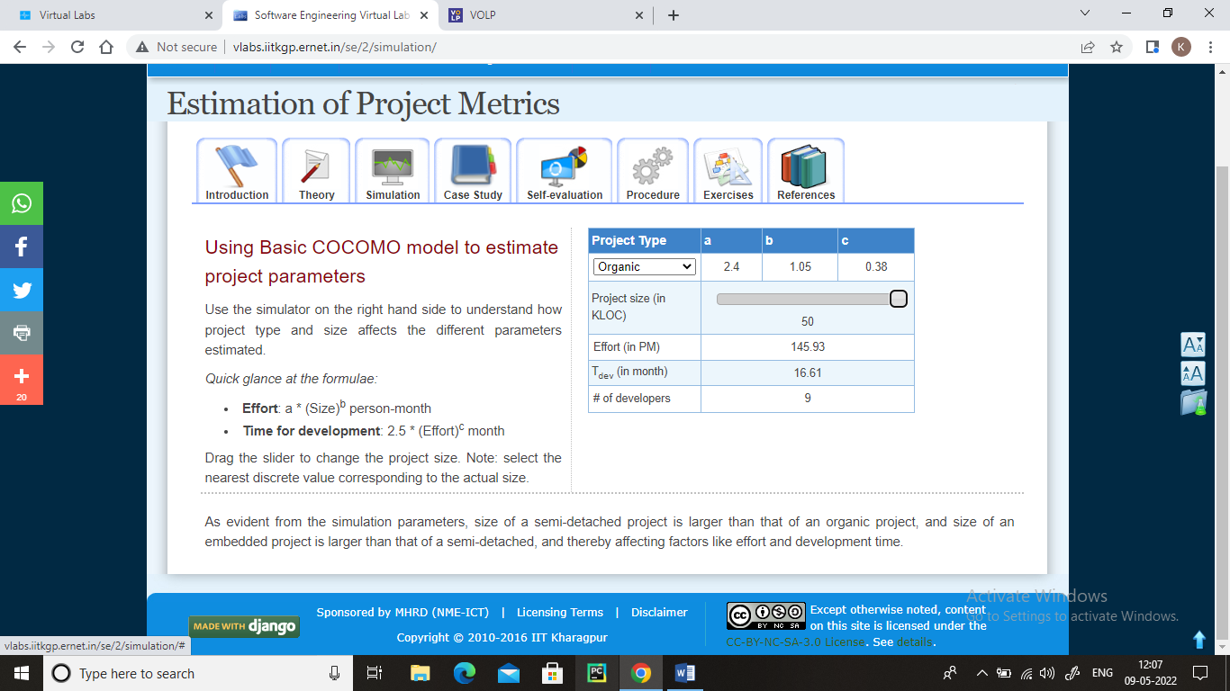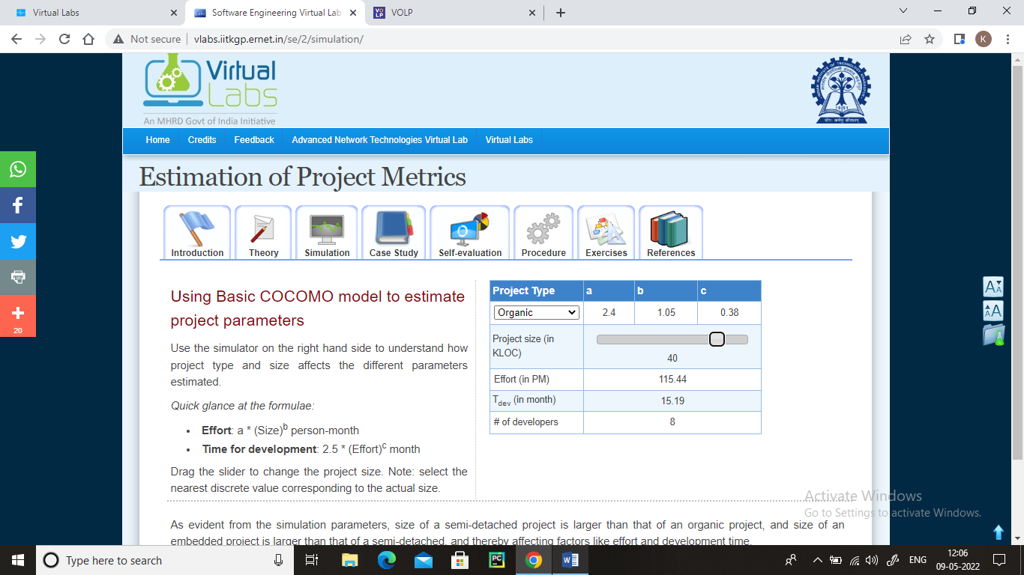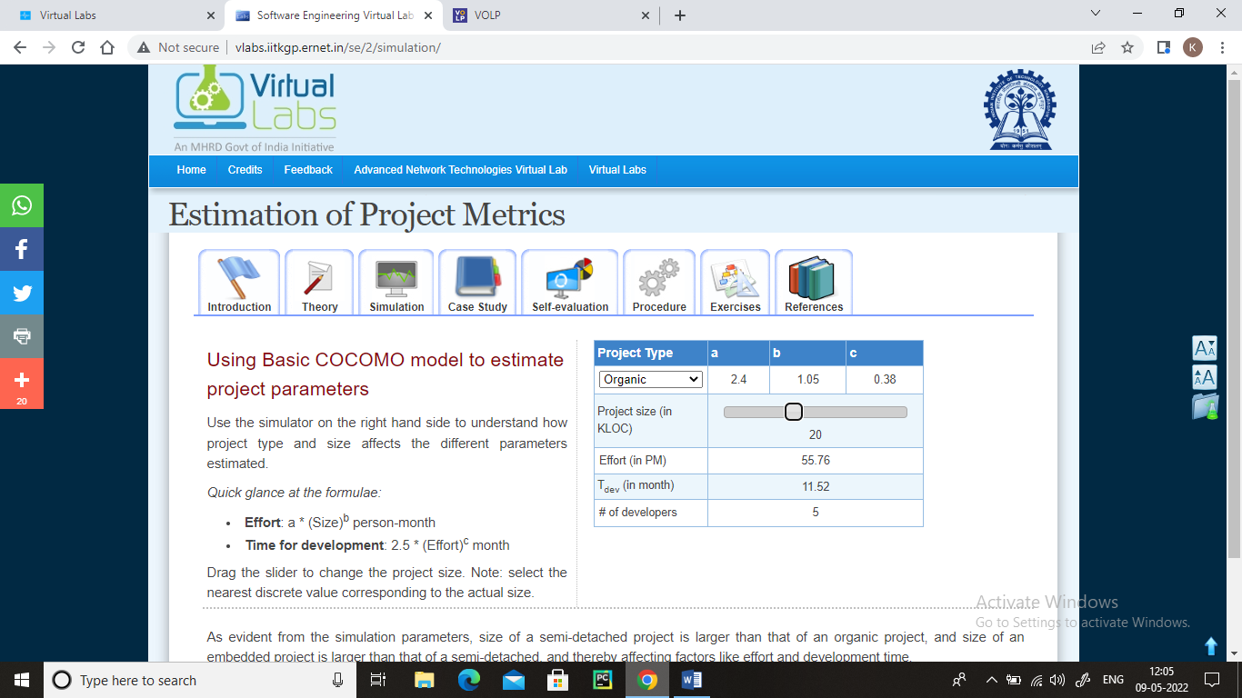

1. Semi-Detached

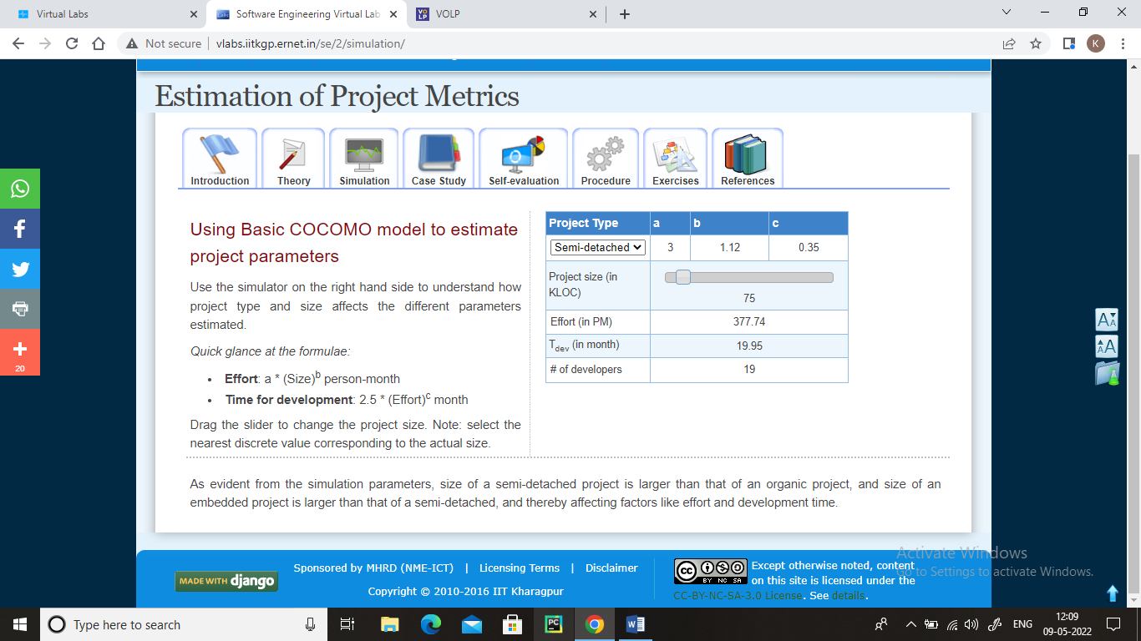

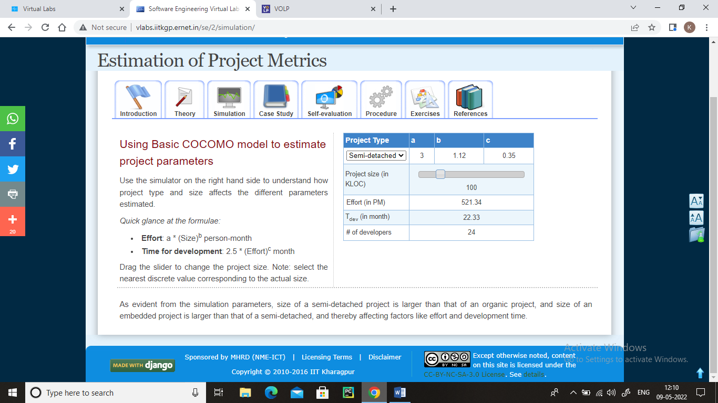

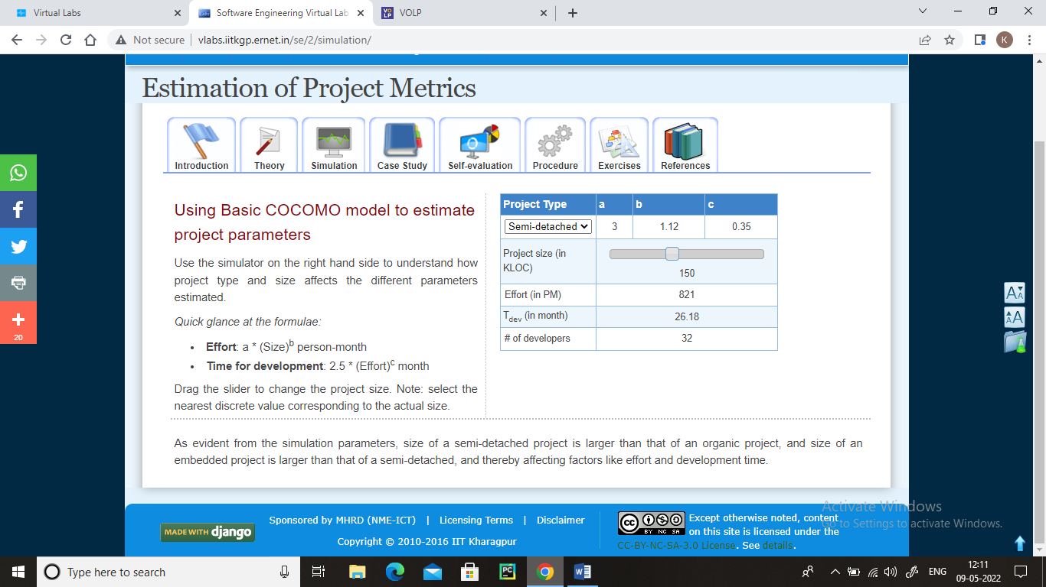

1. Embedded

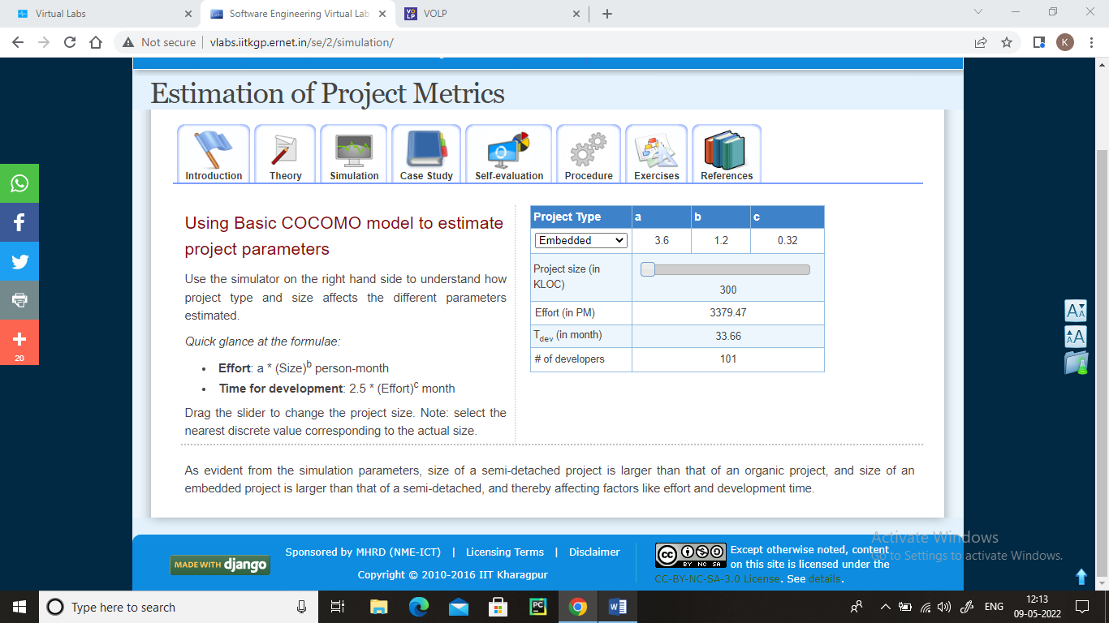

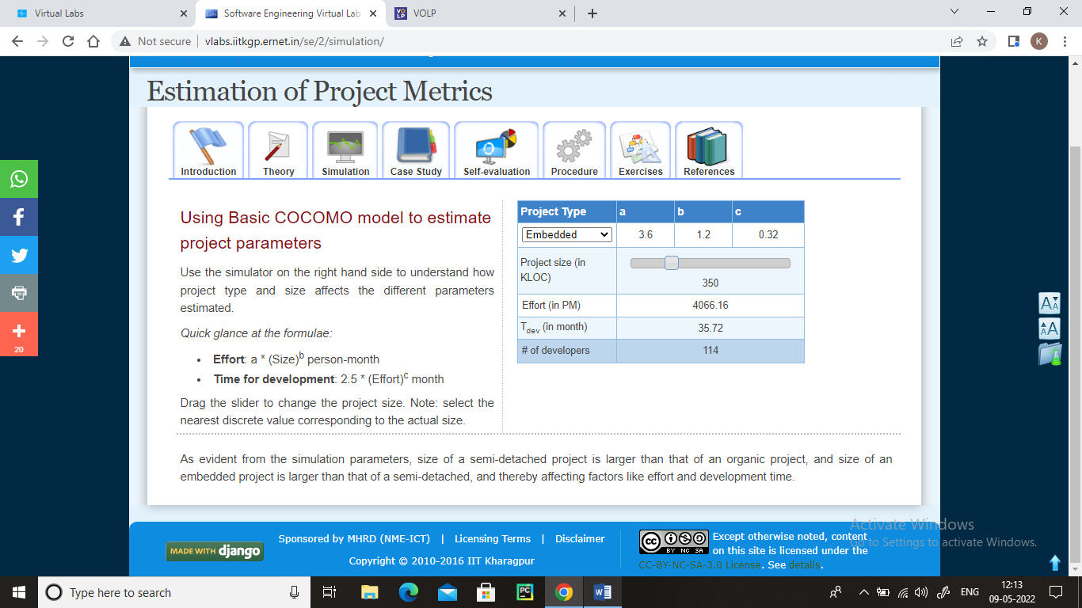

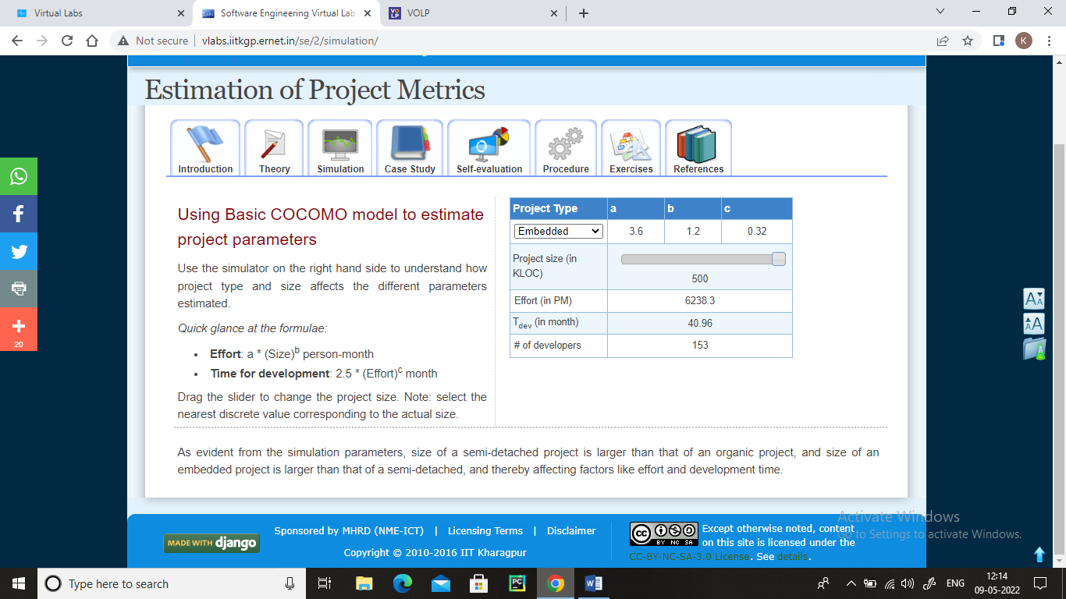

**Self-Evaluation:**

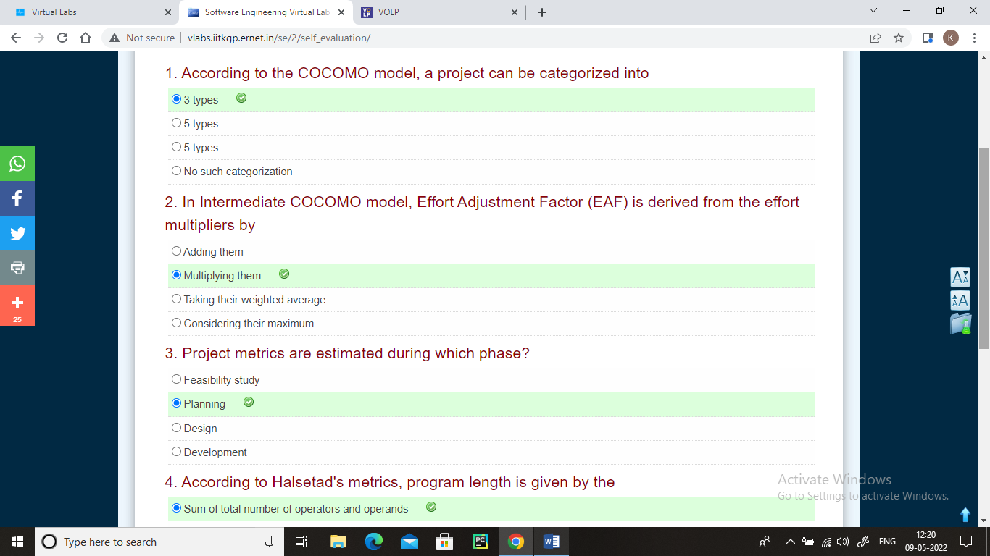

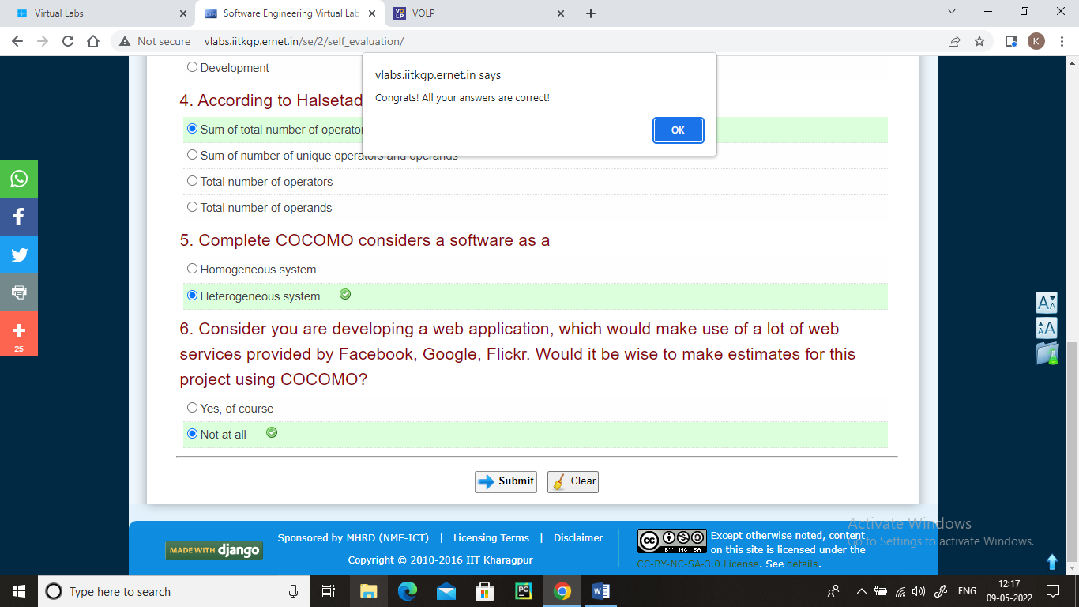

**Procedure:**

Steps for conducting the experiment

1. Read the theory about the experiment
2. View the simulation provided for a chosen, related problem
3. Take the self-evaluation to judge your understanding (optional, but recommended)
4. Solve the given list of exercises

Experiment Specific Instructions

1. The left hand side of the 'Exercises' page will present the problem
2. The right hand side of the page asks to evaluate certain parameters
3. The values of the parameters are to be typed in in the adjoining text boxes
4. If all the values entered are correct, then the solution is correct.

**Exercises:**

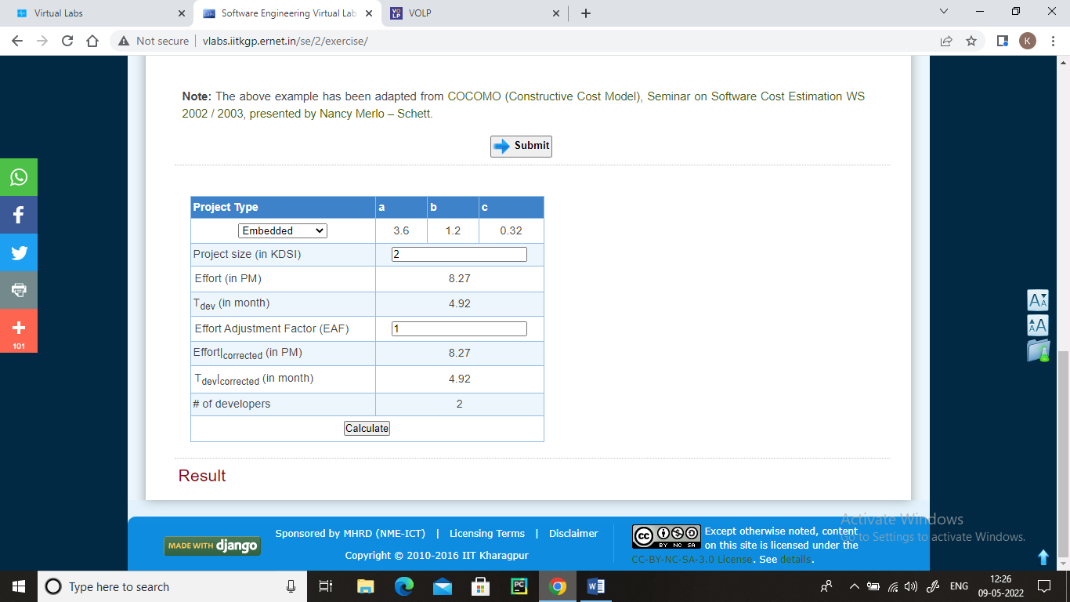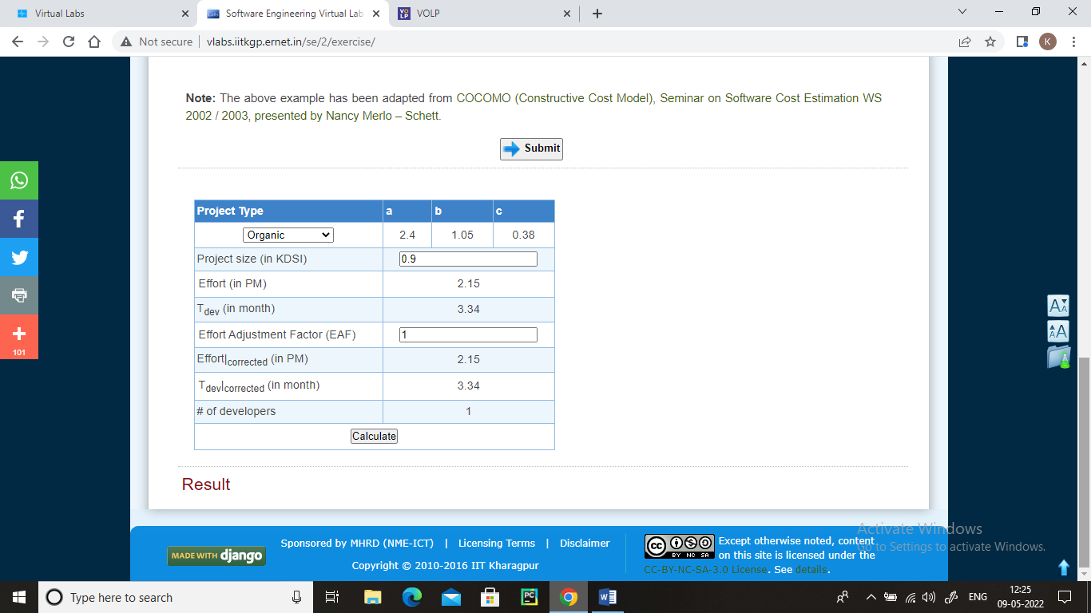1.

2.

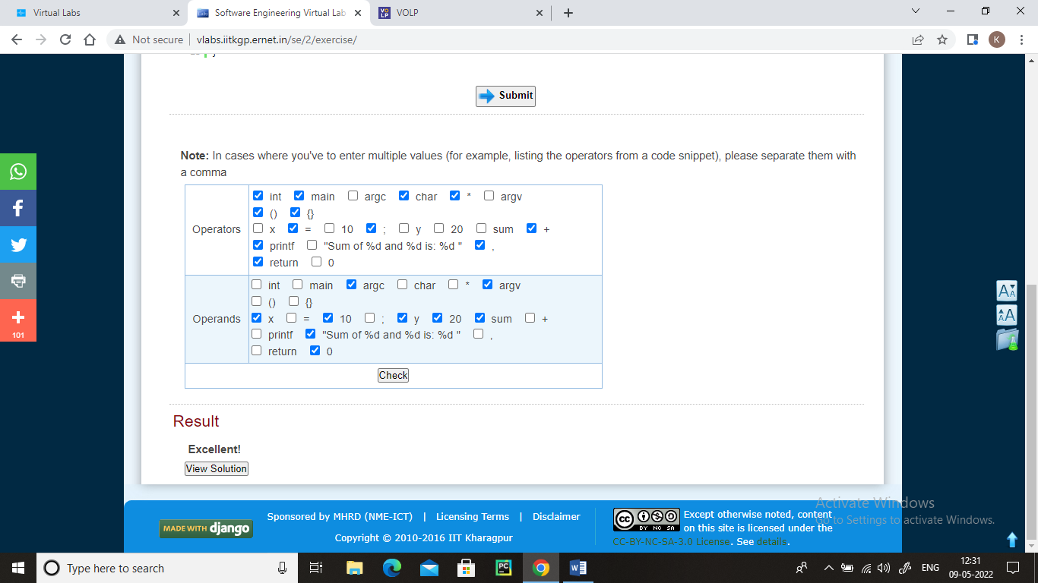

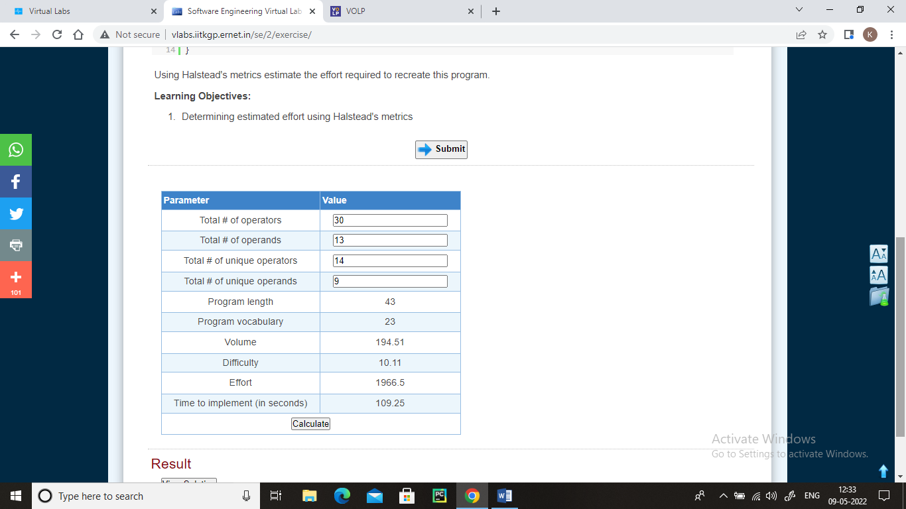3.

**References:**

Bibliography

* Fundamentals of Software Engineering, Rajib Mall, Prentice-Hall of India, 3rd Edition, 2009
* Software Engineering, Ian Sommerville, Addison Wesley Longman, 9th Edition, March 2010

Webliography

* [COCOMO](http://en.wikipedia.org/wiki/COCOMO)
* [Halstead complexity measures](http://en.wikipedia.org/wiki/Halstead_complexity_measures)
* [COCOMO (Constructive Cost Model), Seminar on Software Cost Estimation WS 2002 / 2003, presented by Nancy Merlo – Schett](http://www.ifi.uzh.ch/req/courses/seminar_ws02/reports/Seminar_4.pdf)
* [Software Engineering, National Program on Technology Enhanced Learning](http://nptel.iitm.ac.in/courses/Webcourse-contents/IIT%20Kharagpur/Soft%20Engg/New_index1.html)
* [Halstead Metrics, Verifysoft Technology](http://www.verifysoft.com/en_halstead_metrics.html)