**Code:**

**1.Code for responsive video using i-frame**

<html>

<head>

<title>DENNIS RITCHIE</title>

<link rel="stylesheet" type="text/css" href="main.css">

<meta name="viewport" content="width=device-width">

</head>

<body>

<div id="learn_c">

<h2>Learn C</h2>

</div>

<div id="video" class="videowrapper">

<p style="text-align: center"><iframe width="1000" height="563" src="https://www.youtube.com/embed/c5gg9F8h8Fw?list=PLfVsf4Bjg79CZ5kHTiQHcm-l2q8j06ofd" frameborder="0" allowfullscreen></iframe></p>

<div id="descp">

C language tutorials

</div>

</div>

</body>

</html>

**2.Code for WAI-ARIA**

<html>

<head>

<title>DENNIS RITCHIE</title>

<link rel="stylesheet" type="text/css" href="main.css">

<meta name="viewport" content="width=device-width">

</head>

<body>

<h1 align="center"> Accessible Form </h1>

<form action="">

<fieldset>

<legend>Contact Info</legend>

<p>

<label for="name">Name:</label>

<input type="text" id="name" name="name" />

</p> <p>

<label for="address">Address:</label>

<input type="text" id="address" name="address" /> </p>

<p>

<label for="city">City</label>

<input type="text" id="city" name="city" /> </p>

<p>

<label for="email">Email:</label>

<input type="text" id="email" name="email" />

</p>

</fieldset> <br>

<fieldset>

<legend>Gender</legend> <p>

<input type="radio" name="gender" id="male" value="male" />

<label for="male"> Male</label> </p>

<p>

<input type="radio" name="gender" id="gender" value="female" /> <label for="female"> Female</label>

</p>

</fieldset><br>

<fieldset>

<legend>Your Message</legend><p>

<label for="message">Message:</label></p>

<p>

<textarea name="message" id="message" rows="4" cols="50"></textarea>

</p>

</fieldset>

<p><input type="submit" value="Submit" class="submit" /></p>

</form>

</body>

</html>

**3.code for offine web page viewing**

<!doctype HTML>

<html lang="en" manifest="/cache.manifest">

<head>

<title>DENNIS RITCHIE</title>

<link rel="stylesheet" type="text/css" href="main.css">

<meta name="viewport" content="width=device-width,minimum-sacle=10,initial-scale=1">

</head>

<body>

<div id="header">

<h1>DENNIS RITCHIE</h1>

<h4>Developer of C Language</h4>

</div>

<div id="nav" width="100%" height="auto">

<nav>

<button class="button"><a href="personal.html">Personal Life </a></button>

<button class="button"><a href="career.html">Career </a> </button>

<button class="button"><a href="awards.html">Awards </a> </button>

<button class="button"><a href="learn_c.html">Learn C</a> </button>

<button class="button"><a href="contact.html">Contact Us</a> </button>

</nav>

<br><br>

</div>

<div class="img">

<img src="1.jpeg" alt="Dennis Ritchie" width="100%" height="auto">

</div>

<div id="text1">

<b><i>Dennis MacAlistair Ritchie</b></i> (September 9, 1941 - c. October 12, 2011) was an American computer scientist. He created the C programming language and, with long-time colleague Ken Thompson, the Unix operating system. Ritchie and Thompson received the Turing Award from the ACM in 1983, the Hamming Medal from the IEEE in 1990 and the National Medal of Technology from President Clinton in 1999. Ritchie was the head of Lucent Technologies System Software Research Department when he retired in 2007. He was the "R" in K&R C, and commonly known by his username dmr

</div>

<div class="asde">

<aside>

<h2 id="work" align="center">Notable work</h2>

<marquee direction="up">

<ul>

<li>C (programming language) on which many currently used languages and technologies are based.</li><br>

<li>Unix a multiuser operating system. Several workalikes (commonly referred to as Unix-like systems) have been developed based on Unix's design. Some of these follow POSIX standards, again based on Unix.</li><br>

<li>Unix Programmer's Manual (1971) </li><br>

<li>The C Programming Language (book) (sometimes referred to as K&R; 1978 with Brian Kernighan)</li><br>

</ul>

</marquee>

</aside>

</div>

<div id="footer">

copyright @ Dennis Ritchie

</div>

</body>

</html>

**CSS Code:**

@media screen and (min-width: 950px){

#header{

text-align: center;

color: yellow;

padding: 5px;

background: -webkit-linear-gradient(left, rgba(255,0,0,0), rgba(255,0,0,1)); /* For Safari 5.1 to 6.0 */

background: -o-linear-gradient(right, rgba(255,0,0,0), rgba(255,0,0,1)); /* For Opera 11.1 to 12.0 */

background: -moz-linear-gradient(right, rgba(255,0,0,0), rgba(255,0,0,1)); /* For Firefox 3.6 to 15 */

background: linear-gradient(to right, rgba(255,0,0,0), rgba(255,0,0,1)); /* Standard syntax (must be last) */

}

body{

background: -moz-linear-gradient(left, rgba(241,231,103,1) 0%, rgba(145,232,66,1) 48%, rgba(254,182,69,1) 100%);

background: -webkit-gradient(left top, right top, color-stop(0%, rgba(241,231,103,1)), color-stop(48%, rgba(145,232,66,1)), color-stop(100%, rgba(254,182,69,1)));

background: -webkit-linear-gradient(left, rgba(241,231,103,1) 0%, rgba(145,232,66,1) 48%, rgba(254,182,69,1) 100%);

background: -o-linear-gradient(left, rgba(241,231,103,1) 0%, rgba(145,232,66,1) 48%, rgba(254,182,69,1) 100%);

background: -ms-linear-gradient(left, rgba(241,231,103,1) 0%, rgba(145,232,66,1) 48%, rgba(254,182,69,1) 100%);

background: linear-gradient(to right, rgba(241,231,103,1) 0%, rgba(145,232,66,1) 48%, rgba(254,182,69,1) 100%);

filter: progid:DXImageTransform.Microsoft.gradient( startColorstr='#f1e767', endColorstr='#feb645', GradientType=1 );

}

#nav{

display: bold;

float: right;

padding: 5px;

color: red;

}

div.img{

margin: 5px;

border: 1px solid #ccc;

float: left;

width: 350px;

}

div.img:hover{

-webkit-transform: scale(1.5,1);

-moz-transform: scale(1.5,1);

-o-transform: scale(1.5,1);

-ms-transform: scale(1.5,1);

transform: scale(1.5,1);

border: 2px solid #777;

}

div.img img{

width: 100%;

height: 100%;}

#text1{

width: 450px;

padding: 10px;

float: left;

margin: 2px;

margin-top: 50px;

}

aside{

display: block;

float: right;

width: 350px;

}

#footer{

color: yellow;

text-align: center;

padding: 5px;

clear: both;

background: -webkit-linear-gradient(left, rgba(255,0,0,0), rgba(255,0,0,1)); /* For Safari 5.1 to 6.0 */

background: -o-linear-gradient(right, rgba(255,0,0,0), rgba(255,0,0,1)); /* For Opera 11.1 to 12.0 */

background: -moz-linear-gradient(right, rgba(255,0,0,0), rgba(255,0,0,1)); /* For Firefox 3.6 to 15 */

background: linear-gradient(to right, rgba(255,0,0,0), rgba(255,0,0,1)); /* Standard syntax (must be last) */

}

#career,#views_on_computing,#personal_life,#awards,#notable_work,#learn_c{

text-align: center;

display: block;

}

i{

margin: 5%;

padding: 5%;

}

iframe.youtube-player{text-align: center;}

#descp{

text-align: center;

width: 100%;

height: 100%;

color: red;

font-size: 200%;

}

.button{

background-color: #4CAF50;

font-size: 14px;

border-radius: 15px;

}

#work{

color: green;

}

.videoWrapper {

position: relative;

padding-bottom: 56.25%; /* 16:9 */

padding-top: 25px;

height: 0;

}

.videoWrapper iframe {

position: absolute;

top: 0;

left: 0;

width: 100%;

height: 100%;

}

}

**Steps for offline viewing:**

1. Install Xampp

2. Create a folder expt2 in htdocs

3. Create a cache.manifest file & save it in htdocs folder of Xampp.

4. Paste all the other files required in the folder expt2.

5. Open .htaccess file located in forbidden folder in htdocs

6. Edit & save the .htaccess file

7. Open Xampp & start apache service

8. Now open the webpage in google chrome

9. Close the page & stop apache server

10. Now again open the webpage in google chrome

11. This is the offline mode of the webpage

**Output:**

**Offline:**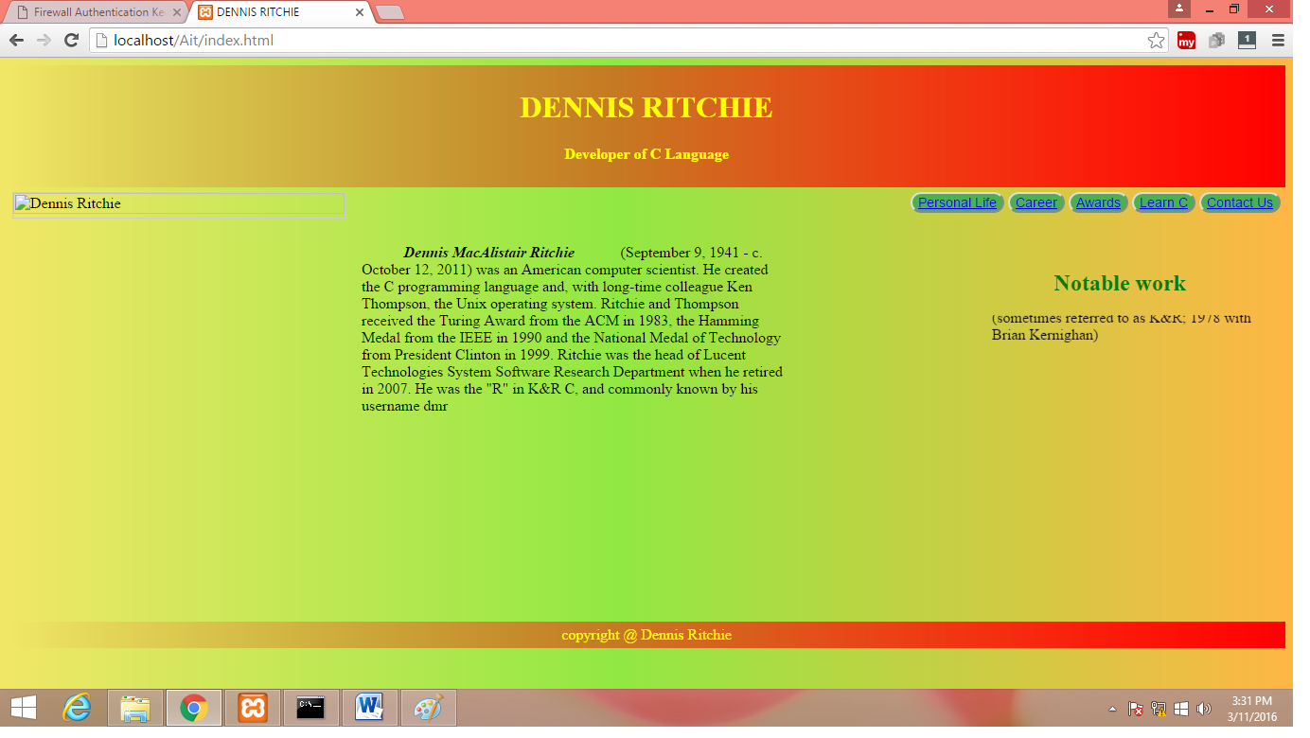

**Online:**

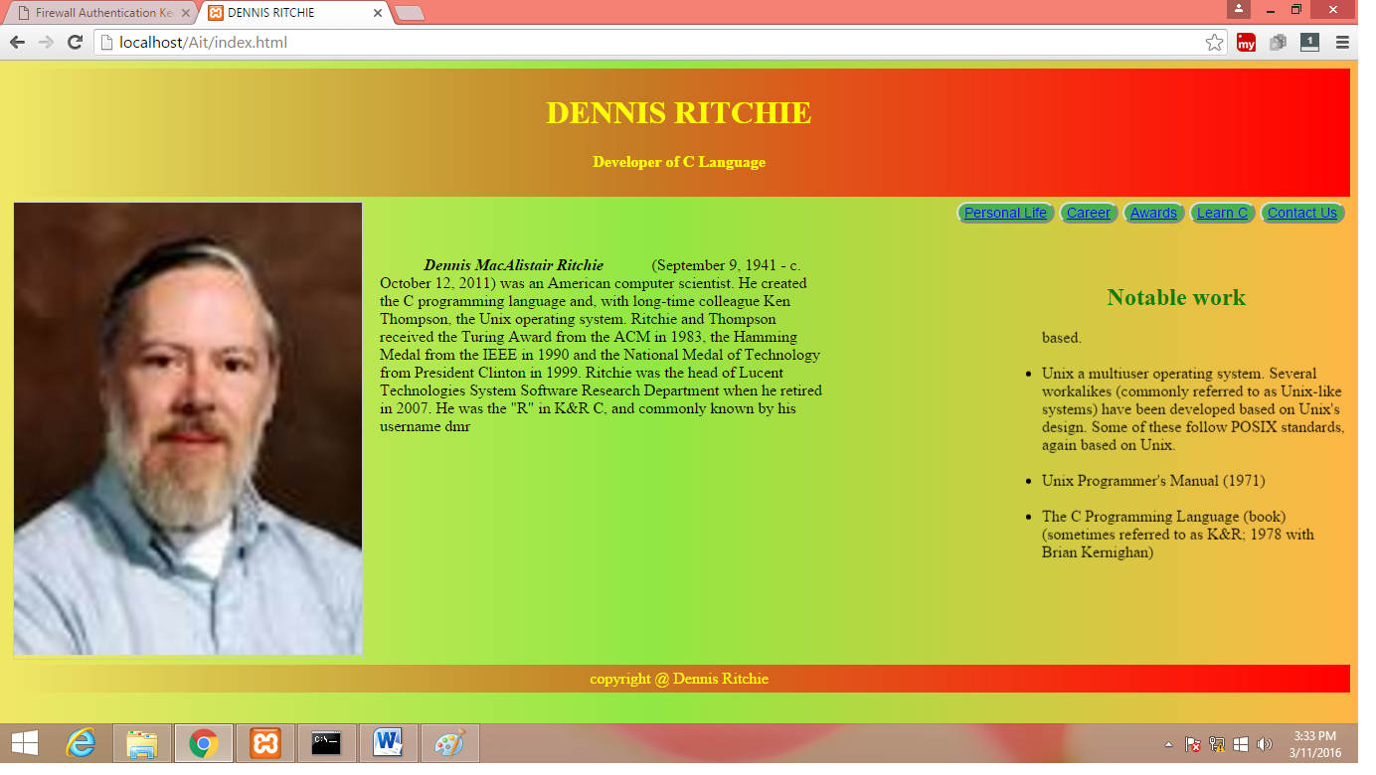

**Web Accessibility(WAI-ARIA):**

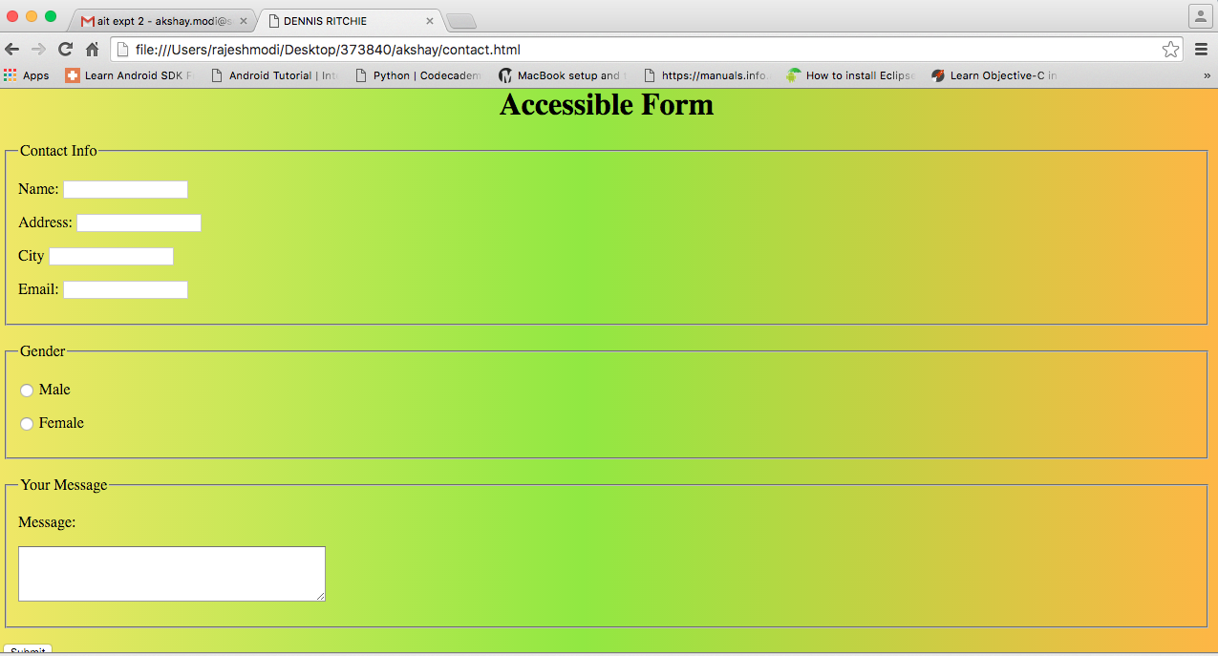

**Responsive Videos(using iframe):**



**(web size)**

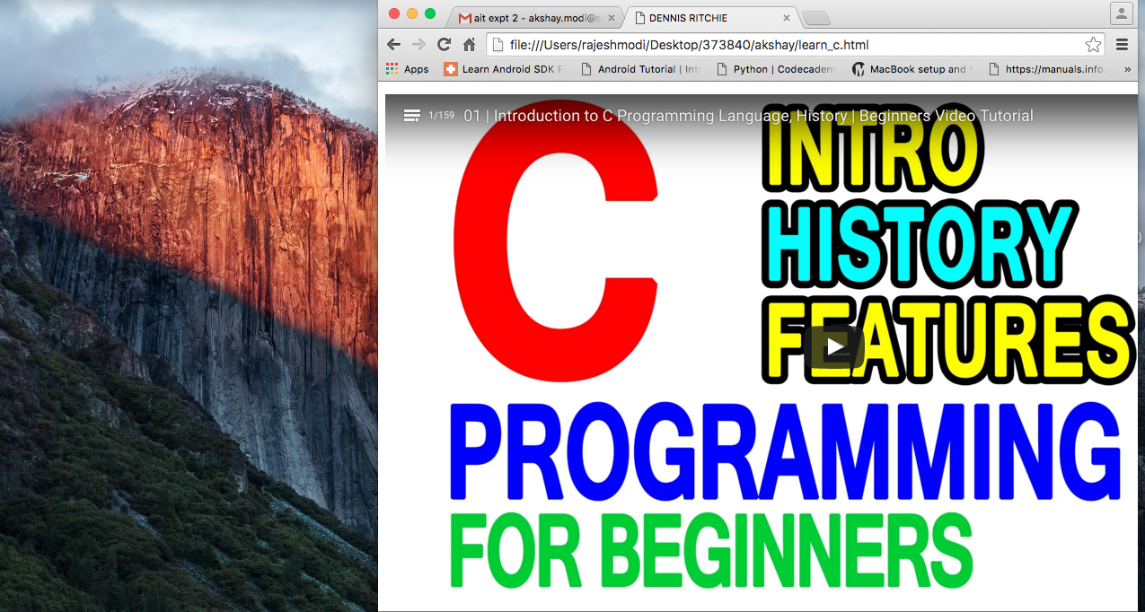

**(reduced size)**