**What is an alternate key?**

It is the candidate key except the primary key.

[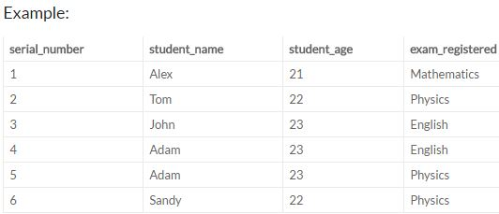](https://i.stack.imgur.com/2yqpi.jpg)

In the above table either {‘serial_number’} or the combination {‘student_name’,’exam_registered’} are the only possible candidate keys. When the database developer sets the column {‘serial_number’} as the primary the key then the combination of {‘student_name’,’exam_registered’} columns will be called as alternate key.

**What is a secondary key?**

It is a column or a group of columns in a table that don’t even qualify for being a super key but still identifies the rows in a table (may not be unique)

[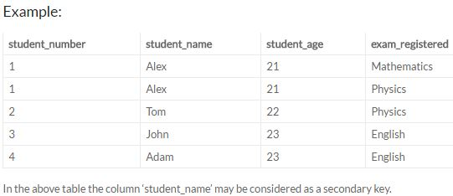](https://i.stack.imgur.com/liKTO.jpg)

1. ID
2. ID, Name
3. ID, Address
4. ID, Department_ID
5. ID, Salary
6. Name, Address
7. Name, Address, Department_ID

**Alternate Key** – Alternate Key can be any of the Candidate Keys except for the Primary Key.

E.g. of Alternate Key is “Name, Address” as it is the only other Candidate Key which is not a Primary Key.

**Secondary Key** – The attributes that are not even the Super Key but can be still used for identification of records (not unique) are known as Secondary Key.

E.g. of Secondary Key can be Name, Address, Salary, Department_ID etc. as they can identify the records, but they might not be unique.

**PARTIAL KEY :**

A partial key means just part of a key - some proper subset of the key attributes.

A table may have one or more choices for the primary key. Collectively these are known as candidate keys. One is selected as the primary key. Those not selected are known as secondary keys or alternative keys.

For example, in the table showing candidate keys above we identified two candidate keys, studentId and firstName + lastName. The studentId would be the most appropriate for a primary key leaving the other candidate key as secondary or alternative key. It should be noted for the other key to be candidate keys, we are assuming you will never have a person with the same first and last name combination. As this is unlikely we might consider firstName + lastName to be a suspect candidate key as it would be restrictive of the data you might enter. It would seem a shame to not allow John Smith onto a course just because there was already another John Smith.