1. Cctv system1

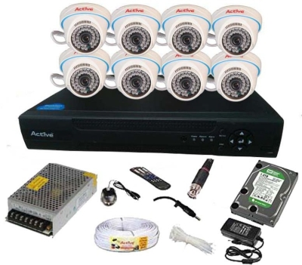

Cctv system1 price : 33999/-

Description : Free- 100mtr Wiring free.

1. Cctv system2

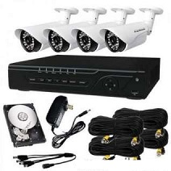

Cctv system2 price : 21999/-

Description : Free-50mtr Wiring free.

1. Camera

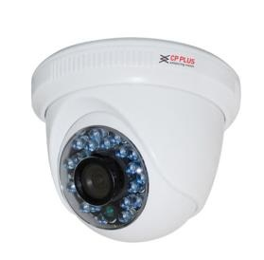

Camera Price : 1999/-

1. Bullet camera

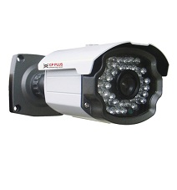

Bullet camera price : 2899/-

1. Cctv dvr

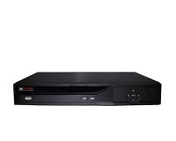

Cctv dvr price : 6599/-

Description : 8 Channel HD HIKvision

1. Access Control System

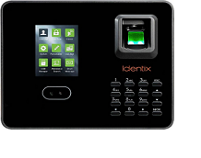

Access Control System price :

1. Video door Phone

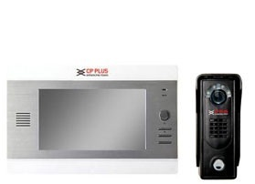

Video door Phone price : 8999/-