Brain Stroke Prediction Using Visual Geometry Group Model

V. V. L. Narayanan1, A. Reddy1,V. Venkatesh1, E. Snir2, S. Tutun2, K. Holdener1, S. Ahmed3, B. Rahmani1

1Saint Louis University, Computer Science Department, St. Louis, MO

2Washingtone University in Saint Louis, Olin Business School, St. Louis, MO

3Saint Louis University, Medical School, St. Louis, MO

*Abstract*—Stroke has become the top reason for the high mortality and disability rate in the current era. Early detection and prediction of stroke can significantly improve patient outcomes. In this study, we propose a deep learning approach using the VGG16 model to predict the occurrence of a brain stroke. We use a dataset consisting of MRI images of patients with and without stroke. The VGG16 model is pre-trained on the ImageNet dataset and fine-tuned on our dataset to predict stroke occurrence. Our experimental results demonstrate that the proposed approach achieves high accuracy and can effectively predict stroke occurrence. We have also conducted an extensive analysis of the model’s performance and provided insights into the important features used by the model to predict stroke occurrence. The proposed approach has the potential to be used in clinical settings to aid in the early detection and prevention of stroke.

# I. INTRODUCTION

It is estimated that over 15 million people suffer from stroke every year. One American has a stroke every four minutes, making it the fifth-highest cause of mortality in the country. According to the World Health Organization, about 17 million people suffer from stroke each year, with approximately 6 million dying and 5 million being left permanently disabled.

## A. Brain Stroke

An interruption in the blood supply to the brain results in a medical emergency known as a brain stroke, also known as a cerebrovascular accident (CVA). A blockage or rupture of a blood artery in the brain may be the reason for this. Due to a lack of oxygen and nutrition, brain cells start to die when blood flow is impaired, which can lead to irreversible brain damage, incapacity, or even death.

Hemorrhagic stroke and ischemic stroke are the two primary subtypes of stroke. A hemorrhagic stroke happens when a blood vessel in the brain bursts and causes bleeding, whereas an ischemic stroke happens when a blood clot plugs an artery in the brain.

High blood pressure, smoking, diabetes, high cholesterol, obesity, and a family history of stroke or heart disease are some of the variables that can raise the risk of stroke. Stroke risk factors can also be influenced by lifestyle choices such as poor diet, inactivity, and stress.

By promoting healthy lifestyle choices and encouraging individuals to seek early medical assistance if they encounter stroke symptoms, public education and awareness initiatives can help decrease the incidence of stroke.

## B. Deep Learning

Artificial intelligence (AI) has advanced significantly in recent years, with applications in everything from autonomous

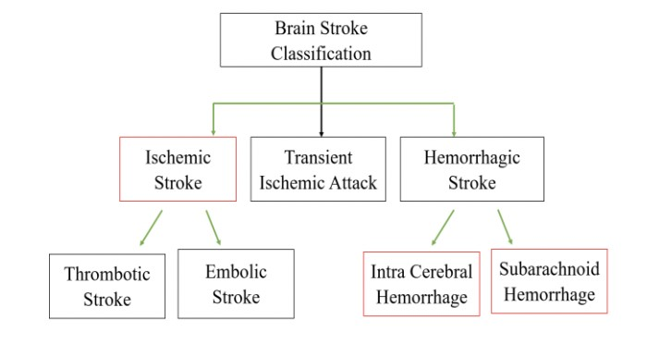

Fig. 1. Brain Stroke Types

vehicles and medical diagnostics to voice and image recognition. The advancement of deep learning, a branch of machine learning that has made strides in a variety of AI applications, has been a major force behind this development. I’ll go over the fundamentals of deep learning, its uses, and its possible social effects in this post.

Deep learning is a vital component of Artificial Intelligence that uses artificial neural networks to model and solve complex problems. These artificial neurons, which function as the processing and transformation units of these neural networks, are organized into numerous layers of interconnected nodes. Deeper layers of neurons learn to recognize increasingly abstract and complicated patterns as they learn to recognize and extract different characteristics of the material.

Deep Learning has the capacity to learn and improve on its own, without being explicitly programmed. By processing large amounts of data and identifying patterns and relationships within that data, deep learning algorithms can learn to perform complex tasks such as image and speech recognition, natural language processing, and even game playing.

In healthcare, deep learning is being used to develop diagnostic tools that can analyse medical images and data to detect diseases such as cancer and Alzheimer’s. These tools have the potential to improve the accuracy and speed of diagnosis, enabling earlier detection and better outcomes for patients.

The remaining project is divided into the following components. The "Related Work" is covered in Part 2, "The Methodology" is shown in Section 3, "Experimental Findings and Analysis" is covered in Section 4, and "Conclusion and Future Scope" is covered in Section 5.

II. RELATED WORK

This section covers all of the related work that has been done by other researchers in the same field of study. Many deep learning-based research currently uses CT or MRI images to identify strokes.

Yoon-A Choi et al. proposed a system for predicting the likelihood of stroke based on real-time bio-signal data using neural networks. 3,322 EEG and ECG signals were collected from stroke patients and healthy individuals and this was used as the dataset. The proposed model is a Convolutional Neural Network (CNN) that extracts features from the signals and a long short-term memory (LSTM) network that models temporal dependencies. This system gave a model accuracy of - 93.9 percent and a sensitivity of 96.7 percent. This research however needed further research to validate the system’s effectiveness in larger and more diverse populations.

Vivek S Yedavalli et al. discussed the potential applications of artificial intelligence (AI) in stroke imaging, including diagnosis, treatment selection, and prognosis prediction using different machine learning models and neural networks. Models like Convolutional Neural Networks (CNN), Long Short-Term Memory (LSTM), Recurrent Neural Networks (RNN), Support Vector Machines (SVM), and Random Forest (RF) were trained and the accuracies were compared to conclude the best model. It was shown that CNN had the best accuracy of 91 percent. This study used 4 different datasets, namely, MRI-GENIE, STRIDE, MR CLEAN, and TRACK-TBI.

Hilbert et al. proposed a deep learning model for predicting the outcome of endovascular treatment in patients with acute ischemic stroke. The dataset was a collection of 92 patients who underwent endovascular treatment for acute ischemic stroke and were divided into a training set of 60 percent and a test set of 32 percent. To improve its performance on the outcome prediction task, the deep learning model was trained on a small subset of the training set (n=10) utilizing transfer learning and fine-tuning approaches. The model was then assessed using the test set and the remaining training data. This proposed system used the VGG16 model. The model was then fine-tuned on the training data using a transfer learning approach, which involves using the pretrained weights of the VGG-16 model and training the final layers on the task-specific dataset. This gave us an accuracy of 80 percent.

Bhagyashree Rajendra Gaidhani et al. presented a method for detecting brain stroke using convolutional neural networks (CNNs) and deep learning models. This is a novel approach that combines CNNs with deep learning models to automatically see brain strokes from computed tomography (CT) images. The dataset is a collection of 250 CT images, including 150 regular and 100 stroke images, that were used to train and evaluate their deep-learning models. The methodology tested four different deep learning models, including a CNN, a deep belief network, a stacked autoencoder, and a convolutional autoencoder, to determine the most effective model for detecting brain stroke. The CNN model achieved the highest accuracy of 97.6 percent for detecting brain stroke, followed by the stacked autoencoder model with an accuracy of 94.8 percent. The authors also performed a comparative analysis with existing methods and found that their proposed method outperformed existing methods for brain stroke detection. This proposed system’s future research could explore the use of larger datasets and more advanced deep learning models to further improve the performance of the brain stroke detection system.

Jeena, R. S et al. compared the performance of traditional hand-crafted features and convolutional neural networks (CNNs) for diagnosing stroke from retinal images. The dataset that was used in this proposed system contained 450 retinal images, including 150 normal, 150 hypertensive, and 150 diabetic images, to train and evaluate their models. The methodology involved in this method comprised of testing of two different approaches: traditional feature extraction using hand-crafted features, and deep learning using a CNN. The results of the study showed that the CNN achieved significantly better performance than the traditional feature extraction method, with an accuracy of 96.5 percent compared to 87.3 percent for the hand-crafted features. The authors also compared the two approaches and found that the CNN had higher sensitivity, specificity, and F1 score for diagnosing stroke from retinal images.

# III. DATA DESCRIPTION

The dataset used for this theory is collected from Kaggle, an online community, and platform that owns millions of diverse datasets that can be used for analysis. They are a collection of medical images, specifically computed tomography (CT) images, of the brain of individuals who have experienced a stroke and of individuals who have not experienced a stroke. There are a total of 2501 images in the datasets out of which 1501 belong to individuals who have not experienced strokes and the remaining 950 belong to individuals who have experienced a stroke.

This displays the binary classification problem in the picture where the images belong to two different classes.

# IV. METHODOLOGY

## A. Data pre-processing

The final image size of the dataset which has been used as an input for the VGG16 (Visual Geometry Group) model is 256x256 pixels. In the next pre-processing step we have split our dataset into training (80 percent), testing (10 percent), and validation (10 percent) sets. To include more samples in our dataset we have implemented an image data generator that creates different variations of an image at each epoch. The variations include random image rotations, horizontal flips, and shifts. Additionally, zoom and brightness effects are set in the range of 0.2 and 0.8. After the pre-processing steps, the transformed images are used by the VGG16 model to predict the outcome of a stroke in a patient.

## B. Baseline model

The VGG16 model which is a 16-layered deep image classification convolutional neural network (CNN) architecture has been used as the baseline model in our research. The pre-trained VGG16 model can classify over 1000 images from different categories. We have incorporated the VGG16 model into our sequential model with several flattened, dense and output layers. The output layer consists of a sigmoid activation function which is used for binary classification that consists of two classes i.e. stroke and non-stroke. Model training was done on 25 epochs and a batch size of 32. The final sequential model used a monitoring metric called early stopping that halts the training process when there is no further improvement in learning.

In this proposed system, we use ’Adam’ optimizer for our model because the Adam optimizer gets dynamically adjusted for each parameter based on the first and second moments of the gradients which increases the efficiency of the model performance and simultaneously, requires low storage space. We are calculating the loss by the binary cross-entropy metric which could compute the gradients correctly and encourage classification with a high accuracy rate.

The model also makes use of early stopping, which creates an early stopping call back that monitors the validation accuracy and stops the training process if the accuracy does not improve for a specified number of epochs.

# V. RESULTS

During the first epoch, the training accuracy started at 61 percent which increased significantly to 83 percent at the end of the 25th epoch. While predicting outcomes on the test dataset the model was able to predict over 80 percent correct outcomes. Since the difference between the train and test accuracies is not too high we can say that the model is not prone to overfitting.

From the Classification report, it can be determined that the value of precision for people with no brain stroke is 0.90, and for the people with brain stroke detection is 0.77 which means that there are more people not detected with brain stroke and fewer people with brain stroke.

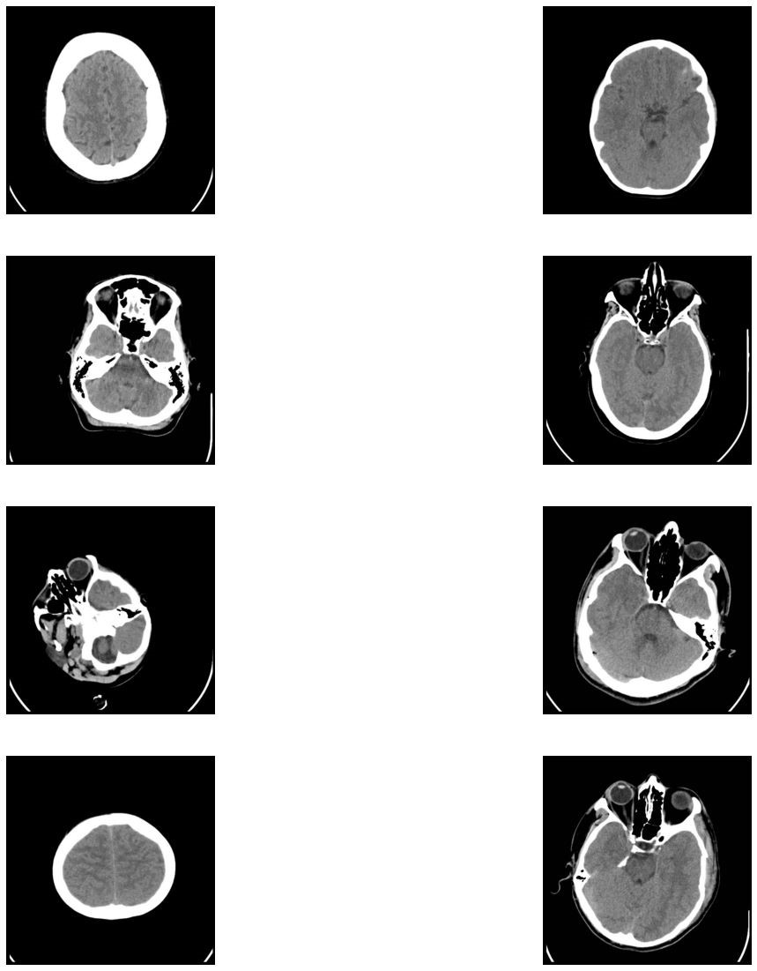

Fig. 2. Brain Stroke Detection

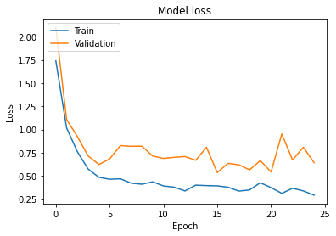 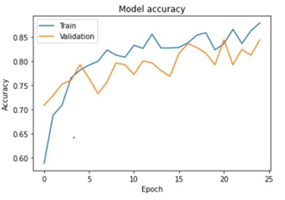

Fig. 3. The AUC for Training Vs Validation Loss

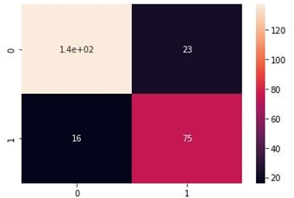

Fig. 4. Confusion Matrix

Fig. 5. Classification Report

# VI. CONCLUSION

In conclusion, the VGG16 model has shown promising results in predicting the occurrence of brain stroke using medical imaging data. Our research has demonstrated that the VGG16 model can achieve high accuracy of 80 percent in predicting the likelihood of stroke by analysing the images of the brain without any overfitting.

However, further research is needed to improve the accuracy and generalizability of the VGG16 model, as well as to explore its potential for other medical imaging applications.

Additionally, it will be important to address ethical and privacy concerns related to the use of patient data in developing and deploying AI models for medical diagnosis. Overall, our research suggests that the VGG16 model has significant potential as a tool for predicting brain stroke using medical imaging data, and underscores the importance of continued research and development in this area.

REFERENCES

1. Chen, L., Bentley, P.,Rueckert, D. (2017, June 13). Fully automatic acute ischemic lesion segmentation in DWI using convolutional neural networks. NeuroImage: Clinical. Retrieved February 27, 2023, from <https://www.sciencedirect.com/science/article/pii/S221315821730147X>
2. Bentley P, Ganesalingam J, Carlton Jones AL, Mahady K, Epton S, Rinne P, Sharma P, Halse O, Mehta A, Rueckert D. Prediction of stroke thrombolysis outcome using CT brain machine learning. Neuroimage Clin. 2014 Mar 30;4:635-40. doi: 10.1016/j.nicl.2014.02.003. PMID: 24936414; PMCID: PMC4053635.
3. Shin H, Kim J, K, Choo Y, J, Choi G, S, Chang M, C: Prediction of Motor Outcome of Stroke Patients Using a Deep Learning Algorithm with Brain MRI as Input Data. Eur Neurol 2022;85:460-466. doi: 10.1159/000525222
4. Ozaltin O, Coskun O, Yeniay O, Subasi A. A Deep Learning Approach for Detecting Stroke from Brain CT Images Using OzNet. Bioengineering. 2022; 9(12):783.

https://doi.org/10.3390/bioengineering9120783

1. Kaur, M., Sakhare, S. R., Wanjale, K., Akter, F. (2022,

April 11). Early stroke prediction methods for prevention of Strokes. Behavioural Neurology. Retrieved February 27, 2023, from https://www.hindawi.com/journals/bn/2022/7725597/

1. Pandian, J.D.; Gall, S.L.; Kate, M.P.; Silva, G.S.; Akinyemi, R.O.; Ovbiagele, B.I.; Lavados, P.M.; Gandhi, D.B.; Thrift, A.G. Prevention of stroke: A global perspective. Lancet 2018, 392, 1269–1278.
2. Huang, G., Liu, Z., Van Der Maaten, L., Weinberger, K. Q. (2017). Densely connected convolutional networks. Proceedings of the IEEE conference on computer vision and pattern recognition, 4700-4708.
3. Chollet, F. (2017). Xception: Deep learning with depthwise separable convolutions. Proceedings of the IEEE conference on computer vision and pattern recognition, 1251-1258.
4. Speiser, J.L.; Karvellas, C.J.; Wolf, B.J.; Chung, D.; Koch, D.G.; Durkalski, V.L. Predicting daily outcomes in acetaminopheninduced acute liver failure patients with machine learning techniques. Comput. Methods Programs Biomed. 2019, 175, 111–120.
5. A. Khosla, Y. Cao, C.C.-Y. Lin, H.-K. Chiu, J. Hu, H. Lee, An integrated machine learning approach to stroke prediction, in: Proceedings of the 16th ACM SIGKDD international conference on Knowledge discovery and data mining, 2010, pp.183–192.
6. Kwekha-Rashid, A.S.; Abduljabbar, H.N.; Alhayani, B. Coronavirus disease (COVID-19) cases analysis using machine-learning applications. Appl. Nanosci. 2021, 2021, 1–13.
7. Fazakis, N.; Dritsas, E.; Kocsis, O.; Fakotakis, N.; Moustakas, K.

Fig. 6. Confusion Matrix

Long-Term Cholesterol Risk Prediction with Machine Learning Techniques in ELSA Database. In Proceedings of the 13th International Joint Conference on Computational Intelligence (IJCCI), Valletta, Malta, 25–27 October 2021; SCIPTRESS: Atlanta, GA, USA, 2021; pp. 445–450.

1. Berrar, D. Bayes’ theorem and naive Bayes classifier. In Encyclopedia of Bioinformatics and Computational Biology: ABC of Bioinformatics; Elsevier: Amsterdam, The Netherlands, 2018; p. 403.
2. Nusinovici, S.; Tham, Y.C.; Yan, M.Y.C.; Ting, D.S.W.; Li, J.; Sabanayagam, C.; Wong, T.Y.; Cheng, C.Y. Logistic regression was as good as machine learning for predicting major chronic diseases. J. Clin. Epidemiol. 2020, 122, 56–69.
3. Dogan, A.; Birant, D. A weighted majority voting ensemble approach for classification. In Proceedings of the 2019 4th International Conference on Computer Science and Engineering (UBMK), Samsun, Turkey, 11–15 September 2019; IEEE: Piscataway, NJ, USA, 2019; pp. 1–6.
4. Hossin, M.; Sulaiman, M.N. A review on evaluation metrics for data classification evaluations. Int. J. Data Min. Knowl. Manag. Process 2015, 5, 1.
5. Russakovsky, O., Deng, J., Su, H., Krause, J., Satheesh, S., Ma, S., ... Berg, A. C. (2015). ImageNet large scale visual recognition challenge. International Journal of Computer Vision, 115(3), 211-252.
6. Simonyan, K., Zisserman, A. (2014). Very deep convolutional networks for large-scale image recognition. arXiv preprint arXiv:1409.1556.
7. Szegedy, C., Ioffe, S., Vanhoucke, V., Alemi, A. A. (2017). Inceptionv4, Inception-ResNet and the impact of residual connections on learning. AAAI, 4278-4284.
8. Chollet, F. (2017). Xception: Deep learning with depthwise separable convolutions. Proceedings of the IEEE conference on computer vision and pattern recognition, 1251-1258.