Rathore Automater
A modern, plan-based automation app with web accounts, daily limits, and optional crypto payments.

Updated: 25 Oct 2025
Audience: Founder/Dev + any helper building web auth/payments and WPF wiring

Executive Summary
Turn the existing Windows (WPF) app into a multi-user product. Users register on a small web portal, choose a plan, and the desktop app enforces plan limits (profiles + 60 actions per profile/day). Start lean, ship fast, and add payment automation later.

Product Goals
• Login + subscription plans (Basic/Silver/Gold/Platinum)
• Enforce profiles-per-plan and 60 actions/profile/day
• Admin can manage users/plans/payments
• Crypto-first payment path; manual approval works from day one
• Desktop remains smooth: responsive UI, click-through overlay, live progress

Plans & Limits
• Basic: 1 profile, 60/day/profile
• Silver: 3 profiles, 60/day/profile
• Gold: 5 profiles, 60/day/profile
• Platinum: Unlimited profiles, 60/day/profile
Server enforces the limits. The client asks permission for each action; the server accepts and increments, or rejects when the daily cap is reached.

Architecture (simple)
Components
• Web API (ASP.NET Core) â€” users, plans, profiles, usage, payments
• DB (Postgres in prod; SQLite in dev)
• Web UI (Razor Pages or small React) â€” auth, plans, profile manager, admin
• WPF App â€” login, pick profile, run automation, call API for limits
• Optional: KeyAuth for fast auth/licensing + a tiny API just for profiles/usage

Data Model
users(id, email unique, password_hash, role, timezone, created_at)
plans(id, name, profile_limit nullable, actions_per_profile_per_day=60, active)
subscriptions(id, user_id, plan_id, status, start_at, end_at)
profiles(id, user_id, name, created_at)
usage_daily(id, profile_id, date_ymd, action_count, UNIQUE(profile_id,date_ymd))
payments(id, user_id, plan_id, amount, currency, status, provider, provider_ref, created_at)

API (essentials)
POST /auth/login email, password â†’ access_token, refresh_token
POST /auth/refresh refresh_token â†’ access_token
GET /me â†’ user, plan, entitlements
GET /me/profiles
POST /me/profiles name
POST /me/usage/record profile_id, count:1, idempotency_key â†’ ok|limit_reached
Admin: /admin/users, /admin/plans, /admin/subscriptions, /admin/usage, /admin/payments
Payments: /payments/create-checkout, /payments/webhook (signature-verified)

Security & Enforcement Principles
• Passwords: bcrypt/Argon2 hashes (never plain).
• Tokens: JWT access (short-lived) + refresh (revocable). Optional device_id claim.
• No ad-hoc SQL: Only audited REST endpoints; parameterized queries/ORM.
• Limits are server-side truth. Client-only counters are advisory at best.
• Anti-tamper: code-signing, TLS pinning, graceful exit (donâ€™t hard-crash), telemetry.
• Rate limiting + WAF/CDN (e.g., Cloudflare) in front of the API.
• Idempotency-Key on all writes (usage, payments, create).
• Admin actions via RBAC endpoints with 2FA + audit logging (no direct DB edits).

Payments (crypto-first)
• MVP: Manual approval â€” show wallet address, user submits TX hash, admin activates plan.
• Automate later: Coinbase Commerce or BTCPay Server with signed webhooks to activate subscription.
• Friendâ€™s bank/UPI possible short-term; map payment â†’ plan in Admin.

Domain & Hosting
• Domains are annual (no true lifetime). Enable auto-renew; use WHOIS privacy + 2FA.
• Registrar: Cloudflare Registrar (near-cost) or Namecheap.
• DNS/HTTPS: Cloudflare DNS + free TLS; Letâ€™s Encrypt if you host elsewhere.
• Hosting (starter): $5â€“$25/month for a small VPS or PaaS free/low tier.

Cost snapshot (lean)
• Domain: $10â€“$20/yr
• Hosting/API: $5â€“$25/mo (free credits may cover early months)
• DB: $0â€“$15/mo (managed) â€” SQLite free for dev
• Email (password reset): $0â€“$15/mo
• Payments: provider fee per txn (varies)
• Monitoring/logs: $0â€“$10/mo (optional)
Use GitHub Education creditswhere possible to slash early costs.

Desktop App: Current Status
• Overlay: WPF click-through overlay, DPI-correct (follows Edge window), tinted text, live progress.
• True pause/resume/stop with a control file between C# and Python.
• UI: Resizable window, responsive pages with scroll; title bar interactions fixed.
• Command box: supports batch runs (e.g., -run_all -e"Default" t2).

Two Paths for Auth
Option A â€” KeyAuth Hybrid (fast start)
• Use KeyAuth for login/licensing/HWID; build a tiny API only for profiles + usage.
• Map KeyAuth plan â†’ entitlements. Enforce daily counts on your server.
Option B â€” Full Custom (future-proof)
• Build auth in the API (JWT + refresh, RBAC). More control and easier to evolve.

Phased Plan (ship value fast)
Phase 1: Auth + Plans â€” register/login, view plans, tokens, entitlements
Phase 2: Profiles â€” add/list/delete, enforce plan profile_limit
Phase 3: Usage â€” POST /usage/record, atomic daily counters, enforcement in app
Phase 4: Admin â€” users/plans/subscriptions/usage; manual payment approvals
Phase 5: Payments â€” crypto checkout + webhook â†’ auto-activate subscriptions

Risks & Mitigations
• Client tampering â†’ server-side enforcement + TLS pinning + code signing.
• Clock/timezone drift â†’ compute date_ymd server-side using user timezone.
• Concurrent usage â†’ unique(profile_id, date_ymd) and atomic upsert.
• Payment fraud/duplicates â†’ webhook signature + idempotency keys.

Whatâ€™s Next (action checklist)
• Create repo for Web API + DB schema (users, plans, profiles, subscriptions, usage_daily)
• Implement /auth/login, /me, /me/profiles, /me/usage/record (SQLite dev)
• Wire WPF LoginPage to real login; cache tokens in Credential Manager
• Call /usage/record per action in automation (stop profile on limit_reached)
• Ship Admin MVP (list users, set plans, manual activate/expire)
• Add crypto checkout + webhook when ready

This document is self-contained and can be shared with a collaborator to start the web portal while we continue polishing the desktop app.

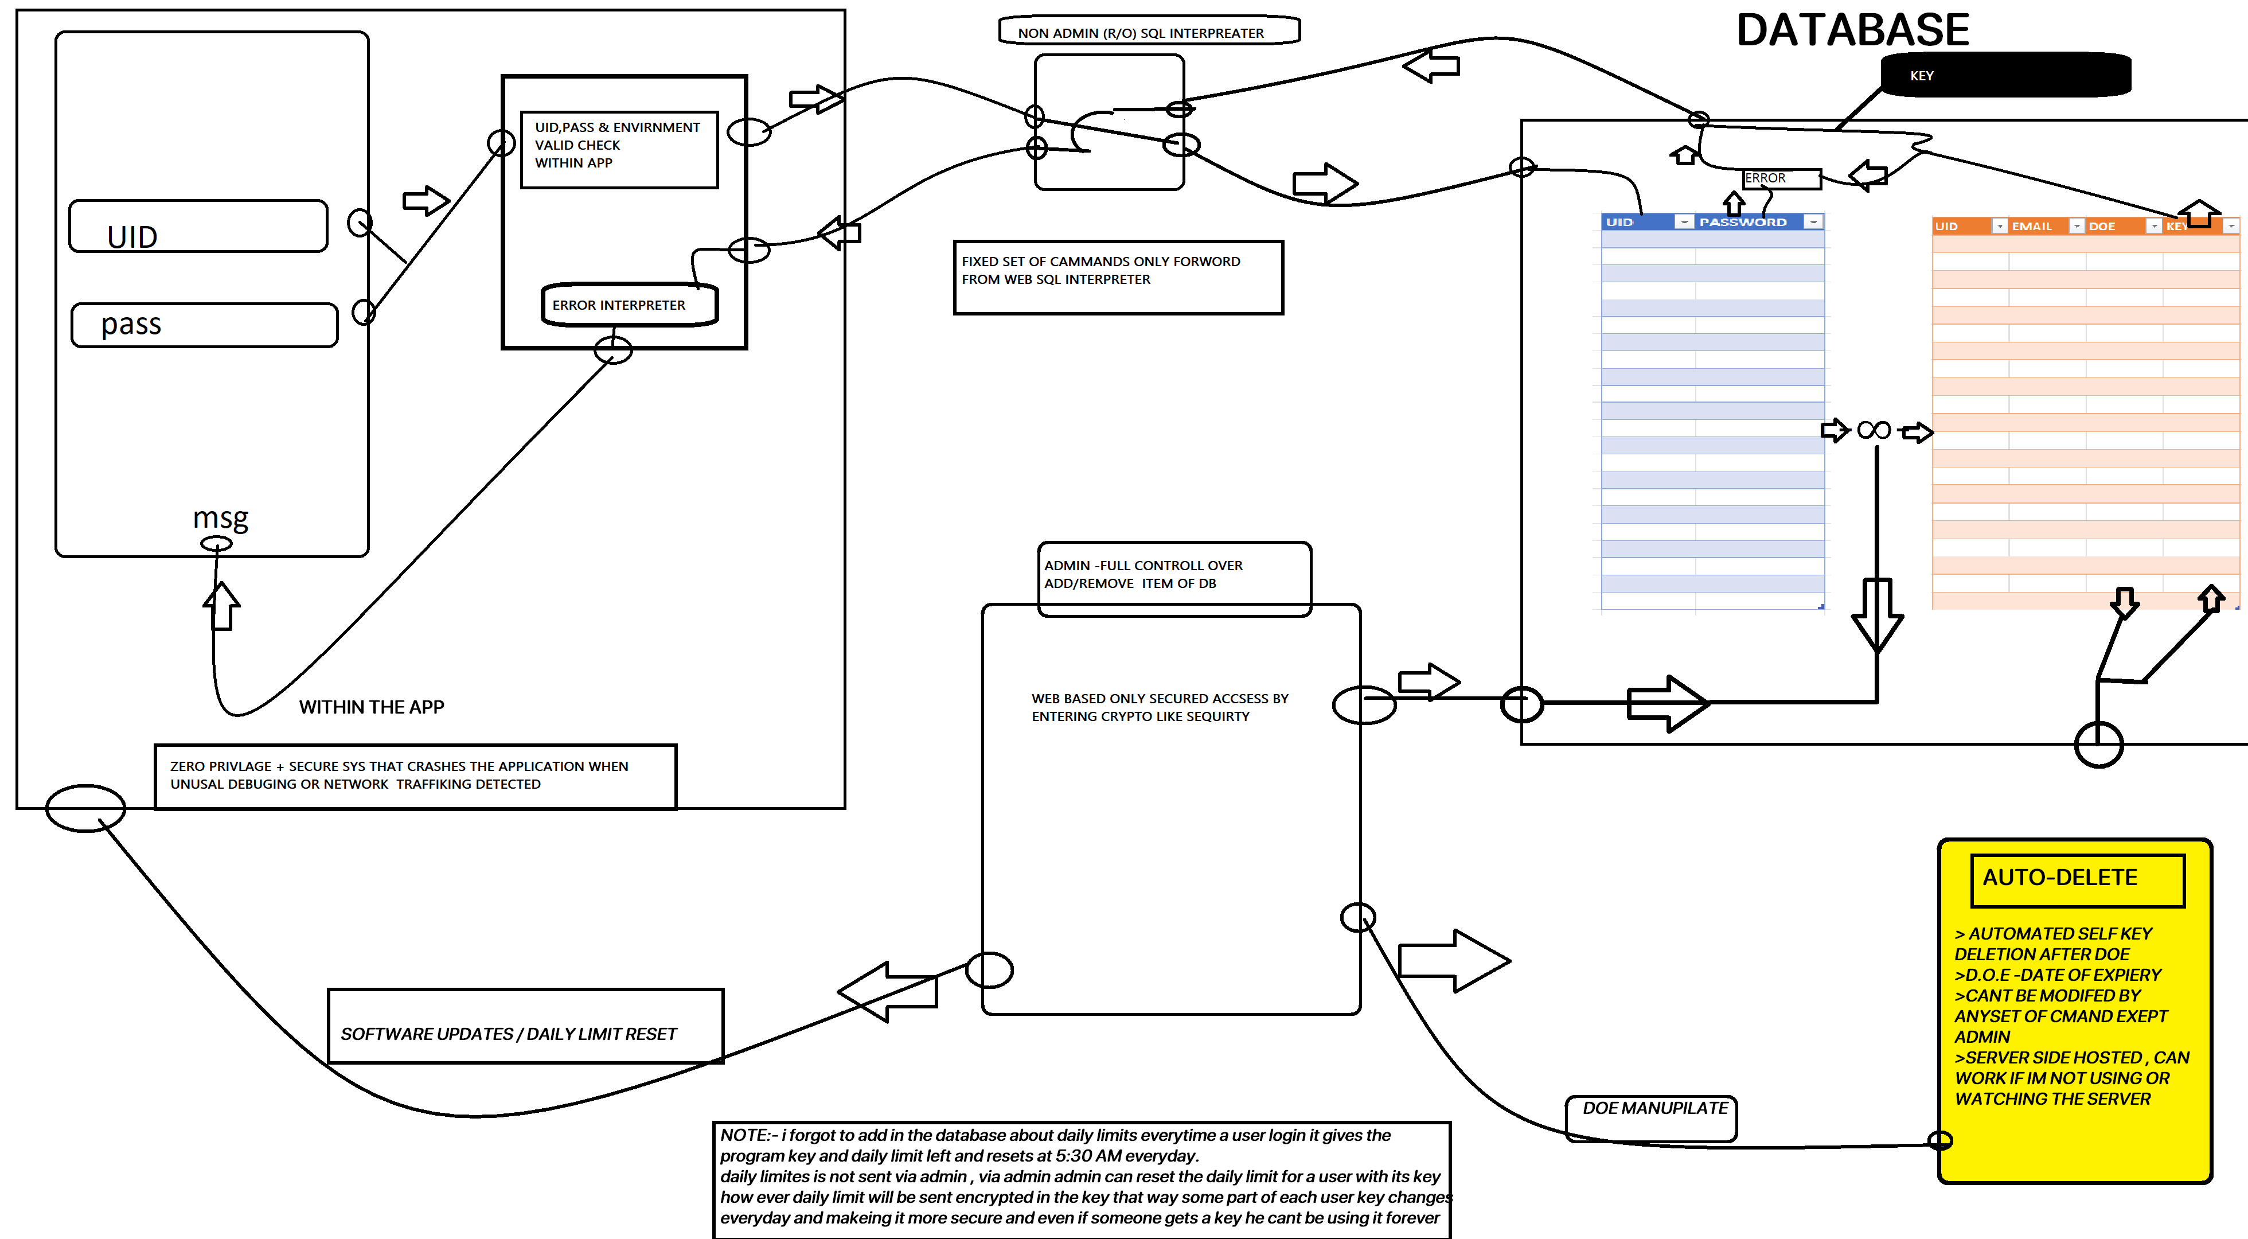
End

