Activity | Data Type
Number of beatings from Wife | Discrete
Results of rolling a dice | Discrete
Weight of a person | Continuous
Weight of Gold | Continuous
Distance between two places | Continuous
Length of a leaf | Continuous
Dog's weight | Continuous
Blue Color | Discrete
Number of kids | Discrete
Number of tickets in Indian railways | Discrete
Number of times married | Discrete
Gender (Male or Female) | Discrete
Q1) Identify the Data type for the Following:

Q2) Identify the Data types, which were among the following
Nominal, Ordinal, Interval, Ratio.
Data | Data Type
Gender | Nominal
High School Class Ranking | Nominal
Celsius Temperature | Interval
Weight | Ratio
Hair Color | Ratio
Socioeconomic Status | Interval
Fahrenheit Temperature | Ratio
Height | Ratio
Type of living accommodation | Nominal
Level of Agreement | Ordinal
IQ(Intelligence Scale) | Ratio
Sales Figures | Interval
Blood Group | Ratio
Time Of Day | Interval
Time on a Clock with Hands | Interval
Number of Children | Interval
Religious Preference | Nominal
Barometer Pressure | Interval
SAT Scores | Ratio
Years of Education | Ratio

Q3) Three Coins are tossed, find the probability that two heads and one tail are obtained?
Ans- 3/8=0.375

Q4) Two Dice are rolled, find the probability that sum is
- Equal to 1 = 0
- Less than or equal to 4 = 1/6
- Sum is divisible by 2 and 3 = 11/9

Q5) A bag contains 2 red, 3 green and 2 blue balls. Two balls are drawn at random. What is the probability that none of the balls drawn is blue?
Ans- 10/21

Q6) Calculate the Expected number of candies for a randomly selected child
Below are the probabilities of count of candies for children (ignoring the nature of the child-Generalized view)
CHILD | Candies count | Probability
A | 1 | 0.015
B | 4 | 0.20
C | 3 | 0.65
D | 5 | 0.005
E | 6 | 0.01
F | 2 | 0.120
Child A – probability of having 1 candy = 0.015.
Child B – probability of having 4 candies = 0.20
Ans – 3.09

Q7) Calculate Mean, Median, Mode, Variance, Standard Deviation, Range & comment about the values / draw inferences, for the given dataset
- For Points,Score,Weigh>
Find Mean, Median, Mode, Variance, Standard Deviation, and Range and also Comment about the values/ Draw some inferences.
Use Q7.csv file
ANS- For Points- Mean= 3.596563
, Median=3.695, Mode=3.92, Variance=0.285, Standard Deviation=0.534
For Score -Mean =3.217, Median=3.325, Mode=3.44, Variance=0.957, Standard Deviation=0.978
For Weight- Mean =17.84, Median=17.71, Mode=17.02, Variance=3.19, Standard Deviation=1.786

Q8) Calculate Expected Value for the problem below
- The weights (X) of patients at a clinic (in pounds), are
108, 110, 123, 134, 135, 145, 167, 187, 199
Assume one of the patients is chosen at random. What is the Expected Value of the Weight of that patient?
Ans- 145.33

Q9) Calculate Skewness, Kurtosis & draw inferences on the following data
Cars speed and distance
Use Q9_a.csv
Ans- Negative Skewness and Kurtosis for speed and Positive Skewness and Kurtosis for distance. It is left skewed.
SP and Weight(WT)
Use Q9_b.csv
Ans-Skewness is positive and kurtosis is positive for SP. Skewness Is negative and positive.Right skewed positive slight magnitude to right

Q10) Draw inferences about the following boxplot & histogram

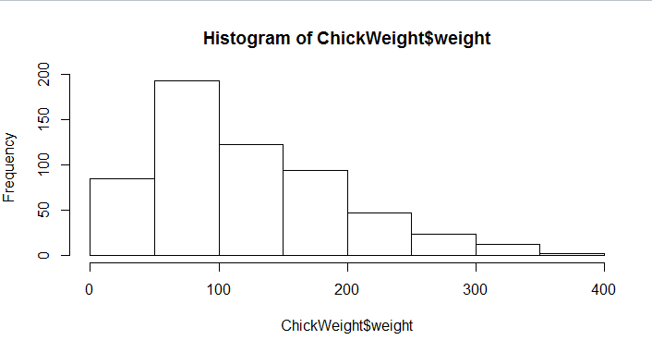

Ans – The most of the data points are concerated in the range of 50-100 wityh frequency 200.
Least range of weight is 400 somewhere around 0-10.
We can notice a long tail along right it is right skewed.

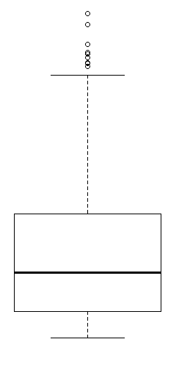
ANS-Median is less than upper right. We have outlier on the upper side of box plot.

Q11) Suppose we want to estimate the average weight of an adult male in Mexico. We draw a random sample of 2,000 men from a population of 3,000,000 men and weigh them. We find that the average person in our sample weighs 200 pounds, and the standard deviation of the sample is 30 pounds. Calculate 94%,98%,96% confidence interval?
ANS- 94% confidence interval= 1.882
98% confidence interval = 2.33
96% confidence interval = 2.05
Q12) Below are the scores obtained by a student in tests
34,36,36,38,38,39,39,40,40,41,41,41,41,42,42,45,49,56
- Find mean, median, variance, standard deviation.
Ans- mean – 41, median- 40, variance-24.11, standard deviation-4.910
- What can we say about the student marks?
Ans- Many students have scored good marks

Q13) What is the nature of skewness when mean, median of data are equal?
Ans- Symetrical
Q14) What is the nature of skewness when mean > median ?
Ans-Right skewed
Q15) What is the nature of skewness when median > mean?
Ans-Left Skewed
Q16) What does positive kurtosis value indicates for a data ?
Ans- The data is normally distributed and kurtosis value is 0.
Q17) What does negative kurtosis value indicates for a data?
Ans- The distribution of data has higher tails and flatter peaks than the normal distribution.
Q18) Answer the below questions using the below boxplot visualization.
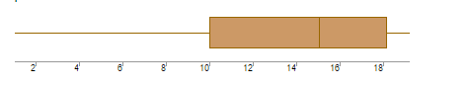
What can we say about the distribution of the data?
Ans- let’s say it is the age of the children’s in school. 50% of people are above 10 years
What is nature of skewness of the data?
Ans-Left skewed median is greater than mean.
What will be the IQR of the data (approximately)?
Ans-8

Q19) Comment on the below Boxplot visualizations?
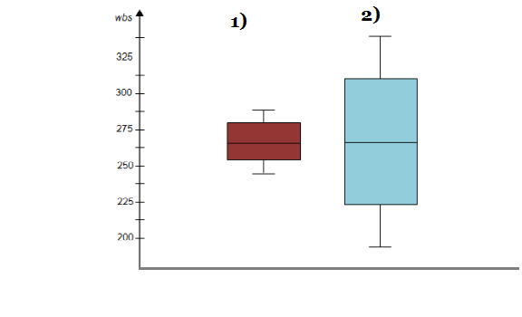
Draw an Inference from the distribution of data for Boxplot 1 with respect Boxplot 2.
Ans- both the plots whiskers level is high in boxplot 2, mean and median are equal hence distribution Is symmetrical.
Q 20) Calculate probability from the given dataset for the below cases

Data _set: Cars.csv
Calculate the probability of MPG of Cars for the below cases.
MPG <- Cars$MPG
  - P(MPG>38)=33
  - P(MPG<40)=61
c. P (20<MPG<50)=69

Q 21) Check whether the data follows normal distribution
- Check whether the MPG of Cars follows Normal Distribution
Dataset: Cars.csv
Ans- Yes the mpg of cars follow normal distribution.

- Check Whether the Adipose Tissue (AT) and Waist Circumference(Waist) from wc-at data set follows Normal Distribution
Dataset: wc-at.csv
Ans-No they do not follow normal distribution.

Q 22) Calculate the Z scores of 90% confidence interval,94% confidence interval, 60% confidence interval
Ans- Z scores of 90%=1.64,94%=1.88,60%=0.841
Q 23) Calculate the t scores of 95% confidence interval, 96% confidence interval, 99% confidence interval for sample size of 25
Ans- t scores for 95% =2.06,96%=2.17,99%=2.79
Q 24) A Government company claims that an average light bulb lasts 270 days. A researcher randomly selects 18 bulbs for testing. The sampled bulbs last an average of 260 days, with a standard deviation of 90 days. If the CEO's claim were true, what is the probability that 18 randomly selected bulbs would have an average life of no more than 260 days
Hint:
rcode pt(tscore,df)
df degrees of freedom
Ans- degree of freedom =17
T distribution= -0.471
Probability=0.3218

