CHAPTER 1
ABSTRACT

ABSTRACT

The traditional method of water quality testing is to collect samples manually and then send them to laboratory for analysis. However, it has been unable to meet the demands of water quality monitoring today. So a set of automatic measurement and reporting system of water quality has been developed. The system consists of multiple sensors of water quality testing, single-chip microcontroller data acquisition module, information transmission module, monitoring center and other accessories. Various parameters of water quality are automatically detected under the control of single chip micro controller all day. The single chip gets the data, and then processes and analyzes them. After that, the data are instantaneously sent to monitoring center by GSM network in the form of SMS. If the water quality is abnormal, the data will be sent to monitoring center and management's mobile in the same way at the same time. It is convenient for management to take corresponding measures timely and be able to detect real-time situation of water quality remotely. The system has realized the automation of water quality monitoring, intelligence of data analyzing and networking of information transferring. It is characterized by advantages of shortcut, accuracy and using manpower and material resources sparingly. The system has widespread application value and can be extended and transplanted to other fields of automatic monitoring where needed.

CHAPTER 2
INTRODUCTION

INTRODUCTION

With the rapid development of the economy, more and more serious problems of environment arise. Water pollution is one of these problems. Routinely monitored parameters of water quality are pH, turbidity, conductivity, dissolved oxygen (DO), chemical oxygen demand (COD), biochemical oxygen demand (BOD), ammonia nitrogen, nitrate, nitrite, phosphate, various metal ions and so on. The most common method to detect these parameters is to collect samples manually and then send them to laboratory for detecting and analyzing. This method wastes too much manpower and material resource, and has the limitations of the samples collecting, long-time analyzing, the aging of experiment equipment and other issues. Sensor is an ideal detecting device to solve these problems. It can convert non-power information into electrical signals. It can easily transfer,
process, transform and control signals, and has many special advantages such as good selectivity, high sensitivity, fast response speed and so on. According to these characteristics and advantages of sensors, automatic measurement and reporting system of water quality is designed and developed. It bases on SMS (Short Messaging Service) in the GSM (Global System for Mobile Communications) network to instantaneously transfer the collected data. It also can remotely monitor the water quality on line. The system implements automation, intelligence and network of water quality monitoring, and uses manpower, material and financial resources sparingly.

CHAPTER 3
LITERATURE SURVEY

Many water measurements are often made in a laboratory requiring a water sample to be collected, preserved, transported, and analyzed at another location. The process of water sampling introduces two significant problems:
- The first problem is the extent to which the sample may be representative of the water source of interest. Many water sources vary with time and with location. The measurement of interest may vary seasonally or from day to night or in response to some activity of man or natural populations of aquatic plants and animals.^{[1]} The measurement of interest may vary with distances from the water boundary with overlying atmosphere and underlying or confining soil. The sampler must determine if a single time and location meets the needs of the investigation, or if the water use of interest can be satisfactorily assessed by averaged values with time and location, or if critical maxima and minima require individual measurements over a range of times, locations or events. The sample collection procedure must assure correct weighting of individual sampling times and locations where averaging is appropriate. Where critical maximum or minimum values exist, statistical methods must be applied to observed variation to determine an adequate number of samples to assess probability of exceeding those critical values.
- The second problem occurs as the sample is removed from the water source and begins to establish chemical equilibrium with its new surroundings – the sample container. Sample containers must be made of materials with minimal reactivity with substances to be measured; and pre-cleaning of sample containers is important. The water sample may dissolve part of the sample container and any residue on that container, or chemicals dissolved in the water sample may sorb onto the sample container and remain there when the water is poured out for analysis. Similar physical and chemical interactions may take place with any pumps, piping, or intermediate devices used to transfer the water sample into the sample container. Water collected from depths below the surface will normally be held at the reduced pressure of the atmosphere; so gas dissolved in the water may escape into unfilled space at the top of the container. Atmospheric gas present in that air space may also dissolve into the water sample. Other chemical reaction equilibria may change if the water sample changes temperature. Finely divided solid particles formerly suspended by water turbulence may settle to the bottom of the sample container, or a solid phase may form from biological growth or chemical precipitation. Microorganisms within the water sample may biochemically alter concentrations of oxygen, carbon dioxide, and organic compounds. Changing carbon dioxide concentrations may alter pH and change solubility of chemicals of interest. These problems are of special concern during measurement of chemicals assumed to be significant at very low concentrations.

CHAPTER 4

PROBLEM DESCRIPTION AND SPECIFICATIONP

4.1 PROBLEM STATEMENT

We are designing a the system which will calculate the turbidity in the water sample and will also find the ph level of the water. The system will result in knowing the turbidity and the ph level of the water. Also the system will helpful in knowing whether the water is drinkable or not.

4.2 PROBLEM DESCRIPTION

The proposed system will consist of sensors which will sense the ph level of the given sample of the water. the Another sensor will sense for the turbidity in the water. The water quality measurement will be display on the LCD and even the user will get the message through the GSM module.

CHAPTER 5
SYSTEM DESIGN

5.1 SYSTEM ARCHITECTURE

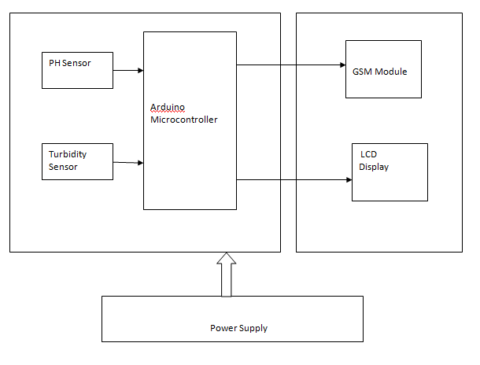

Figure 1. Architecture Diagram

Designing the system to calculate the ph level and the turbidity in the given sample of water.
The architecture can be divided into following modules:-

5.2 MODULES:
1) ARDUINO MICROCONTROLLER
The microcontroller will be use for programming logic for turbidity and ph level of the water. The microcontroller will be use for programming logic for coding. Arduino is an open-source platform used for building electronics projects. Arduino consists of both a physical programmable circuit board (often referred to as a microcontroller) and a piece of software, or IDE (Integrated Development Environment) that runs on your computer, used to write and upload computer code to the physical board.

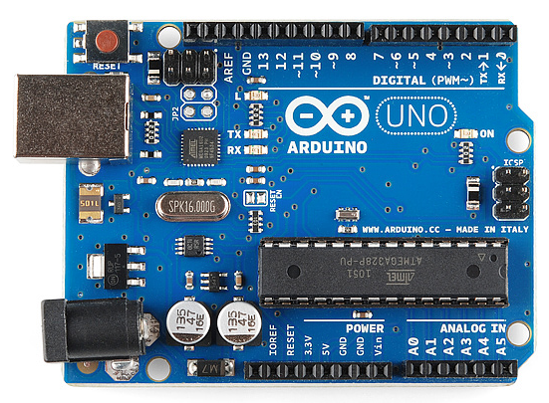

2) PH SENSER:
Ph sensor will count the ph level of the water sample.

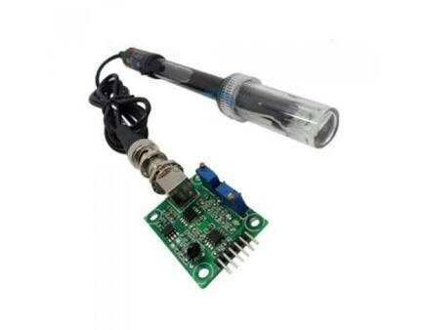

3) TURBIDITY SENSOR:
Turbidity sensor will check how much contaminated is the water sample. This Turbidity Sensor Module detects water quality by measuring level of turbidity. It is able to detect suspended particles in water by measuring the light transmittance and scattering rate which changes relative to the amount of total suspended solids (TSS) in the water. As the TTS increases, the liquid turbidity level increases. This Arduino turbidity sensor have both analog and digital signal output modes. You can select the mode according to the MCU as threshold is adjustable in digital signal mode. This sensors can be used in measurement of water quality in rivers and streams, wastewater and effluent measurements, sediment transport research and laboratory measurements.
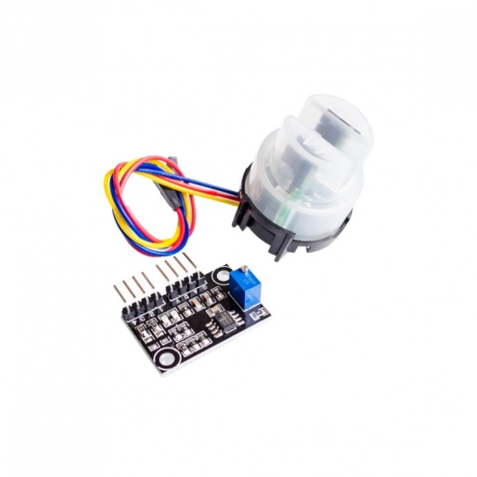

4) GSM MODULE:

The GSM module is used to send the message to the user. GSM (Global System for Mobile Communications, originally Group Special Mobile), is a standard developed by the European Telecommunications Standards Institute (ETSI). It was created to describe the protocols for second-generation (2G) digital cellular networks used by mobile phones and is now the default global standard for mobile communications – with over 90% market share, operating in over 219 countries and territories. The GSM module is used to send the message to the registered number.

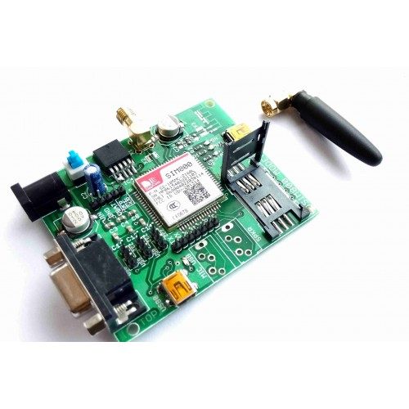

5) LCD:
All the resulted values will be displayed on the LCD

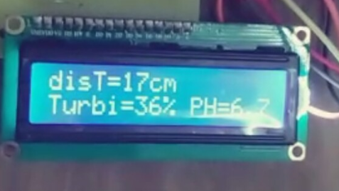

6) DC pumps:
Here DC pumps are used to filter the water if the turbidity count in the given sample is to high then the expected values.

CHAPTER 6

USE CASE DIAGRAM

6.1 USE CASE DIAGRAM

A use case diagram at its simplest is a representation of a user's interaction with the system that shows the relationship between the user and the different use cases in which the user is involved.

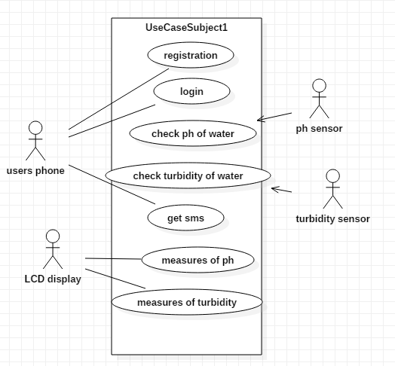

Figure 2. Use case diagram

6.2 ACTIVITY DIAGRAM

Activity diagram is another important diagram in UML to describe the dynamic aspects of the system. Activity diagram is basically a flowchart to represent the flow from one activity to another activity. The activity can be described as an operation of the system.

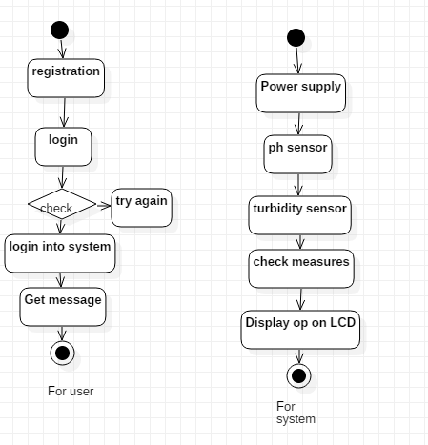
Figure 3. Activity Diagram

CHAPTER 7
BASIC SYSTEM IMPLEMENTATION

7.1 PURPOSE OF SOFTWARE PROJECT PLAN

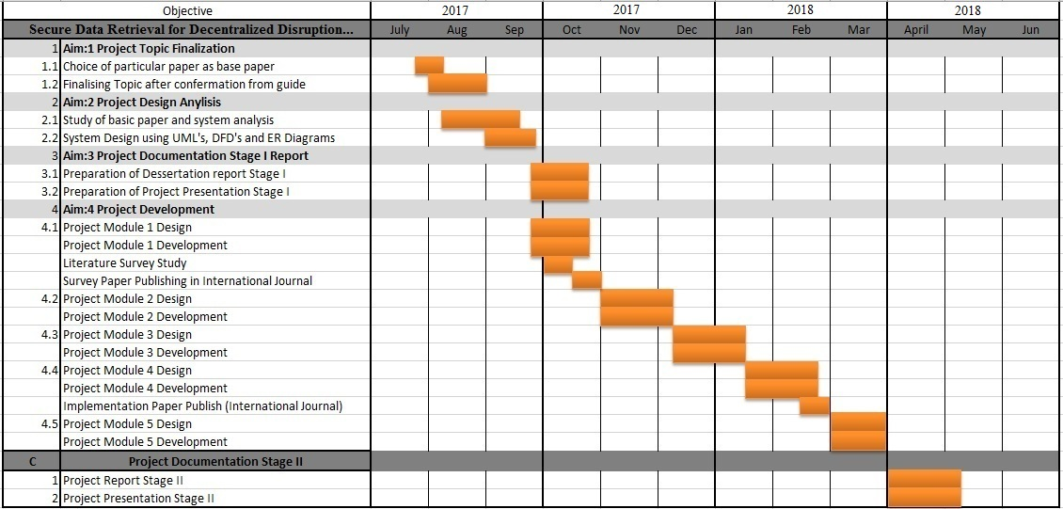

Figure 4. Project plan

7.2 SPECIFICATION

HARDWARE SPECIFICATION

- ph sensor
- turbidity sensor
- power supply
- DC pump
- GSM module

SOFTWARE SPECIFICATION

- Arduino

CHAPTER 8

MILESTONES FOR PROJECT STAGE-II

8.1 PLANNING OF IMPLEMENTATION OF PROPOSED WORK

8.1.1 MATHEMATICAL MODEL

S = {U, S}
Where
U (user) ={u1,u2,u3}

u1 = User registration
u2 = login into system
u3 = user application

S (system) = {a1,a2,a3,a4,a5}
a1 = ph sensors
a2 = turbidity sensors
a3= check measures
a4 = Display values on LCD and send message
a5= filters the water

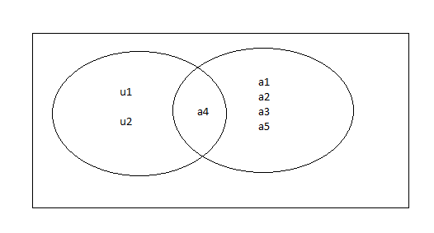
Figure 5. Venn Diagram

8.2 IMPLEMENTATION PLAN

The implementation plan we are going to follow is waterfall model.

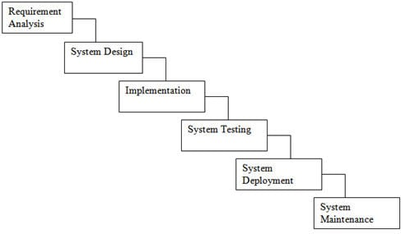

Figure 6. Waterfall model

The waterfall model is a relatively linear sequential design approach for certain areas of engineering design. In software development, it tends to be among the less iterative and flexible approaches, as progress flows in largely one direction ("downwards" like a waterfall) through the phases of conception, initiation, analysis, design, construction, testing, deployment and maintenance.

8.3 EXPECTED OUTCOMES

The system Should work smoothly with all its specified properties. The system should be able to work with expected outcomes.
The system is having some expected outcomes as follow:
- The system should display correct ph level of water.
- System should be able to display turbidity content in the water.
- The system should display correct values on the LCD display.
- System should send the message for all set conditions to the user mobile.

CHAPTER 9
ACTUAL DIAGRAM

ACTUAL DIAGRAM
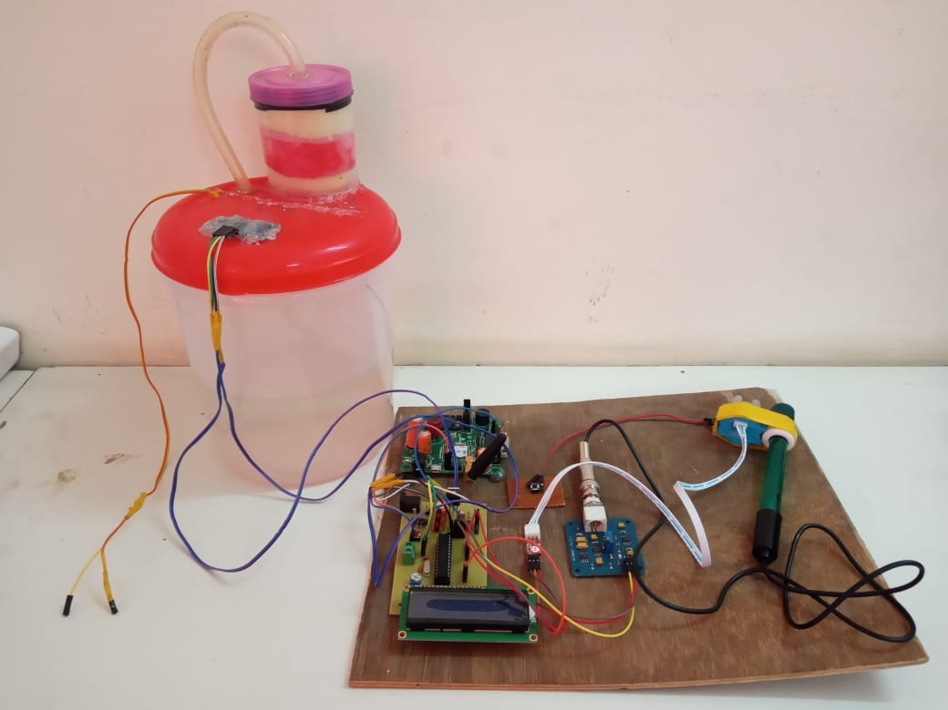

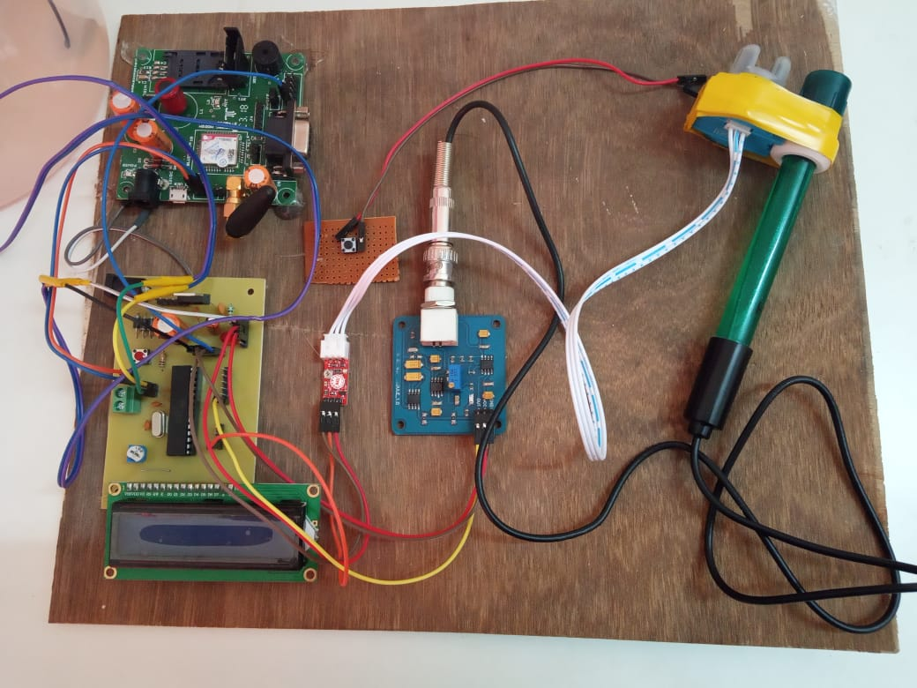

CHAPTER 10

ADVANTAGES AND DISADVANTAGES

ADVANTAGES :-

- The system has good flexibility.
- Due to automation it will reduce the time to check the parameters.
- This is economically affordable for common people.
- Low maintenance.
- Prevention of water diseases.
- The operation is simple.
- It has widespread application and extension value.
- Commercial use.

DISADVANTAGES:-

- The main disadvantages is low connectivity of network over wide area due to wifi module used.

CHAPTER 11

FUTURE SCOPE

FUTURE SCOPE

- Future expansion can be possible by using a wifi module for large area connectivity .
- The system can be expanded to monitor hydrologic, air pollution, industrial and agricultural production and so on. It has widespread application and extension value.
- Different other sensors as are temperature, dissolved oxygen (DO), chemical oxygen demand (COD), biochemical oxygen demand (BOD), ammonia nitrogen, nitrate, nitrite, phosphate, can also be interfaced with the microcontroller to fetch various information about a location.
- Increasing the parameters to be detected and analysed.
- Work can be carried on to include the interfacing of relays to control the supply of water.

CHAPTER 12

CONCLUSION

CONCLUSION

The aim of this project is to provide the accurate measures of the drinking water. This will help in reducing the rate of disease that is happen because of contaminated water. Using ph and turbidity sensors we can find the level of the water or the percentage of contamination it contain. The measures will be sent to the user registered mobile number and can be also view on the LCD display.
Automatic measurement and reporting system of water quality based on GSM makes use of water detection sensor with unique advantage and existing GSM network. This type of system requires less man power for operation The system can monitor water quality automatically, and it is low in cost and does not require people on duty. So the water quality testing is likely to be more economical, convenient and fast. The system has good flexibility. This system is used in commercial and domestic use. This system is used in commercial and domestic use. It can be used in water supply agencies ,for health department to identify the reason of water Diseases so that it can able to measure the water diseases.
Only by replacing the corresponding sensors and changing the relevant software programs, this system can be used to monitor other water quality parameters. The operation is simple. The system can be expanded to monitor hydrologic, air pollution, industrial and agricultural production and so on. It has widespread application and extension value. Real-time water quality data can be seen from a GUI window in PC. The system has advantages such as low carbon emission, low power consumption, more flexible to deploy and so on. In order to monitor water quality in different sites, future work can be focused on establishing a system with more sensor nodes and more base stations.

CHAPTER 13

REFERENCES

REFERENCES

[1] Goldman, Charles R. & Horne, Alexander J. Limnology (1983) McGraw-Hill ISBN 0-07-023651-8 chapter 6

[2] Franson, Mary Ann (1975). Standard Methods for the Examination of Water and Wastewater 14th ed. Washington, DC: American Public Health Association, American Water Works Association & Water Pollution Control Federation. ISBN 0-87553-078-8
[3] https://www.thedailystar.net/health/what-should-be-the-ph-value-drinking-water-138382
[4] https://www.youtube.com/watch?v=GNyLoHTiHbw

