PROJECT PAPER:


Journal homepage: www.mjret.in
ISSN:2348 - 6953

AUTOMATIC MEASUREMENT AND REPORTING SYSTEM OF WATER QUALITY BASED ON GSM

P.B.Deshmukh,P.S.Bankar, P.I.Jadhav, A.V.Raut,G.B.Zaware
BSP,WAGHOLI, JSPM, Pune,India

Abstract: The traditional method of water quality testing is to collect samples manually and then send them to laboratory for analysis. However, it has been unable to meet the demands of water quality monitoring today. So a set of automatic measurement and reporting system of water quality has been developed. The system consists of multiple sensors of water quality testing, single-chip microcontroller data acquisition module, information transmission module, monitoring center and other accessories. Various parameters of water quality are automatically detected under the control of single chip microcontroller all day. The single chip gets the data, and then processes and analyzes them. After that, the data are instantaneously sent to monitoring center by GSM network in the form of SMS. If the water quality is abnormal, the data will be sent to monitoring center and management’s mobile in the same way at the same time. It is convenient for management to take corresponding measures timely and be able to detect real-time situation of water quality remotely. The system has realized the automation of water quality monitoring, intelligence of data analyzing and networking of information transferring. It is characterized by advantages of shortcut, accuracy and using manpower and material resources sparingly. The system has widespread application value and can be extended and transplanted to other fields of automatic monitoring where needed.
Keywords: GSM(global system for mobile communication),DO(dissolved oxygen),COD(chemical oxygen demand),BOD(biochemical oxygen demand),SMS(short messaging service)

INTRODUCTION

With the rapid development of the economy, more and more serious problems of environment arise. Water pollution is one of these problems. Routinely monitored parameters of water quality are temperature, pH, turbidity, conductivity, dissolved oxygen (DO), chemical oxygen demand (COD), biochemical oxygen demand (BOD), ammonia nitrogen, nitrate, nitrite, phosphate, various metal ions and so on. The most common method to detect these parameters is to collect samples manually and then send them to laboratory for detecting and analyzing. This method wastes too much manpower and material resource, and has the limitations of the samples collecting, long-time analyzing, the aging of experiment equipment and other issues. Sensor is an ideal detecting device to solve these problems. It can convert non-power information into electrical signals[1]. It can easily transfer, process, transform and control signals, and has many special advantages such as good selectivity, high sensitivity, fast response speed and so on. According to these characteristics and advantages of sensors, automatic measurement and reporting system of water quality is designed and developed. It bases on SMS (Short Messaging Service) in the GSM (Global System for Mobile Communications) network to instantaneously transfer the collected data[1]. It also can remotely monitor the water quality on line. The system implements automation, intelligence and network of water quality monitoring, and uses manpower, material and financial resources sparingly.

RELATED WORK

  - Existing System: The traditional method of water quality testing is to collect samples manually and then send them to laboratory for analysis. However, it has been unable to meet the demands of water quality monitoring today.

PROPOSED SYSTEM

transferring. It is characterized by advantages of shortcut, accuracy and using manpower and material resources sparingly. The system has widespread application value and can be extended and transplanted to other fields of automatic monitoring where needed.

SOFTWARE REQUIREMENT
  - Operating System: Windows xp/7/8
  - IDE: Eclipse
  - Programming Language: Android/java
  - Database: MySQL

HARDWARE RESOURCES REQUIRED

  - Processor: Intel dual core
  - RAM:1GB
  - Sensor
  - GSM

SYSTEM ARCHITECTURE

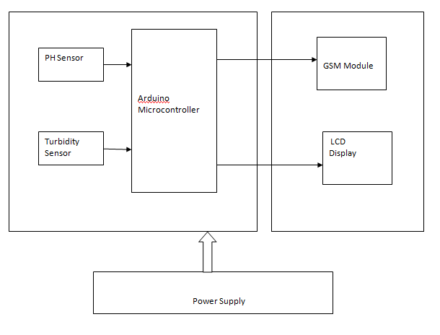
As figure shows ,the system consists of multiple water detection sensor ,single-chip microcontroller data acquisition module ,information transmission module ,monitoring center and other accessories . Temperature sensor used in this system directly converts the temperature signal into digital signal. Other water quality sensor transform the detected chemical signals into electrical signals ,amplified by the signal conditioning circuit .The multiplexers select one road signal and send to A/D converter .then it is converted into
digital signals .Single-chip reads processes the digital processes .it also control the GSM module sending the collected data to the monitoring center in the form of SMS by GSM instantaneously
Monitoring center receives the data and then analyzes ,classifies ,saves them and draws corresponding graphs .that can instantaneously monitor and alarm the situation of water quality.if the water quality is abnormal ,single-chip will control the GSM module to send data to the monitoring center in the form of short message.the alarm in the monitoring center is activated .at the same time ,the data are sent to management mobile phone in this way . it is easy for management to take corresponding measures immediately .when needed
,management can also send ordrs in the form of SMS to GSM module of data collection terminal. GSM module communicates with the single chip. Then the single chip gets the data ,and controls the GSM module to send the data to the managers phones .the system can do all –wheather real-time monitor to water temperature ,pH ,conductivity turbidity
,dissolved oxygen and other water – quality guidline .the design is beneficial for management to know the real-time water quality information ,and make man-machine interaction with the system by mobile.

CONCLUSION
Automatic measurement and reporting system of water quality based on GSM makes use of water detection sensor with unique advantage and existing GSM network. The system can monitor water quality automatically, and it is low in cost and does not require people on duty. So the water quality testing is likely to be more economical, convenient and fast. The system has good flexibility. Only by replacing the corresponding sensors and changing the relevant software programs, this system can be used to monitor other water quality parameters. The operation is simple. The system can be expanded to monitor hydrologic, air pollution, industrial and agricultural production and so on. It has widespread application and extension value.

FUTURE SCOPE
Future expansion can be possible by using a wifi module for large area connectivity .

REFERENCES
- Gold,”Steve.Cracking GSM,”Network Security,2011,4:12-15.

