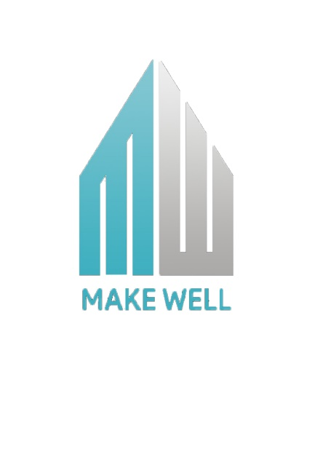

BILL SHEET

|  |  |
| --- | --- |
| DRAWING COST | ₹1000/_ |
| ESTIMATION COST | ₹1500/_ |
| * 3D , ELEVATION | ₹ 4000/_ |
| TOTAL COST | ₹6500/_ |

MAKE WELL PROJECTS &DEDEVELOPERS

* CONSTRUCTION
* ENGINEERING & SUPERVISION
* PLANNING & DESIGN
* 3D VIEW
* PERMIT & PAPER WORK
* INTERIOR DESIGN
* HOME MAINTENANCE
* REAL ESTATE



