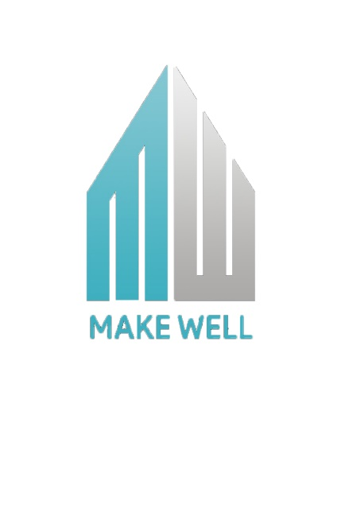

BILL SHEET

|  |  |
| --- | --- |
| DRAWING COST&FURNITURE PLAN | ₹1000/_ |
| PERMIT ,PERMIT DRAWING &POSSESSION CERTIFICATE | ₹6000/_ |
| * 3D , ELEVATION | ₹ 4000/_ |
| * ADVANCE FEE | ₹5000/_ |
| TOTAL | 16,000/_ |

MAKE WELL PROJECTS &DEDEVELOPERS

* CONSTRUCTION
* ENGINEERING & SUPERVISION
* PLANNING & DESIGN
* 3D VIEW
* PERMIT & PAPER WORK
* INTERIOR DESIGN
* HOME MAINTENANCE
* REAL ESTATE



