AKSHAY.N

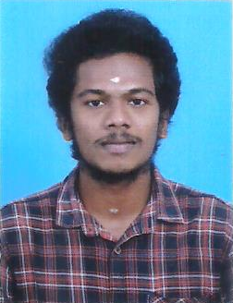

Anakkode, Kuzhalmannam (PO), Palakkad, Kerala, Pin : 678702 [akshaynarayanan97@gmail.com](mailto:akshaynarayanan97@gmail.com)

+91 9946231258

# CAREER OBJECTIVE

Seeking a challenging career in the any suitable field, willing to accept responsibility, easily adaptable nature to new environment, willing to listen and learn excellent communication and interpersonal skills.

# EDUCATIONAL QUALIFICATION

* **B.Sc Electronics *2022***

IHRD, Kottayi, Kuzhalmannam, Palakkad

University of Calicut

Marks Obtained : 60%

* **Plus Two (computer science) *2019***

CA HSS Kuzhalmannam, Palakkad

Marks Obtained : 60%

* **SSLC *2016***

CA HSS, Kuzhalmannam, Palakkad

Marks Obtained : 70%

# ACADEMIC PROJECT

* **MAIN PROJECT**

The project entitled “IOT BASED HELATH MONITORING SYSTEM”.

# TECHNICAL SKILLS

* Microsoft Office
* C++
* HTML
* Java

# ACHIVEMENTS

* D.C.A Certificate (2019)

# PERSONAL DETAILS

* Date of Birth : 24.02.2000
* Gender : Male
* Marital Status : Single
* Nationality : Indian
* Known Language : English, Malayalam, Hindi & Tamil

# DECLARATION

I declare that the above mentioned statement is true as per my knowledge. May be I got an opportunity to work in your esteemed organization. I assure you that I will discharge my duties with zeal and zest

**DATE:**

**PLACE: PALAKKAD AKSHAY.N**