

**(University DataBase Management System)**

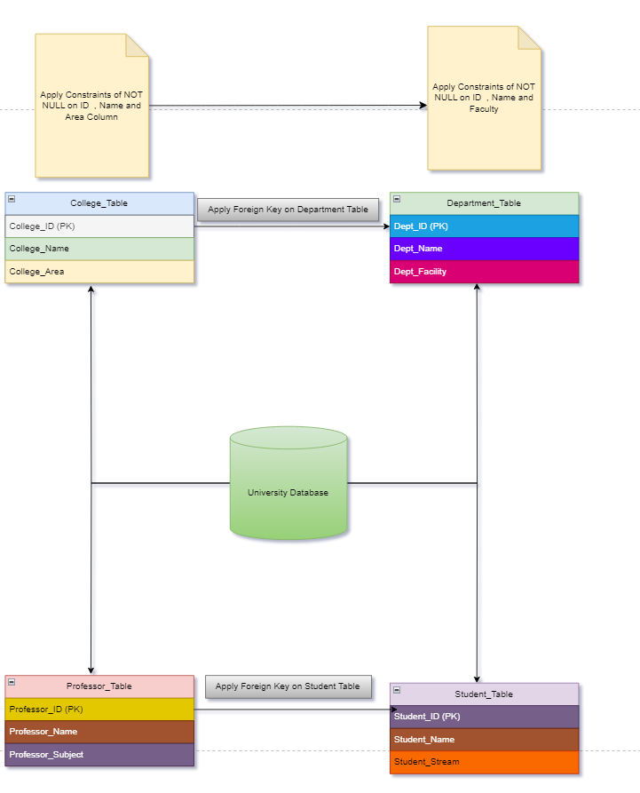

University Database Management System is one of the Fundamental and Intermediate level SQL project

Here in this Project you have to create an efficient DBMS for the any University .

Inorder to create this system Perform the following task:-

**Task 1:-**

1.Create University Database give any University name you want

2. Under this University Create four tables and each table should have following three Column named as:-

A. College_Table

College_ID(PK)

College_Name

College_Area

B. Department_Table

Dept_ID(PK)

Dept_Name

Dept_Facility

C. Professor_Table

Professor_ID(PK)

Professor_Name

Professor_Subject

D. Student_Table

Student_ID(PK)

Student_Name

Student_Stream

3. Apply foreign key on Department key from College_table

4. Apply foreign Key on Student_Table from Professor_Table

5. Insert atleast 10 Records in each table

**Task 2:-**

1. Give the information of College_ID and College_name from College_Table
2. Show Top 5 rows from Student table.
3. What is the name of professor whose ID is 5
4. Convert the name of the Professor into Upper case
5. Show me the names of those students whose name is start with a
6. Give the name of those colleges whose end with a
7. Add one Salary Column in Professor_Table
8. Add one Contact Column in Student_table
9. Find the total Salary of Professor
10. Change datatype of any one column of any one Table

**Task 3:-**

1. Show first 5 records from Students table and Professor table Combine
2. Apply Inner join on all 4 tables together
3. Show Some null values from Department table and Professor table.
4. Create a View from College Table and give those records whose college name starts with C
5. Create Stored Procedure of Professor table whatever customer ID will be given by user it should show whole records of it.
6. Rename the College_Table to College_Tables_Data .