Step Functions CI/CD (GitHub Actions)

Step Functions CI/CD (GitHub Actions)

Overview

This repository contains a GitHub Actions–driven CI/CD pipeline to manage AWS Step Functions state machines from source control.

- Branch-based deploys:
- cert branch deploys to cert
- prod branch deploys to prod (can be gated using GitHub Environments approvals)
- Lifecycle support: create, update, and delete state machines based on the repo source of truth under stepfunctions/.
- Templated ASL: definitions in stepfunctions/definitions/*.asl.json can contain ${...} placeholders that are rendered using environment files in stepfunctions/env/.

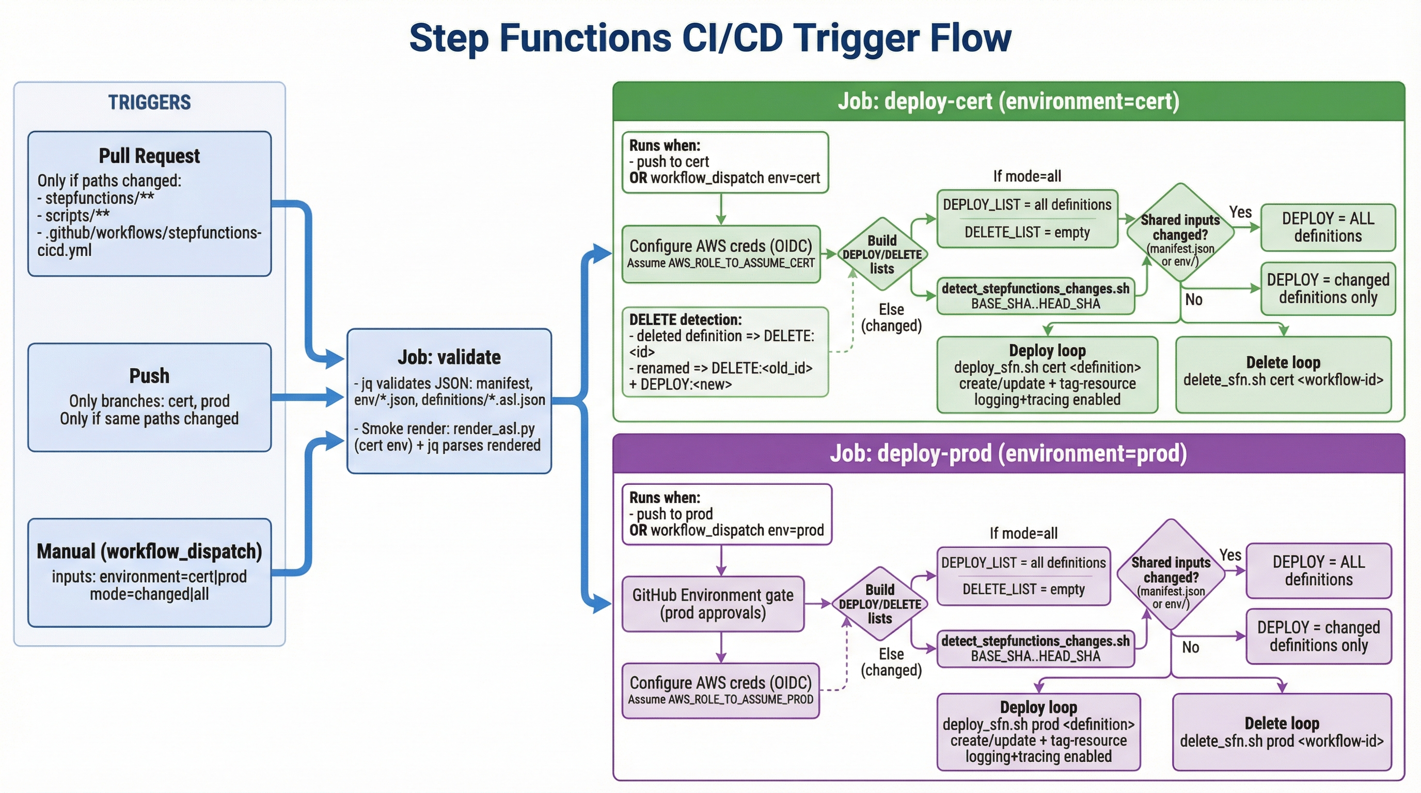

Figure: Step Functions CI/CD Trigger Flow

Diagram summary

- Triggers: PRs validate changes; pushes to cert/prod deploy; manual workflow_dispatch runs with mode=changed|all.
- Validation: confirms manifest.json and env/*.json are valid JSON; renders each ASL template with cert env and validates the rendered JSON.
- Change detection:
- If stepfunctions/env/ changes → deploy all definitions (safe default).
- If manifest.json changes → deploy only workflows whose manifest entries changed; delete workflows removed from the manifest.
- If definition files are deleted/renamed → delete old workflow id; deploy new path on rename.
- Deploy loop: for each item in DEPLOY_LIST, runs deploy_sfn.sh to create/update state machines and enforce tags.
- Delete loop: for each item in DELETE_LIST, runs delete_sfn.sh to delete the state machine by workflow id.

Architectural overview

- Source of truth
- stepfunctions/manifest.json declares workflows (id, definition path, type, tags) and a naming template.
- stepfunctions/definitions/*.asl.json contains the Step Functions ASL definitions (templated).
- stepfunctions/env/{cert,prod}.json provides substitution values for rendering templates.
- CI/CD orchestration
- .github/workflows/stepfunctions-cicd.yml validates JSON and renders templates, then runs deploy/delete loops.
- Deployment mechanism
- scripts/deploy_sfn.sh uses the AWS CLI to create-state-machine or update-state-machine and enforces tags.
- scripts/delete_sfn.sh deletes state machines using the same deterministic naming convention.

Directory structure

- .github/workflows/
- stepfunctions-cicd.yml: workflow entrypoint (PR validation, branch deploys, manual dispatch)
- scripts/
- deploy_sfn.sh: create/update a single state machine from a definition
- delete_sfn.sh: delete a single state machine by workflow id
- detect_stepfunctions_changes.sh: compute deploy/delete lists from git diffs and manifest changes
- detect_changed_stepfunctions.sh: legacy helper (changed definitions list)
- render_asl.py: renders ${KEY} placeholders into a JSON definition
- stepfunctions/
- manifest.json: workflow registry + naming template
- definitions/*.asl.json: state machine definitions (templated)
- env/cert.json, env/prod.json: environment substitution values

Workflow triggers

The workflow triggers on:

- pull_request when files change under:
- stepfunctions/
- scripts/
- .github/workflows/stepfunctions-cicd.yml
- push to branches cert or prod with the same path filters above
- workflow_dispatch manual runs with inputs:
- environment: cert | prod
- mode: changed | all

Script usage & logic

scripts/render_asl.py

- Usage: python3 scripts/render_asl.py <env.json> <input.asl.json> <output.json>
- Logic: Replaces ${KEY} placeholders using the key/value pairs in the env JSON. Lists/dicts are injected as JSON; scalars are string-injected. Validates the final JSON parses.

scripts/deploy_sfn.sh

- Usage: scripts/deploy_sfn.sh <cert|prod> <path-to-definition.asl.json>
- Logic:
- Reads stepfunctions/manifest.json and derives:
- WF_ID = filename without .asl.json
- State machine name using stateMachineNameTemplate (substitutes ${ENV} and ${ID})
- type and tags from the manifest workflow entry
- Renders the definition using scripts/render_asl.py with stepfunctions/env/<env>.json
- Creates or updates the state machine:
- If not found: aws stepfunctions create-state-machine
- If found: aws stepfunctions update-state-machine
- Enforces tags using aws stepfunctions tag-resource

scripts/delete_sfn.sh

- Usage: scripts/delete_sfn.sh <cert|prod> <workflow-id>
- Logic:
- Computes the state machine name using the same template as deploy
- Finds the ARN via list-state-machines
- Deletes using aws stepfunctions delete-state-machine

scripts/detect_stepfunctions_changes.sh

- Usage: scripts/detect_stepfunctions_changes.sh <base_sha> <head_sha>
- Output:
- DEPLOY:<definition-path> lines (create/update)
- DELETE:<workflow-id> lines (delete)
- Logic:
- If anything under stepfunctions/env/ changed → deploy all definitions (safe default).
- If stepfunctions/manifest.json changed:
- Deploy only workflows whose manifest entries changed (new/modified).
- Delete workflows removed from manifest (even if the definition file still exists).
- Also detects deletes/renames of definition files under stepfunctions/definitions/*.asl.json:
- deleted file → DELETE:<old_id>
- renamed file → DELETE:<old_id> and DEPLOY:<new_path>

AWS prerequisites (before running the workflow)

1) GitHub Actions Secrets

Set these secrets in repo settings:

- AWS_ACCESS_KEY_ID
- AWS_SECRET_ACCESS_KEY
- AWS_REGION (example: us-east-2)
- SFN_EXECUTION_ROLE_ARN_CERT
- SFN_EXECUTION_ROLE_ARN_PROD
- SFN_LOG_GROUP_ARN_CERT (recommended)
- SFN_LOG_GROUP_ARN_PROD (recommended)

2) IAM permissions (high level)

The AWS credentials used by GitHub Actions must be able to:

- Create/update/delete state machines: states:CreateStateMachine, states:UpdateStateMachine, states:DeleteStateMachine, states:ListStateMachines, states:TagResource
- Pass the Step Functions execution role: iam:PassRole for the role(s) in SFN_EXECUTION_ROLE_ARN_*

The Step Functions execution role (the role passed to create-state-machine) must have permissions required by your ASL definition. For example, the included ECS dummy workflow requires permissions for ecs:RunTask and EventBridge integration used by .sync patterns.

Adding / deleting a Step Function (examples)

Add (create/update) a workflow

1) Add a definition file:

- stepfunctions/definitions/orders-ecs-run-task.asl.json

2) Add a manifest entry:

{
"id": "orders-ecs-run-task",
"definition": "stepfunctions/definitions/orders-ecs-run-task.asl.json",
"type": "STANDARD",
"tags": { "app": "orders", "managed-by": "github-actions" }
}

3) Ensure required placeholders exist in stepfunctions/env/cert.json and stepfunctions/env/prod.json.

4) Merge to cert (or prod) and the pipeline will deploy it to that environment only.

Delete a workflow

You have two supported delete paths:

- Manifest removal (recommended): remove the workflow entry from stepfunctions/manifest.json → pipeline emits DELETE:<id> and deletes it.
- Definition file removal/rename: deleting/renaming stepfunctions/definitions/<id>.asl.json emits delete/rename deletes.

Deploy all mode

Manual deploy-all is available as:

- workflow_dispatch with mode=all

Behavior:

- DEPLOY_LIST = all tracked definition files in stepfunctions/definitions/*.asl.json
- DELETE_LIST = empty
- Result: deploy/update everything once for the selected environment without deleting anything.

Test cases (to be validated)

1. Created one step function in cert: added definition + manifest entry; merged to cert; workflow deployed it.
2. Created another step function: added a second workflow entry; pipeline deployed it.
3. Deleted step function: deletion supported via manifest removal or definition deletion/rename; pipeline deleted the state machine.
4. Run pipeline without any changes and workflow didn’t get triggered: due to path filters on push/pull_request, no-run occurs when nothing under watched paths changes.
5. If merge to cert branch then it will deploy to cert only: branch gating ensures cert deploy job runs only for cert (prod runs only for prod).
6. Tested deletion workflow by removing one step function from manifest.json: removal emits delete and deletes the state machine.
7. Tested Deploy all: manual dispatch with mode=all deploys all definitions for the chosen environment.

Workflow diagram

![Step Functions CI/CD Trigger Flow](stepfunctions-cicd-trigger-flow.png)

Diagram summary

- Triggers: PRs validate changes; pushes to cert/prod deploy; manual workflow_dispatch runs with mode=changed|all.
- Validation: confirms manifest.json and env/*.json are valid JSON; renders each ASL template with cert env and validates the rendered JSON.
- Change detection:
- If stepfunctions/env/ changes → deploy all definitions (safe default).
- If manifest.json changes → deploy only workflows whose manifest entries changed; delete workflows removed from the manifest.
- If definition files are deleted/renamed → delete old workflow id; deploy new path on rename.
- Deploy loop: for each item in DEPLOY_LIST, runs deploy_sfn.sh to create/update state machines and enforce tags.
- Delete loop: for each item in DELETE_LIST, runs delete_sfn.sh to delete the state machine by workflow id.

Presentation summary (talk track)

“This project provides a GitHub Actions CI/CD pipeline to manage AWS Step Functions as code. We keep a source-of-truth manifest and templated ASL definitions in the repo, and environment-specific values in cert and prod JSON files. On every PR we validate JSON and render templates to ensure the final state machine definitions are valid. When changes are merged to the cert or prod branches, the pipeline detects what’s new, updated, or removed, then runs a deploy loop to create or update only the affected state machines, and a delete loop to remove workflows that were deleted or removed from the manifest. We also support a manual ‘deploy all’ mode to redeploy all definitions safely without deletions. Overall, it standardizes Step Functions deployments, makes changes auditable via git history, and keeps cert and prod deployments controlled by branch and environment gating.”

