Flask + MongoDB Atlas Assignment Report

Project Structure
project_folder/
│── app.py
│── requirements.txt
│── templates/
│ ├── index.html
│ ├── success.html
│ ├── error.html
│── static/
│ ├── style.css

Step 1: Install Required Packages
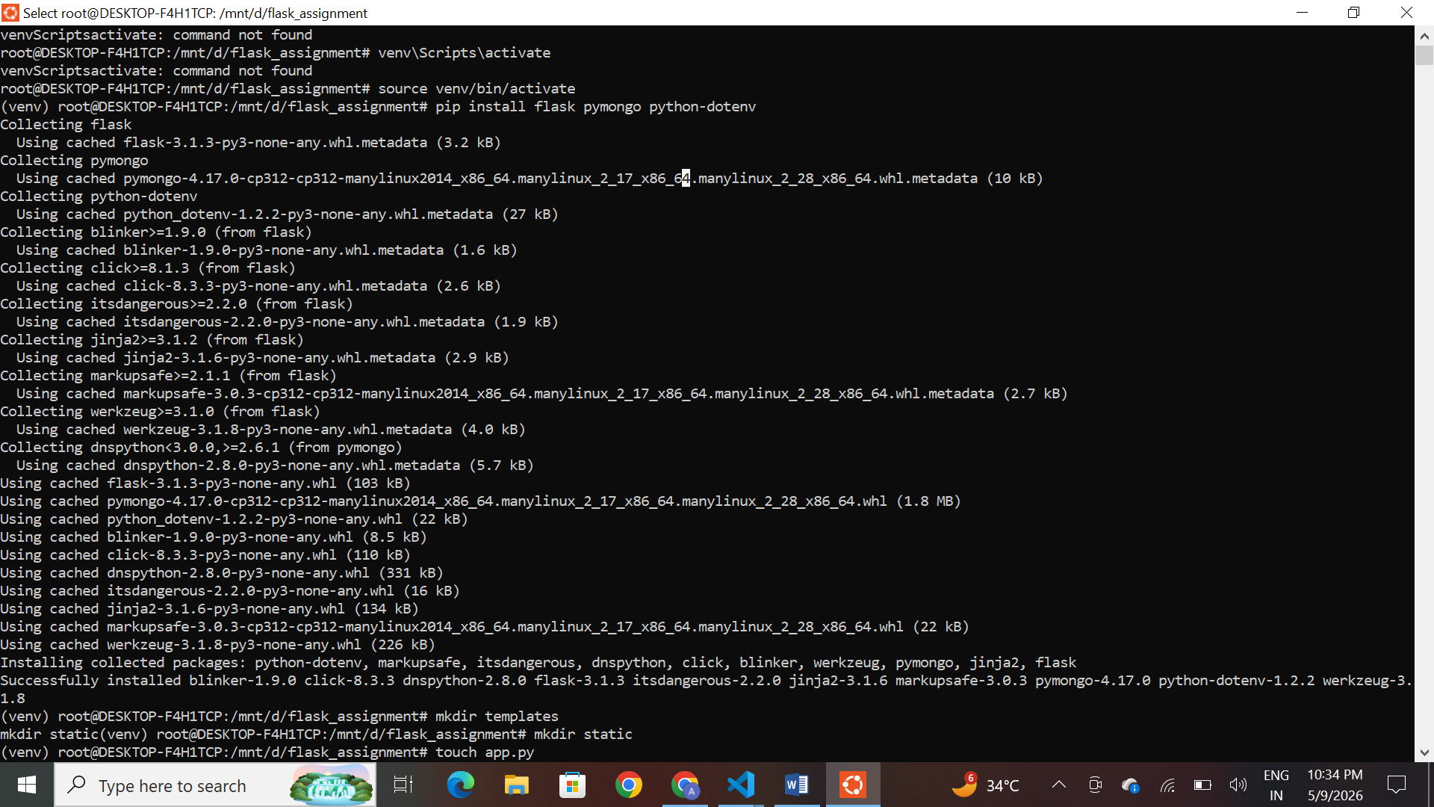

Step 2: Flask Application (app.py)

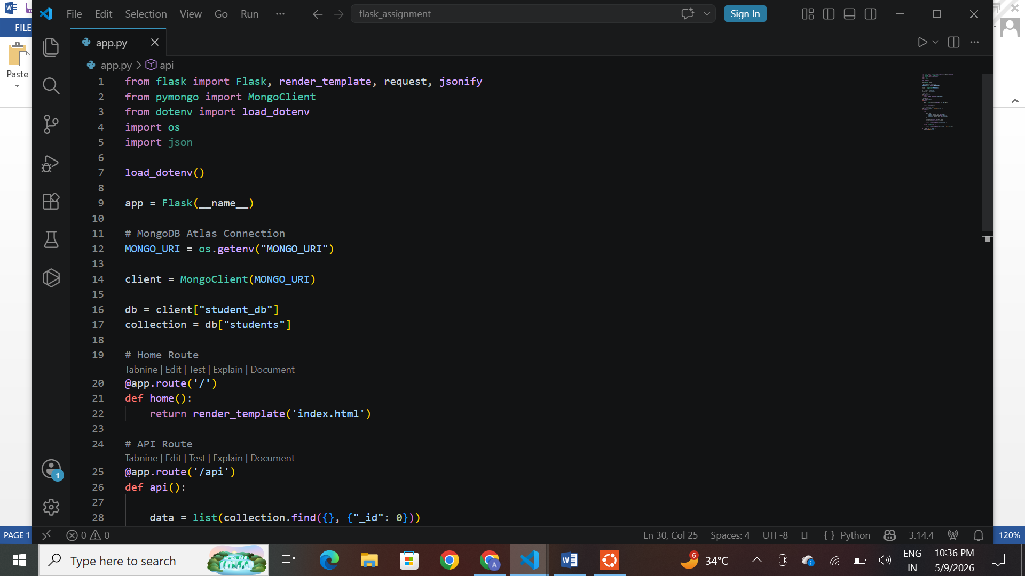
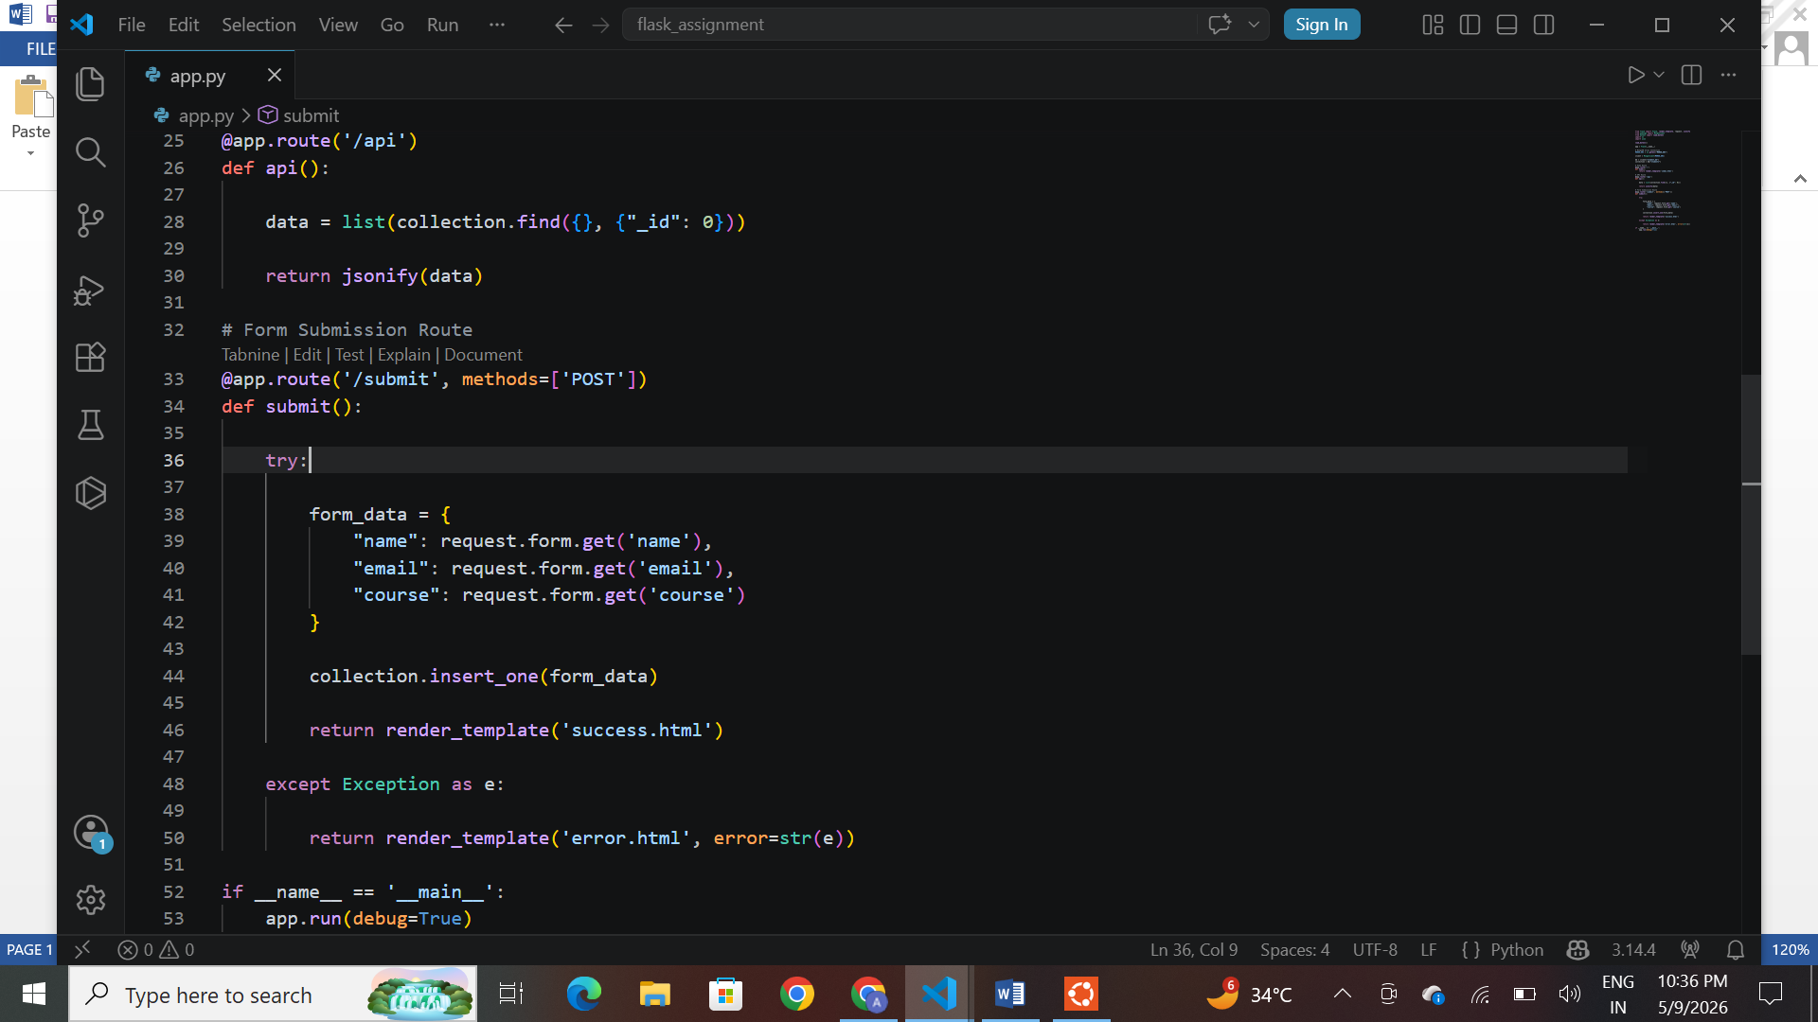

Step 3: Frontend Form (templates/index.html)
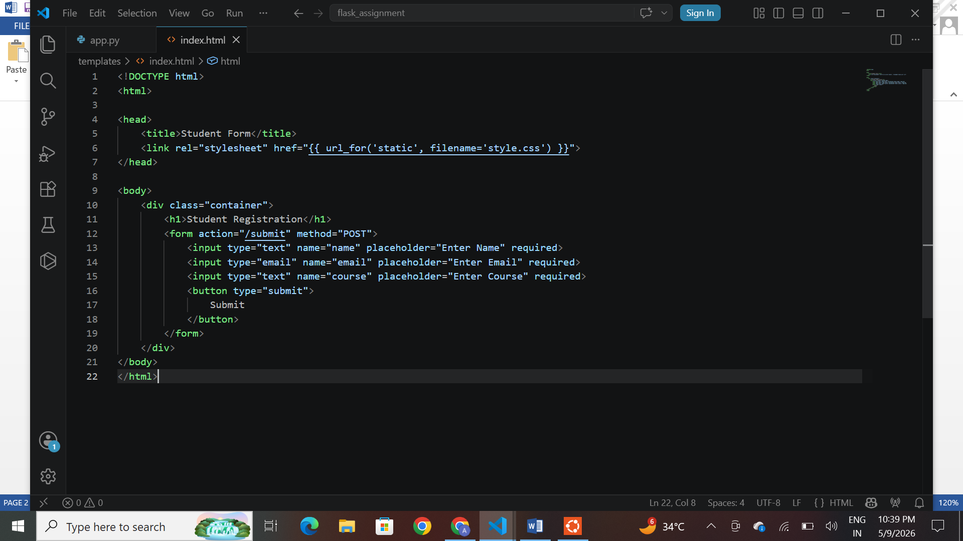

Step 4: Success Page (templates/success.html)
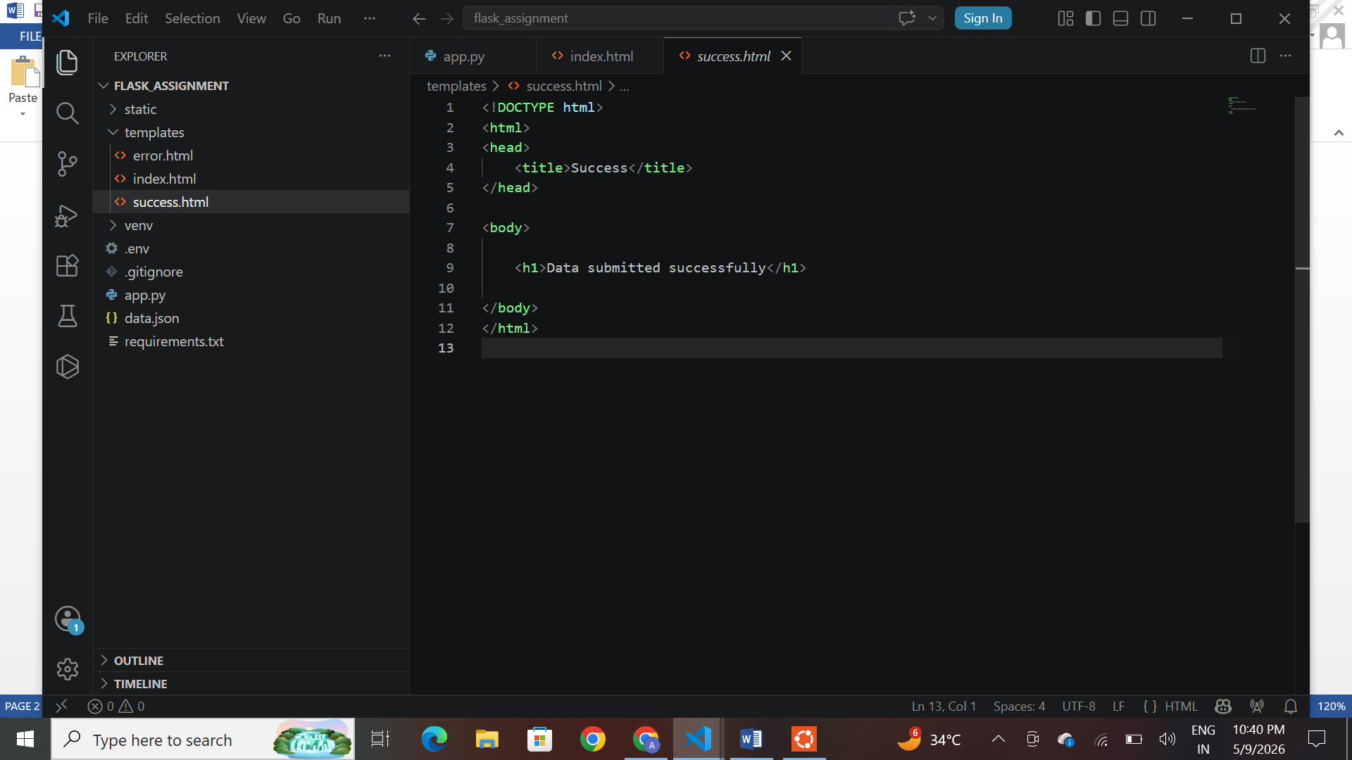

Step 5: Error Page (templates/error.html)
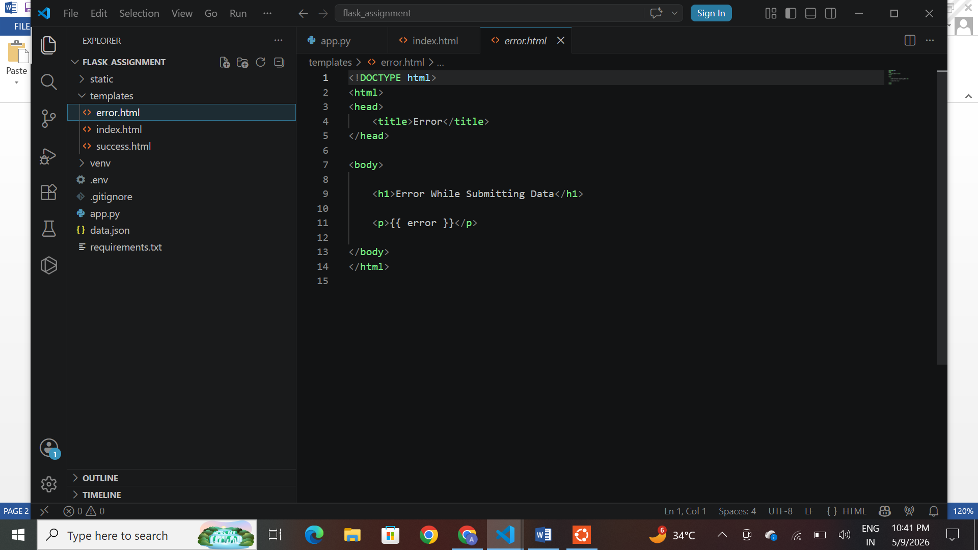

Step 6: CSS File (static/style.css)

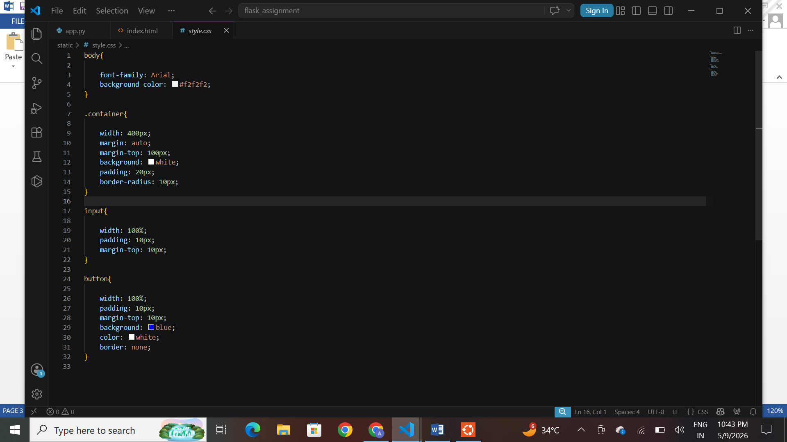

Step 7: Run the Application
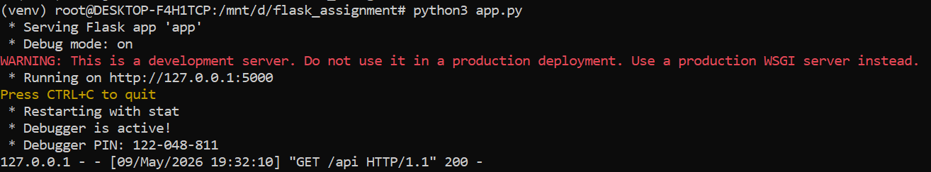

Expected Output

- Terminal showing Flask server running.



- Form page screenshot.

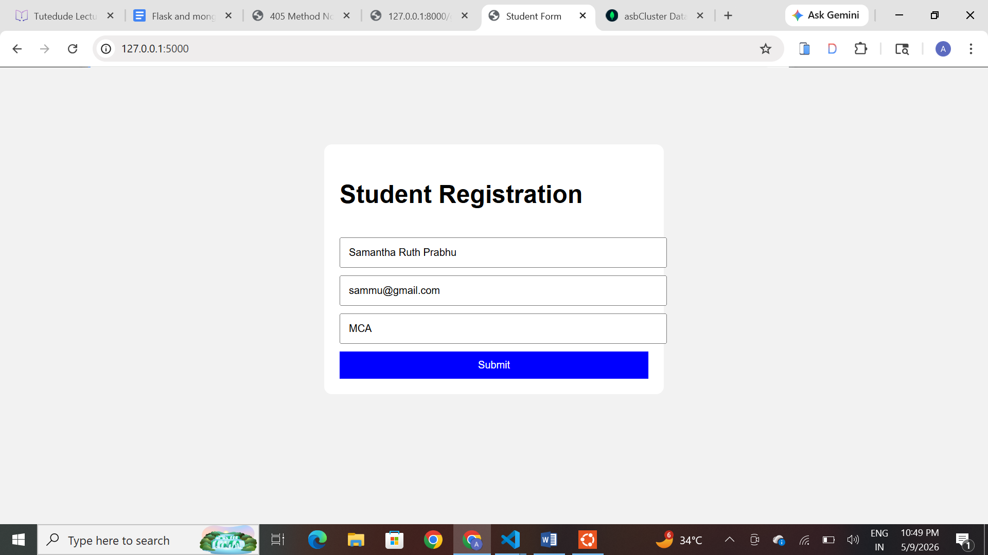

3. Success page screenshot.

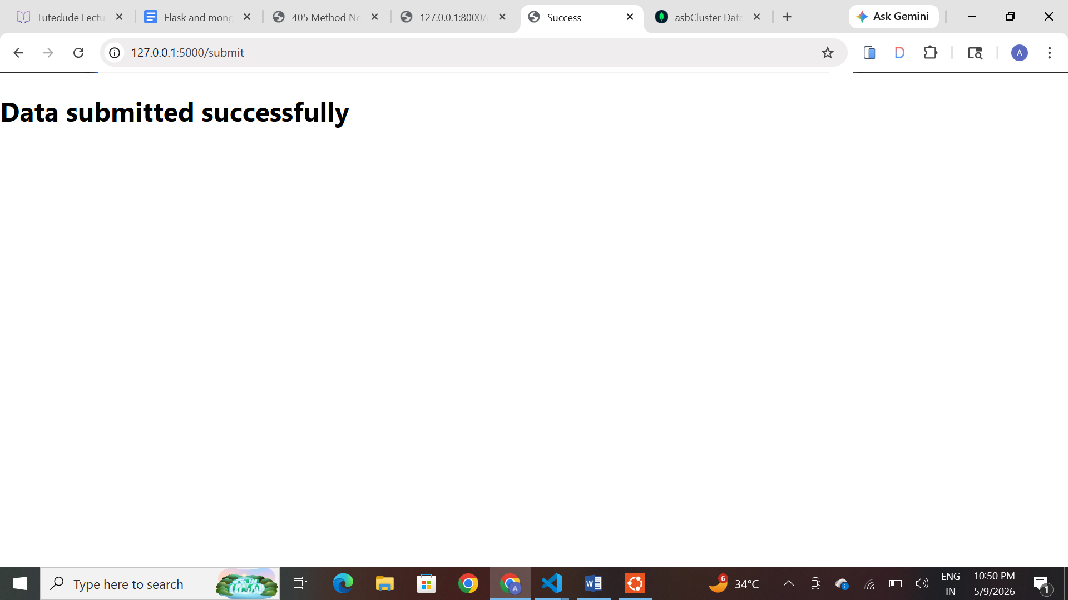
- MongoDB Atlas collection screenshot.

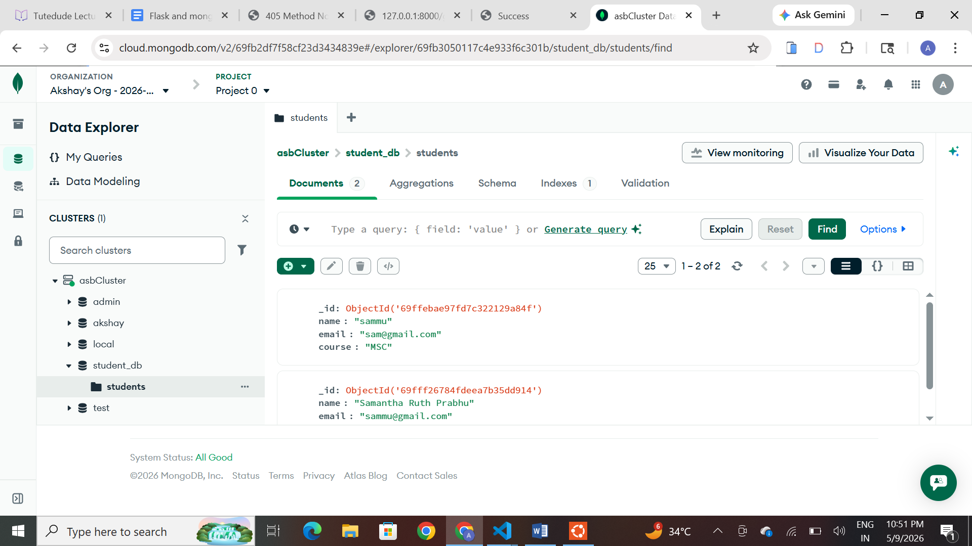

5. /api JSON response screenshot.

