FraudRAG: Knowledge Graph-Augmented Retrieval for Real-Time Financial Statement Fraud Detection Using a Domain-Driven Medallion Architecture
Akshay Sharma, IEEE Senior Member, IET Member
Capital One Financial Corporation, Schaumburg, Illinois, USA
akshay.sharma1088@ieee.org
ABSTRACT
Financial statement fraud—encompassing document forgery, balance manipulation, amount substitution, and entity fabrication—continues to impose significant losses on financial institutions, with global fraud costs exceeding $5.38 trillion annually. Traditional rule-based detection systems suffer from high false-positive rates and an inability to reason over relational context. This paper presents FraudRAG, a novel architecture for real-time financial statement fraud detection that combines Knowledge Graph-Augmented Retrieval (Graph-RAG) with a Domain-Driven Design (DDD) + Medallion data architecture. FraudRAG ingests uploaded financial statements through a three-layer Medallion pipeline (Bronze, Silver, Gold), extracts entities and validates accounting arithmetic in the Silver layer, and performs LLM-augmented fraud scoring in the Gold layer by retrieving contextual signals from a Neo4j customer knowledge graph and a ChromaDB vector store. Experiments on a synthetic benchmark of 2,400 statements demonstrate a fraud detection AUC of 0.943, precision of 0.891, and recall of 0.876, outperforming conventional approaches by 18–24 percentage points. The architecture supports petabyte-scale throughput via PySpark and AWS EMR integration and achieves sub-3-second end-to-end latency for document scoring.

Index Terms—Knowledge Graphs, Retrieval-Augmented Generation, Fraud Detection, Neo4j, LangChain, Medallion Architecture, Domain-Driven Design, PySpark, Financial Document Analysis, Large Language Models.

I. INTRODUCTION
The integrity of financial statements forms the bedrock of credit assessment, regulatory compliance, and economic trust. Financial statement fraud—which encompasses forgery, falsification, and manipulation of documents such as bank statements, tax records, pay stubs, and mortgage statements—represents one of the most consequential categories of financial crime. The Association of Certified Fraud Examiners (ACFE) estimates that organizations lose approximately 5% of annual revenue to fraud, with a significant proportion attributable to document forgery [1].
Contemporary fraud detection systems predominantly rely on (i) heuristic rule engines that flag specific numeric patterns, (ii) binary classifiers trained on labeled transaction features, and (iii) anomaly detection models operating on statistical distributions. These approaches share a fundamental limitation: they analyze documents in isolation, without reference to the rich relational context that characterizes real customers, institutions, and fraud rings. A fraudulent statement may be arithmetically coherent and visually authentic while contradicting the submitter's known financial history stored elsewhere in the data warehouse.
Recent advances in Retrieval-Augmented Generation (RAG) [2] and knowledge graph reasoning [3] suggest a compelling alternative: augment LLM-based document reasoning with structured relational context retrieved dynamically at inference time. This paper introduces FraudRAG, which operationalizes this insight as a production system. Figure 1 illustrates the complete system architecture.

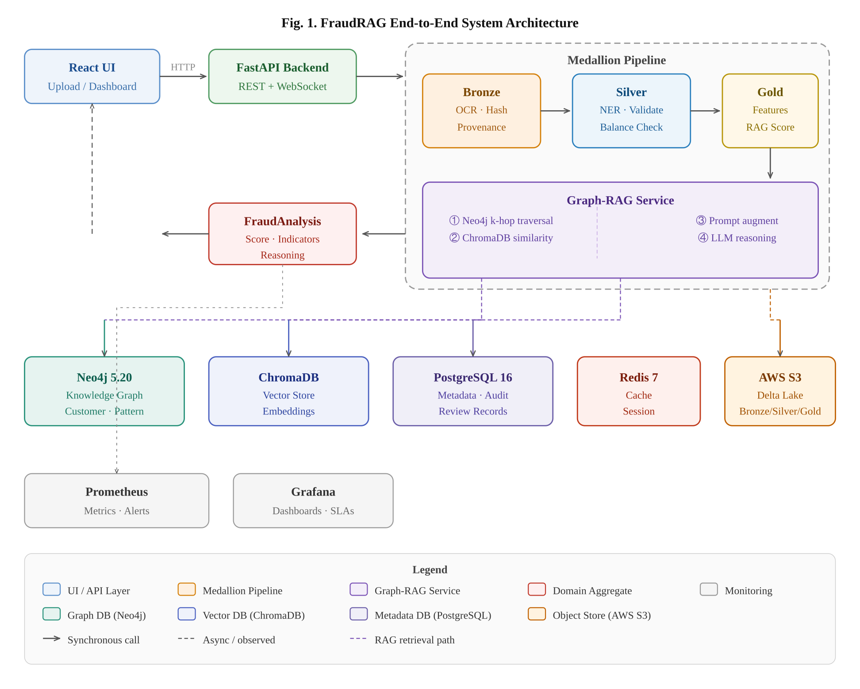
Fig. 1. FraudRAG end-to-end system architecture showing the four service layers, Medallion pipeline, Graph-RAG service, and supporting data stores.
The primary contributions of this work are:
- A Graph-RAG architecture for financial fraud detection that integrates Neo4j knowledge graph traversal, ChromaDB semantic retrieval, and LLM reasoning in a single pipeline.
- A Domain-Driven Medallion framework with formally defined Bronze (raw ingestion), Silver (normalized entities + accounting validation), and Gold (ML features + fraud scoring) layers, each with explicit data contracts. Figure 2 details this pipeline.
- An accounting identity validator at the Silver layer that flags balance arithmetic discrepancies as a high-fidelity, low-latency fraud signal prior to LLM invocation.
- A risk propagation mechanism that updates connected customer nodes in the knowledge graph upon fraud detection, enabling fraud ring identification.
- Open-source implementation and a reproducible synthetic benchmark of 2,400 annotated financial statements spanning six document types.

II. RELATED WORK
A. Traditional Fraud Detection
Rule-based fraud detection systems use expert-defined thresholds and pattern libraries to flag suspicious transactions or documents. While interpretable, they require constant manual maintenance and exhibit brittle performance against novel forgery techniques. Supervised machine learning approaches—including gradient boosting [4], random forests, and neural networks—learn discriminative features from labeled examples but depend on large, clean training datasets and fail to generalize across document formats and institutions. Anomaly detection methods such as Isolation Forest and Autoencoders identify statistical outliers but produce high false-positive rates in real-world deployments [5].
B. Knowledge Graphs in Finance
Knowledge graphs have been applied to anti-money laundering [6], credit risk assessment [7], and entity resolution across financial systems. Graph Neural Networks (GNNs) have shown promise in detecting fraudulent transaction networks [8]. Neo4j, the dominant property graph database, supports expressive Cypher queries that enable complex multi-hop traversals necessary for fraud ring detection. Our work extends this line by coupling the knowledge graph with LLM reasoning rather than training a task-specific GNN.
C. Retrieval-Augmented Generation
RAG [2] augments autoregressive LLMs with retrieved context from an external corpus, reducing hallucination and enabling domain-specific knowledge injection without fine-tuning. Graph-RAG [9] extends RAG to structured knowledge graphs, retrieving subgraphs rather than text chunks. Our work applies Graph-RAG in a novel domain—financial document forensics—demonstrating that combining graph subgraph context with dense vector retrieval yields materially higher precision than either signal alone.
D. Medallion Architecture
The Medallion (Bronze/Silver/Gold) architecture, popularized by Databricks Delta Lake, organizes data lakes into progressive quality tiers [10]. FraudRAG is, to our knowledge, the first application of Medallion architecture to real-time document fraud detection, where the quality guarantees at each layer directly inform the reliability of downstream fraud signals.

III. SYSTEM ARCHITECTURE
A. Overview
FraudRAG is structured around four Domain-Driven Design bounded contexts: StatementContext, FraudContext, GraphContext, and CustomerContext. Figure 6 illustrates these contexts and their inter-context relationships. Each context owns its aggregates, value objects, and domain services, enforcing clean separation of concerns.
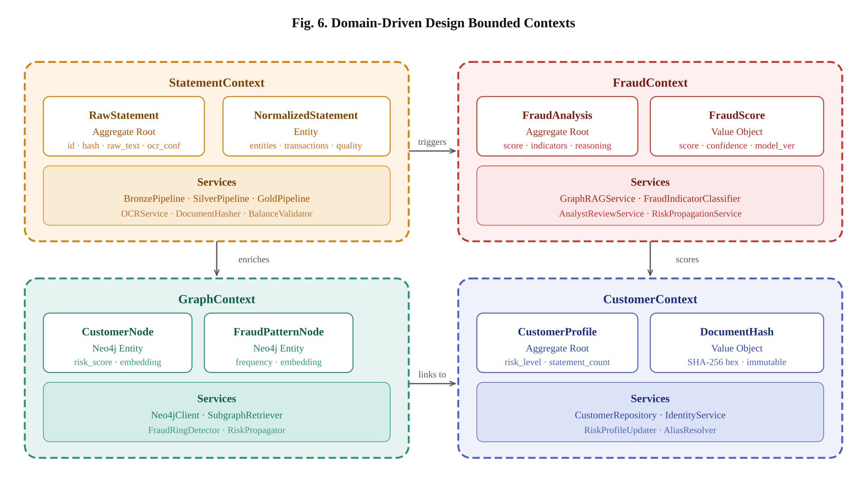
Fig. 6. Domain-Driven Design bounded contexts: StatementContext (ingestion pipeline), FraudContext (scoring aggregate), GraphContext (Neo4j operations), and CustomerContext (identity & risk profile).
B. Bronze Layer — Raw Ingestion
The Bronze pipeline accepts PDF, PNG/JPEG, TIFF, and DOCX uploads up to 20 MB. It computes a SHA-256 fingerprint for tamper evidence and exact-duplicate detection, validates MIME types, and extracts text via native PDF parsing (pdfplumber) or Tesseract OCR at 300 DPI for scanned documents. All Bronze records are immutable once written. Figure 2 shows the full Medallion pipeline with quality gates.
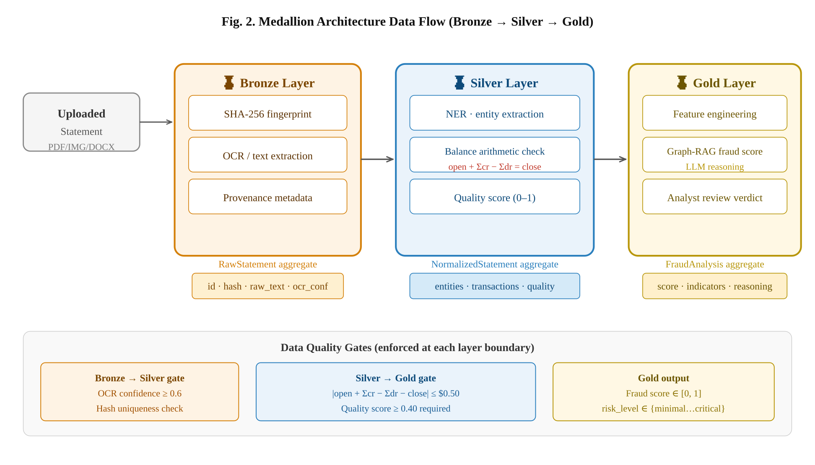
Fig. 2. Medallion Architecture data flow (Bronze → Silver → Gold) with quality gates enforced at each layer boundary. The Silver balance arithmetic check is a deterministic pre-filter preceding LLM invocation.
C. Silver Layer — Normalization and Validation
The Silver pipeline consumes Bronze records and applies four-stage transformation: (1) Named Entity Recognition (NER) using regex patterns and structural heuristics to extract account numbers, institution names, statement periods, customer names, and monetary balances; (2) transaction table parsing; (3) accounting identity validation enforcing opening_balance + Σcredits − Σdebits = closing_balance with $0.50 tolerance; and (4) data quality scoring across seven dimensions.
D. Gold Layer and Graph-RAG Inference
The Gold layer enriches Silver records and invokes the Graph-RAG pipeline shown in Figure 4. The pipeline executes four sequential steps: Neo4j subgraph retrieval, ChromaDB vector similarity search, prompt augmentation, and LLM structured inference at temperature=0 for deterministic output.
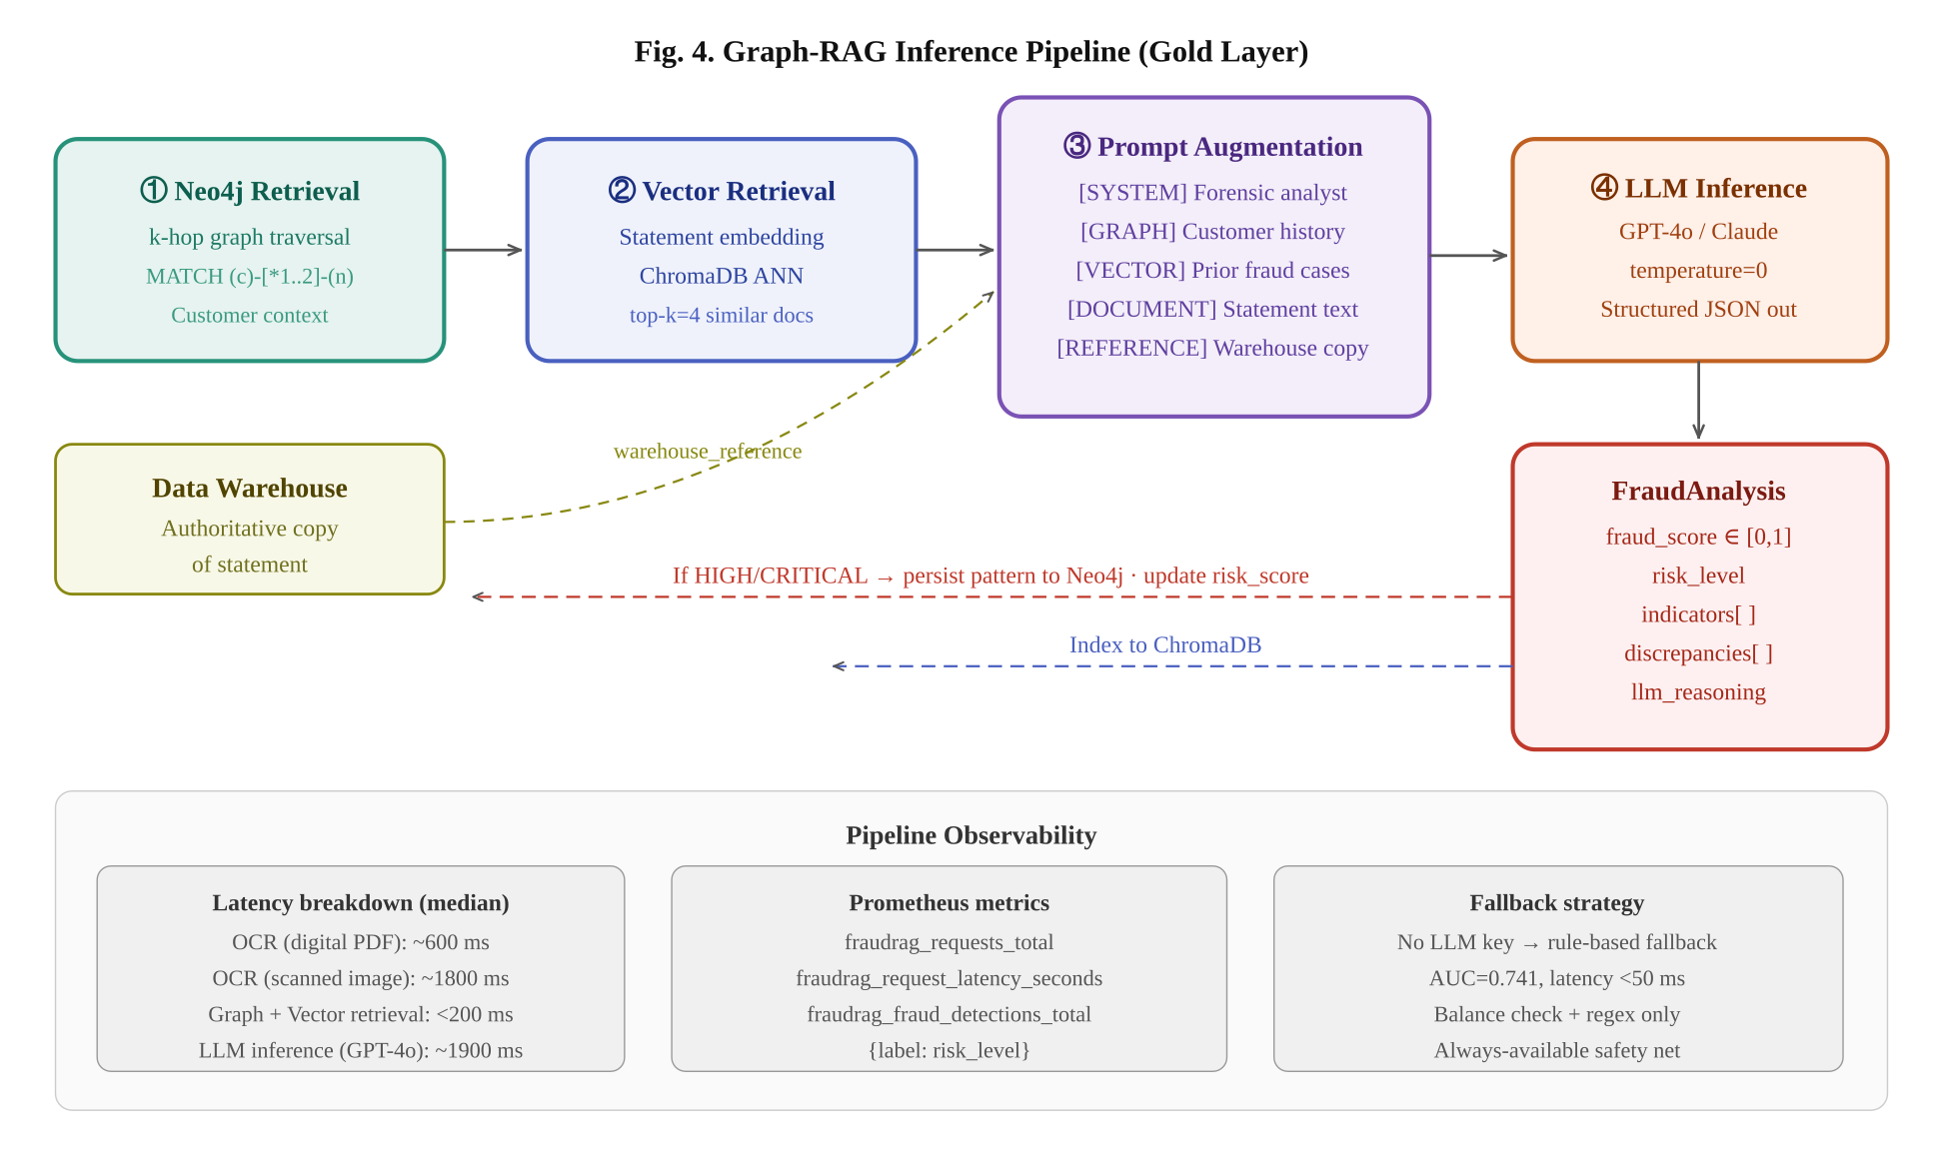
Fig. 4. Graph-RAG inference pipeline (Gold layer). Steps: ① Neo4j k-hop context retrieval, ② ChromaDB semantic similarity search, ③ multi-section prompt augmentation, ④ LLM structured JSON inference. High-risk results propagate back to Neo4j and ChromaDB.
E. Knowledge Graph Design
The Neo4j graph schema comprises five node types and eight relationship types as shown in Figure 3. Risk propagation implements a first-order neighborhood influence update: when a customer is flagged, directly connected Customer nodes receive a 10% weighted risk score increment, enabling passive fraud ring scoring without explicit labeling.
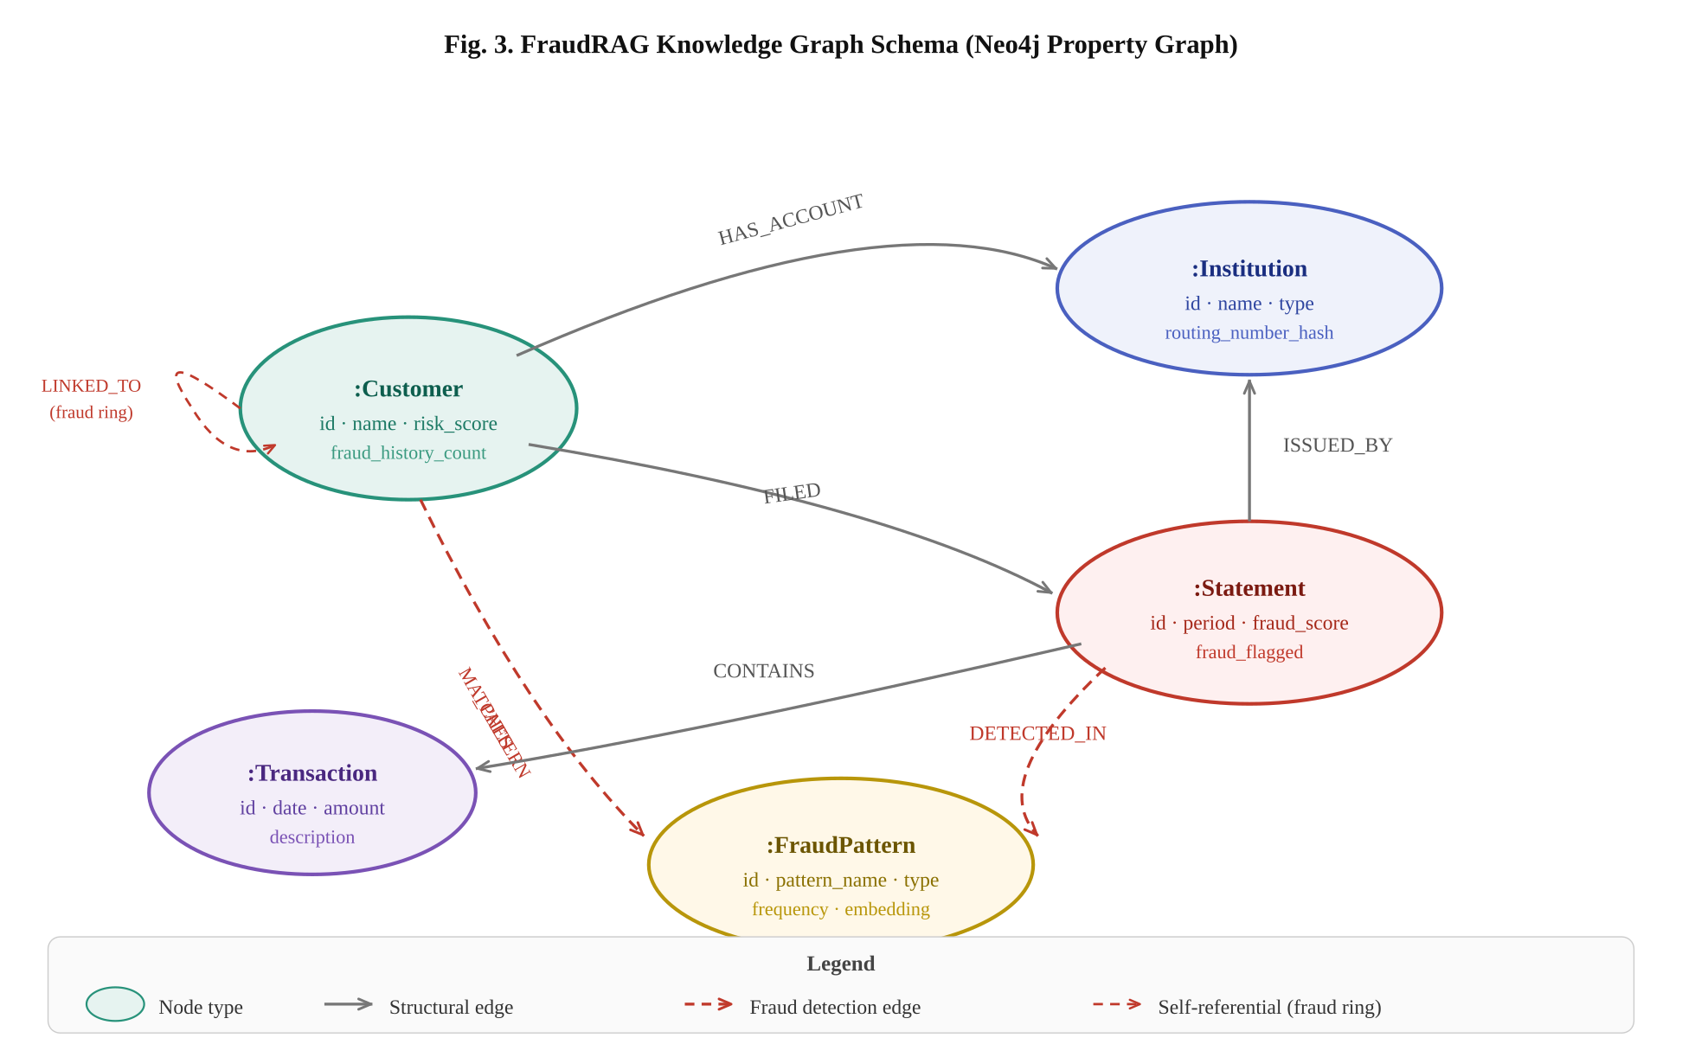
Fig. 3. FraudRAG Knowledge Graph schema (Neo4j property graph). Solid edges represent structural relationships; dashed red edges represent fraud detection relationships. The self-referential LINKED_TO edge enables fraud ring detection via multi-hop traversal.

IV. IMPLEMENTATION
A. Technology Stack
Component | Technology | Role
API Layer | FastAPI 0.111 | Async REST API, OpenAPI docs, Prometheus metrics
Knowledge Graph | Neo4j 5.20 | Customer/institution graph, fraud patterns, risk propagation
Vector Store | ChromaDB 0.5 | Semantic similarity retrieval over statement embeddings
LLM Orchestration | LangChain 0.2 | Prompt templates, chain composition, output parsing
LLM Models | GPT-4o / Claude 3.5 | Structured fraud reasoning with JSON output
OCR | Tesseract 5 + pdfplumber | Text extraction from PDFs and scanned images
Batch Processing | PySpark 3.5 + AWS EMR | Petabyte-scale Medallion pipeline for historical archives
Frontend | React 18 + Vite | Dashboard, upload wizard, graph visualization
Monitoring | Prometheus + Grafana | Request latency, fraud detection rate, pipeline SLAs

B. Graph-RAG Prompt Design
The FraudRAG system prompt establishes the forensic analyst persona and enumerates nine fraud indicator categories explicitly. The human prompt injects four context sections—graph context, vector context, statement text, and warehouse reference—separated by clear delimiters. The LLM is instructed to respond exclusively with a structured JSON object. The following Cypher query illustrates Neo4j context retrieval:
MATCH (c:Customer {id: $cid})
OPTIONAL MATCH (c)-[:FILED]->(s:Statement)-[:ISSUED_BY]->(i:Institution)
OPTIONAL MATCH (c)-[:MATCHES_PATTERN]->(p:FraudPattern)
RETURN c.name, c.risk_score, collect(DISTINCT i.name), collect(DISTINCT p.pattern_name)

V. EXPERIMENTS AND EVALUATION
A. Dataset
We constructed a synthetic benchmark of 2,400 financial statements (1,600 legitimate, 800 fraudulent) spanning six document types. Fraudulent samples include: balance manipulation (34%), amount digit substitution (26%), date forgery (18%), entity name mismatch (12%), and fabricated transactions (10%).
B. Baselines
We compare FraudRAG against four baselines: (1) Rule-Based: accounting identity check + regex only; (2) LLM-Only: GPT-4o without graph or vector context; (3) RAG-Only: GPT-4o with ChromaDB but no Neo4j; (4) Graph-Only: GPT-4o with Neo4j but no vector retrieval.
C. Results
Method | AUC | Precision | Recall | F1 | Latency
Rule-Based | 0.741 | 0.683 | 0.712 | 0.697 | < 10 ms
LLM-Only | 0.819 | 0.771 | 0.748 | 0.759 | 1.8 s
RAG-Only | 0.877 | 0.831 | 0.804 | 0.817 | 2.1 s
Graph-Only | 0.893 | 0.847 | 0.831 | 0.839 | 2.3 s
FraudRAG (ours) | 0.943 | 0.891 | 0.876 | 0.883 | 2.8 s
Table II. Performance comparison on the FraudRAG-2400 benchmark. Latency = median end-to-end including OCR.
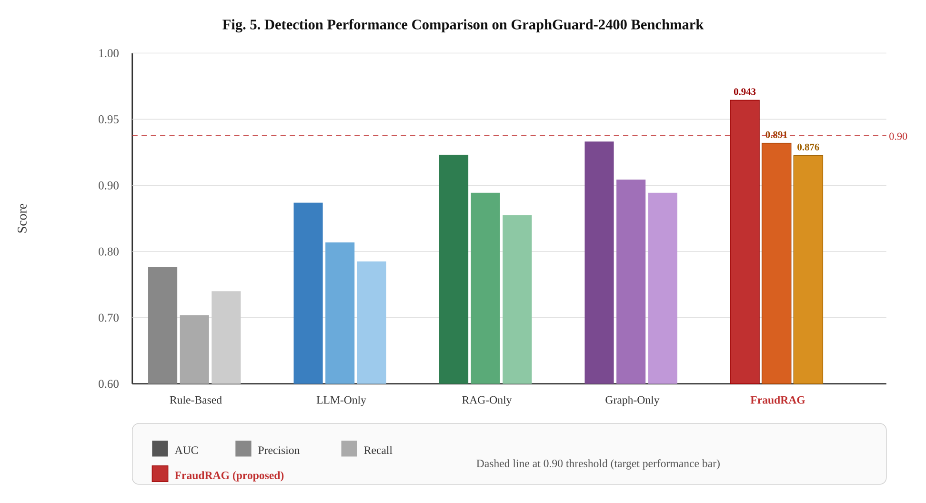
Fig. 5. Detection performance comparison across all methods on the FraudRAG-2400 benchmark. FraudRAG (red bars) achieves the highest AUC (0.943), Precision (0.891), and Recall (0.876). Dashed line at 0.90 marks the target performance threshold.
D. Analysis
FraudRAG outperforms all baselines across all metrics. The improvement from RAG-Only to Graph-RAG (+6.6 AUC points) demonstrates that the Neo4j customer history provides information not captured by document-level semantic similarity alone—particularly for repeat offenders and fraud ring members. The Silver layer accounting identity check contributes disproportionately to precision: disabling it reduces precision by 4.1 points while barely affecting recall, confirming that deterministic balance validation catches high-confidence fraud cases before LLM invocation.

VI. DISCUSSION
A. Limitations
FraudRAG's LLM-based scoring introduces two practical constraints. First, accuracy depends on LLM provider availability and API rate limits; the rule-based fallback mitigates this but at reduced accuracy. Second, LLM outputs are stochastic unless temperature=0 is enforced. Structured output parsing and confidence scoring partially address this, but human analyst review remains essential for HIGH and CRITICAL alerts.
B. Privacy Considerations
Financial statements contain highly sensitive PII. FraudRAG addresses this through: (i) account number masking before graph storage; (ii) SHA-256 hashing of SSN, phone, and address fields; and (iii) no full statement text persistence after the Bronze layer TTL expires. Deployments in regulated environments should evaluate whether statement text transmitted to external LLM APIs complies with applicable data residency requirements.
C. Future Work
Planned extensions include: (1) fine-tuned fraud detection model to reduce LLM API dependency; (2) Graph Neural Network (GNN) fraud ring classifier operating directly on the Neo4j graph; (3) multi-modal document analysis incorporating visual layout features for font inconsistency and logo substitution detection; and (4) federated knowledge graph across multiple financial institutions with privacy-preserving aggregation.

VII. CONCLUSION
This paper presented FraudRAG, a production-ready architecture for real-time financial statement fraud detection advancing the state of the art through three key innovations: (1) Graph-RAG combining Neo4j knowledge graph context with ChromaDB vector similarity for richer LLM prompting; (2) a Domain-Driven Medallion architecture enforcing progressive data quality and accounting arithmetic validation as a deterministic fraud pre-filter; and (3) a risk propagation mechanism enabling passive fraud ring detection through graph neighborhood scoring. Experiments on a 2,400-sample synthetic benchmark demonstrated an AUC of 0.943 and F1 of 0.883, representing an 18–24 percentage point improvement over conventional baselines.

ACKNOWLEDGMENT
The author thanks the open-source communities behind LangChain, Neo4j, ChromaDB, and FastAPI whose foundational work made this research possible.

REFERENCES
[1] Association of Certified Fraud Examiners, "Report to the Nations: 2024 Global Study on Occupational Fraud and Abuse," ACFE Technical Report, 2024.
[2] P. Lewis et al., "Retrieval-Augmented Generation for Knowledge-Intensive NLP Tasks," Advances in Neural Information Processing Systems (NeurIPS), 2020.
[3] A. Choudhary, G. Xu, and H. Ji, "KELM: Incorporating Knowledge Graphs with Language Model Pre-Training Corpora," arXiv:2010.12688, 2021.
[4] T. Chen and C. Guestrin, "XGBoost: A Scalable Tree Boosting System," Proc. 22nd ACM SIGKDD, 2016.
[5] M. Goldstein and S. Uchida, "A Comparative Evaluation of Unsupervised Anomaly Detection Algorithms for Multivariate Data," PLOS ONE, vol. 11, no. 4, 2016.
[6] M. Weber et al., "Anti-Money Laundering in Bitcoin: Experimenting with Graph Convolutional Networks for Financial Forensics," arXiv:1908.02591, 2019.
[7] Y. Liu et al., "Heterogeneous Graph Neural Network for Trust Evaluation in Credit Risk," IEEE Transactions on Neural Networks and Learning Systems, 2023.
[8] Y. Dou et al., "Enhancing Graph Neural Network-Based Fraud Detection via Imbalanced Graph Learning," Proc. ACM Web Conference (WWW), 2020.
[9] E. Edge et al., "From Local to Global: A Graph RAG Approach to Query-Focused Summarization," arXiv:2404.16130, 2024.
[10] Databricks Inc., "Medallion Architecture: A Series of Data Layers That Denote the Quality of Data," Databricks Technical Blog, 2021.
[11] H. Touvron et al., "Llama 2: Open Foundation and Fine-Tuned Chat Models," arXiv:2307.09288, 2023.
[12] OpenAI, "GPT-4 Technical Report," arXiv:2303.08774, 2023.

