Safe-Track

Software Requirements Specification

<V 0.1>

23rd September 2013

Table of Contents
- Introduction
  - Purpose
  - Scope
  - References
  - Overview
  - Definitions, Acronyms, and Abbreviations

- General description
  - Product Perspective
  - Product Functions
  - User characteristics
  - General Constrains
  - Assumption and Dependencies

- Specific Requirement
  - Safe-Track application background and options
    - Background Image and look
    - Start application
    - Setting
  - Setting
    - About Page
    - Activate application
    - Personalize setting
  - Personalize setting
    - Add contact list
    - Add SMS Text
    - Add Email-ID
    - Voice for Fake Call
    - MMS Alert
    - Send Audio Clip
    - Fake Call

- Data flow and Implementation guideline

- Revision History and Approval

Introduction
  - Purpose
This document is meant to be a provide design details for the development of the android application Safe-track. Intended readers are technical team who are going to implement the design.
  - Scope
Safe-track is an android application which is designed to help any android mobile user is at risk or danger. It should be a quick, single click/press SOS when you’re in danger. This will a GPS based safety alarm that sends SOS messages during emergencies to the mobile numbers you have previously chosen. Application should provide user to personalize their setting and use other features of application like sending email, fake call, security alarm etc.
  - References
-NA-
  - Overview
Document details the general description, specific requirement and data flow for application to be followed for Safe-track application.
  - Definitions, Acronyms, and Abbreviations
SOS: It is associated with phrases such as "Save Our Souls"
Safe-track: Brisa Android application
GPS: Global Positioning System
MMS: Multimedia Messaging Service
SMS: Short Messaging Service
BIP: Bluetooth Basic Image Profile
NDK: Native Software development Kit

General Description
  - Product Perspective
There are other SOS android applications available in market. These applications provide basic features, like sending SMS alert to selected contact, when you’re in danger. Safe-Track will have multiple advantages over other application based on features and options provided to the user. Safe-Track should have very unique option of receiving call from selected mobile number automatically (without having to press receive button), Capturing surrounding image or small clip and sending it to the list, blocking other numbers to avoid unwanted calls at critical time. It has security alarm which will work even when mobile is switched off. It also should provide facility to receive calls automatically from selected mobile numbers and block others at the same time to avoid calls from unwanted number in crucial time. Safe-tack also has a unique feature of sending images or MMS, taken from a spy cam, to selected contact list.
Apart from a button to start the application, Safe-Track application also have a option to start on pressing a hardware button defined number of times.
  - Product Functions
Following features has to be provided by product Safe-Track:
- SMS Alert with GPS location to selected contact
- Email
- MMS
- Receiving calls automatically and put on loudspeaker
- Blocking In coming calls from numbers other then selected contact
- Security Alarm
- Activating application using Hardware button on mobile phone
- Receive fake call
- Send Audio Clip
  - User characteristics
User should have option to personalize their setting for application. User will have flexibility to select contact number to be added, selecting MMS alert, receiving fake calls, and sending audio records to the selected contact list.
Application need not check the accuracy of mobile number and email-ID listed.
  - General Constrains
Safe-Track application’s response time, time taken to send SMS alert once app started, should be less then 4 seconds.
Implementation will be on Linux 4.2 or above.
Application implementation should be touch screen based.
  - Assumption and Dependencies
Application has following assumption:
- Mobile with Android support
- SIM card should have enough balance/facilities to send SMS, use GPS, send MMS
- Bluetooth option in mobile, Defined webcam(To be decided by BRISA) and BIP NDK (To be implemented by BRISA) to use MMS alert
- Audio recorder in mobile to use Send Audio Clip feature.

Specific Requirement
  - Safe-Track application background and option
This section details the first look of the Safe-Track application. This will decide on how application would look once it is installed and launched on mobile phone.
Once application is installed on mobile, Safe-Track icon should become visible under APPS option of mobile. Icon may look like below mentioned Figure 1. Implantation should provide flexibility to change icon image when required.

Figure 1 Safe-Track Application ICON
Figure 2 shows the application look on launching. It has two blocks: Background Image and Options. Image is the top part (Above HELP and Setting) of figure shown below. Options are the bottom part of figure 2, which provides 2 buttons to user: HELP and Setting.
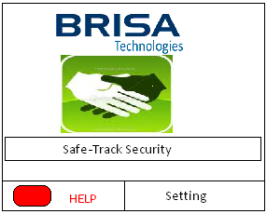
Figure 2 Safe-Track application on Launch
    - Background Image and look
Above Figure shows the on launch look of application, it will have an image as background. Application should be implemented in such a way that changing image should be an easy task.

    - Options
There are two option provided to user on application launching.
HELP button is single click option to user to trigger or start the application. There should be another hardware way to start the application, where if any hardware button is pressed defined number of times, application should start.
Setting button will provide a page with 3 options as “About Page”, “Activate App” checkbox, and “Personalize Setting” page.

  - Setting
On clicking or selecting Setting button on launch page, application will provide 2 buttons for About and Personalize Setting and a checkbox to activate the application, which are shown in figure 3 below.

Color, Font size and page size is symbolic for all Figure which can be discussed while implementation or changed at later point of time.
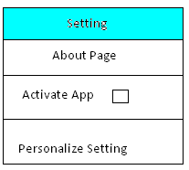
Figure 3 Safe-Track Launch->Setting
    - About
About page should give details on what is the application, why and where is it used and how to use it.
Figure 4 below shows the image which should appear on selecting Safe-Track Launch->Setting->about. Image and text used for about page can be modified at later point of implementation phase.

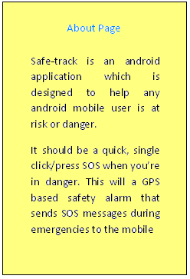
Figure 4 About Page (Safe-Track Launch->Setting->About)
    - Activate App
Activate App will provide a checkbox; selecting it will activate the application. As shown in Figure 3. This checkbox has to be selected to start the application at point of time.

    - Personalize setting
User can personalize their setting using Safe-Track Launch->Setting->Personalize setting. It has multiple buttons and checkbox to select options like adding mobile number for SMS, adding text for SMS, adding email-ID, activate MMS alert etc. It is shown in figure mentioned below:

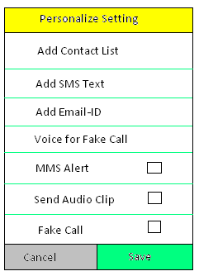
Figure 5 Personalize Setting (Safe-Track Launch->Setting->Personalize Setting)

  - Personalize setting options
    - Add contact list
Add contact list button provides flexibility to user to list the mobile numbers. If one is at risk or danger and started the Safe-Track Application, SMS alert with location and MMS (optional) will be sent to these selected numbers. Maximum number of mobile number which can be added is 5.

User should have option to add mobile number through browsing their existing contact list (Browse button in figure 6) and using keypad (Add button in figure 6).
There should be an option to delete mobile number from existing list (Cross button next to number shown in Figure 6)

If Contact list of Safe-Track application is empty and User choose to activate application using Safe-Track->Setting->Activate App, it should not activate app with message saying “Contact list is Empty, Please add at least contact number to the list”.

Figure mentioned below shows the user options to add mobile numbers:

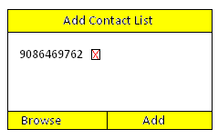
Figure 6 Add Contact List
(Safe-Track Launch-> Setting->Personalize Setting->Add Contact List
    - Add SMS text
SMS content has to be defined by user, which will be sent to previously listed numbers along with current GPS location, when App started. Same SMS text will be used for Email alert.
As shown in below figure, application should provide user to give the text content for SMS/Email:

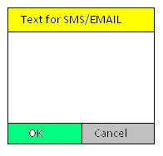
Figure 7 Add SMS text
(Safe-Track Launch-> Setting->Personalize Setting->Add SMS Text)
    - Add Email-ID
Add Email-ID button provides flexibility to user to list the email-id. This email-ID will receive email alert once Safe-Track application is started on mobile. Maximum number of email-id which can be added is 2.
Apart from the email-id where email alert will be received, User will also have to give details for one email-id which will be used to send Email alert as shown in figure below:

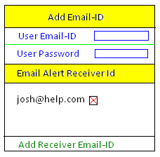
Figure 8 Add Email-ID
(Safe-Track Launch-> Setting->Personalize Setting->Add Email-ID)

    - Voice for Fake Call
Voice for Fake Call button should provide option to browse and select the sound to use for Fake call from mobile or SD card.

    - MMS alert
MMS alert is a checkbox which can be selected if user has Bluetooth webcam and BIP implementation on their mobile. It is an optional feature provided to user.

    - Send Audio Clip
Send Audio Clip checkbox gives an option to record the message from user and send it to contact list once Safe-Track is started.

    - Fake Call
Fake Call checkbox provides a feature to get a fake prerecorded (Safe-Track Launch-> Setting->Personalize Setting->Voice for Fake Call) call from a fixed number, which will be answered automatically and put on loudspeaker to scare one who wants to harm the user.

Data flow and Implementation guideline
Application data flow is detailed as following steps below:
- Step1: User starts the application Safe-Track using Safe-Track Launch->Help button or pressing mobile home button 4 times (It can be customized).
- Step2: Check whether Safe-Track Launch->Setting->Activate App is selected or not? If it is not selected application will not start, if it is activated it should go to step3.
- Step3: Send SMS alert to listed numbers with SMS text (Safe-Track Launch->Setting->Personalize setting->Add SMS Text) and current GPS location.
Block all incoming calls other then listed numbers.
If MMS Alert (Safe-Track Launch->Setting->Personalize setting->MMS Alert) is activated then webcam should capture image for 5 seconds.
- Step4: Send Email alert with SMS text(Safe-Track Launch->Setting->Personalize setting->Add SMS Text) and GPS location
Step3 and Step4 should be handled by 2 different threads since both events are independent of each other. And failing one event should not have impact on other events.
- Step5: If MMS Alert is selected (Safe-Track Launch->Setting->Personalize setting->MMS Alert), send captured image (Step3) to listed numbers.
- Step6: If Fake call is activated (Safe-Track Launch->Setting->Personalize setting->Fake call), receive a prerecorded fake call and put it on loudspeaker.
- Step7: If Send Audio Clip is activated (Safe-Track Launch->Setting->Personalize setting->Send Audio Clip), give a signal to user to record their message for 15 seconds and send it to listed numbers.
Step5, Step6 and Step7 should be handled by different threads since these events are independent of each other. And failing one event should not have impact on other events.
- Step8: Activate security alarm and use highest volume. It should work even if mobile is switched off.
Note : At any point of time after step3, if user receive a call from listed number, it should be attended automatically without having user to receive and put it on loudspeaker using highest volume phone provides.
Application can be turned-off when home button is pressed 4 times or Help button is pressed. This will activate all in-coming call once again.

Revision History and Approval

Date | Version | Author | Change Details | Approval
25th September 2013 | V 0.1 | Dolly Kumari | Initial draft version

