**Learners have to come up with a Report to support the answers to the following questions and suggestions**

Objective Questions

1. List the different dtypes of columns in table “ball_by_ball” (using information schema)

**Ans : There are total 10 columns in table ball_by_ball.**

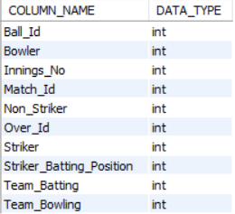

Query:

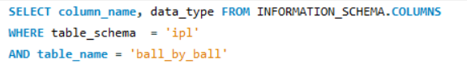

1. What is the total number of run scored in 1st season by RCB (bonus : also include the extra runs using the extra runs table)

**Ans : The total runs scored by RCB team in 1st season is 1983.**



Query:

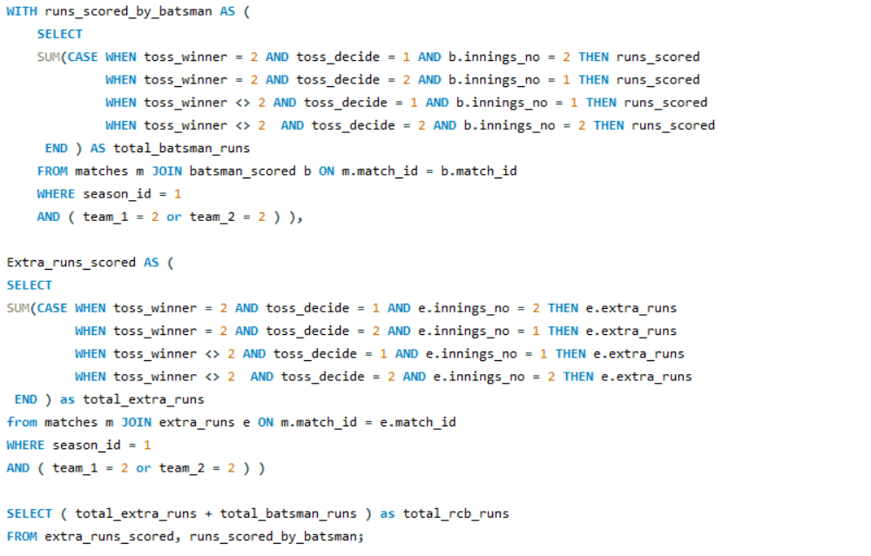

1. How many players were more than age of 25 during season 2 ?

**Ans : There were total 194 players who more more than 25 yrs of age during second season**



Query :

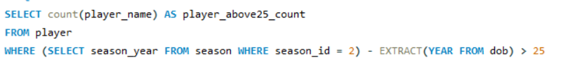

1. How many matches did RCB win in season 1 ?

**Ans : RCB won 4 matches during the 1st 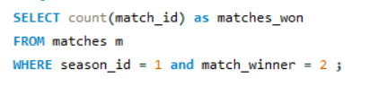season.**

Query :

1. List top 10 players according to their strike rate in last 4 seasons

**Ans : Below is the list of top 10 players according to their strike rate.**

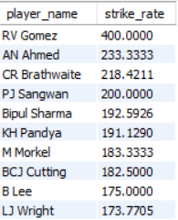

Query :

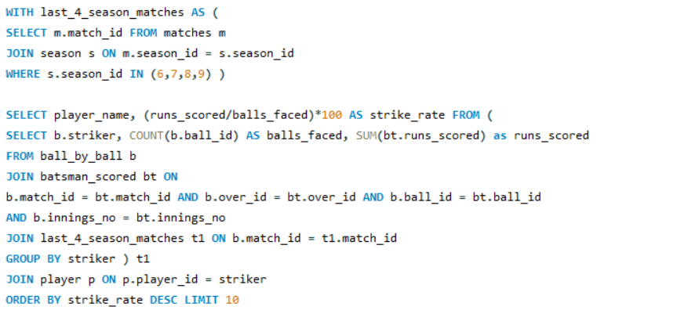

1. What is the average runs scored by each batsman considering all the seasons?

**Ans: The below query was used to get the average runs scored by each batsman across all seasons.**

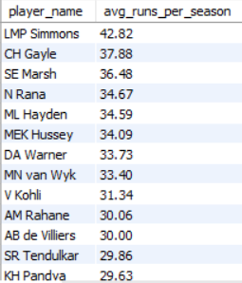

Query:

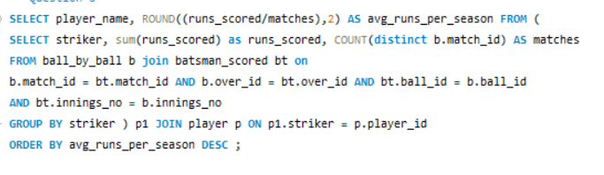

1. What are the average wickets taken by each bowler considering all the seasons?

**Ans: The below query was used to get the bowling averages of each bowler across all seasons.**

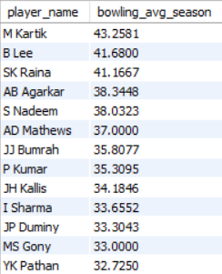

Query:

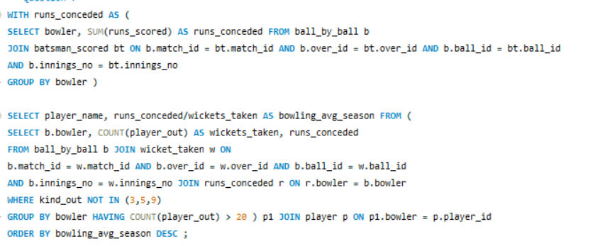

1. List all the players who have average runs scored greater than overall average and who have taken wickets greater than overall average

**Ans: There are total 22 players with average runs scored greater than overall average and average wickets taken greater than overall average wickets.**

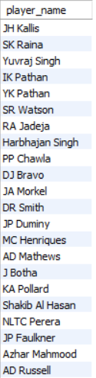

1. Create a table rcb_record table that shows wins and losses of RCB in an individual venue.

Ans:

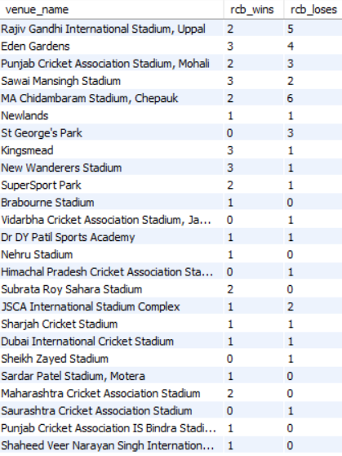

Query :

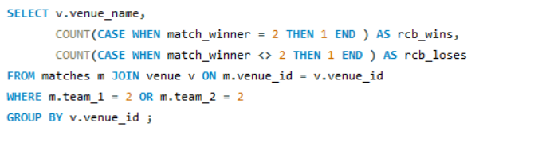

1. What is the impact of bowling style on wickets taken.

**Ans : Right arm medium bowlers have taken the most number of wickets in the past seasons.**

**Batsman are likely to mistime the balls leading to their dismissal.**

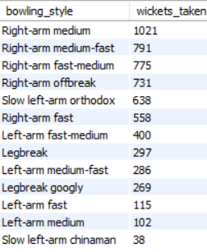

Query:

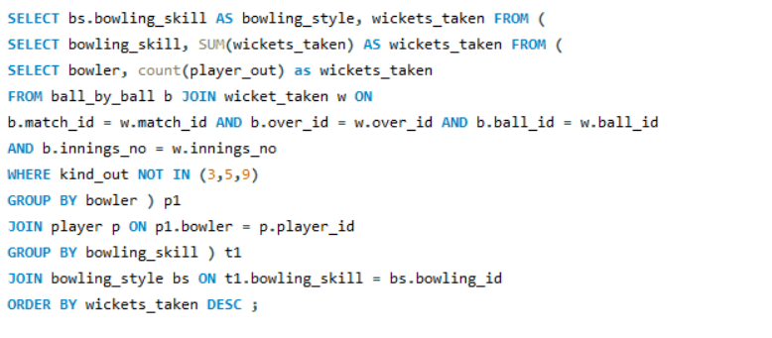

1. Write the sql query to provide a status of whether the performance of the team better than the previous year performance on the basis of number of runs scored by the team in the season and number of wickets taken

**Ans : To answer this question we needed to find the total runs scored by team and total wickets taken by team per season, then applying the LAG() function to calculate previous year performance and then applied CASE statements to derive the performance status.**

**Batting Performance**

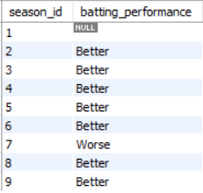

**Bowling Performance**

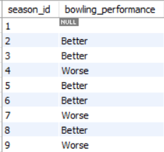

1. Can you derive more KPIs for the team strategy if possible?

**Ans :**

* **Yes the team can look for players who have better strike rate in the last two seasons.( minimum 200 balls faced ).**

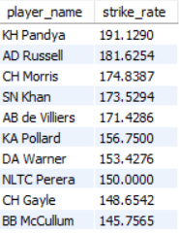

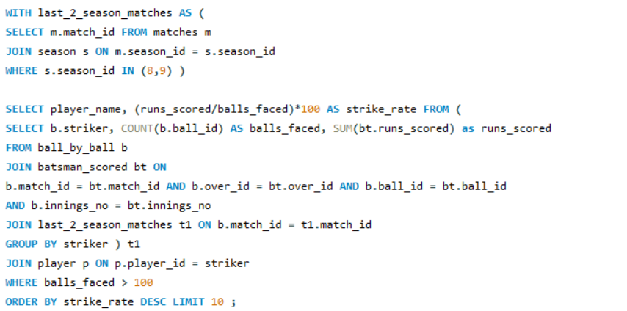

* **The team can also look for bowlers who have taken more wickets in death overs which will help then concede less number of runs.**

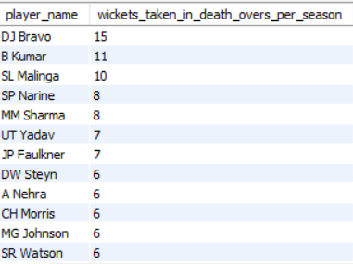

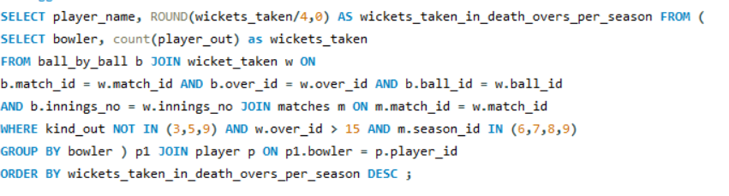

* **The team can also go for players who are more capable of hitting boundaries.**

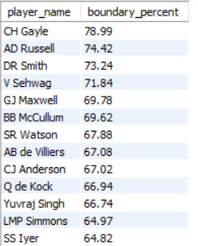

1. Using SQL, write a query to find out average wickets taken by each bowler in each venue. Also rank the gender according to the average value.

**Ans: The average wickets taken by each bowler in each venue along with their rankings.**

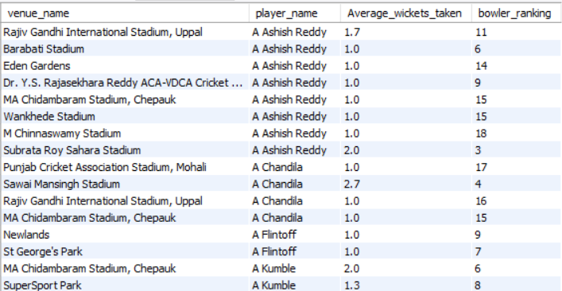

**Query:**

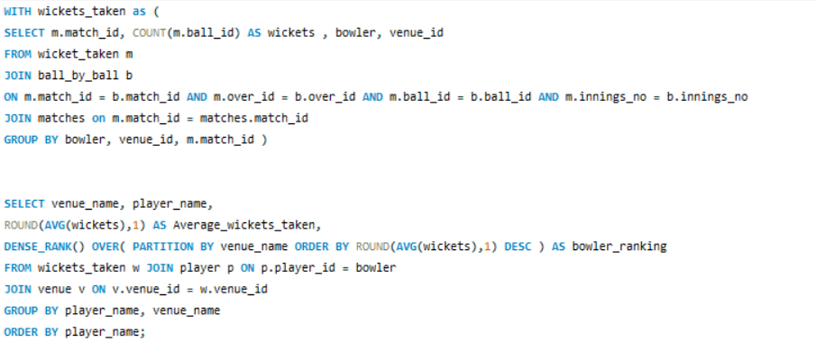

1. Which of the given players have consistently performed well in past seasons? (will you use any visualisation to solve the problem)

Ans :

**Below are the list of players who have performed well in last three seasons:**

**Batsman:**

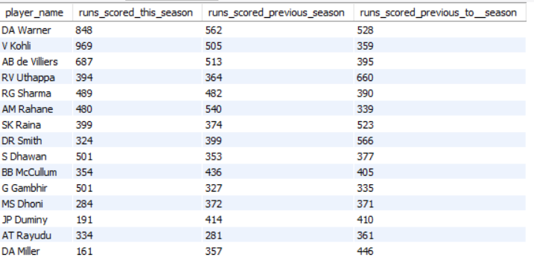

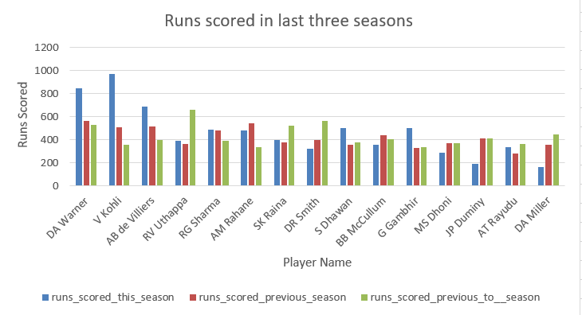

**Bowling:**

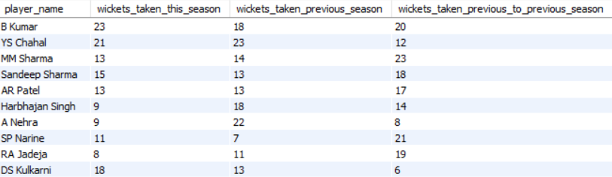

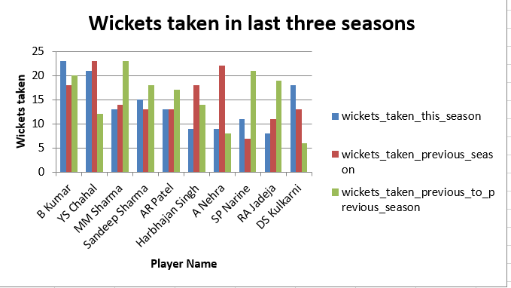

**To solve this problem a bar chart can be used to visualize past performances.**

**Query : Mentioned in the SQL file.**

1. Are there players whose performance is more suited to specific venues or conditions? (how would you present this using charts?)

**Ans: Yes for some players the performance is more suited to specific venues.**

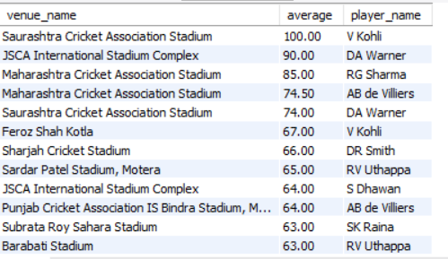

**Clearly from the above result it is visible that certain players are more likely to score big runs on certain venues.**

**A bar chart can be used to visualize this with a filter on venues and players to allow visualization venue by venue**.

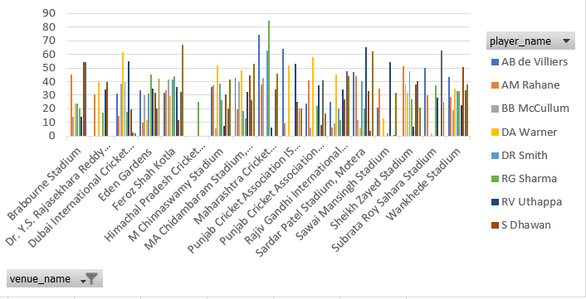

**Query :** 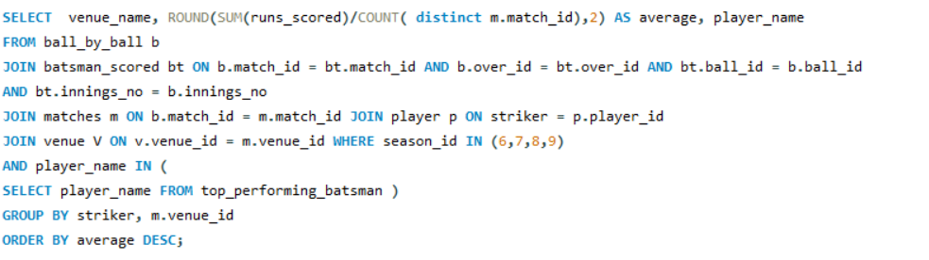

Subjective Questions

1. How does toss decision have affected the result of the match ? (which visualisations could be used to better present your answer) And is the impact limited to only specific venues?

**Ans: In all the matches played the team winning the toss and deciding to field has won most number of matches which is clearly visible in the below chart.**

**Pie chart can be used for better visualizations.** 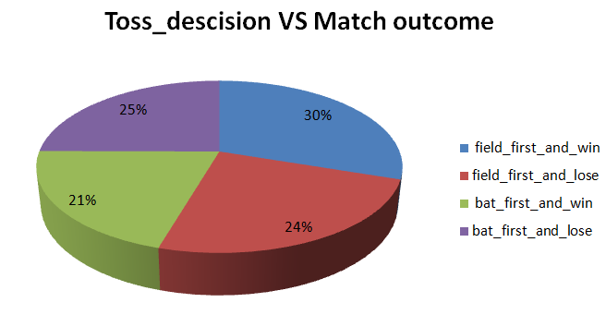

**Also there are few venues such as Wankhede Stadium and Newlands where winning the toss and fielding first has resulted to more number of matches being lost.**

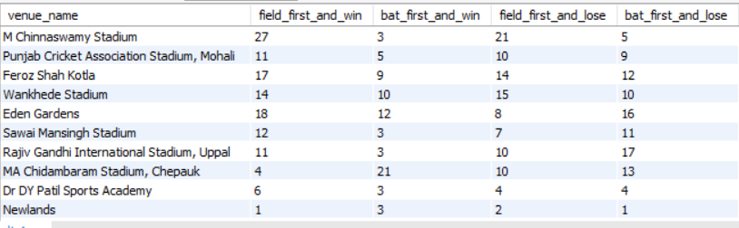

Query : 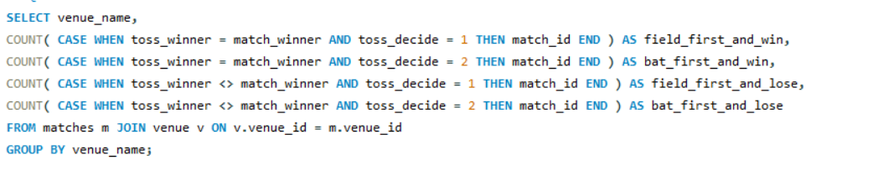

1. Suggest some of the players who would be best fit for the team?

**Ans: The team can look for some power hitters with good strike rate in previous seasons because these players can hit more runs without conceding much balls which will help team to score more numbers of runs and give their bowlers more runs to defend.**

**Also player who is able to score fast will put more pressure on the opposition.**

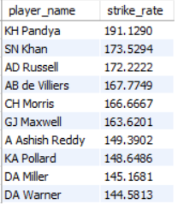

**Query :**

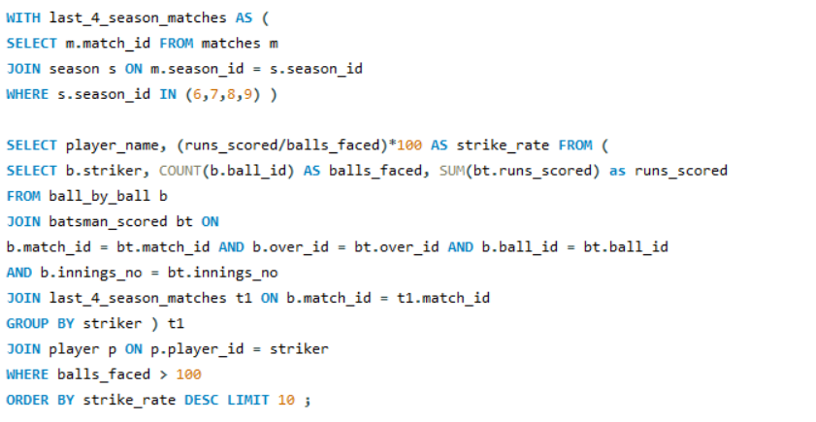

**Also players who have taken most wickets in the death overs.**

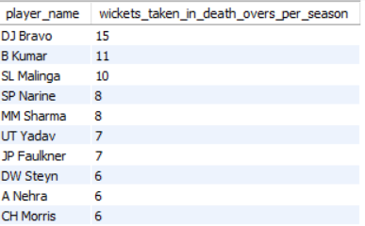

Query : 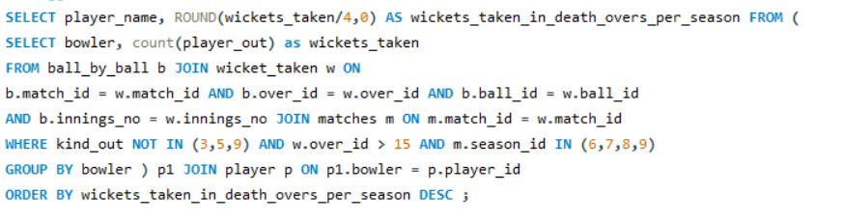

1. What are some of parameters that should be focused while selecting the players?

**Ans: While selecting players the focus should be on the below parameters:**

* **The past performance** – The past performance will play a major role while picking players and creating the best possible team, as player is more likely to do well if he has been consistently performing.
* Below is the list of players who have performed well in the past seasons. 
* **Experience** – Domestic and international experience is very much important as having experience means that a player can handle pressure and keep calm in pressure situations which eventually decides the outcome of the match. 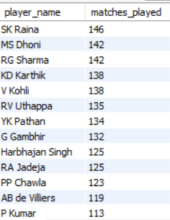
* **The batting/bowling average and the strike rates** – Having good batting and bowling means that the player lead the team, and consistently score runs or take wickets.
  + **Batting average**



* + **Bowling average**



* + **Strike rates**



* **Boundary hitting capability –** Since T20 cricket is a fast paced game, hitting boundaries at regular intervals is a very important factor.



* **Age** – Young talents can be groomed into future stars.

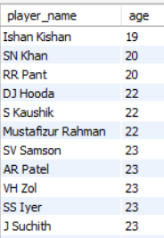

* **Team composition** – Selecting players according to the team requirement so as to make the team balanced.

**Queries are mentioned in the SQL file.**

1. Which players offer versatility in their skills and can contribute effectively with both bat and ball?

**Ans: The players who have scored more runs than the average runs scored and taken more wickets than the average wickets taken in last four seasons can contribute effectively with both bat and the ball.**

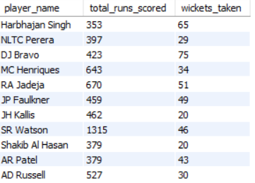

Query :

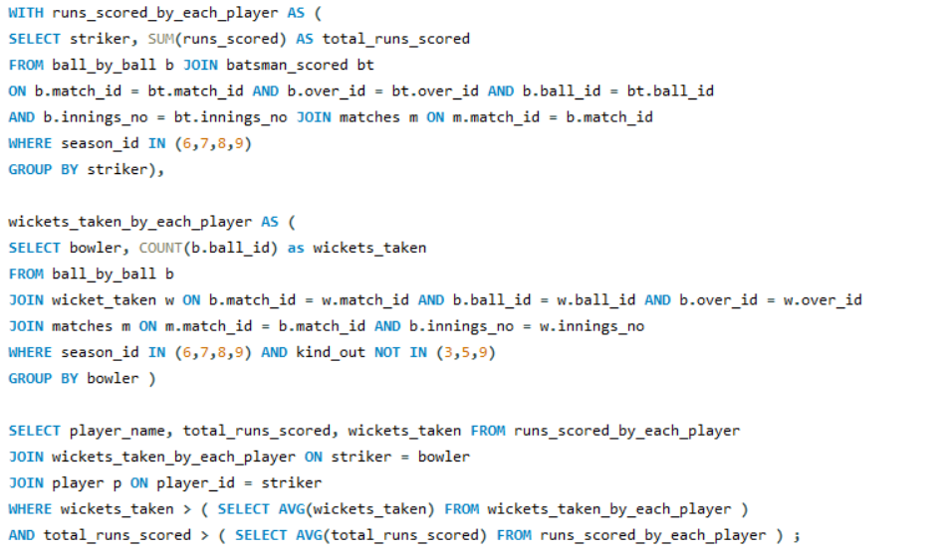

1. Are there players whose presence positively influences the morale and performance of the team? (justify your answer using visualisation)

**Ans: Yes there are players whose presence positively influence the morale and performance of the team.**

**Since this is aT20 league, hitting boundaries in more important and players who are capable of hitting boundaries boost the morale and performance of the team.**

**Below are the list of players who are capable of hitting boundaries and score most of their runs in boundaries**.

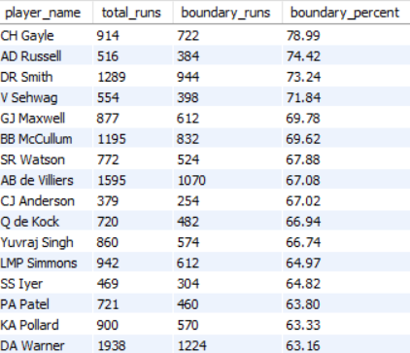

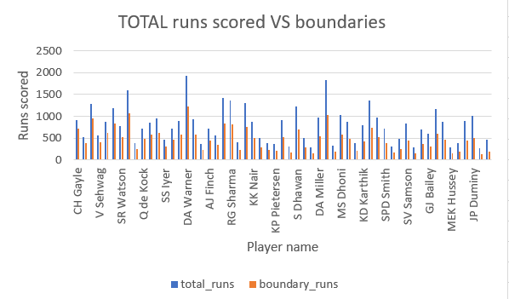

**Query:**

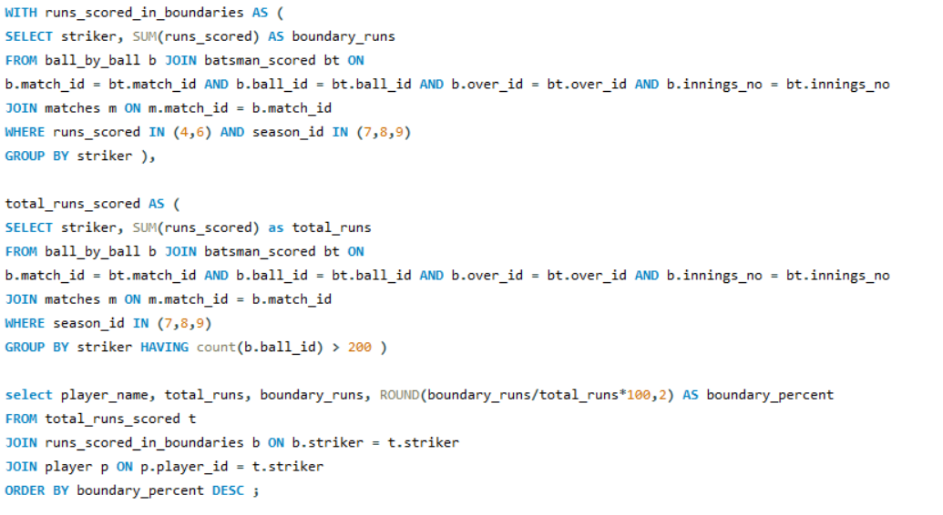

1. What would you suggest to RCB before going to mega auction ?

**Ans:**

* **The batting performance of RCB team over the years is good, but there bowling lacks, so I would suggest the team management to invest in right arm medium bowlers are they have taken the most number of wickets.**
* **Team should invest in some good death bowlers.**
* **Also the team can go for slow left arm bowlers.**
* **Apart from this the team should look to get some good allrounders and power hitters which give boost to the batting innings in the end overs.**
* **The team management should consider all the above points and create a balanced team.**

1. What do you think could be the factors contributing to the high-scoring matches and the impact on viewership and team strategies.

**Ans: The factors contributing to high scoring matches and impact on viewership are :**

* **The runs scored and wickets taken in powerplay overs and death overs will directly affect the viewership and the team strategies.**
  + **Runs scored in powerplay VS runs scored in middle overs**

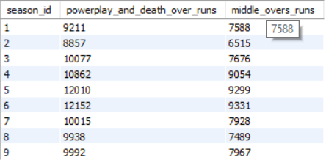

* + **Wickets taken in powerplay vs wickets taken in middle overs**

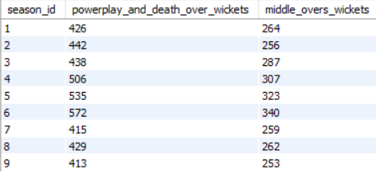

**Query : Mentioned in SQL file**

* **The playing conditions also affects the team strategies.**
* **The player form contributes to high scoring matches.**
* **Pitch conditions** 
  + **Flat pitches with little movements for bowlers favor batsman. Resulting in high scoring matches.**
  + **Hard and dry pitches without much seam or spin allows batsman to play more freely.**
* **Ground dimensions** 
  + **Smaller grounds and shorter boundaries make it easier to hit big shorts and boundaries, leading to high scoring.**
* **Weather conditions**
  + **Clear sunny weather is favorable for batsman, while overcast conditions favors the bowlers especially swing bowling.**
  + **Dew during matches can make the bowl harder for bowlers to grip, favoring the batting team.**
* **Field restrictions**
  + **Powerplay restrictions and shorter boundaries encourage aggressive batting resulting in high scoring matches.**
* **Star players**
  + **Matches featuring star players attract more viewers due to their global popularity and directly affect the viewership.**
* **Team popularity and rivalries**
  + **Historic and high stakes rivalries drive huge viewership.**
  + **Popular team with huge fan base tend to draw more viewers.**
* **Time zones and schedule**
  + **Matches scheduled during prime viewing hours or on holidays lead to higher viewership.**

1. Analyze the impact of home ground advantage on team performance and identify strategies to maximize this advantage for RCB.

**Ans : RCB has a better win percentage at home as compared to away matches.**



Query : 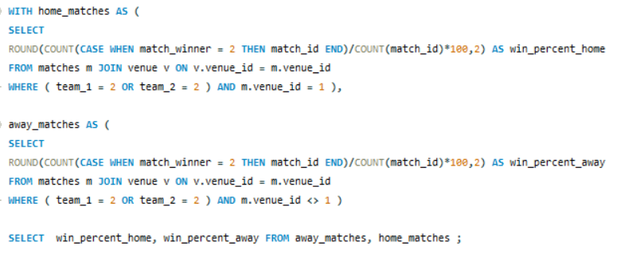

**Each team will be playing 50% of their matches at home and if we see the past performances out of 8 seasons in 4 seasons RCB has conceded more runs than they have scored, so they need to invest in good bowling options as the batsman are performing well if we see the last three seasons performances.**

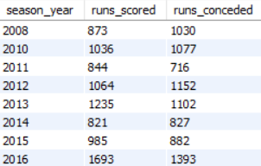

**Query :** 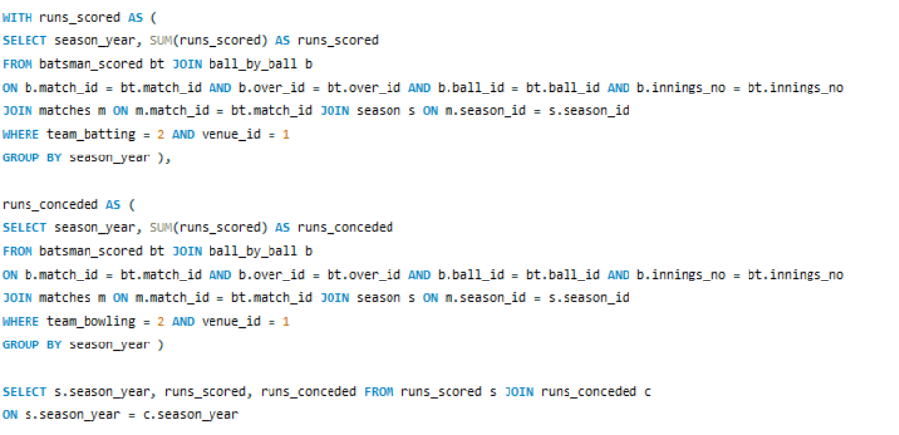

1. Come up with a visual and analytical analysis with the RCB past seasons performance and potential reasons for them not winning a trophy.

**Ans :**

**If we consider RCB past performances the main reasons why they are not wining is**

* **Lack of good bowling options.**
  + **It is clearly visible that the batsman have done extremely well in the last three seasons but their bowlers have let them down.**
  + **Also they are taking less number of wickets in the powerplay and in the death overs as compared to other teams.**

**Below is the overall runs conceded vs runs scored the the RCB team:**

**Clearly the bowlers are leaking out runs.**

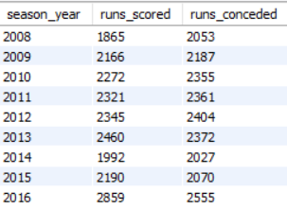

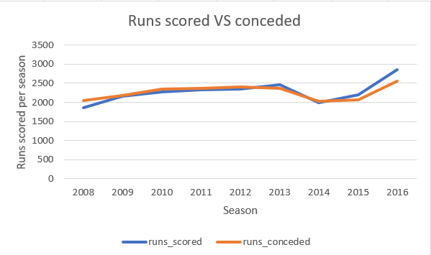

**Query : Mentioned in the SQL file**

* **Lack of team balance**
  + **Over reliable on star players: Team has often relied on star players like Virat Kohli, AB Devilliers, Chris Gayle. While these players have performed well the team overall balance was often lacking.**
  + **Weak bowling attack: The team has a strong batting lineup but lack quality bowlers and match winning spinners. Team with more balanced squads are more successful over the years.**
* **Inconsistent performances**
  + **Choking in big matches: Team has reached final on multiple occasions but failed to perform on decisive matches. This shows the inability to manage pressure.**
  + **Individual brilliance, collective failure: Despite having top class individual players the team has struggled to maintain consistency as a team across seasons. This inconsistency has often led to poor results.**
* **Psychological pressure**
  + **Heavy expectations: Team has one of the highest fan bases in the IPL, which puts immense pressure on the team. The weight of expectations from fans, media adds additional pressure.**
  + **Playoffs pressure: Team has often struggled in knockout matches, where the pressure is at its peak.**

1. How would you approach this problem, if the objective and subjective questions weren't given?

**Ans:**

* **If objective and subjective questions were not given I would have tried to achieve a balanced team with a mix of allrounders, batsman, bowlers with major focus on death bowling as RCB has conceded a lot of runs in the death overs.**
* **Also, I would have tried to visualize the past performances of players, their recent forms, their runs scoring and wicket taking capability in powerplay overs, middle overs and death overs to come up with a suitable plan.**
* **I would also focus on players who would perform with both bat and the ball to give an extra edge over others.**
* **Since this is T20 league I would also have focused on players who are capable of hitting boundaries.**
* **At last I would also come up with a plan to filter players according to their role and consistency.**

1. In the "Match" table, some entries in the "Opponent_Team" column are incorrectly spelled as "Delhi_Capitals" instead of "Delhi_Daredevils". Write an SQL query to replace all occurrences of "Delhi_Capitals" with "Delhi_Daredevils".

**Ans : To replace all the occurrences of ‘Delhi_Capitals’ with ‘Delhi_Daredevils’ we can use a update query as below.**

