Supplementary Material

**Varying impacts of logging frequency on tree communities and carbon storage across evergreen and deciduous tropical forests in the Andaman Islands, India**

**­­**Akshay Surendra,Anand M. Osuri, Jayashree Ratnam

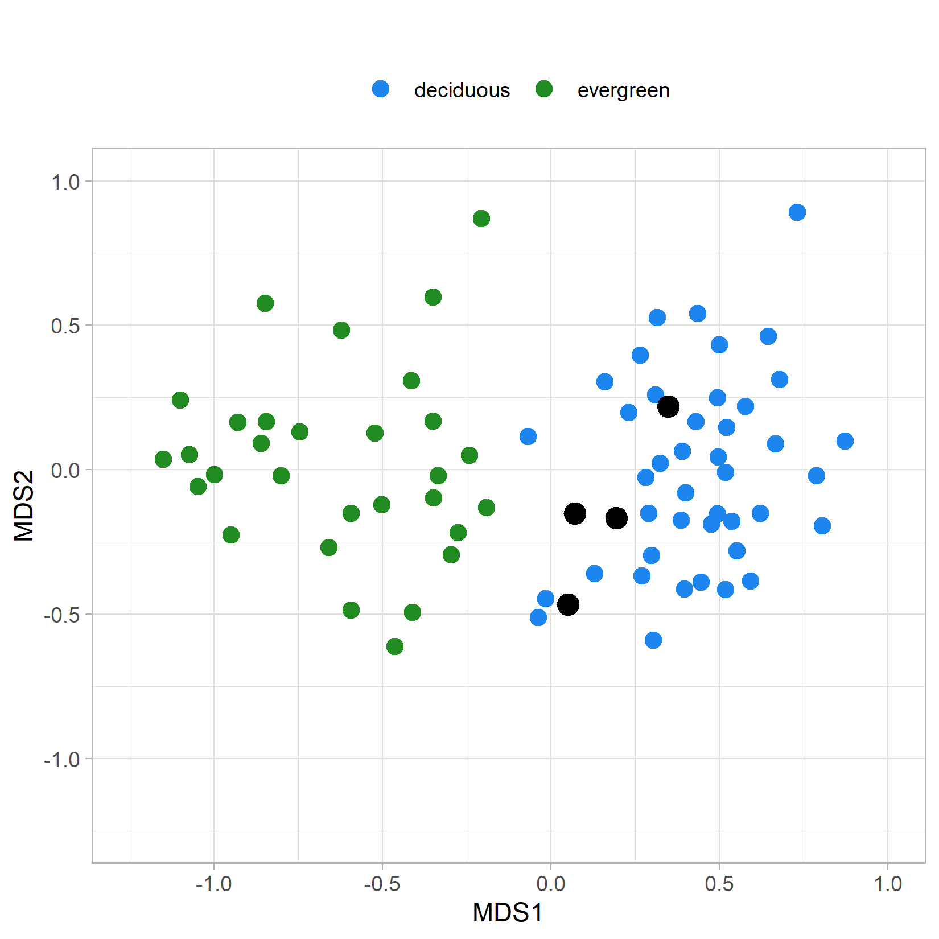

*Figure S1: This Non-metric Multidimensional scaling (NMDS) plot shows the adult tree community (GBH ≥ 30cm) of each plot as points in transformed 2-D space, where plots close to each other are more similar in species composition than plots further apart. Plots were identified as evergreen (green and black) or deciduous (blue) in the field. k-mean clustering (k=2) on the Bray-Curtis distance between plots revealed that 4 plots classified as evergreen in the field were more closely associated with the deciduous cluster (points in black, within-cluster SS / total SS = 14.7%). These four plots were not used in all subsequent analyses.*

|  |  |  |  |  |  |  |  |  |  |  |  |  |  |  |
| --- | --- | --- | --- | --- | --- | --- | --- | --- | --- | --- | --- | --- | --- | --- |
| No | Family | Species | Pole-sized trees per 0.01ha (10cm ≤ GBH < 30cm) | | | | | | Adult-sized trees per 0.05 ha (GBH ≥ 30cm) | | | | | |
| Deciduous patches | | | Evergreen patches | | | Deciduous patches | | | Evergreen patches | | |
| L2 | L1 | B | L2 | L1 | B | L2 | L1 | B | L2 | L1 | B |
|  | **Species that appeared as both pole-sized and adult-sized trees only** | | | | | | | | | | | | | |
| 1 | Euphorbiaceae | *Cleidion*  *nitidum* | 2.1 | 2.5 | 38.3 |  | 0.5 | 1.3 | 0.3 | 0.9 | 2.3 |  |  |  |
| 2 | Dipterocarpaceae | *Dipterocarpus* sp. |  |  |  | 0.7 | 0.5 | 2.5 | 0.1 |  | 0.1 | 8.7 | 7.5 | 6.1 |
| 3 | Putranjivaceae | *Drypetes longifolia* |  |  |  | 1.4 | 0.9 | 1.7 | 0.1 |  |  | 2.7 | 0.5 | 2.0 |
| 4 | Myristicaceae | *Knema andamanica* |  |  |  |  | 0.5 | 4.2 |  |  |  | 4.0 | 3.1 | 4.6 |
| 5 | Lythraceae | *Lagerstroemia hypoleuca* | 2.9 |  |  | 0.7 |  | 0.4 | 6.0 | 2.7 | 1.2 | 0.9 | 1.4 | 0.6 |
| 6 | Malvaceae | *Pterygota*  *alata* |  |  |  | 2.1 | 0.9 | 0.8 | 0.2 | 0.9 |  | 0.3 | 1.3 | 0.6 |
| 7 | Annonaceae | *Sageraea elliptica* | 1.7 | 11.1 | 0.4 |  | 1.4 |  | 1.3 | 1.5 | 1.0 |  | 0.6 |  |
| 8 | Euphorbiaceae | *Suregada multiflora* | 3.8 | 5.6 | 2.9 | 1.4 | 0.5 |  | 0.2 | 2.9 | 0.1 |  | 0.9 |  |
|  | **Species that appeared as pole-sized trees only** | | | | | | | | | | | | | |
| 1 | Phyllanthaceae | *Actephila excelsa* |  |  |  |  |  | 2.5 |  |  |  |  |  |  |
| 2 | Rubiaceae | *Aidia cochinchinensis* | 2.9 | 2.5 | 2.1 |  |  | 0.8 |  |  |  |  |  |  |
| 3 | Phyllanthaceae | *Cleistanthus myrianthus* |  |  |  | 0.7 | 0.5 | 1.7 |  |  |  |  |  |  |
| 4 | Ebenaceae | *Diospyros andamanica* |  |  |  | 2.9 | 2.7 | 0.8 |  |  |  |  |  |  |
| 5 | Ebenaceae | *Diospyros pyrrhocarpa* | 0.4 | 1.1 | 1.3 | 0.7 | 1.8 | 0.8 |  |  |  |  |  |  |
| 6 | Ebenaceae | *Diospyros undulata* | 8.3 | 5.6 | 1.7 | 2.9 | 3.2 | 0.4 |  |  |  |  |  |  |
| 7 | Gentianaceae | *Fagraea racemosa* |  |  |  |  |  | 2.9 |  |  |  |  |  |  |
| 8 | Moraceae | *Ficus hispida* | 0.4 | 0.3 |  |  | 1.4 |  |  |  |  |  |  |  |
| 9 | Myristicaceae | *Horsfieldia glabra* |  |  |  | 1.4 | 0.5 |  |  |  |  |  |  |  |
| 10 | Vitaceae | *Leea*  sp*.* | 2.9 | 2.2 | 0.4 | 2.1 | 4.1 | 1.7 |  |  |  |  |  |  |
| 11 | Annonaceae | *Marsypopetalum crassum* |  |  |  |  | 2.3 |  |  |  |  |  |  |  |
| 12 | Annonaceae | *Miliusa andamanica* | 0.4 | 1.1 | 0.4 |  | 2.7 |  |  |  |  |  |  |  |
| 13 | Annonaceae | *Orophea hexandra* | 0.4 | 2.8 |  |  |  |  |  |  |  |  |  |  |
| 14 | Malvaceae | *Pterospermum aceroides* | 1.3 | 1.1 | 1.7 | 3.6 | 0.5 | 1.3 |  |  |  |  |  |  |
| 15 | Violaceae | *Rinorea benghalensis* | 0.4 | 4.4 | 1.7 |  |  |  |  |  |  |  |  |  |
| 16 | Apocynaceae | *Tabernaemontana alternifolia* | 9.6 | 5.3 | 10.4 | 1.4 | 0.9 |  |  |  |  |  |  |  |
| 17 | Euphorbiaceae | *Trigonostemon viridissimis* |  | 0.6 | 0.4 | 2.1 |  |  |  |  |  |  |  |  |
|  | **Species that appeared as adult-sized trees only** | | | | | | | | | | | | | |
| 1 | Moraceae | *Artocarpus chaplasha* |  |  |  |  |  |  |  | 0.1 | 0.1 | 1.4 | 1.0 | 1.3 |
| 3 | Dilleniaceae | *Dillenia andamanica* |  |  |  |  |  |  | 0.9 | 0.3 | 0.8 |  | 0.5 | 0.2 |
| 4 | Ebenaceae | *Diospyros oocarpa* |  |  |  |  |  |  | 2.3 | 1.9 | 2.0 | 0.1 | 0.1 |  |
| 5 | Ebenaceae | *Diospyros pilosiuscula* |  |  |  |  |  |  | 1.6 | 1.0 | 2.1 |  |  |  |
| 8 | Putranjivaceae | *Drypetes* sp1(small) |  |  |  |  |  |  | 0.3 |  | 1.4 |  |  |  |
| 11 | Anacardiaceae | *Lannea coromandelica* |  |  |  |  |  |  | 1.1 | 0.1 | 0.5 |  | 0.1 | 0.3 |
| 12 | Annonaceae | *Miliusa horsfieldii* |  |  |  |  |  |  | 0.3 | 3.0 | 0.1 |  | 0.4 | 0.1 |
| 13 | Rubiaceae | *Neonauclea gageana* |  |  |  |  |  |  | 1.1 | 0.4 | 0.1 |  | 0.2 |  |
| 14 | Anacardiaceae | *Parishia*  *insignis* |  |  |  |  |  |  | 0.3 |  | 0.1 | 3.0 | 1.4 | 1.8 |
| 15 | Lecythidaceae | *Planchonia andamanica* |  |  |  |  |  |  |  | 0.1 |  | 0.7 | 1.5 | 1.2 |
| 16 | Sapindaceae | *Pometia*  *pinnata* |  |  |  |  |  |  |  |  | 0.1 | 3.1 | 1.5 | 1.3 |
| 17 | Leguminosae | *Pterocarpus dalbergioides* |  |  |  |  |  |  | 2.4 | 3.9 | 4.3 | 0.3 | 0.6 | 1.3 |
| 18 | Malvaceae | *Pterocymbium tinctorium* |  |  |  |  |  |  | 0.6 | 1.5 | 1.1 | 0.7 | 0.6 | 1.7 |
| 22 | Combretaceae | *Terminalia bialata* |  |  |  |  |  |  | 0.7 | 2.3 | 1.7 |  | 0.1 | 0.3 |
| 23 | Combretaceae | *Terminalia procera* |  |  |  |  |  |  | 0.7 | 1.8 | 1.4 | 0.7 | 2.5 | 1.0 |
| 24 | Tetramelaceae | *Tetrameles nudiflora* |  |  |  |  |  |  | 0.4 | 0.8 | 1.3 | 0.3 | 0.9 | 0.3 |

*Table S1: Average density of 49 dominant species, species that comprised of at least 50% of all measured stems in each forest type, logging treatment and plot size (0.01ha and 0.05ha).*

|  |  |  |  |  |
| --- | --- | --- | --- | --- |
| Models and factors | Permutational Analysis of Variance PERMANOVA | | | |
| Sum of Squares (df) | F statistic | p-value | R2 |
| **Composition ~ Logging treatment** |  |  |  |  |
| Logging treatment | 1.745 (2) | 2.541 | 0.003 | 0.069 |
| Residuals | 23.687 (69) |  |  | 0.931 |
| Total | 25.432 (71) |  |  | 1 |
| **Composition ~ Forest type** |  |  |  |  |
| Forest type | 5.382 (1) | 18.789 | 0.001 | 0.212 |
| Residuals | 20.05 (70) |  |  | 0.788 |
| Total | 25.432 (71) |  |  | 1 |
| **Composition ~ Forest type × Logging treatment** |  |  |  |  |
| Forest type | 5.382 (1) | 20.226 | 0.001 | 0.212 |
| Logging treatment | 1.686 (2) | 3.169 | 0.001 | 0.066 |
| Forest type: Logging treatment | 0.802 (2) | 1.508 | 0.052 | 0.032 |
| Residuals | 17.562 (66) |  |  | 0.691 |
| Total | 25.432 (71) |  |  | 1 |

*Table S2: Model outputs for a Permutational ANOVA procedure of species composition against logging frequency, forest type and the interactive effect between the two, corresponding to figure 4 in the main text. R2 values show variance explained, significance is generated through a pseudo F-statistic (randomly assigning every factor to each plot and testing the difference between the observed factor and the null, where a corresponding p-value is generated).*