Metadata analysis

Krishna Anujan

07/03/2023

##What is the status of publishing on tree inventories in India? : An assessment using the novel INvenTree dataset

## Introduction/Background

Global analyses draw on sparse data from the tropics, particularly from South Asian forests. Even though data from India - representing two-thirds of South Asia - exists, a barrier to syntheses is the absence of standardised and accessible data. To address this gap, we formed the India Tree Inventory (INvenTree, <https://inventree.weebly.com>) Network to harmonise published tree data from forest plots across India into an aggregate inventory and identify geographic and human dimensions of data gaps across biomes in India.

## Objectives

We seek to understand (1) publication biases and (2) geographic gaps in tree community research in India.

## Methods

We created a database of peer-reviewed articles published between 1991-2023 from Indian ecosystems that use tree inventory information from multispecies communities. We used a Web of Science (WoS) Search to search abstracts using broad search terms for tree, vegetation, plot or biomass based studies in India, which returned 3353 entries and manually sorted these for relevance. With this filtered dataset, we attempted to discern patterns in publication. We used WoS tools to derive publication year, journal names, authors and affiliations and Google maps-based tools to extract locations of author affiliations. We analysed this dataset using community ecology methods, following Mori et al 2015.

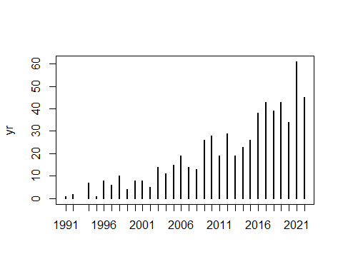

## ### Welcome to rworldmap ###

## For a short introduction type : vignette('rworldmap')

## Results

Manual sorting resulted in 657 potentially relevant publications that report on tree inventories from multispecies communities in India either using plot/transect methods (n=496), checklists (n=54).

Preliminary results show that publications spanned 545 journals; the top 3 were TROPICAL ECOLOGY (n=50), CURRENT SCIENCE (n=32) and BIODIVERSITY AND CONSERVATION (n=28). The Shannon’s diversity of journals was 4.6, suggesting high dominance. Across the papers, there were 2229 instances of authorship with the most number (n=1620) from India, followed by United States of America (n=69). Corresponding authors were predominantly affiliated to institutions in India (n=403 out of 657), followed by United States of America (n=26). There were a total of 525 corresponding author affiliations with a Shannon’s diversity of 6.19.

Ongoing analyses will assess geographic and habitat biases.

## Implications

Based on our metadata analysis, we identify opportunities for collaboration and data sharing among Indian scientists as well as between Indian scientists and foreign collaborators towards a more diverse and equitable community of ecologists. We thus motivate the INvenTree network to share and synthesise tree-based data that will help fill crucial gaps in our understanding of forest dynamics from the region and allow novel syntheses and application.