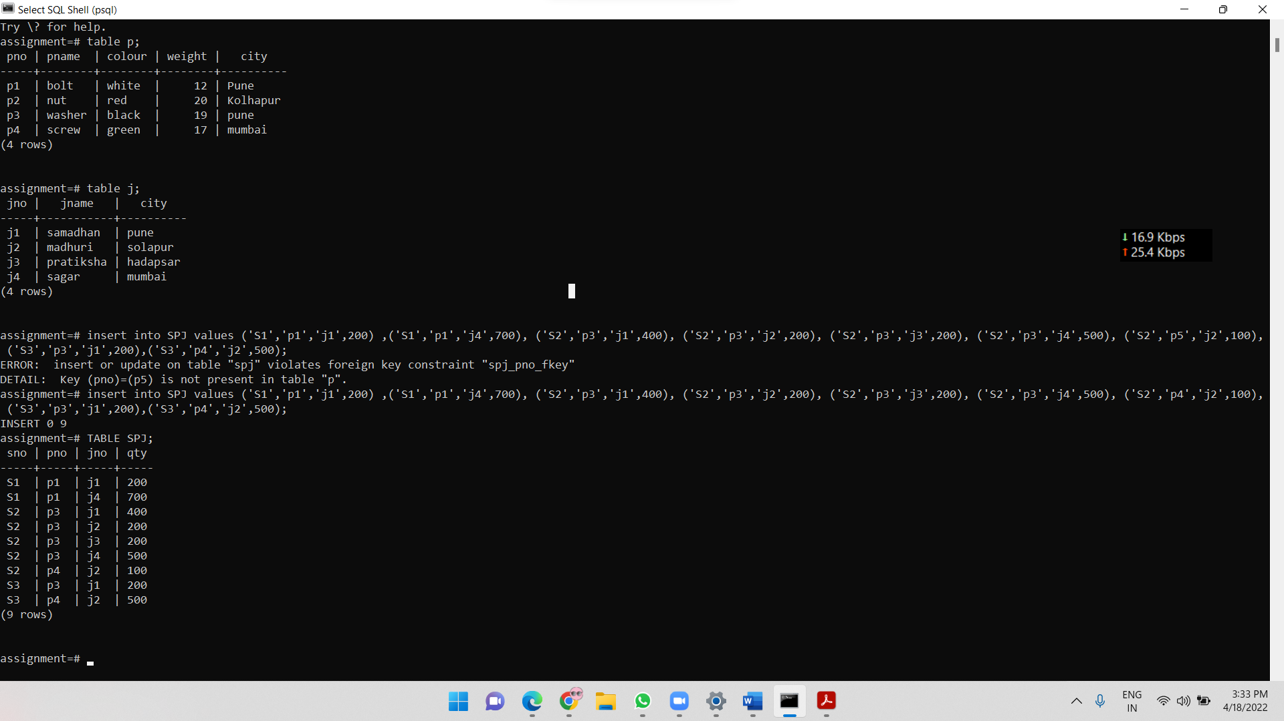

Display all the data from the S table.

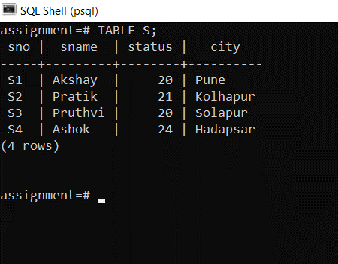

Display only the S# and SNAME fields from the S table.

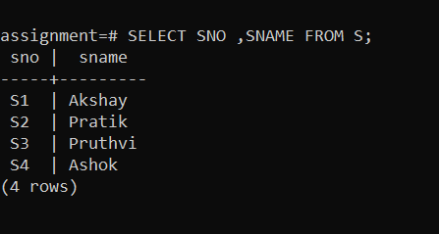

Display the PNAME and COLOR from the P table for the CITY=”London”.

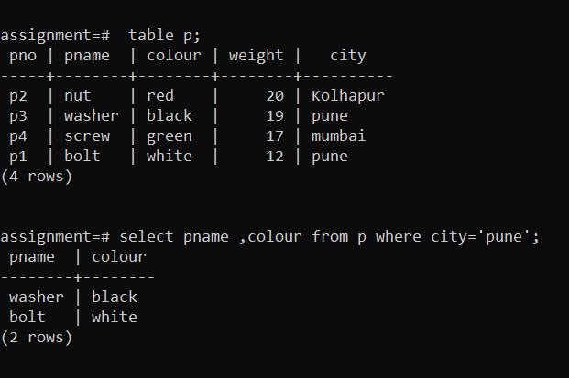

Display all suppliers from pune

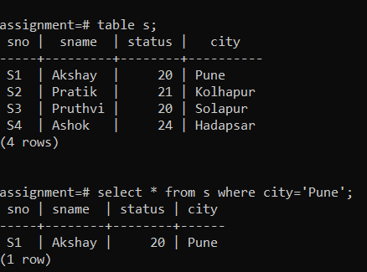

Display all the Suppliers from Paris ~ Solapur or Athens~ Kolhapur.

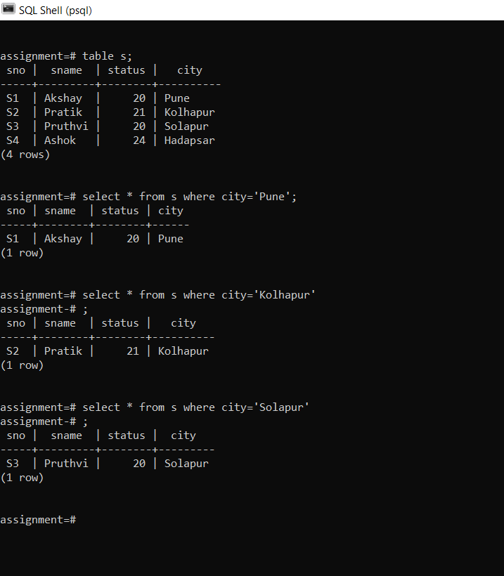

Display all the Projects in Athens.~Kolphapur

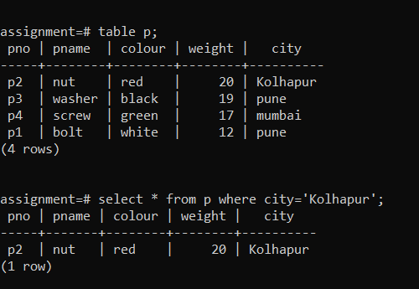

. Display all the Partnames with the weight between 12 and 14 (inclusive of both).

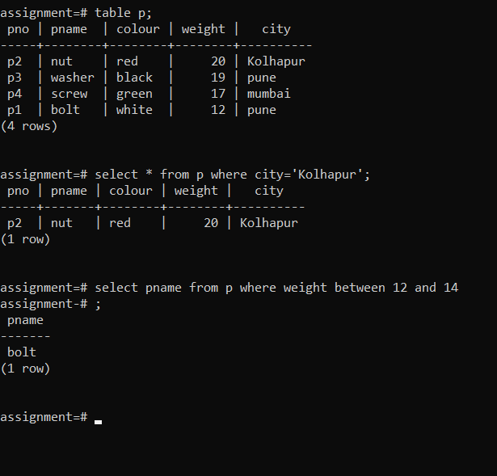

Display all the Suppliers with a Status greater than or equal to 20.

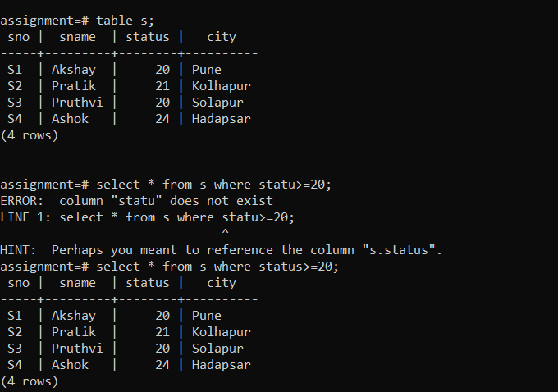

Display all the Suppliers except the Suppliers from London~pune.

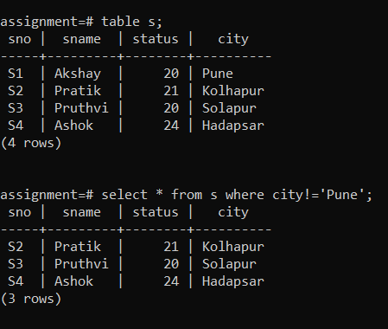

Display only the Cities from where the Suppliers come from.

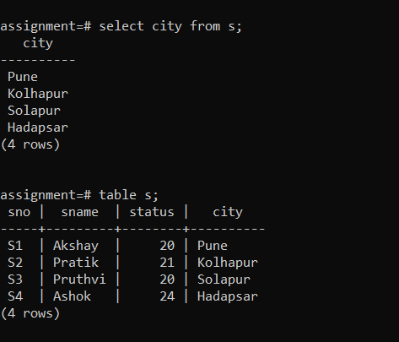

Assuming that the Part Weight is in GRAMS, display the same in MILLIGRAMS and KILOGRAMS.

