Write a SQL statement to rename the table countries to country_new.  
Here is the list of tables.

Explanation : table countries is renamed to country_new

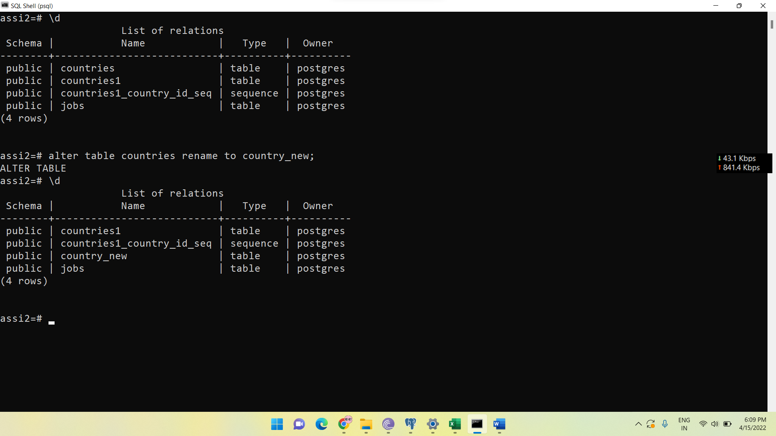

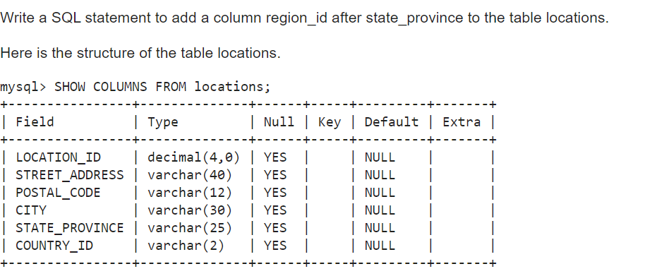

THIS KEYWORD **AFTER** IS **NOT RESERVED IN POSTGRESQL** SO WE CAN’T INSERT COLUMN AT APERTICULAR POSITION.

TO DO THIS WE CAN CREATE ATNOHER TABLE BY PASSING THE SAME VALUES AS THE LOCATIONS TABLE.

Write a SQL statement to change the data type of the column region_id to text in the table locations.

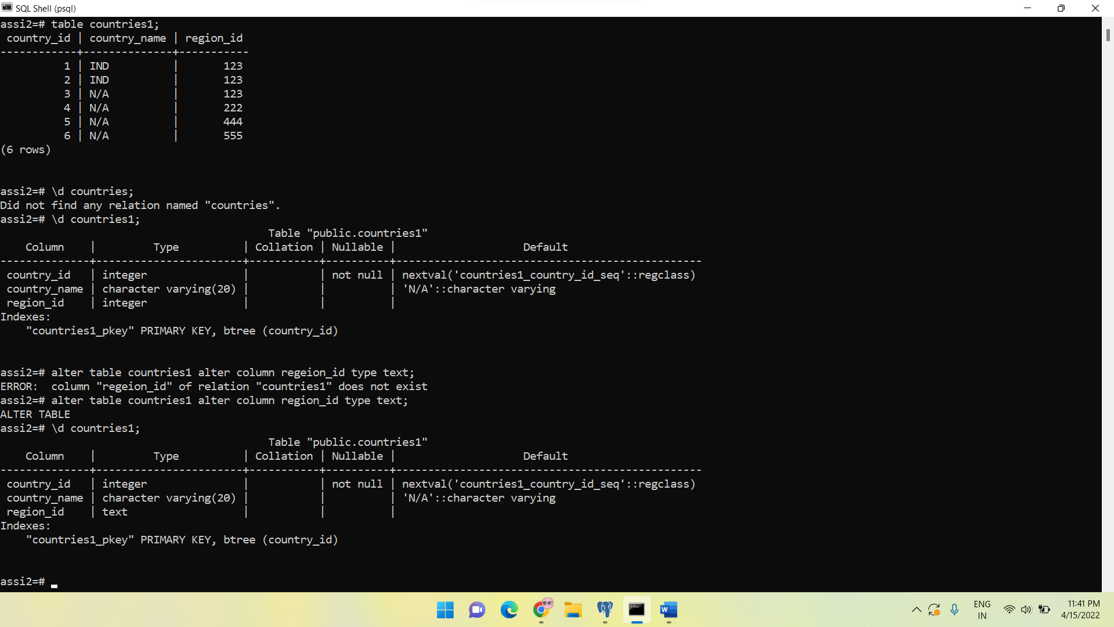

Write a SQL statement to drop the column city from the table locations.

