***\*\*\*Please refer apt321_ss11381_ML_HW3_Part1_Source_Code.ipynb file for Source Code\*\*\****

**Question 1:**

Graph function for x in the interval [-4,4]

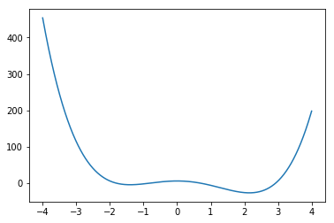

a.

Answer:

Local Minima at x = -1.3971679687499976

Global Minima at x = 2.1471808637959735

b.

Answer:

Setting x = −4 and η = 0.001

Running 6 Iterations:

Before entering the iteration, x is: -4, f(x) is: 454

Iteration 1: X = -3.488, f(x) = 240.90741220147203

Iteration 2: X = -3.159231053824, f(x) = 148.52441854620668

Iteration 3: X = -2.9229164225026394, f(x) = 99.4029877988204

Iteration 4: X = -2.742031675863951, f(x) = 70.0712149441725

Iteration 5: X = -2.59779507407776, f(x) = 51.16573699678776

Iteration 6: X = -2.4794003442716166, f(x) = 38.29644231132754

The minimum occurs at -2.4794003442716166

Running 1200 Iterations:

Before entering the iteration, x is: -4, f(x) is: 454

X converges at Iteration 250

Iteration 1195: X = -1.3971808598447308, f(x) = -4.348957724100302

Iteration 1196: X = -1.3971808598447308, f(x) = -4.348957724100302

Iteration 1197: X = -1.3971808598447308, f(x) = -4.348957724100302

Iteration 1198: X = -1.3971808598447308, f(x) = -4.348957724100302

Iteration 1199: X = -1.3971808598447308, f(x) = -4.348957724100302

Iteration 1200: X = -1.3971808598447308, f(x) = -4.348957724100302

The minimum occurs at -1.3971808598447308

The value of x has converged to local minimum.

c.

Answer:

Setting start with x = 4

Running 6 Iterations:

Before entering the iteration, x is: 4, f(x) is: 198

Iteration 1: X = 3.68, f(x) = 110.61233152000005

Iteration 2: X = 3.450886144, f(x) = 64.53629857986431

Iteration 3: X = 3.276396901609702, f(x) = 37.31076190742675

Iteration 4: X = 3.138067975365072, f(x) = 19.971643359608052

Iteration 5: X = 3.0252501730040535, f(x) = 8.322601113072949

Iteration 6: X = 2.9312689375235244, f(x) = 0.17557478693807127

The minimum occurs at 2.9312689375235244

Running 1200 Iterations:

Before entering the iteration, x is: 4, f(x) is: 198

X converges at Iteration 170

Iteration 1195: X = 2.1471808598447315, f(x) = -26.611979775899705

Iteration 1196: X = 2.1471808598447315, f(x) = -26.611979775899705

Iteration 1197: X = 2.1471808598447315, f(x) = -26.611979775899705

Iteration 1198: X = 2.1471808598447315, f(x) = -26.611979775899705

Iteration 1199: X = 2.1471808598447315, f(x) = -26.611979775899705

Iteration 1200: X = 2.1471808598447315, f(x) = -26.611979775899705

The minimum occurs at 2.1471808598447315

The value of x has converged to global minimum.

d.

Answer:

Setting x = −4 and η = 0.01

Running 1200 Iterations:

Before entering the iteration, x is: -4, f(x) is: 454

Iteration 1: X = 1.12, f(x) = -8.71561728

Iteration 2: X = 1.35166976, f(x) = -14.187225687602176

Iteration 3: X = 1.588129914065571, f(x) = -19.554356180837104

Iteration 4: X = 1.8001695002820235, f(x) = -23.55150883046352

Iteration 5: X = 1.9599549783032466, f(x) = -25.64204722189585

Iteration 6: X = 2.0585082124451546, f(x) = -26.383081197323108

X converges at Iteration 18

Iteration 1195: X = 2.147180859844728, f(x) = -26.611979775899698

Iteration 1196: X = 2.147180859844728, f(x) = -26.611979775899698

Iteration 1197: X = 2.147180859844728, f(x) = -26.611979775899698

Iteration 1198: X = 2.147180859844728, f(x) = -26.611979775899698

Iteration 1199: X = 2.147180859844728, f(x) = -26.611979775899698

Iteration 1200: X = 2.147180859844728, f(x) = -26.611979775899698

The minimum occurs at 2.147180859844728

The value of x has converged to global minimum in early iteration as compared to (c), because the learning rate is high (η = 0.01).

e.

Answer:

Setting x = −4 and η = 0.1

Running 100 Iterations:

Before entering the iteration, x is: -4, f(x) is: 454

Iteration 1: X = 47.2, f(x) = 9689505.955200002

Iteration 2: X = -82626.05440000002, f(x) = 9.321875746621314e+19

Iteration 3: X = 451278842347294.06, f(x) = 8.294875771953852e+58

Iteration 4: X = -7.352328532672759e+43, f(x) = 5.8442611657954e+175

Iteration 5: X = -inf, f(x) = nan

X value is bouncing all over from positive to negative and never converges on a single point. This is because learning rate is too high (η = 0.1).

**Question 2:**

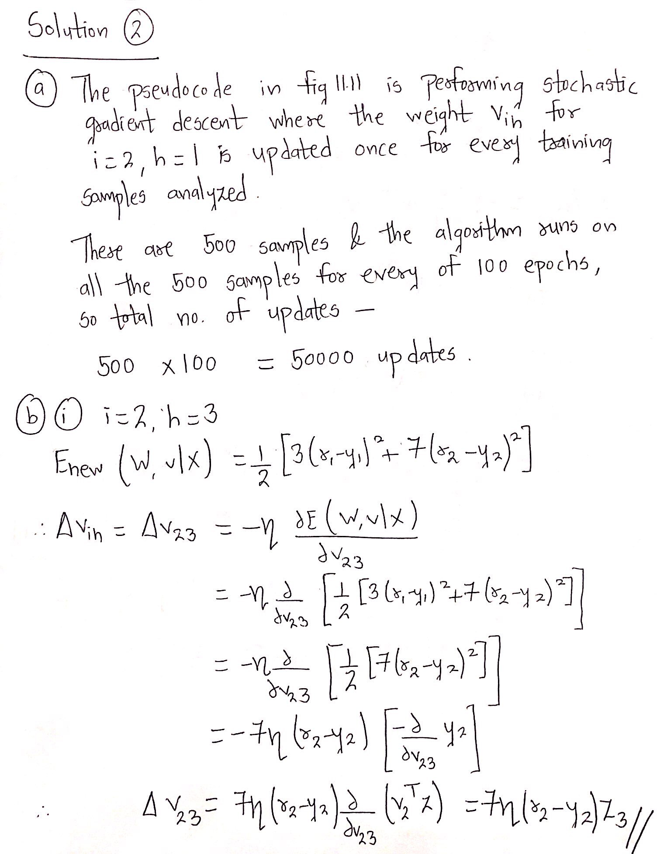

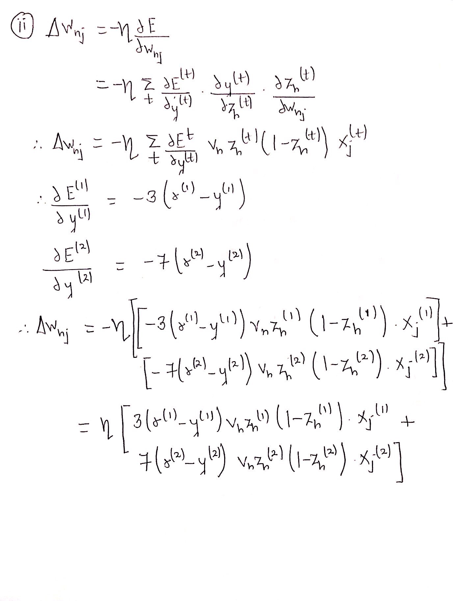

**Question 3:**

a.

Answer:

As NeuralNetRK uses a linear function, it can output values that are negative numbers.

NeuralNetCB, NeuralNetCK and NeuralNetRZeroOne cannot produce negative output.

b.

Answer:

Here, only NeuralNetCK ensures that the sum of the outputs y1, . . . , yk will be 1.

c.

Answer:

Here, K=3 (p1, p2 and p3 -> Probabilities of class face, cat and tree).

Therefore, it would be appropriate to use NeuralNetCK, since K > 2 classes and the sum of the outputs p1, p2, p3 is 1.

d.

Answer:

NeuralNetCK