***\*\*\*Please refer apt321_ss11381_ML_HW4_PART1_Source_Code.ipynb file for Source Code\*\*\****

**Question 1:**

Graph function for x in the interval [-4,4]

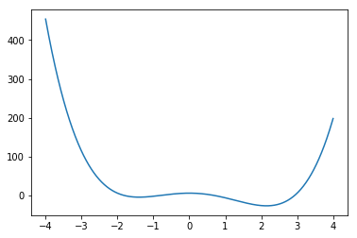

a.

Solution:

Local Minima at x = -1.3971679687499976

Global Minima at x = 2.1471808637959735

b.

Solution:

Setting x = −4 and η = 0.001

Running 6 Iterations:

Before entering the iteration, x is: -4, f(x) is: 454

Iteration 1: X = -3.488, f(x) = 240.90741220147203

Iteration 2: X = -3.159231053824, f(x) = 148.52441854620668

Iteration 3: X = -2.9229164225026394, f(x) = 99.4029877988204

Iteration 4: X = -2.742031675863951, f(x) = 70.0712149441725

Iteration 5: X = -2.59779507407776, f(x) = 51.16573699678776

Iteration 6: X = -2.4794003442716166, f(x) = 38.29644231132754

The minimum occurs at -2.4794003442716166

Running 1200 Iterations:

Before entering the iteration, x is: -4, f(x) is: 454

X converges at Iteration 250

Iteration 1195: X = -1.3971808598447308, f(x) = -4.348957724100302

Iteration 1196: X = -1.3971808598447308, f(x) = -4.348957724100302

Iteration 1197: X = -1.3971808598447308, f(x) = -4.348957724100302

Iteration 1198: X = -1.3971808598447308, f(x) = -4.348957724100302

Iteration 1199: X = -1.3971808598447308, f(x) = -4.348957724100302

Iteration 1200: X = -1.3971808598447308, f(x) = -4.348957724100302

The minimum occurs at -1.3971808598447308

The value of x has converged to local minimum.

c.

Solution:

Setting start with x = 4

Running 6 Iterations:

Before entering the iteration, x is: 4, f(x) is: 198

Iteration 1: X = 3.68, f(x) = 110.61233152000005

Iteration 2: X = 3.450886144, f(x) = 64.53629857986431

Iteration 3: X = 3.276396901609702, f(x) = 37.31076190742675

Iteration 4: X = 3.138067975365072, f(x) = 19.971643359608052

Iteration 5: X = 3.0252501730040535, f(x) = 8.322601113072949

Iteration 6: X = 2.9312689375235244, f(x) = 0.17557478693807127

The minimum occurs at 2.9312689375235244

Running 1200 Iterations:

Before entering the iteration, x is: 4, f(x) is: 198

X converges at Iteration 170

Iteration 1195: X = 2.1471808598447315, f(x) = -26.611979775899705

Iteration 1196: X = 2.1471808598447315, f(x) = -26.611979775899705

Iteration 1197: X = 2.1471808598447315, f(x) = -26.611979775899705

Iteration 1198: X = 2.1471808598447315, f(x) = -26.611979775899705

Iteration 1199: X = 2.1471808598447315, f(x) = -26.611979775899705

Iteration 1200: X = 2.1471808598447315, f(x) = -26.611979775899705

The minimum occurs at 2.1471808598447315

The value of x has converged to global minimum.

d.

Solution:

Setting x = −4 and η = 0.01

Running 1200 Iterations:

Before entering the iteration, x is: -4, f(x) is: 454

Iteration 1: X = 1.12, f(x) = -8.71561728

Iteration 2: X = 1.35166976, f(x) = -14.187225687602176

Iteration 3: X = 1.588129914065571, f(x) = -19.554356180837104

Iteration 4: X = 1.8001695002820235, f(x) = -23.55150883046352

Iteration 5: X = 1.9599549783032466, f(x) = -25.64204722189585

Iteration 6: X = 2.0585082124451546, f(x) = -26.383081197323108

X converges at Iteration 18

Iteration 1195: X = 2.147180859844728, f(x) = -26.611979775899698

Iteration 1196: X = 2.147180859844728, f(x) = -26.611979775899698

Iteration 1197: X = 2.147180859844728, f(x) = -26.611979775899698

Iteration 1198: X = 2.147180859844728, f(x) = -26.611979775899698

Iteration 1199: X = 2.147180859844728, f(x) = -26.611979775899698

Iteration 1200: X = 2.147180859844728, f(x) = -26.611979775899698

The minimum occurs at 2.147180859844728

The value of x has converged to global minimum in early iteration as compared to (c), because the learning rate is high (η = 0.01).

e.

Solution:

Setting x = −4 and η = 0.1

Running 100 Iterations:

Before entering the iteration, x is: -4, f(x) is: 454

Iteration 1: X = 47.2, f(x) = 9689505.955200002

Iteration 2: X = -82626.05440000002, f(x) = 9.321875746621314e+19

Iteration 3: X = 451278842347294.06, f(x) = 8.294875771953852e+58

Iteration 4: X = -7.352328532672759e+43, f(x) = 5.8442611657954e+175

Iteration 5: X = -inf, f(x) = nan

X value is bouncing all over from positive to negative and never converges on a single point. This is because learning rate is too high (η = 0.1).

**Question 2:**

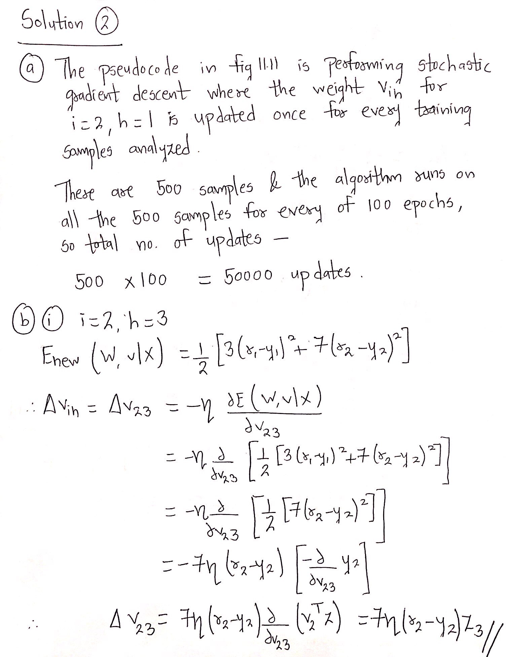

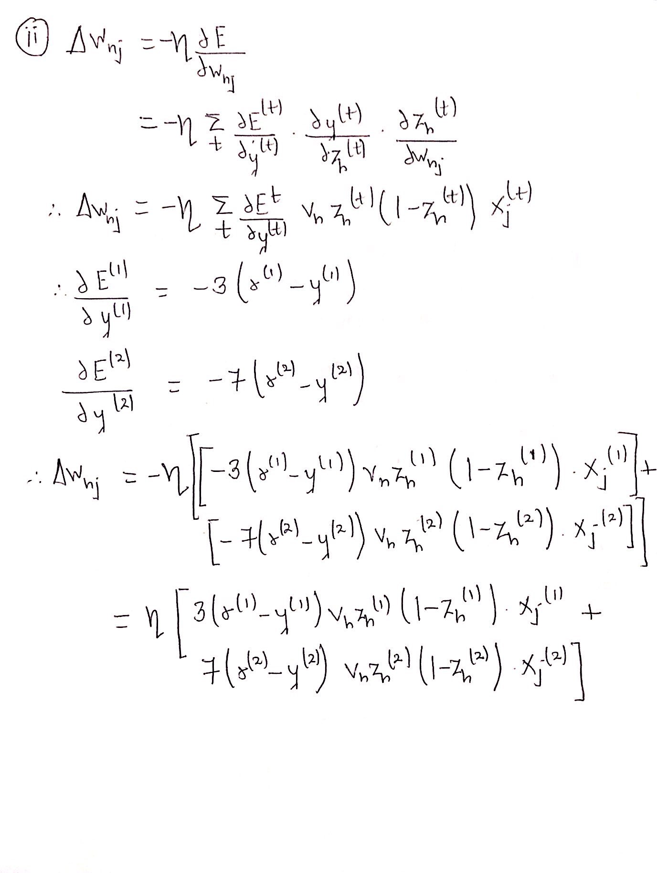

**Question 3:**

a.

Solution:

As NeuralNetRK uses a linear function, it can output values that are negative numbers.

NeuralNetCB, NeuralNetCK and NeuralNetRZeroOne cannot produce negative output.

b.

Solution:

Here, only NeuralNetCK ensures that the sum of the outputs y1, . . . , yk will be 1.

c.

Solution:

Here, K=3 (p1, p2 and p3 -> Probabilities of class face, cat and tree).

Therefore, it would be appropriate to use NeuralNetCK, since K > 2 classes and the sum of the outputs p1, p2, p3 is 1.

d.

Solution:

NeuralNetZeroOne is the appropriate option as:

1. It is a classification problem and there are two values 0/1.
2. NeuralNetCB cannot applied as it is a single output solution.
3. Problem expects probabilities for politics and style.

Eg. if politics: x1=1, else 0, if formal_style: x2=1, else 0

**Question 4:**

a.

Solution:

Neural Net Algorithm learns from weight which is not appropriate in this case.

Example consider - almond = 1, anise = 2, creosote = 3, and fishy = 4:

Here, neural net algorithm will consider the ‘fishy’ value as weighted value(Prediction = weight * odor) 4 (double of anise) , which is not true.

Whereas in case of Random Forest, it will support rules such as:

if odor = 1:

//encoding of almond

process algo…

else if odor = 2:

//encoding of anise

Process algo…

Therefore, if an algorithm is learning by weight, we should not use label encoding and hence, in our case, it would be fine to do this if we were using a random forest, rather than a neural net. An alternative solution would be to use one-hot encoding.

b.

i. Solution:

For transforming attribute ‘stalk shape`, we can add one-hot encoding in our existing transformed dataset: if stalk_shape=tapering: z5=1, else 0; if stalk_shape=enlarging: z6=1, else 0,

Transformed Dataset:

|  |  |  |  |  |  |  |  |
| --- | --- | --- | --- | --- | --- | --- | --- |
|  | z1 | z2 | z3 | z4 | z5 | z6 | label |
| x1 | 0 | 0 | 0 | 1 | 1 | 0 | 0 |
| x2 | 0 | 0 | 1 | 0 | 0 | 1 | 0 |

ii. Solution:

If we use one-hot encoding, there is a problem of losing the hierarchy (high > medium > low) and hence, it is better to use label encoding which retains the order.

iii. Solution:

Here, it is appropriate to use (0,1) instead of one-hot encoding as it will generate the same dataset.

Example: Dataset for Coin Tosses.

|  |  |
| --- | --- |
| Attributes | Outcome |
| x1 | Heads |
| x2 | Tails |
| x3 | Heads |

Use (0,1) encoding -> if heads: x=1, if tails: x=0

|  |  |
| --- | --- |
| Attributes | Outcome |
| x1 | 1 |
| x2 | 0 |
| x3 | 1 |

Using one-hot encoding will give

|  |  |  |
| --- | --- | --- |
| Attributes | z1=Heads | z2=Tails |
| x1 | 1 | 0 |
| x2 | 0 | 1 |
| x3 | 1 | 0 |

Here, z2 is redundant and can be eliminated as z1 can alone represented the whole dataset.

In case of three attributes, the value of attribute can be either of 3 outcomes and hence, it is appropriate to use one-hot encoding to represent the data.