🎓
SchoolAttendance
Teacher & Student Attendance Platform
Technical Documentation & System Reference
Android · Kotlin · Firebase · Google Gemini AI

Version 1.0 • Prepared for Development & Deployment Reference

Table of Contents

1. Overview
SchoolAttendance is a production-ready Android application built for schools to manage both teacher and student attendance digitally. It replaces manual paper logs with GPS-verified check-ins, photo verification, and an AI-powered sheet scanner — all backed by Firebase for authentication and real-time data sync.
The project moves away from manual logging by combining three verification layers: location data, camera capture, and generative-AI document understanding, giving school administrators a reliable and auditable attendance record.

1.1 Key Features
- Teacher Management — secure registration with real email verification and password reset via Firebase Authentication.
- Teacher Attendance — mark attendance with real-time GPS location and photo capture for verification.
- AI Student Scanner — scan physical attendance sheets using Google Gemini. Automatically extracts student names, roll numbers, and daily attendance status with high precision.
- Dynamic Dashboard — view attendance history and manage teacher/student profiles in one place.
- Real-time Sync — all data is synced instantly across devices using Firebase Firestore.

1.2 Technology Stack

Field | Type / Notes
Language | Kotlin
Architecture | MVVM / Jetpack (ViewBinding, Lifecycle, Coroutines)
Database | Firebase Firestore
Authentication | Firebase Auth
AI / ML | Google Gemini (Generative AI SDK)
Networking | Ktor Client
UI Toolkit | Material Components (Day / Night theme support)

2. Technical Architecture
The diagram below summarizes how the Android client interacts with device sensors, Google Gemini, and the Firebase backend.
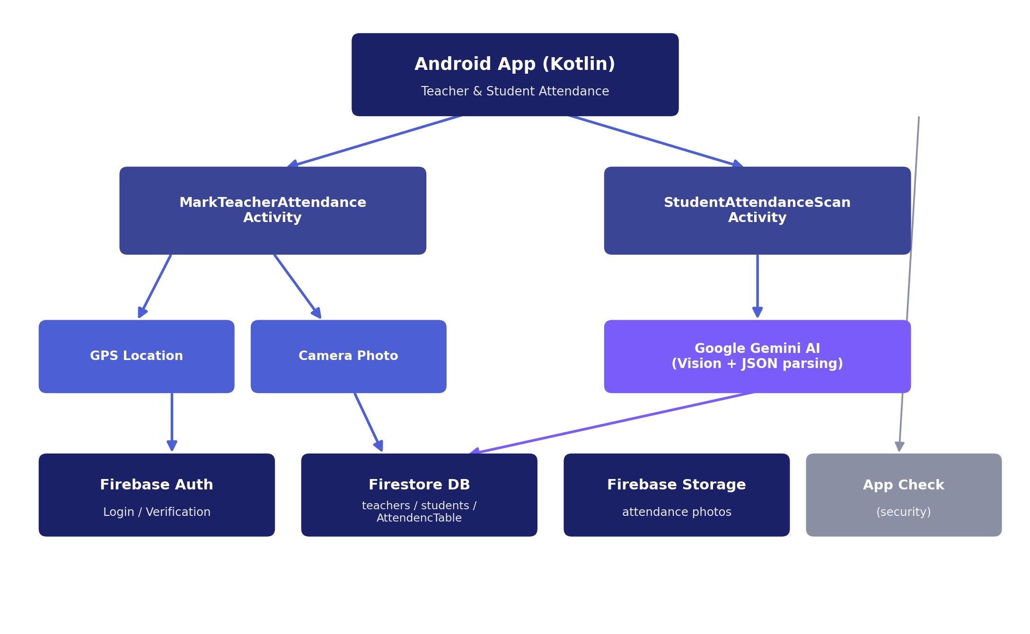
Figure 1 — High-level system architecture

2.1 Authentication Flow
- Registration — collects teacher details (name, employee ID, school code, etc.) and creates a Firebase Auth account. Requires email verification before first login.
- Login — authenticates verified teachers and routes them to the dashboard.

2.2 Attendance Modules

A. Teacher Attendance (MarkTeacherAttendanceActivity)
- GPS Verification — uses FusedLocationProviderClient to confirm the teacher is at the school premises (latitude/longitude comparison can be added to submitAttendance).
- Photo Verification — captures a real-time photo of the teacher/school using ActivityResultLauncher.
- Storage — saves photos to Firebase Storage and metadata (time, location status) to the AttendencTable collection in Firestore.

B. Student Attendance AI Scanner (StudentAttendanceScanActivity)
- Image Processing — captures high-resolution images of attendance grids; decodeSampledAndRotatedBitmap optimizes the image for AI processing without losing detail.
- Gemini Integration — a carefully engineered prompt instructs the model to align day columns and detect marks (dots, ticks) with high precision, while returning a value for every day — present or absent — so no day is silently skipped.
- Response Handling — receives structured JSON per API call and merges results by roll number; entries with no data at all are discarded, while genuinely all-absent students are kept.
- Firestore Batch Write — uses firestore.batch() to efficiently save multiple student records in a single network request.

To keep accuracy high on a full A4/legal attendance sheet, the scanner splits the workload into two Gemini calls against the same full image — one per half of the month — then merges the results by roll number, as shown below.
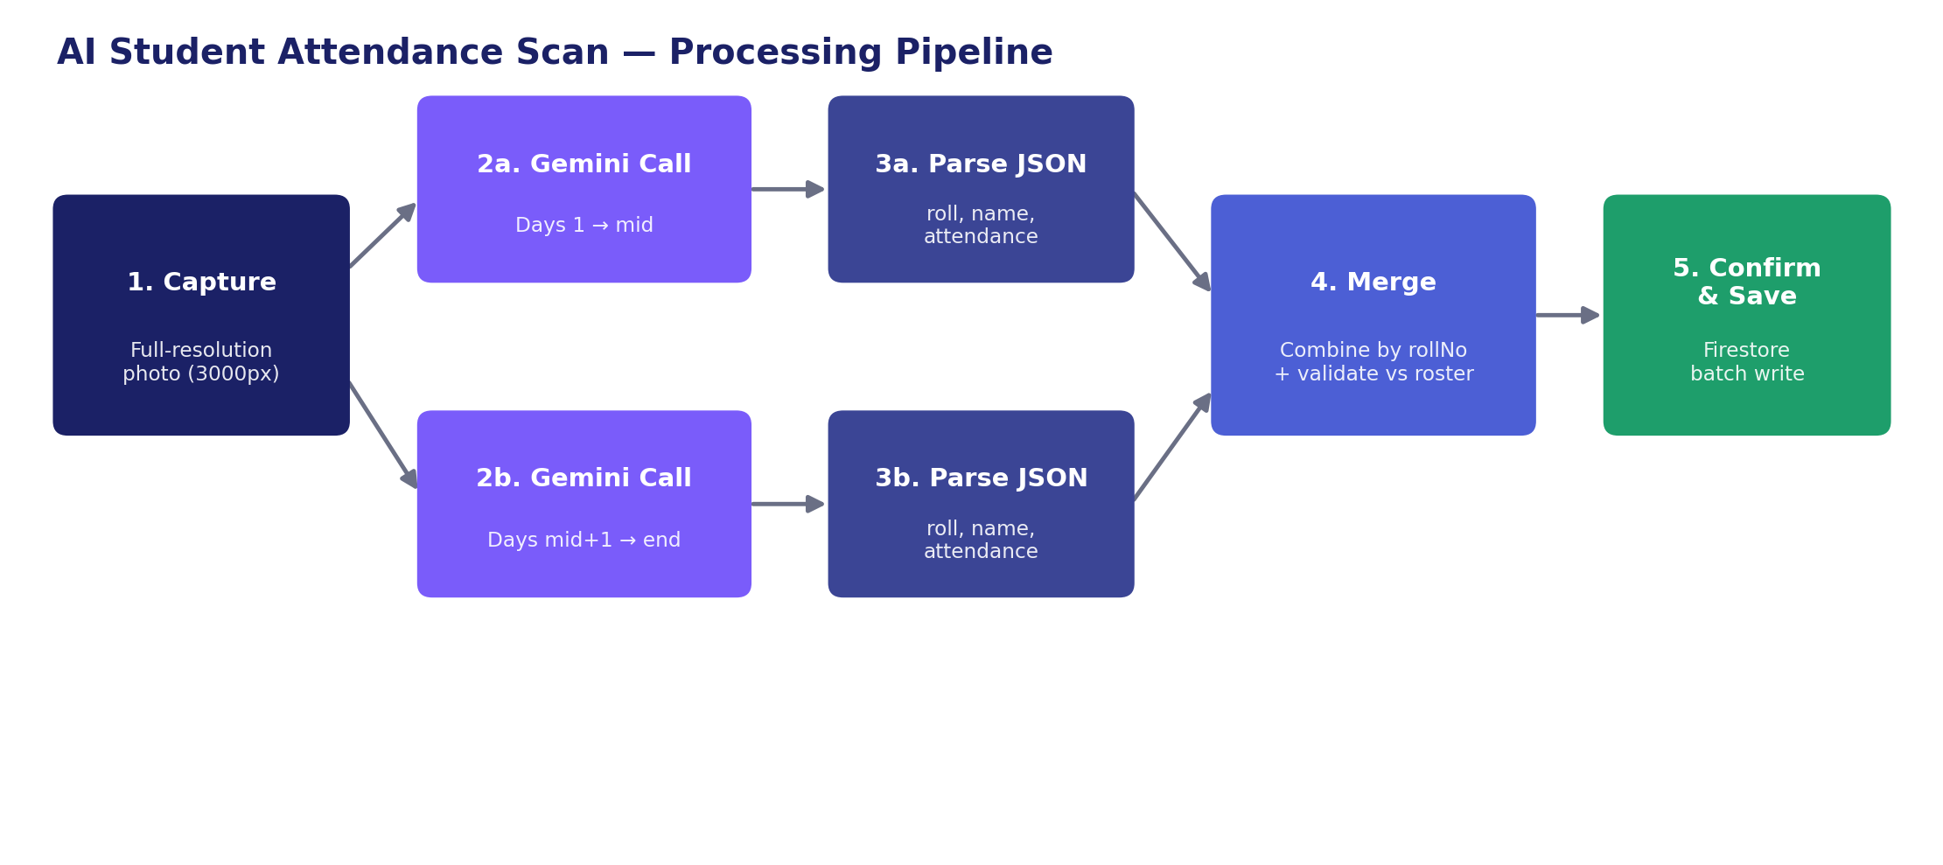
Figure 2 — AI scanning pipeline: capture → dual Gemini calls → merge → save

3. Database Schema (Firestore)
Firestore is organized into three top-level collections, plus a per-month attendance sub-collection nested under each student document.
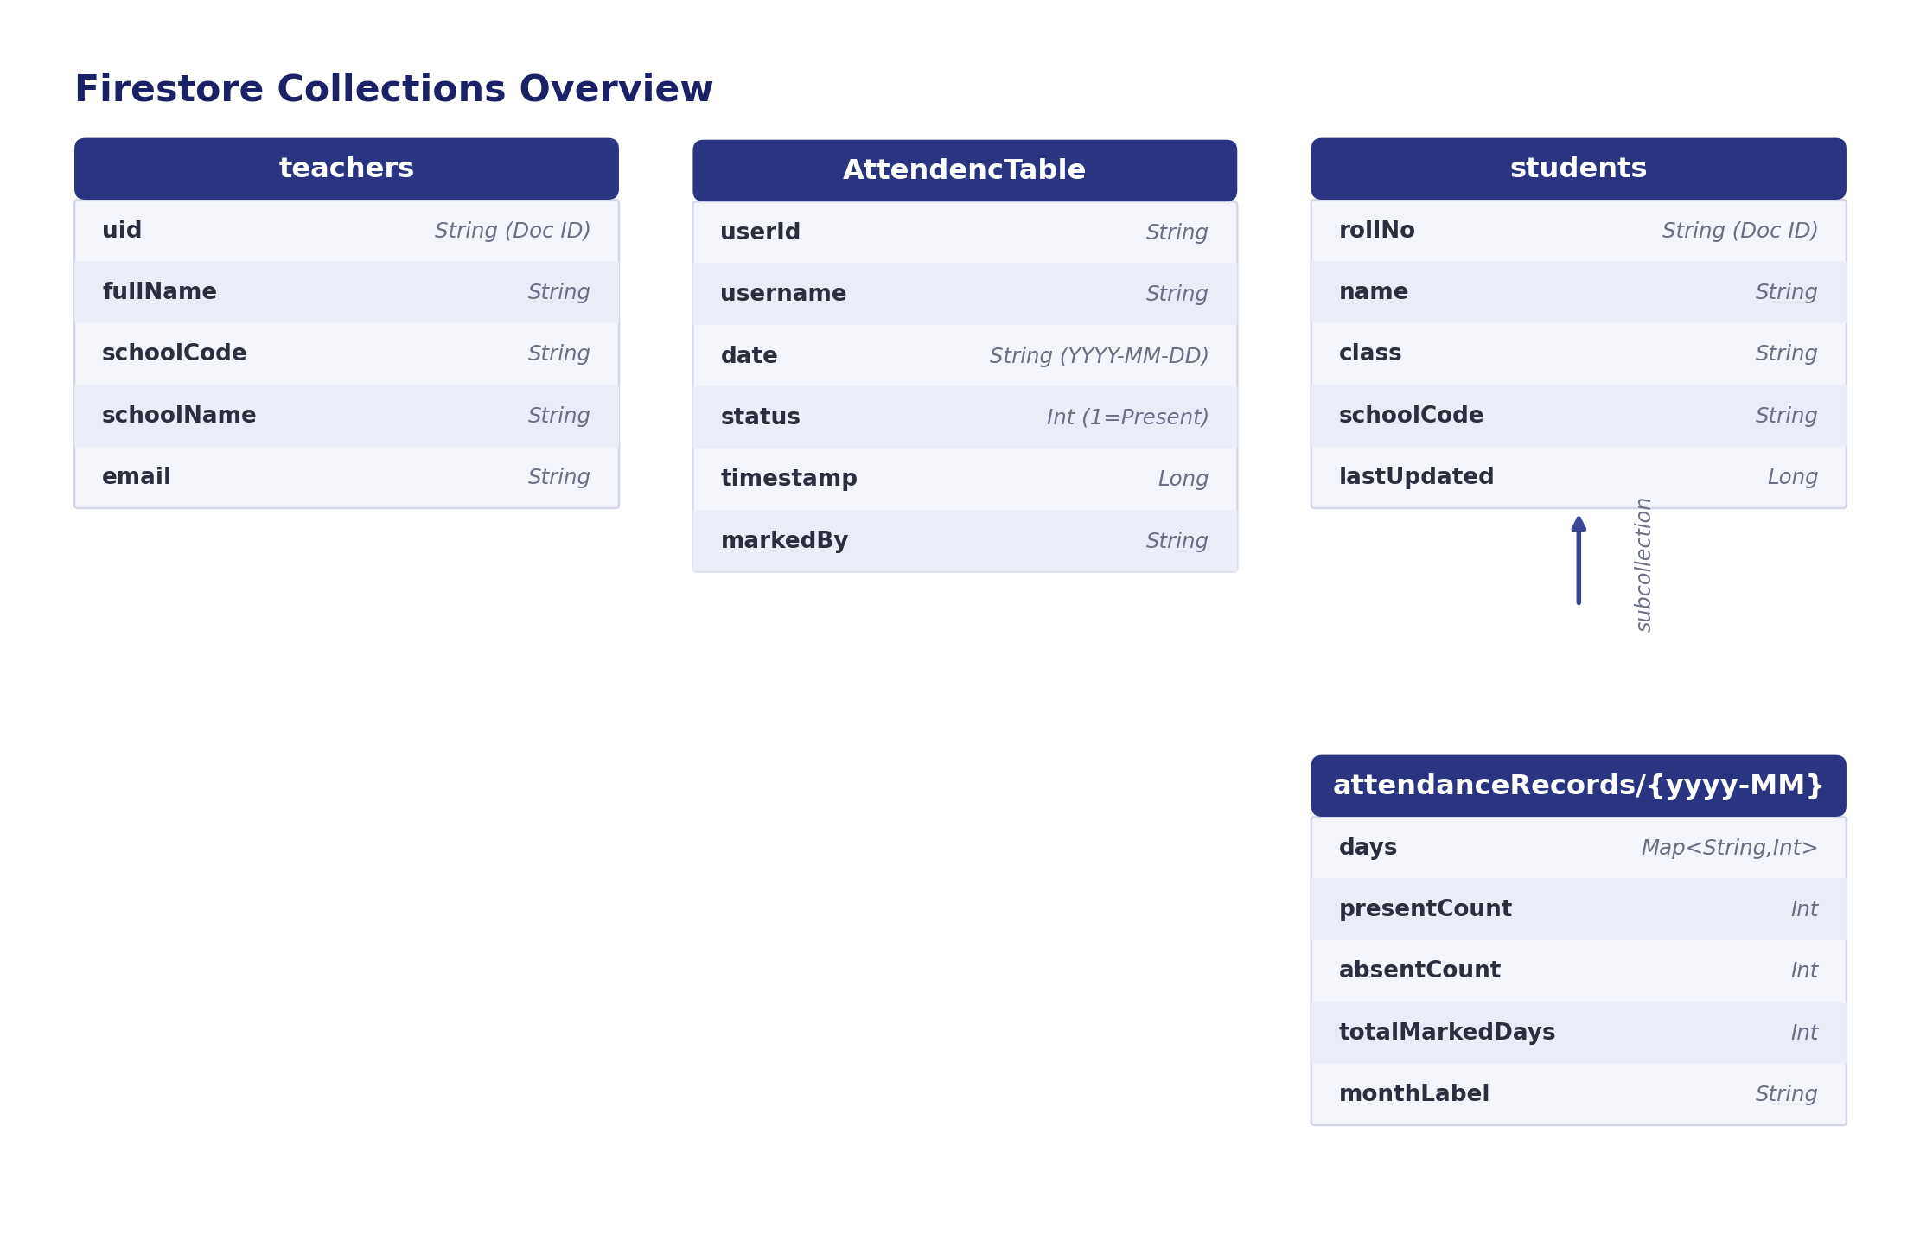
Figure 3 — Firestore collection layout

teachers (Collection)
Field | Type / Notes
uid | String — Document ID
fullName | String
schoolCode | String
schoolName | String
email | String

AttendencTable (Collection)
Field | Type / Notes
userId | String
username | String
date | String (YYYY-MM-DD)
status | Integer — 1 for Present
timestamp | Long
markedBy | String

students (Collection)
Field | Type / Notes
rollNo | String — Document ID
name | String
class | String
schoolCode | String
lastUpdated | Long

students/{rollNo}/attendanceRecords/{yyyy-MM} (Sub-collection)
Field | Type / Notes
days | Map<String, Int> — e.g. { "1": 1, "2": 0 }
presentCount | Integer
absentCount | Integer
totalMarkedDays | Integer
monthLabel | String — e.g. "2026-06"

4. Prerequisites & Setup

4.1 Firebase Setup
- Create a project at Firebase Console.
- Add an Android app with package name com.school.attendance.
- Download google-services.json and place it in the app/ directory.
- Enable Email/Password sign-in under Authentication.
- Create a Firestore Database and a Firebase Storage bucket.

4.2 Google AI Setup
- Generate an API key from Google AI Studio.
- Store the key outside source control (e.g. local.properties + BuildConfig) rather than hardcoding it in an Activity — see Security Notes.

4.3 Build the Project
- Open the project in Android Studio (Hedgehog or newer).
- Click “Sync Project with Gradle Files.”
- Run on a physical device — recommended for accurate camera and GPS testing.

4.4 Project Structure
com.school.attendance/
├── activities/ Splash, Login, Register, Dashboard, etc.
├── models/ Data classes for Teacher and Attendance
├── adapters/ RecyclerView adapters for history lists
├── StudentAttendanceScanActivity.kt AI engine for sheet scanning
└── MarkTeacherAttendanceActivity.kt GPS + selfie capture

5. Security Notes
- App Check — temporarily disabled in SchoolAttendanceApplication.kt for development. Enable it before any production release.
- API Keys — never hardcode the Gemini API key directly in an Activity file. If a key is ever committed to a public or scanned repository, Google will detect and revoke it automatically (“leaked key” error). Load it via local.properties + BuildConfig instead, and rotate immediately if this occurs.
- ProGuard — minification is enabled for release builds to protect the source code.

6. Troubleshooting

6.1 AI Extraction Accuracy
- Alignment — ensure the paper is flat and the camera is parallel to the page.
- Lighting — shadows across the grid can confuse the model; use even, consistent lighting.
- Resolution — the app processes images at 3000px. Lower this in processCapturedPhotoFile if memory errors occur on older devices.

6.2 Common Errors

Field | Type / Notes
404 Not Found | The Gemini model name is incorrect, or the API key lacks access to that model. Confirm the model string is current and valid.
403 — “leaked API key” | Google detected the key exposed publicly (e.g. pushed to GitHub) and revoked it. Generate a new key and load it via BuildConfig, never hardcoded.
SecurityException | Occurs if Firebase App Check fails. Check SchoolAttendanceApplication.kt to toggle App Check status.
NoClassDefFoundError (Ktor) | Gradle hasn’t synced the Ktor dependencies required by the Generative AI SDK — re-sync the project.

7. Future Roadmap
- Admin Web Portal — view aggregate reports and export Excel sheets.
- Offline Mode — local caching of attendance using a Room database.
- Multi-Class Support — allow teachers to select different classes before scanning.
Developed with ❤ for Schools.

