Exploratory Data Analysis
Predicting Severe Injury in European Football, 2020–2025
WAI Project · Sports Analytics · Akshay Thomas, IIM Ranchi

1. Data and scope
The analysis covers 15,603 recorded injuries to 4,081 players across the five major European leagues over the 2020/21 to 2024/25 seasons. Each row is one injury: its type, its start and end dates, the days and games missed, and the player's age, position, club and league.
Two Transfermarkt datasets were merged in: 92,152 player profiles supplying height, preferred foot and main position, and 143,195 career injury records used to build injury-history features.

1.1 Record linkage
The primary dataset and Transfermarkt are joined on player name. Transfermarkt names carry a trailing numeric id in parentheses — "Alexander Nübel (10)" — so a naive exact-name join matches 0% of rows. Stripping that suffix with a regular expression before lowercasing and trimming raises the match rate to 97.2%. The remaining 2.8% receive imputed medians and zeroed history features.
This is worth stating because a 0% match rate is easy to mistake for incompatible datasets rather than a formatting difference, and because namesakes may be silently conflated by any name-based join.

1.2 Data quality
After cleaning there are no missing values in any of the eighteen candidate numeric features or six categorical features. The merged frame holds 15,603 rows across 40 columns, unchanged in row count from the primary dataset — the merge added columns, not rows, which is the behaviour a left join should produce and was verified as such.

2. The target variable
Severity is defined as an absence of 28 days or more. That threshold follows the common clinical convention separating short-term from long-term absence. It is a modelling choice, not a property of the data, and a different cut-off would produce a different target and different results.
Class | Injuries | Share
Not severe (< 28 days) | 10,057 | 64.5%
Severe (28+ days) | 5,546 | 35.5%
Ratio | 1.8 : 1 | mild imbalance

Days out range from 1 to 1,013, with a mean of 36.1 and a median of 18. The mean sits well above the median because a small number of very long absences — ruptures, reconstructions — pull the tail. Half of all injuries resolve within about two and a half weeks.
At 35.5% minority the imbalance is mild. This matters for modelling: SMOTE and similar oversampling techniques are designed for minority classes in the 1–10% range, and applying them here would manufacture a large volume of synthetic rows to correct a modest skew.
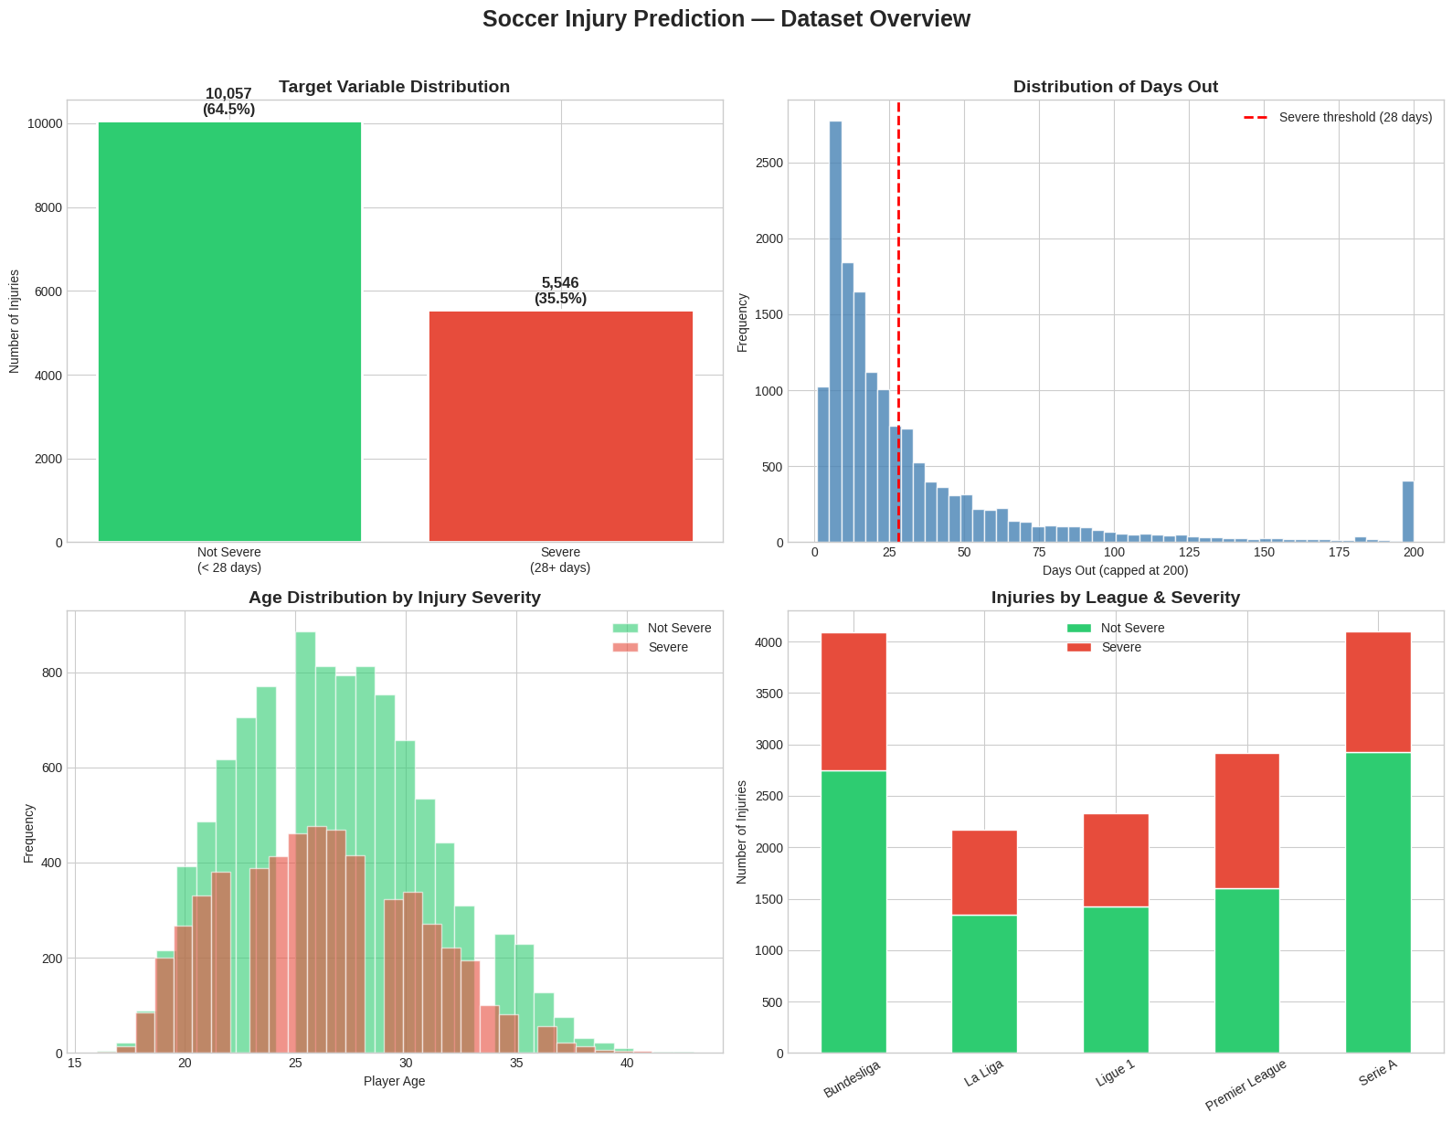
Figure 1. Dataset overview. Clockwise from top left: the target split; the distribution of days out (the bar at 200 is a display cap, pooling every absence beyond it); injuries by league and severity; the age distribution split by severity.

3. Injury patterns
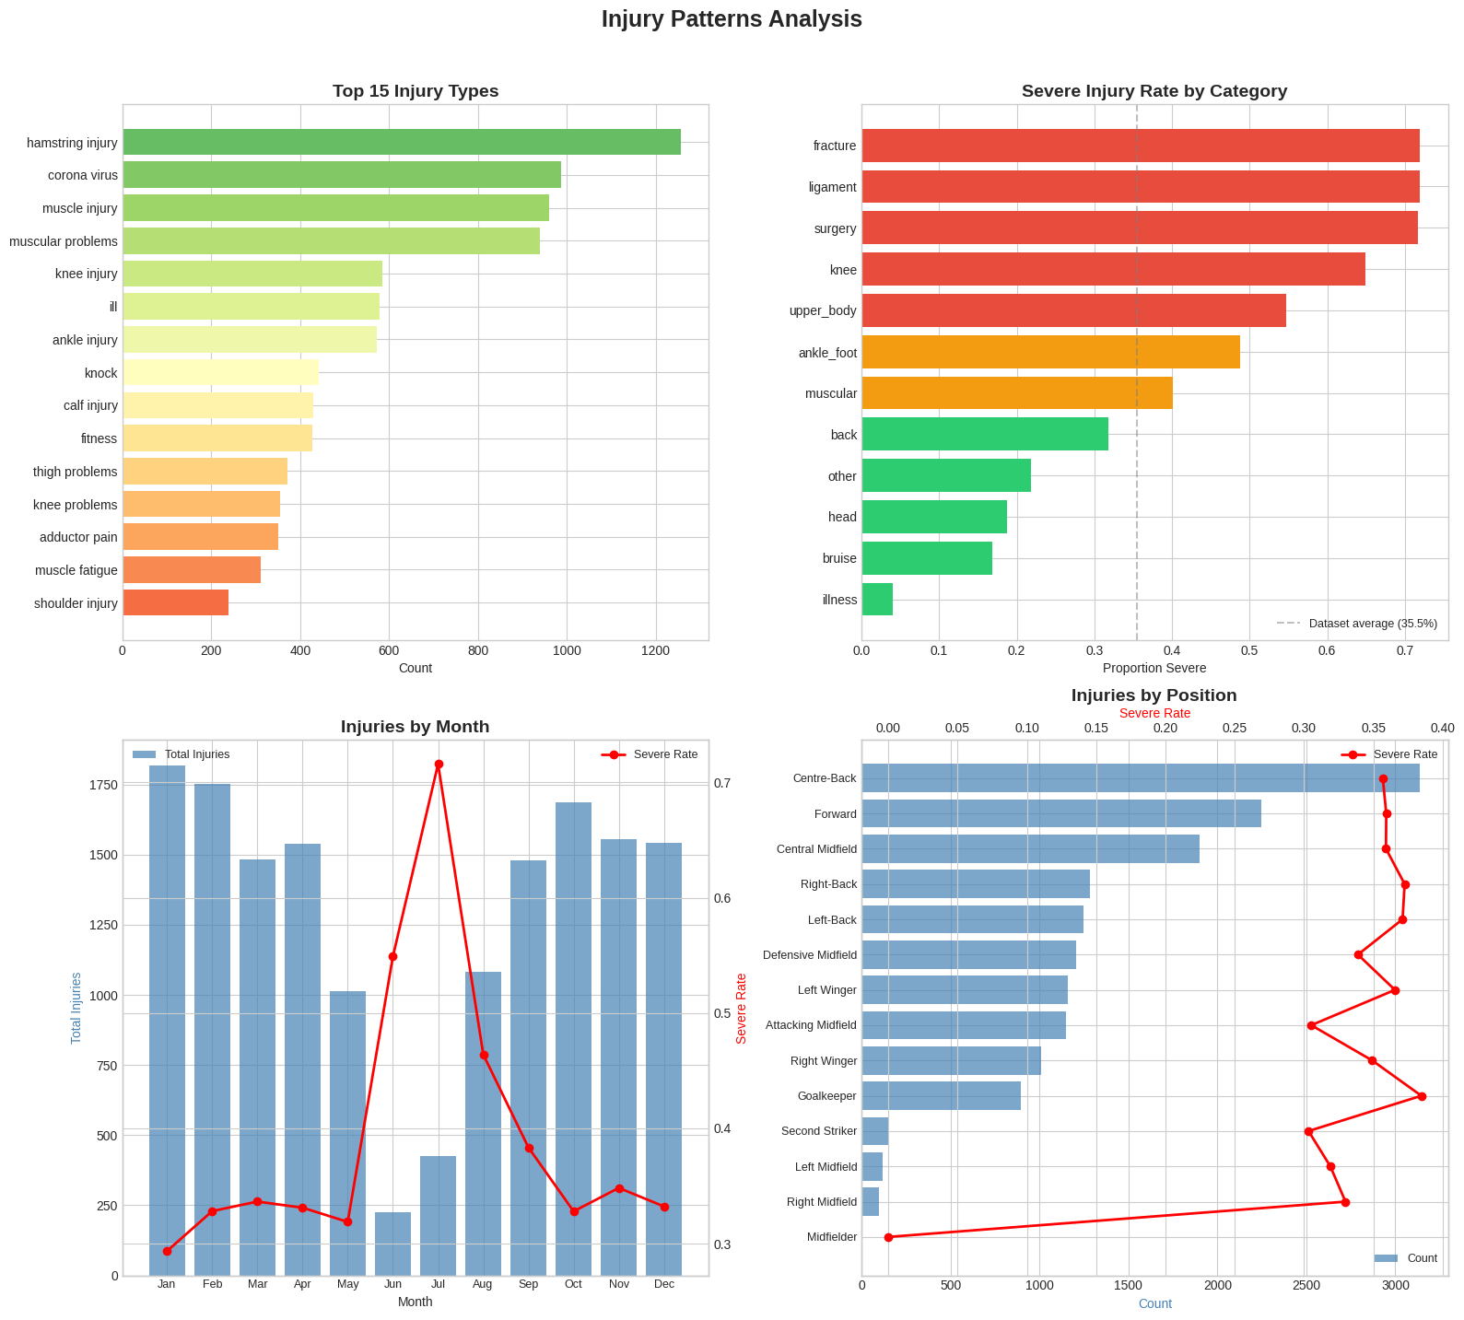
Figure 2. Injury patterns. Most frequent injury types, severity rate by category, injuries by month with the severe rate overlaid, and injuries by playing position.

3.1 What is common is not what is severe
The most frequent injury is the hamstring injury, with 1,256 occurrences. The most severe category is fracture, of which 72.0% keep a player out 28 days or more — against a dataset-wide rate of 35.5%.
These are different questions and the distinction drives the whole analysis. Frequency tells a club what its medical department will spend most of its time on; severity rate tells it which cases will cost a season. A model built to predict severity must be judged on the second.

3.2 League and position
Dimension | Highest severity rate | Rate
League | Premier League | 45.2%
Position | Goalkeeper | 38.5%
Injury category | Fracture | 72.0%

The Premier League's 45.2% is nearly ten points above the dataset average, a substantial gap for a whole-league effect. Fixture congestion and reporting practice are both plausible explanations and the data cannot separate them; the association should be reported without a causal reading.
Goalkeeper as the riskiest position is less intuitive but consistent with the mechanism — goalkeepers sustain fewer soft-tissue injuries from repeated sprinting and more impact injuries from diving and collisions, and impact injuries are more often fractures.

4. Player history and feature correlations
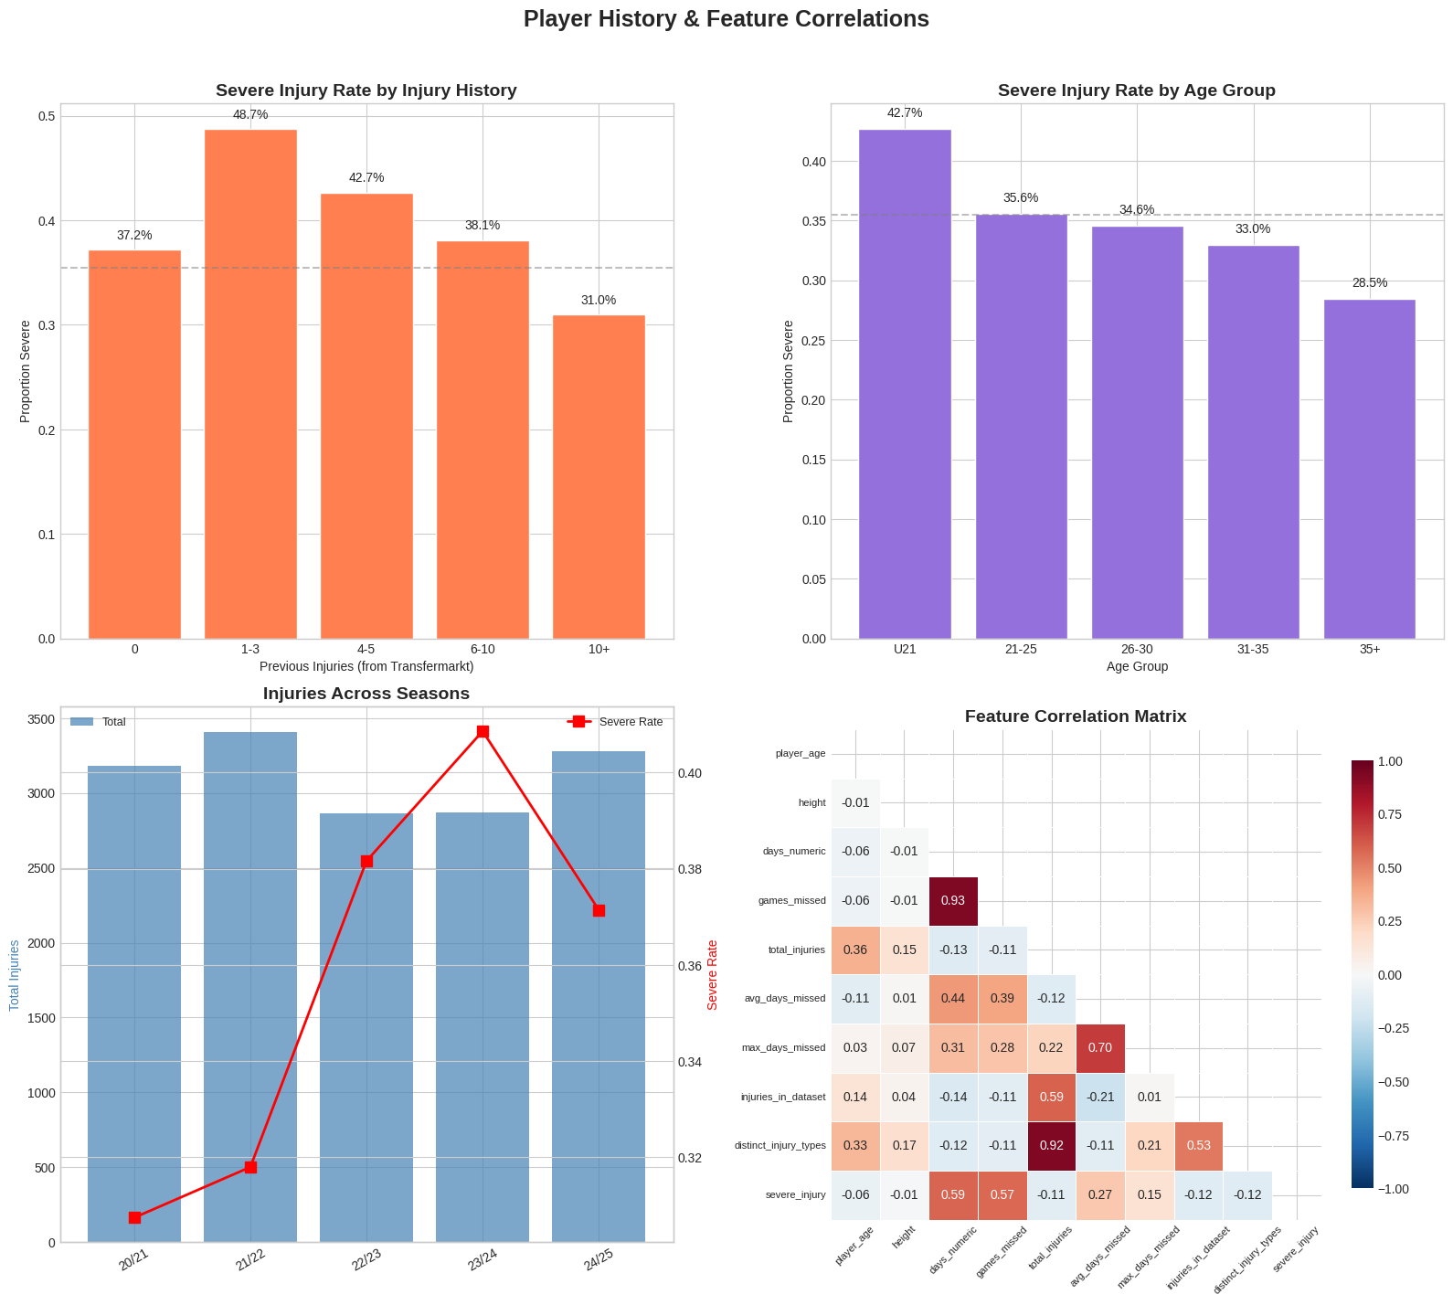
Figure 3. Severity rate by prior-injury count and by age group, injuries across seasons, and the correlation matrix for the numeric features.
One note on the prior-injury panel: the bin edges were set to −1, 0, 3, 5, 10, 100 rather than starting at 0. pandas.cut is left-exclusive, so a lower edge of 0 would have silently dropped every player with no prior injuries — a group of real interest — and mislabelled every remaining bucket.

4.1 Injury history points the opposite way to intuition
Players carrying more prior injuries suffer slightly LESS severe injuries, not more. The median severe case belongs to a player with 10 prior injuries; the median non-severe case to a player with 12. The correlation between total prior injuries and severity is −0.11.
The plausible reading is selection rather than protection: players who accumulate long injury records are players who play a great deal, and volume of play produces many minor knocks. A long record signals availability, not fragility. This should be stated carefully — it is an association in reported injuries, not evidence that injuries protect players.

5. Statistical tests
# | Test | Statistic | p-value | Result
1 | T-test — age vs severity | t = −8.03 | < 0.001 | Significant
2 | Chi-square — position vs severity | χ² = 24.74 (df 13) | 0.025 | Significant
3 | Chi-square — league vs severity | χ² = 235.72 | < 0.001 | Significant
4 | Chi-square — injury category vs severity | χ² = 2,165.61 | < 0.001 | Significant
5 | Mann-Whitney U — injury history vs severity | U = 24,130,570 | < 0.001 | Significant

Every test returns significant, which at n = 15,603 is close to inevitable and is why effect size matters more than the p-value here.
The chi-square statistics are directly comparable because they share a target. Injury category scores 2,165.6 — an order of magnitude above league at 235.7 and roughly ninety times position at 24.7. What kind of injury a player sustains is far more strongly associated with severity than who they are or where they play. This is the single most useful finding in the EDA, and it was borne out later by the model's own feature importances.
The age result is significant but small: severe cases average 26.17 years against 26.76 for non-severe. That is a difference of seven months, in the opposite direction to the assumption that older players suffer worse injuries. With this sample size the test detects it easily; it is not a difference a club could act on.

6. Key findings
- 15,603 injuries, 4,081 players, 5 leagues, 5 seasons — 35.5% severe, a 1.8:1 imbalance that is mild enough for class weighting rather than synthetic oversampling.
- Fracture is the most severe category at 72.0% severe; hamstring injury is the most common type at 1,256 cases. Frequency and severity are different questions.
- Injury category is by far the strongest association with severity (χ² = 2,165.6), an order of magnitude above league or position.
- The Premier League is the riskiest league at 45.2% severe; Goalkeeper the riskiest position at 38.5%.
- Players with more prior injuries suffer slightly less severe injuries (median 10 vs 12, r = −0.11) — the opposite of the intuitive expectation.
- Age has a small, statistically significant effect in the counter-intuitive direction: severe cases are marginally younger (26.2 vs 26.8 years).
- Half of all injuries resolve within 18 days; the mean of 36.1 days is pulled up by a long tail reaching 1,013 days.

7. What the EDA implies for modelling
- Observations are not independent. 15,603 injuries belong to 4,081 players, so any split or cross-validation must be grouped by player. This is the most consequential single implication.
- Use class weighting, not SMOTE, given the mild 1.8:1 imbalance.
- Injury category and type must be in the feature set; they carry the strongest signal.
- Days out and games missed cannot be features — they are the target restated. Their correlations with severity (0.585 and 0.574) appear in the correlation matrix and are definitional, not predictive.
- Report recall on the severe class. A missed severe injury costs a club far more than a false alarm, and accuracy on a 1.8:1 split will flatter any model.

8. Limitations of this analysis
- Only recorded injuries appear. Knocks managed without a reported absence are absent from the data entirely, so every rate here is a rate among reported injuries.
- No exposure data. Minutes played, training load, match congestion and travel are unavailable, and are among the strongest known injury predictors in the sports-science literature.
- Thin categories. Of the 14 position labels, "Midfielder" appears once. Rare categories give unstable per-group estimates and should be read with caution or collapsed.
- Name-based linkage leaves 2.8% of rows unmatched and may conflate namesakes.
- Every relationship reported here is associational. The EDA can say which injuries are followed by long absences; it cannot say what causes them.

All figures and statistics are reproduced by the Phase 3 cells of WAI_Soccer_Injury_Prediction.ipynb.

