**Assignment : Create a simple Spring Boot Application, package it in a docker container and deploy it to azure app service. After successful deployment, delete all the resources.**

1. Download the project as a zip from <https://github.com/akshaytiwari0203/azure_learning> and extract it.

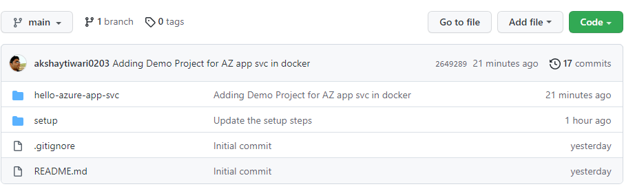

2. Copy the folder hello-azure-app-svc to a location where you would like to keep your code.

3. Import this folder as a maven project into eclipse.

4. Once project is built, run the project as a java application.

5. Go to the browser and type url http://localhost:8080/akshay

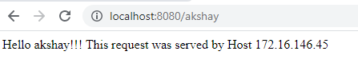

6. Open a command prompt and navigate inside the location where you copied hello-azure-app-svc

cd <base_path>\ hello-azure-app-svc

7. Build the project using maven

mvn clean install

8. Login to dockerhub

docker login

9. Build the docker image (note there is a . in the end of command.

docker build -t <docker_hub_user_name>/hello-azure-app-svc .

10. Check the image that you have created and note the imageid

docker images

11. Tag the image

docker tag <image_id> <docker_hub_user_name>/hello-azure-app-svc

12. Run the image locally

docker run -p 8080:8080 <docker_hub_user_name>/hello-azure-app-svc

13. On browser, navigate to <http://localhost:8080/><your_name> and check if out put is as expected

14. Execute following to identify the CONTAINER_ID of your container

docker ps

15. Stop the container

docker stop CONTAINER_ID

16. Push the image to docker hub.

docker push <docker_hub_user_name>/hello-azure-app-svc

17. Create an App service instance on Azure.

18. Explore various blades on azure portal for this app service

19. After verification delete the resource group